**Biblioteca Project**

**Proposal**

**Description:**

Project to simulate a Library administrative system. The system provides functionality for the admin personnel to organize library sections, managing book inventory, including their location at the library, and provided a frontend for customer that allows them to search for books and been able to add them to a cart for taking them home.

**Key ideas:**

* Admin personnel able to define library sections.
* Admin personnel able to manage books inventory.
* Allow users searching for books
  + Users can search by: genres, title, author, and year, ISBN

**Features Functionality and Mockups:**

* Main Page - Library front end designed to allow user to search for books and add to a cart for taking books out home. The page will also allow filter teh books in the screen

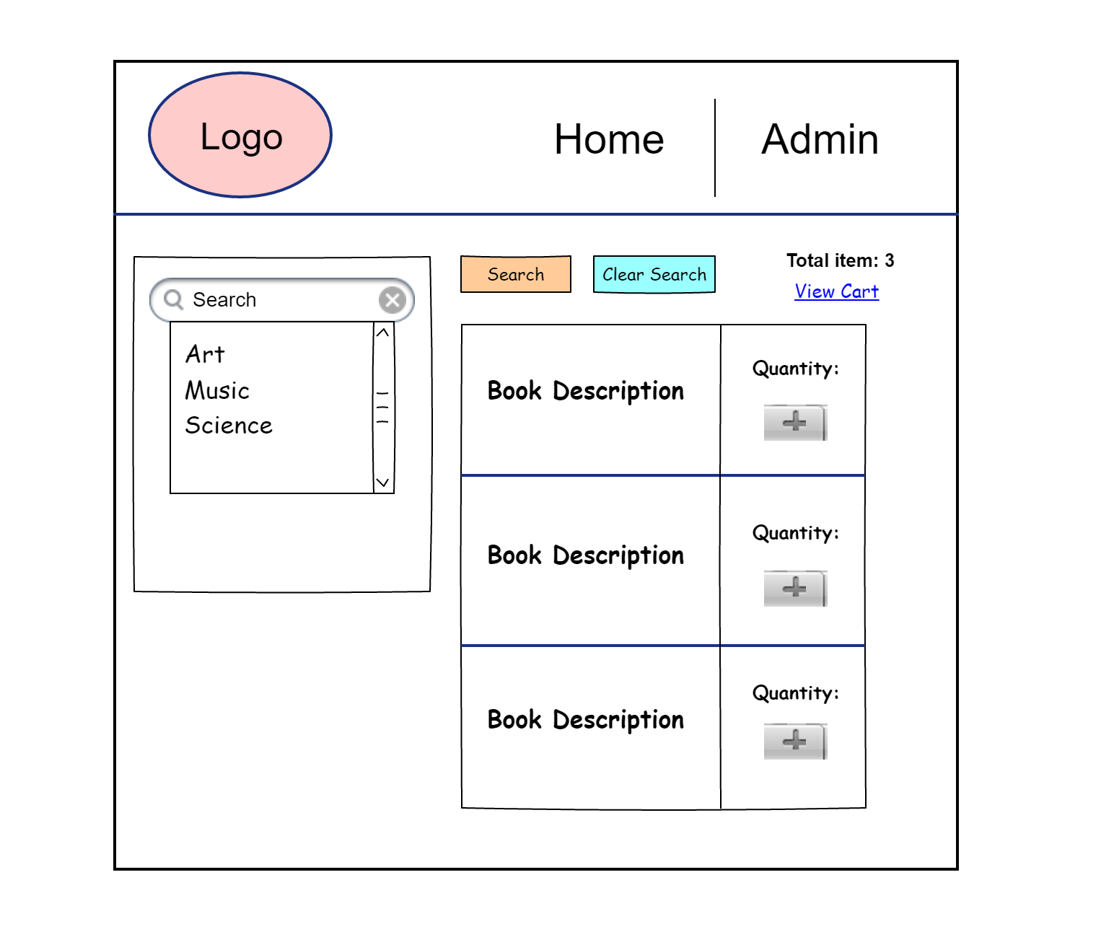

* User Search Button Page - Teh search will be a MODAL page that allow the user to enter the information know about the book. Upon hitting the search button the screen will disappear and present the results in the main page.

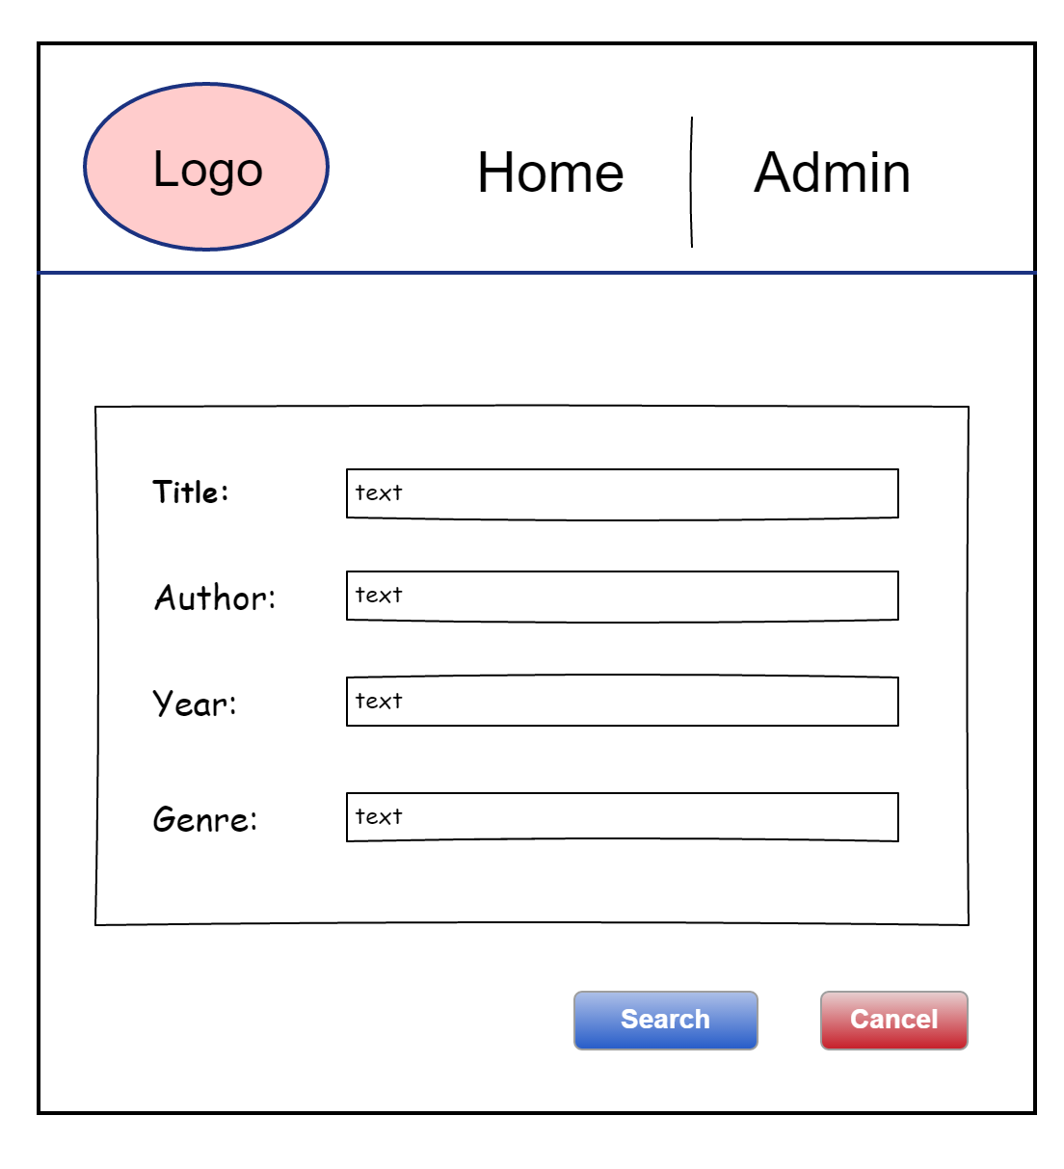

* View Cart Page - The user can check into a cart the book want to reserve to take home. The Cart view will decrement the inventory quantity after the user goes to the cart and hit “Check out”

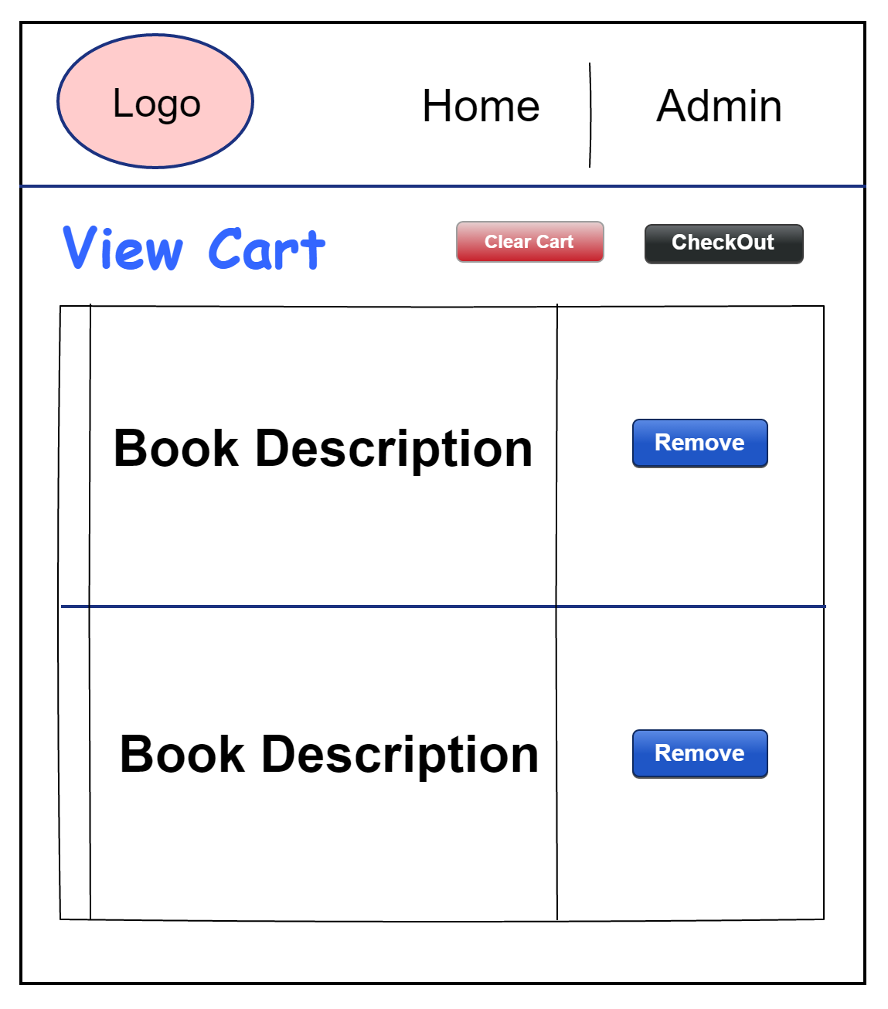

* Admin Page - This is the main page for the admin personnel. This page will present the options for managing definition for library sections and book inventory.

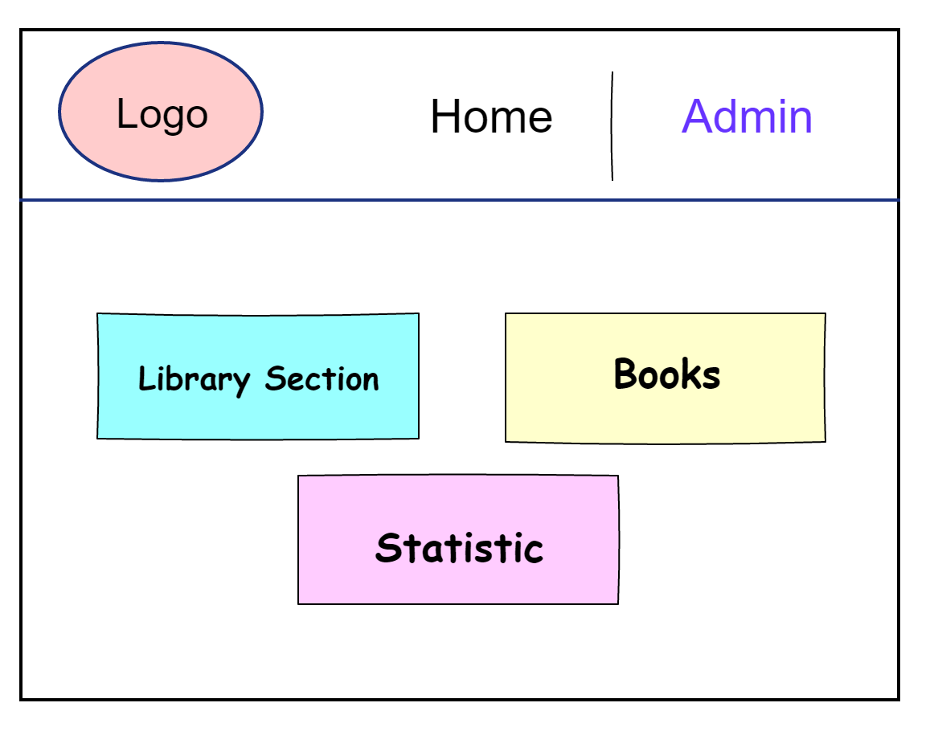

* Statistic

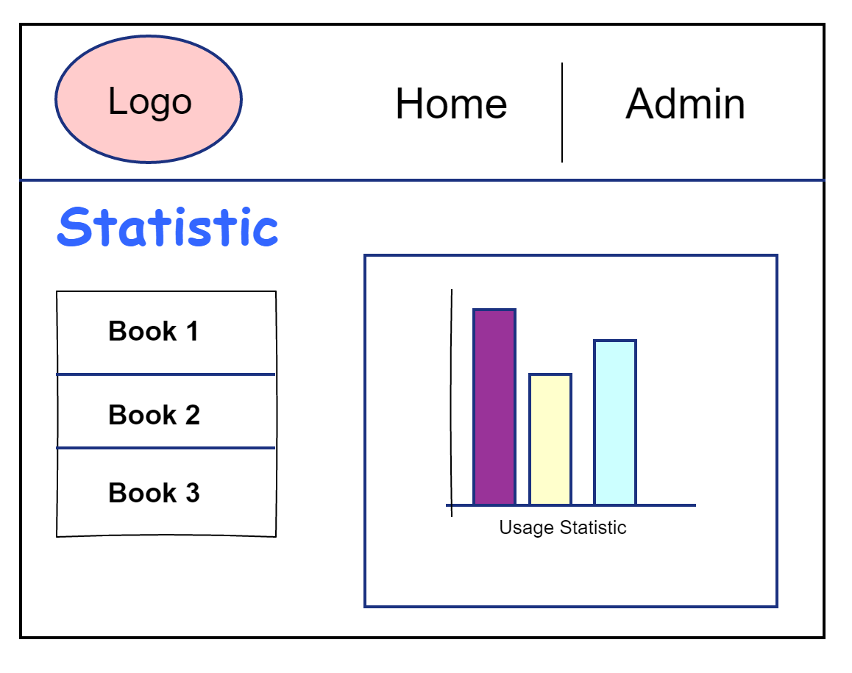

* Library Section - This page will offer a CRUD operation over library sections.

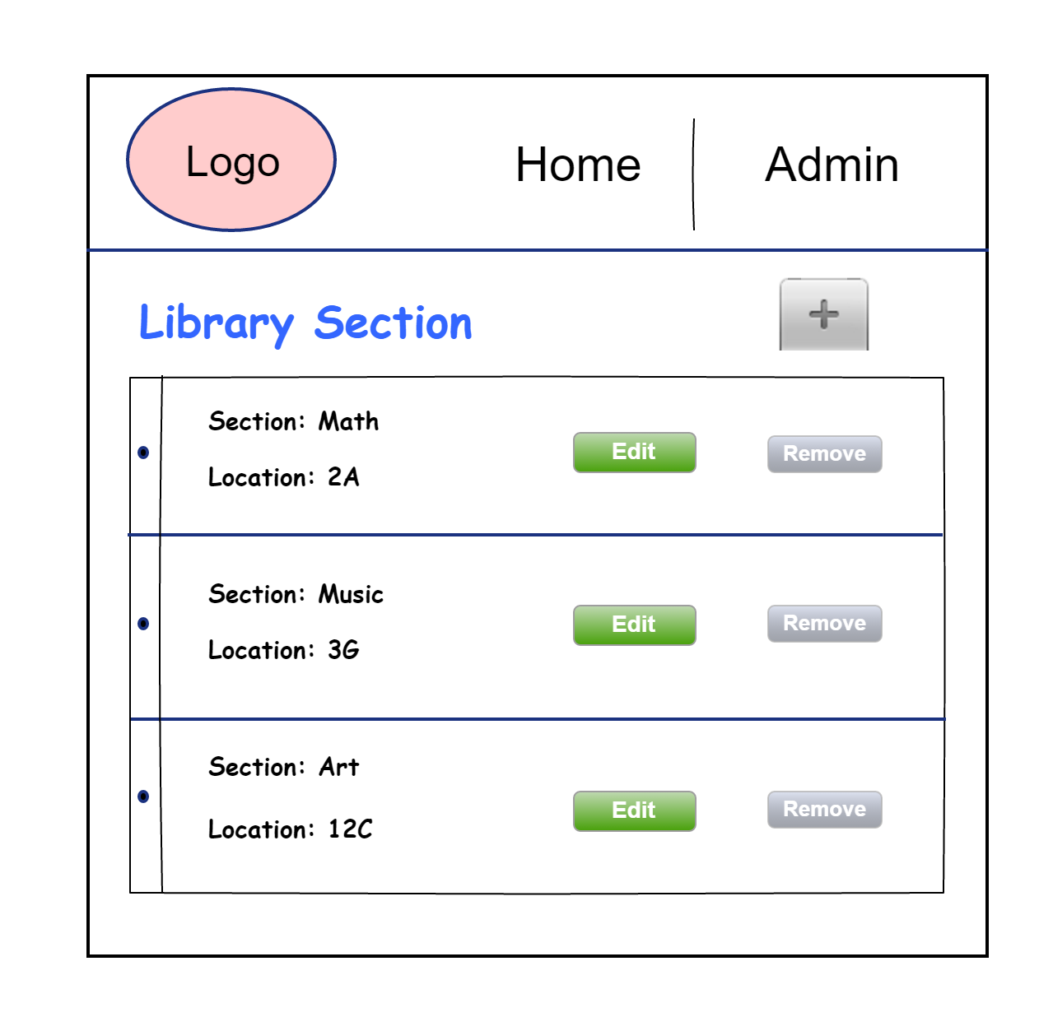

* Add Button Page under Library Section

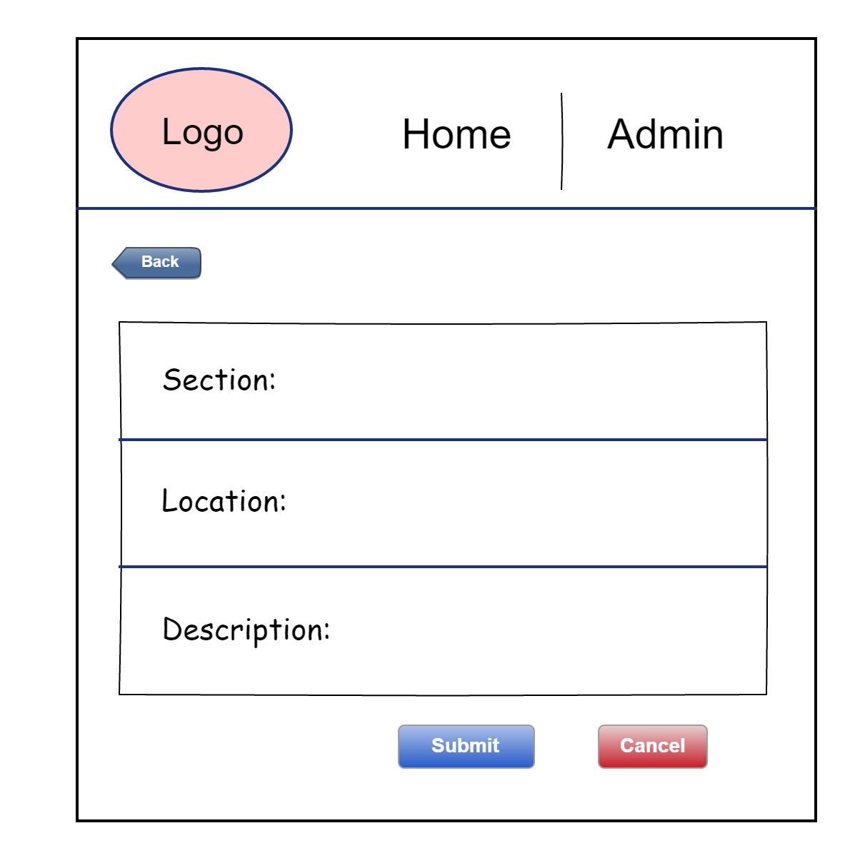

* Remove Page under Library Section

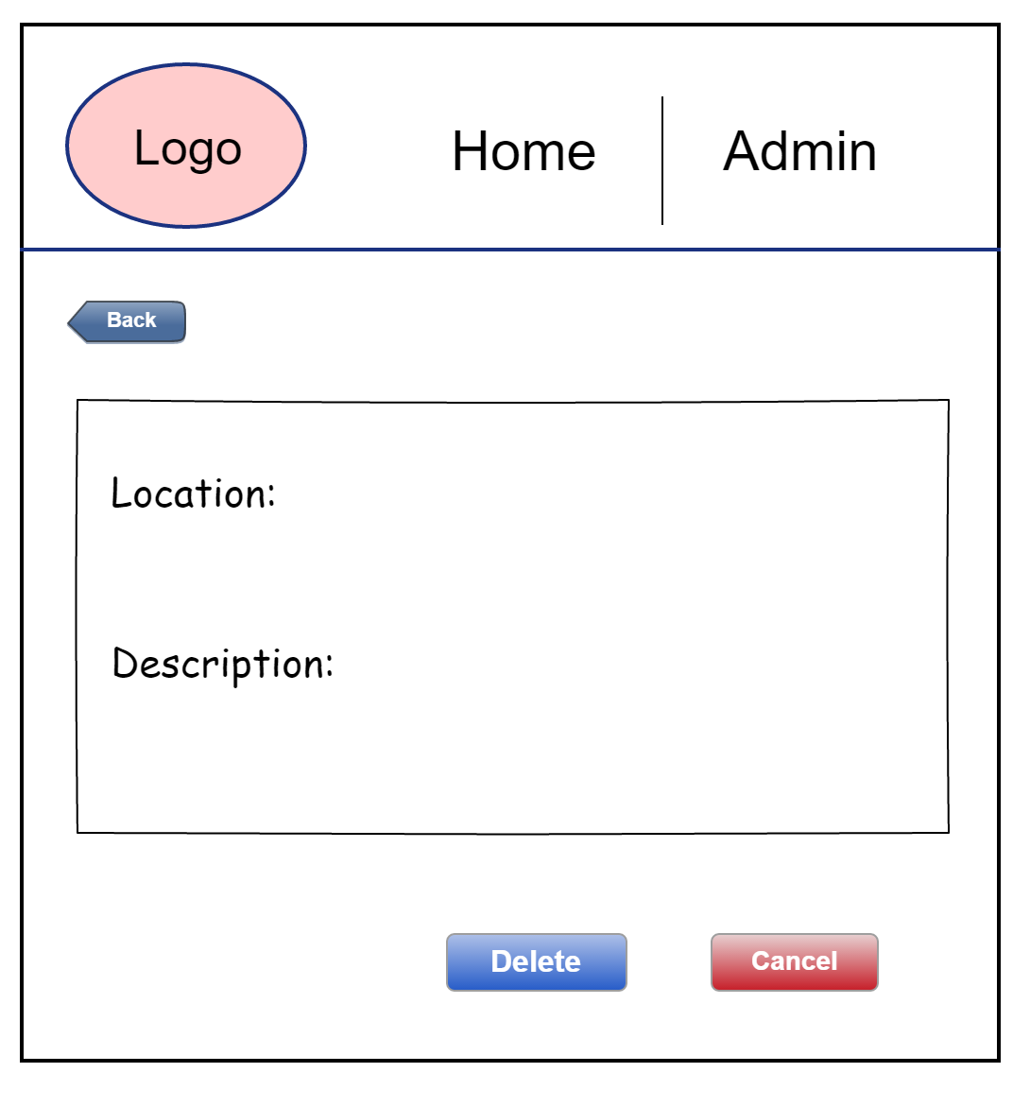

* Edit page under Library Section

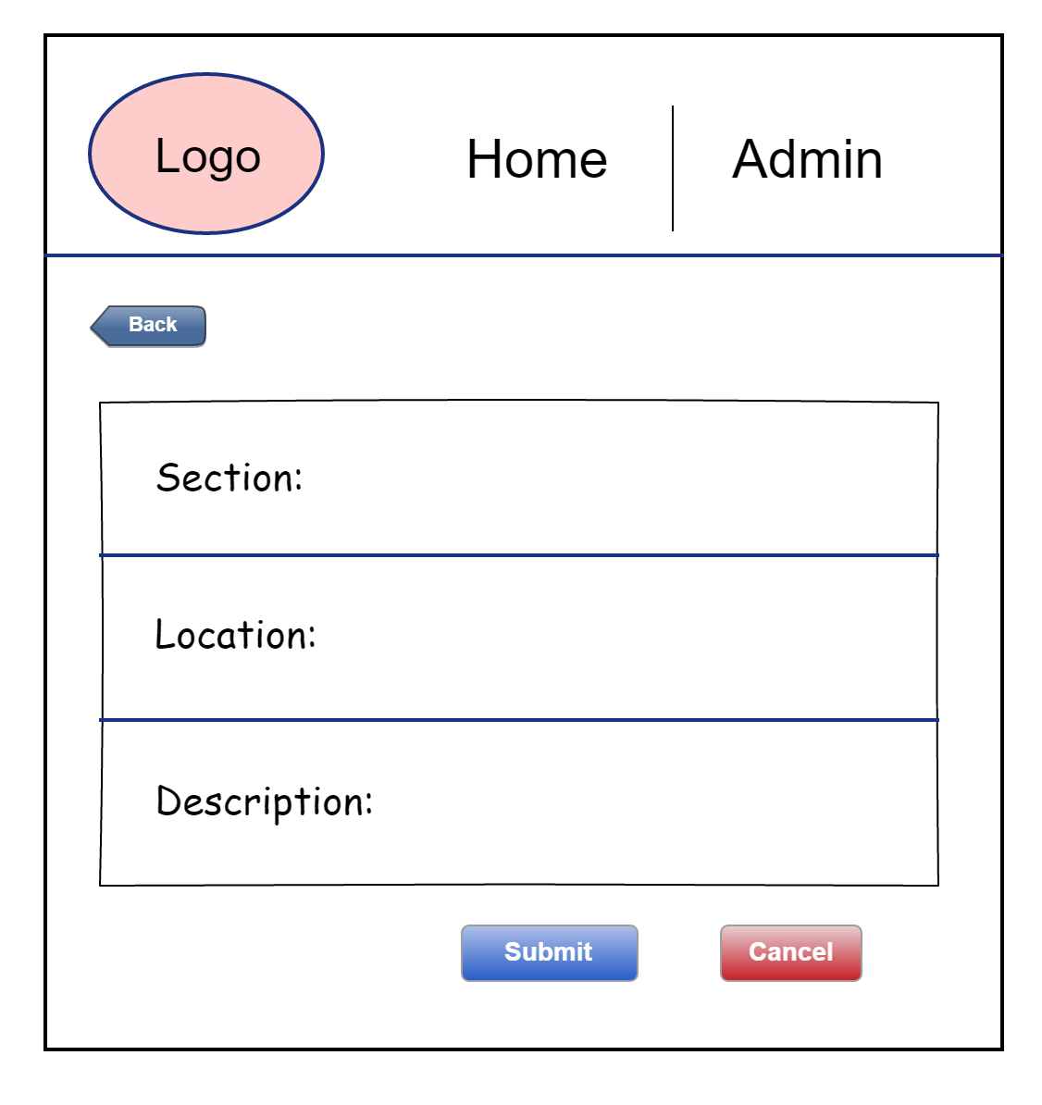

* Books Page - This page will offer CRUD operation for book inventory

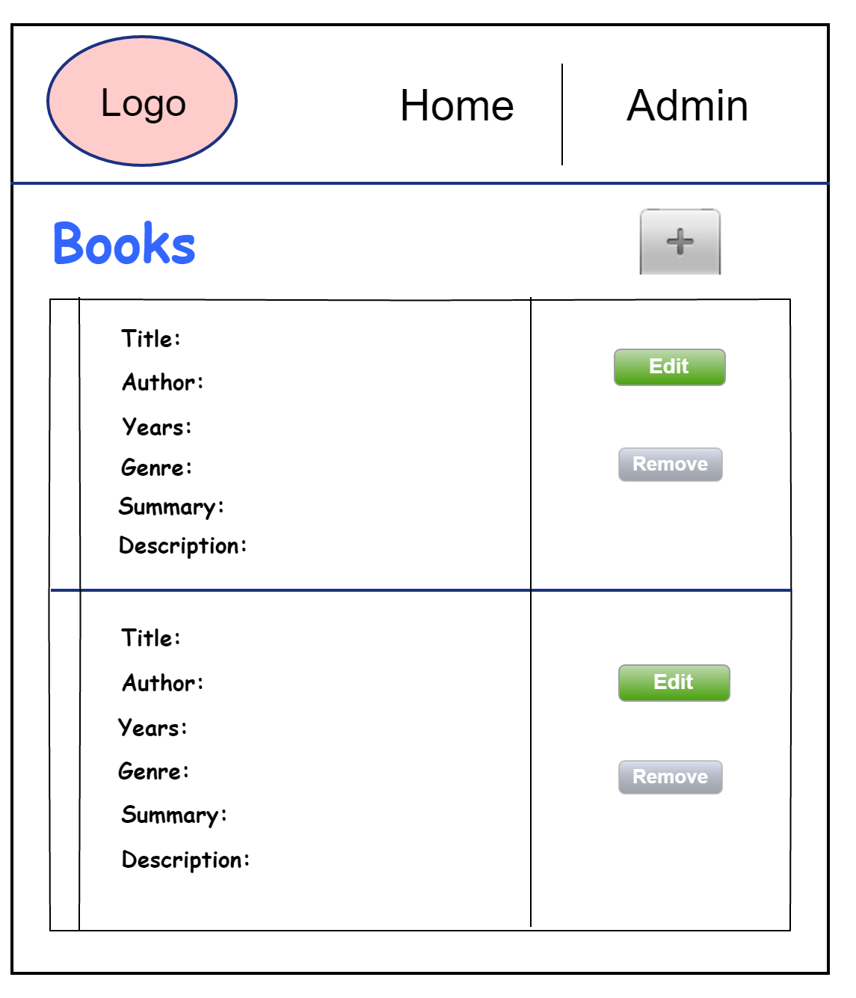

* Add Button under Books Section

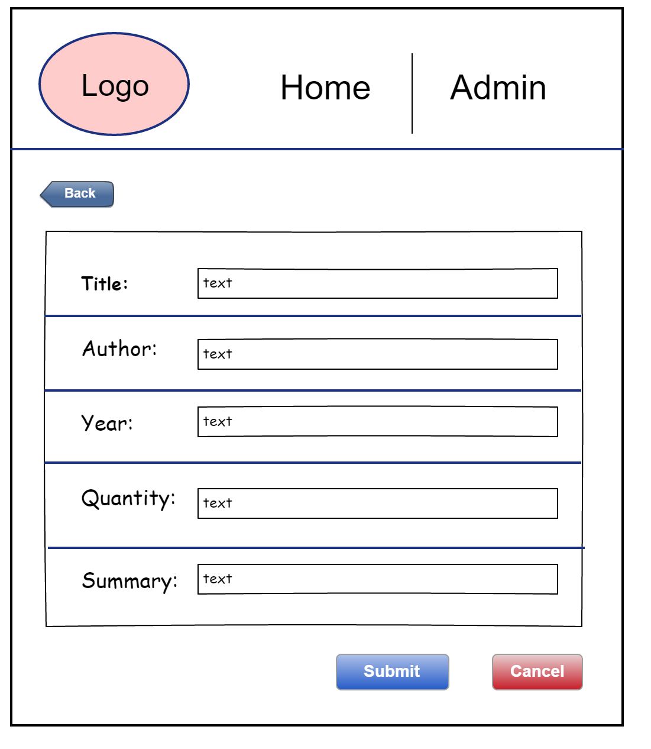

* Edit page under Books Section

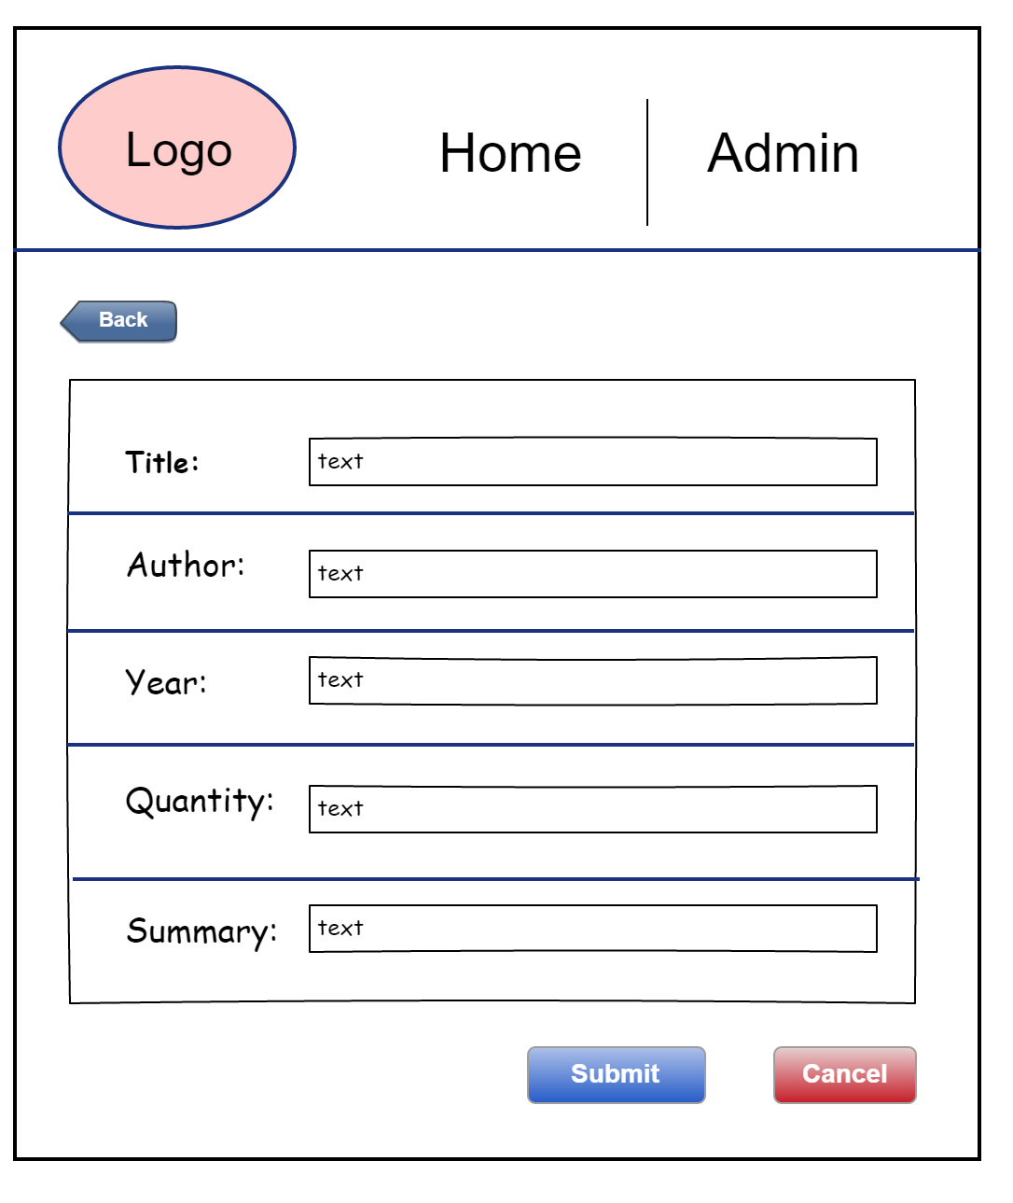

* Remove Page under Books Section

