# Word Guess Game (using NodeJS)

Word Guess Game is a guessing game similar to the Hangman game.

## Description

The game is an application made with NodeJS, and offers a good example integrating several custom modules that contain functionality encapsulated in objects.

The game will present the user a secret word, giving a clue about the total letters that composes the word. The user job is to discover each letter in the word. The user will have 12 possible guesses to discover the word.

## How does it work

To start the game, the user needs to execute the following command:

**node playgame.js**

This command will initiate the game, and the following question will be posted in the terminal:

**Hi, Do you want to play a game?**

If the user selects “Y”, the application will grab at random one of the possible secret words and the user will be presented with the maximum number of guessing opportunities, and the option to provide one letter guess at a time. The game will continue until the word is discovered or the user runs out of guessing opportunities.

The following image depicts the ideas.

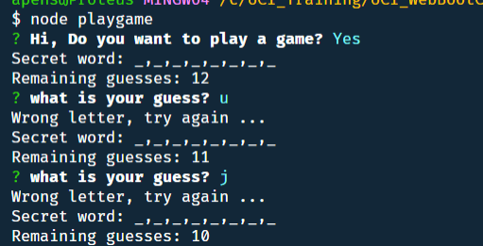

If the user discovers the word or runs out of opportunities, the system will inform a message indicating that the success or failure, and invite the user to a new game. If the user will have the option to decline the new game and terminate the application

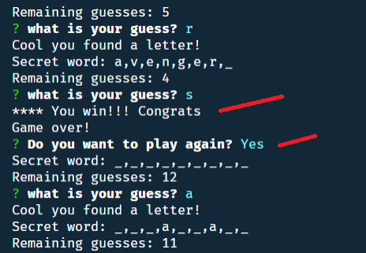

## Who can benefit from this application

This application is beneficial for NodeJS developer, providing sample programming structures using JavaScript, and the use the ‘**inquirer**’ external module, and the use of custom-made modules that encapsulate the logic of the game.

## How developers can get started

To start, the developer must have NodeJS installed in the computer. After, that the project can be cloned and initialized with the external module. Here are the steps for getting started

1. Install NodeJS into the computer (<https://nodejs.org/en/>). Download button and run through the installation file.
2. Fork the project or clone it into the computer.
3. In the folder project, Make a `**.gitignore**` file and add the following lines to it. This will tell git not to track these files, and thus they won't be committed to Github.

node_modules

.DS_Store

1. Bring all external module dependencies using the command: **node i**

After, the initialization, and using Microsoft Visual Code, the project folder should resemble as depicted below, and should be ready for execution.

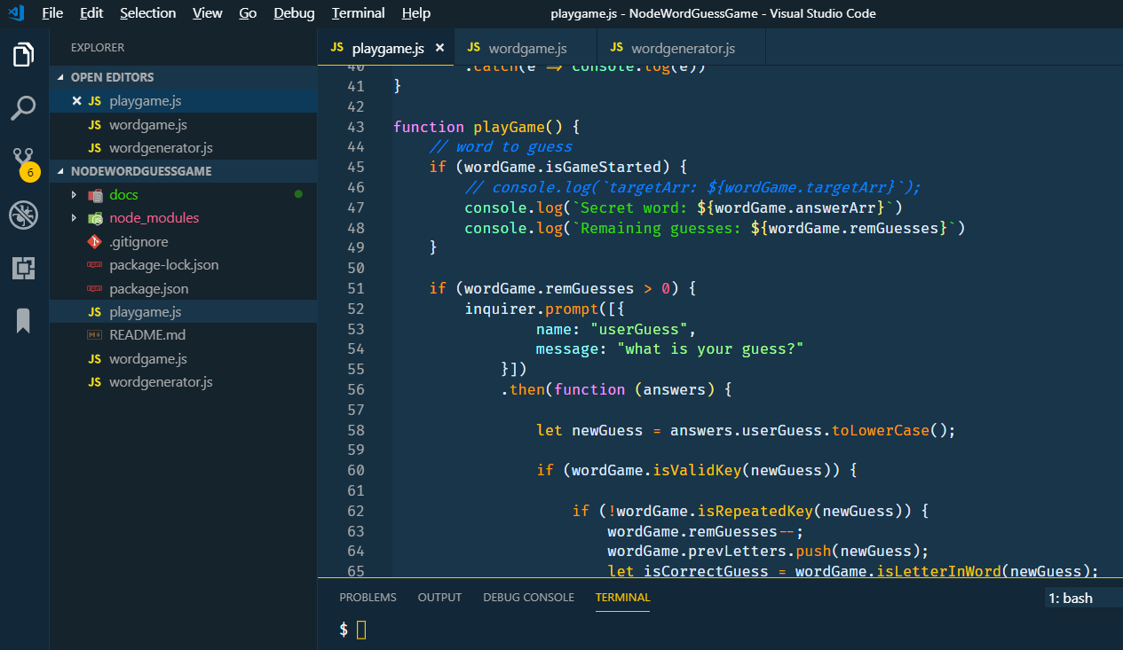

## Who maintains and contributes to the project

This is a personal project based on UCI Bootcamp training.

## Where users can get help with your project

The developer can refer to the following links:

* NodeJs : <https://nodejs.org/en/>
* Module inquirer: <https://www.npmjs.com/package/inquirer>
* Express for NodeJS: <https://expressjs.com/>
* Word Game with Frontend: <https://pensadotech.github.io/WordGuessGame/>
* Word Game with Frontend repo: <https://github.com/pensadotech/WordGuessGame>