
REPUBLIQUE DU CAMEROUN  *****************  PAIX — TRAVAIL — PATRIE  *****************  MINISTÈRE DE  L’ENSEIGNEMENT  SUPÉRIEUR |  | REPUBLIC OF CAMEROON  *****************  PEACE – WORK –  FATHERLAND  *****************  MINISTRY OF HIGHER  EDUCATION
 |    | 



Internship carried out at AFRILAND FIRST BANK, Douala, Bonanjo
From July 1 to August 31 2026, in preparation for advancement to 3rd year
Field: BACHELOR OF ENGINEERING (DATA SCIENCE AND ARTIFICIAL INTELLIGENCE).
Written and presented by:
SOLI MOKI LIMNYUY NGALLA.
Student Registration No: IUC24E000XXXX.
Under the supervision of:
Academic Supervisor:  TANDAH MARCELLE | Professional Supervisor:  M./Mrs. ………………………


DEDICATION

This work is dedicated to my beloved family,
for their love, their sacrifices and their unfailing support.

ACKNOWLEDGEMENTS
Every accomplishment is the result of collaboration, guidance and perseverance. The completion of this internship report marks an important milestone in my academic and professional journey, and I am deeply grateful to all those whose support, advice and encouragement made it possible.
First and foremost, I give thanks to Almighty God for granting me life, health, strength and wisdom throughout this internship period.
I wish to express my sincere gratitude to the following persons:
- Mr. GUIMEZAP Paul, Founder and President of the Institut Universitaire de la Côte (IUC), for his visionary leadership and his dedication to a stimulating environment for student development and innovation;
- Dr. TCHIDJDE Prudence, Director of the School of Engineering and Applied Sciences (SEAS), for the quality of the management, guidance and constant encouragement throughout my studies;
- Mr. FONKOU Leister, Head of the IT Department at SEAS, for the commitment to academic excellence and continuous support toward the professional growth of students;
- TANDAH MARCELLE, my academic supervisor, for the valuable guidance, patience and insightful advice given during the preparation of this report;
- M./Mrs. ………………, my professional supervisor at Afriland First Bank, for the availability, technical support and constant follow-up during the internship;
- The Management and the entire staff of Afriland First Bank, Douala Bonanjo, in particular the members of the IT and Human Resources teams, for their warm welcome, their collaboration and the time they spent answering my questions on the recruitment process;
- The teaching staff of SEAS – IUC, for the quality of the training received;
- My family and friends, for their encouragement and moral support throughout this rewarding experience.

TABLE OF CONTENTS
DEDICATION i
ACKNOWLEDGEMENTS ii
LIST OF FIGURES v
LIST OF TABLES vi
LIST OF ACRONYMS vii
ABSTRACT viii
RÉSUMÉ ix
GENERAL INTRODUCTION 1
Context of the study 1
Definition of the main concepts 1
Problem statement 1
Aim of the study 2
Organisation of the work 2
PART ONE: CONCEPTUAL FRAMEWORK 3
CHAPTER 1: PRESENTATION OF THE COMPANY AND ACTIVITIES CARRIED OUT DURING THE INTERNSHIP PERIOD 4
Introduction 4
1.1 Presentation of the company 4
1.1.1 Identification sheet 4
1.1.2 Historical background 4
1.1.3 Missions and activities 4
1.1.4 Organisational chart 5
1.1.5 The Information Systems department 5
1.2 Activities carried out during the internship 5
1.2.1 Reception within the structure 5
1.2.2 Weekly activities 5
1.2.3 Tools at my disposal 6
1.3 Choice and justification of the research topic 7
Conclusion 7
CHAPTER 2: OVERVIEW OF RECRUITMENT MANAGEMENT AND APPLICANT TRACKING SYSTEMS 8
Introduction 8
2.1 The recruitment process 8
2.2 Business process modelling 8
2.3 Personal data protection and CV security 8
2.4 Web technologies 9
2.5 Comparison of possible solutions 9
Conclusion 10
PART TWO: EMPIRICAL STUDY 11
CHAPTER 3: DIAGNOSIS OF THE EXISTING SYSTEM AND REQUIREMENTS SPECIFICATION 12
Introduction 12
3.1 Presentation of the existing system 12
3.2 Functioning of the existing system 12
3.3 Advantages and limits of the existing system 13
3.4 Requirements specification (cahier des charges) 13
3.4.1 Context and objectives of the project 13
3.4.2 Scope 13
3.4.3 Actors 14
3.4.4 Functional requirements 14
3.4.5 Non-functional requirements 15
3.4.6 Constraints 15
3.4.7 Deliverables and acceptance criteria 16
3.4.8 Planning 16
Conclusion 16
CHAPTER 4: CHOICE AND IMPLEMENTATION OF THE SOLUTION 17
Introduction 17
4.1 Technical notebook of the new system 17
4.1.1 Choice and justification of the components 17
4.1.2 Architecture of the solution 17
4.2 UML design of the system 18
4.2.1 Use case diagram 18
4.2.2 Class diagram 19
4.2.3 Activity diagram 20
4.2.4 Sequence diagram 20
4.3 Modelling of the recruitment business process 21
4.4 Database design 22
4.5 Secure management of CVs 23
4.6 REST API 24
4.7 Installation and configuration procedure 25
4.7.1 Prerequisites 25
4.7.2 Installation steps 25
4.7.3 Configuration 26
4.8 Presentation of the interfaces 26
4.9 Tests 30
4.10 Cost estimate of the solution 31
Conclusion 31
GENERAL CONCLUSION 32
BIBLIOGRAPHY AND WEBOGRAPHY 33
Bibliography 33
Webography 33
APPENDIX 34
Appendix 1: Extract of the database creation script 34
Appendix 2: Quick user guide for the HR manager 34

LIST OF FIGURES
Figure 1: Simplified organisational chart of the host structure 5
Figure 2: Topology of the existing recruitment process 12
Figure 3: Gantt chart of the project 16
Figure 4: Three-tier architecture of TalentFlow 18
Figure 5: Use case diagram 18
Figure 6: Class diagram 19
Figure 7: Activity diagram of the processing of an application 20
Figure 8: Sequence diagram of the secure upload and consultation of a CV 21
Figure 9: State machine of an application with the default stages 21
Figure 10: Physical data model (PostgreSQL) 23
Figure 11: Defence-in-depth layers protecting the CVs 23
Figure 12: Login page of the HR workspace 26
Figure 13: HR dashboard 27
Figure 14: Creation of a job offer with its customizable stages 27
Figure 15: Public career page and application form with secure CV upload 28
Figure 16: Kanban board of the recruitment pipeline 28
Figure 17: Candidate search with filters 29
Figure 18: Candidate profile with secure CV viewer and history 29
Figure 19: Notifications and automatic e-mail rules 30

LIST OF TABLES
Table 1: Identification sheet of Afriland First Bank 4
Table 2: Weekly activities carried out during the internship 5
Table 3: Tools used during the internship 6
Table 4: Comparison of the possible solutions 9
Table 5: Strengths and weaknesses of the existing system 13
Table 6: Actors of the system and their roles 14
Table 7: Functional requirements of TalentFlow 14
Table 8: Non-functional requirements 15
Table 9: Deliverables of the project 16
Table 10: Choice and justification of the technologies 17
Table 11: Textual description of the use case “Apply & upload CV” 19
Table 12: Security measures applied to CVs 23
Table 13: Main endpoints of the REST API 24
Table 14: Main test cases 30
Table 15: Cost estimate of the solution (FCFA) 31

LIST OF ACRONYMS
Acronym | Meaning
API | Application Programming Interface
ATS | Applicant Tracking System
AES-GCM | Advanced Encryption Standard – Galois/Counter Mode
BPM | Business Process Management
BPMN | Business Process Model and Notation
CDC | Cahier Des Charges (requirements specification)
CRUD | Create, Read, Update, Delete
CSS | Cascading Style Sheets
CV | Curriculum Vitae
DSI | Direction des Systèmes d’Information
HR | Human Resources
HTTPS | HyperText Transfer Protocol Secure
IUC | Institut Universitaire de la Côte
JSON | JavaScript Object Notation
JWT | JSON Web Token
MIME | Multipurpose Internet Mail Extensions
ORM | Object-Relational Mapping
OWASP | Open Worldwide Application Security Project
RBAC | Role-Based Access Control
REST | REpresentational State Transfer
SEAS | School of Engineering and Applied Sciences
SME | Small and Medium-sized Enterprise
SMTP | Simple Mail Transfer Protocol
SPA | Single Page Application
SQL | Structured Query Language
TLS | Transport Layer Security
UML | Unified Modeling Language
UUID | Universally Unique Identifier

ABSTRACT
This report presents the work carried out during my academic internship at Afriland First Bank, Douala – Bonanjo, from July 1 to August 31, 2026, in partial fulfilment of the requirements of the Bachelor of Engineering programme of the School of Engineering and Applied Sciences (SEAS) of the Institut Universitaire de la Côte (IUC).
During the internship, I observed that recruitment, both in the host structure and in the small and medium-sized enterprises (SMEs) that form a large part of its customers, is still handled with tools that were not designed for it: CVs arrive by e-mail, WhatsApp, paper and job boards, they are copied into Excel sheets and exchanged by e-mail, and nobody has a complete view of where each application stands. CVs are lost or duplicated, candidates rarely receive an answer, and personal data are stored without protection on personal phones and shared computers.
To address this problem, I designed and developed TalentFlow, a web platform for recruitment and job application tracking. The platform allows a company to publish job offers on a public career page, to receive CVs through a single secured channel, to model its own recruitment process as customizable stages displayed on a Kanban board, to search and filter candidates, and to follow its activity on an HR dashboard with automatic notifications. The solution is built with React for the front-end, Node.js/Express for the REST API and PostgreSQL for data storage. Particular attention was paid to the modelling of the recruitment business process and to the secure management of CVs: file validation and antivirus scanning, AES-256 encryption at rest, short-lived signed links, role-based access control and an audit trail of every access.
Keywords: recruitment, applicant tracking system, business process modelling, secure file management, React, Node.js, Express, PostgreSQL.

RÉSUMÉ
Ce rapport présente le travail réalisé au cours de mon stage académique effectué à Afriland First Bank, Douala – Bonanjo, du 1er juillet au 31 août 2026, dans le cadre de la formation de Bachelor of Engineering de la School of Engineering and Applied Sciences (SEAS) de l’Institut Universitaire de la Côte (IUC).
Au cours de ce stage, nous avons constaté que le recrutement, aussi bien dans la structure d’accueil que dans les petites et moyennes entreprises (PME) qui constituent une part importante de sa clientèle, est encore géré avec des outils inadaptés : les CV arrivent par e-mail, WhatsApp, papier et sites d’emploi, ils sont recopiés dans des fichiers Excel, et personne n’a une vue complète de l’état de chaque candidature. Des CV sont perdus ou dupliqués, les candidats reçoivent rarement une réponse et les données personnelles sont conservées sans protection.
Pour répondre à ce problème, nous avons conçu et développé TalentFlow, une plateforme web de recrutement et de suivi des candidatures. Elle permet de publier des offres d’emploi sur une page carrière publique, de recevoir les CV par un canal unique et sécurisé, de modéliser son propre processus de recrutement sous forme d’étapes personnalisables affichées dans un tableau Kanban, de rechercher et filtrer les candidats, et de piloter l’activité grâce à un tableau de bord RH et à des notifications automatiques. La solution repose sur React, Node.js/Express et PostgreSQL. Une attention particulière a été portée à la modélisation du processus métier et à la gestion sécurisée des CV : validation et analyse antivirus des fichiers, chiffrement AES-256, liens signés à durée limitée, contrôle d’accès par rôles et journalisation de chaque consultation.
Mots-clés : recrutement, suivi des candidatures, modélisation de processus métier, gestion sécurisée des fichiers, React, Node.js, Express, PostgreSQL.

GENERAL INTRODUCTION

Context of the study
Recruitment is one of the most decisive processes of any organisation: the quality of the people hired determines the quality of the services delivered. In Cameroon, as in many developing economies, small and medium-sized enterprises (SMEs) represent the large majority of companies and of formal jobs. These companies hire regularly but rarely have a dedicated Human Resources (HR) department or a recruitment software. Job offers are shared on Facebook, LinkedIn, WhatsApp groups or posted at the entrance of the premises, and applications arrive through all these channels at the same time.
This study was carried out at Afriland First Bank, Douala – Bonanjo, from July 1 to August 31, 2026. As a bank, Afriland First Bank works daily with SMEs, which are among its main customers, and it also recruits staff and interns itself. Through discussions with the HR staff and with customer advisers, I observed that the same difficulty appears everywhere: applications are received through several channels and their follow-up is lost.

Definition of the main concepts
- Recruitment: the set of activities by which an organisation attracts, selects and hires the people it needs (definition of the need, publication of the offer, collection of applications, selection, decision, integration).
- Application (candidature): the act by which a person applies for a given job offer; it is made of personal data, a CV and possibly answers to screening questions.
- Recruitment pipeline: the ordered sequence of stages (e.g. New, Screening, Interview, Test, Offer, Hired) through which each application moves until a final decision.
- Applicant Tracking System (ATS): a software application that centralises job offers and applications and supports the recruitment pipeline.
- Business process modelling: the representation of the activities, actors, rules and events of a business process in order to analyse and automate it.
- Secure CV management: the set of technical and organisational measures that guarantee the confidentiality, integrity, availability and lawful processing of candidates’ personal data.

Problem statement
The central problem of this study can be stated as follows: how can a small company centralise applications received from multiple channels, follow each of them through a recruitment process adapted to its own practices, and protect the personal data contained in the CVs? This main question leads to the following specific questions:
- How can the different sources of applications be gathered into a single channel?
- How can a recruitment process be modelled so that each company can customise its own stages?
- How can HR staff quickly find the right candidates among hundreds of CVs?
- How can candidates and recruiters be kept informed without additional manual work?
- How can CVs be stored and consulted securely, in accordance with personal data protection rules?

Aim of the study
The general objective of this work is to design and implement a web platform for recruitment and job application tracking, named TalentFlow. More specifically, the platform must make it possible to: publish job offers and receive CVs; define customizable recruitment stages; filter and search candidates; and provide notifications and an HR dashboard. For the host company and its SME customers, the expected benefits are a reduction of the time spent on administrative tasks, no more lost applications, a better experience for candidates and a lawful, secured handling of personal data.

Organisation of the work
Apart from this general introduction and the general conclusion, this report is organised into two parts. Part One (conceptual framework) contains Chapter 1, which presents the host company and the activities carried out during the internship, and Chapter 2, which gives an overview of recruitment management and of the existing solutions. Part Two (empirical study) contains Chapter 3, which diagnoses the existing system and presents the requirements specification (cahier des charges) of the new platform, and Chapter 4, which presents the choice and the implementation of the solution, its installation procedure and its cost estimate.

PART ONE: CONCEPTUAL FRAMEWORK

Chapter 1: Presentation of the company and activities carried out during the internship period
Chapter 2: Overview of recruitment management and applicant tracking systems

CHAPTER 1: PRESENTATION OF THE COMPANY AND ACTIVITIES CARRIED OUT DURING THE INTERNSHIP PERIOD

Introduction
This chapter presents the host structure, Afriland First Bank, then describes week by week the activities carried out during the internship, and finally explains the choice and the justification of the research topic.

1.1 Presentation of the company

1.1.1 Identification sheet
Table 1: Identification sheet of Afriland First Bank
Item | Information
Company name | Afriland First Bank
Former name | CCEI Bank (Caisse Commune d’Épargne et d’Investissement)
Legal form | Public limited company (Société Anonyme)
Year of creation | 1987
Sector of activity | Banking and financial services
Head office | Yaoundé, Cameroon
Internship site | Douala – Bonanjo
Group | Afriland First Group
Website | www.afrilandfirstbank.com

1.1.2 Historical background
Afriland First Bank was created in 1987 under the name CCEI Bank (Caisse Commune d’Épargne et d’Investissement) by Cameroonian promoters, with the objective of offering banking services adapted to local entrepreneurs. The bank took the name Afriland First Bank in 2002. Over the years it has developed a network of branches across the Cameroonian territory and has extended its activities to other African countries within Afriland First Group. It is today one of the leading commercial banks in Cameroon.

1.1.3 Missions and activities
As a commercial bank, Afriland First Bank offers a wide range of services to individuals, SMEs, large companies and institutions:
- collection of deposits and management of current and savings accounts;
- granting of loans to individuals and to companies, with a strong focus on SMEs and entrepreneurs;
- national and international money transfers and trade finance;
- electronic banking: cards, mobile and internet banking;
- advice and support to companies in the management of their activities.

1.1.4 Organisational chart
The bank is organised around a general management and functional directorates. Figure 1 gives a simplified view of the organisation, showing the unit in which the internship took place.
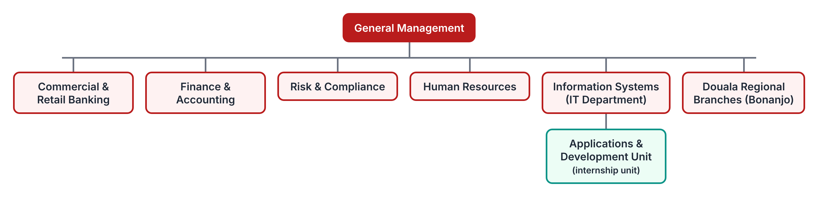
Figure 1: Simplified organisational chart of the host structure

1.1.5 The Information Systems department
The Information Systems department is responsible for the availability and the security of the information system of the bank: core banking applications, networks, workstations, electronic banking channels and internal business applications. Within this department, the applications and development unit designs or adapts internal tools for the other departments (Human Resources, Commercial, Risk, etc.). It is in this unit that I was received, which allowed me to work both with developers and with the business users of the HR department.

1.2 Activities carried out during the internship

1.2.1 Reception within the structure
On July 1, 2026, I was received by my professional supervisor, who presented the bank, its organisation and its internal rules (working hours, dress code, confidentiality, use of IT resources). I signed a confidentiality commitment and received access to a workstation and to the development environment of the unit.

1.2.2 Weekly activities
Table 2 summarises the activities carried out each week and what I learned from them.
Table 2: Weekly activities carried out during the internship
Week | Activities | What I learned / problems solved
W1  01 – 05 July | Reception, presentation of the bank and of the IT department; installation of the work environment; observation of the daily tasks of the unit. | Organisation of a bank, security rules, use of the ticketing tool.
W2  06 – 12 July | Support to the IT help desk (workstation configuration, network issues); interviews with HR staff about the recruitment of interns and staff. | Troubleshooting methods; understanding of the recruitment process and of its pain points.
W3  13 – 19 July | Study of the existing process: collection of examples of Excel tracking sheets, e-mails and paper CVs; interviews with SME customers via account managers; writing of the requirements specification. | Requirements elicitation; writing of functional and non-functional requirements.
W4  20 – 26 July | UML modelling (use cases, classes, activities, sequences); design of the database; validation of the design with the supervisor. | Business process modelling; relational database design and normalisation.
W5  27 July – 02 Aug. | Set-up of the project (Git, Docker, PostgreSQL); development of authentication, users, roles and job offers in the Express API. | JWT authentication, password hashing, REST API design, Prisma migrations.
W6  03 – 09 Aug. | Development of the customizable pipeline and of the application workflow; development of the public career page in React. | Transactions in PostgreSQL, React components and state management.
W7  10 – 16 Aug. | Secure CV upload (validation, antivirus, encryption, signed URLs); candidate search with full-text search; notifications by e-mail and in-app. | File upload security (OWASP), PostgreSQL full-text search, job queues.
W8  17 – 23 Aug. | HR dashboard; unit and integration tests; deployment on a test server; demonstration to HR staff and collection of feedback. | Testing with Jest and Supertest; Docker deployment; user feedback.
W9  24 – 31 Aug. | Corrections after feedback; user guide and technical documentation; writing of the internship report; end-of-internship presentation. | Technical writing and oral presentation.

1.2.3 Tools at my disposal
Table 3: Tools used during the internship
Category | Tools
Hardware | Laptop (Intel Core i5, 16 GB RAM, 512 GB SSD), local network and Internet access
Operating systems | Windows 11 (workstation), Ubuntu Server 22.04 (test server)
Development | Visual Studio Code, Node.js 20, npm, Git and GitHub, Docker Desktop, Postman
Database | PostgreSQL 16, pgAdmin 4, Prisma ORM
Design | draw.io / StarUML (UML diagrams), Figma (interface mock-ups)
Office | Microsoft Word, Excel, PowerPoint, Microsoft Teams

1.3 Choice and justification of the research topic
During the second week, the HR staff explained that, for each internship or job campaign, they receive several hundred applications by e-mail, by WhatsApp and on paper. These applications are recopied in Excel files, CVs are forwarded by e-mail to managers, and it often becomes impossible to know which candidate has been contacted, interviewed or rejected. Account managers confirmed that many SME customers of the bank face exactly the same situation, with even fewer resources.
The topic “Web platform for recruitment and job application tracking” was therefore chosen because it answers a real and recurrent need of the host structure and of its customers, because its result can be used immediately, and because it allowed me to apply the skills of my training: requirements analysis, business process modelling, web development and information security.

Conclusion
This chapter presented Afriland First Bank, the activities carried out during the nine weeks of the internship and the reasons for the choice of the topic. The next chapter presents the theoretical background of recruitment management and the existing solutions.

CHAPTER 2: OVERVIEW OF RECRUITMENT MANAGEMENT AND APPLICANT TRACKING SYSTEMS

Introduction
This chapter presents the theory needed to understand the study: the recruitment process, the notion of business process modelling, the principles of personal data protection applied to CVs and the technologies of the web. It then compares the possible solutions to the problem.

2.1 The recruitment process
Whatever the size of the company, a recruitment generally follows the same main phases:
- Definition of the need: job title, missions, required profile, contract type, budget;
- Sourcing: publication of the offer on one or several channels (career page, job boards, social networks, schools, word of mouth);
- Collection of applications: reception of CVs, cover letters and answers to questions;
- Selection: screening of CVs, phone interview, tests, face-to-face interviews, reference checks;
- Decision and offer: choice of the candidate, negotiation, offer letter;
- Integration (onboarding): welcome and induction of the new employee;
- Closure: answer to all the candidates who were not selected and archiving of the file.
The selection phase is the one that varies most from one company to another: a bank may require several interviews and background checks, while a small shop may hire after a single interview. A good tool must therefore allow each company to define its own stages.

2.2 Business process modelling
A business process is a set of activities, performed by actors, that transforms inputs into a result of value for a customer. Business Process Management (BPM) studies how to identify, model, analyse, automate and improve such processes. The most common notations are BPMN (Business Process Model and Notation), the UML activity diagram and the state machine diagram.
A recruitment process lends itself well to modelling as a state machine: each application is an object whose state is the current stage, and the events (move, reject, hire) are transitions triggered by actors. Each transition can carry rules (who may perform it, which data are required) and effects (notification, history record). This is the approach retained for TalentFlow.

2.3 Personal data protection and CV security
A CV contains personal data: identity, contact details, photo, date of birth, career, sometimes salary expectations. In Cameroon, Law No. 2024/017 of 23 December 2024 on personal data protection sets rules for the processing of such data; in Europe, the General Data Protection Regulation (GDPR) plays the same role. The main principles common to these texts are:
- lawfulness and consent: the candidate must be informed of the purpose of the processing and agree to it;
- purpose limitation and minimisation: only the data needed for recruitment are collected;
- limited retention: data are kept for a defined period, then deleted or anonymised;
- security: the controller must protect data against loss, unauthorised access and disclosure;
- rights of the data subject: access, rectification and erasure.
On the technical side, the OWASP File Upload Cheat Sheet recommends validating the type of uploaded files with an allow-list and by their content (magic bytes), limiting their size, renaming them, storing them outside the web root, scanning them with an antivirus and serving them only to authorised users.

2.4 Web technologies
A modern web application is usually built in three tiers: a client running in the browser (single page application), an application server exposing a REST API, and a database. The proposed stack is the following:
- React is a JavaScript library for building user interfaces from reusable components; it is maintained by Meta and has a very large ecosystem.
- Node.js is a JavaScript runtime that executes code on the server with an event-driven, non-blocking model well suited to I/O-intensive applications such as APIs; Express is its most widely used minimalist web framework.
- PostgreSQL is an open-source relational database system known for its reliability, its compliance with SQL standards and advanced features such as full-text search, JSON types and arrays.

2.5 Comparison of possible solutions
Several solutions can be considered to solve the problem of application follow-up. Table 4 compares them.
Table 4: Comparison of the possible solutions
Solution | Advantages | Limits
Shared e-mail box + Excel | Free, known by everyone, no installation. | No single view, manual copying, no history, CVs scattered, no security, no notification.
Generic tools (Trello, Google Forms + Sheets) | Cheap, quick to set up, Kanban view available. | Not designed for recruitment, CVs stored on third-party servers, weak access control, no candidate communication.
International SaaS ATS (e.g. Workable, Lever, Recruitee) | Complete features, mature, maintained. | Monthly subscription in foreign currency per user, international card payment required, data hosted abroad, interface not adapted to local channels.
Open-source ATS (e.g. OpenCATS) | Free licence, self-hosted. | Old technology and interface, little maintenance, customisation of stages limited, needs strong technical skills.
Custom platform (TalentFlow) | Adapted to local practices, data hosted under the company’s control, customizable process, modern stack, low cost. | Development and maintenance effort; must be secured carefully.

The custom solution is retained because it is the only one that combines low cost, control of personal data and adaptation to the practices of Cameroonian SMEs, while remaining a realistic project for the duration of the internship.

Conclusion
This chapter presented the recruitment process, business process modelling, the requirements of personal data protection and the technologies used, and justified the choice of a custom platform. The next part is devoted to the empirical study.

PART TWO: EMPIRICAL STUDY

Chapter 3: Diagnosis of the existing system and requirements specification
Chapter 4: Choice and implementation of the solution

CHAPTER 3: DIAGNOSIS OF THE EXISTING SYSTEM AND REQUIREMENTS SPECIFICATION

Introduction
This chapter describes the recruitment process as it was observed on the field, explains how it works, identifies its strengths and its limits, and finally presents the requirements specification (cahier des charges) of the platform to be built.

3.1 Presentation of the existing system
The existing system is not a software application but a set of manual practices and general-purpose tools. Figure 2 shows its topology.
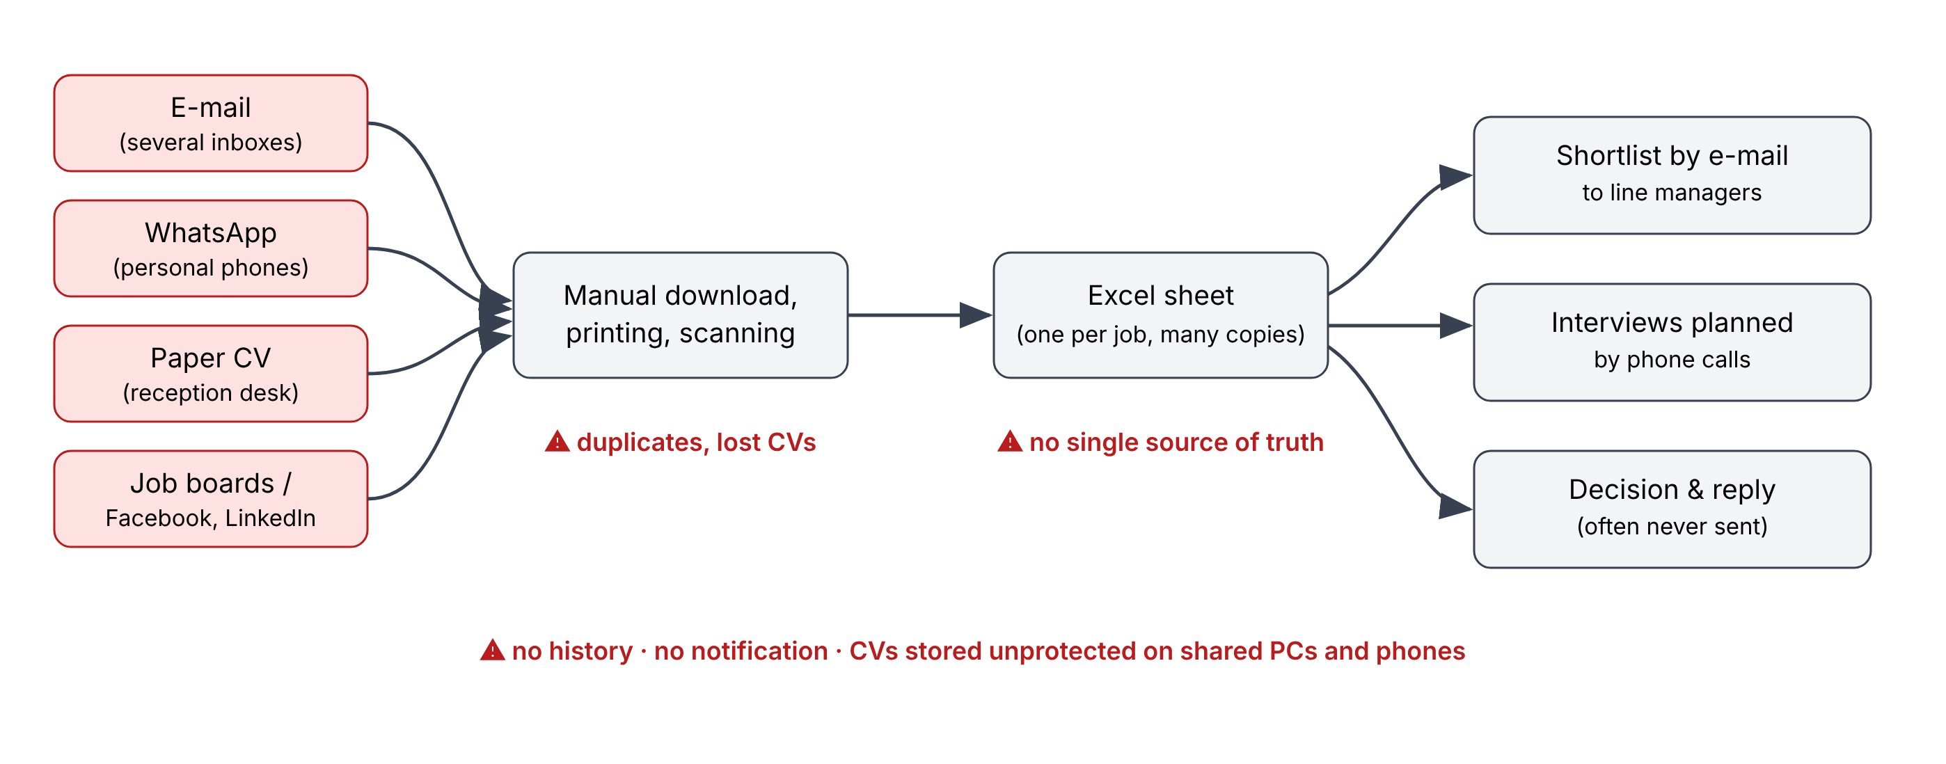
Figure 2: Topology of the existing recruitment process

3.2 Functioning of the existing system
- A need is expressed by a manager; the HR officer writes the offer in Word and shares it by e-mail, on social networks and on WhatsApp groups.
- Candidates send their CV to one of several e-mail addresses, to the personal WhatsApp number of an employee, or drop a paper copy at the reception.
- The HR officer downloads, prints or scans the CVs, then records each candidate in an Excel sheet (name, phone, position, date).
- Selected CVs are forwarded by e-mail to the line manager, who answers (or not) with comments.
- Interviews are planned by phone; results are written on paper or in the Excel sheet.
- The selected candidate is called; the other candidates generally receive no answer.

3.3 Advantages and limits of the existing system
Table 5: Strengths and weaknesses of the existing system
Aspect | Positive aspects | Limits
Technical | Tools already available and known by the staff; no installation. | Multiple sources, duplicates and lost CVs; no search in CV content; no history of decisions; file versions diverge.
Organisational | Flexible, adaptable to any situation. | Depends on one person; no shared view between HR and managers; candidates not informed; long delays.
Security | — | CVs stored on personal phones, mailboxes and shared computers; no access control; no traceability; no retention rule.
Financial | No direct cost. | Hidden cost: time spent on copying, searching and calling (estimated at several hours per week per recruitment); cost of bad or late hires.

The main limits that the new solution must overcome are therefore: the dispersion of applications, the absence of a shared and traceable process, the lack of communication with candidates and the insecure storage of CVs.

3.4 Requirements specification (cahier des charges)

3.4.1 Context and objectives of the project
Project: TalentFlow – web platform for recruitment and job application tracking. Project owner (student): SOLI MOKI Limnyuy Ngalla. Academic supervisor: TANDAH MARCELLE. Field: Employment / Human Resources. Level of difficulty: medium to advanced.
Problem: small companies receive CVs through several channels and lose track of applications. Objective: provide a single platform that centralises offers and applications, supports a customizable recruitment process, and handles CVs securely.

3.4.2 Scope
Included: job offer publication and public career page; online application with CV upload; manual import of applications received by e-mail or on paper; customizable stages; Kanban pipeline; candidate search and filters; evaluations and comments; e-mail and in-app notifications; HR dashboard; user and role management; secure CV storage. Excluded from this version: payroll, onboarding and employee management, video interviews, automatic CV parsing by artificial intelligence (planned as a perspective).

3.4.3 Actors
Table 6: Actors of the system and their roles
Actor | Description | Main rights
Visitor | Any Internet user consulting the career page. | Browse and search open offers.
Candidate | Person applying for an offer. | Apply with CV, track the status of the application, exercise the right to erasure.
Recruiter / Line manager | Employee involved in the selection for a given offer. | View the candidates of assigned offers, evaluate, comment, move candidates between stages.
HR Manager | Person responsible for recruitment in the company. | All recruiter rights + create/publish/close offers, configure stages and templates, dashboard, exports.
Administrator | Technical or company administrator. | Manage users, roles, company settings, retention policy, consult audit logs.

3.4.4 Functional requirements
The functional requirements are prioritised with the MoSCoW method (M = Must, S = Should, C = Could).
Table 7: Functional requirements of TalentFlow
Ref. | Requirement | Prio.
FR-01 | Users authenticate with e-mail and password; accounts are linked to one company and one role. | M
FR-02 | The HR manager creates, edits, publishes, closes and duplicates job offers (title, description, location, contract, deadline, skills, screening questions). | M
FR-03 | Each published offer is visible on a public career page with a shareable link. | M
FR-04 | A candidate applies online by filling a form and uploading a CV (PDF or DOCX, max 5 MB) and gives consent to data processing. | M
FR-05 | HR staff can manually add an application received by e-mail, WhatsApp or on paper, indicating its source. | M
FR-06 | Duplicate applications (same e-mail for the same offer) are detected and merged. | S
FR-07 | The HR manager defines recruitment stages (add, rename, reorder, delete) per company template and per offer. | M
FR-08 | Applications are displayed in a Kanban board; a candidate is moved between stages by drag and drop or by button. | M
FR-09 | Every stage change is recorded with author and date (history). | M
FR-10 | Users rate and comment candidates; comments are visible to the recruitment team only. | S
FR-11 | Candidates are searched by keywords, including the text content of the CV. | M
FR-12 | Candidates are filtered by offer, stage, experience, skills, source, rating and date. | M
FR-13 | An e-mail is sent to the candidate at application and at configurable stage changes (templates with variables). | M
FR-14 | Users receive in-app notifications (new applications, pending reviews, upcoming deadlines). | S
FR-15 | The HR dashboard shows open offers, applications per period, funnel by stage, sources and time-to-hire. | M
FR-16 | Candidates can follow the status of their application through a private link. | S
FR-17 | Data of a candidate can be exported or anonymised on request (right to erasure). | S
FR-18 | Applications older than the retention period are anonymised automatically. | C
FR-19 | Lists of candidates can be exported in CSV/Excel. | C
FR-20 | The administrator manages users and roles and consults the audit log. | M

3.4.5 Non-functional requirements
Table 8: Non-functional requirements
Category | Requirement
Security | HTTPS only; passwords hashed with bcrypt; JWT access tokens (15 min) + refresh token in httpOnly cookie; RBAC on every endpoint; CVs encrypted at rest (AES-256-GCM) and served through signed URLs valid 5 minutes; antivirus scan of every upload; audit log of every CV access; protection against OWASP Top 10 (injection, XSS, CSRF, broken access control).
Privacy | Explicit consent at application; retention period configurable (24 months by default); right of access and erasure.
Performance | API response time < 500 ms for 95 % of requests; search on 10,000 candidates < 1 s; upload of a 5 MB CV < 5 s on a 4G connection.
Availability | Target availability of 99 %; daily database backup kept 30 days.
Usability | Responsive interface usable on smartphone (career page) and desktop (back-office); bilingual French/English; a new HR user can publish an offer in less than 10 minutes without training.
Compatibility | Latest versions of Chrome, Firefox, Edge and Safari; Android and iOS browsers.
Maintainability | Code versioned with Git; layered architecture; automated tests on critical functions; documented API.
Portability | Deployment with Docker on any Linux server or cloud provider.

3.4.6 Constraints
- Technical: React for the front-end, Node.js/Express for the back-end, PostgreSQL for the database (stack imposed by the project).
- Time: the project must be designed, developed and documented within the nine weeks of the internship.
- Budget: use of free and open-source tools; low hosting cost suited to an SME.
- Legal: compliance with the rules on personal data protection.

3.4.7 Deliverables and acceptance criteria
Table 9: Deliverables of the project
Deliverable | Acceptance criteria
Requirements specification and UML design | Validated by the professional and academic supervisors.
Source code (front-end, back-end, database scripts) | Versioned in Git; builds and runs with a single Docker Compose command.
Deployed test instance | All “Must” requirements demonstrated on a realistic scenario.
Test report | Critical tests (authentication, upload, stage transition, access control) pass.
User guide and technical documentation | An HR user can publish an offer and process applications using the guide.
Internship report and presentation | Conform to the SEAS-IUC report format.

3.4.8 Planning
The project was planned over the nine weeks of the internship as shown in Figure 3.
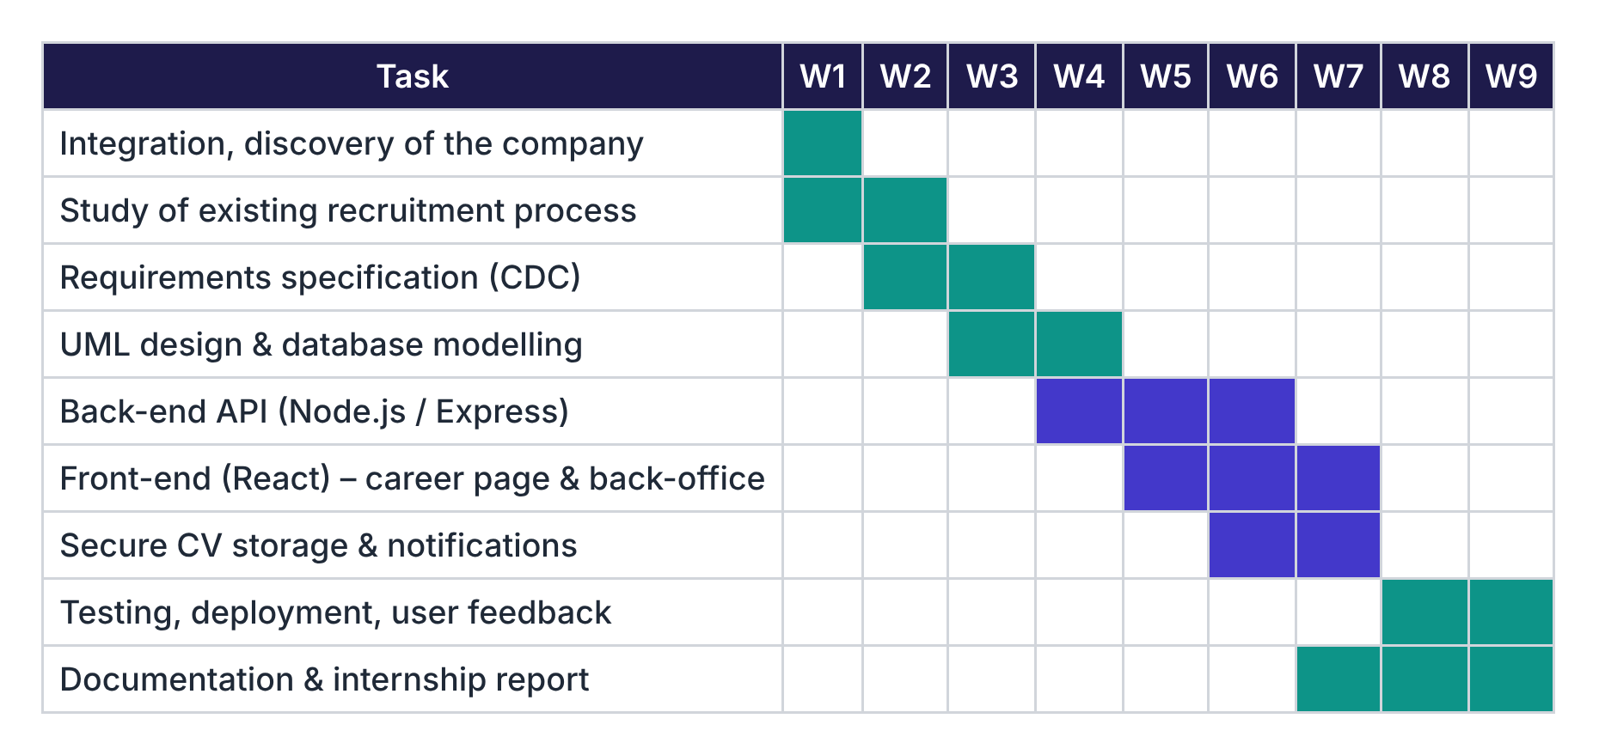
Figure 3: Gantt chart of the project

Conclusion
The diagnosis showed that the existing process, based on general-purpose tools, leads to lost applications, lack of traceability and insecure storage of personal data. The requirements specification translated these findings into precise functional and non-functional requirements. The next chapter presents how these requirements were implemented.

CHAPTER 4: CHOICE AND IMPLEMENTATION OF THE SOLUTION

Introduction
This chapter presents the technical notebook of the new system: the choice and justification of its components, its architecture, its UML design, the modelling of the recruitment process, the security of CVs, the installation and configuration procedure, the interfaces obtained, the tests carried out and the cost estimate.

4.1 Technical notebook of the new system

4.1.1 Choice and justification of the components
Table 10: Choice and justification of the technologies
Component | Choice | Justification
Front-end | React 18 + Vite, React Router, TanStack Query, Tailwind CSS | Component-based, very large community, fast development; Vite gives instant builds; TanStack Query handles caching and synchronisation with the API.
Drag and drop | dnd-kit | Accessible, lightweight library for the Kanban board.
Back-end | Node.js 20 LTS + Express 4 | Same language (JavaScript) on client and server; non-blocking I/O suited to file uploads and notifications; simple and well-known framework.
Validation | Zod | Single schema used to validate requests and to type data.
ORM | Prisma | Typed queries, migrations versioned with the code, protection against SQL injection.
Database | PostgreSQL 16 | Reliable relational DBMS, transactions, enumerated types, arrays, native full-text search (tsvector) used to search CV content.
File storage | MinIO (S3-compatible), private bucket | Files kept outside the web server, pre-signed URLs, can be replaced by any S3 provider.
Antivirus | ClamAV (clamd) | Free, open-source antivirus engine usable as a network service.
Queue & cache | Redis + BullMQ | Asynchronous sending of e-mails and scheduled jobs (reminders, retention).
E-mail | Nodemailer + SMTP | Standard, works with any e-mail provider.
Real-time | Socket.IO | Instant in-app notifications and Kanban updates.
Deployment | Docker Compose + Nginx + Let’s Encrypt | Reproducible installation, free TLS certificates.

4.1.2 Architecture of the solution
The platform follows a three-tier architecture (Figure 4). The React single page application communicates with the Express API over HTTPS using JSON. The API applies authentication, authorisation and validation, then accesses PostgreSQL through Prisma and the object storage for CV files. A worker process consumes the Redis queue to send e-mails and run scheduled jobs.
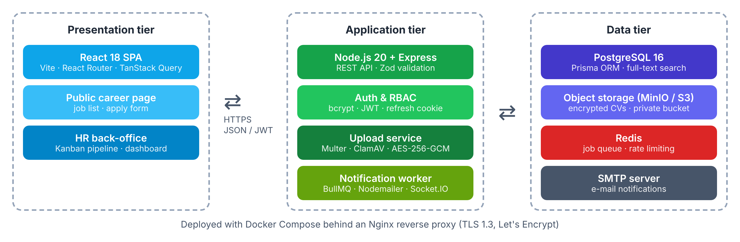
Figure 4: Three-tier architecture of TalentFlow
The back-end code is organised in layers: routes (HTTP endpoints) → middlewares (authentication, RBAC, validation, upload) → services (business rules) → repositories (Prisma). This separation makes the business rules independent of the framework and easier to test.

4.2 UML design of the system

4.2.1 Use case diagram
The use case diagram (Figure 5) shows the five actors and the main services they expect from the system.
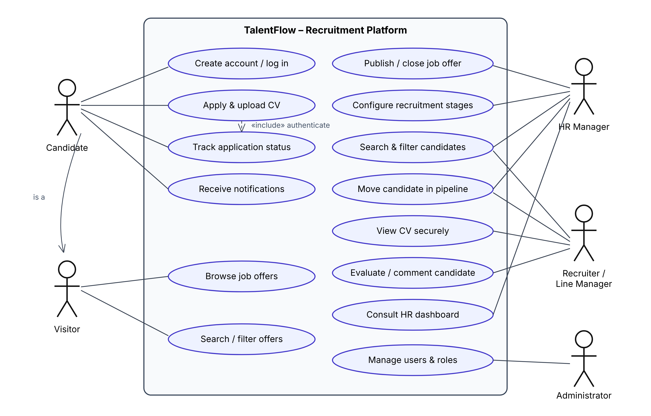
Figure 5: Use case diagram
Table 11: Textual description of the use case “Apply & upload CV”
Item | Description
Actor | Candidate
Pre-condition | The job offer is published and its deadline is not passed.
Nominal scenario | 1. The candidate opens the offer page and clicks “Apply”.  2. The system displays the form and the screening questions.  3. The candidate fills the form, attaches the CV and accepts the privacy notice.  4. The system validates the file, scans it, encrypts and stores it.  5. The system creates the application in the first stage and sends a confirmation e-mail.
Alternative scenarios | 4a. Invalid type, size > 5 MB or virus detected: the file is rejected with an explicit message.  5a. An application with the same e-mail already exists for this offer: the CV is updated instead of creating a duplicate.
Post-condition | The application appears in the “New” column of the pipeline and HR users are notified.

4.2.2 Class diagram
The class diagram (Figure 6) shows the main entities. A Company publishes JobOffers; each offer owns an ordered list of PipelineStages. An Application links a Candidate to an offer and points to its current stage; each change of stage creates a StageHistory entry. The CV is represented by a CvDocument that stores only the key of the encrypted file and its fingerprint.
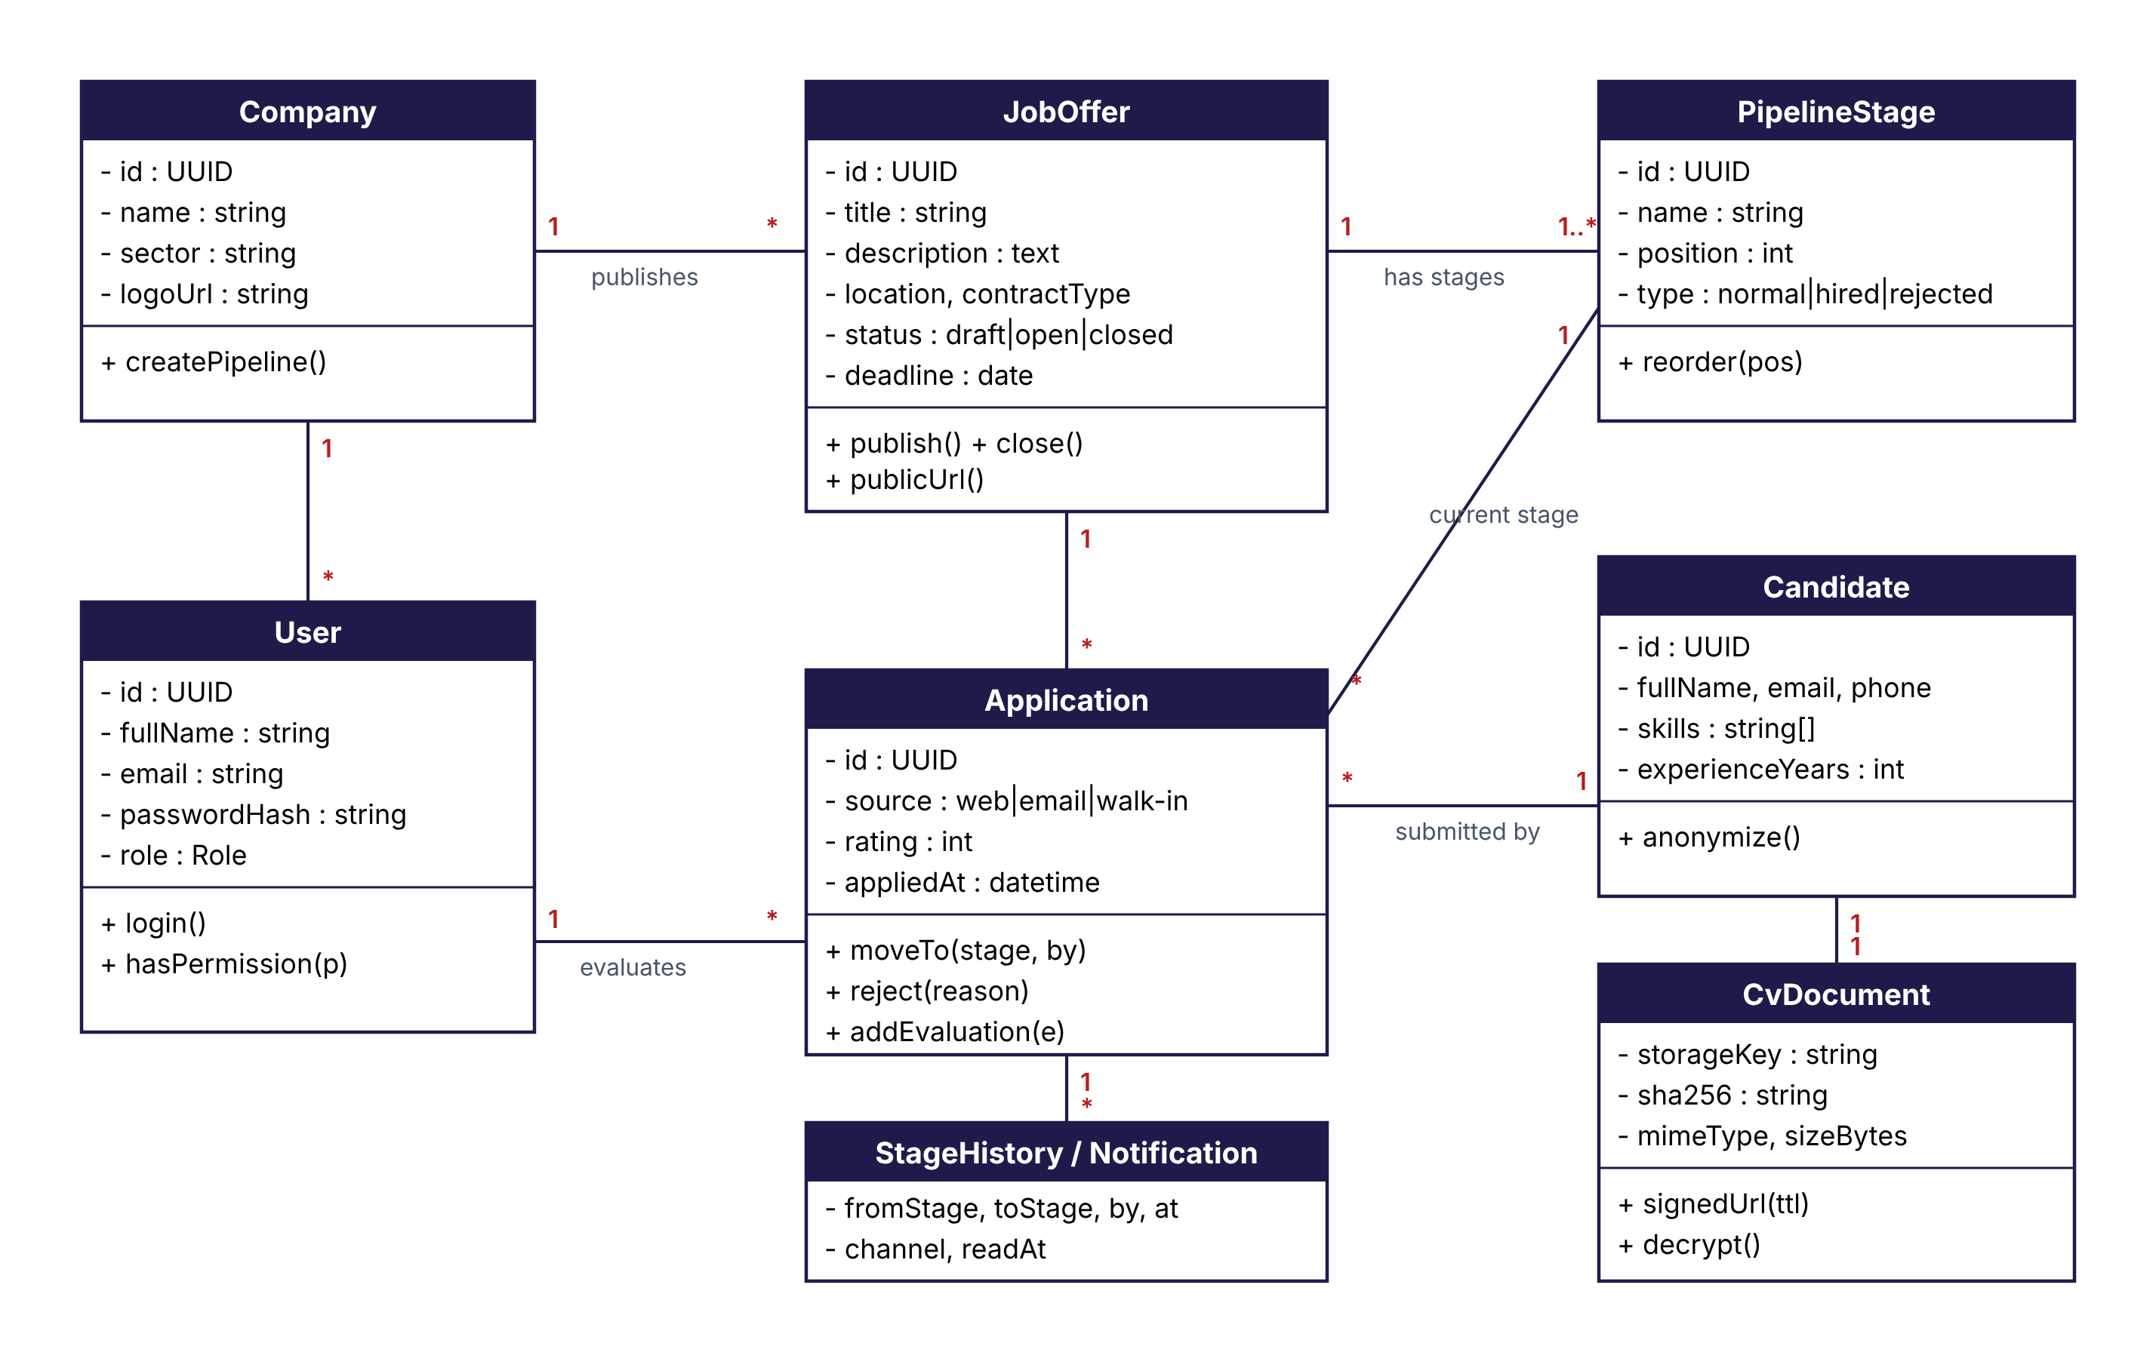
Figure 6: Class diagram

4.2.3 Activity diagram
The activity diagram (Figure 7) describes the life cycle of an application, from the publication of the offer to the final decision, across the three swimlanes candidate, system and HR.
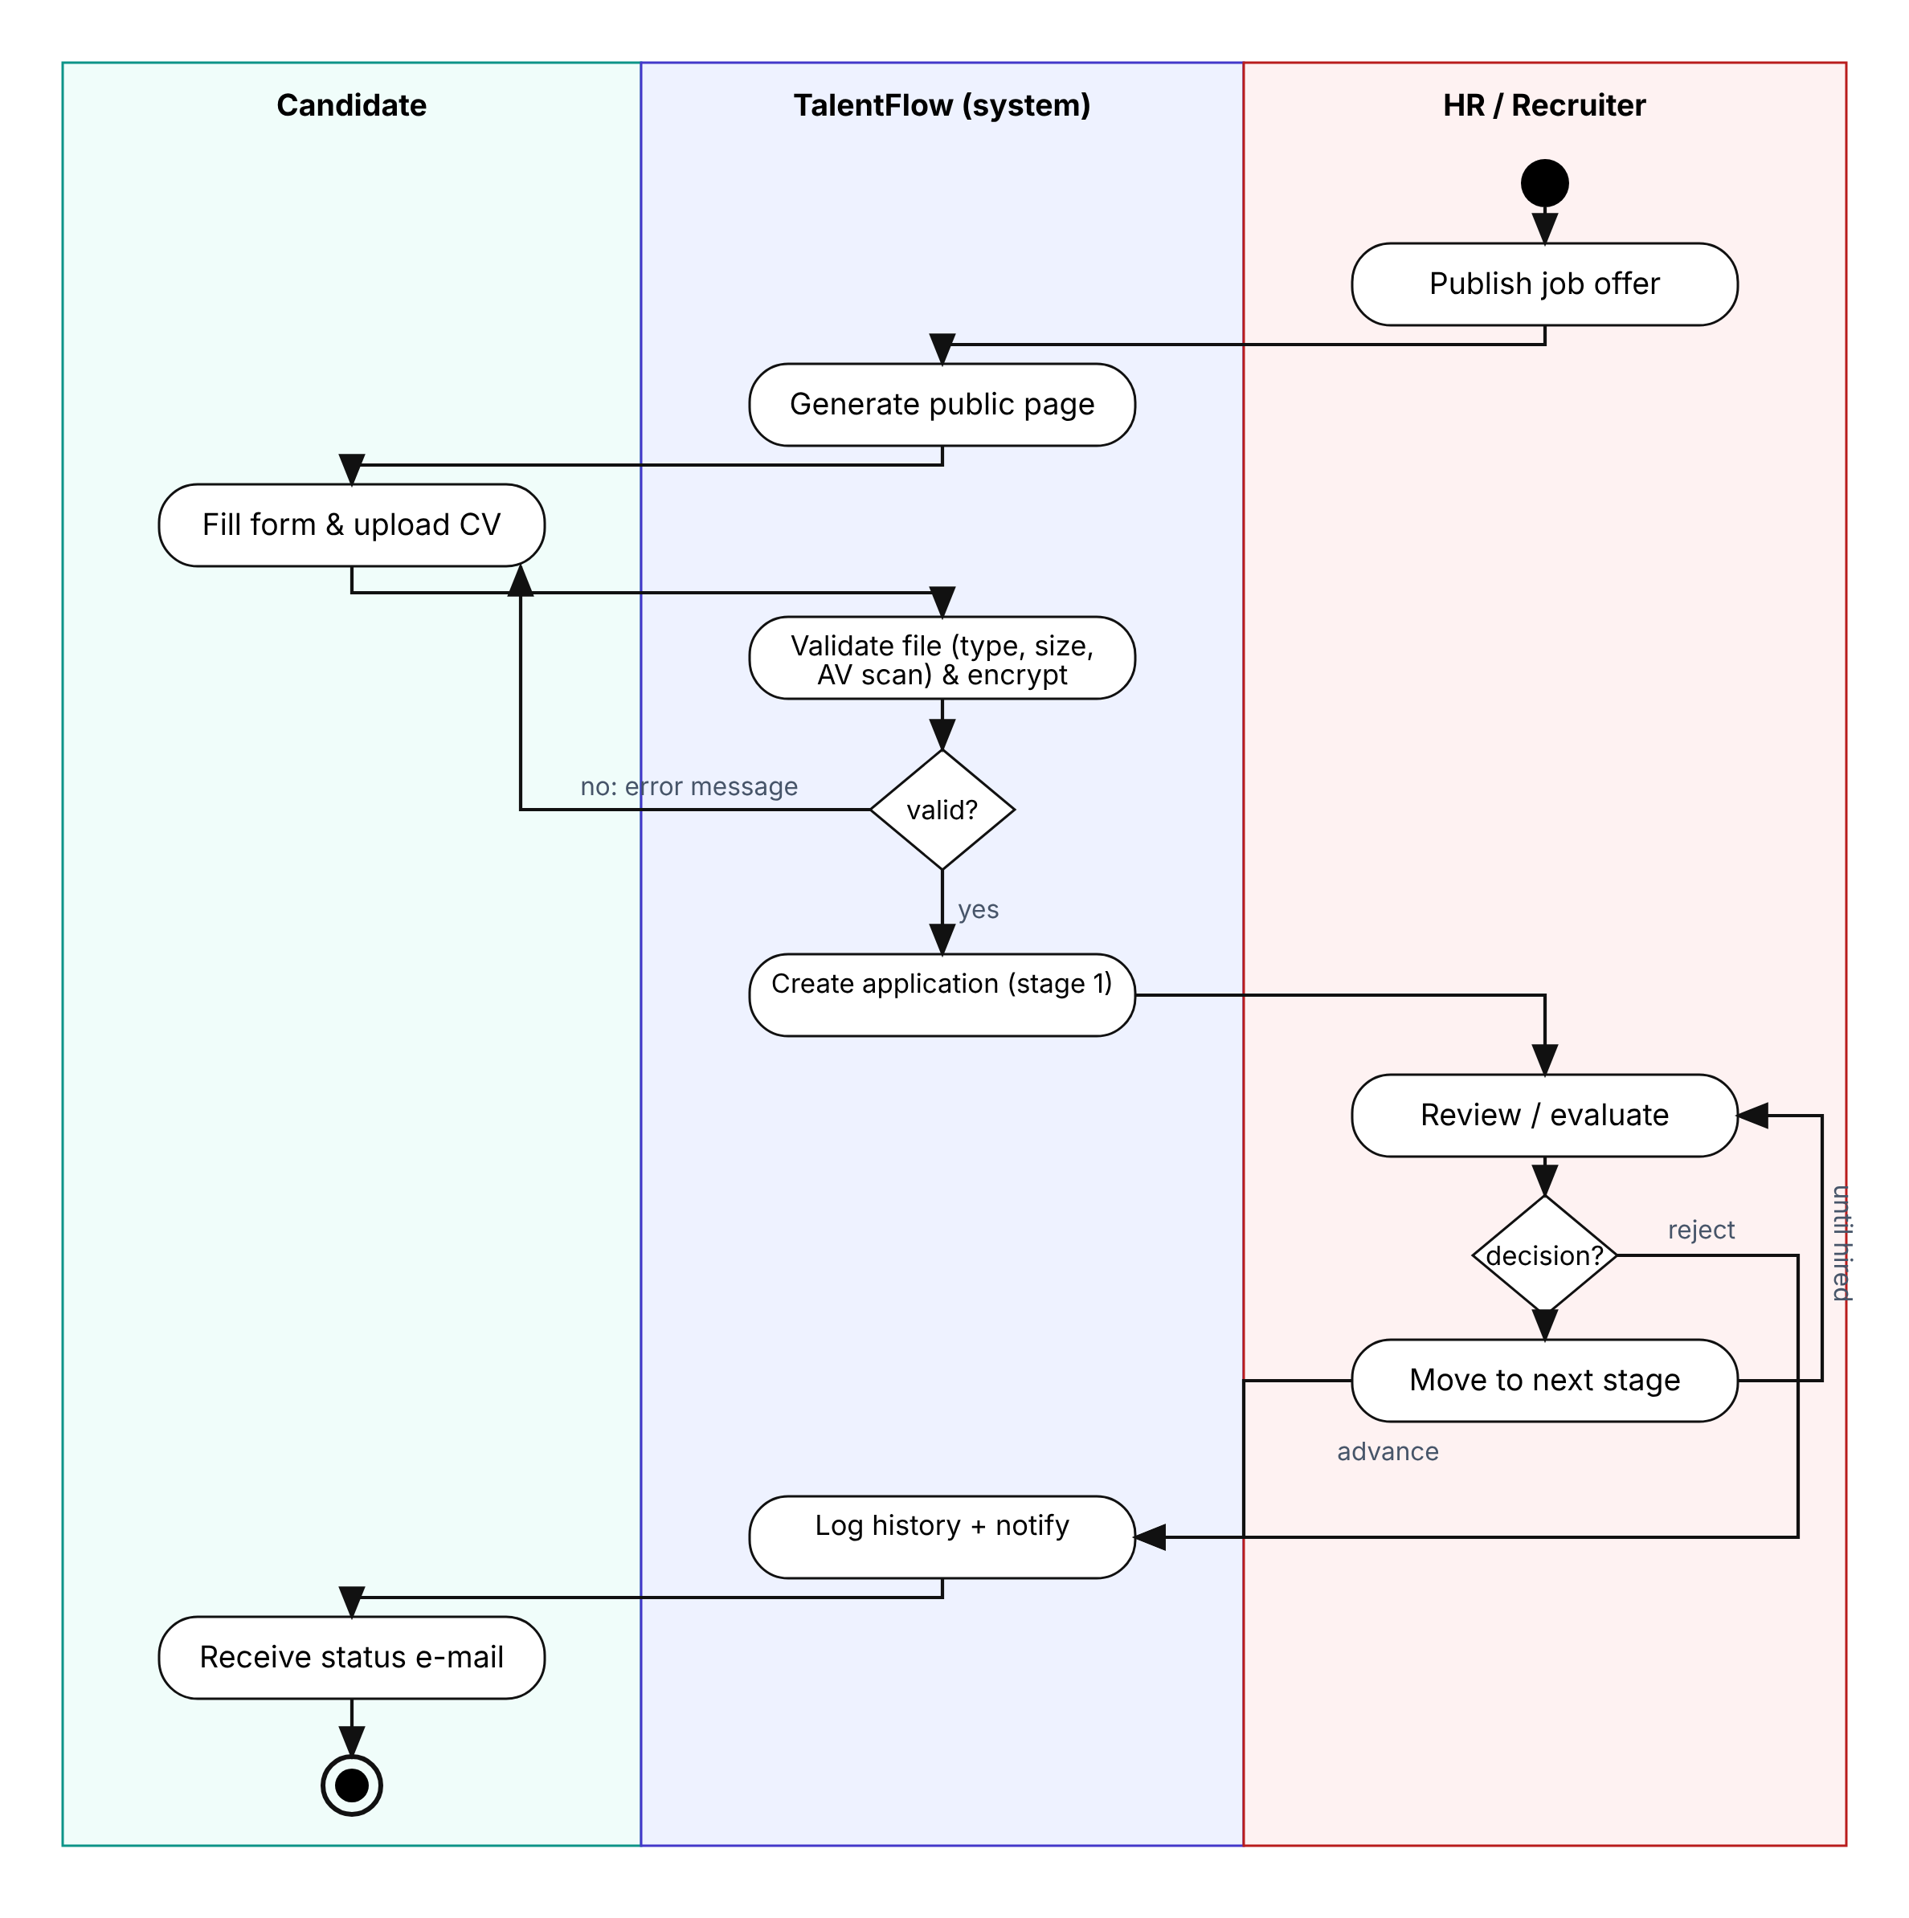
Figure 7: Activity diagram of the processing of an application

4.2.4 Sequence diagram
The sequence diagram (Figure 8) details the secure upload of a CV and its later consultation by an HR user.
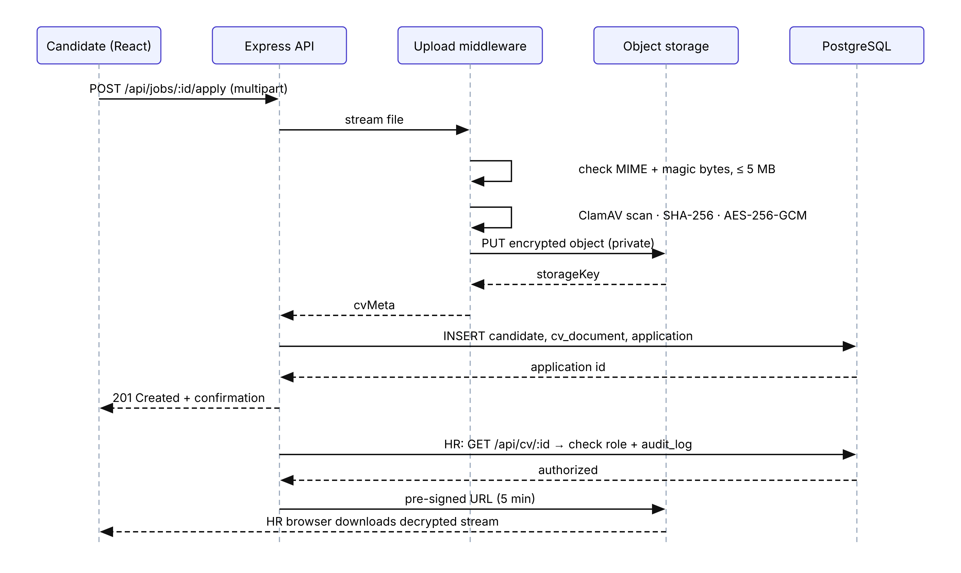
Figure 8: Sequence diagram of the secure upload and consultation of a CV

4.3 Modelling of the recruitment business process
The heart of the platform is the modelling of the recruitment process as a configurable state machine (Figure 9). Instead of hard-coding the stages, they are stored as data in the table pipeline_stages, with a position and a kind (normal, hired or rejected). When an offer is created, the stages of the company template are copied, and the HR manager can then adapt them to the offer.
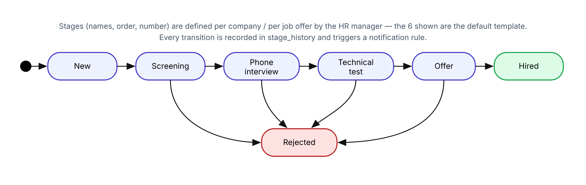
Figure 9: State machine of an application with the default stages
The following business rules are enforced by the service layer:
- BR1 – An application is always in exactly one stage of the offer it belongs to.
- BR2 – Only users with the role HR manager or recruiter assigned to the offer can move an application.
- BR3 – Moving to a stage of kind rejected requires a reason; the candidate is notified after a configurable delay (48 h by default) to avoid abrupt messages.
- BR4 – Moving to hired closes the application; when the number of positions is reached, the offer can be closed automatically.
- BR5 – A stage that still contains applications cannot be deleted; its applications must first be moved.
- BR6 – Every transition is written in stage_history in the same database transaction as the update of the application, and triggers the notification rules attached to the target stage.
The code below shows how a transition is executed inside a transaction, so that the application and its history can never be inconsistent:
// services/application.service.js
async function moveToStage({ applicationId, toStageId, user, reason }) {
return prisma.$transaction(async (tx) => {
const app = await tx.application.findUniqueOrThrow({
where: { id: applicationId }, include: { stage: true } });
const target = await tx.pipelineStage.findFirstOrThrow({
where: { id: toStageId, jobOfferId: app.jobOfferId } }); // BR1
await assertCanManageOffer(tx, user, app.jobOfferId); // BR2
if (target.kind === 'rejected' && !reason)
throw new BusinessError('A rejection reason is required'); // BR3
const updated = await tx.application.update({
where: { id: applicationId }, data: { stageId: target.id } });
await tx.stageHistory.create({ data: { // BR6
applicationId, fromStageId: app.stageId, toStageId: target.id,
movedById: user.id, reason } });
await notificationQueue.add('stage-changed',
{ applicationId, toStageId: target.id }, { delay: target.kind === 'rejected' ? 48 * 3600e3 : 0 });
return updated;
});
}

4.4 Database design
The physical data model (Figure 10) is implemented in PostgreSQL. Primary keys are UUIDs, which avoids exposing sequential identifiers in URLs. Foreign keys guarantee referential integrity; a unique constraint on (job_offer_id, candidate_id) prevents duplicate applications; a tsvector column indexed with GIN allows full-text search in offers and in the text extracted from CVs.
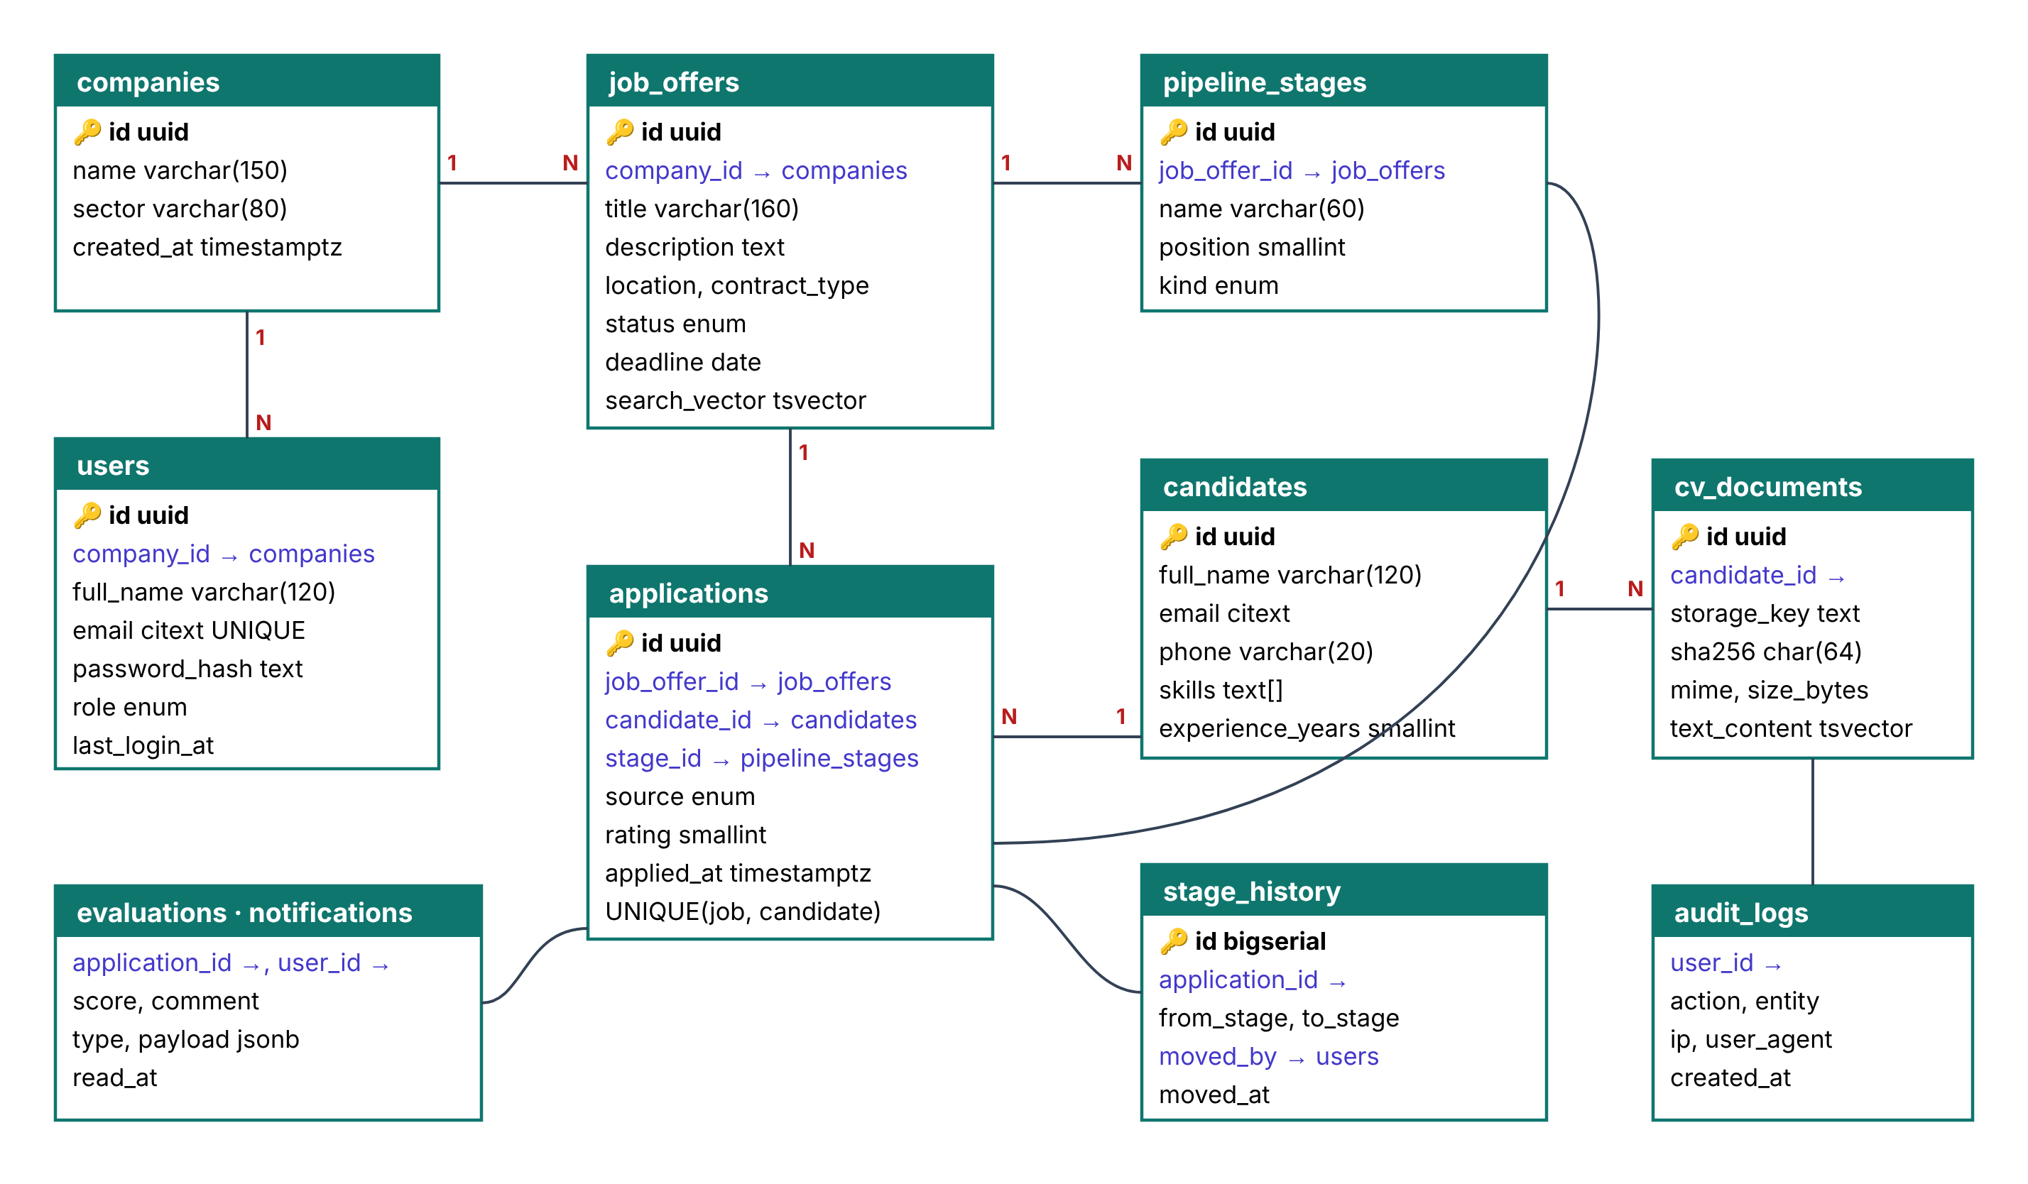
Figure 10: Physical data model (PostgreSQL)

4.5 Secure management of CVs
Because CVs are the most sensitive data of the platform, they are protected by several successive layers of defence (Figure 11).
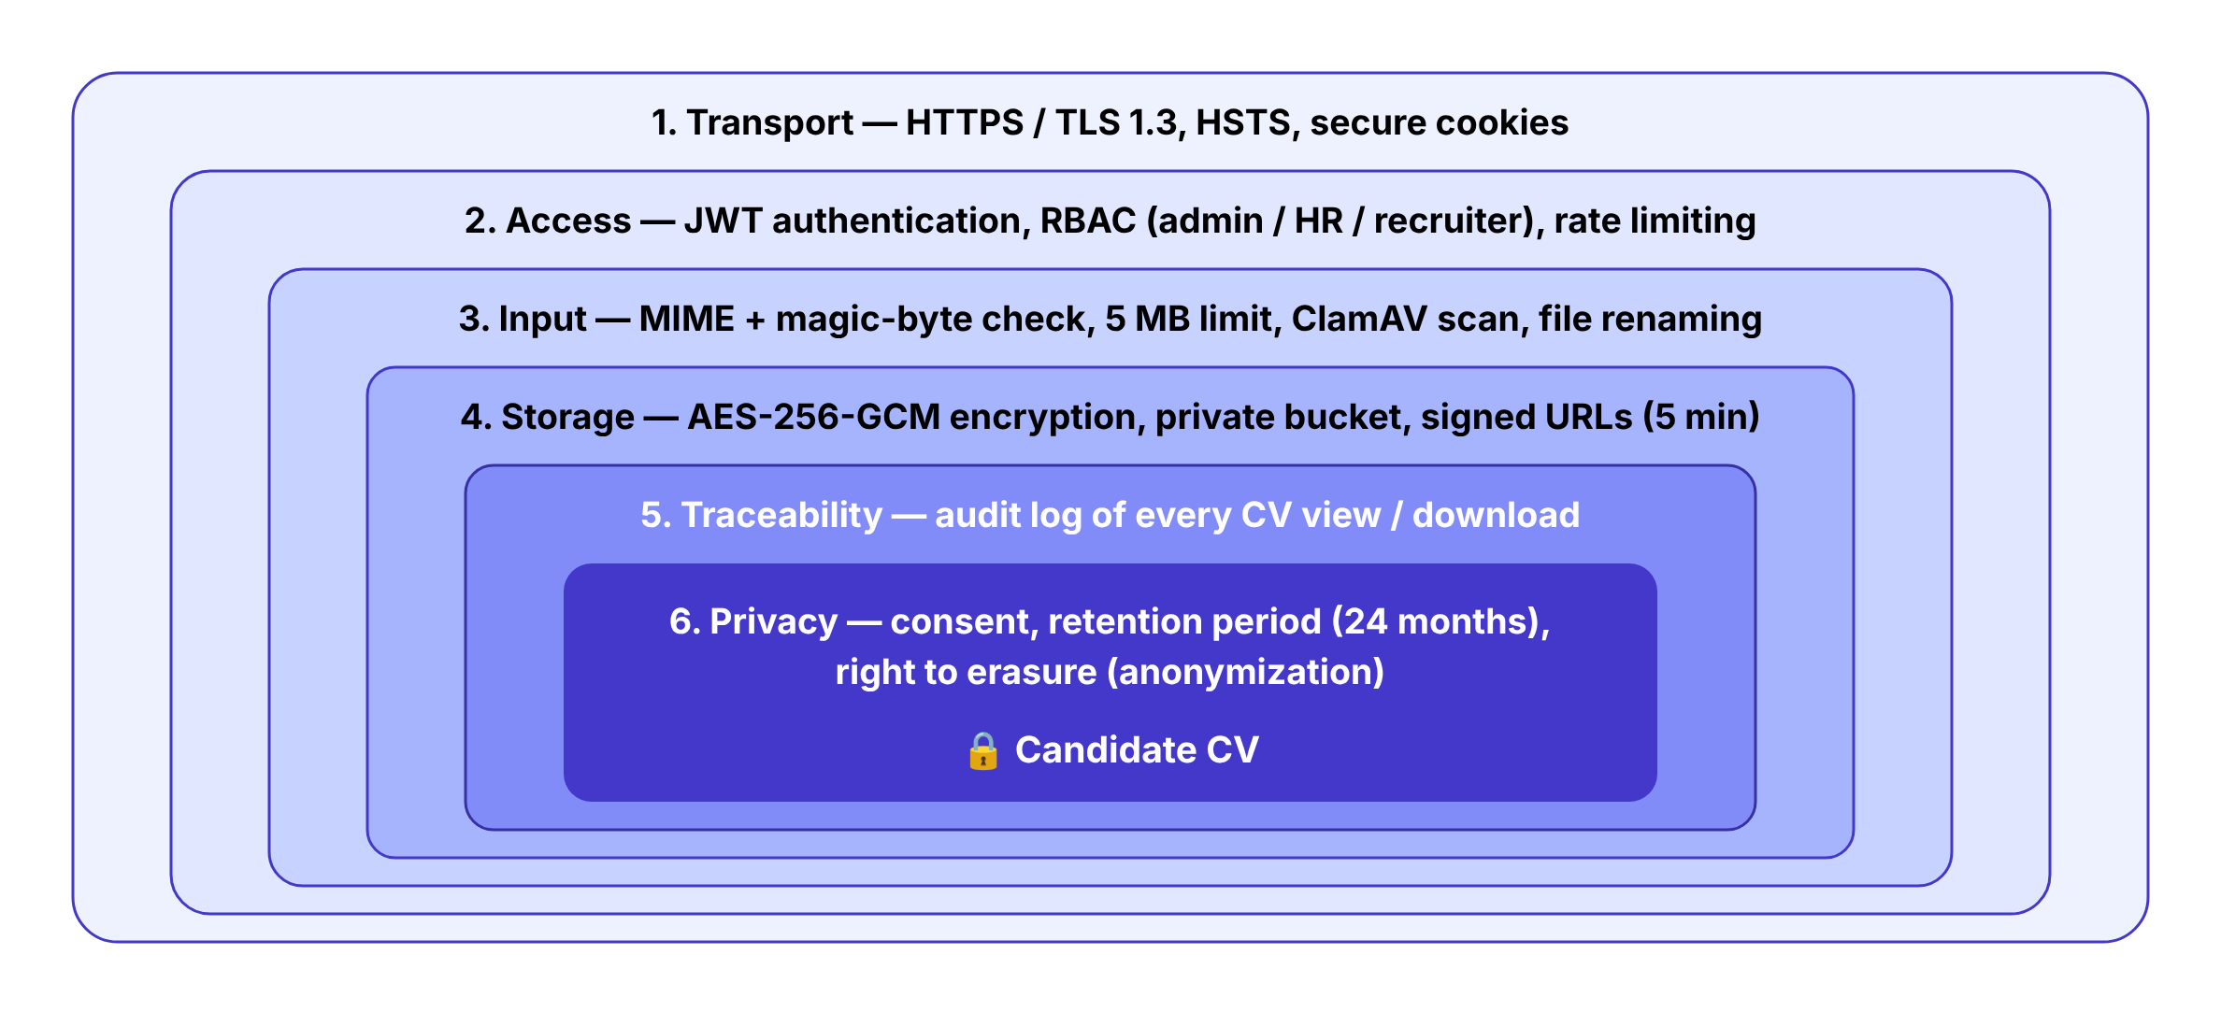
Figure 11: Defence-in-depth layers protecting the CVs
Table 12: Security measures applied to CVs
Threat | Measure implemented
Upload of a malicious file (script, macro, virus) | Allow-list of extensions (.pdf, .docx) and verification of the real type with magic bytes; size limit of 5 MB; ClamAV scan; random file name; files never served from the web server.
Theft of files from the server or the storage | Encryption with AES-256-GCM before storage, with a key kept in the server environment and never in the database; private bucket.
Unauthorised access to a CV | Authentication by JWT; role-based access control and check that the user belongs to the company and is assigned to the offer; pre-signed URL valid for 5 minutes only.
Silent abuse by an internal user | Audit log of every CV view and download (user, date, IP address); watermark on downloaded copies.
Interception on the network | HTTPS only (TLS 1.2+), HSTS, secure and httpOnly cookies.
Brute force on accounts | Password hashing with bcrypt (cost 12); rate limiting; account locked for 15 minutes after 5 failures.
Excessive retention | Consent at application; retention period of 24 months by default, after which a scheduled job anonymises the candidate and deletes the file; erasure on request.

The upload middleware below illustrates the first layers of this protection:
// middlewares/cvUpload.js
const upload = multer({ storage: multer.memoryStorage(),
limits: { fileSize: 5 * 1024 * 1024, files: 1 } });
const ALLOWED = { 'application/pdf': 'pdf',
'application/vnd.openxmlformats-officedocument.wordprocessingml.document': 'docx' };

async function secureCv(req, res, next) {
const file = req.file;
if (!file) return res.status(400).json({ error: 'CV is required' });
const type = await fileTypeFromBuffer(file.buffer); // magic bytes
if (!type || !ALLOWED[type.mime]) return res.status(415).json({ error: 'PDF or DOCX only' });
const scan = await clamav.scanBuffer(file.buffer);
if (scan.isInfected) return res.status(422).json({ error: 'File rejected' });
const iv = crypto.randomBytes(12);
const cipher = crypto.createCipheriv('aes-256-gcm', CV_KEY, iv);
const enc = Buffer.concat([cipher.update(file.buffer), cipher.final()]);
const key = `cv/${crypto.randomUUID()}.${ALLOWED[type.mime]}.enc`;
await storage.putObject(BUCKET, key, Buffer.concat([iv, cipher.getAuthTag(), enc]));
req.cv = { storageKey: key, mime: type.mime, size: file.size,
sha256: crypto.createHash('sha256').update(file.buffer).digest('hex') };
next();
}

4.6 REST API
Table 13: Main endpoints of the REST API
Method & route | Description | Access
POST /api/auth/login | Authenticate and obtain tokens | Public
POST /api/auth/refresh | Renew the access token | Cookie
GET /api/public/jobs | List open offers (search, filters) | Public
POST /api/public/jobs/:id/apply | Apply with CV (multipart) | Public
GET /api/public/applications/:token | Candidate follows the status | Private link
GET | POST /api/jobs | List / create offers | HR
PATCH /api/jobs/:id | Edit, publish, close an offer | HR
GET | PUT /api/jobs/:id/stages | Read / reorder the stages | HR
GET /api/jobs/:id/pipeline | Kanban data | HR, Recruiter
POST /api/applications/:id/move | Move to a stage | HR, Recruiter
POST /api/applications/:id/evaluations | Rate / comment | HR, Recruiter
GET /api/candidates | Search and filter candidates | HR, Recruiter
GET /api/cv/:id/url | Signed URL to view a CV (logged) | HR, Recruiter
DELETE /api/candidates/:id | Anonymise (right to erasure) | HR, Admin
GET /api/dashboard | Indicators of the HR dashboard | HR
GET | POST /api/users | Manage users and roles | Admin
GET /api/audit-logs | Consult the audit trail | Admin

4.7 Installation and configuration procedure

4.7.1 Prerequisites
- A Linux server (Ubuntu 22.04 LTS) with at least 2 vCPU, 4 GB RAM and 40 GB of disk;
- Docker Engine 24+ and Docker Compose v2;
- A domain name pointing to the server (e.g. recrutement.company.cm);
- An SMTP account for sending e-mails.

4.7.2 Installation steps
# 1. Get the source code
git clone https://github.com/<organisation>/talentflow.git && cd talentflow
# 2. Create the configuration file
cp .env.example .env && nano .env
# 3. Generate the CV encryption key (32 bytes, base64)
openssl rand -base64 32
# 4. Build and start all services
docker compose up -d --build
# 5. Create the database schema and the first administrator
docker compose exec api npx prisma migrate deploy
docker compose exec api npm run seed:admin -- --email admin@company.cm
# 6. Obtain the TLS certificate
docker compose run --rm certbot certonly --webroot -w /var/www/certbot -d recrutement.company.cm

4.7.3 Configuration
# .env (extract)
NODE_ENV=production
APP_URL=https://recrutement.company.cm
DATABASE_URL=postgresql://talentflow:********@db:5432/talentflow
JWT_ACCESS_SECRET=******** # 64 random characters
JWT_ACCESS_TTL=15m
CV_ENCRYPTION_KEY=******** # output of: openssl rand -base64 32
S3_ENDPOINT=http://minio:9000
S3_BUCKET=talentflow-cv
CLAMAV_HOST=clamav
REDIS_URL=redis://redis:6379
SMTP_HOST=smtp.provider.com
SMTP_USER=no-reply@company.cm
CV_RETENTION_MONTHS=24
SIGNED_URL_TTL_SECONDS=300

After installation, the administrator logs in, fills in the company profile (name, logo, colours of the career page), creates the user accounts of the HR team, defines the default recruitment stages and adapts the e-mail templates. A daily backup of the database is configured with a cron job running pg_dump.

4.8 Presentation of the interfaces
This section presents the main screens of the platform.
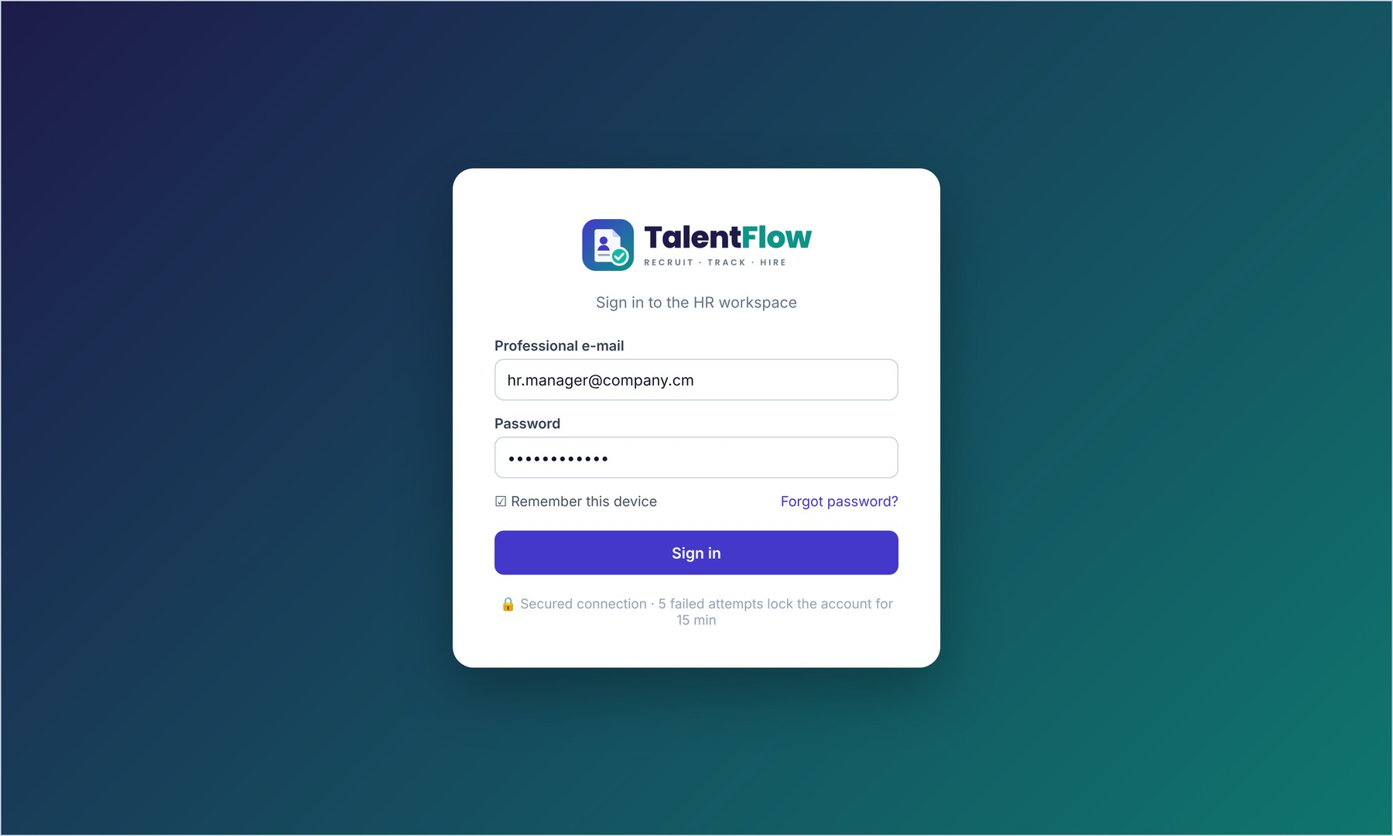
Figure 12: Login page of the HR workspace
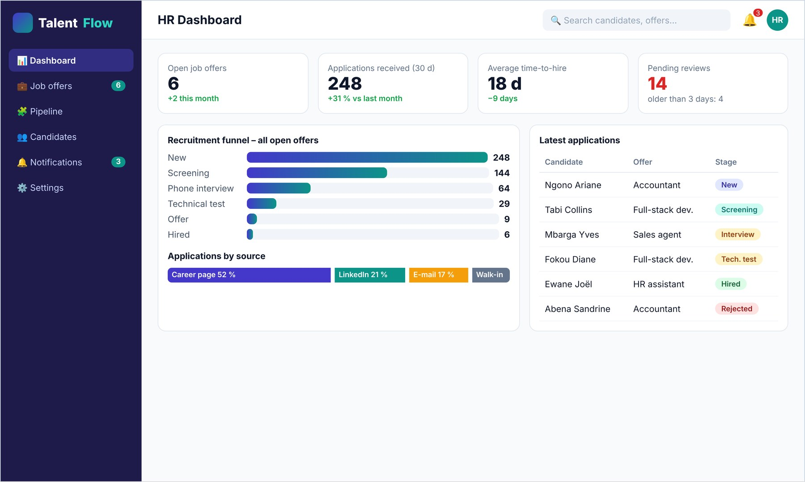
Figure 13: HR dashboard
The HR dashboard (Figure 13) gives at a glance the number of open offers, the applications received, the average time-to-hire and the reviews waiting for too long, as well as the recruitment funnel and the distribution of applications by source.
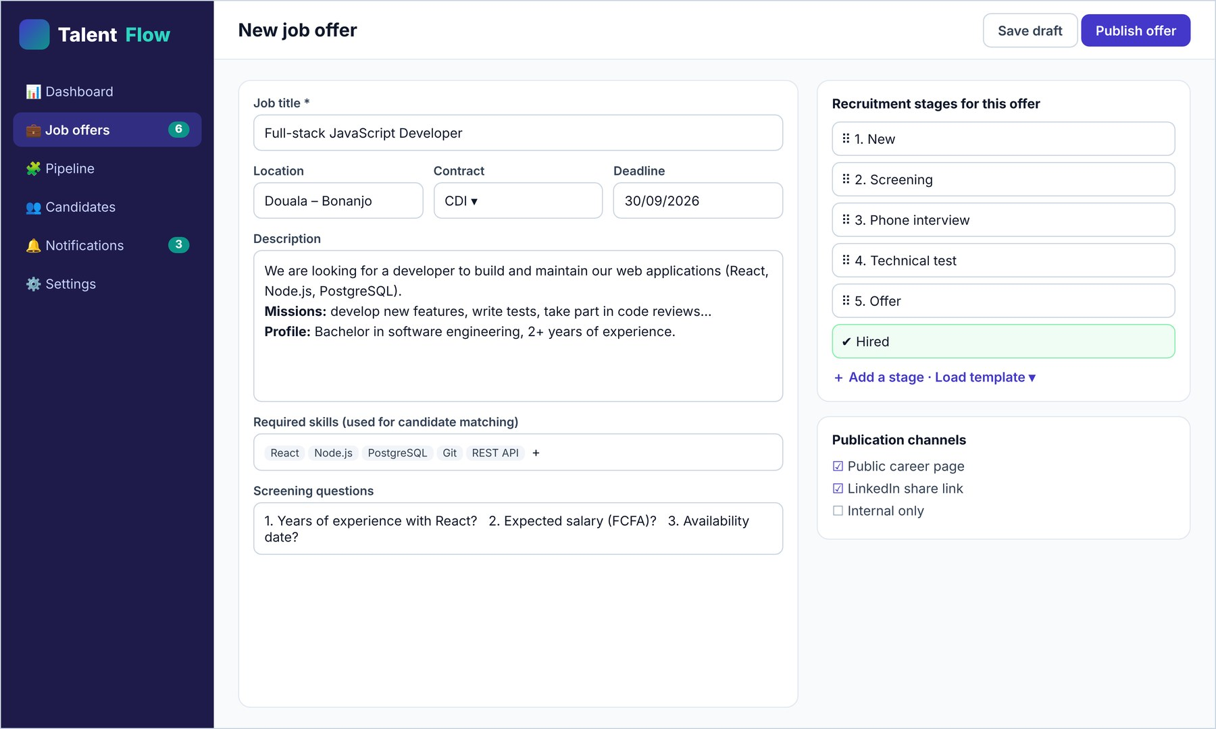
Figure 14: Creation of a job offer with its customizable stages
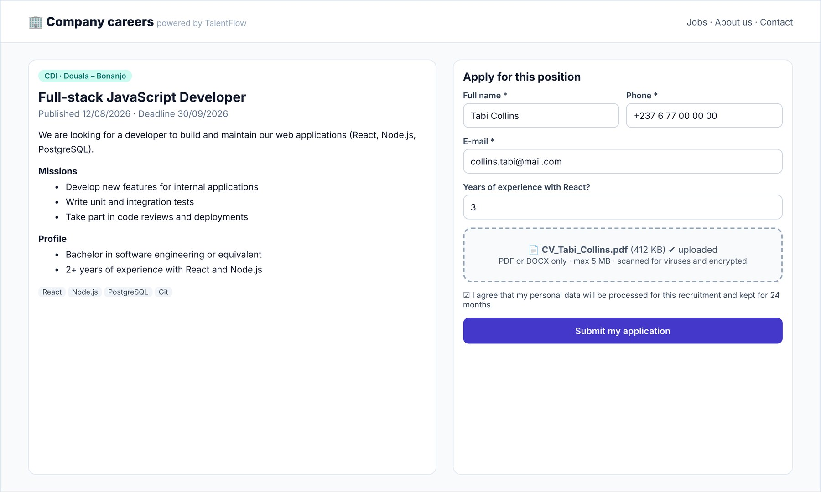
Figure 15: Public career page and application form with secure CV upload
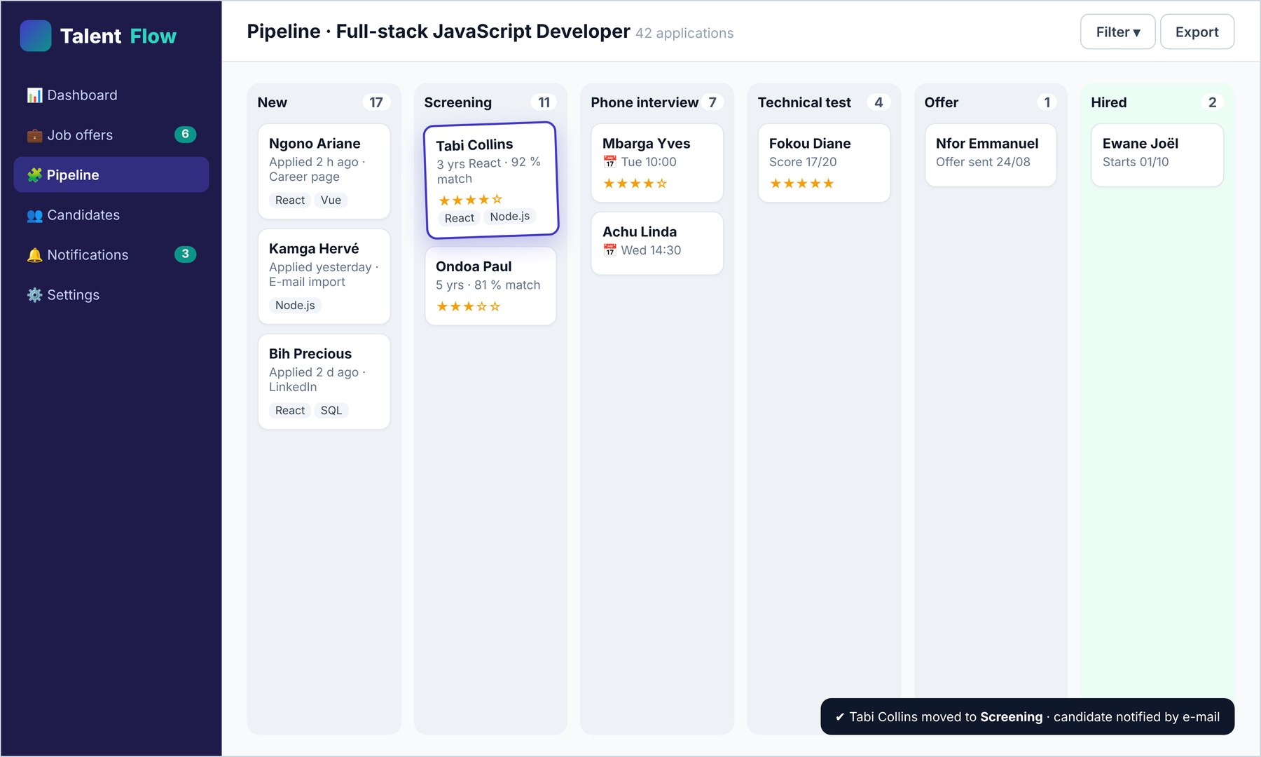
Figure 16: Kanban board of the recruitment pipeline
On the Kanban board (Figure 16), the recruiter moves a candidate from one stage to another by drag and drop. The move is recorded in the history and the candidate automatically receives the e-mail configured for the new stage.
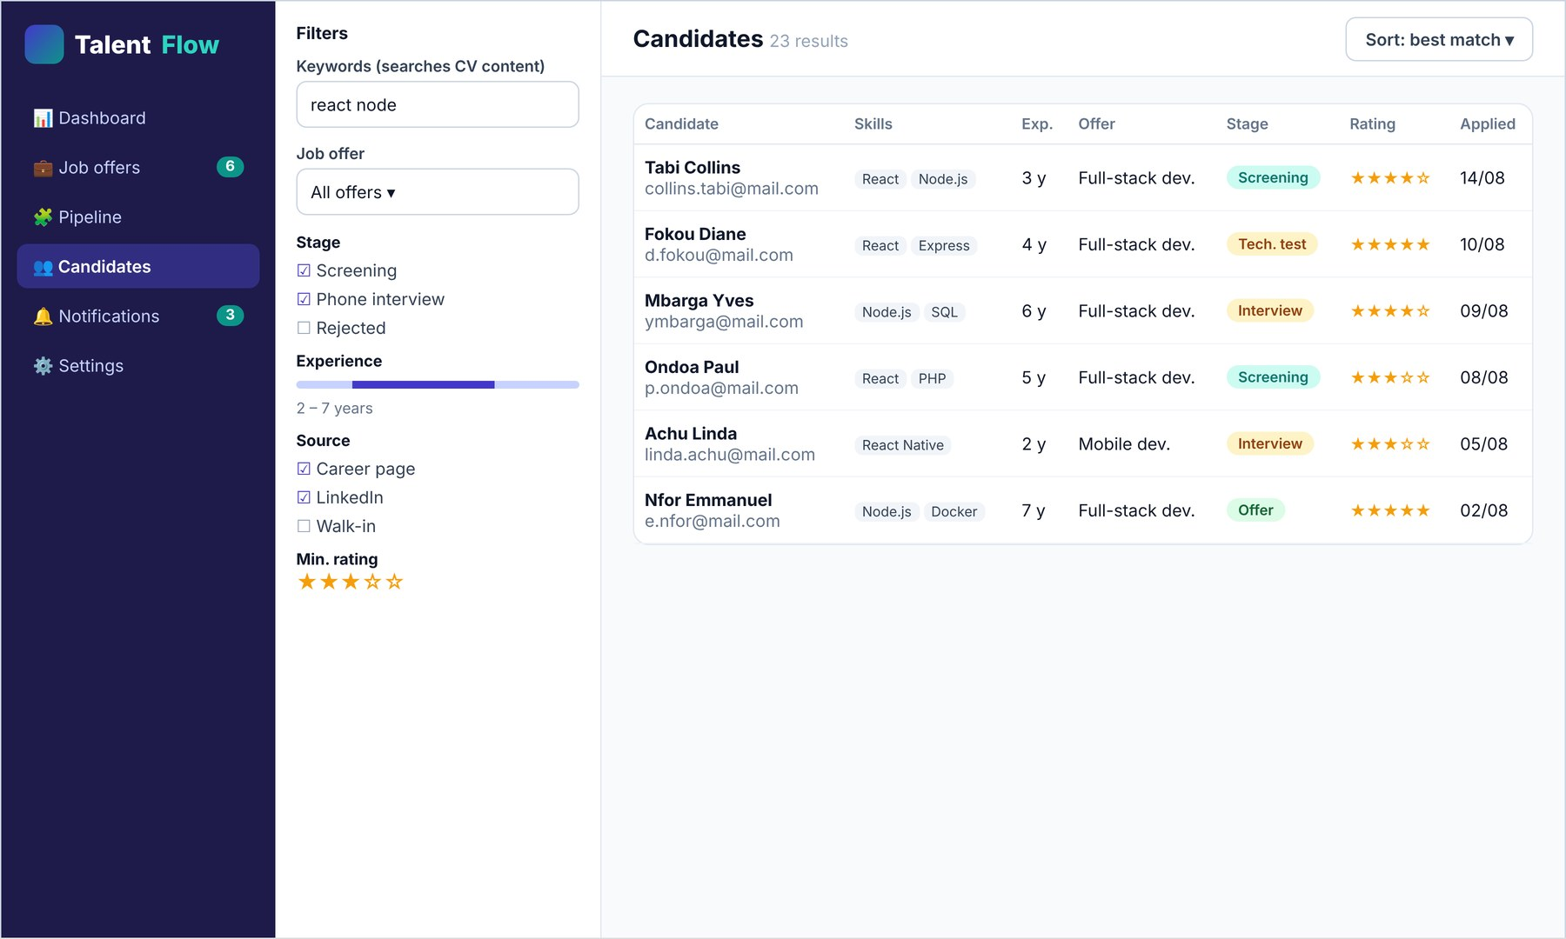
Figure 17: Candidate search with filters
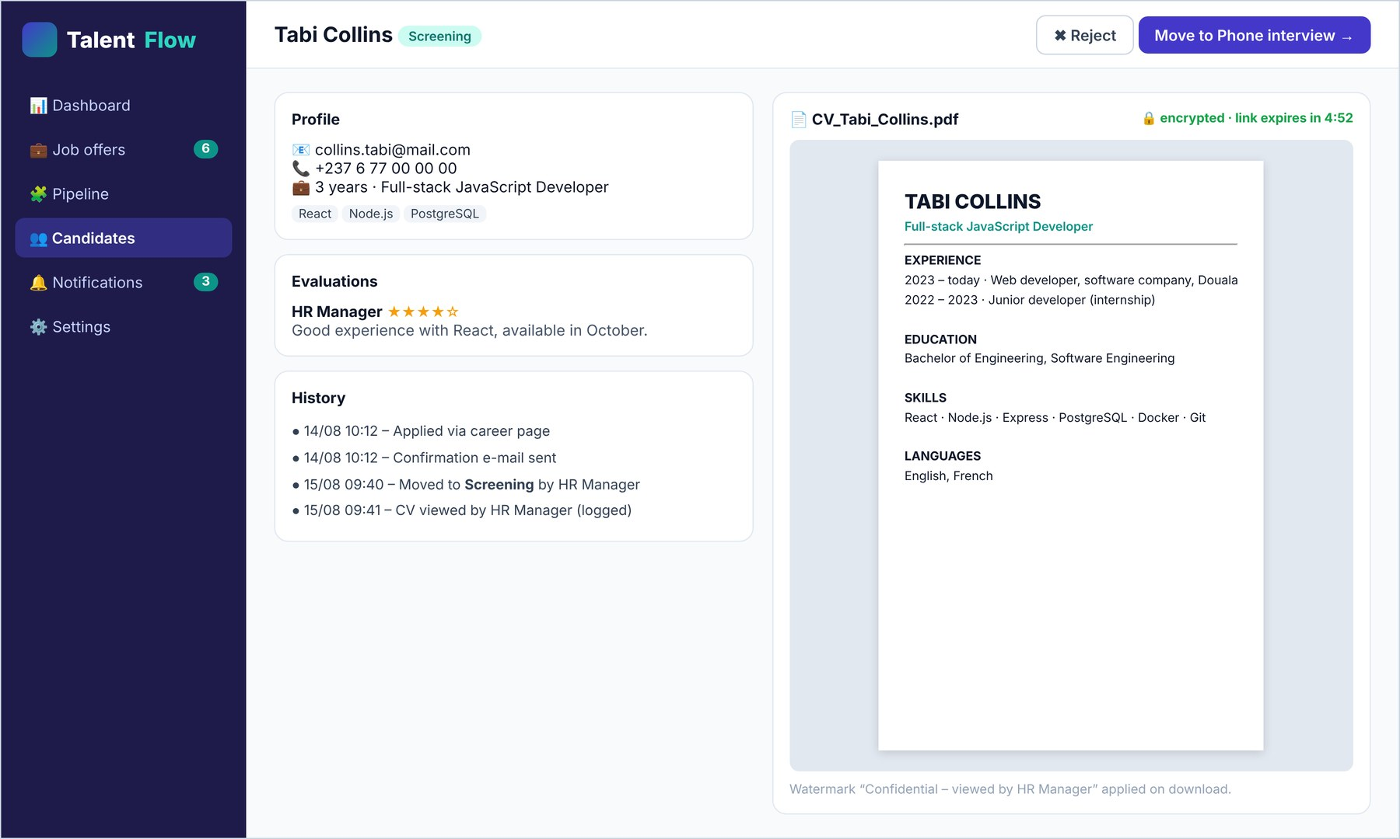
Figure 18: Candidate profile with secure CV viewer and history
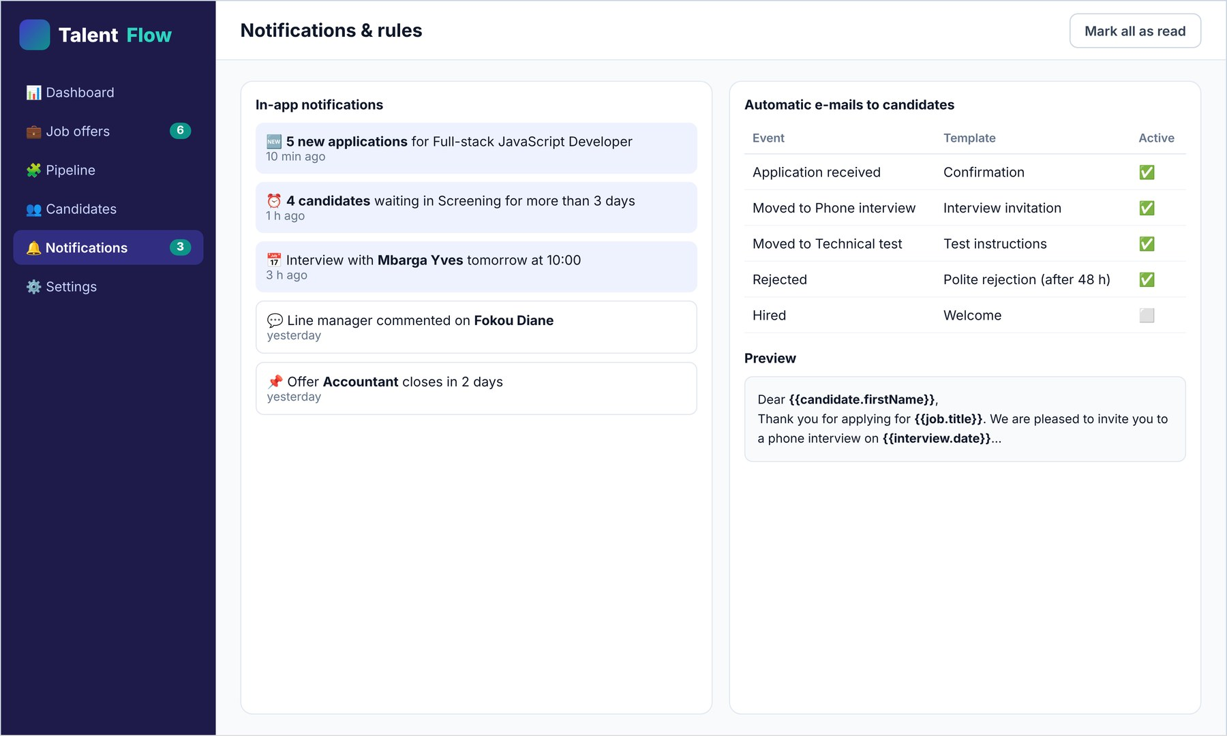
Figure 19: Notifications and automatic e-mail rules

4.9 Tests
Unit tests were written with Jest for the business services and integration tests with Supertest for the API endpoints, using a dedicated PostgreSQL test database. Table 14 summarises the main test cases.
Table 14: Main test cases
ID | Test case | Expected result | Status
T01 | Login with a wrong password 5 times | Account locked for 15 minutes | Passed
T02 | Apply with a PDF of 2 MB | Application created in stage “New”, confirmation e-mail queued | Passed
T03 | Apply with an .exe renamed as .pdf | HTTP 415 – file rejected | Passed
T04 | Apply with the EICAR antivirus test file | HTTP 422 – file rejected | Passed
T05 | Apply twice with the same e-mail for the same offer | No duplicate; CV updated | Passed
T06 | Recruiter moves a candidate of an offer not assigned to them | HTTP 403 – forbidden | Passed
T07 | Reject a candidate without reason | HTTP 400 – reason required | Passed
T08 | Open the signed URL of a CV after 6 minutes | Access denied (link expired) | Passed
T09 | Search “react node” among 10,000 generated candidates | Relevant results in less than 1 s | Passed
T10 | Delete a stage that still contains applications | Operation refused with a message | Passed

4.10 Cost estimate of the solution
The cost estimate includes the material and services needed to run the platform for one year, and the handwork needed to develop and deploy it. Prices are indicative and given in CFA francs (FCFA).
Table 15: Cost estimate of the solution (FCFA)
Item | Quantity | Unit price | Total
Material and services
Cloud server (VPS 2 vCPU, 4 GB RAM) – 12 months | 12 months | 15 000 | 180 000
Domain name (.cm) – 1 year | 1 | 25 000 | 25 000
Transactional e-mail service – 12 months | 12 months | 5 000 | 60 000
TLS certificate (Let’s Encrypt), open-source software | — | 0 | 0
Subtotal material and services |  |  | 265 000
Handwork
Analysis and design (requirements, UML, database) | 10 days | 25 000 | 250 000
Development (back-end, front-end, security) | 25 days | 25 000 | 625 000
Tests, deployment and training of users | 5 days | 25 000 | 125 000
Subtotal handwork |  |  | 1 000 000
TOTAL (material + handwork) |  |  | 1 265 000

For comparison, an international SaaS applicant tracking system typically costs several hundred thousand FCFA per year for a small team, with data hosted abroad. Once developed, TalentFlow can be offered to several SMEs on the same infrastructure (multi-company model), which makes it even more economical.

Conclusion
This chapter presented the technical choices, the architecture, the UML design, the modelling of the recruitment process as a configurable state machine, the measures that protect the CVs, the installation procedure, the interfaces, the tests and the cost of the solution. TalentFlow meets the “Must” requirements of the specification.

GENERAL CONCLUSION
This internship at Afriland First Bank, Douala – Bonanjo, from July 1 to August 31, 2026, allowed me to discover the functioning of a large banking institution and to work on a concrete problem: small companies receive CVs through several channels and lose track of applications.
Summary of the problems solved. The study of the existing process showed that applications were dispersed between e-mails, WhatsApp, paper and Excel sheets, that no one had a shared view of the process, that candidates were not informed and that CVs were stored without protection. TalentFlow solves these problems by centralising offers and applications in a single platform, by giving a clear and traceable view of each application, by informing candidates automatically and by protecting CVs.
Methodology and proposed solution. After the analysis of the existing system and the writing of the requirements specification, the solution was modelled with UML, the recruitment process was represented as a configurable state machine, and the platform was developed with React, Node.js/Express and PostgreSQL. The secure management of CVs relies on a defence-in-depth approach: validation and antivirus scanning of files, encryption at rest, role-based access, short-lived signed links and audit logging.
Difficulties encountered and solutions. The main difficulties were the limited time to cover all the requirements (solved by prioritising them with the MoSCoW method), the variety of recruitment practices to be supported (solved by making the stages configurable instead of fixed), the complexity of file security (solved by following the OWASP recommendations step by step), and the integration of new technologies such as Prisma and BullMQ (solved through documentation and the advice of my supervisors).
Perspectives. Several improvements are planned for the next versions: automatic extraction of information from CVs and matching score with the offer using natural language processing; integration with WhatsApp Business and e-mail inboxes to import applications automatically; scheduling of interviews synchronised with calendars; a mobile application for recruiters; multi-company offer as a service for SME customers; and statistics on diversity and recruitment costs.
On a personal level, this internship strengthened my skills in requirements analysis, business process modelling, full-stack web development and application security, as well as my communication and teamwork skills in a professional environment.

BIBLIOGRAPHY AND WEBOGRAPHY

Bibliography
- Sommerville, I. (2016). Software Engineering (10th ed.). Pearson.
- Dumas, M., La Rosa, M., Mendling, J., & Reijers, H. A. (2018). Fundamentals of Business Process Management (2nd ed.). Springer.
- Roques, P. (2018). UML 2 par la pratique : études de cas et exercices corrigés. Eyrolles.
- Kleppmann, M. (2017). Designing Data-Intensive Applications. O’Reilly Media.
- Republic of Cameroon (2024). Law No. 2024/017 of 23 December 2024 relating to the protection of personal data.
- European Union (2016). Regulation (EU) 2016/679 – General Data Protection Regulation.
- Dworkin, M. (2007). Recommendation for Block Cipher Modes of Operation: Galois/Counter Mode (GCM) and GMAC. NIST SP 800-38D.

Webography
- React documentation – https://react.dev
- Express documentation – https://expressjs.com
- Node.js documentation – https://nodejs.org/docs
- PostgreSQL 16 documentation, Full Text Search – https://www.postgresql.org/docs/16/textsearch.html
- Prisma documentation – https://www.prisma.io/docs
- OWASP File Upload Cheat Sheet – https://cheatsheetseries.owasp.org/cheatsheets/File_Upload_Cheat_Sheet.html
- OWASP Top 10 – https://owasp.org/www-project-top-ten/
- OWASP Application Security Verification Standard – https://owasp.org/www-project-application-security-verification-standard/
- ClamAV documentation – https://docs.clamav.net
- Afriland First Bank – https://www.afrilandfirstbank.com

APPENDIX

Appendix 1: Extract of the database creation script
CREATE TYPE stage_kind AS ENUM ('normal', 'hired', 'rejected');
CREATE TYPE user_role AS ENUM ('admin', 'hr_manager', 'recruiter');

CREATE TABLE job_offers (
id uuid PRIMARY KEY DEFAULT gen_random_uuid(),
company_id uuid NOT NULL REFERENCES companies(id),
title varchar(160) NOT NULL,
description text NOT NULL,
status varchar(10) NOT NULL DEFAULT 'draft',
deadline date,
search_vector tsvector GENERATED ALWAYS AS
(to_tsvector('french', title || ' ' || description)) STORED
);
CREATE INDEX job_offers_search_idx ON job_offers USING gin(search_vector);

CREATE TABLE pipeline_stages (
id uuid PRIMARY KEY DEFAULT gen_random_uuid(),
job_offer_id uuid NOT NULL REFERENCES job_offers(id) ON DELETE CASCADE,
name varchar(60) NOT NULL,
position smallint NOT NULL,
kind stage_kind NOT NULL DEFAULT 'normal',
UNIQUE (job_offer_id, position) DEFERRABLE INITIALLY DEFERRED
);

CREATE TABLE applications (
id uuid PRIMARY KEY DEFAULT gen_random_uuid(),
job_offer_id uuid NOT NULL REFERENCES job_offers(id),
candidate_id uuid NOT NULL REFERENCES candidates(id),
stage_id uuid NOT NULL REFERENCES pipeline_stages(id),
source varchar(20) NOT NULL DEFAULT 'web',
rating smallint CHECK (rating BETWEEN 1 AND 5),
applied_at timestamptz NOT NULL DEFAULT now(),
UNIQUE (job_offer_id, candidate_id)
);

Appendix 2: Quick user guide for the HR manager
- Log in at the address of the platform with the account created by the administrator.
- Open Job offers → New offer, fill in the form, adapt the stages if necessary and click Publish.
- Share the public link of the offer on social networks and job boards.
- Add manually the CVs received by e-mail or on paper with Add application and select the source.
- Open Pipeline, review the candidates and move them between stages; rate and comment them.
- Use Candidates to search by keyword or filter by stage, experience or rating.
- Follow the indicators on the Dashboard and close the offer when the position is filled.

