
REPUBLIQUE DU CAMEROUN  * * * * * * * * * *  PAIX — TRAVAIL — PATRIE  * * * * * * * * * *  MINISTERE DE L’ENSEIGNEMENT  SUPERIEUR |  | REPUBLIC OF CAMEROON  * * * * * * * * * *  PEACE – WORK – FATHERLAND  * * * * * * * * * *  MINISTRY OF HIGHER EDUCATION

 |  | 
INTERNSHIP REPORT

Internship carried out at G&C CREATIVE TECHNOLOGY, Douala, Ndogbong
From July 1 to August 31, 2026
Field: BACHELOR OF ENGINEERING (COMPUTER SCIENCE ENGINEERING).
Written and presented by:
SOLI MOKI LIMNYUY NGALLA.
Student Registration No: IUC24E0082740.
Under the supervision of:
Academic Supervisor:  TANDAH MARCELLE | Professional Supervisor:  Mr. MBUN GODLOVE


REPUBLIQUE DU CAMEROUN  * * * * * * * * * *  PAIX — TRAVAIL — PATRIE  * * * * * * * * * *  MINISTERE DE L’ENSEIGNEMENT  SUPERIEUR |  | REPUBLIC OF CAMEROON  * * * * * * * * * *  PEACE – WORK – FATHERLAND  * * * * * * * * * *  MINISTRY OF HIGHER EDUCATION

INTERNSHIP REPORT
Internship carried out at G&C CREATIVE TECHNOLOGY, Douala, Ndogbong
From July 1 to August 31, 2026
Field: BACHELOR OF ENGINEERING (COMPUTER SCIENCE ENGINEERING).
Written and presented by:
SOLI MOKI LIMNYUY NGALLA.
Student Registration No: IUC24E0082740.
Under the supervision of:
Academic Supervisor:  TANDAH MARCELLE | Professional Supervisor:  Mr. MBUN GODLOVE

CERTIFICATION
This is to certify that the internship report entitled “Design and Implementation of Bolo: a Web Platform for Recruitment and Job Application Tracking” is the original work carried out by SOLI MOKI Limnyuy Ngalla at G&C Creative Technology, Douala, from July 1 to August 31, 2026, in partial fulfilment of the requirements for the award of the Bachelor of Engineering (B.Eng.) degree in Computer Science Engineering at the School of Engineering and Applied Sciences (SEAS) of the Institut Universitaire de la Côte (IUC).
APPROVED BY:
ACADEMIC SUPERVISOR | HEAD OF DEPARTMENT
TANDAH MARCELLE | SIGNATURE…………………
SIGNATURE……………… | DATE…………………………
DATE……………………

DEDICATION

To my family, for their love, their patience and their constant support.

ACKNOWLEDGEMENTS
Every achievement is the result of guidance, collaboration and perseverance. I am deeply grateful to all those whose support made this internship and this report possible.
First of all, I thank Almighty God for the life, the health and the strength granted to me throughout this internship. I also express my sincere gratitude to:
- Mr. GUIMEZAP Paul, Founder and President of the Institut Universitaire de la Côte (IUC), for his vision and for the environment created for students to grow and innovate;
- The Director of the School of Engineering and Applied Sciences (SEAS) and the Head of the Computer Science Department, for the quality of our training and their constant encouragement;
- TANDAH MARCELLE, my academic supervisor, for the availability, the advice and the careful review of this work;
- Engr. MBUN Godlove Mbun, Founder and Chief Executive Officer of G&C Creative Technology and my internship supervisor, for welcoming me into the company, for the trust placed in me and for the guidance given throughout these nine weeks;
- Mrs. Claudia MBUN, Manager of G&C Creative Technology, and the whole team of G&C Creative Technology, for their warm welcome, for the time spent explaining how trainees and interns are recruited, and for testing the platform;
- All the lecturers of the IUC, for the knowledge and the method they passed on to us;
- My family and my friends, for their moral and material support at every stage of this work.

TABLE OF CONTENTS
CERTIFICATION i
DEDICATION ii
ACKNOWLEDGEMENTS iii
LIST OF FIGURES vi
LIST OF TABLES vii
LIST OF ACRONYMS viii
ABSTRACT ix
RÉSUMÉ x
GENERAL INTRODUCTION 1
General context of the study 1
Definition of the main concepts 1
Problematic 1
Aim of the study 2
Organisation of the work 2
PART ONE: CONCEPTUAL FRAMEWORK 3
CHAPTER 1 PRESENTATION OF THE COMPANY AND
ACTIVITIES CARRIED OUT DURING THE INTERNSHIP 4
Introduction 4
1.1 Presentation of the company 4
1.1.1 Identification sheet 4
1.1.2 Historical background 4
1.1.3 Activities 5
1.1.4 Vision and mission 5
1.1.5 Location 5
1.1.6 Organisation 6
1.2 Activities carried out during the internship 6
1.2.1 Detail of the main activities 7
1.3 Choice and justification of the topic 8
Conclusion 8
CHAPTER 2 OVERVIEW OF THE TOPIC STUDIED
(LITERATURE REVIEW) 9
Introduction 9
2.1 The recruitment process 9
2.2 Business process modelling 9
2.3 Protection of personal data and security of CVs 10
2.4 Architecture of web applications 10
2.5 Existing solutions 11
2.6 Software process models 11
Conclusion 11
PART TWO: EMPIRICAL STUDY 12
CHAPTER 3 DIAGNOSTIC OF THE EXISTING SYSTEM
AND REQUIREMENTS SPECIFICATION 13
Introduction 13
3.1 Presentation and functions of the existing system 13
3.2 Advantages of the existing system 14
3.3 Limits of the existing system 14
3.4 Requirements specification (cahier des charges) 14
3.4.1 Actors and use cases 14
3.4.2 Use case scenarios 15
3.4.3 Functional requirements 18
3.4.4 Non-functional requirements 18
3.4.5 Constraints and deliverables 19
3.5 Feasibility study 19
Conclusion 20
CHAPTER 4 PROPOSED SOLUTION AND IMPLEMENTATION 21
Introduction 21
4.1 Architecture of the new system 21
4.2 Justification of the tools used 22
4.3 Modelling of the recruitment business process 23
4.4 Detailed design 25
4.4.1 Data flow diagrams 25
4.4.2 Data model 26
4.4.3 Sequence diagrams 27
4.4.4 REST API 29
4.4.5 Secure management of CVs 29
4.5 User interface design 30
4.6 Implementation 31
4.7 Tests and results 40
4.8 Installation and configuration procedures 43
4.9 Cost estimate of the solution 44
4.10 Limits of the current version 44
Conclusion 45
GENERAL CONCLUSION 46
Summary of the problems solved 46
Methodology and solutions proposed 46
Difficulties encountered and solutions 46
Perspectives 46
BIBLIOGRAPHY AND WEBOGRAPHY 47
Bibliography 47
Webography 47
APPENDIX 48
Appendix 1: Usability test scenario (5 HR users) 48
Appendix 2: Extract of the database creation script 48
Appendix 3: Additional screenshots 49

LIST OF FIGURES
Figure 1: Location of G&C Creative Technology: (a) location plan, (b) map (source: G&C Creative Technology) 6
Figure 2: Organisation chart of G&C Creative Technology (source: author, from the company’s organigramme) 6
Figure 3: Planning of the internship (July 1 – August 31, 2026) (source: author) 7
Figure 4: Topology of the existing situation and its five main problems (source: author) 13
Figure 5: Use case diagram of Bolo (source: author) 15
Figure 6: High-level architecture of Bolo (source: author) 21
Figure 7: Deployment diagram (source: author) 22
Figure 8: Layered structure of the server and organisation of the repository (source: author) 22
Figure 9: BPMN model of the recruitment process with Bolo (source: author) 24
Figure 10: State machine of an application (default stages of the demonstration company) (source: author) 24
Figure 11: Context data flow diagram (level 0) (source: author) 25
Figure 12: Level-1 data flow diagram of Bolo (source: author) 26
Figure 13: Physical data model (PostgreSQL) (source: author) 27
Figure 14: Sequence diagram “log in to the HR workspace” (UC-03) (source: author) 27
Figure 15: Sequence diagram “apply and follow an application” (UC-01 and UC-02) (source: author) 28
Figure 16: Sequence diagram “move or reject a candidate” (UC-06) (source: author) 28
Figure 17: Sequence diagram of the secure upload and consultation of a CV (source: author) 30
Figure 18: The Bolo logo and its variants (source: author) 31
Figure 19: Colours and fonts of the interface (source: author) 31
Figure 20: Login page of the HR workspace (source: author) 32
Figure 21: List of job offers with applications, delays exceeded and openings filled (source: author) 32
Figure 22: Editing an offer and its own stages (here with an added “Essai de conduite” stage) (source: author) 33
Figure 23: Public pages on a smartphone: (a) career page, (b) job offer, (c) application form (source: author) 34
Figure 24: After applying: (a) confirmation, (b) tracking in French, (c) offer and (d) tracking in English (source: author) 34
Figure 25: Capture of a CV received by WhatsApp (photo of a paper CV) (source: author) 35
Figure 26: Kanban board of an offer: source, language, rating and days in the stage on each card (source: author) 36
Figure 27: Rejecting a candidate: the reason stays internal, the answer leaves 48 h later (source: author) 36
Figure 28: Candidate profile with the CV shown in the application, watermark and link countdown (source: author) 37
Figure 29: Search “sage dsf” in profiles and CV text, with filters (source: author) 37
Figure 30: Bilingual message templates sent to candidates (source: author) 38
Figure 31: Audit log: who viewed which CV, and when (source: author) 38
Figure 32: In-app notifications of the HR team (source: author) 39
Figure 33: HR dashboard: funnel, guaranteed answer rate, delays and sources (source: author) 39
Figure 34: Execution of the automated test suite: 43 tests, 43 passed (source: author) 42
Figure 35: Measured response times with 10,000 candidates (median / 95th percentile) (source: author) 42
Figure 36: Automated tests and state of the requirements at the end of the internship (source: author) 43
Figure 37: Filters: English-speaking candidates in progress with at least 2 years of experience (source: author) 49
Figure 38: Kanban after a rejection, with the confirmation message (source: author) 49

LIST OF TABLES
Table 1: Identification sheet of G&C Creative Technology 4
Table 2: Activities of G&C Creative Technology 5
Table 3: Weekly summary of the activities carried out 7
Table 4: Notations for modelling the recruitment process 9
Table 5: Relational and document-oriented databases for recruitment data 10
Table 6: Existing solutions and the needs of the study 11
Table 7: Comparison of software process models 11
Table 8: Functions of the existing system 13
Table 9: Limits of the existing system and their consequences 14
Table 10: Scenario of the use case “Apply for a job (UC-01)” 15
Table 11: Scenario of the use case “Track an application (UC-02)” 16
Table 12: Scenario of the use case “Log in to the HR workspace (UC-03)” 16
Table 13: Scenario of the use case “Publish a job offer and its stages (UC-04)” 16
Table 14: Scenario of the use case “Capture a CV received outside the platform (UC-05)” 17
Table 15: Scenario of the use case “Move or reject a candidate (UC-06)” 17
Table 16: Scenario of the use case “Consult a CV (UC-07)” 17
Table 17: Scenario of the use case “Erase a candidate’s data (UC-08)” 18
Table 18: Functional requirements by module (M = Must, S = Should, C = Could) 18
Table 19: Non-functional requirements and measurable targets 18
Table 20: Main technical risks and mitigations 19
Table 21: Tools of the solution: choice, alternatives considered and justification 22
Table 22: Development and documentation tools 23
Table 23: Business rules of the recruitment pipeline 24
Table 24: Main REST routes (session required except the public routes) 29
Table 25: Security measures applied to CVs and how they are verified 30
Table 26: Colour tokens of the interface 31
Table 27: Automated tests per area 40
Table 28: Test cases of the project (selection) 40
Table 29: Results of the non-functional requirements 43
Table 30: Cost estimate of the solution (indicative) 44
Table 31: Tasks of the usability test 48

LIST OF ACRONYMS
Acronym | Meaning
ADCP | Autorité de protection des données à caractère personnel (Cameroon)
AES-GCM | Advanced Encryption Standard – Galois/Counter Mode
API | Application Programming Interface
ATS | Applicant Tracking System
BPMN | Business Process Model and Notation
CNPS | Caisse Nationale de Prévoyance Sociale
CV | Curriculum Vitae
FCFA | Franc de la Coopération Financière en Afrique centrale
FR / NFR | Functional / Non-Functional Requirement
GIN | Generalized Inverted Index (PostgreSQL)
HMAC | Hash-based Message Authentication Code
HR | Human Resources
HTTP(S) | HyperText Transfer Protocol (Secure)
IUC | Institut Universitaire de la Côte
JSON | JavaScript Object Notation
JWT | JSON Web Token
MoSCoW | Must, Should, Could, Won’t (prioritisation method)
OWASP | Open Worldwide Application Security Project
RBAC | Role-Based Access Control
REST | Representational State Transfer
SEAS | School of Engineering and Applied Sciences
SLA | Service Level Agreement (here: maximum time in a stage)
SME | Small and Medium-sized Enterprise
SMS / SMTP | Short Message Service / Simple Mail Transfer Protocol
SPA | Single-Page Application
SUS | System Usability Scale
SYSCOHADA | Système comptable de l’OHADA
UML | Unified Modeling Language

ABSTRACT
This report presents the work carried out during my internship at G&C Creative Technology, a computer business and training centre in Ndogbong, Douala, from July 1 to August 31, 2026, as part of the Bachelor of Engineering in Computer Science Engineering at the Institut Universitaire de la Côte (IUC). Small and medium-sized enterprises, including the host company, receive CVs through WhatsApp, e-mail, paper copies and social networks; as a result, CVs are lost or duplicated, nobody shares a view of where each candidate stands, candidates rarely receive an answer and personal data are kept without protection. To solve this problem, I designed and built Bolo, a web platform for recruitment and job application tracking that gathers every channel into one pipeline, models the recruitment process as a configurable state machine whose stages, delays and messages are defined for each job offer, guarantees an answer to every candidate in French or English, and protects CVs through content-based type checking, antivirus scanning, AES-256-GCM encryption, five-minute signed links, an audit log and the right to erasure required by Law No. 2024/017. The project followed an iterative and incremental process, from a specification of 34 functional and 16 measurable non-functional requirements and a BPMN and UML design to three increments built with React, Node.js/Express and PostgreSQL; it is validated by 43 automated tests, all passed, and on 10,000 candidates a search answers in 39 ms and moving a candidate takes 6 ms.
Keywords: recruitment, applicant tracking system, business process modelling, state machine, secure file management, personal data protection, React, Node.js, PostgreSQL, Cameroon.

RÉSUMÉ
Ce rapport présente le travail réalisé pendant mon stage chez G&C Creative Technology, centre de services et de formation informatique situé à Ndogbong (Douala), du 1er juillet au 31 août 2026, dans le cadre du Bachelor of Engineering en Computer Science Engineering de l’Institut Universitaire de la Côte (IUC). Les petites et moyennes entreprises, dont l’entreprise d’accueil, reçoivent des CV par WhatsApp, e-mail, papier et réseaux sociaux ; des CV sont alors perdus ou en double, personne ne partage une vue de l’avancement de chaque candidat, les candidats reçoivent rarement une réponse et les données personnelles sont conservées sans protection. Pour résoudre ce problème, j’ai conçu et développé Bolo, une plateforme web de recrutement et de suivi des candidatures qui réunit tous les canaux dans un même pipeline, modélise le processus de recrutement comme un automate à états configurable dont les étapes, les délais et les messages sont définis pour chaque offre, garantit une réponse à chaque candidat en français ou en anglais, et protège les CV par une vérification du type d’après le contenu, une analyse antivirus, un chiffrement AES-256-GCM, des liens signés de cinq minutes, un journal d’accès et le droit à l’effacement prévu par la loi n° 2024/017. Le projet a suivi une démarche itérative et incrémentale, d’un cahier des charges de 34 exigences fonctionnelles et 16 exigences non fonctionnelles mesurables et d’une conception BPMN et UML jusqu’à trois incréments réalisés avec React, Node.js/Express et PostgreSQL ; il est validé par 43 tests automatisés, tous réussis, et sur 10 000 candidats une recherche répond en 39 ms et le déplacement d’un candidat prend 6 ms.
Mots-clés : recrutement, suivi des candidatures, modélisation de processus métier, automate à états, gestion sécurisée des fichiers, protection des données personnelles, React, Node.js, PostgreSQL, Cameroun.

GENERAL INTRODUCTION

General context of the study
In Cameroon, small and medium-sized enterprises (SMEs) make up the large majority of companies and of formal jobs. They hire regularly – an accountant, sales agents, drivers, a storekeeper – but rarely have a Human Resources department, and never a recruitment software. A job offer is posted on Facebook, shared in WhatsApp groups and pinned at the entrance; applications then arrive through every channel at once: the personal WhatsApp of the HR officer, several mailboxes, paper CVs left at the reception, messages under the Facebook post. The same person may apply three times; another CV is never seen again.
As part of the Bachelor of Engineering programme in Computer Science Engineering at the School of Engineering and Applied Sciences (SEAS) of the Institut Universitaire de la Côte (IUC), I carried out my internship in the Department of Software Development of G&C Creative Technology, Douala – Ndogbong, from July 1 to August 31, 2026. G&C is itself an SME: besides its business centre, it runs a training centre and hosts many interns and trainees every year, and it builds websites and applications for other small companies. Discussions with its managers and with two of its SME clients showed the same difficulty on both sides: companies receive CVs through several channels and lose track of applications. This led to the project Bolo, a web platform for recruitment and job application tracking.

Definition of the main concepts
- Applicant Tracking System (ATS): software that centralises job offers and applications and follows each candidate until a decision.
- Recruitment pipeline: the ordered list of stages (for example New, Screening, Interview, Test, Offer) through which every application moves until it is hired or rejected.
- Business process modelling: the representation of the activities, actors, rules and events of a business process (here, recruitment) with a notation such as BPMN, in order to analyse and automate it.
- State machine: a model in which an object (an application) is always in exactly one state (a stage) and changes state only through allowed transitions triggered by events.
- Secure CV management: the technical and organisational measures that keep the CVs confidential, intact and available to authorised people only, and processed lawfully.
- Personal data: any information relating to an identified or identifiable person – a CV contains many of them (identity, phone, career, sometimes a photo).

Problematic
The question is not whether a recruitment software can be written – many exist – but whether one can be designed for the reality of a Cameroonian SME: CVs arriving through WhatsApp and on paper, candidates who give a phone number before an e-mail address, two official languages, prepaid mobile data, a recruitment practice that differs from one company and one position to another, and a new law on personal data protection. The central question is therefore: how can we design and implement, with one developer, in nine weeks and at a very low cost, a web platform that gathers applications from every channel into one traceable process, adapts to the recruitment stages of each company, and protects the CVs it stores?

Aim of the study
The general objective is to design and implement Bolo. The specific objectives are to: (1) offer a single entry point for all applications – an online career page and a quick capture of the CVs received elsewhere; (2) model the recruitment process so that each company, and each offer, can define its own stages, delays and messages; (3) let HR staff find the right candidates quickly through search and filters, including in the text of the CVs; (4) keep candidates and the team informed with automatic, bilingual messages and notifications, so that no candidate is left without an answer; (5) store and show CVs securely, in line with Law No. 2024/017; and (6) apply a rigorous method with measurable requirements that become tests. For G&C Creative Technology, the project is a tool for its own recruitment of trainees and interns, and a product it can install for its SME clients.

Organisation of the work
Besides this introduction and the general conclusion, the report has two parts. Part One (conceptual framework) presents the host company and the internship activities (Chapter 1) and the literature review (Chapter 2). Part Two (empirical study) analyses the existing system and specifies the requirements (Chapter 3), then presents the solution, its implementation, tests, installation and cost (Chapter 4).

PART ONE:

CONCEPTUAL FRAMEWORK

CHAPTER 1
PRESENTATION OF THE COMPANY AND
ACTIVITIES CARRIED OUT DURING THE INTERNSHIP

Introduction
This chapter presents G&C Creative Technology, the host company of the internship – its history, its activities, its vision and mission, its location and its organisation – then the activities carried out week by week, and finally the choice of the topic.

1.1 Presentation of the company

1.1.1 Identification sheet
Table 1: Identification sheet of G&C Creative Technology
Item | Information
Name | G&C Creative Technology
Legal nature | Start-up / sole proprietorship – private enterprise
Founder and CEO | Engr. MBUN Godlove Mbun
Manager | Mrs. Claudia MBUN
Creation | January 2023 (activity started in Buea in 2017/2018)
Head office | Ndogbong, Carrefour Zachman, Douala
Capital stock | 2,300,000 FCFA
Size | SME – 9 staff
Telephone | (+237) 675 78 02 38
E-mail | creativetech1@gmail.com
Internship unit | Department of Software Development, Installations and Hardware Maintenance

1.1.2 Historical background
The idea of G&C Creative Technology was conceived in 2015/2016 by its founder, Engr. MBUN Godlove Mbun, after his Bachelor of Engineering (B.Eng.) in Computer Engineering at the Faculty of Engineering and Technology of the University of Buea. The activity started in 2017/2018 in Buea (Molyko – Checkpoint) as a documentation and printing centre, while he was completing his Master of Engineering (M.Eng.). After the master’s degree in 2018, he moved to Douala, where he worked for several companies, schools and higher institutions for about four years to gather the means of the project.
In 2022 he started organising computer trainings for students and workers. In January 2023, with the assistance of Mrs. Claudia MBUN, who became its manager, G&C Creative Technology was created in Douala with a starting capital of 2.3 million FCFA. The company sells computers and accessories, runs a documentation centre (typing, printing, scanning) and a training centre, and develops websites and software for its clients.

1.1.3 Activities
The activities of the company are organised in two centres (Table 2).
Table 2: Activities of G&C Creative Technology
Centre | Activities
Business centre | Sales of computers and accessories  Installation, maintenance, administration and security of computer networks  Development of web applications  Installation of operating systems and application software  Photocopy, printing, scanning and typing of documents
Training centre | Microsoft Word, Excel, PowerPoint and Publisher certifications  Database and network administration; cloud computing  Ethical hacking and cyber security  Web application design  Video, audio and photo editing (Photoshop, Illustrator, CapCut, PowerDirector)  Digital marketing and search engine optimisation

1.1.4 Vision and mission
Vision: to reduce the rate of unemployment by providing the necessary computer skills to individuals, so that they can be self-employed and become entrepreneurs.
Mission:
- To reach the population with services such as building websites, securing networks and certifications;
- To train individuals and the employees of organisations in their areas of expertise in computing;
- To strengthen the workforce of organisations in the domain of information and communication technology (ICT).

1.1.5 Location
G&C Creative Technology is located at Ndogbong, near Carrefour Zachman, in Douala, about 100 metres from the crossroads on the road towards PK 8, opposite Winner’s Chapel International Ndogbong (Figure 1).
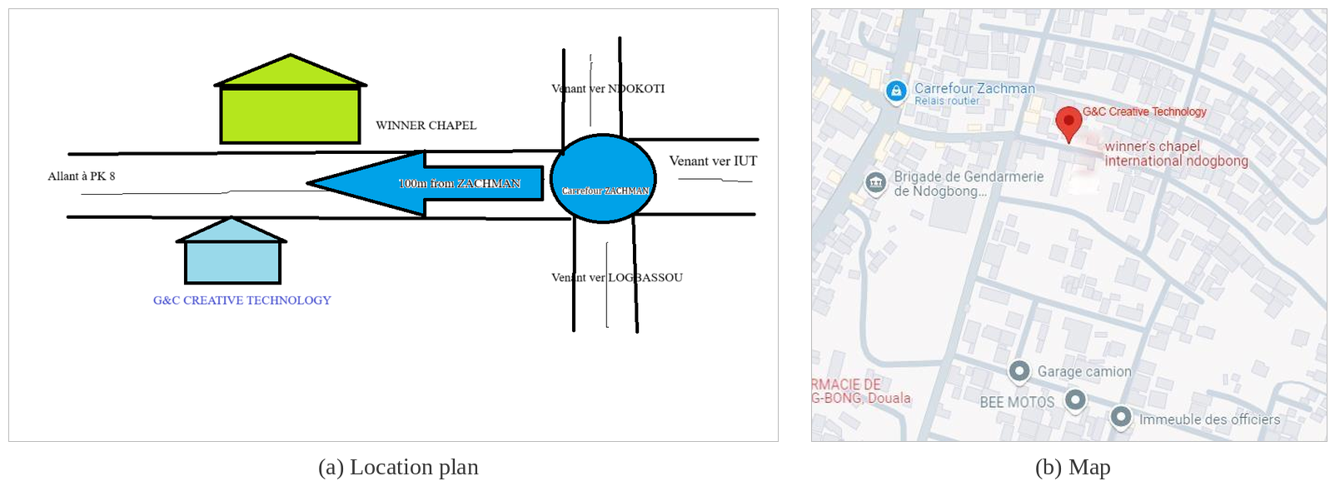
Figure 1: Location of G&C Creative Technology: (a) location plan, (b) map (source: G&C Creative Technology)

1.1.6 Organisation
The company is led by the Chief Executive Officer, assisted by a secretary and by the manager, who coordinates five departments and the cashier (Figure 2). I was attached to the Department of Software Development, Installations and Hardware Maintenance, which develops the websites and applications of the clients.
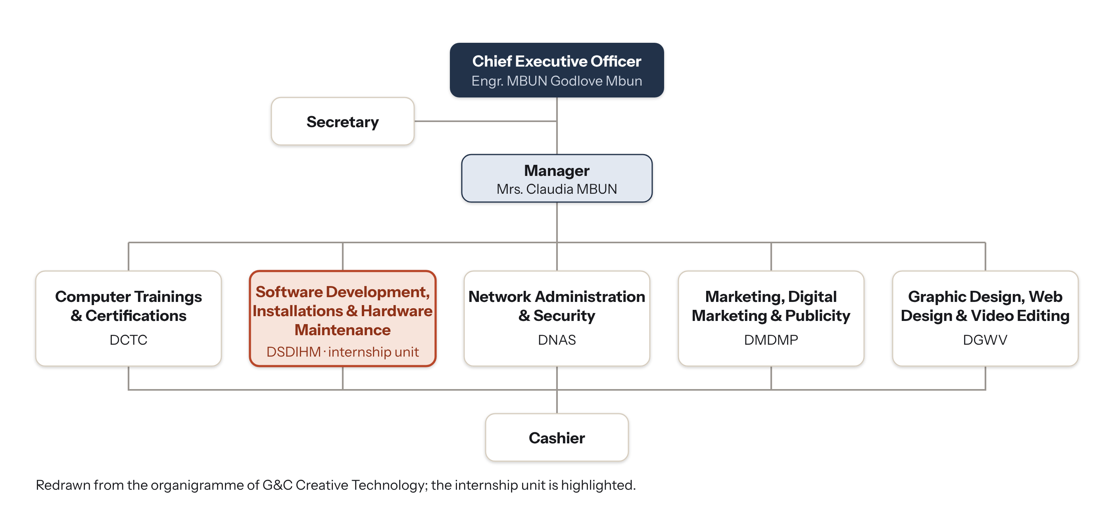
Figure 2: Organisation chart of G&C Creative Technology (source: author, from the company’s organigramme)

1.2 Activities carried out during the internship
The internship started on Wednesday, July 1, 2026. I was received by my internship supervisor, Engr. MBUN Godlove Mbun, who presented the company, its two centres, its internal rules (working hours, use of the equipment, confidentiality) and the team. After a first week of discovery and support in the business centre, the subject was agreed upon: a tool that gathers and follows job applications, useful to G&C for its own recruitment of trainees and interns and to the SMEs it serves. The nine weeks then followed the phases of the software development life cycle (Figure 3 and Table 3).
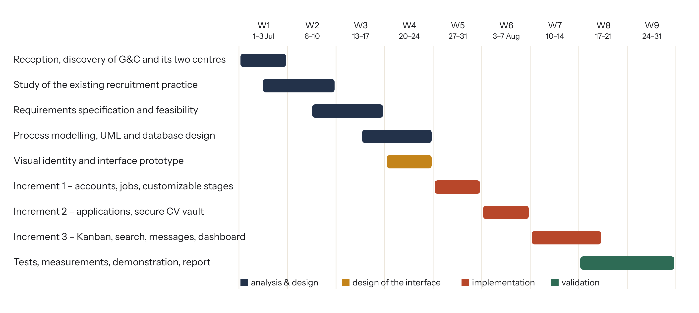
Figure 3: Planning of the internship (July 1 – August 31, 2026) (source: author)
Table 3: Weekly summary of the activities carried out
Week | Activities carried out | Lessons and problems solved
1 (Jul 1–3) | Reception by the CEO; discovery of the business and training centres; installation of the development tools; laptop maintenance in the business centre | How a small ICT company combines services, training and development
2 (Jul 6–10) | Interviews with the manager on the recruitment of trainees and interns, and with two SME clients; collection of Excel sheets, e-mails and WhatsApp messages | Understand the business need before coding
3 (Jul 13–17) | Requirements specification (34 FR, 16 NFR); feasibility study; choice of the process model | Writing measurable requirements that become tests
4 (Jul 20–24) | BPMN process model, UML diagrams, database design; visual identity and interface prototype | Stages must be data, not code
5 (Jul 27–31) | Increment 1: project setup, authentication, roles, job offers, customizable stages | JWT in httpOnly cookie, bcrypt, Zod validation
6 (Aug 3–7) | Increment 2: online application, CV vault (type check, scan, encryption), manual capture | File upload security (OWASP); no orphan files
7 (Aug 10–14) | Increment 3: Kanban pipeline, business rules, bilingual messages, search in CV text | Transactions; PostgreSQL full-text search
8 (Aug 17–21) | Increment 3 (end): dashboard, audit log, erasure and retention; integration tests | A test per business rule; one clock for time rules
9 (Aug 24–31) | Measurements on 10,000 candidates, demonstration to the CEO and the manager, documentation, report | Reporting honestly what is and is not verified

1.2.1 Detail of the main activities
Weeks 1 and 2 – discovery and framing. Besides support tasks in the business centre (laptop maintenance, installation of software), I interviewed the manager, who receives the applications of trainees and interns, and two SME clients of the company. I collected anonymised examples of what they use today: an Excel sheet per offer, CVs forwarded by e-mail, WhatsApp conversations. Three observations shaped the project: the phone number is the identifier every candidate has (many give no e-mail), paper and WhatsApp CVs must enter the same process as online applications, and each company – even each position – has different stages.
Weeks 3 and 4 – analysis and design. The requirements were written with MoSCoW priorities and measurable targets (Chapter 3); the feasibility study showed a direct cost limited to hosting. The recruitment process was modelled in BPMN and as a configurable state machine, then the architecture, the data model and the REST API were designed. A complete visual identity (name, logo, colours, fonts) was created so that the product would not look like a generic template.
Weeks 5 to 9 – implementation and tests. Each increment delivered a working version tested by automated integration tests against a real PostgreSQL database. The last two weeks were devoted to measurements, a demonstration to the CEO and the manager, documentation and this report.
This internship strengthened my technical skills (React, Node.js, Express, PostgreSQL, application security, Git) and my methodological skills (requirements engineering, business process modelling, UML, test planning, technical writing).

1.3 Choice and justification of the topic
The topic “Design and implementation of Bolo, a web platform for recruitment and job application tracking” was chosen because it answers a real and frequent problem of G&C Creative Technology, which receives many applications of trainees and interns every holiday period, and of the SMEs it serves; it is aligned with the activities of the Department of Software Development (web applications for clients) and with the company’s training in cyber security; it is a complete engineering exercise – process modelling, web development, database, security, tests – and it is feasible by one developer in nine weeks with free and open-source tools.

Conclusion
This chapter presented G&C Creative Technology, a Douala-based ICT business and training centre, the activities of the nine weeks of internship and the reasons for the choice of the topic. The next chapter reviews the concepts and technologies needed for the study.

CHAPTER 2
OVERVIEW OF THE TOPIC STUDIED
(LITERATURE REVIEW)

Introduction
This chapter presents the theory needed to understand the study: the recruitment process, business process modelling, the protection of personal data and the security of uploaded files, the architecture of web applications, the existing solutions and the software process models.

2.1 The recruitment process
Whatever the size of the company, a recruitment follows the same main phases: definition of the need, sourcing (publication of the offer), collection of applications, selection, decision and offer, integration, and closure – answering every candidate who was not selected. The selection phase varies most: a bank may require several interviews and background checks, a small shop may hire after one interview, a transport company adds a driving test. A useful tool must therefore let each company define its own stages, and even adapt them for one offer.
Two weaknesses are frequent in SMEs: the collection phase is scattered over many channels, and the closure phase is often forgotten – candidates who were not selected never hear back, which harms the image of the employer.

2.2 Business process modelling
A business process is a set of activities, performed by actors, that turns an input into a result of value. Business Process Management (Dumas et al., 2018) studies how to identify, model, analyse, automate and improve such processes. Several notations exist (Table 4).
Table 4: Notations for modelling the recruitment process
Notation | Strengths | Use in this project
BPMN 2.0 | Standard of the OMG; lanes per actor; events and gateways; readable by business users | Global process with the candidate, the system, HR and recruiters
UML activity diagram | Close to BPMN; integrated with the other UML diagrams | Not used (BPMN preferred for the business view)
UML state machine | Describes the life cycle of one object: states, transitions, guards | Life cycle of an application; basis of the implementation

The recruitment process lends itself well to a state machine: each application is an object whose state is its current stage; the events (move, hire, reject) are transitions performed by authorised actors; guards express the rules (a rejection needs a reason); actions express the effects (a message to the candidate, a line in the history). If the states are stored as data rather than written in the code, every company can change them without a new version of the software – this is the key design choice of Bolo.

2.3 Protection of personal data and security of CVs
A CV contains personal data. In Cameroon, Law No. 2024/017 of 23 December 2024 on the protection of personal data applies to public and private processing; it gives data subjects the rights of access, rectification, deletion, objection and portability, restricts transfers of data abroad, and creates a supervisory authority, the ADCP. The European GDPR follows the same principles. For a recruitment tool they mean: inform the candidate and obtain consent; collect only what is necessary; keep the data for a limited time; protect it against loss and unauthorised access; and allow its deletion.
On the technical side, the OWASP File Upload Cheat Sheet recommends: an allow-list of file types checked from the content (magic bytes) and not from the extension; a size limit; a random file name; storage outside the web root; an antivirus scan; and access through authorised, short-lived links. Encrypting files at rest with an authenticated algorithm such as AES-256-GCM (NIST SP 800-38D) protects them even if the disk or a backup is stolen.

2.4 Architecture of web applications
A single-page application (SPA) loads once in the browser and then exchanges only data with the server through a REST API (Fielding, 2000). React builds the interface from reusable components; Node.js runs JavaScript on the server with an event loop suited to many simultaneous requests; Express is its most used web framework. For the data, the choice is between a relational and a document database (Table 5).
Table 5: Relational and document-oriented databases for recruitment data
Criterion | Relational (PostgreSQL) | Document (MongoDB)
Data model | Tables linked by foreign keys | JSON-like documents
Integrity | Constraints (unique, foreign keys, check) | Mostly checked by the application
Transactions | Full ACID transactions | Multi-document transactions possible, less natural
Search | Native full-text search (tsvector, GIN index) | Text index
Fit for this project | Applications, stages, history and rules are strongly related | Less suited to the many relations

PostgreSQL was chosen: recruitment data are strongly related (a job has stages, an application points to a stage, a move creates a history line), and a stage change must update several tables in one transaction. Its full-text search also allows searching inside the text of the CVs without an extra search engine.

2.5 Existing solutions
Table 6: Existing solutions and the needs of the study
Need | Excel + WhatsApp | Google Forms + Sheets | International ATS (SaaS) | Open-source ATS | Bolo
One entry for all channels | No | Online only | Online + e-mail | Partly | Online + manual capture
Stages per offer | No | No | Yes | Limited | Yes, with delay and message
Paper / photo CV | Manual | No | Rarely | No | Yes (photo resized)
Phone as identifier | Yes | No | No (e-mail) | No | Yes
FR / EN answers | Manual | No | Yes, paid plans | Partly | Automatic, per candidate
CV security | None | Third-party storage | Good | Variable | Encryption, signed links, log
Cost for an SME | Free | Free | Monthly fee per user, card payment | Free, hard to host | Hosting only

International ATS cover most needs but cost a monthly fee per user in foreign currency, are designed around e-mail and do not take paper or WhatsApp CVs into account; free tools do not model a process nor protect the data. None combines these needs for a Cameroonian SME.

2.6 Software process models
Table 7: Comparison of software process models
Model | Advantages | Limits for this project
Waterfall | Simple, well documented | Working product only at the end
V-model | Tests designed early | Sequential, little room for change
Iterative and incremental | A working version after each increment; risks isolated | Needs a stable architecture
Agile (Scrum) | Very flexible | Rituals heavy for one developer

The iterative and incremental model was chosen: the requirements were mostly known after the interviews, the deadline was strict, and the riskiest part (secure file handling) could be isolated in its own increment. From the V-model, the measurable non-functional requirements were reused directly as acceptance tests.

Conclusion
This chapter presented the recruitment process, BPMN and state machines, the legal and technical rules for protecting CVs, the web architecture and PostgreSQL, the existing solutions and the iterative model, and showed that no existing solution fits the needs of a Cameroonian SME.

PART TWO:

EMPIRICAL STUDY

CHAPTER 3
DIAGNOSTIC OF THE EXISTING SYSTEM
AND REQUIREMENTS SPECIFICATION

Introduction
This chapter presents the existing system – the way applications are received and followed today – its functions, advantages and limits, and derives the requirements specification (cahier des charges) and the feasibility of the new system.

3.1 Presentation and functions of the existing system
The existing system is not a software but a set of practices around general-purpose tools (Figure 4). Applications arrive through five channels; the HR officer downloads, prints or scans them, records the candidates in an Excel sheet per offer, keeps the files in a shared folder and forwards some CVs to the managers by e-mail; interviews are arranged by phone.
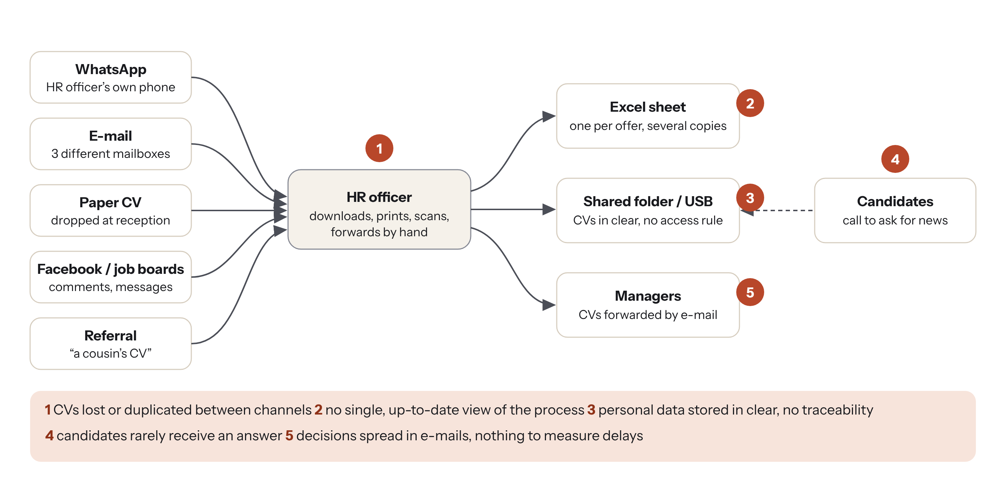
Figure 4: Topology of the existing situation and its five main problems (source: author)
Table 8: Functions of the existing system
Function | How it is done today
Publish an offer | Word document shared on Facebook, WhatsApp groups and at the entrance
Receive applications | WhatsApp, three mailboxes, paper, social networks, referrals
Record candidates | One Excel sheet per offer, copied and sent around
Select | CVs forwarded by e-mail to managers; comments in replies
Inform candidates | Phone call to the selected candidate; others rarely informed

3.2 Advantages of the existing system
Technically, the tools are already known and available: everybody uses WhatsApp and Excel, nothing must be installed and the process adapts to any situation. Financially, it has no direct cost.

3.3 Limits of the existing system
Table 9: Limits of the existing system and their consequences
Limit | Observed situation | Consequence
Scattered channels | Five channels, three mailboxes, a personal phone | CVs lost or duplicated; good profiles missed
No shared view | Several copies of the Excel sheet | Nobody knows the real state of a candidate
No traceability | Decisions in e-mails and phone calls | Delays cannot be measured; disputes cannot be checked
Candidates without answer | Only the selected candidate is called | Bad image of the employer; repeated calls to HR
Unprotected personal data | CVs on phones, USB keys, shared folders | Risk of leaks; not compliant with Law No. 2024/017
Hidden cost | Hours of copying, searching and calling | Slow recruitments, sometimes a poor hire

The new system must overcome these limits while keeping the advantages of the existing practice: candidates must still be able to use WhatsApp or a paper CV, and the cost for the company must stay very low.

3.4 Requirements specification (cahier des charges)

3.4.1 Actors and use cases
The system has five human actors – Visitor, Candidate (a Visitor who applies), Recruiter (a line manager assigned to some offers), HR manager (a Recruiter with all rights on the company’s offers) and Administrator – and two external systems: the e-mail/SMS gateway and the antivirus. Figure 5 shows the use cases; the highlighted ones are the signature features of Bolo.
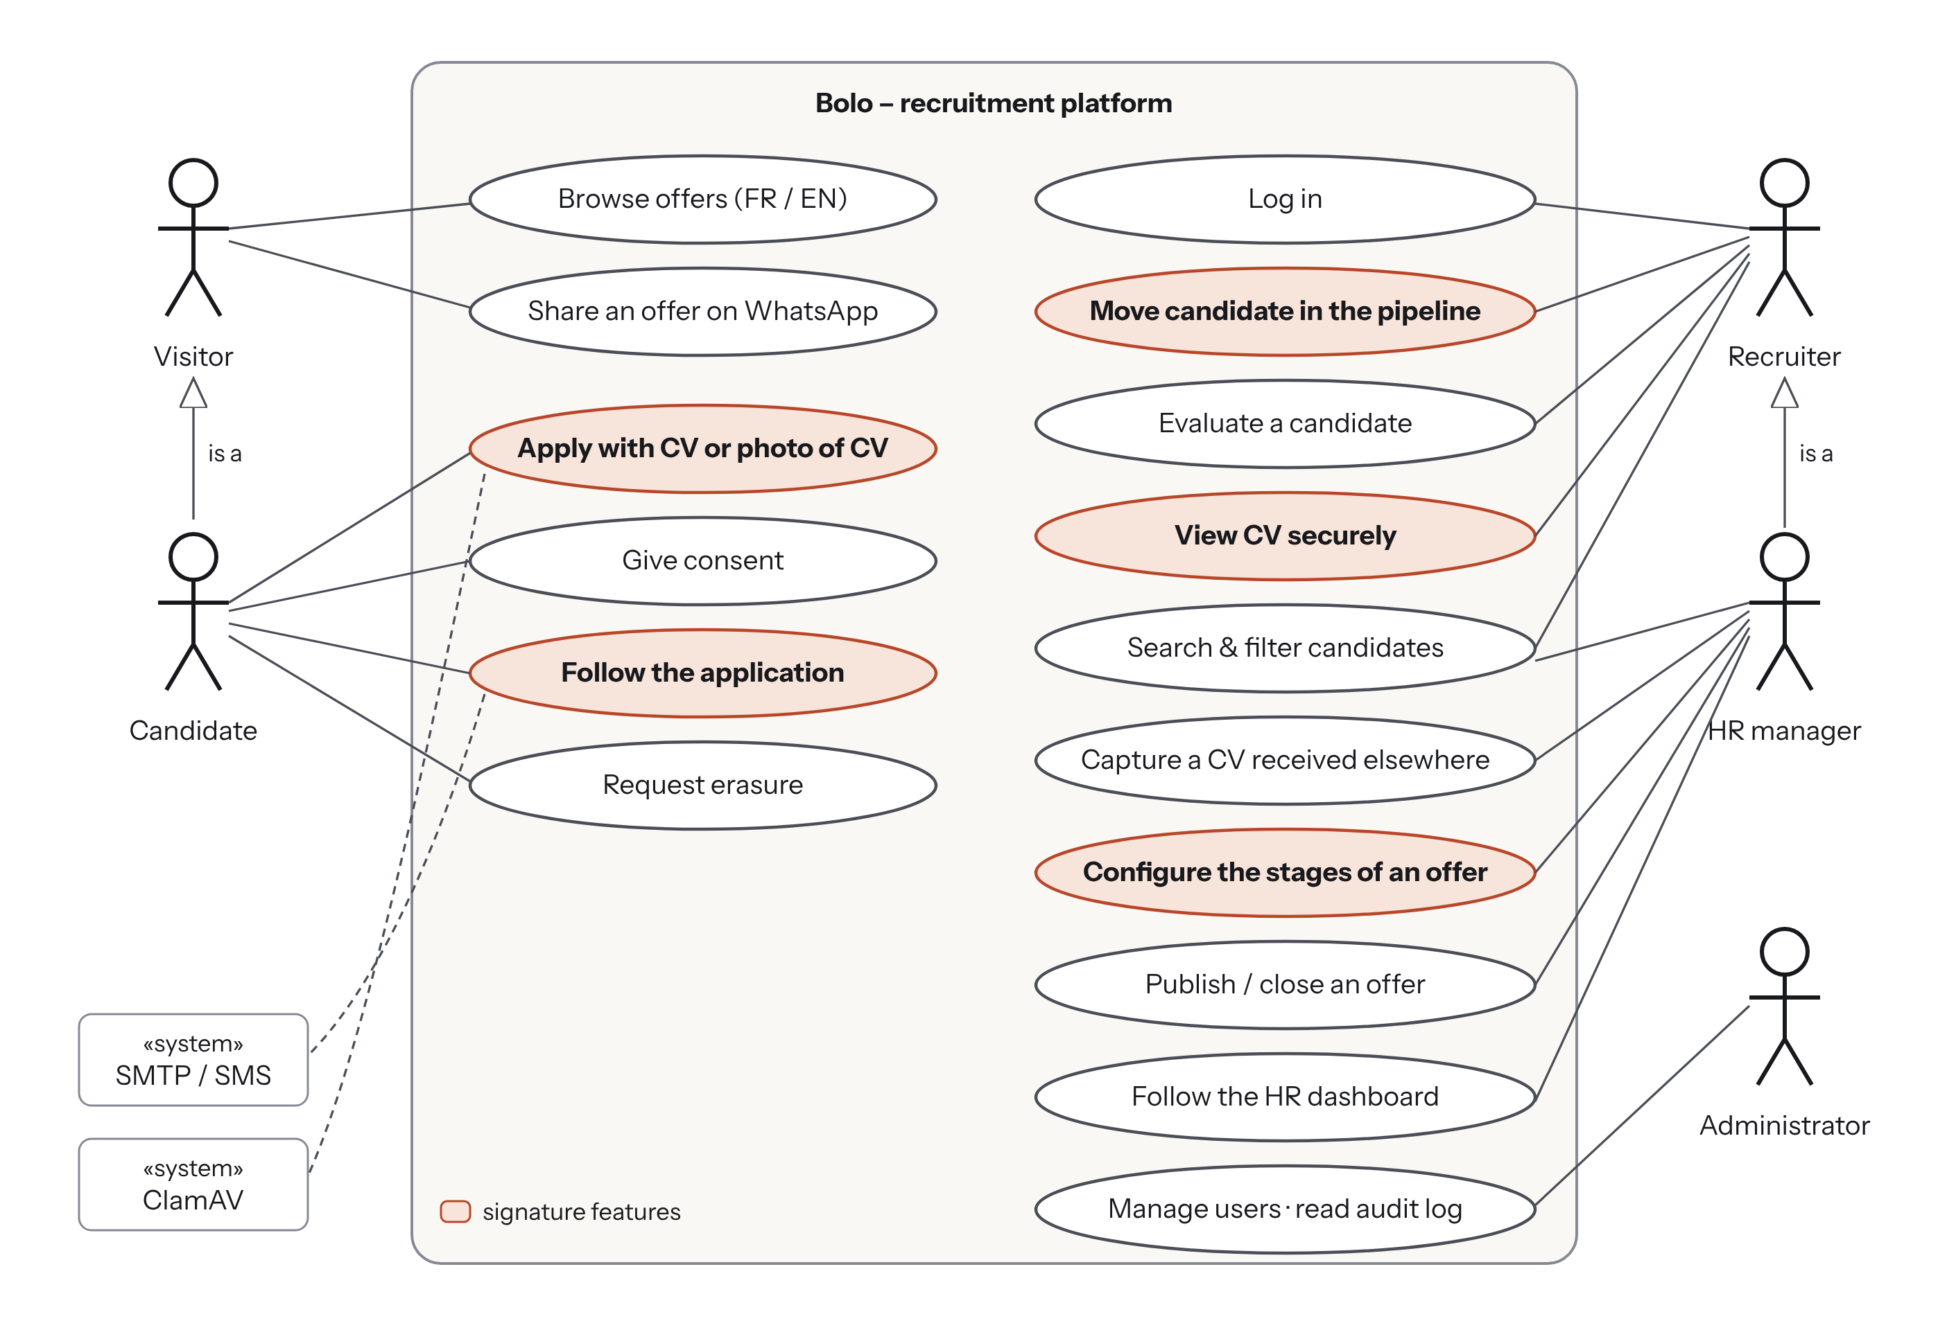
Figure 5: Use case diagram of Bolo (source: author)

3.4.2 Use case scenarios
The diagram above names the use cases; the tables below describe the most important ones step by step, with their preconditions, their main scenario, their alternative or error scenarios and their postconditions. Each scenario is covered by automated tests (section 4.7).
Table 10: Scenario of the use case “Apply for a job (UC-01)”
Item | Description
Actor | Candidate (visitor, no account)
Goal | Send an application with a CV for a published job offer
Preconditions | The offer is published and its deadline is not passed
Main scenario | 1. The candidate opens the career page and chooses an offer.  2. The system shows the offer and the application form in French or English.  3. The candidate enters name, Cameroonian phone number, optional e-mail, experience and skills, attaches a CV (PDF, Word or photo) and accepts the privacy notice.  4. The system checks the data, the real type and size of the file and scans it, then encrypts and stores it.  5. The system creates or finds the candidate by phone number, creates the application in the first stage and queues the acknowledgement.  6. The system shows “Application sent” with a personal tracking link.
Alternative / error scenarios | 4a. File larger than 5 MB → refused (413).  4b. File whose content is not a PDF, Word document or image (e.g. a renamed .exe) → refused (415).  4c. Antivirus detection → refused (422) and the file is deleted.  3a. Consent, CV or valid phone number missing → error message, nothing is stored.  5a. Same phone number for the same offer → no duplicate application.  *. More than 20 applications per hour from the same address → refused (429).
Postconditions | Application in the first stage; encrypted CV; acknowledgement queued (e-mail, or SMS when there is no e-mail); HR team notified

Table 11: Scenario of the use case “Track an application (UC-02)”
Item | Description
Actor | Candidate
Preconditions | The candidate has the tracking link received after applying
Main scenario | 1. The candidate opens the tracking link.  2. The system finds the application by its random token.  3. The system shows a simple status – received, in review or decision – in the candidate’s language, never the internal stage, rating or comments.
Alternative scenarios | 2a. Unknown token → “application not found”.  3a. A rejection is pending (48 h delay) → the status stays “in review” until the answer is actually sent.
Postconditions | No data is modified

Table 12: Scenario of the use case “Log in to the HR workspace (UC-03)”
Item | Description
Actor | Administrator, HR manager or Recruiter
Preconditions | The user has an account created by the administrator
Main scenario | 1. The user enters e-mail and password.  2. The system checks that the account is not locked and compares the password with its bcrypt hash.  3. The system resets the failure counter, opens an 8-hour session in an httpOnly cookie and shows the dashboard.
Alternative scenarios | 2a. Wrong password → error (401) and the failure counter is increased.  2b. Fifth failure → account locked for 15 minutes (423).
Postconditions | Session opened; every later request is checked for role and company

Table 13: Scenario of the use case “Publish a job offer and its stages (UC-04)”
Item | Description
Actor | HR manager or Administrator
Preconditions | User logged in with the HR or Admin role
Main scenario | 1. The user clicks “New offer” and fills title, department, place, contract, openings, deadline, description, profile and key skills.  2. The system proposes the company’s default stages; the user renames, adds, reorders or removes stages and sets for each one a maximum delay and the message sent to the candidate.  3. The user saves and publishes.  4. The system checks that the pipeline has exactly one “hired” and one “rejected” stage, saves the offer and shows it on the career page.
Alternative scenarios | 1a. A recruiter tries to create an offer → refused (403).  4a. Pipeline without a “hired” or “rejected” stage → refused with a message.  2a. Removing a stage that holds applications → refused.
Postconditions | Offer published with its own stages; action written in the audit log

Table 14: Scenario of the use case “Capture a CV received outside the platform (UC-05)”
Item | Description
Actor | HR manager, Administrator or Recruiter
Preconditions | The CV was received by WhatsApp, e-mail, on paper or by referral
Main scenario | 1. The user clicks “Capture a received CV” and chooses the offer and the source.  2. The user enters the candidate’s name, phone number, language, experience and skills and attaches the file or a photo of the paper CV.  3. The system applies the same checks as for an online application, stores the CV and places the application in the first stage with its source.
Alternative scenarios | Same file errors as UC-01; known phone number → the existing candidate is reused.
Postconditions | Application created with its source (e.g. WhatsApp); acknowledgement queued; capture written in the audit log

Table 15: Scenario of the use case “Move or reject a candidate (UC-06)”
Item | Description
Actor | HR manager, Administrator, or Recruiter assigned to the offer
Preconditions | The application belongs to an offer of the user’s company that the user can see
Main scenario | 1. The user drags the candidate’s card to another stage of the Kanban board.  2. The system checks the role, the company and that the stage belongs to the same offer.  3. In one transaction, the system changes the stage, writes the history and the audit log and queues the message of the new stage.  4. The board shows the card in its new column.
Alternative scenarios | 1a. Target stage “Not retained”: the user must choose a reason; the answer is queued 48 hours later.  1b. The card is moved back from “Not retained” within 48 hours: the pending answer is cancelled.  3a. The last opening is filled: the team is notified to close the offer.  2a. Recruiter not assigned to the offer → refused (403).
Postconditions | New stage; history and audit entries; message queued or cancelled

Table 16: Scenario of the use case “Consult a CV (UC-07)”
Item | Description
Actor | HR manager, Administrator, or assigned Recruiter
Main scenario | 1. The user opens a candidate’s profile.  2. The system checks the rights and returns a link signed with HMAC, valid 5 minutes and bound to the user.  3. The browser requests the file with this link; the system decrypts it, sends it without cache and writes “CV viewed” in the audit log.  4. The CV is displayed inside the application with a watermark.
Alternative scenarios | 2a. User of another company or unassigned recruiter → refused (403).  3a. Link modified or expired → refused (403).
Postconditions | The view is traceable in the audit log

Table 17: Scenario of the use case “Erase a candidate’s data (UC-08)”
Item | Description
Actor | HR manager or Administrator, at the candidate’s request
Main scenario | 1. The user opens the candidate’s profile and chooses “Right to erasure”.  2. The system asks for confirmation.  3. The system anonymises the candidate (name, phone, e-mail, skills) and deletes every CV file, then writes the action in the audit log.
Postconditions | No personal data or CV remains; statistics are kept

3.4.3 Functional requirements
The 34 functional requirements are grouped in seven modules and prioritised with the MoSCoW method (Table 18).
Table 18: Functional requirements by module (M = Must, S = Should, C = Could)
Module | Main requirements | Priorities
Accounts & access (FR-01–04) | Log in / out; roles admin, HR, recruiter; lock after failed attempts; user management | 3 M, 1 S
Job offers (FR-05–09) | Create and edit; publish on the career page; close with an answer to every candidate; share on WhatsApp; assign recruiters | 3 M, 2 S
A. Configurable process (FR-10–14) | Stages per offer (add, rename, reorder, delete); Kanban moves; history of every move; maximum delay per stage; rejection reason and delayed answer | 4 M, 1 S
B. Applications & CVs (FR-15–21) | Online application with CV or photo; capture of CVs received by WhatsApp, e-mail, paper or referral; no duplicate (phone); secure viewing; PDF, Word, JPG, PNG; consent; photo resized in browser | 6 M, 1 C
Search (FR-22–24) | Full-text search in profiles and CV text; filters (offer, stage, experience, source, language, rating); evaluations 1–5 | 2 M, 1 S
C. Communication (FR-25–29) | Bilingual templates; e-mail or SMS when no e-mail; in-app notifications; public tracking page; real sending through SMTP / SMS gateway | 1 M, 4 S
D. Dashboard & compliance (FR-30–34) | HR dashboard; audit log of CV views; right to erasure; automatic anonymisation after 24 months; export to Excel; interview scheduling | 3 M, 1 S, 2 C

3.4.4 Non-functional requirements
Each of the 16 non-functional requirements has a measurable target, so that it becomes an acceptance test (Table 19).
Table 19: Non-functional requirements and measurable targets
ID | Category | Target
NFR-01 | Performance | Search among 10,000 candidates in under 1 s
NFR-02 | Performance | Moving a candidate answered in under 300 ms
NFR-03 | Performance / data | Career page under 300 kB transferred; usable on 3G
NFR-04 | Performance | Application with a 1 MB CV processed by the server in under 2 s
NFR-05 | Security | Passwords hashed with bcrypt (cost 12), never returned
NFR-06 | Security | Account locked 15 min after 5 failed logins
NFR-07 | Security | Every private route requires a valid session and the right role
NFR-08 | Security | Strict isolation between companies
NFR-09 | Security | CV type checked from content, antivirus scan, AES-256-GCM at rest
NFR-10 | Security | CV links signed, bound to one user, valid 5 minutes
NFR-11 | Traceability | Every CV view written in the audit log
NFR-12 | Privacy | Consent required; erasure on request; anonymisation after 24 months
NFR-13 | Usability | A new HR user publishes an offer in under 10 min; SUS ≥ 70
NFR-14 | Compatibility | Recent Chrome, Firefox, Edge, Safari; from 360 px wide
NFR-15 | Maintainability | Layered code; automated tests for every business rule
NFR-16 | Availability | Installation with one command; daily database backup

3.4.5 Constraints and deliverables
- Technical: React for the client, Node.js/Express for the server, PostgreSQL for the database (stack set by the project).
- Time: nine weeks, one developer.
- Budget: free and open-source tools; low-cost hosting suited to an SME.
- Legal: compliance with Law No. 2024/017 on personal data protection.
- Deliverables: requirements specification, design, source code with tests, installation files, user guide and this report.

3.5 Feasibility study
Economic feasibility. All the software used is free and open source (React, Node.js, PostgreSQL, ClamAV, Docker). The only recurring cost is the hosting of a small server, a domain name and the sending of e-mails and SMS (section 4.9). Technical feasibility. The stack is mastered in our training; the new elements – full-text search, file encryption, antivirus – are documented and testable locally. Legal feasibility. Only the data needed for recruitment are collected; consent is recorded; data stay on a server chosen by the company; candidates can obtain the deletion of their data. Operational feasibility. The HR team keeps its habits: a CV received on WhatsApp is simply captured in Bolo with its source.
Table 20: Main technical risks and mitigations
Risk | Mitigation
Malicious file uploaded as a CV | Type checked from content, size limit, antivirus, file never executed nor served directly
Loss of the encryption key | Key kept outside the database and the code; offline copy documented in the installation guide
Candidates without e-mail | Phone number as identifier; SMS as fallback channel
Stages changed while candidates are in them | A stage that holds applications cannot be deleted (rule BR5)
Poor connection of candidates | Light public pages loaded separately; photos resized in the browser

Conclusion
The existing practice, although free and familiar, scatters applications, leaves no trace, keeps CVs unprotected and leaves candidates without answer. These limits were turned into 34 functional and 16 measurable non-functional requirements, and the new system is feasible at a very low cost.

CHAPTER 4
PROPOSED SOLUTION AND IMPLEMENTATION

Introduction
This chapter presents Bolo: the architecture and the justification of the tools used, the modelling of the recruitment process, the detailed design (data flow diagrams, data model, sequence diagrams, API and security of CVs), the user interface, the implementation, the tests and results, the installation procedure and the cost estimate.

4.1 Architecture of the new system
Bolo uses a three-tier client-server architecture (Figure 6). The browser loads either the HR back-office or the public career pages; the two are separate bundles, so that a candidate on a 3G connection never downloads the back-office. The Express server checks the session and the role, applies the business rules in a service layer and accesses PostgreSQL, the encrypted CV storage and the antivirus. Messages to candidates are written in an outbox table in the same transaction as the decision, then sent by a background job – a message is therefore never lost, nor sent for a decision that was cancelled.
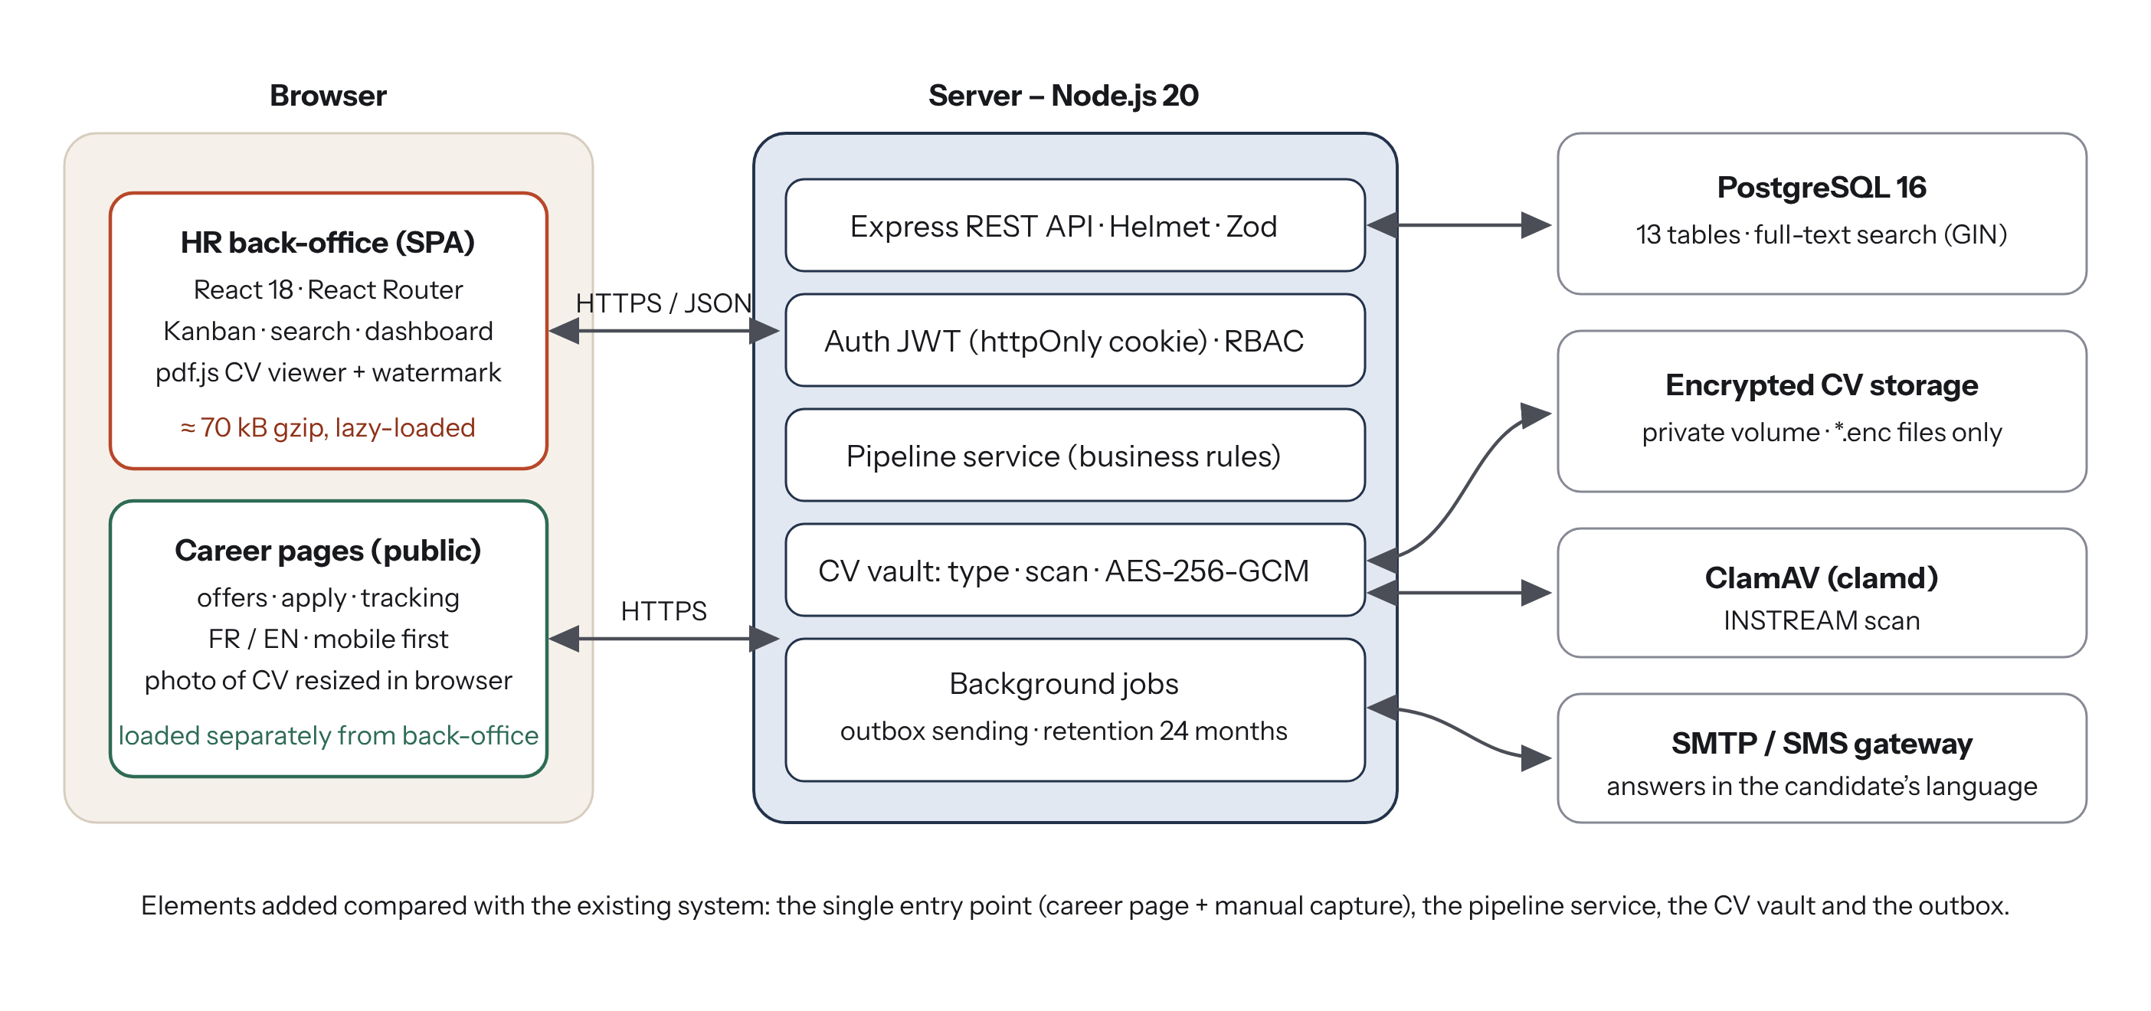
Figure 6: High-level architecture of Bolo (source: author)
Figure 7 shows where each part runs in production, and Figure 8 the layered organisation of the server code and of the repository.
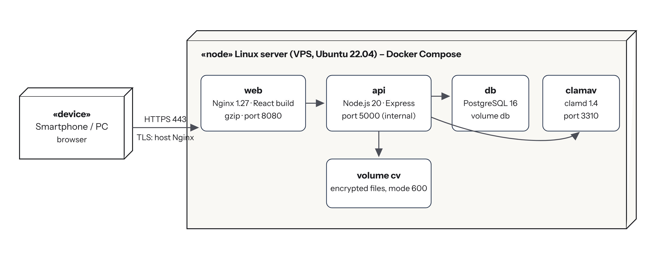
Figure 7: Deployment diagram (source: author)
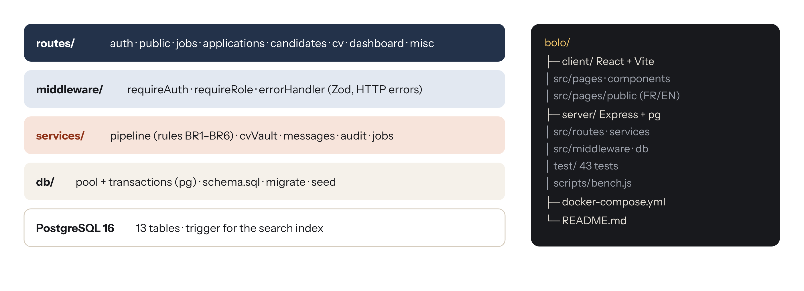
Figure 8: Layered structure of the server and organisation of the repository (source: author)

4.2 Justification of the tools used
Each part of the architecture above is built with a tool chosen against alternatives, according to four criteria: the needs of the requirements (security of CVs, search, 3G), the cost (free and open source only), the skills available in the host company for maintenance, and the maturity of the tool. Table 21 gives the choice for each layer and the reason why it was preferred; Table 22 lists the tools used to develop, test and document the project.
Table 21: Tools of the solution: choice, alternatives considered and justification
Layer | Tool chosen | Alternatives considered | Why this choice
Interface | React 18 + Vite 5 + React Router 6 | Angular, Vue.js, server-rendered pages (EJS) | Component model suited to the Kanban board and forms; the most widespread library in Douala companies; Vite builds the public pages and the back-office as separate, light bundles for 3G
CV display | pdf.js, mammoth | Download of the file; Google Docs viewer | CVs are shown inside the application with a watermark and never leave to a third-party service
Server | Node.js 20 + Express 4 | PHP/Laravel, Python/Django, Java/Spring Boot | One language (JavaScript) on client and server; non-blocking I/O suited to file uploads; small, well-known framework; free LTS version
Validation | Zod | Joi, manual checks | One schema per request, readable error messages, no unchecked input reaches the database
Database | PostgreSQL 16 | MySQL, MongoDB | Transactions and constraints protect the pipeline rules; arrays for skills; built-in full-text search (GIN) for CV text; pgcrypto for identifiers
Authentication | JWT in httpOnly cookie + bcrypt | Server sessions, Firebase Auth | No session store to maintain; cookie not readable by scripts; bcrypt is the reference for password hashing; no external account needed
File security | Multer, ClamAV, Node crypto (AES-256-GCM, HMAC) | Storage in clear; cloud storage (S3) | Free antivirus; authenticated encryption detects any modification; files stay on the company’s server
Tests | node:test + Supertest | Jest, Mocha | Test runner built into Node (no extra dependency); Supertest calls the real HTTP API against a real PostgreSQL database
Deployment | Docker Compose + Nginx | Manual installation, PaaS (Heroku) | One command installs database, antivirus, API and interface; runs on a cheap VPS; Nginx compresses and caches the public pages

Table 22: Development and documentation tools
Tool | Use in the project
Visual Studio Code | Code editor for the client and the server
Git and GitHub | Version control of the code and of the report; history of the three increments
npm | Installation of the libraries and project scripts (dev, test, db:seed)
PostgreSQL client (psql) | Creation of the database and inspection of the data during development
Chromium developer tools | Debugging of the interface and measurement of the weight of the career page
SVG drawings (UML, BPMN 2.0, DFD notations) | Diagrams of this report
Microsoft Word / LibreOffice | Writing of the report and of the requirements specification

4.3 Modelling of the recruitment business process
The recruitment process was first modelled in BPMN 2.0 with one lane per actor (Figure 9). It shows the single entry point (the candidate applies, or HR captures a CV received elsewhere), the checks done by the system before the application exists, the work of HR and recruiters, and the end of the process – a message in the candidate’s language, whatever the decision.
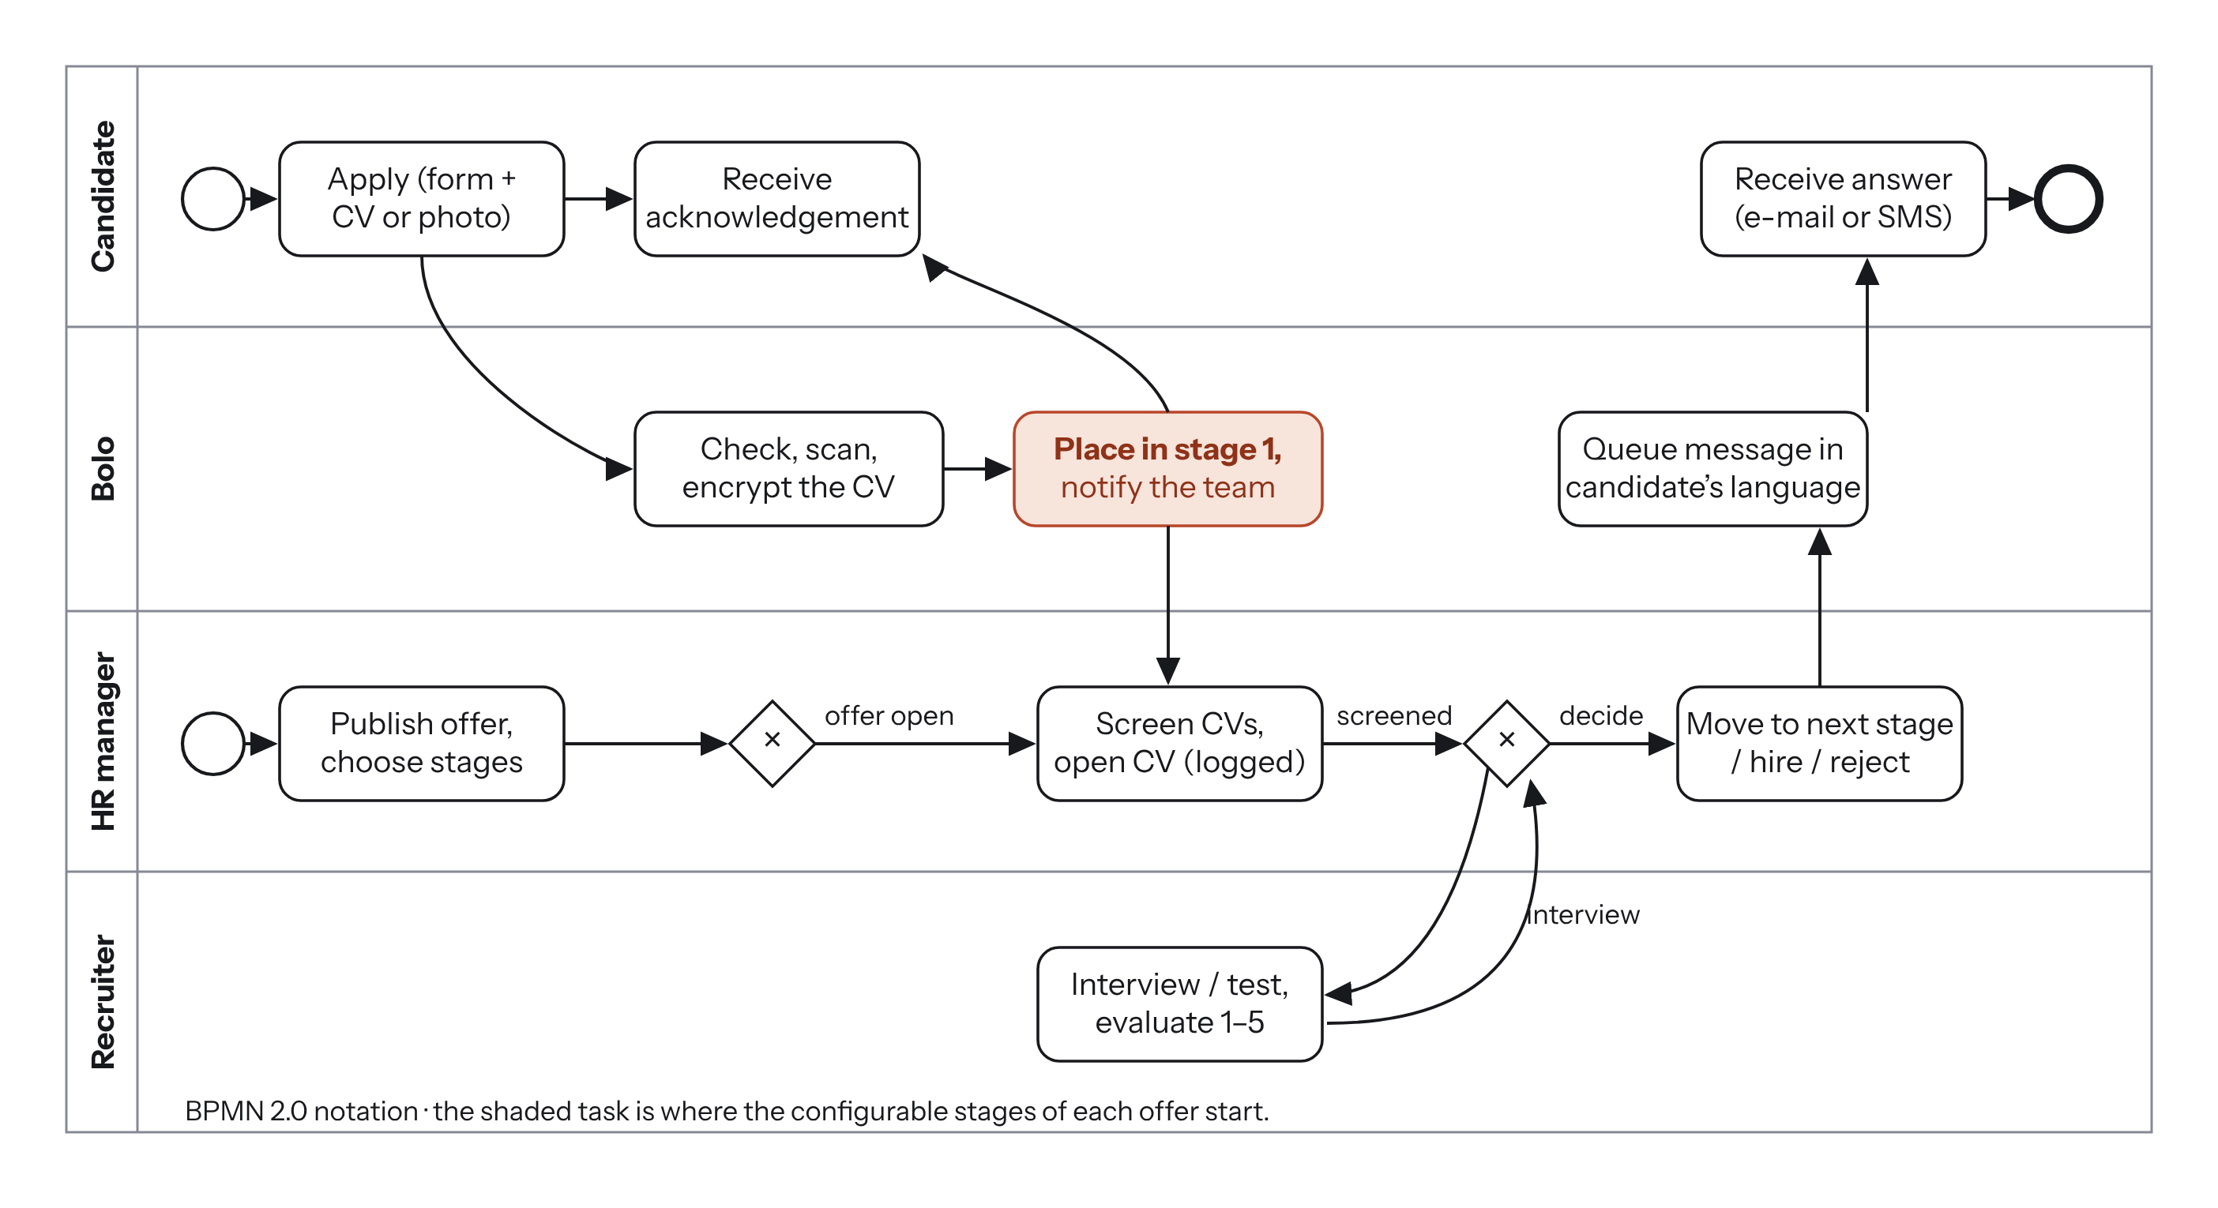
Figure 9: BPMN model of the recruitment process with Bolo (source: author)
The life cycle of an application is then a configurable state machine (Figure 10). The states are rows of the table stages: when an offer is created, the company template is copied, and HR can rename, add, remove or reorder the stages of that offer only, and set for each one a maximum delay (SLA) and the message sent to the candidate. The rules of Table 23 are enforced by the service layer and each of them is covered by an automated test.
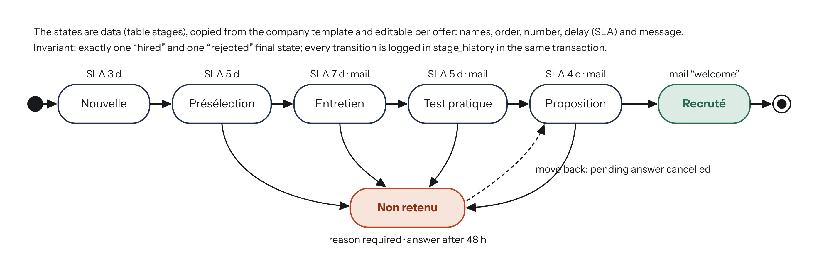
Figure 10: State machine of an application (default stages of the demonstration company) (source: author)
Table 23: Business rules of the recruitment pipeline
Rule | Description | Test
BR1 | An application can only move to a stage of its own offer | pipeline #4
BR2 | Admins and HR manage all offers; a recruiter only the offers assigned to them | pipeline #7
BR3 | A rejection needs a reason; the answer is sent 48 h later and can be cancelled | pipeline #5, #6
BR4 | When all openings are filled, the team is told to close the offer | pipeline #9
BR5 | A stage that still holds applications cannot be removed | pipeline #10
BR6 | Every move writes the history and queues the message in the same transaction | pipeline #3
BR7 | Closing an offer answers every candidate still in progress (“no candidate left without an answer”) | pipeline #14
BR8 | A pipeline has exactly one “hired” and one “rejected” final stage | pipeline #12

The core of the implementation is the function that moves an application; the extract below shows how the rules are applied inside one transaction:
// server/src/services/pipeline.js (extract)
export async function moveApplication(client, user, { applicationId, toStageId, reason }) {
const { rows: [app] } = await client.query(`SELECT a.*, s.kind AS from_kind, j.company_id, ...
FROM applications a JOIN stages s ON s.id = a.stage_id JOIN jobs j ON j.id = a.job_id
WHERE a.id = $1 AND j.company_id = $2 FOR UPDATE OF a`, [applicationId, user.company_id]);
if (!app) throw notFound('Application');
await assertCanManageJob(client, user, app.job_id); // BR2
const { rows: [target] } = await client.query(
'SELECT * FROM stages WHERE id = $1 AND job_id = $2', [toStageId, app.job_id]);
if (!target) throw new HttpError(400, 'This stage does not belong to the job'); // BR1
if (target.kind === 'rejected' && !reason?.trim())
throw new HttpError(400, 'A reason is required to reject a candidate'); // BR3
await client.query('UPDATE applications SET stage_id = $2, stage_entered_at = now() ...');
await client.query('INSERT INTO stage_history (...) VALUES (...)'); // BR6
if (target.email_key) await queueCandidateMessage(client, { ...,
delayHours: target.kind === 'rejected' ? config.rejectionDelayHours : 0 });
}

4.4 Detailed design

4.4.1 Data flow diagrams
The data flow diagrams show how information moves between the users, the processes of Bolo and the data stores, independently of the code. The context diagram (level 0) treats Bolo as a single process exchanging data with four external entities: the candidate, the HR team, the message gateway and the antivirus.
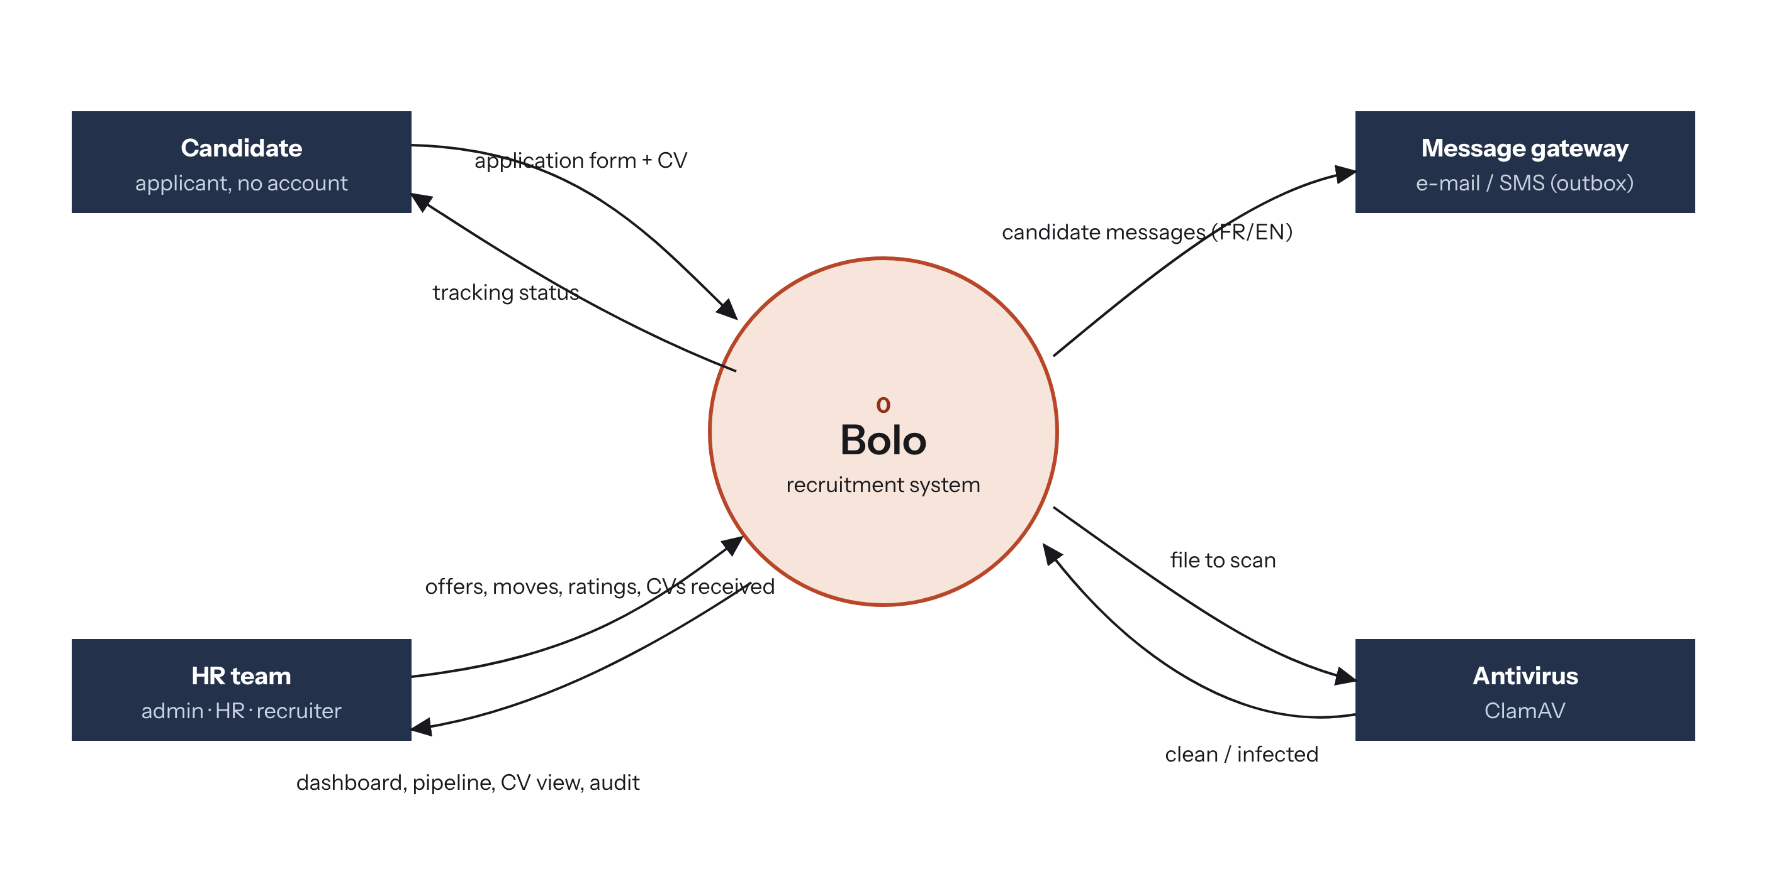
Figure 11: Context data flow diagram (level 0) (source: author)
The level-1 diagram opens the system into six processes and six data stores. An application received from the candidate (process 1) has its CV checked and encrypted (process 2) and is stored with the candidate; the HR team manages the pipeline (process 3), which writes the stage history and puts the message of each stage in the outbox; the sending process (5) reads the messages due and passes them to the gateway; offers and their stages are managed by process 4, and process 6 produces the dashboard, the search results and the audit log.
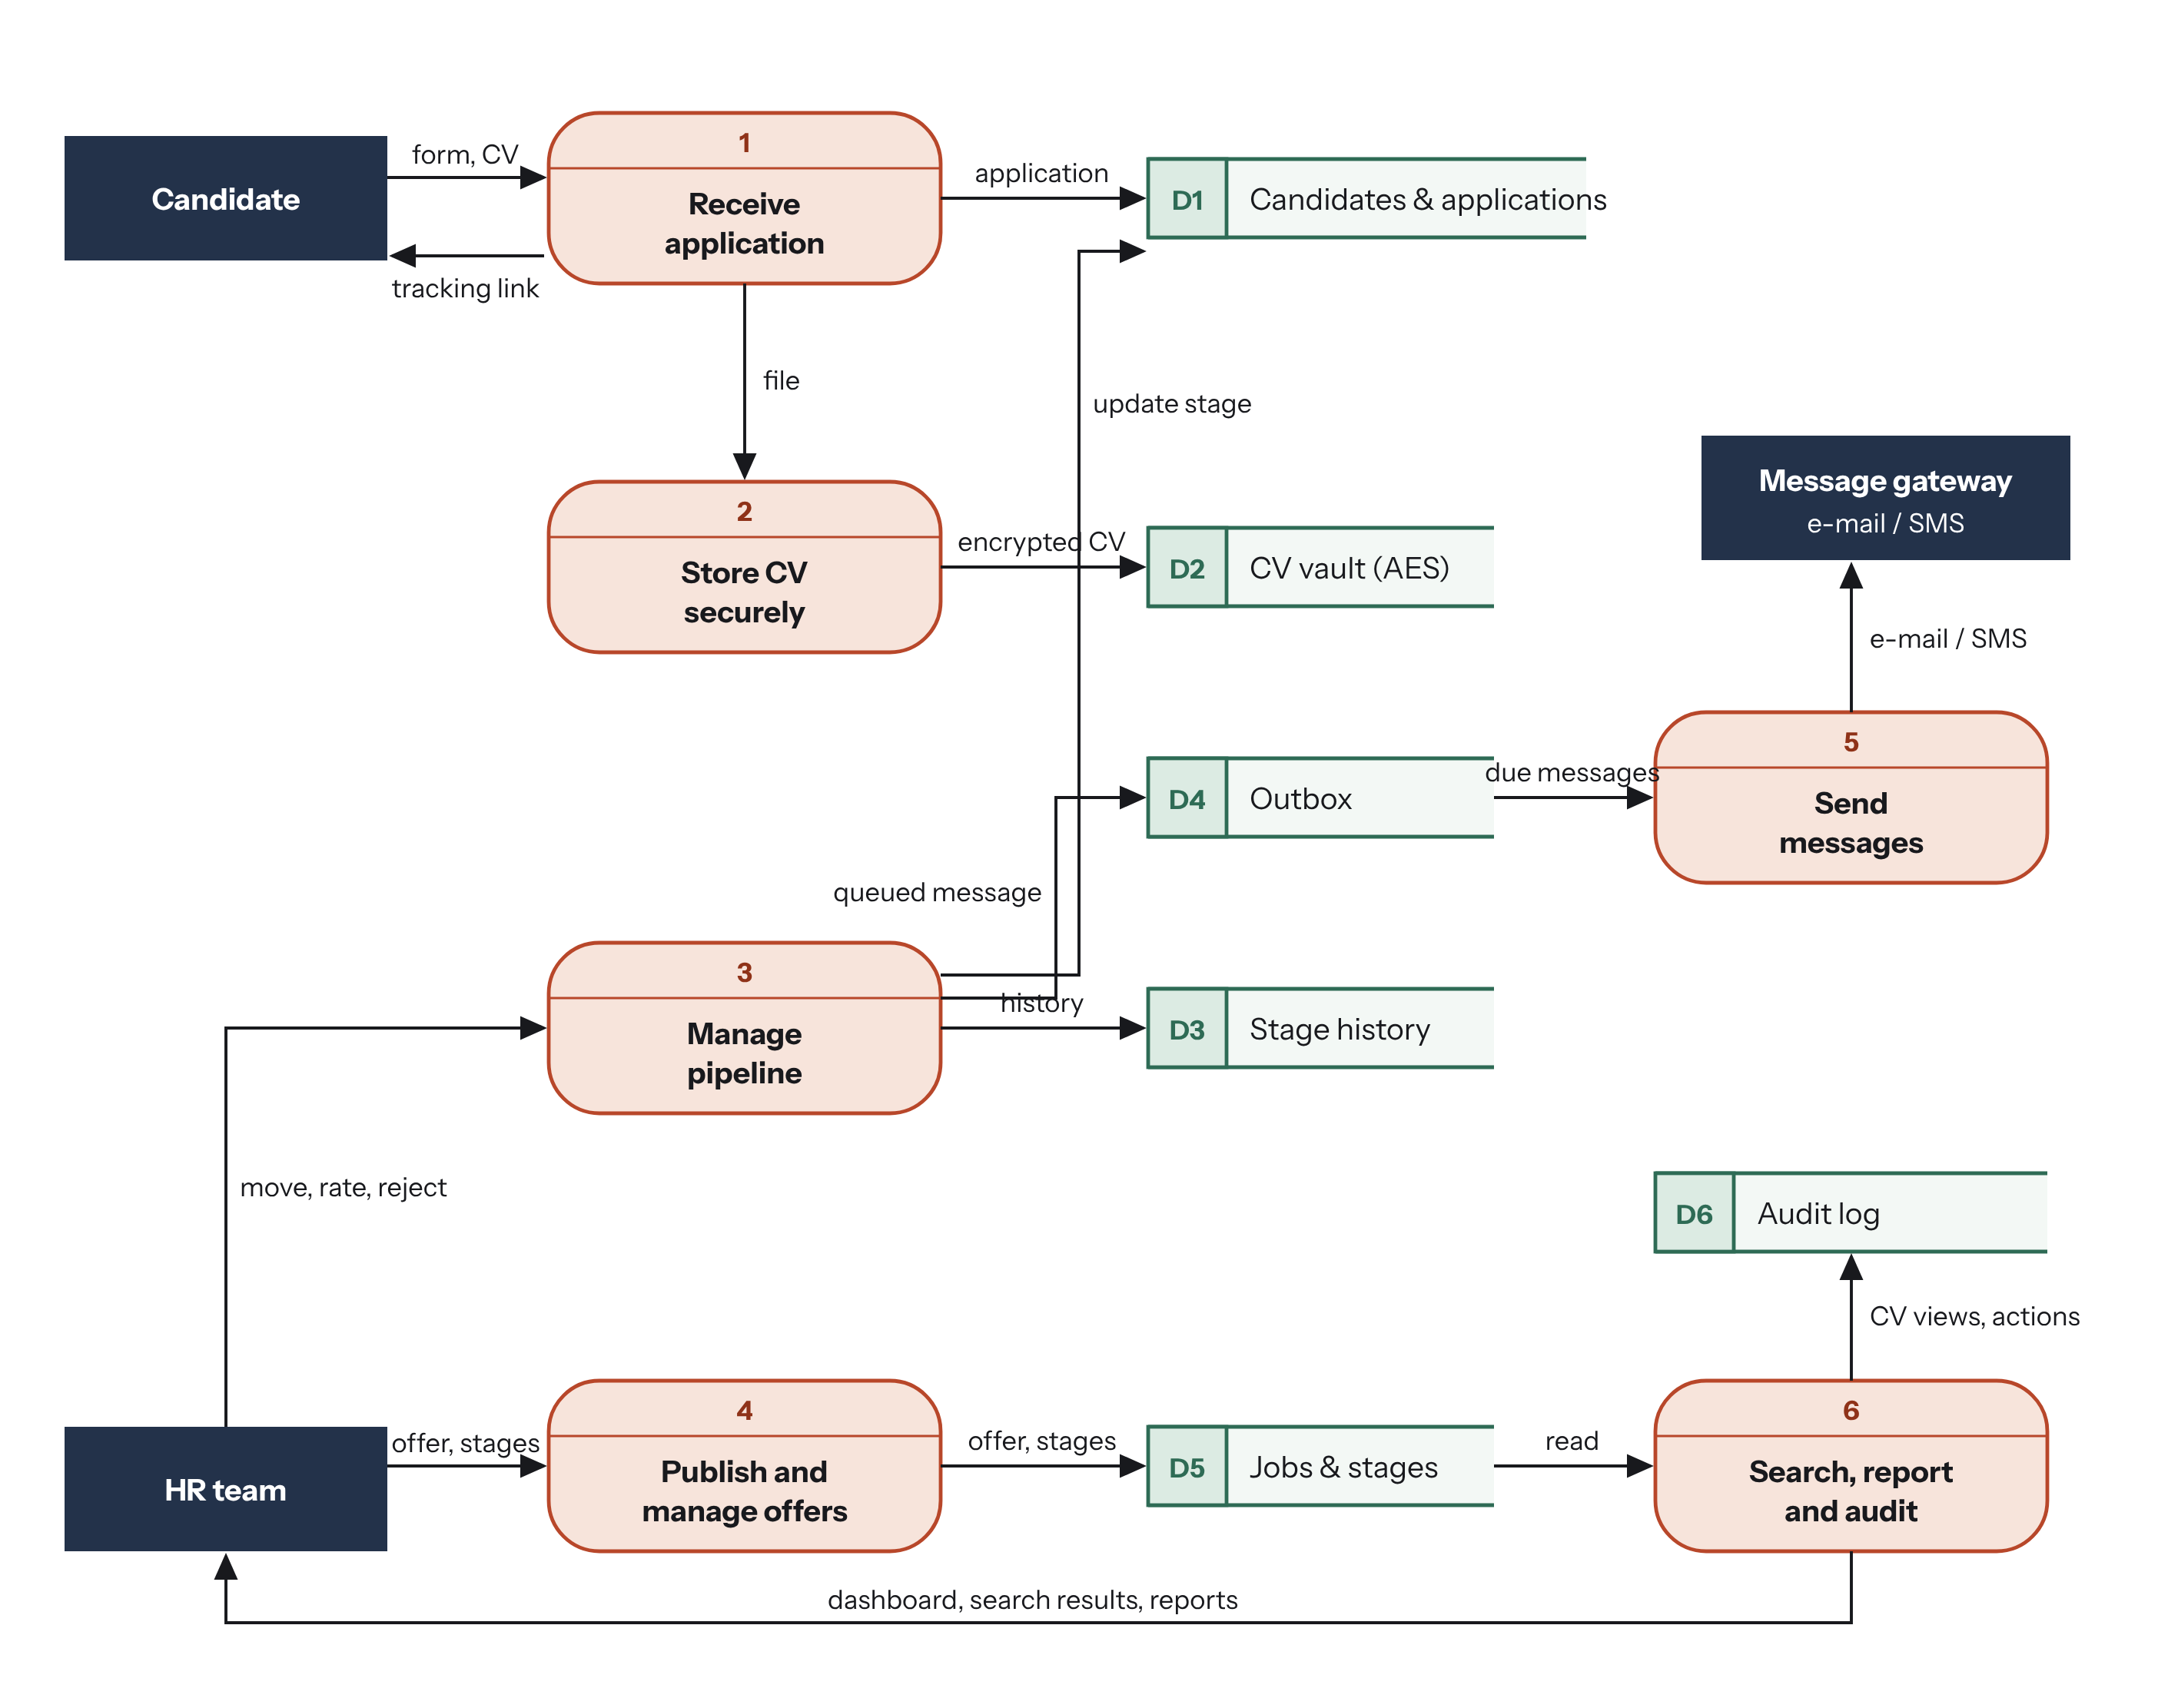
Figure 12: Level-1 data flow diagram of Bolo (source: author)

4.4.2 Data model
The database has 13 tables (Figure 13). Three choices are important. The phone number identifies a candidate within a company (unique index): a person who applies twice, or whose CV arrives by WhatsApp and then online, is not duplicated. The current stage is a foreign key of the application, and every change is kept in stage_history, from which delays and the dashboard are computed. The CV file is never in the database: the table cv_documents stores only the key of the encrypted file, its SHA-256 fingerprint and the words of its text for the search.
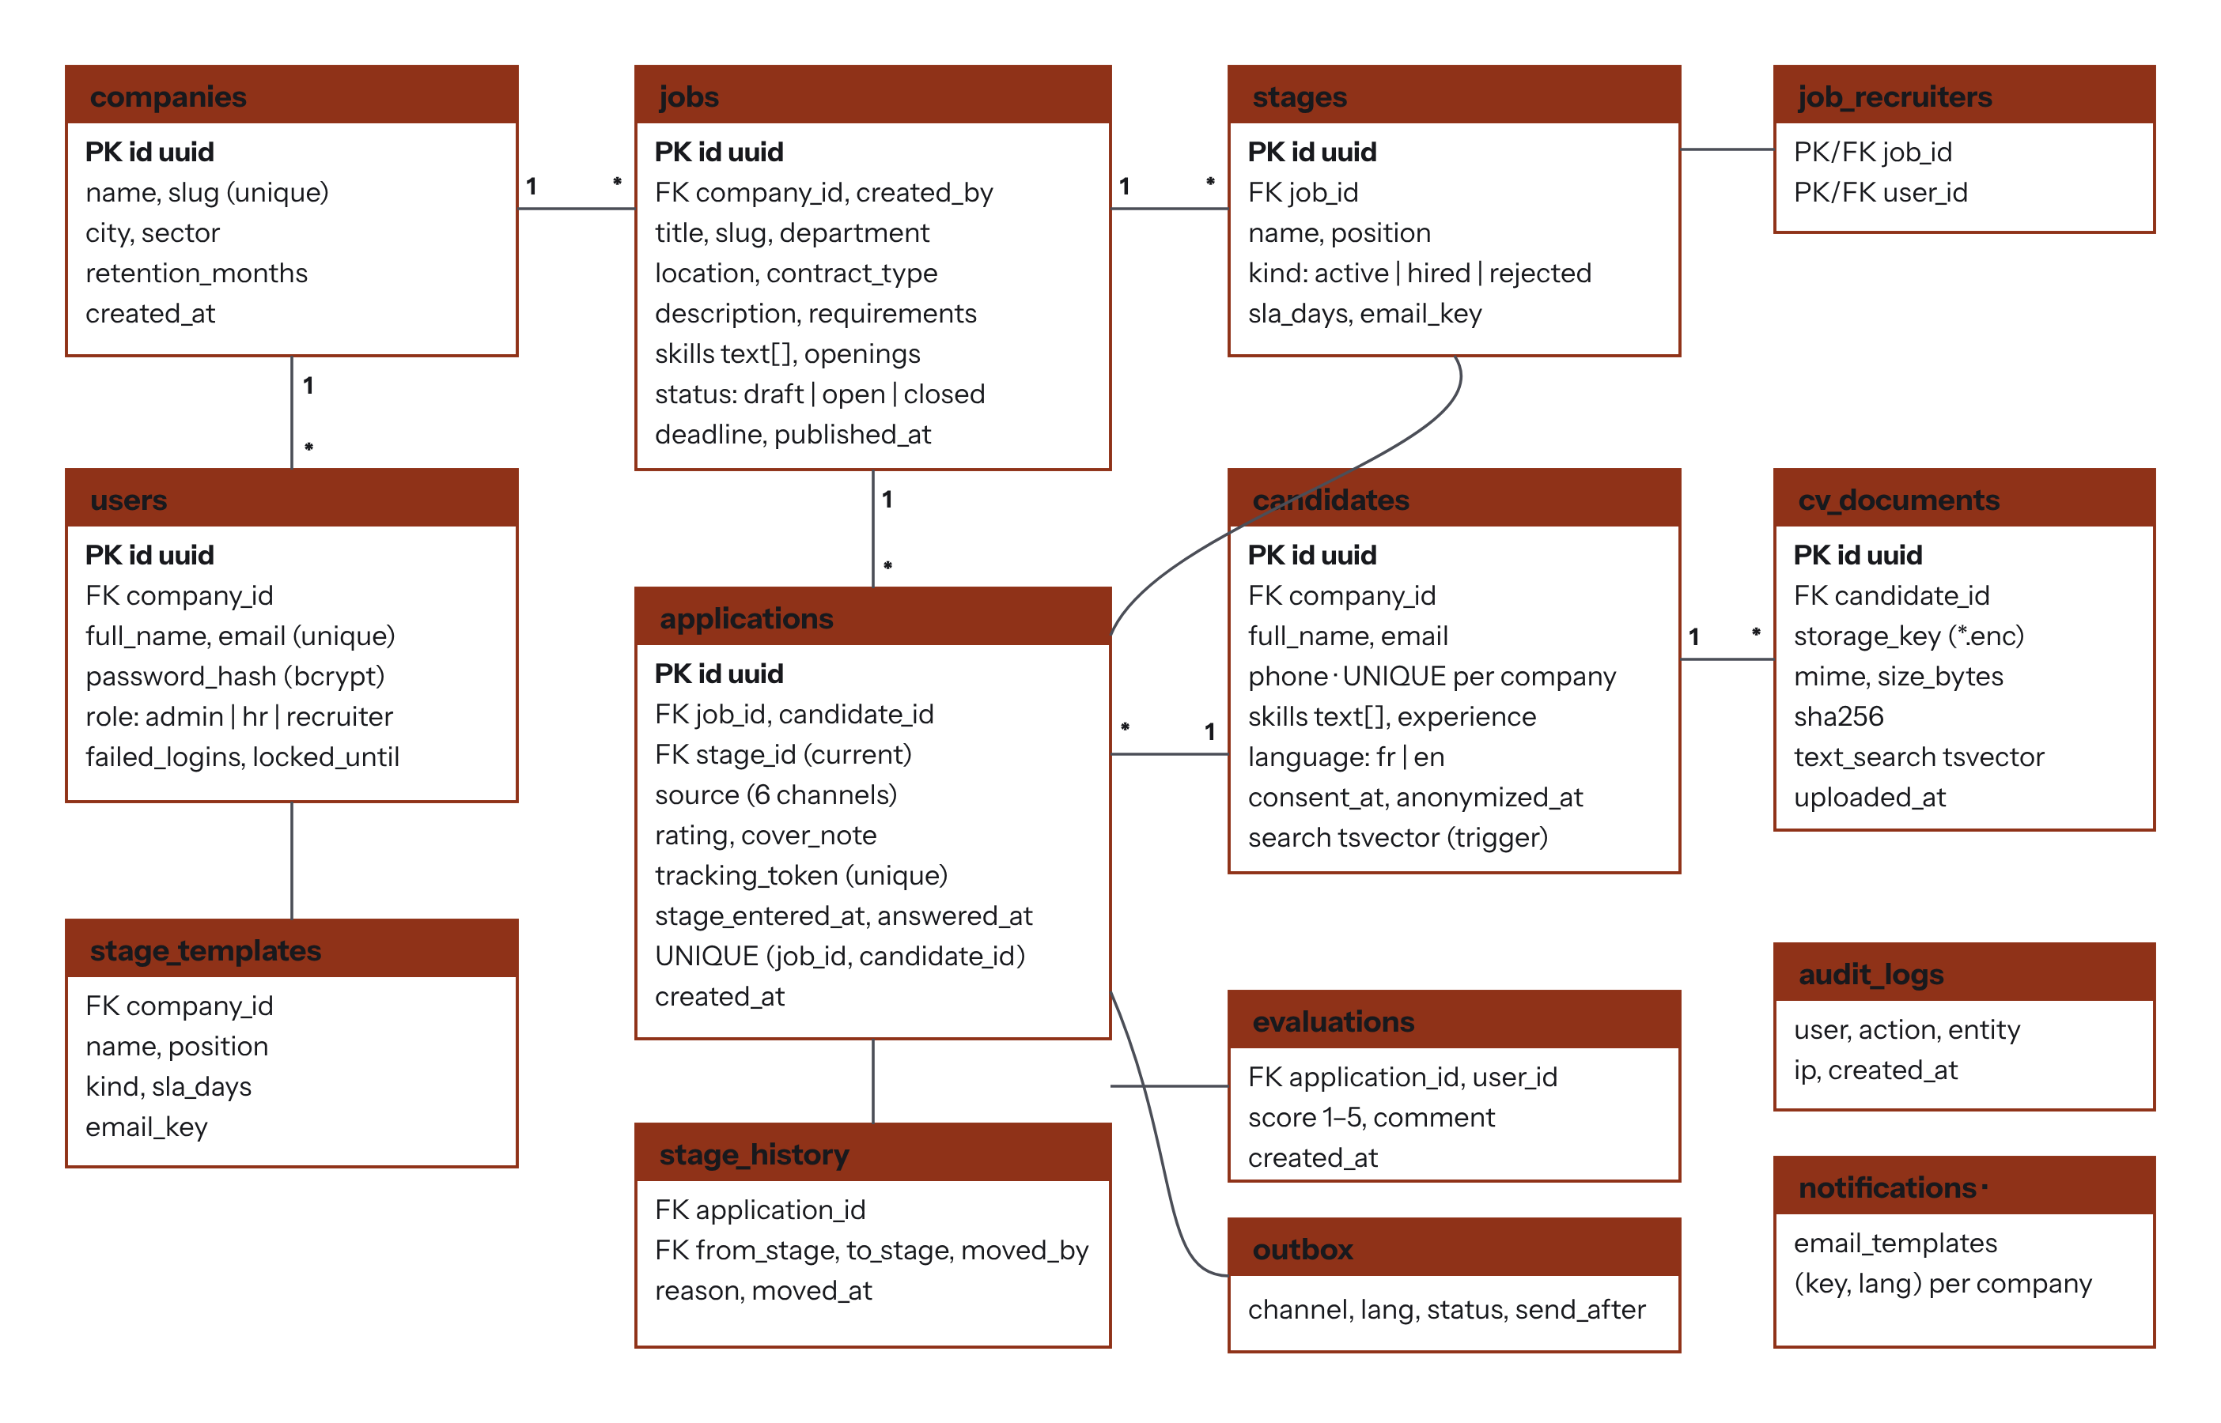
Figure 13: Physical data model (PostgreSQL) (source: author)

4.4.3 Sequence diagrams
The sequence diagrams show, in time order, the messages exchanged between the user, the interface, the API, the services and the database for the three main scenarios: logging in, applying until the answer is sent, and moving or rejecting a candidate. The secure upload and consultation of a CV is detailed in section 4.4.5.
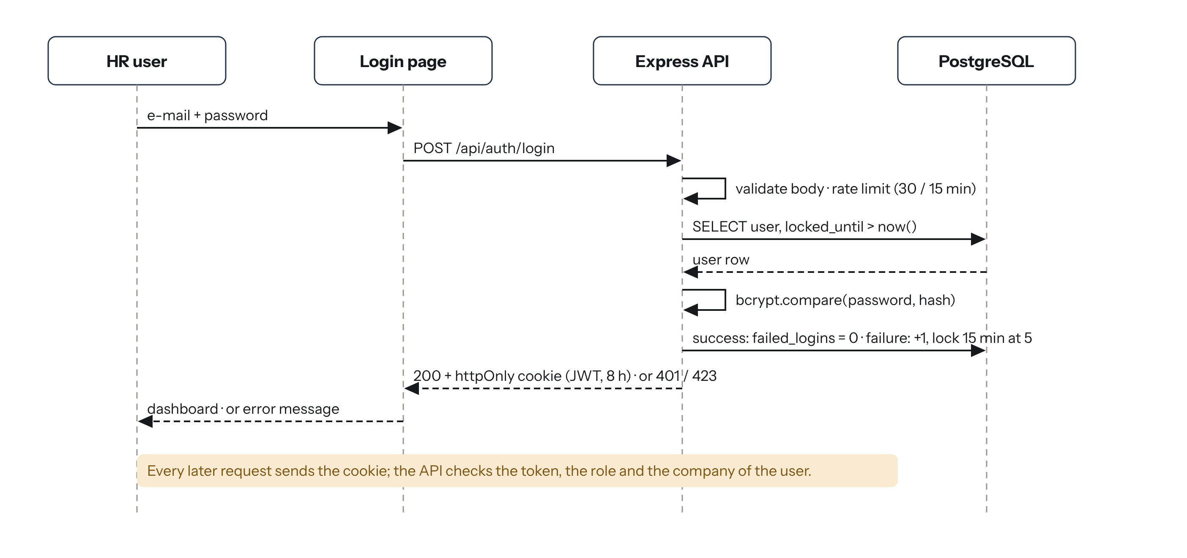
Figure 14: Sequence diagram “log in to the HR workspace” (UC-03) (source: author)
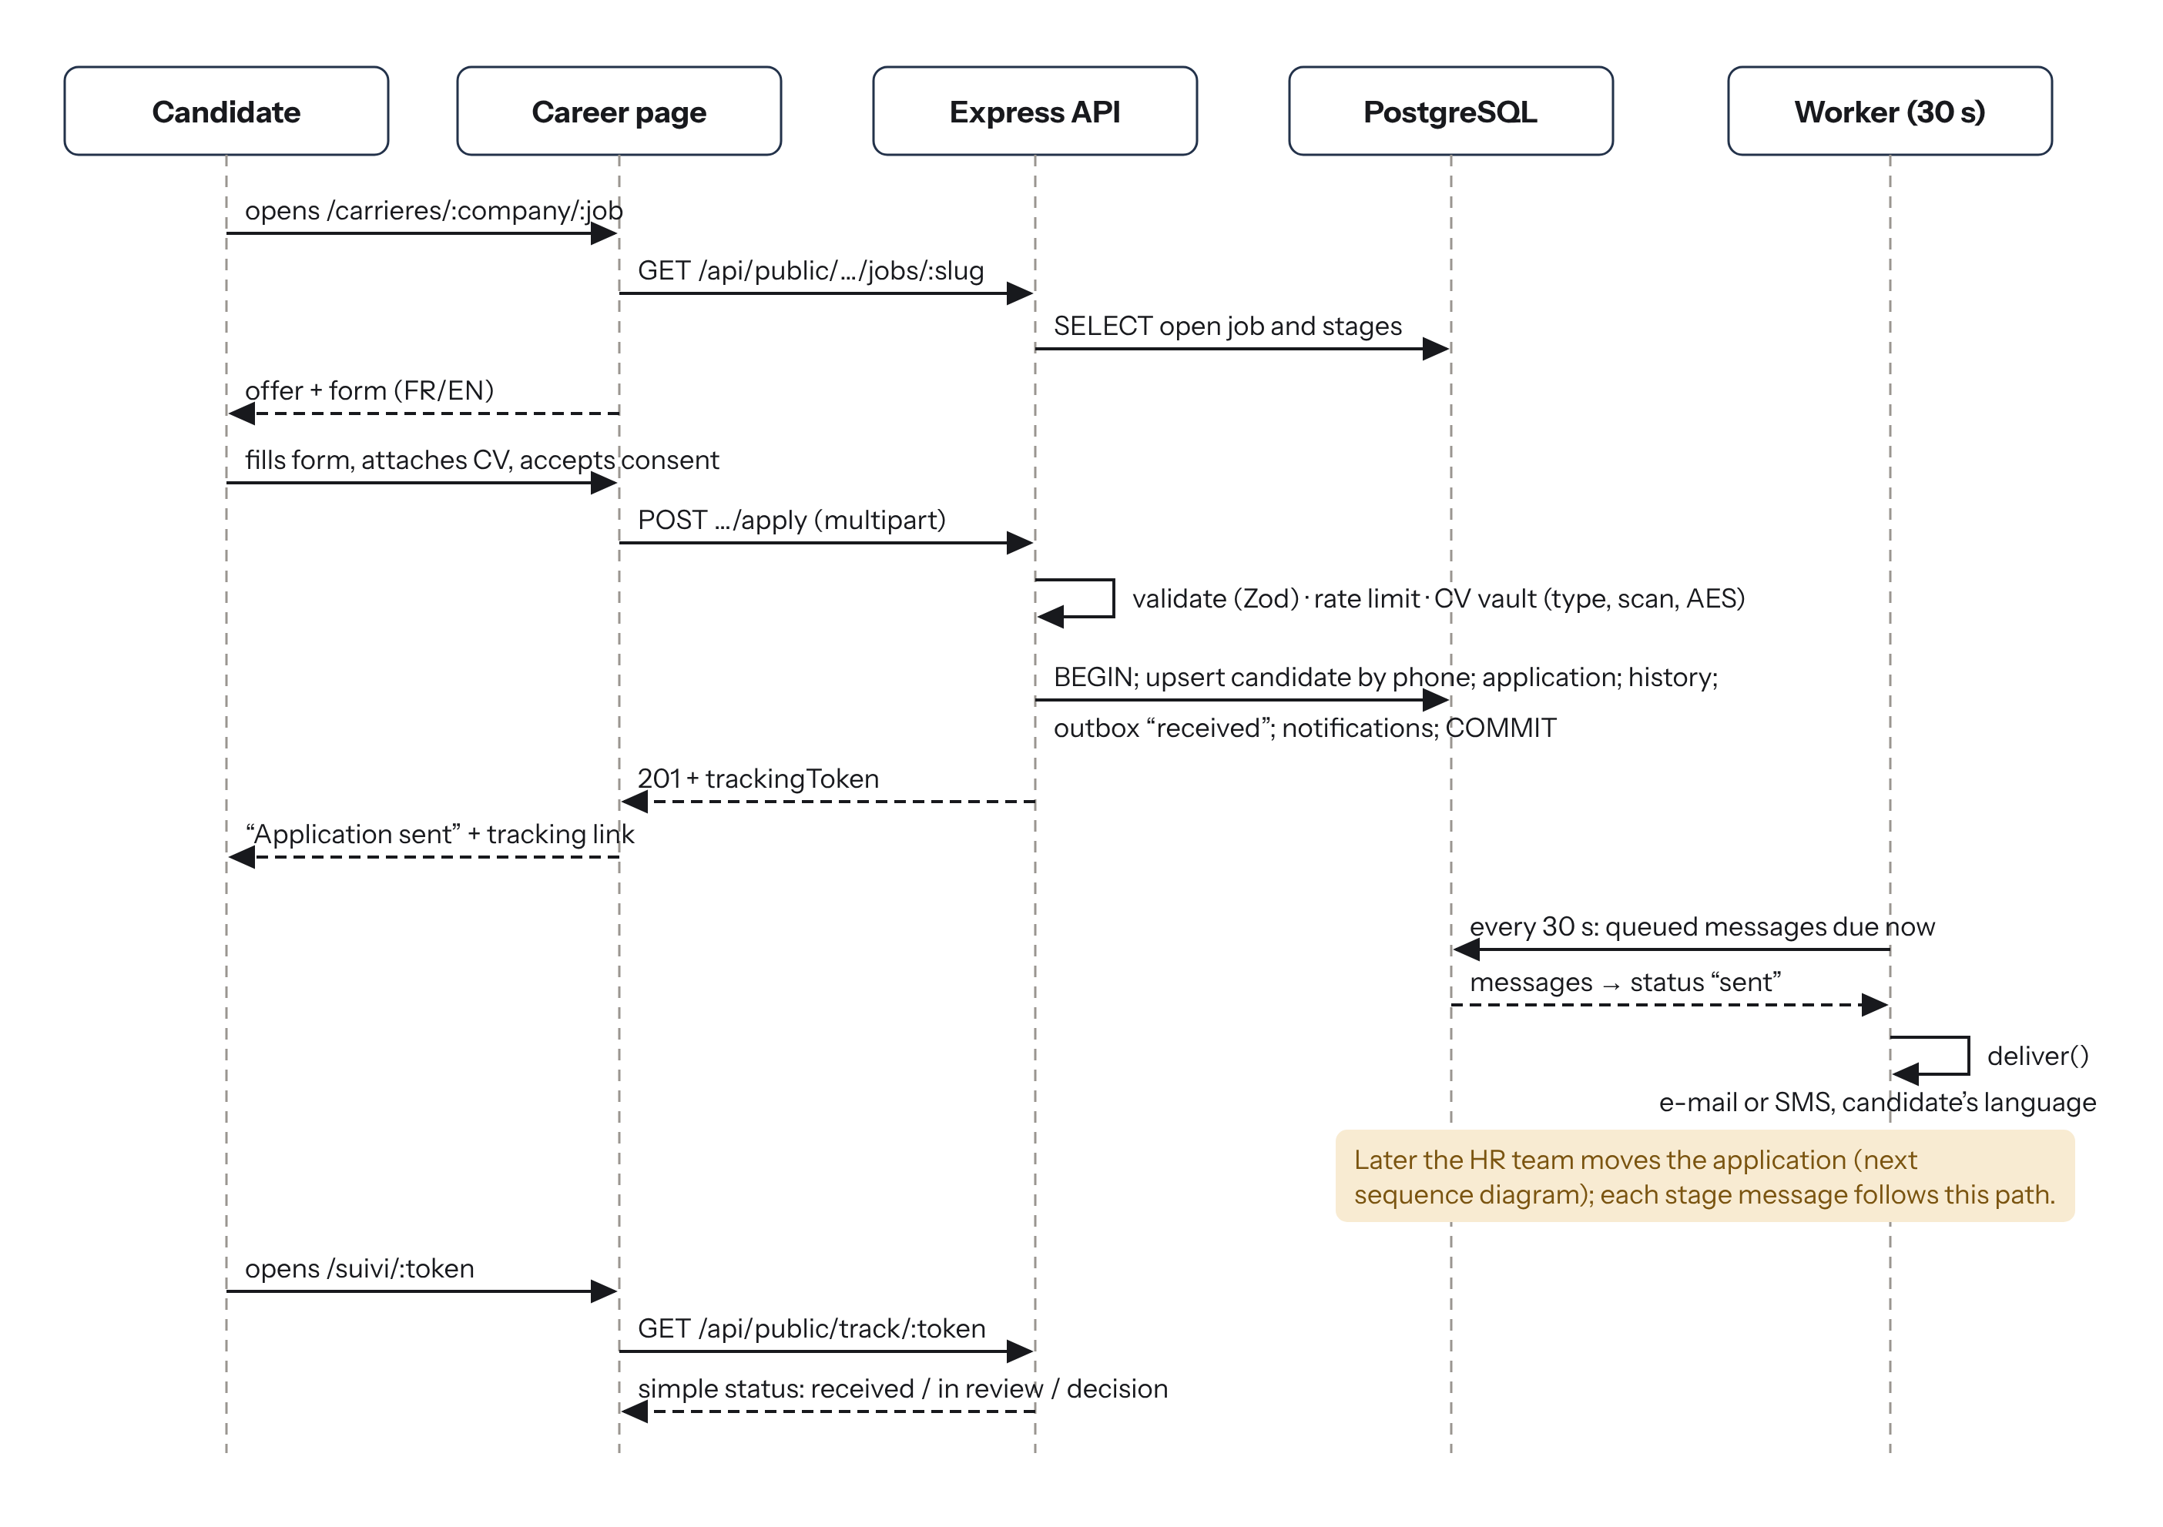
Figure 15: Sequence diagram “apply and follow an application” (UC-01 and UC-02) (source: author)
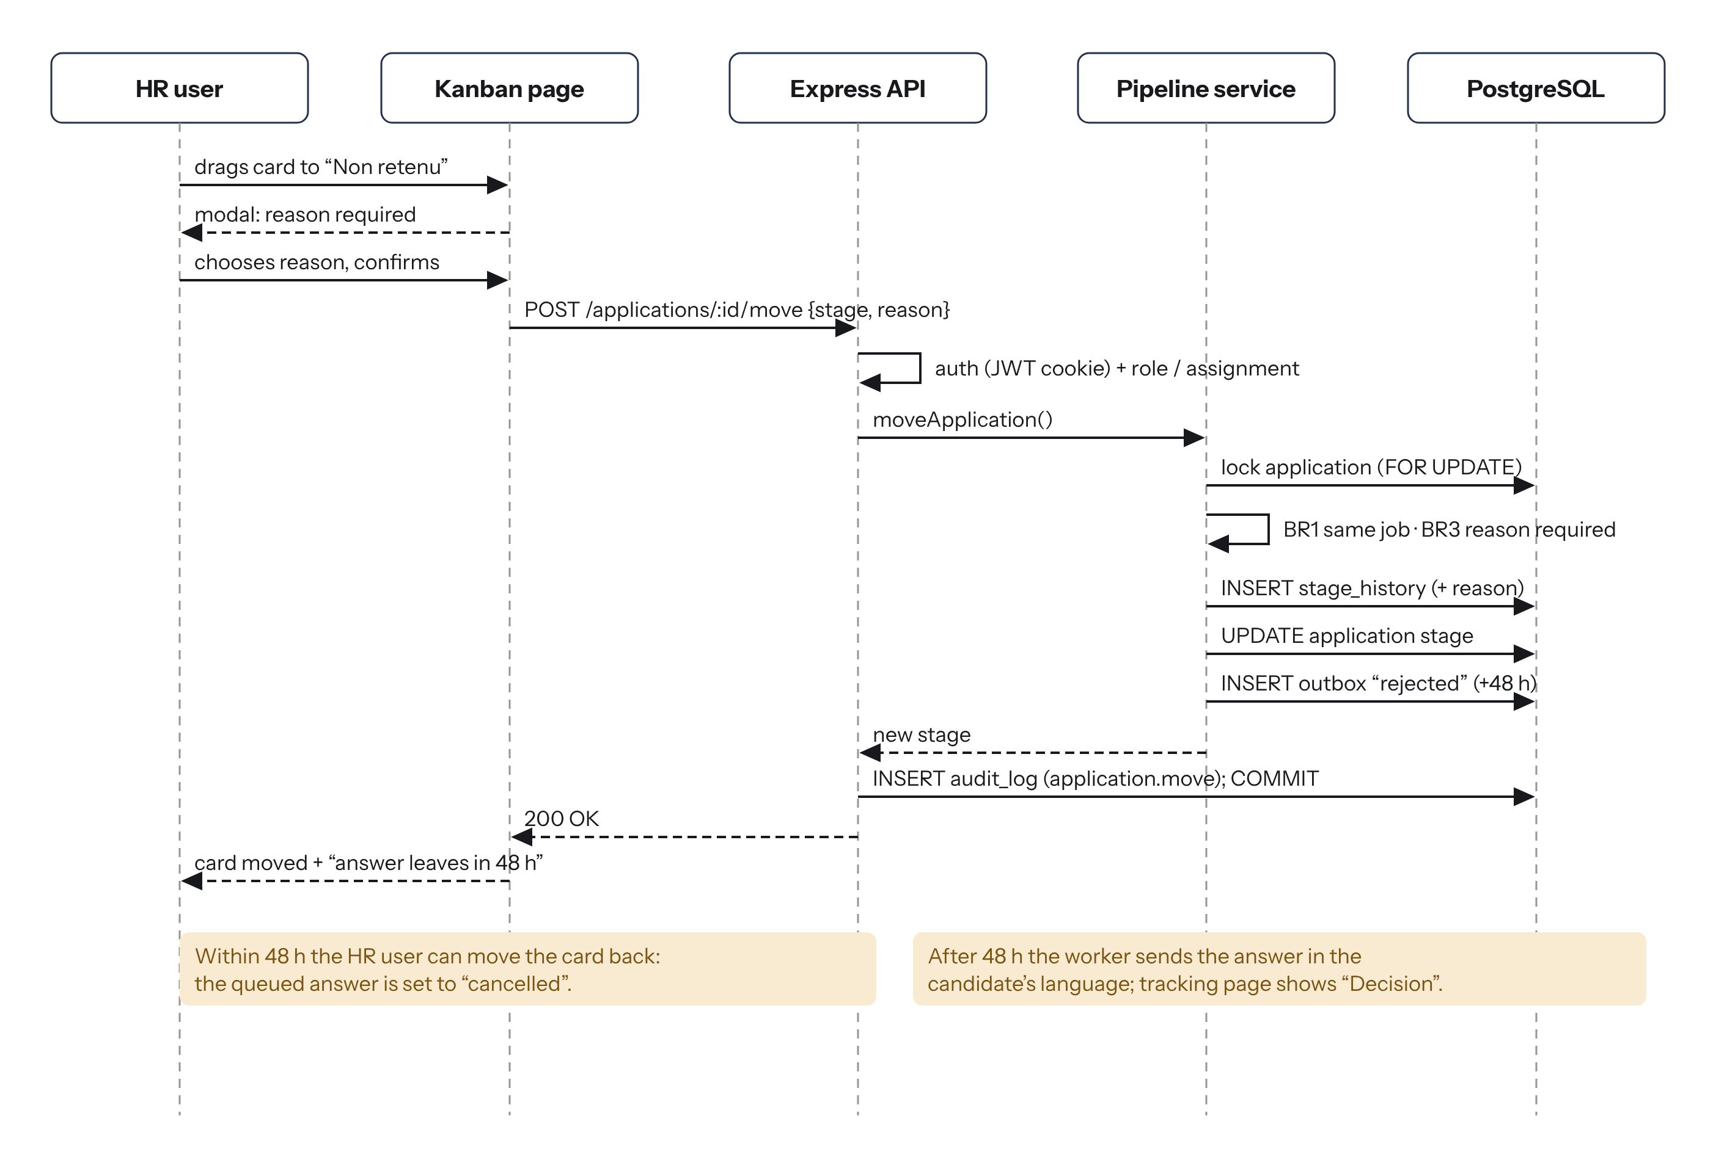
Figure 16: Sequence diagram “move or reject a candidate” (UC-06) (source: author)

4.4.4 REST API
Table 24: Main REST routes (session required except the public routes)
Method | Route | Purpose | FR
POST | /api/auth/login, /logout | Open or close a session (httpOnly cookie) | FR-01
GET | /api/public/:company/jobs[/:job] | Career page and offer | FR-06
POST | /api/public/:company/jobs/:job/apply | Online application with CV (multipart) | FR-15
GET | /api/public/track/:token | Public status of an application | FR-28
GET / POST / PATCH | /api/jobs, /api/jobs/:id | List, create and edit offers | FR-05
PUT | /api/jobs/:id/stages | Replace the stages of an offer | FR-10
POST | /api/jobs/:id/publish, /close | Publish; close and answer everyone | FR-06, 07
GET | /api/jobs/:id/pipeline | Kanban data | FR-11
POST | /api/applications | Capture a CV received elsewhere | FR-16
POST | /api/applications/:id/move, /evaluations | Move; evaluate | FR-11, 24
GET | /api/candidates?q=&… | Search and filters | FR-22, 23
POST / GET | /api/cv/:id/link, /api/cv/:id/file | Signed link; decrypted file | FR-18
DELETE | /api/candidates/:id | Right to erasure | FR-32
GET | /api/dashboard, /api/audit | Indicators; audit log | FR-30, 31

4.4.5 Secure management of CVs
Figure 17 details the path of a CV, from the upload by the candidate to its consultation by HR. The measures and the tests that prove them are summarised in Table 25.
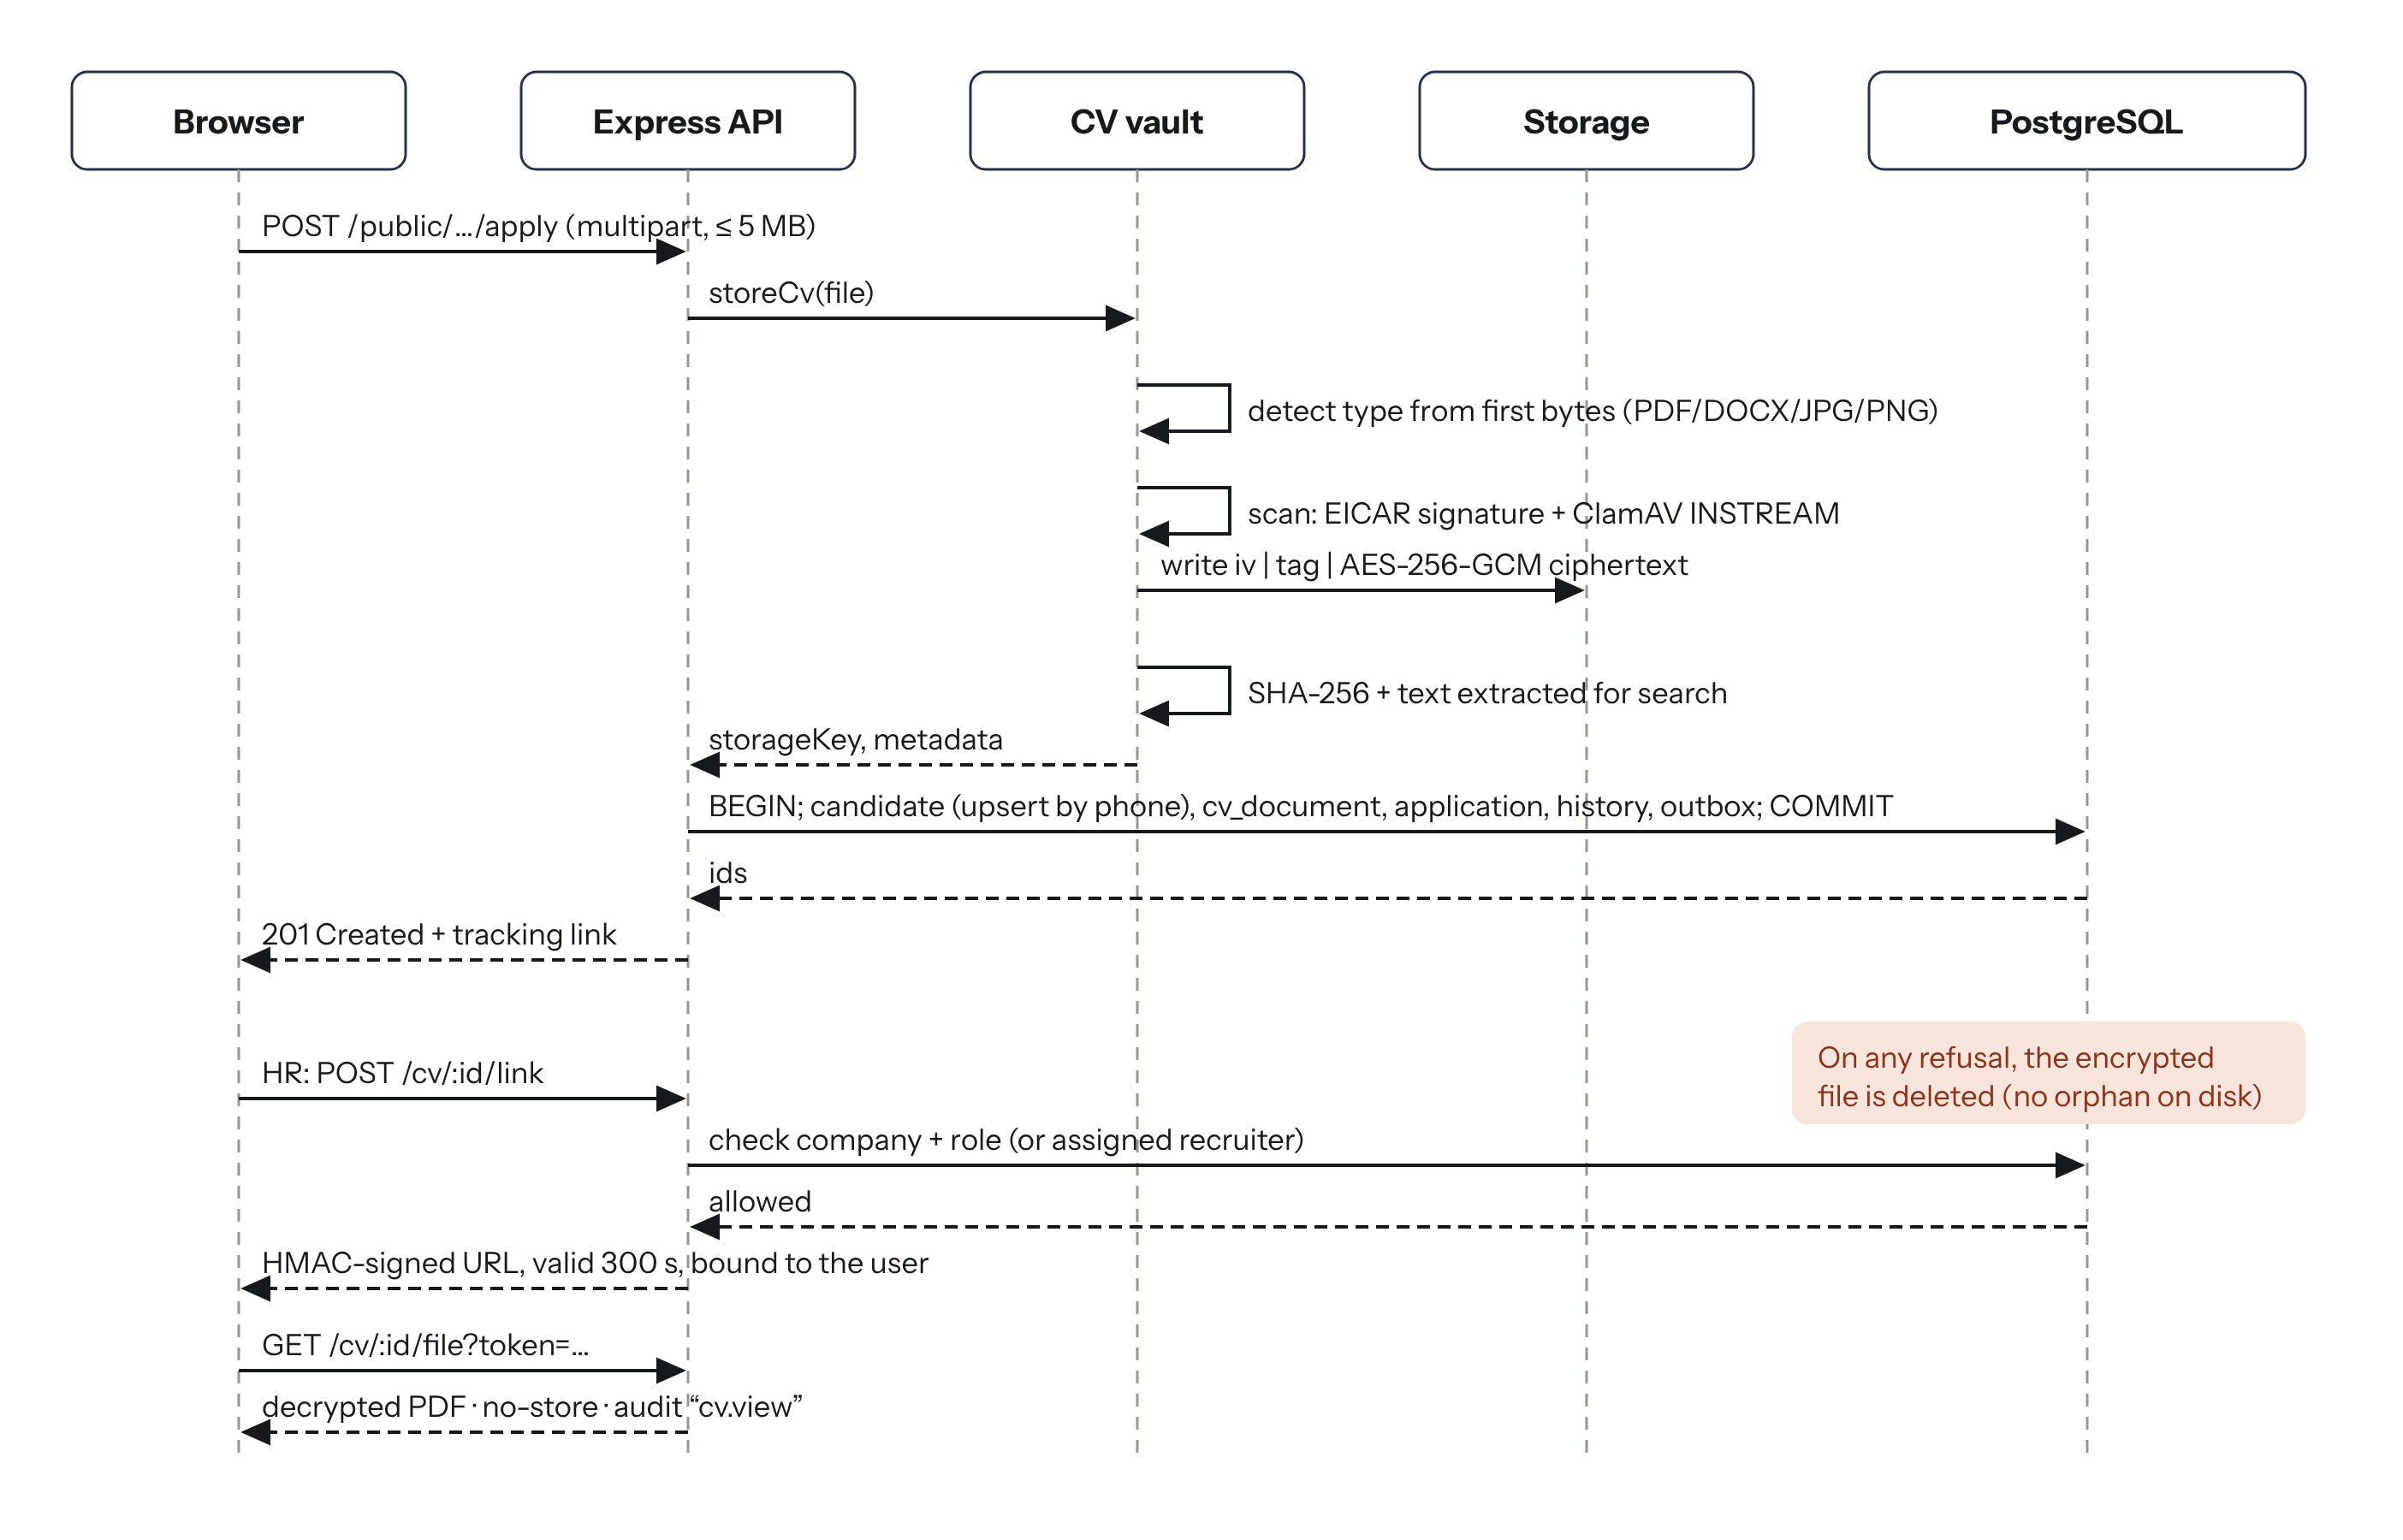
Figure 17: Sequence diagram of the secure upload and consultation of a CV (source: author)
Table 25: Security measures applied to CVs and how they are verified
Threat | Measure | Verified by
Executable or script disguised as a CV | Real type read from the first bytes; allow-list PDF, DOCX, JPG, PNG; 5 MB limit | Tests: .exe renamed .pdf → 415; 5 MB + 10 bytes → 413
Virus | EICAR signature check and ClamAV INSTREAM scan before storage | Test with the EICAR file → 422
Theft of the disk or a backup | AES-256-GCM encryption, random name, key outside the database | Test: stored file unreadable; decryption gives the original
Unauthorised viewing | Company check, role or assignment; HMAC link valid 300 s, bound to the user | Tests: other company, unassigned recruiter, modified or expired link
Silent internal abuse | Audit log of every view; watermark with the viewer’s name | Test: one line “cv.view” per opening
Brute force on accounts | bcrypt cost 12; 5 failures lock the account 15 min; rate limits | Test: sixth attempt → 423
Excessive retention | Consent at application; erasure on request; anonymisation after 24 months | Tests: erasure deletes the files; retention job
Injection | Parameterised SQL everywhere; inputs validated by Zod | Test: “ DROP TABLE ” searched as text

4.5 User interface design
A complete visual identity was created so that Bolo does not look like a generic template. The name comes from Cameroonian street French (“le bolo” = the job). The logo is a lowercase b whose bowl holds an ochre dot – the right person found among many (Figure 18). The main colour, laterite, recalls the red earth of Cameroonian roads; the login page uses a geometric pattern inspired by the ndop cloth of the Grassfields. Titles use the serif Fraunces and the interface uses Instrument Sans, both self-hosted (Figure 19, Table 26).

Figure 18: The Bolo logo and its variants (source: author)
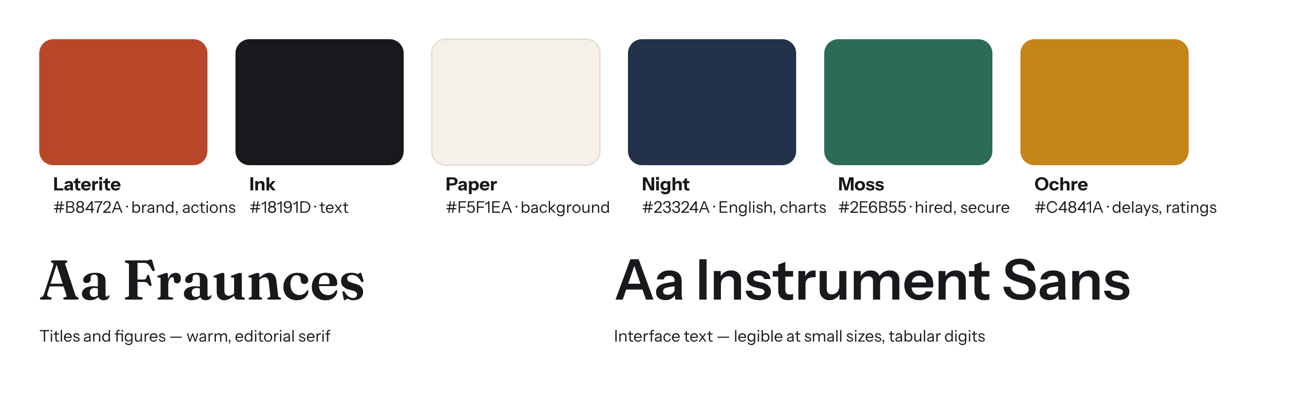
Figure 19: Colours and fonts of the interface (source: author)
Table 26: Colour tokens of the interface
Token | Value | Role
laterite | #B8472A | Brand, primary buttons, active menu, French badge
ink | #18191D | Main text
paper | #F5F1EA | Background of the application
night | #23324A | English badge, charts
moss | #2E6B55 | Hired, security indicators
ochre | #C4841A | Delays exceeded, ratings

Interface rules: the back-office is designed for a computer and the public pages mobile first; every candidate card shows the source channel, the language and the time spent in the stage, which turns ochre when the delay is exceeded; destructive or sensitive actions (rejecting, erasing) always ask for confirmation and explain the consequence.

4.6 Implementation
The application was built in three increments, each ending with automated tests and a commit. It contains about 3,500 lines of JavaScript, CSS and SQL in 53 source files (1,580 for the server, 1,420 for the interface and 480 for the tests). The screenshots below were taken on the running application with a fictitious demonstration company, “Wouri Distribution SARL”, and 171 fictitious applications created through the real services (each CV encrypted, each move written in the history).
Increment 1 – accounts, offers and configurable stages (FR-01 to FR-14). Login with a session cookie, roles, account lock; creation of offers with a copy of the company stages; stage editor; publication on the career page (Figures 20 to 22).
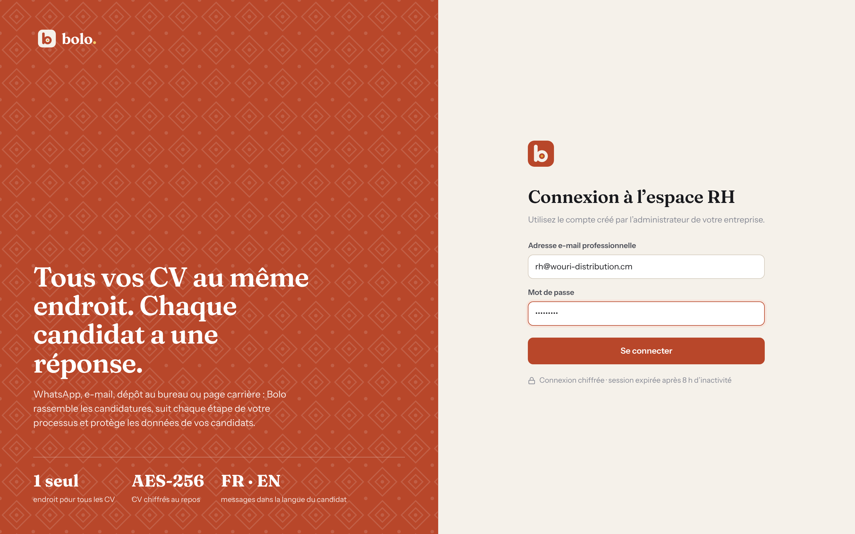
Figure 20: Login page of the HR workspace (source: author)
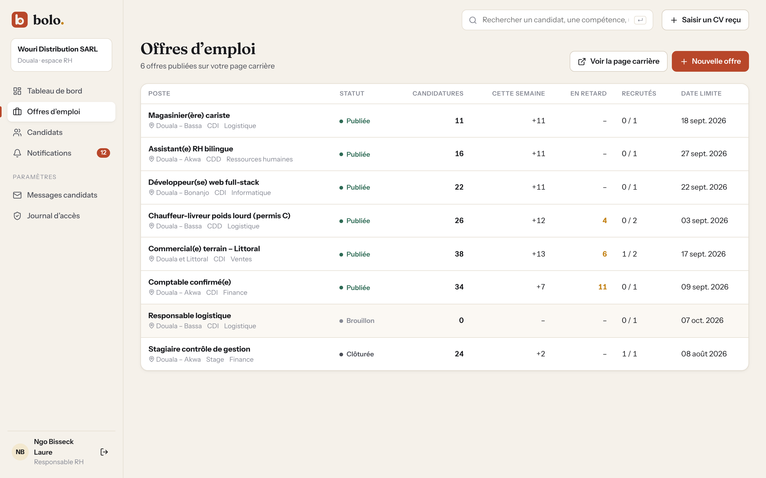
Figure 21: List of job offers with applications, delays exceeded and openings filled (source: author)
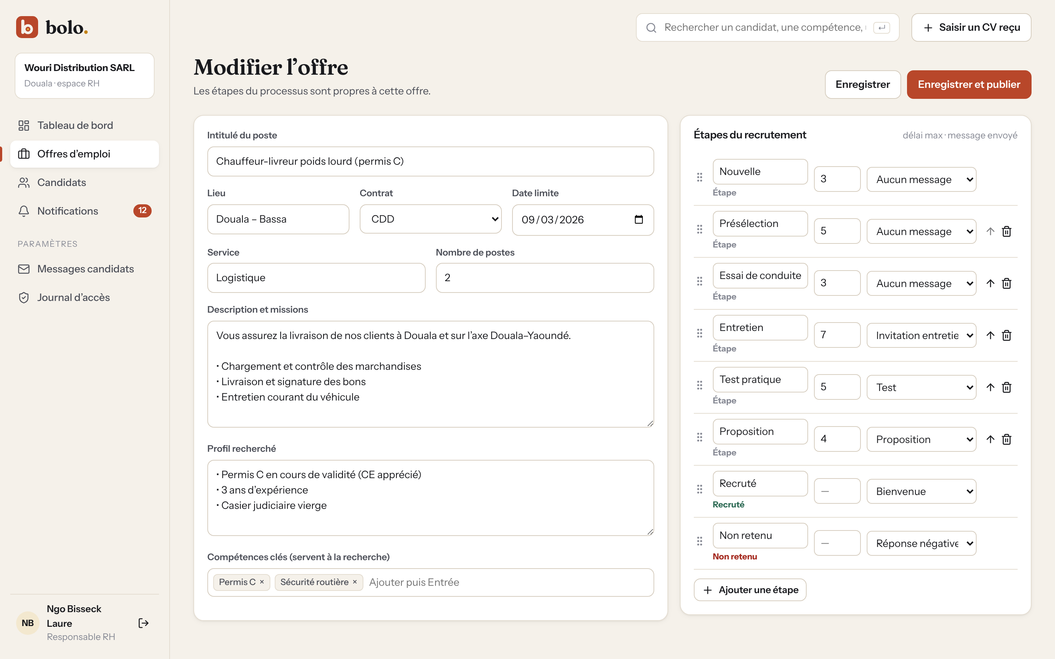
Figure 22: Editing an offer and its own stages (here with an added “Essai de conduite” stage) (source: author)
Problems solved: a JWT kept in the browser’s storage could be read by a malicious script, so the session was moved to an httpOnly, SameSite=strict cookie; the default stages are copied – not shared – so that changing one offer never changes another.
Increment 2 – applications and the CV vault (FR-15 to FR-21). Public career pages in French and English, online application with CV or photo of a paper CV, manual capture of CVs received elsewhere, and the CV vault (Figures 23 to 25).
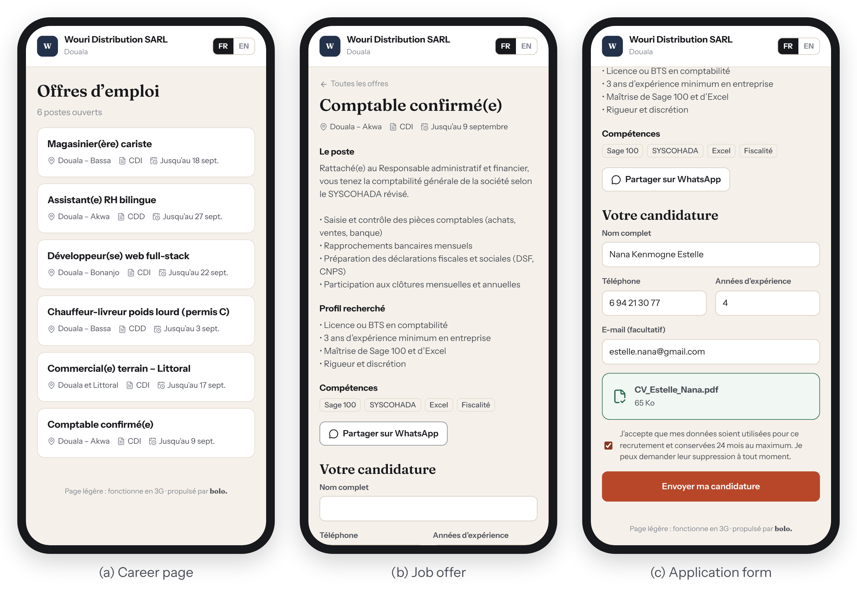
Figure 23: Public pages on a smartphone: (a) career page, (b) job offer, (c) application form (source: author)
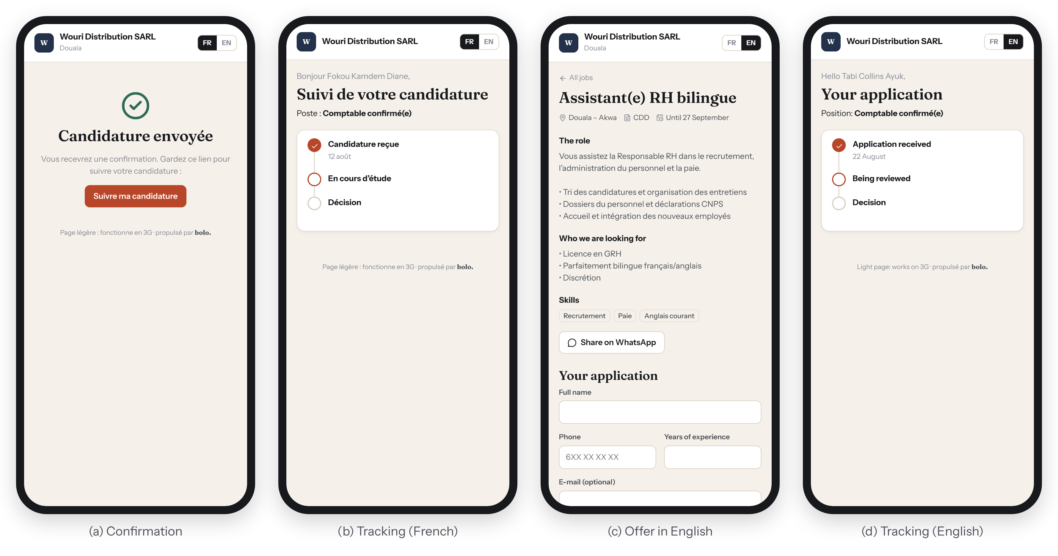
Figure 24: After applying: (a) confirmation, (b) tracking in French, (c) offer and (d) tracking in English (source: author)
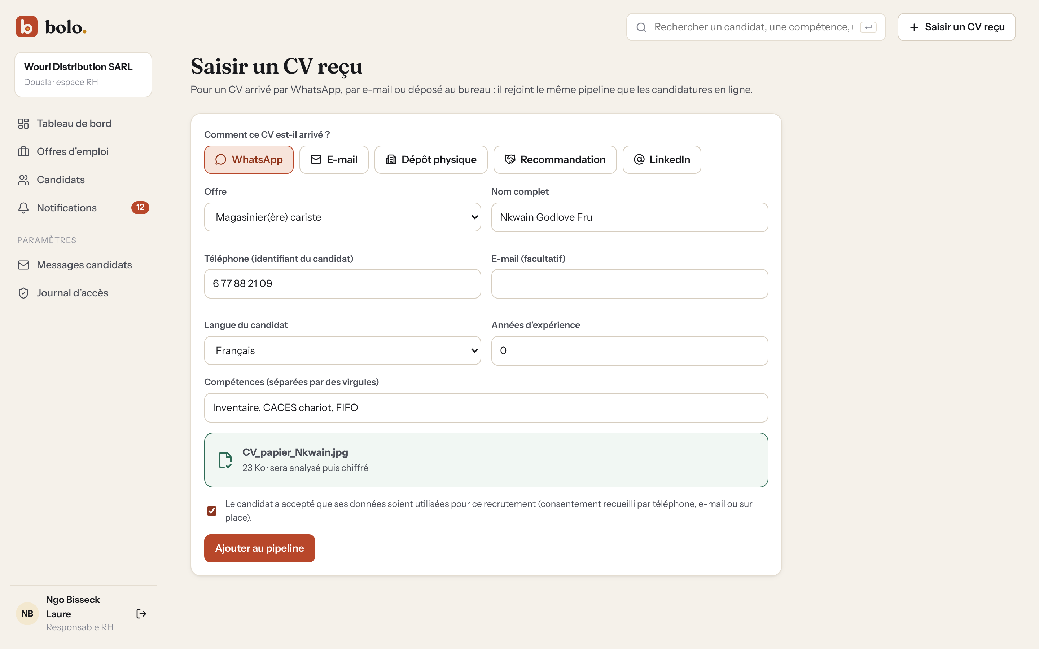
Figure 25: Capture of a CV received by WhatsApp (photo of a paper CV) (source: author)
Problems solved: when an application was refused after the file had been stored, an encrypted file stayed on the disk; the upload is now undone in every error case (tested). A photo of a paper CV taken with a phone weighs 3 to 5 MB; it is now resized to 1,600 pixels and re-encoded in the browser before upload, which divides its weight by about ten for the candidate.
Increment 3 – pipeline, search, messages and dashboard (FR-22 to FR-32). Kanban board with drag and drop, rejection dialog, candidate profile with the secure CV viewer, search in profiles and CV text, bilingual message templates, notifications, audit log and dashboard (Figures 26 to 33).
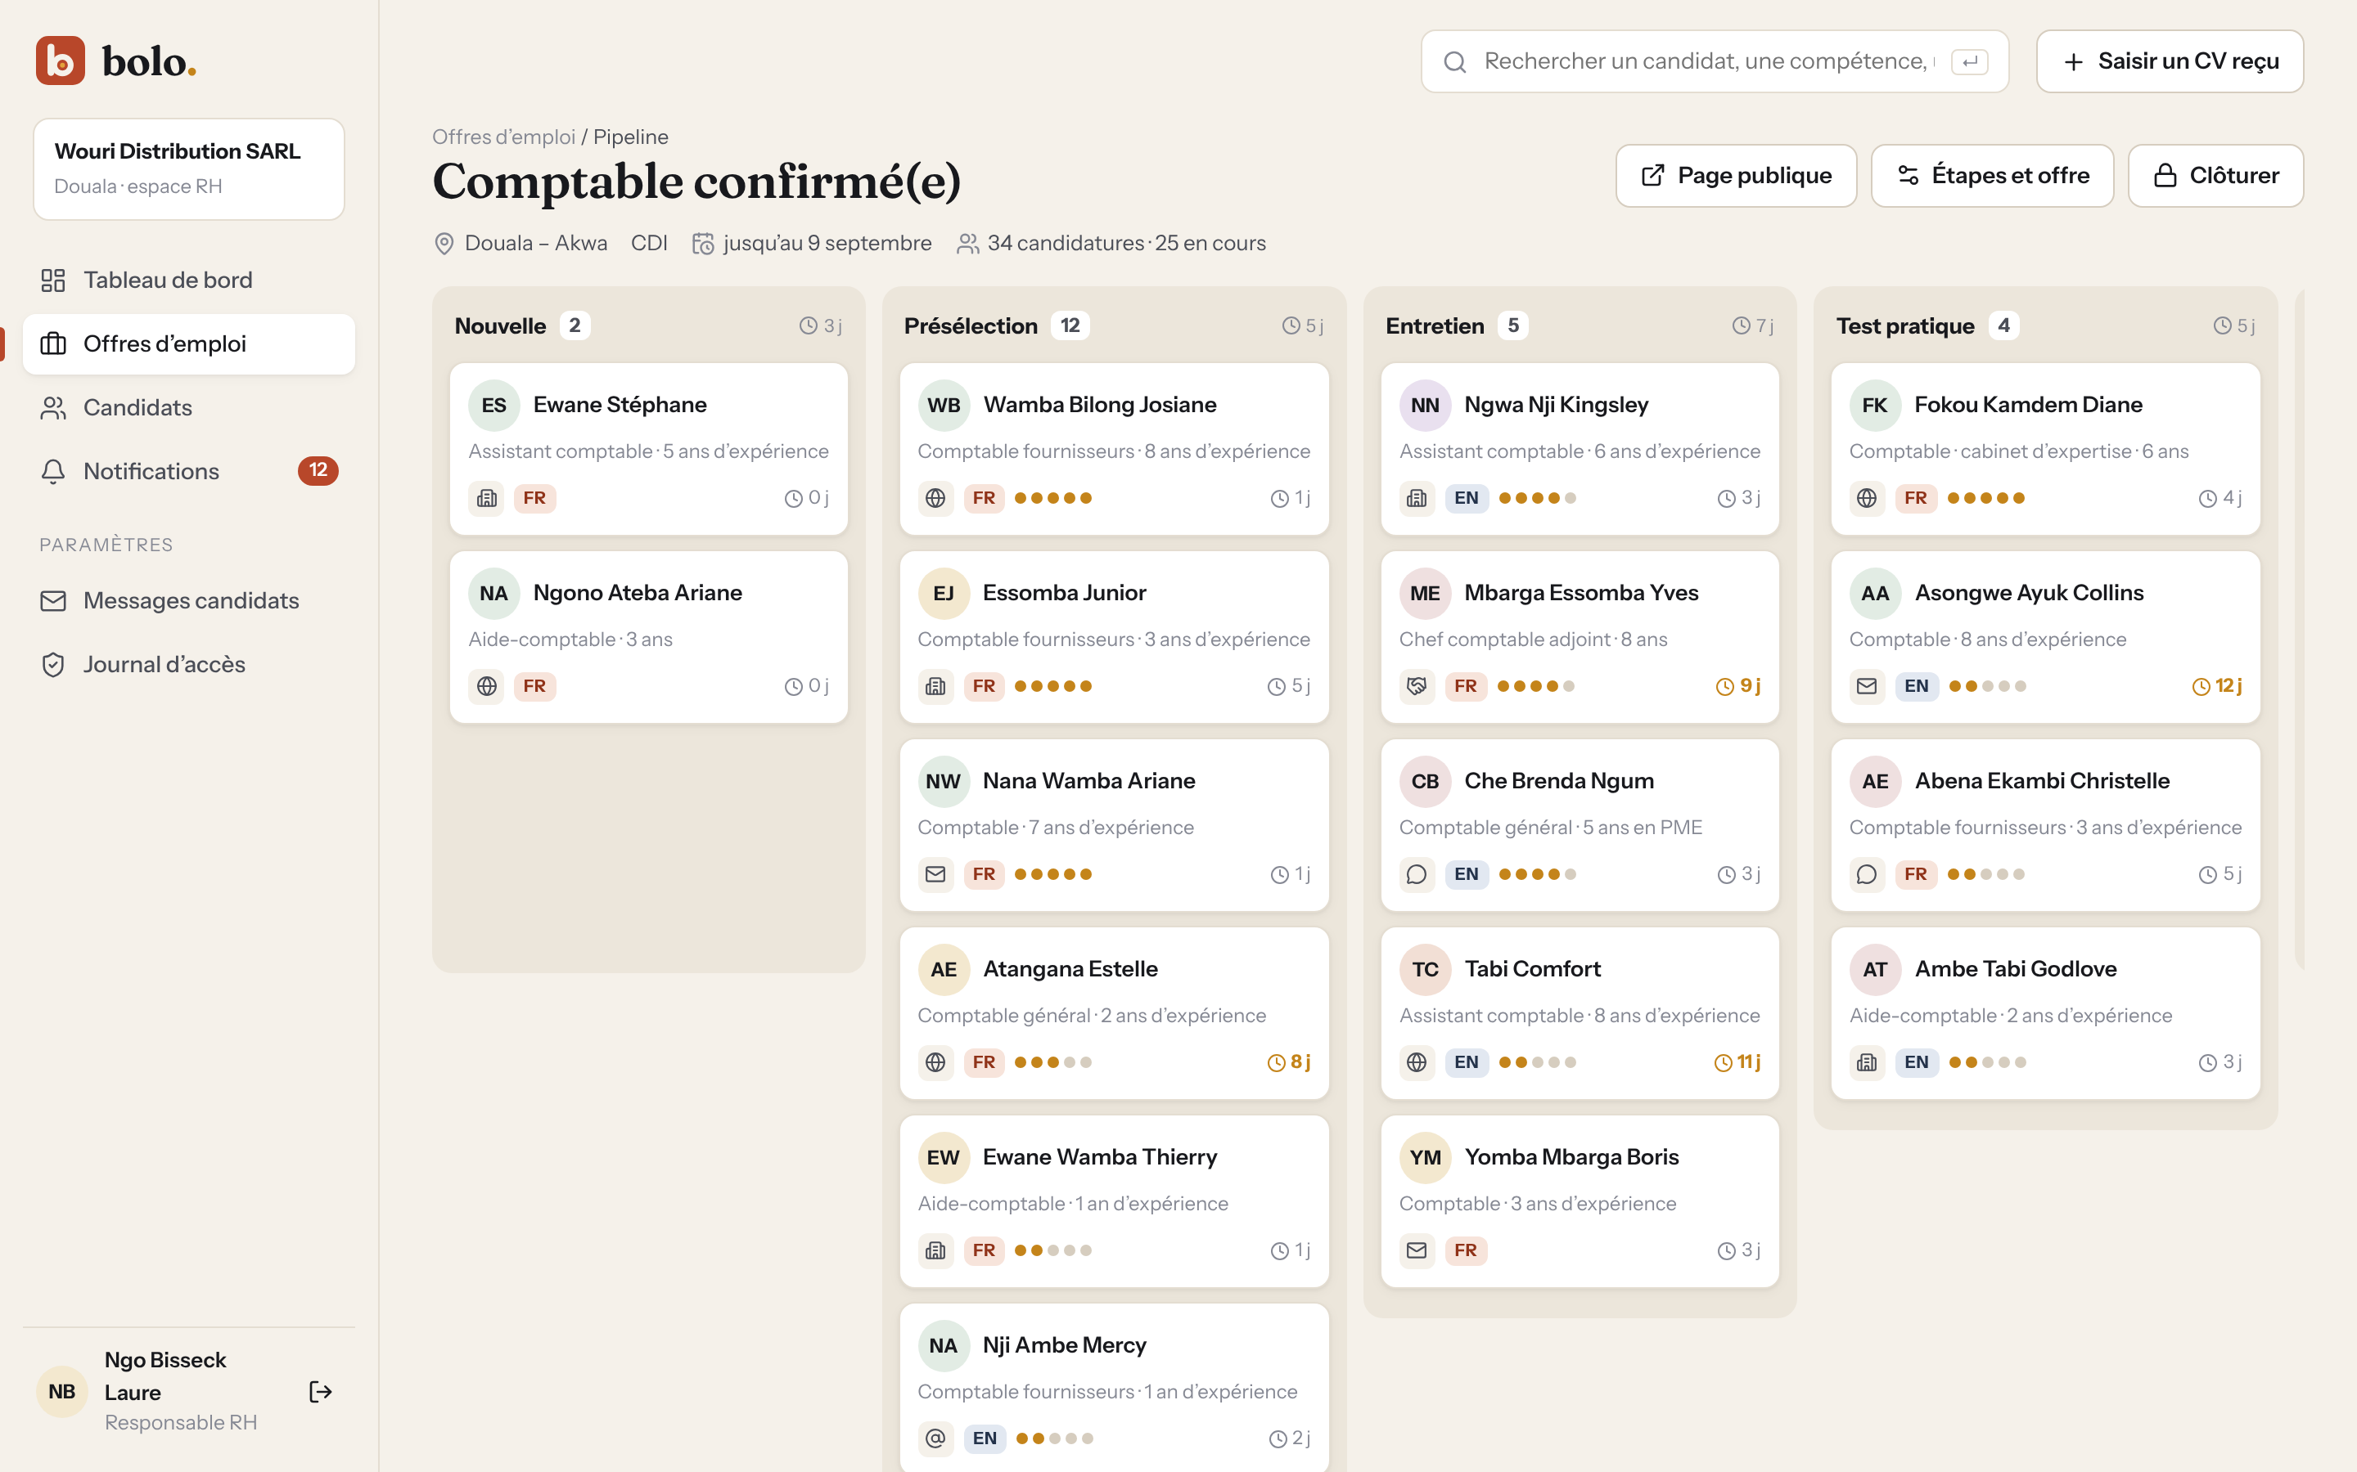
Figure 26: Kanban board of an offer: source, language, rating and days in the stage on each card (source: author)
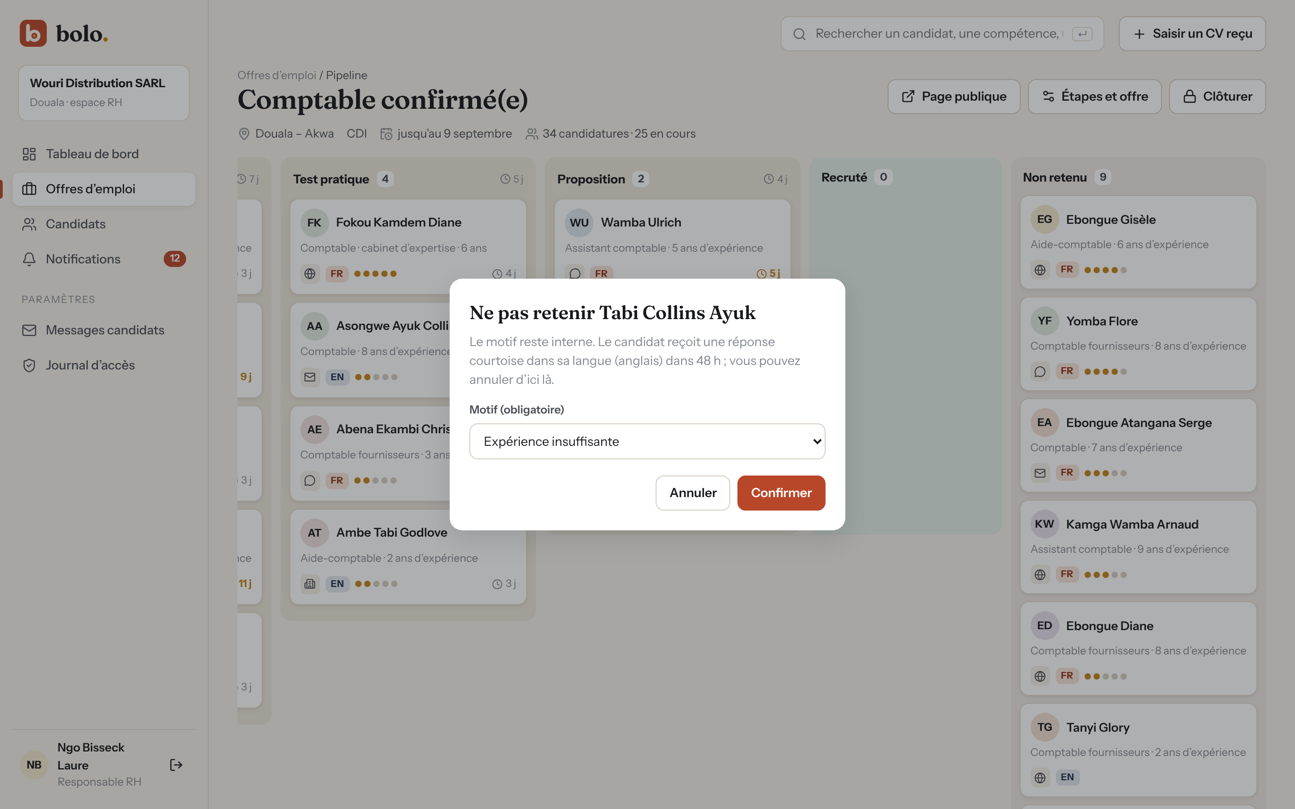
Figure 27: Rejecting a candidate: the reason stays internal, the answer leaves 48 h later (source: author)
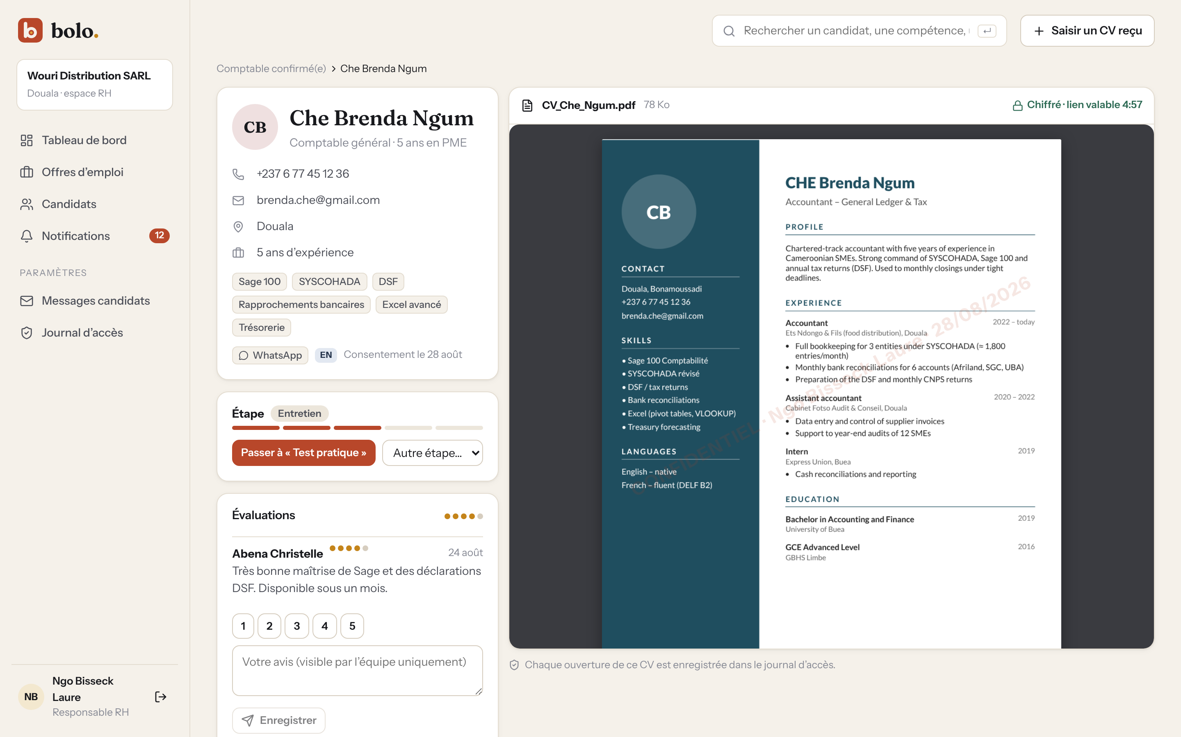
Figure 28: Candidate profile with the CV shown in the application, watermark and link countdown (source: author)
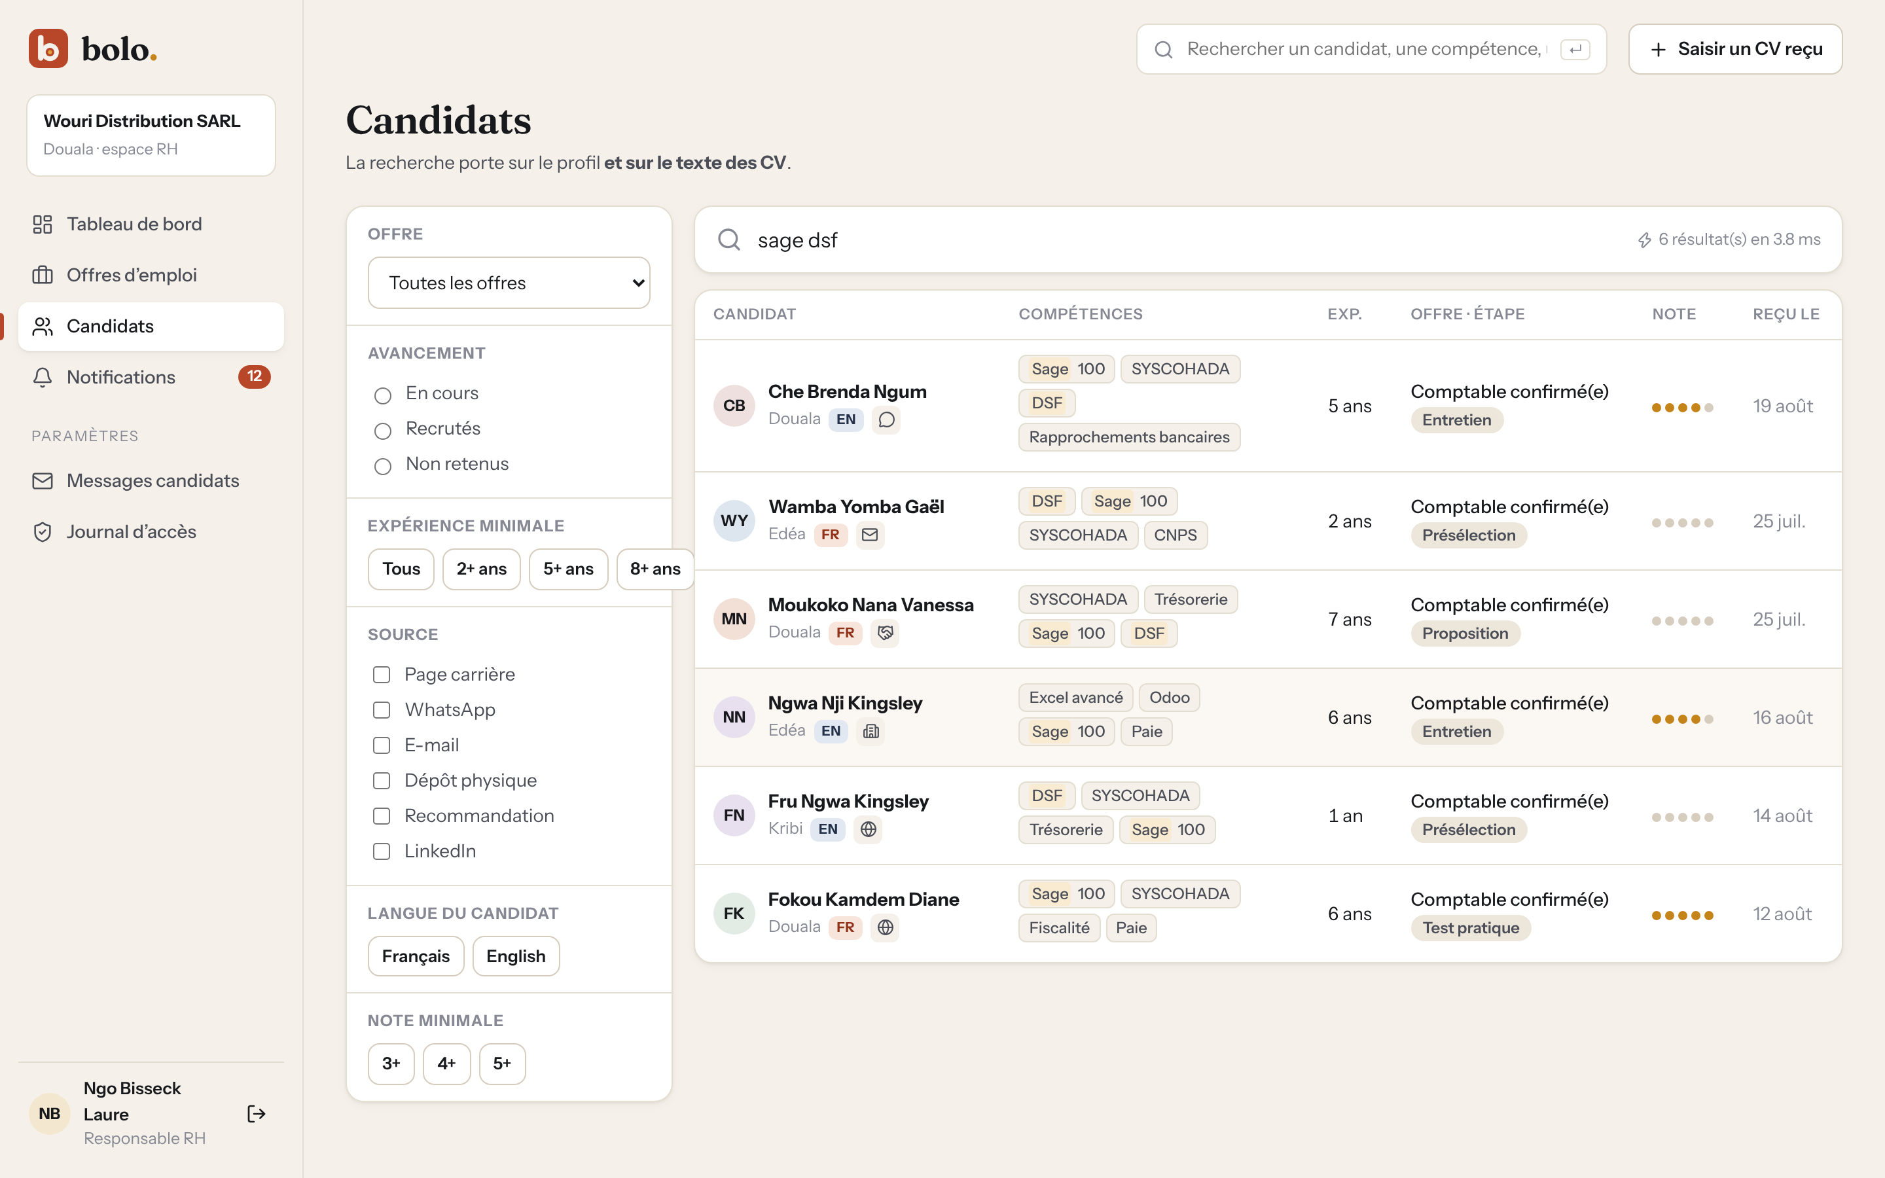
Figure 29: Search “sage dsf” in profiles and CV text, with filters (source: author)
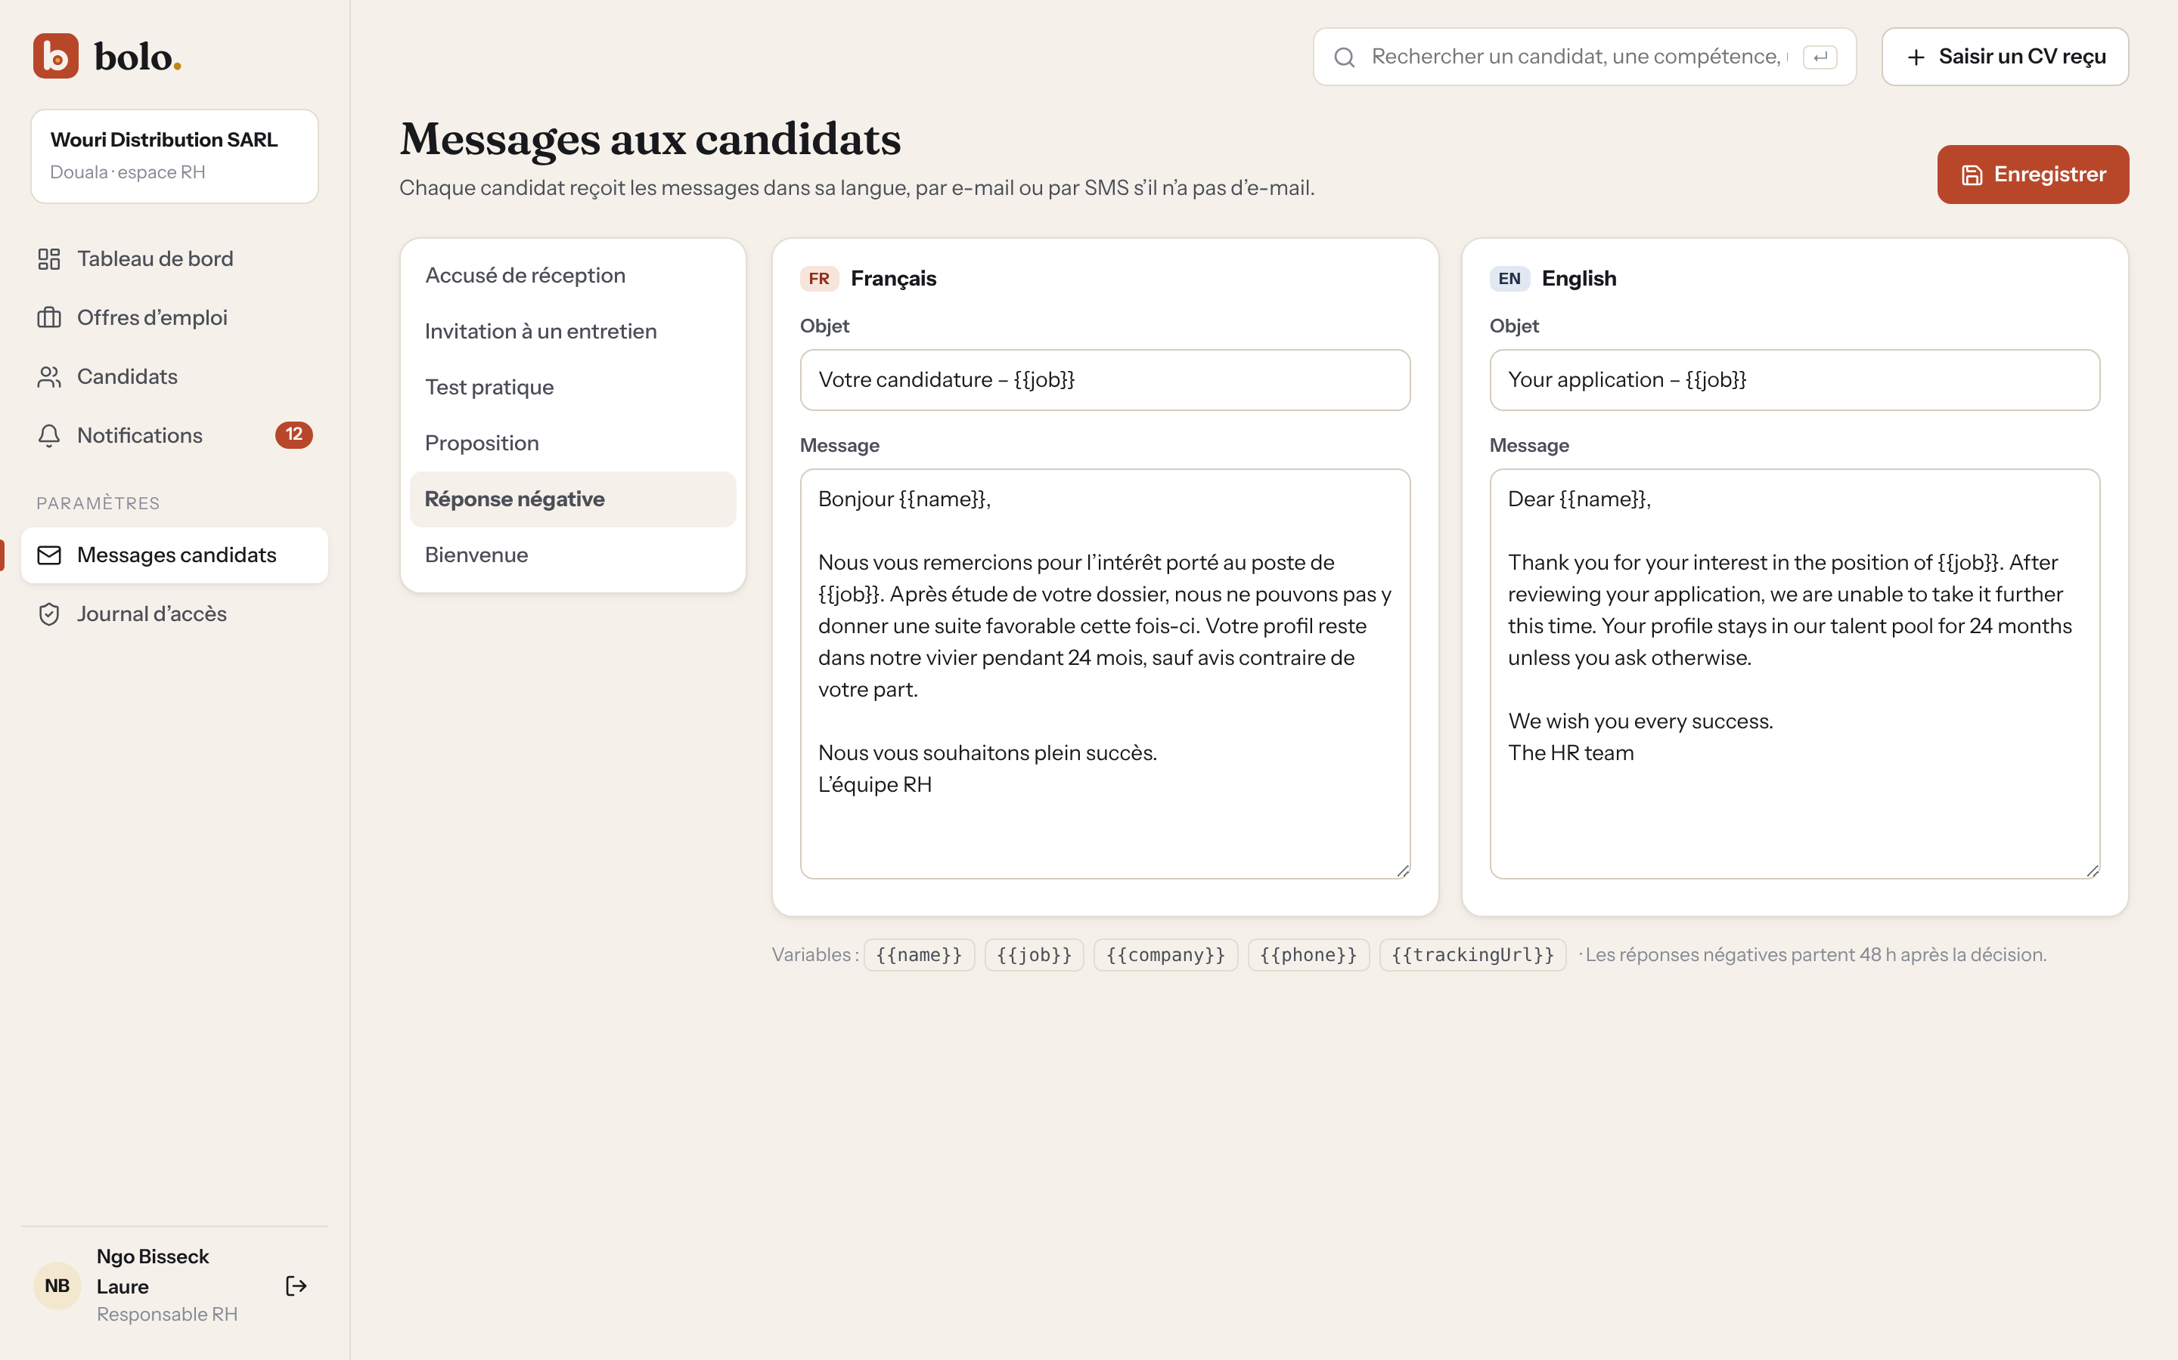
Figure 30: Bilingual message templates sent to candidates (source: author)
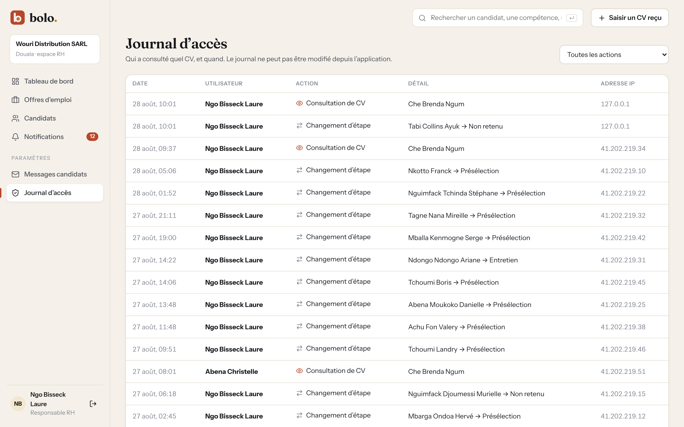
Figure 31: Audit log: who viewed which CV, and when (source: author)
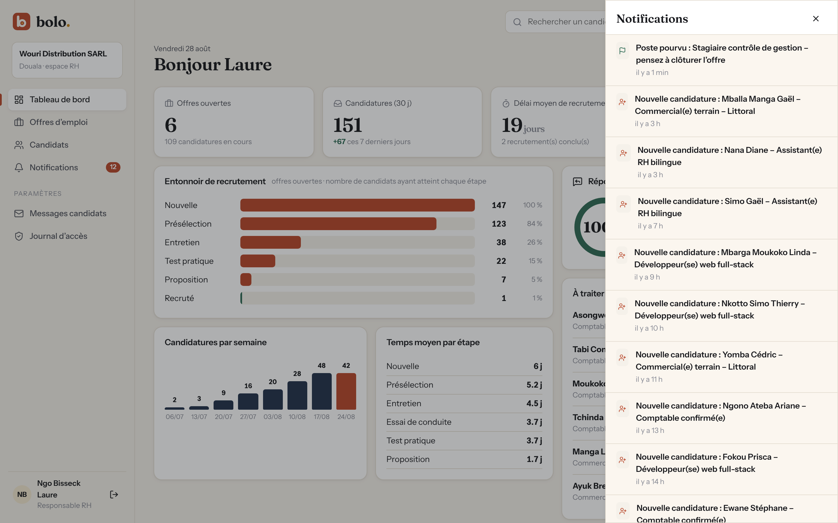
Figure 32: In-app notifications of the HR team (source: author)
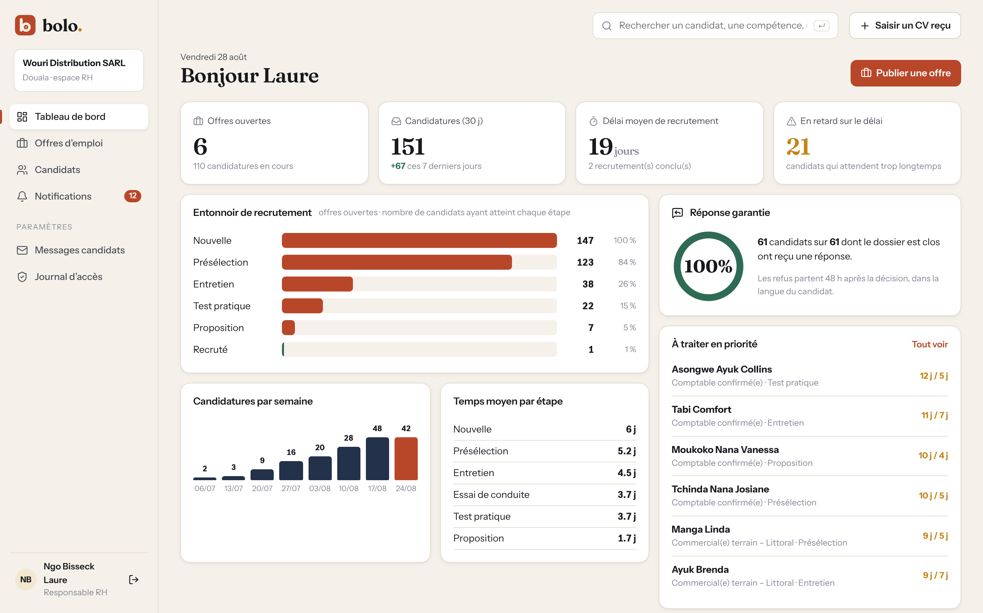
Figure 33: HR dashboard: funnel, guaranteed answer rate, delays and sources (source: author)
Problems solved: the search first missed “comptabilité” when the user typed “compta”; words are now searched as prefixes and accents are removed. A candidate rejected by mistake and moved back would still have received the rejection: the pending message is now cancelled when an application leaves a final stage. A test failed only because the database and the test runner did not use the same clock; time rules (account lock) are now evaluated by PostgreSQL alone.

4.7 Tests and results
Bolo is tested by 43 automated integration tests (Node test runner and Supertest) that call the HTTP API against a real PostgreSQL 16 database, recreated before each test file with two companies, so that isolation between companies is also tested. All 43 tests pass (Figure 36).
Table 27: Automated tests per area
Area | Examples of checks | Passed
Authentication & roles | Right and wrong password; lock after 5 failures; session required; invalid token | 5 / 5
Online application & CV checks | PDF accepted, encrypted and acknowledged; no duplicate by phone; SMS when no e-mail; JPEG accepted; .exe, EICAR, > 5 MB refused; consent required; no orphan file; public status | 11 / 11
Pipeline business rules | BR1 to BR8; recruiter scope; isolation between companies; evaluations; closing an offer | 14 / 14
CV access, search, erasure | Signed link, modified and expired link, other company, unassigned recruiter; search in profile and in CV text; injection; erasure | 7 / 7
Messages, dashboard, retention | Delayed sending; public status before and after the answer; custom and disabled templates; dashboard counts; roles; retention | 6 / 6
Total |  | 43 / 43

Table 28 details a selection of the test cases with their input, the expected result and the result obtained; Figure 34 shows the execution of the whole suite.
Table 28: Test cases of the project (selection)
ID | Test case | Input / action | Expected result | Obtained
TC-01 | Login with the right password | rh@… / correct password | 200, session cookie, dashboard | Passed
TC-02 | Login with a wrong password | correct e-mail / wrong password | 401, failure counter + 1 | Passed
TC-03 | Account lock | 5 wrong passwords in a row | 423, account locked 15 min | Passed
TC-04 | Protected route without session | GET /api/jobs without cookie | 401 | Passed
TC-05 | Online application with a PDF | form + 1 MB PDF + consent | 201, CV encrypted on disk, acknowledgement queued | Passed
TC-06 | Duplicate application | same phone, same offer, twice | 200 “duplicate”, only one application | Passed
TC-07 | Candidate without e-mail | form without e-mail | acknowledgement queued by SMS | Passed
TC-08 | Photo of a paper CV | JPEG file | accepted | Passed
TC-09 | Disguised executable | .exe renamed CV.pdf | 415, nothing stored | Passed
TC-10 | Infected file | EICAR antivirus test file | 422, file deleted | Passed
TC-11 | File too large | 6 MB file | 413 | Passed
TC-12 | Required fields | no consent / no CV / invalid phone | 400, nothing stored | Passed
TC-13 | Public tracking | GET /suivi/:token | simple status only, no internal stage | Passed
TC-14 | Move a candidate | move to “Entretien” | history written, interview message queued | Passed
TC-15 | Reject without reason | move to “Non retenu”, no reason | 400 reason required | Passed
TC-16 | Reject with reason | move to “Non retenu” + reason | answer queued 48 h later | Passed
TC-17 | Cancel a rejection | move back within 48 h | pending answer cancelled | Passed
TC-18 | Stage of another offer | move to a stage of another job | refused (BR1) | Passed
TC-19 | Isolation between companies | user of company B opens an application of A | 404 (not found) | Passed
TC-20 | Recruiter rights | recruiter creates an offer | 403 | Passed
TC-21 | Signed CV link | valid link, then modified and expired link | PDF + audit entry; then 403 | Passed
TC-22 | Search | “sage dsf”, then SQL-like input | matches in profile and CV text; input treated as text | Passed
TC-23 | Right to erasure | erase a candidate | personal data anonymised, CV files deleted | Passed
TC-24 | Delayed sending | worker run before and after 48 h | answer sent only after the delay | Passed
TC-25 | Closing an offer | close with candidates in progress | every candidate receives an answer | Passed

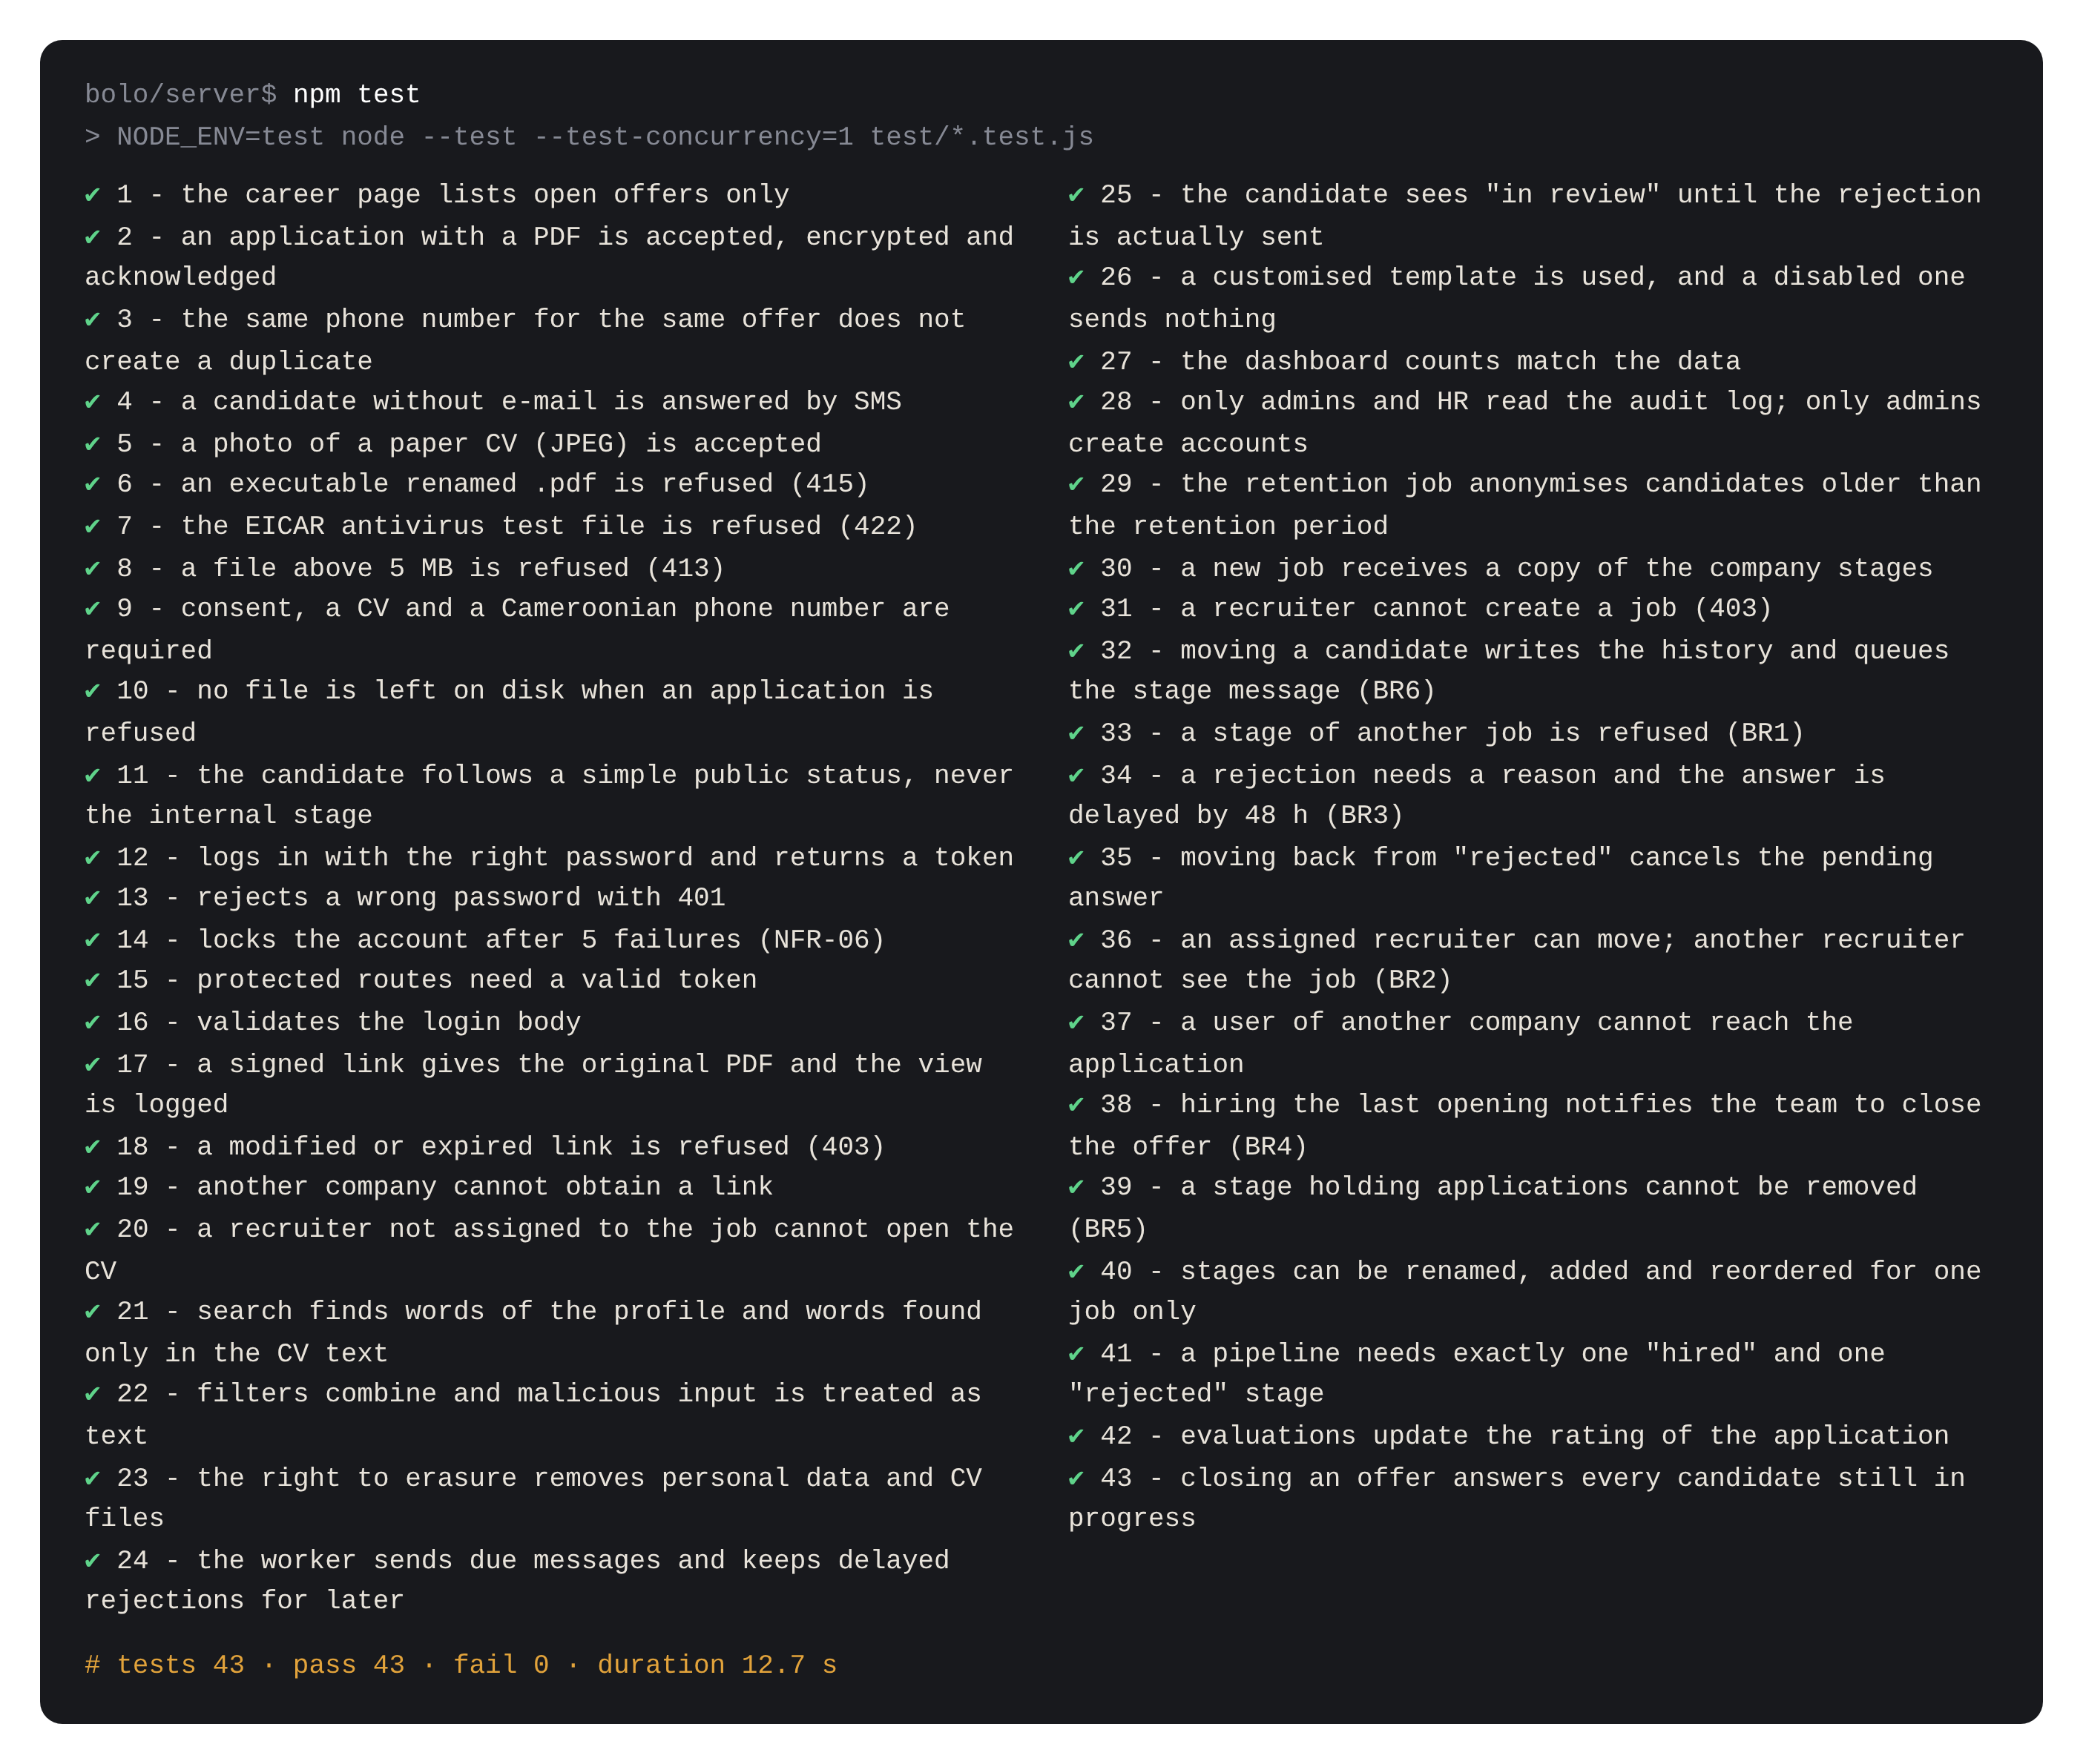
Figure 34: Execution of the automated test suite: 43 tests, 43 passed (source: author)
The performance requirements were measured with a script (server/scripts/bench.js) on a database of 10,000 candidates and 10,000 applications, on the development server (Figure 35).
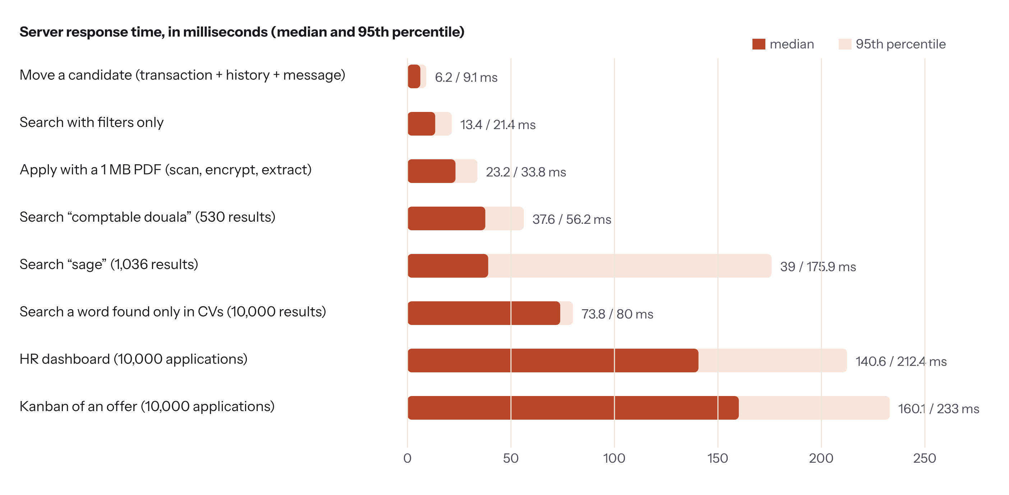
Figure 35: Measured response times with 10,000 candidates (median / 95th percentile) (source: author)
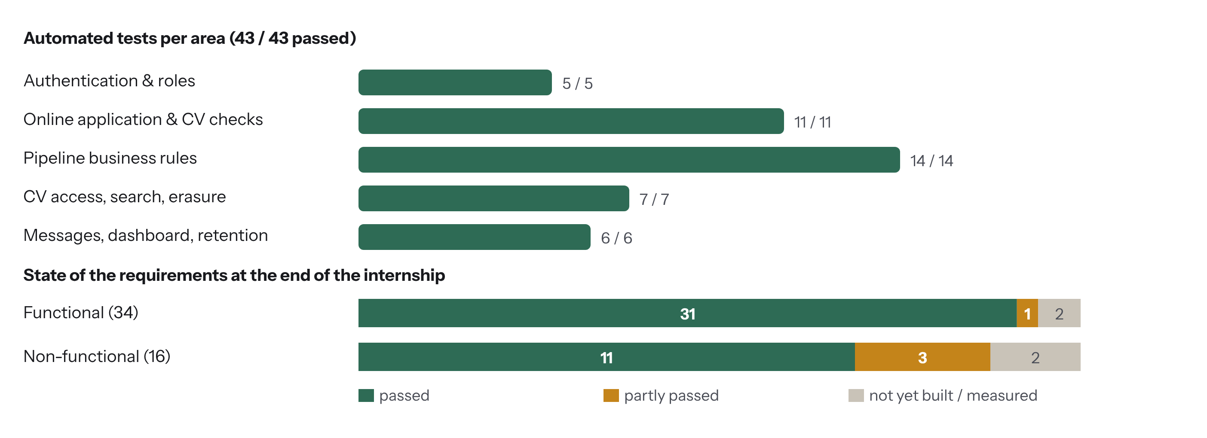
Figure 36: Automated tests and state of the requirements at the end of the internship (source: author)
Table 29: Results of the non-functional requirements
ID | Target | Result | Status
NFR-01 | Search 10,000 candidates < 1 s | Median 37–74 ms, worst 95th percentile 176 ms | Passed
NFR-02 | Move < 300 ms | Median 6.2 ms, 95th percentile 9.1 ms | Passed
NFR-03 | Career page < 300 kB; usable on 3G | 276 kB raw, about 136 kB with gzip; not yet measured on a real 3G network | Partly
NFR-04 | 1 MB CV processed < 2 s | Median 23 ms on the server (network time not included) | Passed
NFR-05 to 08 | bcrypt, lock, sessions and roles, isolation | Covered by tests and code review | Passed
NFR-09 | Type, antivirus, encryption | Type and encryption tested; antivirus tested with EICAR only, ClamAV not yet run in production | Partly
NFR-10, 11, 12 | Signed links, audit, privacy | Covered by tests | Passed
NFR-13 | Offer published < 10 min; SUS ≥ 70 | Usability test with users planned (Appendix 1) | Not yet measured
NFR-14 | Main browsers, from 360 px | Checked on Chromium (desktop and 390 px mobile); other browsers not yet tested | Partly
NFR-15 | Layered code, tests | 3 layers; 43 tests; every business rule tested | Passed
NFR-16 | One-command installation; backups | Docker Compose files written; production deployment not yet done | Not yet measured

Among the 34 functional requirements, 31 are complete, one is partly done (FR-29: messages are produced, queued and “sent” by a console transport; the connection to a real SMTP server and SMS aggregator remains to be configured) and two optional ones are not built (FR-33 export to Excel and FR-34 interview scheduling).

4.8 Installation and configuration procedures
Prerequisites: a Linux server (2 vCPU, 4 GB of RAM), Docker and Docker Compose, a domain name and an e-mail account for sending. For development: Node.js 20 and PostgreSQL 16.
# 1. Get the code and create the configuration
git clone <repository> bolo && cd bolo
cp server/.env.example server/.env
openssl rand -hex 32 # -> JWT_SECRET
openssl rand -base64 32 # -> CV_ENCRYPTION_KEY (keep an offline copy!)
# 2. Start database, antivirus, API and web server
DB_PASSWORD=******** docker compose up -d --build
# 3. Development mode instead
cd server && npm install && npm run db:seed && npm run dev # API on :5000
cd client && npm install && npm run dev # web on :5173
# 4. Tests
cd server && npm test # 43 tests

The server reads its configuration from environment variables: DATABASE_URL, JWT_SECRET, CV_ENCRYPTION_KEY, STORAGE_DIR, CV_MAX_BYTES (5 MB), CV_LINK_TTL_SECONDS (300), REJECTION_DELAY_HOURS (48), APPLY_LIMIT_PER_HOUR (20) and CLAMAV_HOST. After installation, the administrator creates the accounts of the HR team, sets the default stages and adapts the message templates. The database is saved every night with pg_dump; the encrypted CV volume is saved with it, and the encryption key separately.

4.9 Cost estimate of the solution
Table 30: Cost estimate of the solution (indicative)
Item | Quantity | Unit cost (FCFA) | Total (FCFA)
Software (React, Node.js, PostgreSQL, ClamAV, Docker) | Open source | 0 | 0
Laptop computer | Already owned | 0 | 0
Internet connection (data bundles) | 9 weeks | 5,000 | 45,000
Server (VPS 2 vCPU, 4 GB) – first year | 12 months | 15,000 | 180,000
Domain name (.cm) – first year | 1 | 25,000 | 25,000
Subtotal material and services |  |  | 250,000
Analysis, requirements and process modelling | 10 days | 25,000 | 250,000
Design and visual identity | 5 days | 25,000 | 125,000
Implementation (3 increments) | 20 days | 25,000 | 500,000
Tests, measurements and documentation | 7 days | 25,000 | 175,000
Subtotal handwork | 42 days |  | 1,050,000
TOTAL (material + handwork) |  |  | 1,300,000

The handwork is valued at an indicative daily rate for a junior developer. One installation can serve several SMEs (each company is isolated in the database), which divides the hosting cost; sending SMS would add a cost per message, paid to a local aggregator.

4.10 Limits of the current version
- Messages are queued and their content is tested, but they are not yet sent through a real SMTP server or SMS aggregator.
- The antivirus path was tested with the EICAR signature; ClamAV itself has not yet been run in a production environment.
- The usability test with real HR users and the SUS questionnaire have not yet been carried out; the screenshots use fictitious demonstration data.
- Not built in this version: export to Excel, interview scheduling, import of CVs directly from a WhatsApp Business number or a mailbox.
- Rate limits are kept in the memory of one server instance.

Conclusion
Bolo combines a single entry point for every channel, a recruitment process modelled as a configurable state machine, and a CV vault that protects personal data from the upload to the consultation. Its business rules and security measures are validated by 43 automated tests, and its response times stay far below the targets on 10,000 candidates; real message sending, the production antivirus and the usability test are the next steps.

GENERAL CONCLUSION

Summary of the problems solved
This internship at G&C Creative Technology, from July 1 to August 31, 2026, aimed to give small companies a way to stop losing track of applications. The study started from five problems of the existing practice: CVs scattered over many channels, no shared view of the process, no traceability, candidates left without answer and personal data stored without protection. Bolo answers them with a single entry point – a light bilingual career page and the capture of CVs received elsewhere – a pipeline whose stages are defined for each offer, an answer guaranteed to every candidate in their language, and a vault that protects every CV.

Methodology and solutions proposed
The project followed the software development life cycle with an iterative and incremental model: interviews and collection of the existing documents, a requirements specification of 34 functional and 16 measurable non-functional requirements, a BPMN model of the process and a configurable state machine, a UML and database design, a visual identity, and three tested increments on React, Node.js/Express and PostgreSQL. The platform is validated by 43 automated integration tests, all passed, and by measurements on 10,000 candidates.

Difficulties encountered and solutions
Making the process configurable without making the code fragile was the main design difficulty: storing the stages as data with explicit invariants (one “hired” and one “rejected” stage, no deletion of a non-empty stage) solved it. File security was new to me: I followed the OWASP recommendations step by step and wrote a test for each threat. Several subtle defects were found by the tests – an orphan file after a refused application, a rejection message that would still have left after a candidate was moved back, two clocks disagreeing – and were corrected. Finally, the MoSCoW priorities made it possible to deliver every “Must” requirement within nine weeks.

Perspectives
In the near future: connect a real SMTP server and a Cameroonian SMS aggregator; deploy on a server and run ClamAV in production; measure the career page on a real 3G network; run the usability test with five HR users and the SUS questionnaire; build the export to Excel and the scheduling of interviews. In later versions: import of applications from a WhatsApp Business number and from a mailbox, extraction of skills from CVs to suggest the best matches, and a multi-company offer that G&C Creative Technology could install and maintain for its SME clients.
Beyond the application, this internship taught me how a small ICT company combines services, training and software development, how to lead a complete project from a business need to a tested product, and the rigour of measuring and documenting what is really done. It confirmed my interest in software engineering applied to the realities of Cameroonian companies.

BIBLIOGRAPHY AND WEBOGRAPHY

Bibliography
- Dumas, M., La Rosa, M., Mendling, J., & Reijers, H. A. (2018). Fundamentals of Business Process Management (2nd ed.). Springer.
- Dworkin, M. (2007). Recommendation for Block Cipher Modes of Operation: Galois/Counter Mode (GCM) and GMAC (NIST SP 800-38D). NIST.
- Fielding, R. T. (2000). Architectural Styles and the Design of Network-based Software Architectures (Doctoral dissertation). University of California, Irvine.
- Jones, M., Bradley, J., & Sakimura, N. (2015). JSON Web Token (JWT) (RFC 7519). IETF.
- Object Management Group (2011). Business Process Model and Notation (BPMN), Version 2.0. OMG.
- Pressman, R. S., & Maxim, B. R. (2020). Software Engineering: A Practitioner’s Approach (9th ed.). McGraw-Hill.
- Provos, N., & Mazières, D. (1999). A future-adaptable password scheme. USENIX Annual Technical Conference, 81–91.
- Sommerville, I. (2016). Software Engineering (10th ed.). Pearson.
- Brooke, J. (1996). SUS: A “quick and dirty” usability scale. In Usability Evaluation in Industry (pp. 189–194). Taylor & Francis.
- Republic of Cameroon (2024). Law No. 2024/017 of 23 December 2024 relating to the protection of personal data.
- European Union (2016). Regulation (EU) 2016/679 – General Data Protection Regulation.

Webography
- OWASP File Upload Cheat Sheet: https://cheatsheetseries.owasp.org/cheatsheets/File_Upload_Cheat_Sheet.html
- OWASP Top 10: https://owasp.org/Top10/
- PostgreSQL 16 documentation – Full Text Search: https://www.postgresql.org/docs/16/textsearch.html
- React: https://react.dev · Express: https://expressjs.com · Node.js: https://nodejs.org/docs
- pdf.js: https://mozilla.github.io/pdf.js/ · ClamAV: https://docs.clamav.net
- DLA Piper, Data protection laws of the world – Cameroon: https://www.dlapiperdataprotection.com/?c=CM

APPENDIX

Appendix 1: Usability test scenario (5 HR users)
The test will measure NFR-13 (an offer published in under 10 minutes) and the System Usability Scale (SUS ≥ 70). Each participant performs six tasks on a computer, then fills in the SUS questionnaire (ten statements rated 1 to 5; score = sum of the adjusted answers × 2.5).
Table 31: Tasks of the usability test
No. | Task read to the participant | Success criterion
1 | « Publiez une offre de magasinier avec une étape “Visite de l’entrepôt”. » | Offer visible on the career page
2 | « Ajoutez le CV reçu ce matin sur WhatsApp. » | Application in the first stage, source WhatsApp
3 | « Trouvez les candidats qui connaissent Sage. » | Search used, list displayed
4 | « Invitez Che Brenda à un entretien. » | Moved to “Entretien”, message queued
5 | « Ne retenez pas Tabi Collins. » | Reason chosen, answer scheduled
6 | « Qui a consulté le CV de Che Brenda aujourd’hui ? » | Audit log opened and read

Appendix 2: Extract of the database creation script
CREATE TABLE stages (
id uuid PRIMARY KEY DEFAULT gen_random_uuid(),
job_id uuid NOT NULL REFERENCES jobs(id) ON DELETE CASCADE,
name varchar(60) NOT NULL,
position smallint NOT NULL,
kind varchar(10) NOT NULL DEFAULT 'active' CHECK (kind IN ('active','hired','rejected')),
sla_days smallint,
email_key varchar(20)
);
CREATE TABLE applications (
id uuid PRIMARY KEY DEFAULT gen_random_uuid(),
job_id uuid NOT NULL REFERENCES jobs(id) ON DELETE CASCADE,
candidate_id uuid NOT NULL REFERENCES candidates(id) ON DELETE CASCADE,
stage_id uuid NOT NULL REFERENCES stages(id),
source varchar(12) NOT NULL CHECK (source IN ('career_page','whatsapp','email',
'walk_in','referral','linkedin')),
tracking_token varchar(48) NOT NULL UNIQUE,
answered_at timestamptz,
stage_entered_at timestamptz NOT NULL DEFAULT now(),
UNIQUE (job_id, candidate_id)
);
-- one candidate per phone number and company: the phone is the identifier everybody has
CREATE UNIQUE INDEX candidates_phone_uq ON candidates (company_id, phone);

Appendix 3: Additional screenshots
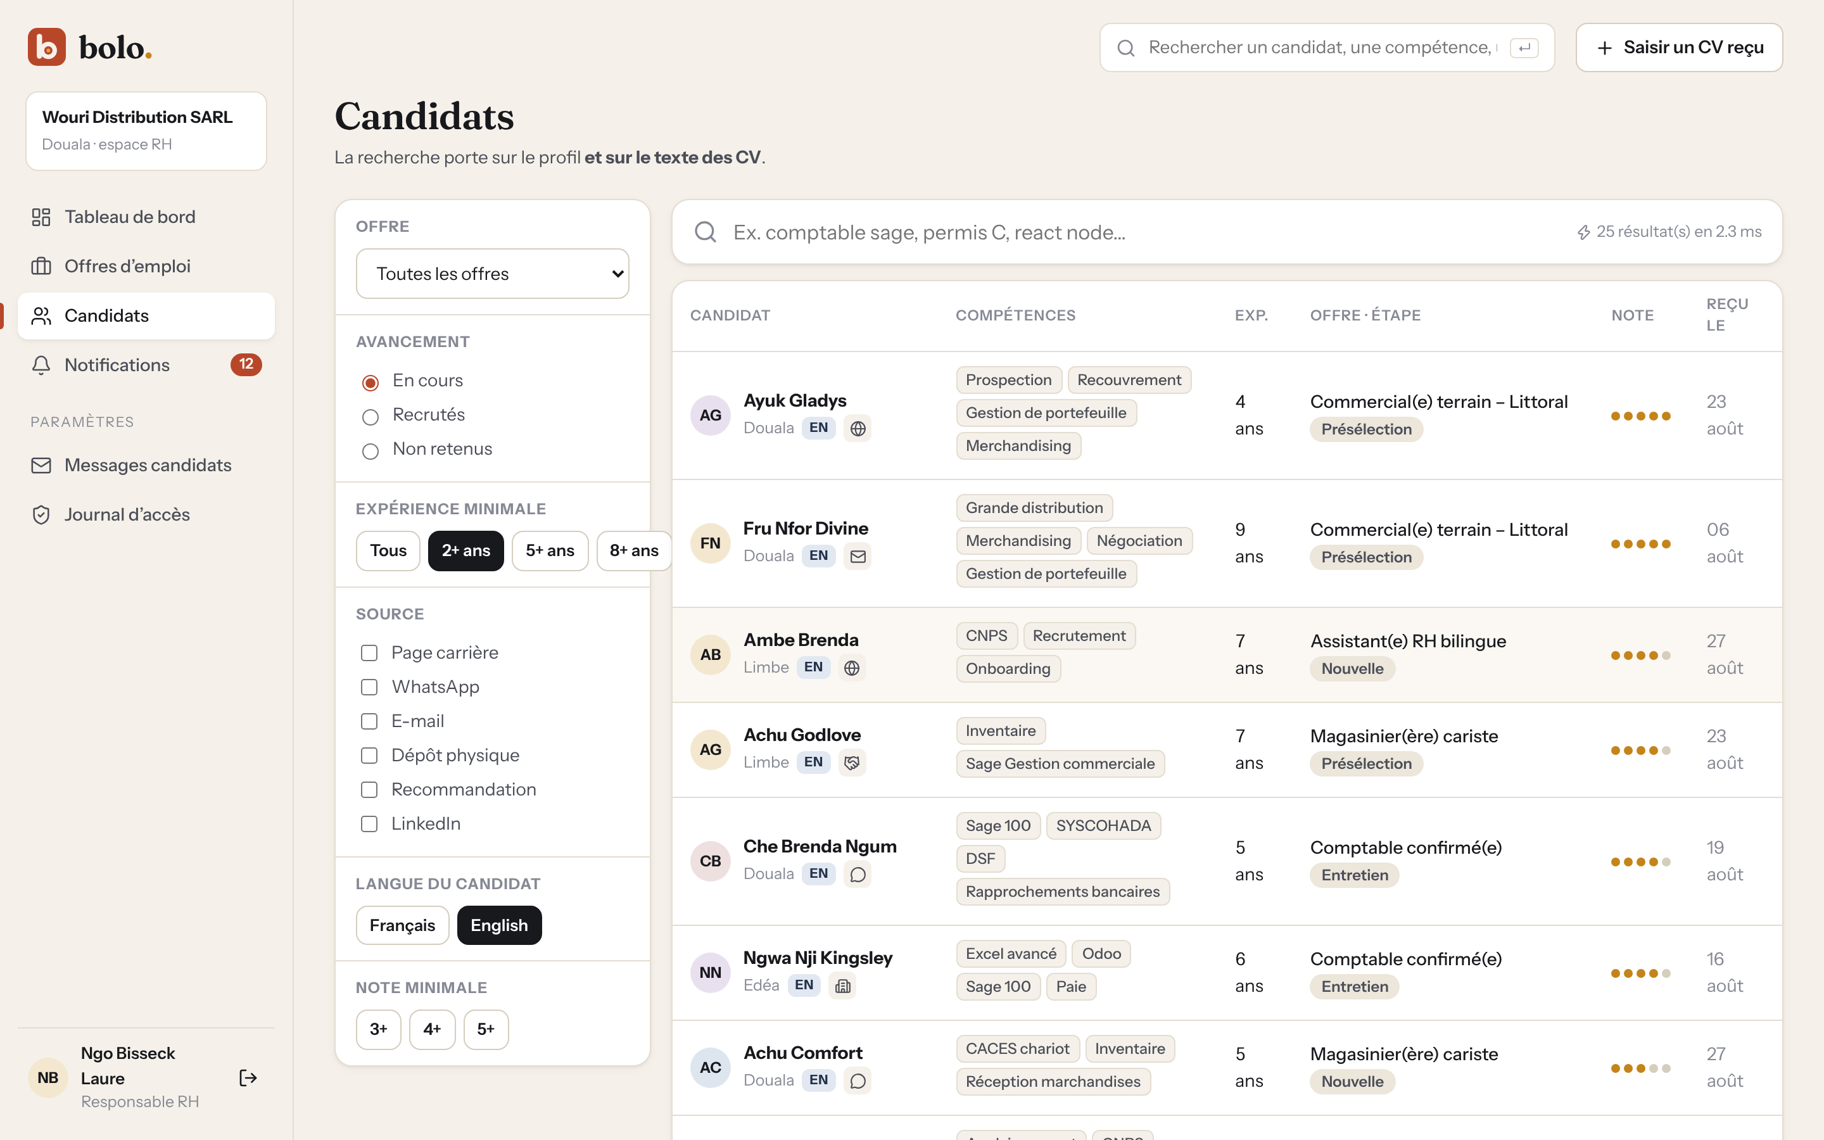
Figure 37: Filters: English-speaking candidates in progress with at least 2 years of experience (source: author)
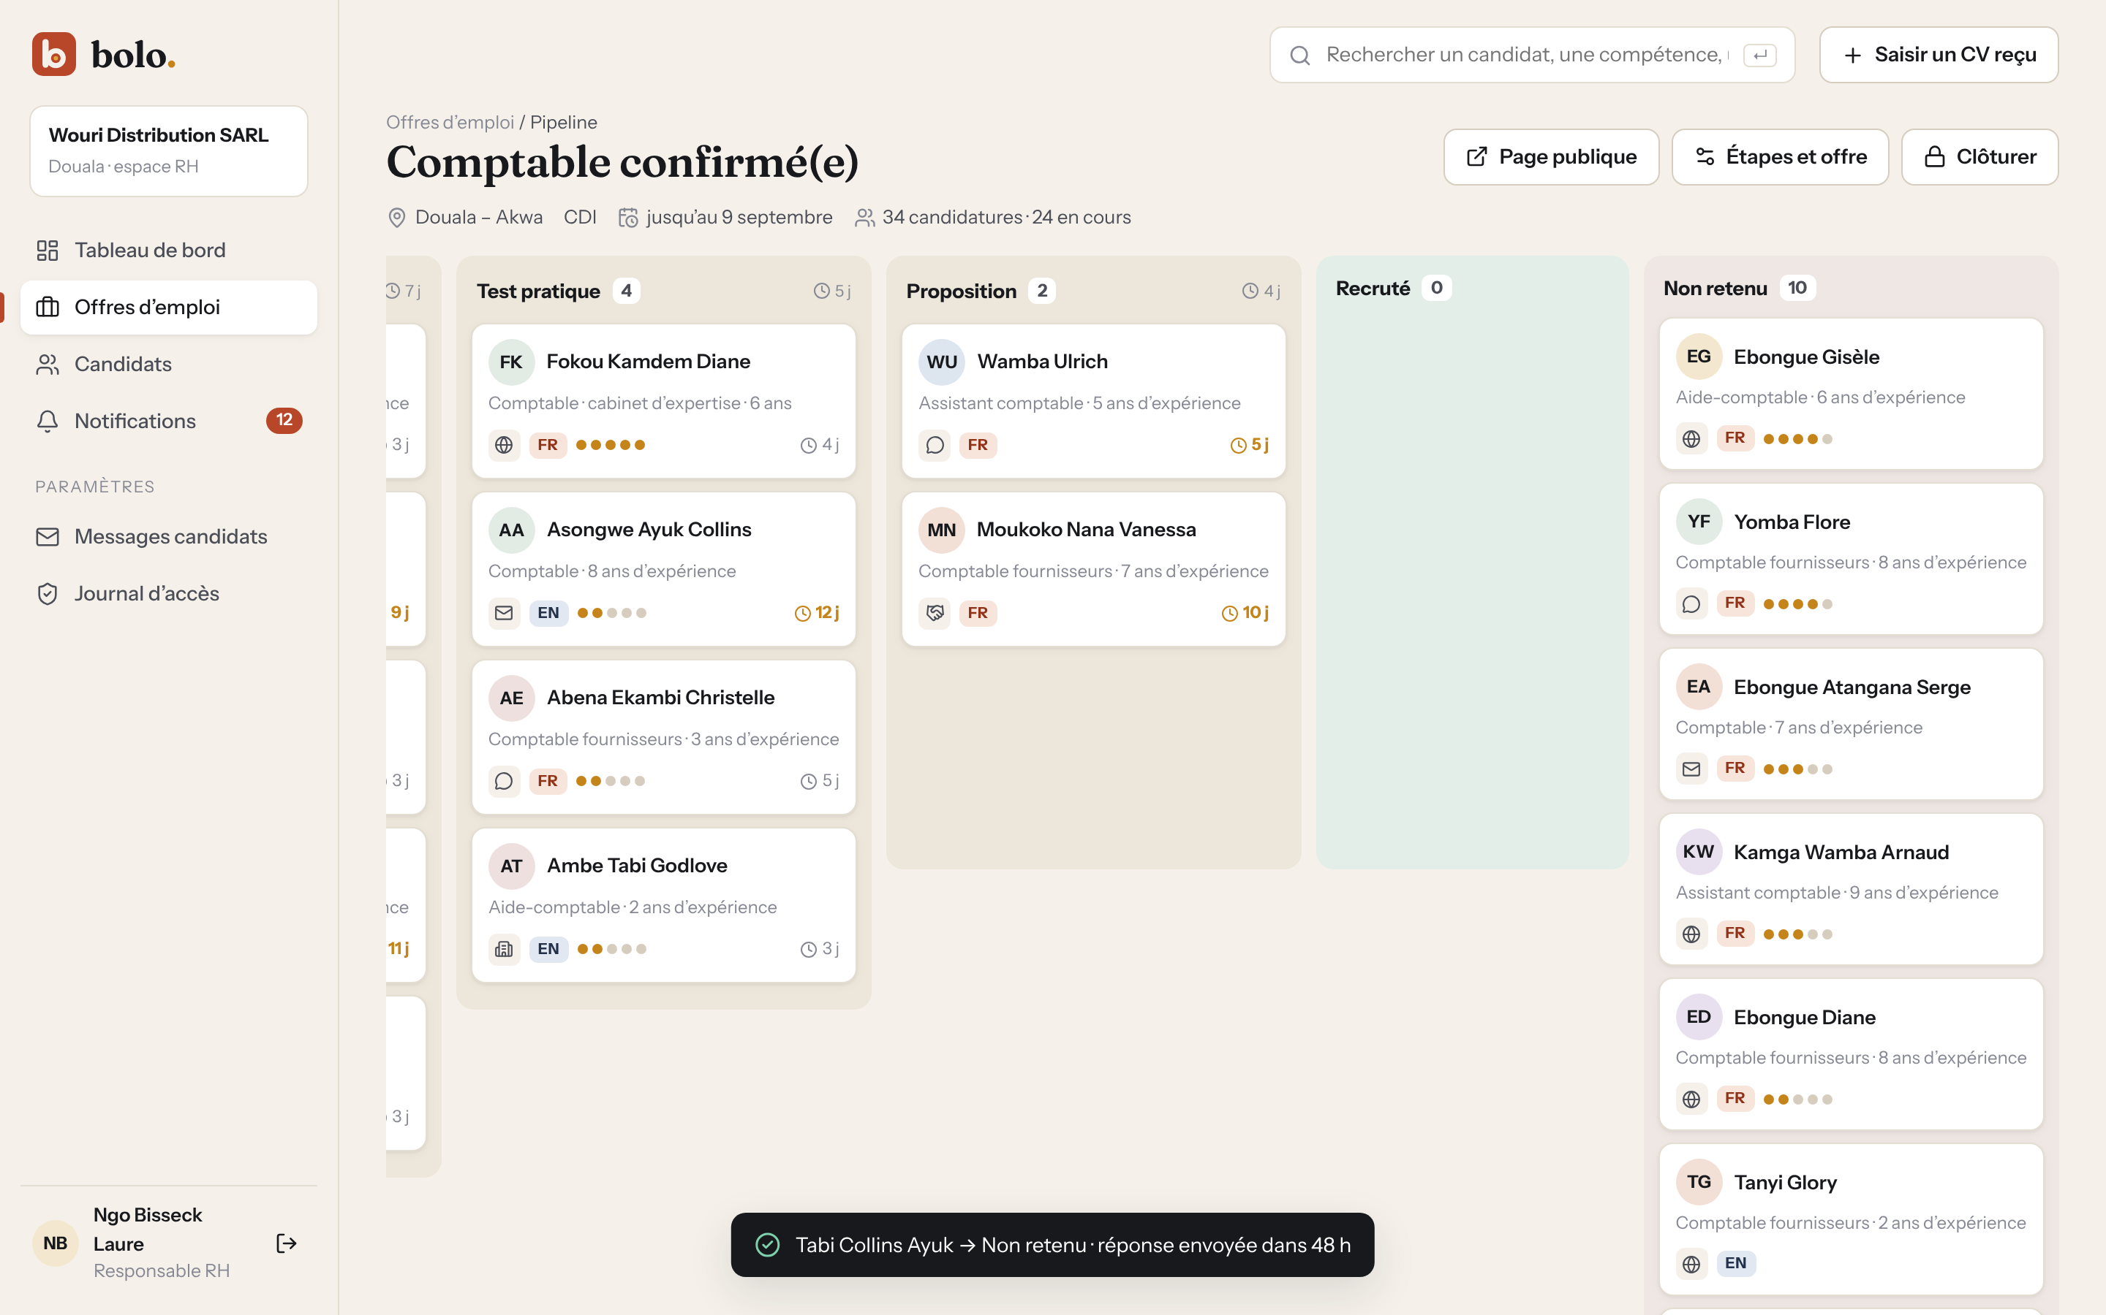
Figure 38: Kanban after a rejection, with the confirmation message (source: author)

