SECS/GEM Reference Manual
for the
Cooling Equipment System

Manual Information

Document Description: | This manual describes SECS/GEM standard supports and implements in the Cooling Equipment System
Document ID: | Cooling_Equipment _SECSGEM_Manual_V1.2.0
Document Author: | Muhammad Adib Fikri
Revision Number: | 1.2.0
File Name: | Cooling_Equipment _SECSGEM_Manual_V1.2.0
Status: | Released
Created Date: | 1st September 2023
Revised Date: | 7th May 2024
Applies To Software Revision: | 1.1.0.0

COPYRIGHT NOTICE

The information in this document is proprietary to PENTAMASTER TECHNOLOGY SDN. BHD. and all other of that corporation’s subsidiaries. It is supplied in confidence and except for evaluation purposes should not be disclosed, duplicated or otherwise revealed in whole, or in part, to third parties without the prior written consent of PENTAMASTER TECHNOLOGY SDN. BHD.

Many of the designations used by manufacturers and sellers to distinguish their products are claimed as trademarks. Where those designations appear in this document, the authors acknowledge their respective trademark claims.
Information in this document is subject to change without notice.
If this document was transmitted electronically, the formatting of the output may not match the original document design.

DOCUMENT CHANGE HISTORY

Version | Released Date | Changed By | Description
1.0.0 | 1st September 2023 | Muhammad Adib | Initial release.
1.1.0 | 8th February 2024 | Muhammad Adib | Add AlarmOccurred and AlarmCleared in custom Event
1.2.0 | 7th May 2024 | Muhammad Adib | Modified Variable ID and Report ID

TABLE OF CONTENTS

COPYRIGHT NOTICE 2
DOCUMENT CHANGE HISTORY 3
TABLE OF CONTENTS 5
1 INTRODUCTION 8
1.1 Application 8
1.2 SECS Standard 8
1.3 GEM Compliance Statement 9
1.4 SECS-I Connection 10
1.4.1 SECS-I Physical Connection 10
1.4.2 SECS-I Parameters 11
1.5 HSMS Connection 11
1.5.1 HSMS Physical Connection 11
1.5.2 HSMS Parameters 12
2 STATE MODELS 13
2.1 Establish Communications State Model 13
2.2 Control State Model 16
2.3 Process State Model 19
2.4 Alarm State Model 20
2.5 Limit Monitoring State Model 21
2.6 Spooling State Model 23
3 SECS MESSAGE SUMMARY 26
3.1 Host To Equipment 27
3.2 Equipment to Host 28
4 SECS MESSAGES DETAIL 29
4.1 Stream 1: Equipment Status 29
4.2 Stream 2: Equipment Control and Diagnostics 32
4.3 Stream 5: Exception Reporting 41
4.4 Stream 6: Data Collection 43
4.5 Stream 7: Process Program Management 45
4.6 Stream 9: System Errors 47
4.7 Stream 10: Terminal Services 48
5 SECS SCENARIO 49
5.1 Alarm Management 49
5.1.1 Enable/Disable Alarms 49
5.1.2 Send Alarm Report 49
5.1.3 Upload Alarm Information 49
5.2 Clock 50
5.2.1 Equipment Requests Date and Time 50
5.2.2 Host Instructs Equipment to Set Date and Time 50
5.2.3 Host Requests Date and Time 50
5.3 ControlState 50
5.3.1 Equipment Initiated Are You There 50
5.3.2 Host Sends Off Line 51
5.3.3 Host Sends On Line 51
5.3.4 Operator Sets Off-Line When Equipment In On-Line State 51
5.3.5 Operator Sets On-Line (Remote) When Equipment In Off-Line State 51
5.3.6 Operator Sets On-Line (Local) When Equipment In Off-Line State 52
5.4 Data Collection 53
5.4.1 Equipment Reports Event 53
5.4.2 Event Reporting Setup 53
5.4.3 Host Requests Equipment Constants 54
5.4.4 Host Requests Equipment Constants Namelist 54
5.4.5 Host Requests Event Report 54
5.4.6 Host Requests Report (Variable Data Collection) 54
5.4.7 Host Requests Status Variable Namelist 54
5.4.8 Host Request Status Variable Report 54
5.4.9 Set Equipment Constants 55
5.4.10 Trace Data Collection 55
5.5 Error Messages 56
5.5.1 Message Fault due to Unrecognized Device ID 56
5.5.2 Message Fault due to Unrecognized Stream 56
5.5.3 Message Fault due to Unrecognized Function 56
5.5.4 Message Fault due to Illegal Data Format 56
5.5.5 Message Fault due to Transaction Timer Time-out 56
5.5.6 Message Fault due to Data Too Long 57
5.5.7 Message Fault due to Conversation Timeout 57
5.6 Establish Communications 58
5.6.1 Equipment Attempts to Establish Communications 58
5.6.2 Equipment Attempts to Establish Communications Denied 58
5.6.3 Equipment Attempts to Establish Communications Fails 58
5.6.4 Host Attempts to Establish Communications 59
5.6.5 Host Initiated Are You There 59
5.6.6 Simultaneous Attempt to Establish Communications (I) 59
5.6.7 Simultaneous Attempt to Establish Communications (II) 59
5.7 Limit Monitoring 60
5.7.1 Host Defines Limit Attributes 60
5.7.2 Host Queries Equipment for Current Limits 60
5.8 Process Program Management 61
5.8.1 Program Deletion by the Host 61
5.8.2 Program Directory Request 61
5.8.3 Host-initiated Program Download Request 61
5.8.4 Host-initiated Process Program Upload (Unformatted) 61
5.9 Remote Control 62
5.9.1 Host Sends Remote Command to Equipment 62
5.9.2 Host Sends Enhanced Remote Command to Equipment 62
5.10 Spooling 63
5.10.1 Define Spooled Messages 63
5.10.2 Request or Delete Spooled Data 63
5.11 Terminal Service 64
5.11.1 Host Sends Information to Equipment’s Display Device 64
5.11.2 Host Sends Multi-block Text Message to Equipment 64
5.11.3 Operator Sends Information to the Host 64
6 REMOTE COMMANDS 65
APPENDIX A: DATA ITEM DICTIONARY 67
APPENDIX B: VARIABLE ITEM DICTIONARY 73
APPENDIX C: COLLECTION EVENT 79
APPENDIX D: DEFAULT REPORTS LIST 81
APPENDIX E: ALARM LIST 82

1 INTRODUCTION

1.1 Application

This manual has been prepared to define the communication functions available between PENTAMASTER TECHNOLOGY SDN. BHD., the manufacturer of semiconductor manufacturing equipment Cooling Equipment Machine, which is hereafter called as "the equipment" and its host computer.

Unless otherwise specified, the descriptions made in this manual conform in general to the descriptions made in the SEMI E4-91, SEMI E5-93, and SEMI E30-94.

1.2 SECS Standard

The SEMI Equipment Communications Standard (SECS) is published by Semiconductor Equipment and Materials International (SEMI). It defines a computer to computer communications interface between a unit of factory Equipment and a Host Computer.

This Equipment complies to either SECS-I (E4, serial communication) or HSMS (E37, network communication), and to the generic portions of the SECS-II (E5) standard, and implements an appropriate subset of the SECS-II standard messages required by GEM (E30).

Cooling Equipment Machine complies to the following versions of standards:

Item | Standard
SECS-I | SEMI E4-91  SEMI Equipment Communications Standard 1, Message Transfer
SECS-II | SEMI E5-93  Equipment Communications Standard 2, Message Contents
GEM | SEMI E30-94  Generic Model for Communications And Control of SEMI Equipment
HSMS | SEMI E37-95  High-Speed SECS Message Services (HSMS), Generic Services
HSMS-SS | SEMI E37.1-95  High-Speed SECS Message, Single-Session Mode (HSMS-SS)

1.3 GEM Compliance Statement

This GEM Compliance Statement accurately indicates for each capability whether it has been implemented, and whether the implementation is in a GEM compliant manner. The GEM Compliance Statement for the Equipment is given in the Table as below.

Table: GEM Compliance Statement

Fundamental GEM Requirements | Implemented | GEM Compliant
State Models | Yes | Yes
Equipment Processing States | Yes
Host Initiated S1F13/S1F14 Scenario | Yes
Event Notification | Yes
On-Line Identification | Yes
Error Messages | Yes
Documentation | Yes
Control (Operator Initiated) | Yes
Additional Capabilities | Implemented | GEM Compliant
Establish Communications | Yes | Yes
Dynamic Event Report Configuration | Yes | Yes
Variable Data Collection | Yes | Yes
Trace Data Collection | Yes | Yes
Status Data Collection | Yes | Yes
Alarm Management | Yes | Yes
Remote Control | Yes | Yes
Equipment Constants | Yes | Yes
Process Program Management | Yes | Yes
Material Movement | Yes | Yes
Equipment Terminal Services | Yes | Yes
Clock | Yes | Yes
Limits Monitoring | Yes | Yes
Spooling | Yes | Yes
Control (Host Initiated) | Yes | Yes

1.4 SECS-I Connection

In case of serial (RS-232) communication, the communication between the equipment and the host conforms to the SECS-I/II as defined by the SEMI (Semiconductor Equipment and Materials International).

1.4.1 SECS-I Physical Connection

The following set values are used as circuit parameters:

Item | Description
Electrical I/F | EIA RS-232-C complied
Connector | <ISO 2110-1980(D-sub) 25pin [FEMALE]>
Connector location | <Connector location>
Signal pins | Pin# Description  1 shield  2 data transmit (output)  3 data receive (input)  7 signal ground
Data rate | 9600 bps (changeable) [300-19200]
Characters | Start bit = 1bit  Data bit = 8bit (LSB-MSB)  Stop bit = 1bit  Parity bit = none

1.4.2 SECS-I Parameters

The following set values are used as circuit control parameters:

Parameters | Settable range | Default | Description
Device ID | 0 - 7FFF (hex) | 0 | Identifier assigned to the equipment.
T1 | 0.1 - 10.0 (sec) | 0.5 (sec) | Detects an interruption between characters.
T2 | 0.2 - 25.0 (sec) | 10 (sec) | Detects a lack of protocol response.
T3 | 1 - 120 (sec) | 45 (sec) | Detects a lack of reply message.
T4 | 1 - 120 (sec) | 45 (sec) | Detects an interruption in a multi-block message.
RTY | 0 - 31 (times) | 3 (times) | The maximum of send retries allowed.

1.5 HSMS Connection

In case of network (EtherNet) communication, the communication between the equipment and the host conforms to the HSMS, HSMS-SS and SECS-II as defined by the SEMI (Semiconductor Equipment and Materials International).

1.5.1 HSMS Physical Connection

If HSMS communication port is equipped, the equipment follows the following connection type:

Item | Description
Electrical I/F | IEEE 802.3 complied
Connector | 100Base
Connector location | Panel PC RJ45

1.5.2 HSMS Parameters

The following set values are used as circuit control parameters:

Parameters | Settable range | Default | Description
Connect Mode | PASSIVE/ACTIVE | PASSIVE | HSMS connection mode.
IP  Address | Determined by TCP/IP conventions | N/A | Remote IP address when the equipment is ACTIVE; Local IP address when the equipment is PASSIVE.
Port Number | Determined by TCP/IP conventions | N/A | The Port number when the equipment is ACTIVE/PASSIVE.
T3 | 1 - 120 (sec) | 45 (sec) | Detects a lack of reply message.
T5 | 1 - 240 (sec) | 60 (sec) | Connect Separation Timeout.
T6 | 1 - 240 (sec) | 5 (sec) | Control Transaction Timeout.
T7 | 1 - 240 (sec) | 10 (sec) | NOT SELECTED Timeout.
T8 | 1 - 120 (sec) | 5 (sec) | Network Inter-character Timeout.

2 STATE MODELS

2.1 Establish Communications State Model

This section describes the model of established communication state the equipment may provide.

1) Description of Functions

The equipment manages the state of communication line with the host as the model of establish communication state. The established communication state model provides the functions conforming to those specified in the E30.

2) State Definition

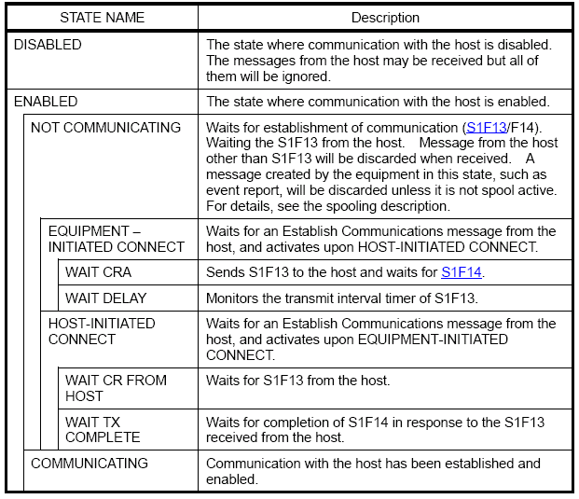

3) State Chart

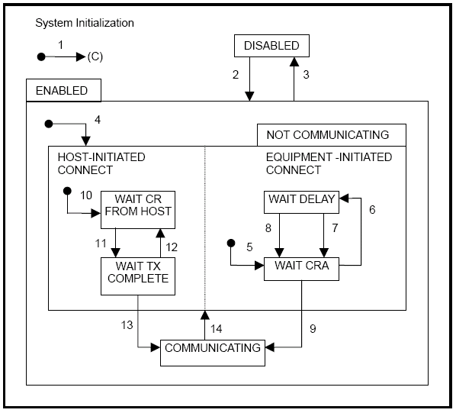

4) Transition Table

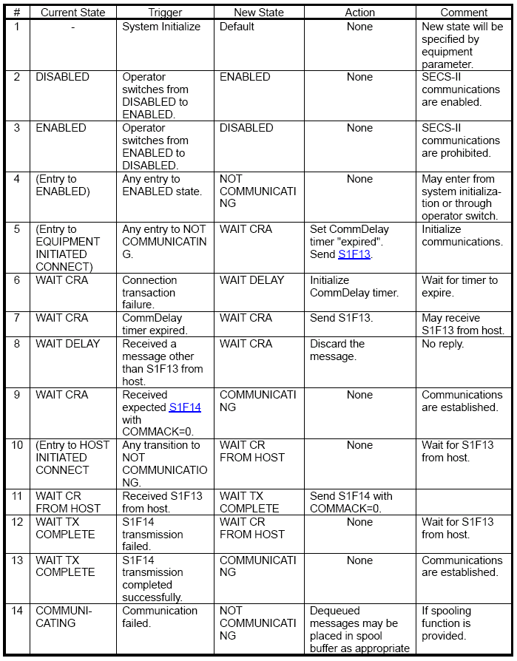

2.2 Control State Model

This section describes the control state the equipment provides.

1) Description of Functions

The equipment provides the control state model as operating mode to be manipulated by host or operator.

2) State Definition

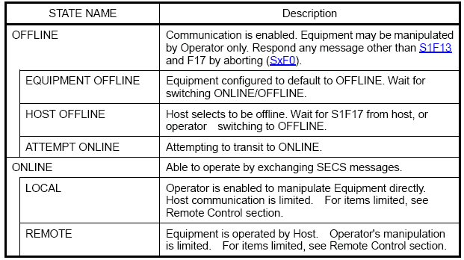

3) State Chart

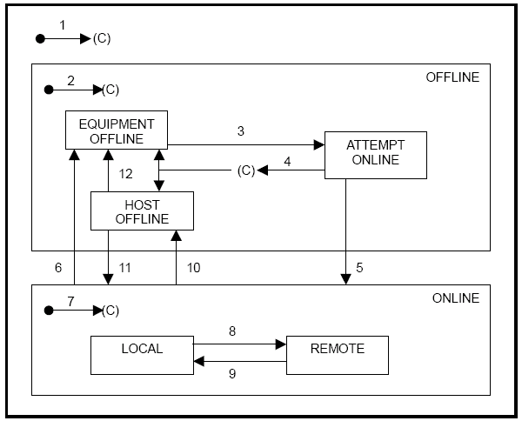

4) Transition Table

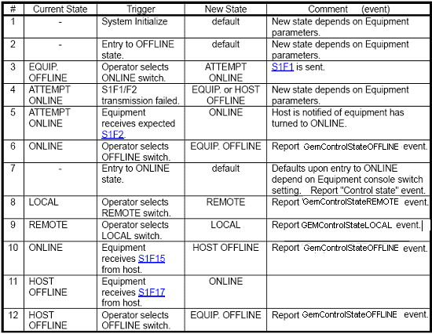

2.3 Process State Model

This section describes the process state models provided by the equipment.

1) Description of Functions

This state represents current availability of the equipment.

2) State Definition

STATE NAME | Description
RUNNING | Equipment is now running.
STOP | Equipment is now stop.

2.4 Alarm State Model

1) Description of Functions

This state represents current alarm condition of the equipment.

2) State Definition

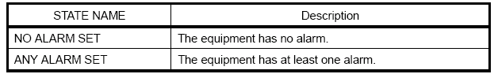

3) State Chart

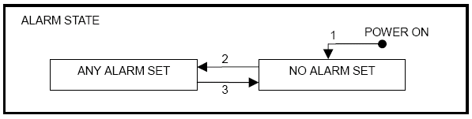

4) Transition Table

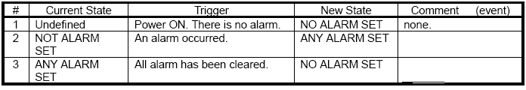

2.5 Limit Monitoring State Model

- Description of Functions

The equipment provides the following as limit monitoring function.
  - The maximum number of SVs, which can be monitored in same time is 4.
  - Host is capable of specifying 7 limit ID's (LIMITID) for one SV.
  - Equipment will constantly monitor the LIMITID specified by the host. If the SV experiences a change exceeding a LIMITID, the equipment sends it as a GemLimitZoneTransition event report.
  - A LIMITID has the band width between the UPPERDB and LOWERDB.
  - Equipment's SV monitor interval is set to one second, and a change occurring in shorter time span may not be monitored.
  - The SV's specifiable of the limit values are defined separately.

2) State Definition

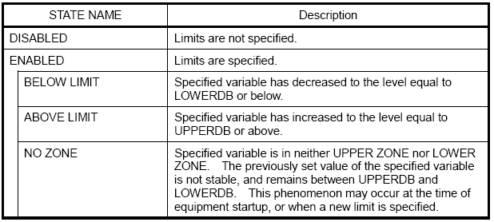

3) State Chart

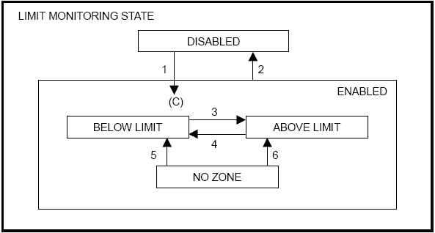

4) Transition Table

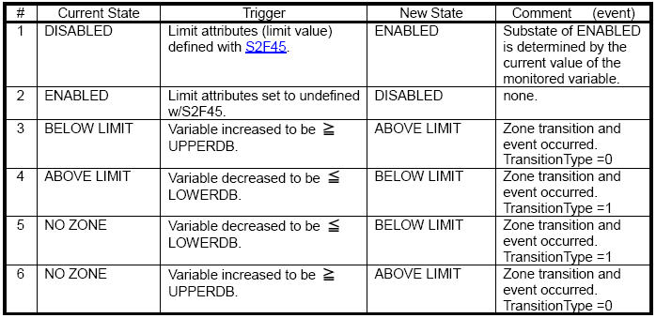

2.6 Spooling State Model

1) Description of Functions

The equipment provides the following functions for queuing messages intended for the host during times of communication failure and subsequently deliver them when communication is restored:
- Once the communication with the host is established, any message failed to send to the host will be stored in the spool area.
- The messages in the spool area will be transmitted to the host when it requests.
- Action to take when the spool area has become full may be specified on the equipment constant "OverWriteSpool".
- The spooled data will be retained in non-volatile storage when the equipment power is turned off.
- The messages to spool are limited to the primary messages issued by the equipment excluding the Stream 1 messages. The host may specify what messages to spool.
- If a block comprising a multi-block message failed to be transmitted, the entire message will be spooled.

2) State Definition

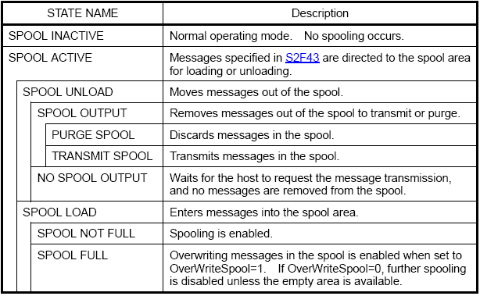

3) State Chart

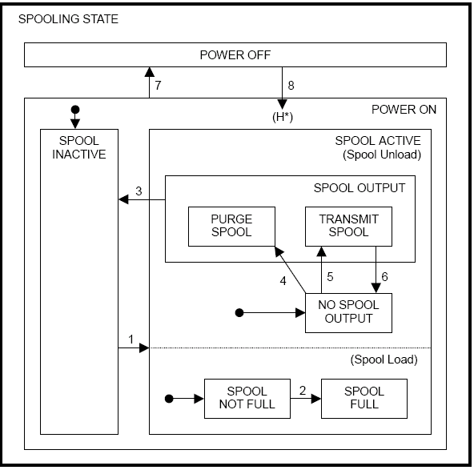

4) Transition Table

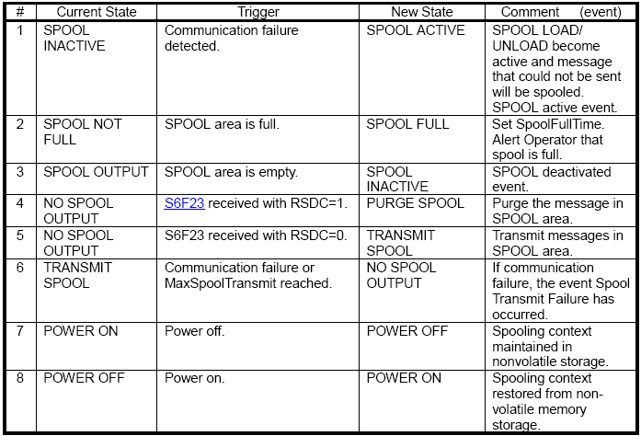

3 SECS MESSAGE SUMMARY

Cooling Equipment system supports the following SECS II messages.

3.1 Host To Equipment

Table 1: Supported SECS Messages, Host->Equipment
Host Primary | Equipment Reply | Description
(Any) | SxF0 | Off-line Abort Reply
S1F1 | S1F2 | Are You There Request
S1F3 | S1F4 | Selected Equipment Status Request
S1F11 | S1F12 | Status Variable Namelist Request
S1F13 | S1F14 | Establish Communication Request
S1F15 | S1F16 | Request Off-line
S1F17 | S1F18 | Request On-line
S2F13 | S2F14 | Equipment Constant Request
S2F15 | S2F16 | New Equipment Constant Send
S2F17 | S2F18 | Date and Time Request
S2F23 | S2F24 | Trace Initialize Send
S2F25 | S2F26 | Loopback Diagnostic Request
S2F29 | S2F30 | Equipment Constant Namelist Request
S2F31 | S2F32 | Date and Time Send
S2F33 | S2F34 | Define Report
S2F35 | S2F36 | Link Event Report
S2F37 | S2F38 | Enable/Disable Event Report
S2F39 | S2F40 | Multi-Block Inquire
S2F41 | S2F42 | Host Command Send
S2F43 | S2F44 | Reset Spooling Streams and Function
S2F45 | S2F46 | Define Variable Limit Attributes
S2F47 | S2F48 | Variable Limit Attributes Request
S5F3 | S5F4 | Enable/Disable Alarm Send
S5F5 | S5F6 | List Alarms Request
S5F7 | S5F8 | List Enabled Alarm Request
S6F15 | S6F16 | Event Report Request
S6F19 | S6F20 | Individual Report Request
S6F23 | S6F24 | Request Spooled Data
S7F1 | S7F2 | Process Program Load Inquire/Grant
S7F3 | S7F4 | Process Program Send
S7F5 | S7F6 | Process Program Request
S7F17 | S7F18 | Delete Process Program Send
S7F19 | S7F20 | Current EPPD Request
S10F3 | S10F4 | Terminal Display, Single
S10F5 | S10F6 | Terminal Display, Multiblock

3.2 Equipment to Host

Table 2: Supported SECS Messages, EquipmentHost
Equipment Primary | Host Reply | Description
(Any) | SxF0 | Off-line Abort Reply
S1F1 | S1F2 | Are You There Request
S1F13 | S1F14 | Establish Communications Request
S2F17 | S2F18 | Date and Time Request
S5F1 | S5F2 | Alarm Report Send
S6F1 | S6F2 | Trace Data Send
S6F5 | S6F6 | Multi-block Data Send Inquire
S6F11 | S6F12 | Event Report Send
S9F1 | -- | Unrecognized Device ID
S9F3 | -- | Unrecognized Stream Type
S9F5 | -- | Unrecognized Function Type
S9F7 | -- | Illegal Data
S9F9 | -- | Transaction Timer Time-out
S9F13 | -- | Conversation Timeout
S9F11 | -- | Data Too Long
S10F1 | S10F2 | Terminal Request

4 SECS MESSAGES DETAIL

This section contains the SECS messages referenced in this document. All standard messages are identical to SECS-II and GEM.

Abbreviations: S = Single block / M = Multi block
H = Host / E = Equipment (QGEMService)
->valid direction
reply (required)
[reply] (optional)

4.1 Stream 1: Equipment Status
This message stream provides a means of exchanging information about the status of the equipment, including its current mode.

S1F0 Abort Transaction (S1F0) S, H<—>E
Description: Used in lieu of an expected reply to abort a transaction. Function 0 is defined in every stream and has the same meaning in every stream.
Structure: Header only.

S1F1 Are You There Request (R) S, H<->E, reply
Description: Establishes whether the equipment or the host is on line. A function 0 response to this message means that communications are inoperative. In the equipment, a function 0 is equivalent to a timeout on the receive timer after issuing S1F1 to the host.
Structure: Header only.

S1F2 On Line Data (D) S, H<->E
Description: Data signifying that the equipment is alive.
Structure: L,2
<MDLN>
<SOFTREV>
Exception: The host sends a zero-length list to the equipment.

S1F3 Selected Equipment Status Request (SSR) S, H->E, reply
Description: A request to the equipment to report selected status values.
Structure: L,n
<SVID1>
…
<SVIDn>
Exception: A zero-length list means report all SVIDs.

S1F4 Selected Equipment Status Data (SSD) M, H<-E
Description: The equipment reports the value of each SVID requested, in the order requested. The host remembers the names of values requested.
Structure: L,n
<SV1>
…
<SVn>
Exception: If n=0, no response can be made. A zero length list returned for Svi means that SVIDi does not exist.

S1F11 Status Variable Namelist Request (SVNR) S, H->E, reply
Description: A request to the equipment to identify certain status variables.
Structure: L,n
<SVID1>
…
<SVIDn>
Exception: A zero length list means report all SVIDs.

S1F12 Status Variable Namelist Reply (VNRR) M, H<-E
Description: The equipment reports the name and units of the requested status variables to the host.
Structure: L,n
L,3
<SVID1>
<SVNAME1>
<UNITS1>
…
L,3
<SVIDn>
<SVNAMEn>
<UNITSn>

S1F13 Establish Communication Request (CR) S, H<->E, reply
Description: The purpose of this message is to formally establish communications between equipment and host. This is the first message sent following any period of inability to communicate.
Structure: L,2
<MDLN>
<SOFTREV>
Exception: The host sends a zero-length list to the equipment.

S1F14 Establish Communication Request Acknowledge (CRA) S, H<->E
Description: The purpose of this message is to accept or deny the Establish Communication Request (S1F13). MDLN and SOFTREV are on-line data and are valid only if COMMACK = Accepted.
Structure: L,2
<COMMACK>
L,2
<MDLN>
<SOFTREV>
Exception: The host sends a zero-length list for item 2 to the equipment.

S1F15 Request OFF-LINE (ROFL) S, H->E, reply
Description: The host requests an equipment transition to the OFF-LINE state.
Structure: Header only.

S1F16 OFF-LINE Acknowledge (OFLA) S, H<-E
Description: Acknowledge or error.
Structure: <OFLACK>.

S1F17 Request ON-LINE (RONL) S, H->E, reply
Description: The host requests an equipment transition to the ON-LINE state.
Structure: Header only.

S1F18 ON-LINE Acknowledge (ONLA) S, H<-E
Description: Acknowledge or error.
Structure: <ONLACK>.

4.2 Stream 2: Equipment Control and Diagnostics
All messages, which is deal with host control of the equipment. This includes all remote operations and equipment self-diagnostics, but specifically excludes control operations associated with material transfer.

S2F0 Abort Transaction (S2F0) S, H<—E
Description: Same form as S1F0

S2F13 Equipment Constant Request (ECR) S, H->E, reply
Description: Equipment constants, such as those used for calibration, servo gain, alarm limits, data collection mode, plus other values that are infrequently changed, can be obtained using this message.
Structure: L,n
<ECID1>
...
<ECIDn>
Exception: A zero-length list means report all ECVs according to a predefined order.

S2F14 Equipment Constant Data (ECD) M, H<-E
Description: Data response to S2F13 in the order requested.
Structure: L,n
<ECV1>
...
<ECVn>
Exception: If n=0, then no response exists. A zero length ECVi means that ECIDi does not exist.

S2F15 New Equipment Constant Send (ECS) S, H->E, reply
Description: Change one, or more, equipment constants.
Structure: L,n
L,2
<ECID1>
<ECV1>
L,2
<ECIDn>
<ECVn>

S2F16 New Equipment Constant Acknowledge (ECA) S, H<-E
Description: Acknowledge or error.
Structure: <EAC>

S2F17 Date and Time Request (DTR) S, H<->E, reply
Description: Useful to check that the equipment time base is synchronize with the host time base.
Structure: Header only.

S2F18 Date and Time Data (DTA) S, H<->E
Description: Actual time data.
Structure: <TIME>

S2F23 Trace Initialize Send (TIS) S, H->E, reply
Description: Host requests the equipment to periodically sample and report the status variables in the equipment. If the TRID has the same values as previously entered ones, the previous setting will be terminated and the new trace will be initiated. TOTSMP = 0 means to terminate the trace of the specified TRID.
Structure: L,5
<TRID>
<DSPER>
<TOTSMP>
<REPGSZ>
L,n
<SVID1>
…
<SVIDn>

S2F24 Trace Initialize Acknowledge (TIA) S, H<-E
Description: Equipment acknowledges trace initialize data.
Structure: <TIAACK>
Note: The number of the TRID's that may be traced is up to 4. If the trace for more than 4 is specified, it returns 'TIAACK = 2' meaning further number of tracing cannot be performed. The minimum data sampling period rate is 5 second. The maximum number of report group size allows is 4. The maximum number of the SVID allows in a report group size is 100.

S2F25 Loopback Diagnostic Request (LDR) S, H->E, reply
Description: A diagnostic message to checkout protocol and communication circuits.
Structure: <ABS>

S2F26 Loopback Diagnostic Data (LDD) S, H<-E
Description: The echoed binary string.
Structure: <ABS>

S2F29 Equipment Constant Namelist Request (ECNR) S, H->E, reply
Description: This function allows the host to obtain basic information about which equipment constants are available on the equipment.
Structure: L,n
<ECID1>
…
<ECIDn>
Exception: A zero length list means, send information on all ECIDs.

S2F30 Equipment Constant Namelist (ECN) S, H<-E
Description: Return response to S2F29.
Structure: L,n (number of equipment constants)
L,6
<ECID1>
<ECNAME1>
<ECMIN1>
<ECMAX1>
<ECDEF1>
<UNITS1>
L,6
…
…
L,6
<ECIDn>
<ECNAMEn>
<ECMINn>
<ECMAXn>
<ECDEFn>
<UNITSn>

S2F31 Date and Time Set Request (DTS) S, H->E, reply
Description: The host requires the equipment to synchronize its internal clock with the host time based TIME which is given.
Structure: <TIME>

S2F32 Date and Time Set Acknowledge (DTA) S, H<-E
Description: Acknowledge the receipt of time and date.
Structure: <TIACK>

S2F33 Define Report (DR) M, H->E, reply
Description: The purpose of this message is for the host to define a group of reports for the equipment.
Structure: L,2
<DATAID>
L,a
L,2
<RPTID1>
L,b
<VID1>
...
<VIDb>
...
L,2
<RPTIDa>
L,c
<VID1>
...
<VIDc>
Exception:
- A zero length list following DATAID deletes all report definitions and associated links.
- A zero length list following RPTID deletes report type RPTID. All CEID links to this RPTID are also deleted.
- Default RPTIDs are reserved for equipment system. New RPTID required for new report definitions.
- Default RPTIDs cannot not delete from the equipment system.

S2F34 Define Report Acknowledge (DRA) S, H<-E
Description: Acknowledge or error.
Structure: <DRACK>

S2F35 Link Event Report (LER) M, H->E, reply
Description: The purpose of this message is for the host to link n reports to an event (CEID). These linked event reports will default to 'disabled' upon linking. That is, the occurrence of an event would not cause the report to be sent until reporting for the event is enabled using S2F37.
Structure: L,2
<DATAID>
L,a
L,2
<CEID1>
L,b
<RPTID1>
...
<RPTIDb>
...
L,2
<CEIDa>
L,c
<RPTID1>
...
<RPTIDc>
Exception: A zero length list following CEID deletes all report links to that event.

S2F36 Link Event Report Acknowledge (LERA) S, H<-E
Description: Acknowledge or error.
Structure: <LRACK>

S2F37 Enable/Disable Event Report (EDER) S, H->E, reply
Description: The purpose of this message is for the host to enable or disable reporting for a group of events (CEIDs).
Structure: L,2
<CEED>
L,n #CEIDs
<CEID1>
…
<CEIDn>
Exception: A list of zero length following <CEED> means all CEIDs.

S2F38 Enable/Disable Event Report Acknowledge (EERA) S, H<-E
Description: Acknowledge or error.
Structure: <ERACK>

S2F39 Multiblock Inquire (DMBI) S, H->E, reply
Description: If an S2F33 or S2F35 message is more than one block, this transaction must precede the message.
Structure: L,2
<DATAID>
<DATALENGTH>

S2F40 Multiblock Grant (MBG) S, H<-E
Description: Acknowledge or error.
Structure: <GRANT>

S2F41 Host Command Send (HCS) S, H->E, reply
Description: The host requests the Equipment to perform the specified remote command with the associated parameters.
Structure: L,2
<RCMD> remote command
L,n n = number of parameters
L,2
CPNAME1 name of parameter #1
CPVAL1 value of parameter #1
…
L,2 n = number of parameters
CPNAMEn name of parameter #n
CPVALn value of parameter #n

S2F42 Host Command Acknowledge (HCA) S, H<-E
Description: Acknowledge host command or error. If a command is not accepted due to one or more invalid parameters (ie, HCACK=3), a list of invalid parameters is returned containing the parameter name and the reason it is invalid.
Structure: L,2
<HCACK>
L,n n = number of invalid parameters
L,2
CPNAME1 name of invalid parameter #1
CPACK1 reason of invalidity for parameter #1
...
L,2
CPNAMEn name of invalid parameter #n
CPACKn reason of invalidity for parameter #n
Note:
If there are no invalid parameters, a list of zero length will be sent for item 2.

S2F43 Reset Spooling Streams and Function (RSSF) S, H->E, reply
Description: Host selects specific streams and functions to be spooled whenever spooling is active.
Structure: L,m
L,2
<STRID1>
L,n
<FCNID1>
…
<FCNIDn>
…
L,2
<STRIDm>
L,n
<FCNID1>
…
<FCNIDn>
Note: If to set off spooling on all messages, set 'm=0'. If to set off spooling on all the messages of a specific stream, set 'n=0'. Spooling cannot be specified on Stream1. The FCNID specified by a STRID will replace the spooling specified by the same STRID previously. Addition of an FCNID cannot be specified.

S2F44 Reset Spooling Acknowledge (RSA) M, H<-E
Description: Equipment acknowledges Host's reset spooling request.
Structure: L,2
<RSPACK>
L,m
L,3
<STRID1>
<STRACK1>
L,n
<FCNID1>
…
<FCNIDn>
…
L,3
<STRIDm>
<STRACKm>
L,n
<FCNID1>
…
<FCNIDn>
Note: If RSACK=0 and m=0, it indicates no error was found. If n=0, it indicates no functions error for the stream.

S2F45 Define Variable Limit Attributes (DVLA) M, H->E, reply
Description: Host specifies limit monitoring.
Structure: L,2
<DATAID>
L,m
L,2
<VID1>
L,n
L,2
<LIMITID1>
L,p
<UPPERDB1>
<LOWERDB1>
…
L,2
<LIMITIDn>
L,p
<UPPERDBn>
<LOWERDBn>
…
L,2
<VIDm>
L,n
L,2
<LIMITID1>
L,p
<UPPERDB1>
<LOWERDB1>
…
L,2
<LIMITIDn>
L,p
<UPPERDBn>
<LOWERDBn>
Note: Set 'm=0' to cancel all of the limit monitoring. Set 'n=0' to cancel all of the limit monitoring for the VID. Set 'p = 0' to cancel the specific LIMITID.

S2F46 Variable Limit Attributes Acknowledge (VLAA) M, H<-E
Description: Equipment acknowledges Host's limit monitoring.
Structure: L,2
<VLAACK>
L,m m = number of invalid parameters
L,3
<VIDp>VIDp = VID with error
<LVACKp>LVACKp = reason
L,n
<LIMITID1>
<LIMITACK1>
…
L,3
<VIDx>
<LVACKx>
L,n
<LIMITID1>
<LIMITACK1>
Note: 'm=0' indicates no invalid limit attributes. 'n=0' indicates no invalid limit attributes for that VID.

S2F47 Variable Limit Attributes Request (VLAR) S, H->E, reply
Description: Host queries Equipment for current variable limit attribute definitions.
Structure: L,m
<VID1>
<VID2>
…
<VIDm>
Note: 'm' indicates the number of VIDs of which limit attributes are queried. Set 'm=0' to specify all VIDs which have limit attributes.

S2F48 Variable Limit Attributes Send (VLAS) M, H<-E
Description: Equipment sends Host values of requested variable limit attribute definitions in the order requested.
Structure: L,m
L,2
<VID>
L,p {p=0,4}
<UNITS1>
<LIMITMIN1>
<LIMITMAX1>
L,n
L,3
<LIMITID1>
<UPPERDB1>
<LOWERDB1>
…
L,3
<LIMITIDn>
<UPPERDBn>
<LOWERDBn>
…
L,2
<VIDm>
L,p {p=0,4}
<UNITS1>
<LIMITMIN1>
<LIMITMAX1>
L,n
L,3
<LIMITID1>
<UPPERDB1>
<LOWERDB1>
…
L,3
<LIMITIDn>
<UPPERDBn>
<LOWERDBn>
Note: 'm' is the number of VIDs in this request. 'n' is the number of LIMITIDs set on the VID. 'p=0' indicates that specific VID does not support limit monitoring function. 'n=0' indicates that no limit is set on the VID.

S2F49 Enhanced Remote Command (ERC) M, H<-E
Description: The host requests an object of perform the specified remote command with its associated parameters. If multi-block, it shall be preceded by the S2F39/F40 Multi-Block Inquire/Grant transaction.
Structure: L,4
<DATAID>
<OBJSPEC>
<RCMD>
L,m # of parameter groups
L, 2
<CPNAME1> command parameter 1 name
<CEPVAL1> command enhanced parameter 1 value
L, 2
<CPNAME2> command parameter 2 name
<CEPVAL2> command enhanced parameter 2 value
…
L, 2
<CPNAMEm> command parameter m name
<CEPVALm> command enhanced parameter m value

If a specific value of CPNAME is defined to have a CEPVAL defined as a LIST, it shall always be a LIST. If the CEPVAL that is associated to that specific value of CPNAME is defined to be anything other than LIST, it will result in a format error.

Exception: A zero length list, m=0, indicates that no parameter groups are sent with the command. OBJSPEC can get a null length item.

Note: If CEPVAL is a LIST, the items that make up a list of items with an identical format, as illustrated below.

<CPNAME>
L,m
<CPVALa1>
<CPVALa2>
…
<CPVALam>

S2F50 Enhanced Remote Command Acknowledge (ERCA) M, H<-E
Description: This equipment acknowledges Enhanced Remote Command or reports any error(s). If the command is not accepted due to one or more invalid parameters,
(i.e. HCACK = 3), then a list of invalid parameters will be returned containing the parameter name and reason for being invalid
Structure: L, 2
<HCACK>
L, n # of parameters groups
L, 2
<CPNAME1>
<CEPACK1>
…
L, 2
<CPNAMEn>
<CEPACKn>

4.3 Stream 5: Exception Reporting
This stream contains messages regarding equipment alarms. The alarms are generated by the equipment in response to changing conditions detected by the equipment.

S5F0 Abort Transaction (S5F0)
Description: Same form as S1F0.

S5F1 Alarm Report Send (ARS) S, H<-E, reply
Description: This message reports a change in or presence of an alarm condition. One message will be issued when the alarm is set and one when the alarm is cleared.
Structure: L,3
<ALCD>
<ALID>
<ALTX>

S5F2 Alarm Report Acknowledge (ARA) S, H->E
Description: Acknowledge or error.
Structure: <ACKC5>

S5F3 Enable/Disable Alarm Send (EAS) S, H->E, reply
Description: This message will change the state of the enable bit of all alarms in the equipment. The enable bit determines if the alarms will be sent to the host.
Structure: L,2
<ALED>
<ALID>
Note: A zero-length item for ALID means that all alarms are enabled or disabled.

S5F4 Enable/Disable Alarm Acknowledge (EAA) S, H<-E
Description: Acknowledge or error.
Structure: <ACKC5>

S5F5 List Alarms Request (LAR) S, H->E, reply
Description: This message requests the equipment to send alarm information to the host.
Structure: <ALID1,…ALIDn>
Exception: A zero length item means send all possible alarms regardless of the state of ALED.

S5F6 List Alarm Data (LAD) M, H<-E
Description: This message contains the alarm data known to the equipment. There are “m” alarms in the list.
Structure: L,m
L,3
<ALCD1>
<ALID1>
<ALTX1>
…
L,3
<ALCDm>
<ALIDm>
<ALTXm>
Exception: A zero-length item returned for ALTXi means that the given ALIDi does not exist.

S5F7 List Enabled Alarm Request (LEAR) S, H->E, reply
Description: This message requests the equipment to send enabled alarm information to the host.
Structure: Header only.

S5F8 List Enabled Alarm Data (LEAD) M, H<-E
Description: This message contains the enabled alarm data known to the equipment. There are “m” alarms in the list.
Structure: L,m
L,3
<ALCD1>
<ALID1>
<ALTX1>
…
L,3
<ALCDm>
<ALIDm>
<ALTXm>
Exception: A zero-length item returned for ALTXi means that enabled ALIDi does not exist.

4.4 Stream 6: Data Collection
This message stream covers the needs of in-process measurement and equipment monitoring.

S6F0 Abort Transaction (S6F0) S, H<—E
Description: Same form as S1F0.

S6F1 Trace Data Send (TDS) M, H<-E, reply
Description: Equipment reports trace data as specified in the S2F23.
Structure: L,4
<TRID>
<SMPLN>
<STIME>
L,n
<SV1>
<SV2>
…
<SVn>
Note: The SV's are arranged in the sequence of sampling cycle, and the data of the same sampling cycle are arranged in the order of the SVID's specified in the S2F23.

S6F2 Trace Data Acknowledge (TDA) S, H->E
Description: Host acknowledges trace data report.
Structure: <ACKC6>

S6F5 Multi-block Data Send Inquire (MBI) S, H<-E, reply
Description: If the discrete data report S6F11 can involve more than one block, this transaction precedes the transmission.
Structure: L,2
<DATAID>
<DATALENGTH>

S6F6 Multi-block Grant (MBG) S, H->E
Description: Grant permission to send multi-block message.
Structure: <GRANT>

S6F11 Event Report Send (ERS) S, H<-E, reply
Description: The purpose of this message is for the equipment to send a defined, linked and enabled group of reports to the host upon the occurrence of an event (CEID).
Structure: L,3
<DATAID>
<CEID>
L,a
L,2 data of report #1
<RPTID1>
L,b
<V1>
...
<Vb>
...
L,2 data of report #a
<RPTIDa>
L,c
<V1>
...
<Vc>
Exception: If there are no reports linked to the event, a ‘null’ report is assumed. A zero-length list for the number of reports means there are no reports linked to the given CEID.

S6F12 Event Report Acknowledge (ERA) S, H->E
Description: Acknowledge or error.
Structure: <ACKC6>

S6F15 Event Report Request (ERR) S, H->E, reply
Description: Host requests the equipment to send an event report group by specifying its CEID.
Structure: <CEID>

S6F16 Event Report Data (ERD) M, H<-E
Description: Equipment sends host the reports linked to the CEID.
Structure: Same as S6F11.

S6F19 Individual Report Request (IRR) S, H->E, reply
Description: Host requests the equipment a defined report by specifying the report ID.
Structure: <RPTID>

S6F20 Individual Report Data (IRD) M, H<-E
Description: Equipment sends host variable data defined for the given RPTID.
Structure: L,n
<V1>
…
<Vn>
Note: The 'n=0' means RPTID is not defined.

S6F23 Request Spooled Data (RSD) S, H->E, reply
Description: Host requests the equipment to send spooled data.
Structure: <RSDC>

S6F24 Request Spooled Data Ack. Send (RSDAS) S, H<-E
Description: Equipment acknowledges spooled data send request and starts sending it.
Structure: <RSDA>

4.5 Stream 7: Process Program Management
The functions in this stream are used to manage and transfer process programs. Process programs are the equipment-specific descriptions that determine the procedure to be conducted on the material by a single equipment. Methods are provided to transfer programs between equipment and host.

S7F0 Abort Transaction (S7F0) S, H<—E
Description: Same form as S1F0.

S7F1 Process Program Load Inquire (PPI) S, H<->E, reply
Description: This message is used to initiate the transfer of a process program (recipe) or to select one from a number of stored programs. The message may be used to initiate the transfer of an unformatted process program (S7F3/F4).
Structure: L,2
<PPID>
<LENGTH>

S7F2 Process Program Load Grant (PPG) S, H<->E
Description: This message gives permission for the process program to be loaded.
Structure: <PPGNT>

S7F3 Process Program Send (PPS) M, H<->E, reply
Description: The program is sent.
Structure: L,2
<PPID>
<PPBODY>

S7F4 Process Program Acknowledge (PPA) S, H<->E
Description: Acknowledge or error.
Structure: <ACKC7>

S7F5 Process Program Request (PPR) S, H<->E, reply
Description: This message is used to request the transfer of a process program.
Structure: <PPID>

S7F6 Process Program Data (PPD) M, H<->E
Description: This message is used to request the transfer a process program.
Structure: L,2
<PPID>
<PPBODY>
Exception: A zero length list means request denied.

S7F17 Delete Process Program Send (DPS) S, H<->E, reply
Description: This message is used by the host to request the equipment deletes programs from the equipment storage (hard disk).
Structure: L,n (number of process programs to be deleted)
<PPID1>
…
<PPIDn>
Exception: If n = 0, then delete all process programs

S7F18 Delete Process Program Acknowledge (DPA) S, H<->E
Description: Acknowledge or error.
Structure: <ACKC7>

S7F19 Current EPPD Request (RER) S, H->E, reply
Description: This message is used to request the transmission of the current equipment process program directory (EPPD). This directory is a list of all the PPIDs of the process programs currently stored on the hard disk of the Equipment.
Structure: Header only

S7F20 Current EPPD Data (RED) S, H<-E
Description: This message is used to transmit the current equipment process program directory (EPPD).
Structure: L,n (number of process programs in the directory)
<PPID1>
…
<PPIDn>

4.6 Stream 9: System Errors
This message stream provides a method of informing the host that a message block has been received which cannot be handled, or that a timeout on a transaction (receive) timer has occurred. The message indicates that either a Message Fault or a Communications Fault has occurred, it does not indicate a Communications Failure.

S9F0 Abort Transaction (S9F0) S, H<—E
Description: Same form as S1F0.

S9F1 Unrecognized Device ID (UDN) S, H<-E
Description: The device ID in the message block header did not correspond to any known device ID on the equipment.
Structure: <MHEAD>

S9F3 Unrecognized Stream Type (USN) S, H<-E
Description: The equipment does not recognize the stream type in the message block header.
Structure: <MHEAD>

S9F5 Unrecognized Function Type (UFN) S, H<-E
Description: The equipment does not recognize the function type in the message block header.
Structure: <MHEAD>

S9F7 Illegal Data (IDN) S, H<-E
Description: This message indicates that the stream and function of the received message were recognized, but the associated data format could not be interpreted.
Structure: <MHEAD>

S9F9 Transaction Timer Timeout (TTN) S, H<-E
Description: This message indicates that a transaction (receive) timer has timed out and that the corresponding transaction has been aborted. It is up to the host to respond to this error in an appropriate manner to keep the system operational.
Structure: <SHEAD>

S9F11 Data Too Long (DLN) S, H<-E
Description: This message to the host indicates that the equipment has received more data than it can handle.
Structure: <MHEAD>

S9F13 Conversation Timeout (CTN) S, H<-E
Description: This message indicates that the equipment has expected data, but none was received within a reasonable length of time. In such cases, resources are cleared.
Structure: L,2
<MEXP>
<EDID>

4.7 Stream 10: Terminal Services
The function of this stream is to pass text messages between the host and the operator's monitor screen on the equipment. The equipment makes no attempt to interpret the text of the message, but merely displays it. Management of the human response, times etc, to the information displayed is the responsibility of the host.

S10F0 Abort Transaction (S10F0) S, H<—E
Description: Same form as S1F0.

S10F1 Terminal Request (TRN) S, H<-E, reply
Description: A terminal text message from the equipment to the host.
Structure: L,2
<TID>
<TEXT>

S10F2 Terminal Request Acknowledge (TRA) S, H->E
Description: Acknowledge or error.
Structure: <ACKC10>

S10F3 Terminal Display, Single (VTN) S, H->E, reply
Description: Data from the host to be displayed on the equipment.
Structure: L,2
<TID>
<TEXT>

S10F4 Terminal Display, Single Acknowledge (VTA) S, H<-E
Description: Acknowledge or error.
Structure: <ACKC10>

S10F5 Terminal Display, Multi-Block (VTN) M, H->E, reply
Description: Data from host to be displayed on the equipment monitor.
Structure: L,2
<TID>
L,n n = number of lines to display, maximum 8
<TEXT1>
…
<TEXTn>

S10F6 Terminal Display, Multi-Block Acknowledge (VTA) S, H<-E
Description: Acknowledge or error.
Structure: <ACKC10>

5 SECS SCENARIO

5.1 Alarm Management

5.1.1 Enable/Disable Alarms
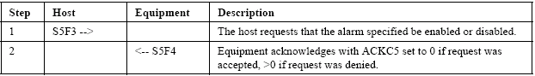

5.1.2 Send Alarm Report
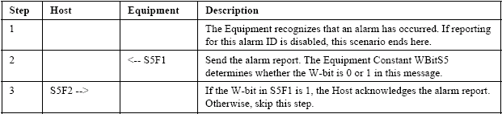

5.1.3 Upload Alarm Information
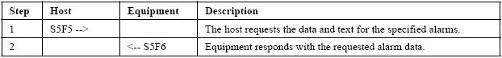

5.2 Clock

5.2.1 Equipment Requests Date and Time
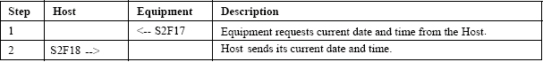

5.2.2 Host Instructs Equipment to Set Date and Time
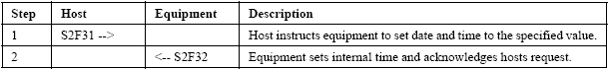

5.2.3 Host Requests Date and Time
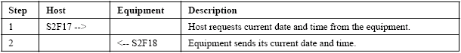

5.3 ControlState

5.3.1 Equipment Initiated Are You There
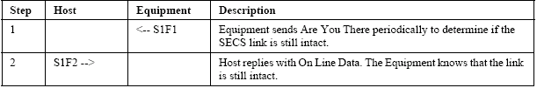

5.3.2 Host Sends Off Line
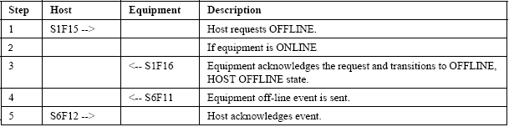

5.3.3 Host Sends On Line
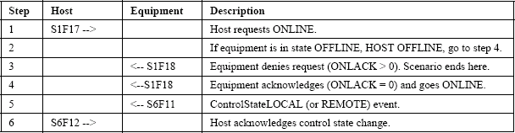

5.3.4 Operator Sets Off-Line When Equipment In On-Line State
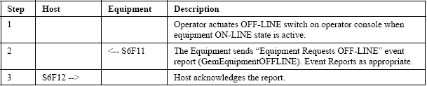

5.3.5 Operator Sets On-Line (Remote) When Equipment In Off-Line State
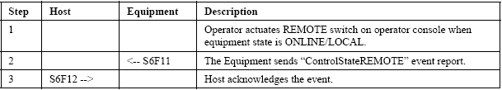

5.3.6 Operator Sets On-Line (Local) When Equipment In Off-Line State
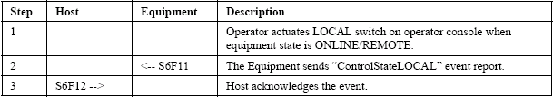

5.4 Data Collection

5.4.1 Equipment Reports Event
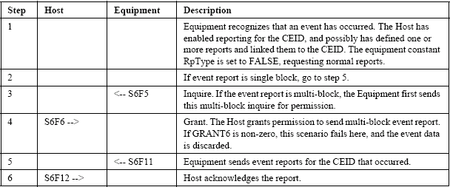

5.4.2 Event Reporting Setup
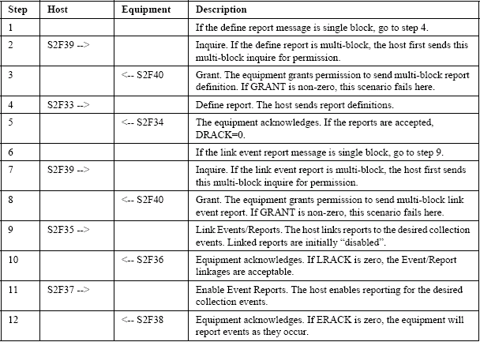

5.4.3 Host Requests Equipment Constants
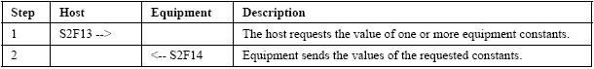

5.4.4 Host Requests Equipment Constants Namelist
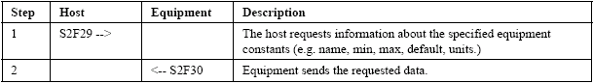

5.4.5 Host Requests Event Report
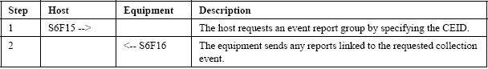

5.4.6 Host Requests Report (Variable Data Collection)
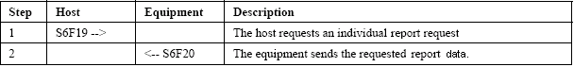

5.4.7 Host Requests Status Variable Namelist
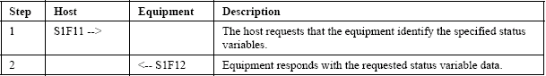

5.4.8 Host Request Status Variable Report
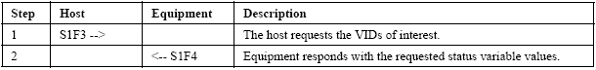

5.4.9 Set Equipment Constants
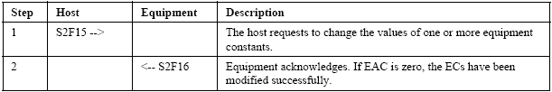

5.4.10 Trace Data Collection
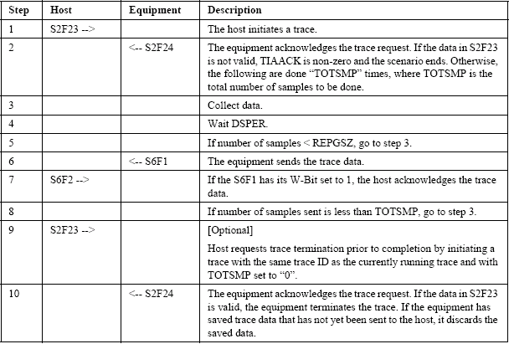

5.5 Error Messages

5.5.1 Message Fault due to Unrecognized Device ID
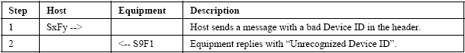

5.5.2 Message Fault due to Unrecognized Stream
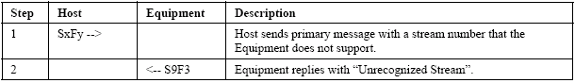

5.5.3 Message Fault due to Unrecognized Function
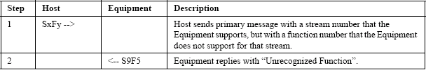

5.5.4 Message Fault due to Illegal Data Format
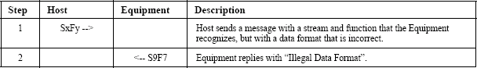

5.5.5 Message Fault due to Transaction Timer Time-out
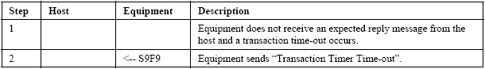

5.5.6 Message Fault due to Data Too Long
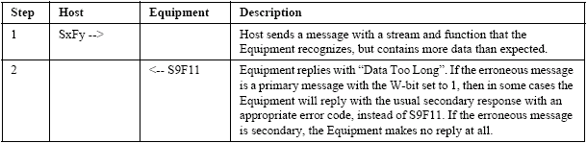

5.5.7 Message Fault due to Conversation Timeout
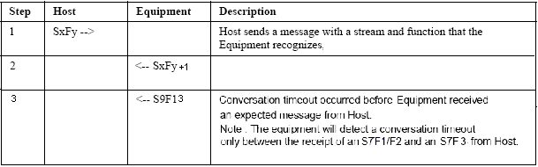

5.6 Establish Communications

5.6.1 Equipment Attempts to Establish Communications
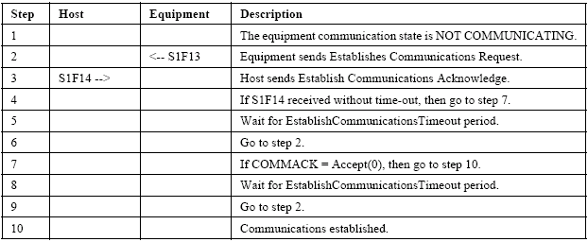

5.6.2 Equipment Attempts to Establish Communications Denied
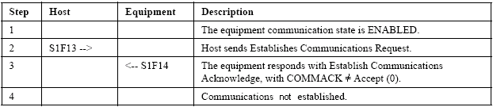

5.6.3 Equipment Attempts to Establish Communications Fails
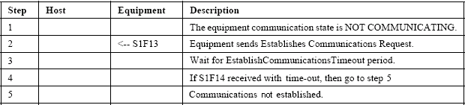

5.6.4 Host Attempts to Establish Communications
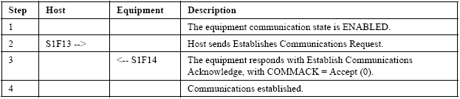

5.6.5 Host Initiated Are You There
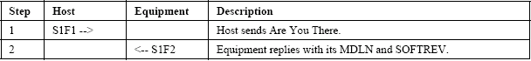

5.6.6 Simultaneous Attempt to Establish Communications (I)
The equipment receives S1F14 from the host before sending S1F14.
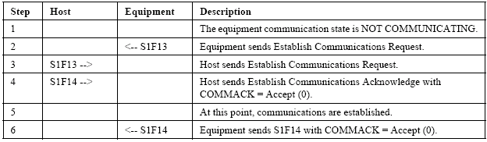

5.6.7 Simultaneous Attempt to Establish Communications (II)
The equipment sends S1F14 to the host before receiving S1F14.
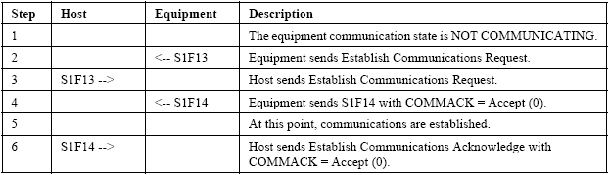

5.7 Limit Monitoring

5.7.1 Host Defines Limit Attributes
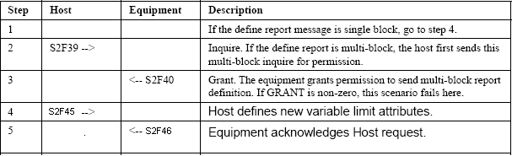

5.7.2 Host Queries Equipment for Current Limits
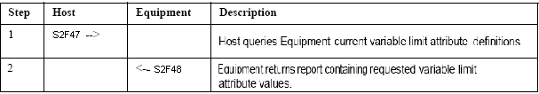

5.8 Process Program Management

5.8.1 Program Deletion by the Host
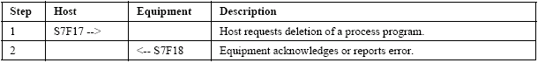

5.8.2 Program Directory Request
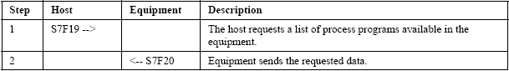

5.8.3 Host-initiated Program Download Request
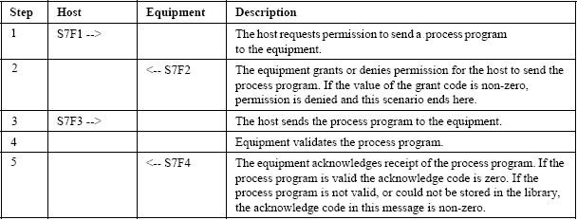

5.8.4 Host-initiated Process Program Upload (Unformatted)
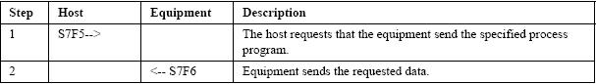

5.9 Remote Control

5.9.1 Host Sends Remote Command to Equipment
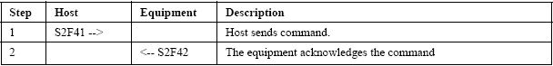

5.9.2 Host Sends Enhanced Remote Command to Equipment
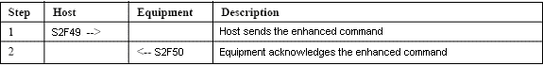

5.10 Spooling

5.10.1 Define Spooled Messages
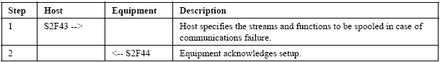

5.10.2 Request or Delete Spooled Data
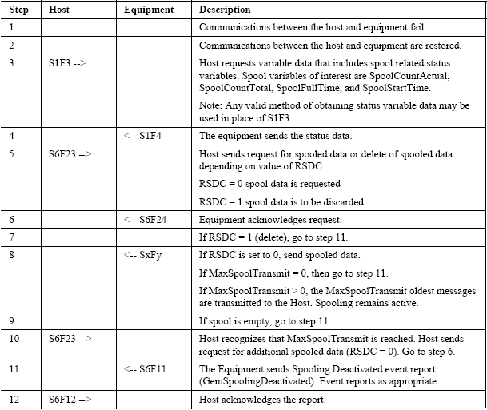

5.11 Terminal Service

5.11.1 Host Sends Information to Equipment’s Display Device
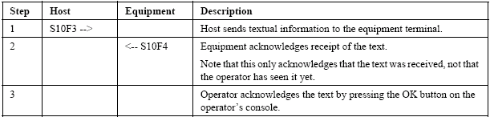

5.11.2 Host Sends Multi-block Text Message to Equipment
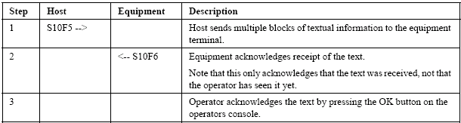

5.11.3 Operator Sends Information to the Host
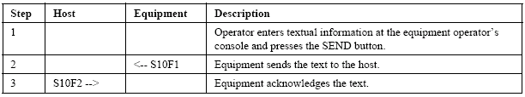

6 REMOTE COMMANDS

Table 6-1 lists the remote commands available on the system. The format for each command is given in Table 6-2, and parameters used with each command are listed in Table 6-3.

Table 6-1: Remote Commands
RCMD | Description
SETUPJOB | Job Information received to be store in database by equipment
STARTJOB | Start Job information received as permission to start a job

Table 6-2: Remote Command Formats
RCMD and Format | Description
SETUPJOB  L, 2  1. “SETUPJOB”  2. L, 3  1. L, 2  1. “JobParameters”  2. L, 2  1. L, 2  1. “JobName”  2. <JobName>  2. L, 2  1. “LotNumber”  2. <LotNumber>  2. L, 2  1 “RecipeParameter”  2. L, 2  1. L, 2  1. “CT”  2. <CT>  2. L, 2  1. “ST”  2. <ST>  3. L, 2  1. “Carriers”  2. L, n  1. <Carriers> | JobParameters consist of 2 elements which are <JobName> and <LotNumber>  RecipeParameter consist of 2 elements which are <CT> and <ST>  Carrier consist a list of elements which are <Carriers>
STARTJOB  L, 2  1. “JobName”  2. <JobName> | JobName consist of an element which is <JobName>

Table 6-3: Remote Command Parameters
CPNAME | Used In | Description | Format
JobName | SETUPJOB | JobName to be run by equipment | A, 20 bytes
LotNumber | SETUPJOB | LotNumber to be run by equipment | A, 20 bytes
CT | SETUPJOB | Cooling Time in seconds | A, 20 bytes
ST | SETUPJOB | Staging Time in seconds | A, 20 bytes
Carriers | SETUPJOB | List of carriers ID | A, 20 bytes
JobName | STARTJOB | JobName to be start by equipment | A, 20 bytes

APPENDIX A: DATA ITEM DICTIONARY

The following data items are used by the SECS-II messages (SECS-II Messages Detail).

Data Item | Description/ Codes | Format | Where Used
ABS | Any binary string to confirm communication line is alive.  Variable data length,  maximum of 40 bytes. | B | S2F25,F26
ACKC5 | Acknowledge code, 1 byte  0 = Accepted  64 = ALED has an illegal value  65 = ALID has an illegal value  * ACKC5 not = 0 returned from HOST is regarded as accepted. | B | S5F2,F4
ACKC6 | Acknowledge code, 1 byte  0 = Accepted and done  >0 = Error, not done  * ACKC6 not = 0 returned from HOST is regarded as accepted. | B | S6F12
ACKC7 | Acknowledge code, 1 byte  0 = Accepted  1 = Permission not granted  2 = Length error  3 = Matrix overflow  4 = PPID (recipe file) not found  64 = Illegal PPID (recipe file name) | B | S7F4,F18
ACKC10 | Acknowledge code, 1 byte  0 = Accepted for display  1 = Message will not be displayed  2 = Terminal not available | B | S10F2,F4,F6
ALCD | Alarm code, 1 byte  bit 8 = 1 means alarm set  bit 8 = 0 means all alarms cleared  bit 7-1 are not used | B | S5F1,F6
ALED | Alarm enable/disable code, 1 byte  bit 8 = 1 means enable all alarms  bit 8 = 0 means disable all alarms | B | S5F3
ALID | Alarm identification | U4 | S5F1,F3,F5,F6
ALTX | Alarm text | A | S5F1
CEED | Collection event enable/disable code, 1 byte  FALSE = Disable  TRUE = Enable | BL | S2F37
CEID | Collected Event ID | U4 | S2F35,S6F11,F15,F16
CEPACK | Command enhanced parameter acknowledge, 1 byte  1 = Parameter Name (CPNAME) does not exist  2 = Illegal Value specified for CEPVAL  3 = Illegal Format specified for CEPVAL  4 = Parameter Name (CPNAME) not valid as used | B | S2F50
COMMACK | Establish communications acknowledge code, 1 byte  0 = Accepted.  1 = Denied, try again. | B | S1F14
CPACK | Command parameter acknowledge code, 1 byte  1 = Parameter Name (CPNAME) does not exist  2 = Illegal Value specified for CPVAL  3 = Illegal Format specified for CPVAL | B | S2F42
CPNAME | Command Parameter Name. User defined. | A | S2F41,F42,F49,F50
CPVAL | Command Parameter Value. | Any, except L | S2F41
DATAID | Data Identifier. A unique name used to link multi-block messages for a single event report. | U4 | S2F33,F35, F39,F49,S6F5,F11,F16
DATALENGTH | Total number of bytes to be sent. | U4 | S2F39,S6F5
DRACK | Acknowledge code, 1 byte  0 = Accepted.  1 = Denied. Insufficient space.  2 = Denied. Invalid format.  3 = Denied. At least one RPTID already defined.  4 = Denied. At least one VID does not exist. | B | S2F34
DSPER | Character string to indicate data sampling period, 6 bytes  hhmmss | A | S2F23
EAC | Equipment acknowledge code, 1 byte  0 = Acknowledge  1 = Denied, at least one constant does not exist  2 = Denied, busy  3 = Denied, at least one constant out of range | B | S2F16
ECDEF | Equipment constant default value | Any | S2F30
ECID | Equipment constant ID | U4 | S2F13,F15,F29,F30
ECMAX | Equipment constant maximum value | Any | S2F30
ECMIN | Equipment constant minimum value | Any | S2F30
ECNAME | Equipment constant name  Note:  A zero length value means that an illegal ECID has been given or that the ECV doesn’t exist with the actual configuration or settings of the equipment. | A | S2F30
ECV | Equipment constant value  Note:  A zero length value means that an illegal ECID has been given or that the ECV doesn’t exist with the actual configuration or settings of the equipment. | Any | S2F14,F15
EDID | Expected data identification  One possible response  MEXP EDID  S7F3 <PPID> | A | S9F13
ERACK | Enable/disable event report acknowledge code, 1 byte  0 = Accepted  1 = Denied. At least one CEID does not exist | B | S2F38
FCNID | Function number | U1 | S2F43,F44
GRANT | Permission to send, 1 byte  0 = Permission granted  1 = Busy, try again  2 = Insufficient space | B | S2F40,S6F6
HCACK | Host command parameter acknowledge code, 1 byte  0 = Acknowledge, command has been performed  1 = Command does not exist  2 = Cannot perform now  3 = At least one parameter is invalid  4 = Acknowledge, command will be performed later  5 = rejected, not in remote mode / already in desired condition  6 = Invalid object | B | S2F42,F50
LENGTH | Length of the process program in bytes | U4 | S7F1
LIMITACK | Acknowledge code for variable limit attribute set, 1 byte  1 = LIMITID does not exist  2 = UPPERDB > LIMITMAX  3 = LOWERDB < LIMITMIN  4 = UPPERDB < LOWERDB  5 = UPPERDB/LOWERDB format error  6 = ASCII character string cannot be translated into numeric  7 = Duplicated variable limit is set for this variable  64 = Error occurred on equipment software | B | S2F46
LIMITID | Identifier of Limit (as defined by UPPERDB and LOWERDB), 1 byte | B | S2F45,F46,F48
LIMITMAX | The maximum value allowed for the specific variable | Any | S2F48
LIMITMIN | The minimum value allowed for the specific variable | Any | S2F48
LOWERDB | The variable limit attribute, which defines the lower boundary of Limit ID. Specified together with UPPERDB | Any | S2F45,F48
LRACK | Acknowledge code, 1 byte  0 = Accepted.  1 = Denied. Insufficient space.  2 = Denied. Invalid format.  3 = Denied. At least one CEID link already defined.  4 = Denied. At least one CEID does not exist.  5 = Denied. At least one RPTID does not exist. | B | S2F36
LVACK | Variable limit definition acknowledge code, 1 byte.  1 = Variable does not exist  2 = Variable has no limit capability  3 = Same variable is repeated in the message  4 = Limit value error as described in LIMITACK  64 = Error occurred on equipment software | B | S2F46
MDLN | Equipment model | A | S1F2,F13,F14,S7F23,F26
MEXP | Message expected in the form SxFy, where x is stream and y is function | A | S9F13
MHEAD | SECS message block header, associated with message block in error, 10 bytes | B | S9F1,F3,F5,F7,F11
OBJSPEC | A text string that is used to point to a specific object instance | A | S2F49
OFLACK | Acknowledge code for OFF-LINE request, 1 byte  0 = OFF-LINE acknowledge | B | S1F16
ONLACK | Acknowledge code for ON-LINE request, 1 byte  0 = ON-LINE accepted  1 = ON-LINE not allowed  2 = Equipment already ON-LINE | B | S1F18
PPBODY | Process Program Body (recipe file) | B | S7F3,F6
PPGNT | Process Program Grant status, 1 byte  0 = OK  1 = Already have  2 = No space  3 = Invalid PPID  4 = Busy, try later  5 = Other error | B | S7F2
PPID | Process program ID (recipe file name) | A | S7F1,F3,F5,F6,F23,F25,F26
RCMD | Remote command code. User defined | A | S2F41,F49
REPGSZ | Reporting group size | U4 | S2F23
RPTID | Report ID. The grouping ID of variable data.  Report ID <= 100 is reserved for predefined RPTID in the equipment system. Host need to use RPTID > 100 to define report. | U4 | S2F33,F35,S6F11,F16,F19
RSDA | Request spool data acknowledge code, 1 byte  0 = OK  1 = Denied, busy try again later  2 = Denied, spooled data does not exist  64 = Error occurred on equipment software | B | S6F24
RSDC | Request spool data code  0 = Transmit spooled messages  1 = Purge spooled message | U1 | S6F23
RSPACK | Reset spooling acknowledge code, 1 byte  0 = Acknowledge, spooling setup accepted  1 = Spooling setup rejected  64 = Error occurred on equipment software | B | S2F44
SHEAD | Stored message header related to the transaction timer, 10 bytes | B | S9F9
SMPLN | Sample number. Indicates the sampling count of trace report. The first time is counted one, and increased by one | U4 | S6F1
SOFTREV | Software Revision code | A | S1F2,F13,F14,S7F23,F26
STIME | Character string expressing latest sampled time, 12 bytes  YYMMDDhhmmss | A | S6F1
STRACK | Spool set stream acknowledge code, 1 byte  1 = Specified Stream cannot be set (example: Stream = 1)  2 = Specified Stream is invalid  3 = Specified Stream/Function is invalid  4 = Secondary message was specified  64 = Error occurred on equipment software | B | S2F44
STRID | Stream number | U1 | S2F43,F44
SV | Status variable value  Note:  A zero length value means that an illegal SVID has been given or that the SV doesn’t exist with the actual configuration or settings of the equipment. | Any | S1F4,S6F1
SVID | Status variable data ID | U4 | S1F3,F11,F12,S2F23
SVNAME | Status variable name  Note:  A zero length value means that an illegal SVID has been given or that the Status Value doesn’t exist with the actual configuration or settings of the equipment. | A | S1F12
TEXT | A single line of characters | A | S10F1,F3,F5
TIAACK | Trace acknowledge code, 1 byte  - = Everything correct  - = Too many SVIDs  - = No more trace allowed  - = Invalid sampling period  - = Duplicated SVIDs  - = SVIDs not exist  64 = Error occurred on equipment software | B | S2F24
TIACK | Time acknowledge code, 1 byte  0 = OK  1 = Error, not done | B | S2F32
TID | Terminal number, 1 byte. 0 = Main terminal | B | S10F1,F3,F5
TIME | Time of day. Depending upon the ECV “TimeFormat” the equipment sends the following formats:  YYMMDDhhmmss 12 characters  YYYYMMDDhhmmsscc 16 characters  The equipment accepts both formats from the host | A | S2F18,F31
TOTSMP | Total samples to be made | U4 | S2F23
TRID | Trace request ID | U4 | S2F23,S6F1
UNITS | Units identifier of a SV or ECV.  Notes:  A zero length value means that no units are defined for the given  SV or ECV (Example: any error counter). A zero length value will also be returned, if an illegal SVID or ECID has been given or if the SV or ECV doesn’t exist with the actual configuration or settings of the equipment. | A | S1F1,S2F30,F48
UPPERDB | The variable limit attribute, which defines the upper boundary of Limit ID. Specified together with LOWERDB | Any | S2F45,F48
V | Variable data value (includes SVs, ECVs, DVVALs). | Any | S6F11,F16,F20
VID | Variable data ID (includes SVIDs, ECIDs, DVIDs). | U4 | S2F33,F45,F46,F47,F48
VLAACK | Variable limit attribute acknowledge code, 1 byte  0 = Acknowledge  1 = Limit attribute definition error  2 = Cannot perform now  64 = Error occurred on equipment software | B | S2F46

APPENDIX B: VARIABLE ITEM DICTIONARY

This section describes variables and constants related specifically to the GEM interface itself.

1-100 = reserved for GEM Variables
Above 101 = reserved for Cooling Equipment Variables

Communications Data Items
VID | Type | Format | Description
1 | EC | U1 | InitCommState  Determines whether communications are enabled or disabled following system initialization.  0 = Disabled  1 = Enabled (default)
2 | SV | U1 | CommState  Indicates current communication state of the system.  0 = Disabled  1 = Enabled-Not Communicating  2 = Enabled-Communicating
3 | EC | U2 | EstablishCommunicationTimeout  Determines how often the equipment attempts to establish communications with the host. Units = s.  Valid range is 0 - 1800. Default is 30 seconds.  A value of 0 means the equipment will not attempt to establish contact, but will wait for the host to do so.
4 | EC | U2 | HeartBeat  Determines how long the equipment waits after sending the last message before sending an S1F1 “heartbeat” message. Units = s.  Valid range is 0 - 1800. Default is 30 seconds.  A value of 0 disables the heartbeat.

Command Data Items
VID | Type | Format | Description
5 | SV | A | PreviousCommand  Name of the last command issued to the equipment.

Alarm Data Items
VID | Type | Format | Description
6 | EC | U1 | WBITS5  Determines whether S5 messages will have the “W” bit set (i.e., will expect a reply from the host).  0 = W bit cleared  1 = W bit set (default)
7 | DV | U4 | AlarmID  Indicates the alarm ID of the cause of the latest transition.
8 | SV | L | AlarmsEnable  A list of the currently enabled alarms.
9 | SV | L | AlarmsSet  A list of the alarms currently in the set (or unsafe) condition.
10 | SV | U1 | AlarmState  Indicates the direction of the latest alarm transition.  0 = ON to OFF  1 = OFF to ON

Event Reporting Data Items
VID | Type | Format | Description
11 | SV | U4 | PreviousCEID  Indicates the CEID of the previous event.
12 | EC | U1 | WBITS6  Determines whether S6 messages will have the “W” bit set (i.e., will expect a reply from the host).  0 = W bit cleared  1 = W bit set (default)
13 | SV | L | EventsEnabled  A list of events that are enabled.

Clock Data Items
VID | Type | Format | Description
14 | SV | A | Clock  The host’s view of the current time and date. Units = cs.  The format of the data is YYYYMMDDhhmmsscc
15 | EC | U1 | TimeFormat  Determines whether a 12-byte or 16-byte value (required for Year 2000 compliance) for the current date/time will be used.  0 = 12-byte format  1 = 16-byte format (default)

ControlState Data Items
VID | Type | Format | Description
16 | EC | U1 | InitControlState  Determines whether the equipment comes up in the on-line or off-line control state.  1 = Off-line (default)  2 = On-line
17 | EC | U1 | OfflineSubstate  Determines what off-line substate the equipment is to come up in if the InitControlState is set to Off-line.  1 = Off-line, equipment off-line (default)  2 = Off-line, attempt on-line  3 = Off-line, host off-line.
18 | EC | U1 | OnlineFailed  Determines what off-line substate the equipment enters if an attempt to go on-line fails.  1 = Off-line, equipment off-line (default)  3 = Off-line, host off-line
19 | EC | U1 | OnlineSubstate  Determines what on-line substate the equipment enters when going on-line.  4 = On-line, local (default)  5 = On-line, remote
20 | SV | U1 | ControlState  1 = Off-line, equipment off-line  2 = Off-line, attempt on-line  3 = Off-line, host off-line  4 = On-line, local  5 = On-line, remote
21 | SV | U1 | PreviousControlState  1 = Off-line, equipment off-line (default)  2 = Off-line, attempt on-line  3 = Off-line, host off-line  4 = On-line, local  5 = On-line, remote

Process Program Data Items
VID | Type | Format | Description
22 | DV | A | PPChangeName  The name of the last process program to be changed. Valid on GemPPChangeEvent.
23 | DV | U1 | PPChangeStatus  Indicates how a process program has been changed.  0 = Unknown  1 = Created  2 = Changed  3 = Deleted
24 | DV | A | PPExecName  The name of the process program currently loaded into the equipment.
25 | EC | A | PPDirectory  Indicates the directory, where all the recipes stored.
26 | EC | A | PPFileExt  Indicates the recipe extension.
Limit Monitoring Data Items
VID | Type | Format | Description
27 | DV | B | EventLimit  Limit ID that triggered zone transition of limit monitoring function.
28 | DV | U4 | LimitVariable  SVID that triggered zone transition by limit monitoring function.
29 | DV | B | TransitionType  Data indicates the direction of zone transition invoked by limit monitoring.  0 = Lower to Upper  1 = Upper to Lower

Spooling Data Items
VID | Type | Format | Description
30 | EC | U4 | MaxSpoolTransmit  Determines how many messages will be transmitted to the host when the host requests the spool contents. A value of 0 indicates all messages will be sent.  Default = 0.
31 | EC | U1 | ConfigSpool  Determines whether spooling is enabled or disabled.  0 = Disabled (default)  1 = Enabled
32 | SV | U4 | SpoolCountActual  The number of messages actually contained in the spool file.
33 | SV | U4 | SpoolCountTotal  The number of messages that have been (or would have been) written to the spool since the last transmit or purge.
34 | EC | BL | OverWriteSpool  Indicates what to do when the spool file becomes full.  TRUE = Overwrite oldest message (default)  FALSE = Discard new messages
35 | SV | A | SpoolFullTime  Indicates the date and time that the spool became full. Units = cs.  Data format is YYYYMMDDhhmmsscc.
36 | SV | U1 | SpoolLoadSubstate  Indicates the current substate of the Spool Load state model.  6 = Spool not full  7 = Spool full
37 | SV | A | SpoolStartTime  Indicates the date and time that spooling started. Units = cs.  Data format is YYYYMMDDhhmmsscc.
38 | SV | U1 | SpoolState  Indicates the current state of the spooling state model.  1 = Spooling active  2 = Spooling inactive
39 | SV | U1 | SpoolUnloadSubstate  Indicates the current state of the Spool Unload state model.  3 = Purge spool  4 = Transmit spool  5 = No spool output

Terminal Services Data Items
VID | Type | Format | Description
40 | EC | U1 | WBITS10  Determines whether S10 messages from the equipment will have the W (wait for reply) bit set or cleared.  0 = W bit cleared  1 = W bit set (default)

Data Items
VID | Type | Format | Description
41 | EC | A | EquipmentName  Contains a description of the equipment.
42 | SV | A | PreviousProcessState  Indicates the previous processing state. See “ProcessState” for values.
43 | SV | A | ProcessState  Indicates the current processing state.  Values are as follows:  0 = INIT  1 = IDLE  2 = RUN  3 = ERROR  4 = PURGING
44 | SV | A | EquipmentModel  Indicates the equipment model number (MDLN).
45 | SV | A | SoftwareRevision  Indicates the software revision (SOFTREV).

Cooling Equipment Data Items
VID | Type | Format | Description
101 | DV | A | Job ID  Indicates the Job ID.  Example: JobID1
102 | DV | A | Carrier ID  Indicates the Carrier ID.  Example: Carrier1
103 | DV | A | Load Port ID  Indicates the Load Port ID.  Example: A
104 | DV | A | Job Status  Indicates the status for a Job  Example: Queued, Selected, WaitingForStart, Executing, Completed and Destroyed
105 | DV | A | Lot ID  Indicates the Lot ID.  Example: LotID1

APPENDIX C: COLLECTION EVENT

As with the data items, there are events that are related to the functioning of the GEM interface and events that are related to the functioning of the Cooling Equipment system. This section is divided into <two> subsections along these lines.

1-100 = reserved for GEM Events
101-5000 = reserved for Cooling Equipment Events

GEM Events
CEID | Description/Trigger | Default RPTID
1 | GemControlStateLOCAL  Indicates that the GEM control state has transitioned to LOCAL control. | 1
2 | GemControlStateREMOTE  Indicates that the GEM control state has transitioned to REMOTE control. | 1
3 | GemEquipmentOFFLINE  Indicates that the GEM control state has transitioned to the OFFLINE state. | 1
4 | GemPPChangeEvent  Indicates that a process program on the equipment has been changed.  Suggested Data: PPChangeName, PPChangeStatus | 2
5 | GemProcessStateChange  Indicates that a process state on the equipment has been changed. | 3
6 | GemLimitZoneTransition  Indicates that limit zone transition has occurred. | 4
7 | GemSpoolingActivated  Indicates that spooling has been activated and messages are being spooled.  Suggested Data: SpoolStartTime | 5, 6
8 | GemSpoolingDeactivated  Indicates that the entire spool has been transmitted or purged and messages are no longer being spooled. | 6
9 | GemSpoolTransmitFailure  Indicates that a spooled message could not be transmitted. | 6
10 | GemMessageAcknowledge  Indicates that a terminal message has acknowledged by operator. | N/A

Cooling Equipment Events
CEID | Description/Trigger | Default RPTID
101 | LoadPortReadyToLoad/ LoadPortEmpty  Indicates that load port is ready to load with carrier. | 102
102 | LoadPortToBlocked  Indicates that load port have been loaded with carrier. | 103
103 | LoadPortReadyToUnload  Indicates that carrier is ready for unload from load port. | 104
104 | Job Status  Indicates the Job and Lot status. | 101
105 | AlarmOccurred  Indicates there is alarm occurred. | N/A
106 | AlarmCleared  Indicates all alarm is cleared. | N/A

APPENDIX D: DEFAULT REPORTS LIST

This section lists default RPTIDs, which the equipment has.

RPTID | Report Format | VID | VID Format | VID Type
1 | - Clock  - ControlState  - PreviousControlState | 14  20  21 | A  U1  U1 | SV  SV  SV
2 | - Clock  - PPChangeName  - PPChangeStatus | 14  22  23 | A  A  U1 | SV  DV  DV
3 | - Clock  - ProcessState  - PreviousProcessState | 14  43  42 | A  A  A | SV  SV  SV
4 | - EventLimit  - LimitVariable  - TransitionType | 27  28  29 | B  U4  B | DV  DV  DV
5 | - SpoolStartTime | 37 | A | SV
6 | - SpoolState  - SpoolLoadSubstate  - SpoolUnloadSubstate | 38  36  39 | U1  U1  U1 | SV  SV  SV
101 | - Lot ID  - Job ID  - Job Status | 105  101  104 | A  A  A | DV  DV  DV
102 | - LoadPort ID | 103 | A | DV
103 | - Lot ID  - Carrier ID  - LoadPort ID | 105  102  103 | A  A  A | DV  DV  DV
104 | - Lot ID  - Carrier ID  - LoadPort ID | 105  102  103 | A  A  A | DV  DV  DV

APPENDIX E: ALARM LIST

This section lists alarms, which the equipment has.

Error

ALID | ALTX
1 | Didn't receive any StartJob from server after WaitingForStart send to server
2 | Loading Time Expired !
3 | Not Enough Available LoadPort
52 | Staging Time Expired !
101 | Unauthorized removal of Tray Carrier from the LoadPort (AA-01-01)
102 | Unauthorized removal of Tray Carrier from the LoadPort (AA-01-02)
103 | Unauthorized removal of Tray Carrier from the LoadPort (AA-01-03)
104 | Unauthorized removal of Tray Carrier from the LoadPort (AA-01-04)
105 | Unauthorized removal of Tray Carrier from the LoadPort (AA-01-05)
106 | Unauthorized removal of Tray Carrier from the LoadPort (AA-02-01)
107 | Unauthorized removal of Tray Carrier from the LoadPort (AA-02-02)
108 | Unauthorized removal of Tray Carrier from the LoadPort (AA-02-03)
109 | Unauthorized removal of Tray Carrier from the LoadPort (AA-02-04)
110 | Unauthorized removal of Tray Carrier from the LoadPort (AA-02-05)
111 | Unauthorized removal of Tray Carrier from the LoadPort (AA-03-01)
112 | Unauthorized removal of Tray Carrier from the LoadPort (AA-03-02)
113 | Unauthorized removal of Tray Carrier from the LoadPort (AA-03-03)
114 | Unauthorized removal of Tray Carrier from the LoadPort (AA-03-04)
115 | Unauthorized removal of Tray Carrier from the LoadPort (AA-03-05)
116 | Unauthorized removal of Tray Carrier from the LoadPort (AA-04-01)
117 | Unauthorized removal of Tray Carrier from the LoadPort (AA-04-02)
118 | Unauthorized removal of Tray Carrier from the LoadPort (AA-04-03)
119 | Unauthorized removal of Tray Carrier from the LoadPort (AA-04-04)
120 | Unauthorized removal of Tray Carrier from the LoadPort (AA-04-05)
121 | Unauthorized removal of Tray Carrier from the LoadPort (AA-05-01)
122 | Unauthorized removal of Tray Carrier from the LoadPort (AA-05-02)
123 | Unauthorized removal of Tray Carrier from the LoadPort (AA-05-03)
124 | Unauthorized removal of Tray Carrier from the LoadPort (AA-05-04)
125 | Unauthorized removal of Tray Carrier from the LoadPort (AA-05-05)
126 | Unauthorized removal of Tray Carrier from the LoadPort (AA-06-01)
127 | Unauthorized removal of Tray Carrier from the LoadPort (AA-06-02)
128 | Unauthorized removal of Tray Carrier from the LoadPort (AA-06-03)
129 | Unauthorized removal of Tray Carrier from the LoadPort (AA-06-04)
130 | Unauthorized removal of Tray Carrier from the LoadPort (AA-06-05)
131 | Unauthorized removal of Tray Carrier from the LoadPort (AA-07-01)
132 | Unauthorized removal of Tray Carrier from the LoadPort (AA-07-02)
133 | Unauthorized removal of Tray Carrier from the LoadPort (AA-07-03)
134 | Unauthorized removal of Tray Carrier from the LoadPort (AA-07-04)
135 | Unauthorized removal of Tray Carrier from the LoadPort (AA-07-05)
136 | Unauthorized removal of Tray Carrier from the LoadPort (AB-01-01)
137 | Unauthorized removal of Tray Carrier from the LoadPort (AB-01-02)
138 | Unauthorized removal of Tray Carrier from the LoadPort (AB-01-03)
139 | Unauthorized removal of Tray Carrier from the LoadPort (AB-01-04)
140 | Unauthorized removal of Tray Carrier from the LoadPort (AB-01-05)
141 | Unauthorized removal of Tray Carrier from the LoadPort (AB-02-01)
142 | Unauthorized removal of Tray Carrier from the LoadPort (AB-02-02)
143 | Unauthorized removal of Tray Carrier from the LoadPort (AB-02-03)
144 | Unauthorized removal of Tray Carrier from the LoadPort (AB-02-04)
145 | Unauthorized removal of Tray Carrier from the LoadPort (AB-02-05)
146 | Unauthorized removal of Tray Carrier from the LoadPort (AB-03-01)
147 | Unauthorized removal of Tray Carrier from the LoadPort (AB-03-02)
148 | Unauthorized removal of Tray Carrier from the LoadPort (AB-03-03)
149 | Unauthorized removal of Tray Carrier from the LoadPort (AB-03-04)
150 | Unauthorized removal of Tray Carrier from the LoadPort (AB-03-05)
151 | Unauthorized removal of Tray Carrier from the LoadPort (AB-04-01)
152 | Unauthorized removal of Tray Carrier from the LoadPort (AB-04-02)
153 | Unauthorized removal of Tray Carrier from the LoadPort (AB-04-03)
154 | Unauthorized removal of Tray Carrier from the LoadPort (AB-04-04)
155 | Unauthorized removal of Tray Carrier from the LoadPort (AB-04-05)
156 | Unauthorized removal of Tray Carrier from the LoadPort (AB-05-01)
157 | Unauthorized removal of Tray Carrier from the LoadPort (AB-05-02)
158 | Unauthorized removal of Tray Carrier from the LoadPort (AB-05-03)
159 | Unauthorized removal of Tray Carrier from the LoadPort (AB-05-04)
160 | Unauthorized removal of Tray Carrier from the LoadPort (AB-05-05)
161 | Unauthorized removal of Tray Carrier from the LoadPort (AB-06-01)
162 | Unauthorized removal of Tray Carrier from the LoadPort (AB-06-02)
163 | Unauthorized removal of Tray Carrier from the LoadPort (AB-06-03)
164 | Unauthorized removal of Tray Carrier from the LoadPort (AB-06-04)
165 | Unauthorized removal of Tray Carrier from the LoadPort (AB-06-05)
166 | Unauthorized removal of Tray Carrier from the LoadPort (AB-07-01)
167 | Unauthorized removal of Tray Carrier from the LoadPort (AB-07-02)
168 | Unauthorized removal of Tray Carrier from the LoadPort (AB-07-03)
169 | Unauthorized removal of Tray Carrier from the LoadPort (AB-07-04)
170 | Unauthorized removal of Tray Carrier from the LoadPort (AB-07-05)
171 | Unauthorized removal of Tray Carrier from the LoadPort (AC-01-01)
172 | Unauthorized removal of Tray Carrier from the LoadPort (AC-01-02)
173 | Unauthorized removal of Tray Carrier from the LoadPort (AC-01-03)
174 | Unauthorized removal of Tray Carrier from the LoadPort (AC-01-04)
175 | Unauthorized removal of Tray Carrier from the LoadPort (AC-01-05)
176 | Unauthorized removal of Tray Carrier from the LoadPort (AC-02-01)
177 | Unauthorized removal of Tray Carrier from the LoadPort (AC-02-02)
178 | Unauthorized removal of Tray Carrier from the LoadPort (AC-02-03)
179 | Unauthorized removal of Tray Carrier from the LoadPort (AC-02-04)
180 | Unauthorized removal of Tray Carrier from the LoadPort (AC-02-05)
181 | Unauthorized removal of Tray Carrier from the LoadPort (AC-03-01)
182 | Unauthorized removal of Tray Carrier from the LoadPort (AC-03-02)
183 | Unauthorized removal of Tray Carrier from the LoadPort (AC-03-03)
184 | Unauthorized removal of Tray Carrier from the LoadPort (AC-03-04)
185 | Unauthorized removal of Tray Carrier from the LoadPort (AC-03-05)
186 | Unauthorized removal of Tray Carrier from the LoadPort (AC-04-01)
187 | Unauthorized removal of Tray Carrier from the LoadPort (AC-04-02)
188 | Unauthorized removal of Tray Carrier from the LoadPort (AC-04-03)
189 | Unauthorized removal of Tray Carrier from the LoadPort (AC-04-04)
190 | Unauthorized removal of Tray Carrier from the LoadPort (AC-04-05)
191 | Unauthorized removal of Tray Carrier from the LoadPort (AC-05-01)
192 | Unauthorized removal of Tray Carrier from the LoadPort (AC-05-02)
193 | Unauthorized removal of Tray Carrier from the LoadPort (AC-05-03)
194 | Unauthorized removal of Tray Carrier from the LoadPort (AC-05-04)
195 | Unauthorized removal of Tray Carrier from the LoadPort (AC-05-05)
196 | Unauthorized removal of Tray Carrier from the LoadPort (AC-06-01)
197 | Unauthorized removal of Tray Carrier from the LoadPort (AC-06-02)
198 | Unauthorized removal of Tray Carrier from the LoadPort (AC-06-03)
199 | Unauthorized removal of Tray Carrier from the LoadPort (AC-06-04)
200 | Unauthorized removal of Tray Carrier from the LoadPort (AC-06-05)
201 | Unauthorized removal of Tray Carrier from the LoadPort (AC-07-01)
202 | Unauthorized removal of Tray Carrier from the LoadPort (AC-07-02)
203 | Unauthorized removal of Tray Carrier from the LoadPort (AC-07-03)
204 | Unauthorized removal of Tray Carrier from the LoadPort (AC-07-04)
205 | Unauthorized removal of Tray Carrier from the LoadPort (AC-07-05)
301 | Unauthorized Tray Carrier inside the LoadPort (AA-01-01)
302 | Unauthorized Tray Carrier inside the LoadPort (AA-01-02)
303 | Unauthorized Tray Carrier inside the LoadPort (AA-01-03)
304 | Unauthorized Tray Carrier inside the LoadPort (AA-01-04)
305 | Unauthorized Tray Carrier inside the LoadPort (AA-01-05)
306 | Unauthorized Tray Carrier inside the LoadPort (AA-02-01)
307 | Unauthorized Tray Carrier inside the LoadPort (AA-02-02)
308 | Unauthorized Tray Carrier inside the LoadPort (AA-02-03)
309 | Unauthorized Tray Carrier inside the LoadPort (AA-02-04)
310 | Unauthorized Tray Carrier inside the LoadPort (AA-02-05)
311 | Unauthorized Tray Carrier inside the LoadPort (AA-03-01)
312 | Unauthorized Tray Carrier inside the LoadPort (AA-03-02)
313 | Unauthorized Tray Carrier inside the LoadPort (AA-03-03)
314 | Unauthorized Tray Carrier inside the LoadPort (AA-03-04)
315 | Unauthorized Tray Carrier inside the LoadPort (AA-03-05)
316 | Unauthorized Tray Carrier inside the LoadPort (AA-04-01)
317 | Unauthorized Tray Carrier inside the LoadPort (AA-04-02)
318 | Unauthorized Tray Carrier inside the LoadPort (AA-04-03)
319 | Unauthorized Tray Carrier inside the LoadPort (AA-04-04)
320 | Unauthorized Tray Carrier inside the LoadPort (AA-04-05)
321 | Unauthorized Tray Carrier inside the LoadPort (AA-05-01)
322 | Unauthorized Tray Carrier inside the LoadPort (AA-05-02)
323 | Unauthorized Tray Carrier inside the LoadPort (AA-05-03)
324 | Unauthorized Tray Carrier inside the LoadPort (AA-05-04)
325 | Unauthorized Tray Carrier inside the LoadPort (AA-05-05)
326 | Unauthorized Tray Carrier inside the LoadPort (AA-06-01)
327 | Unauthorized Tray Carrier inside the LoadPort (AA-06-02)
328 | Unauthorized Tray Carrier inside the LoadPort (AA-06-03)
329 | Unauthorized Tray Carrier inside the LoadPort (AA-06-04)
330 | Unauthorized Tray Carrier inside the LoadPort (AA-06-05)
331 | Unauthorized Tray Carrier inside the LoadPort (AA-07-01)
332 | Unauthorized Tray Carrier inside the LoadPort (AA-07-02)
333 | Unauthorized Tray Carrier inside the LoadPort (AA-07-03)
334 | Unauthorized Tray Carrier inside the LoadPort (AA-07-04)
335 | Unauthorized Tray Carrier inside the LoadPort (AA-07-05)
336 | Unauthorized Tray Carrier inside the LoadPort (AB-01-01)
337 | Unauthorized Tray Carrier inside the LoadPort (AB-01-02)
338 | Unauthorized Tray Carrier inside the LoadPort (AB-01-03)
339 | Unauthorized Tray Carrier inside the LoadPort (AB-01-04)
340 | Unauthorized Tray Carrier inside the LoadPort (AB-01-05)
341 | Unauthorized Tray Carrier inside the LoadPort (AB-02-01)
342 | Unauthorized Tray Carrier inside the LoadPort (AB-02-02)
343 | Unauthorized Tray Carrier inside the LoadPort (AB-02-03)
344 | Unauthorized Tray Carrier inside the LoadPort (AB-02-04)
345 | Unauthorized Tray Carrier inside the LoadPort (AB-02-05)
346 | Unauthorized Tray Carrier inside the LoadPort (AB-03-01)
347 | Unauthorized Tray Carrier inside the LoadPort (AB-03-02)
348 | Unauthorized Tray Carrier inside the LoadPort (AB-03-03)
349 | Unauthorized Tray Carrier inside the LoadPort (AB-03-04)
350 | Unauthorized Tray Carrier inside the LoadPort (AB-03-05)
351 | Unauthorized Tray Carrier inside the LoadPort (AB-04-01)
352 | Unauthorized Tray Carrier inside the LoadPort (AB-04-02)
353 | Unauthorized Tray Carrier inside the LoadPort (AB-04-03)
354 | Unauthorized Tray Carrier inside the LoadPort (AB-04-04)
355 | Unauthorized Tray Carrier inside the LoadPort (AB-04-05)
356 | Unauthorized Tray Carrier inside the LoadPort (AB-05-01)
357 | Unauthorized Tray Carrier inside the LoadPort (AB-05-02)
358 | Unauthorized Tray Carrier inside the LoadPort (AB-05-03)
359 | Unauthorized Tray Carrier inside the LoadPort (AB-05-04)
360 | Unauthorized Tray Carrier inside the LoadPort (AB-05-05)
361 | Unauthorized Tray Carrier inside the LoadPort (AB-06-01)
362 | Unauthorized Tray Carrier inside the LoadPort (AB-06-02)
363 | Unauthorized Tray Carrier inside the LoadPort (AB-06-03)
364 | Unauthorized Tray Carrier inside the LoadPort (AB-06-04)
365 | Unauthorized Tray Carrier inside the LoadPort (AB-06-05)
366 | Unauthorized Tray Carrier inside the LoadPort (AB-07-01)
367 | Unauthorized Tray Carrier inside the LoadPort (AB-07-02)
368 | Unauthorized Tray Carrier inside the LoadPort (AB-07-03)
369 | Unauthorized Tray Carrier inside the LoadPort (AB-07-04)
370 | Unauthorized Tray Carrier inside the LoadPort (AB-07-05)
371 | Unauthorized Tray Carrier inside the LoadPort (AC-01-01)
372 | Unauthorized Tray Carrier inside the LoadPort (AC-01-02)
373 | Unauthorized Tray Carrier inside the LoadPort (AC-01-03)
374 | Unauthorized Tray Carrier inside the LoadPort (AC-01-04)
375 | Unauthorized Tray Carrier inside the LoadPort (AC-01-05)
376 | Unauthorized Tray Carrier inside the LoadPort (AC-02-01)
377 | Unauthorized Tray Carrier inside the LoadPort (AC-02-02)
378 | Unauthorized Tray Carrier inside the LoadPort (AC-02-03)
379 | Unauthorized Tray Carrier inside the LoadPort (AC-02-04)
380 | Unauthorized Tray Carrier inside the LoadPort (AC-02-05)
381 | Unauthorized Tray Carrier inside the LoadPort (AC-03-01)
382 | Unauthorized Tray Carrier inside the LoadPort (AC-03-02)
383 | Unauthorized Tray Carrier inside the LoadPort (AC-03-03)
384 | Unauthorized Tray Carrier inside the LoadPort (AC-03-04)
385 | Unauthorized Tray Carrier inside the LoadPort (AC-03-05)
386 | Unauthorized Tray Carrier inside the LoadPort (AC-04-01)
387 | Unauthorized Tray Carrier inside the LoadPort (AC-04-02)
388 | Unauthorized Tray Carrier inside the LoadPort (AC-04-03)
389 | Unauthorized Tray Carrier inside the LoadPort (AC-04-04)
390 | Unauthorized Tray Carrier inside the LoadPort (AC-04-05)
391 | Unauthorized Tray Carrier inside the LoadPort (AC-05-01)
392 | Unauthorized Tray Carrier inside the LoadPort (AC-05-02)
393 | Unauthorized Tray Carrier inside the LoadPort (AC-05-03)
394 | Unauthorized Tray Carrier inside the LoadPort (AC-05-04)
395 | Unauthorized Tray Carrier inside the LoadPort (AC-05-05)
396 | Unauthorized Tray Carrier inside the LoadPort (AC-06-01)
397 | Unauthorized Tray Carrier inside the LoadPort (AC-06-02)
398 | Unauthorized Tray Carrier inside the LoadPort (AC-06-03)
399 | Unauthorized Tray Carrier inside the LoadPort (AC-06-04)
400 | Unauthorized Tray Carrier inside the LoadPort (AC-06-05)
401 | Unauthorized Tray Carrier inside the LoadPort (AC-07-01)
402 | Unauthorized Tray Carrier inside the LoadPort (AC-07-02)
403 | Unauthorized Tray Carrier inside the LoadPort (AC-07-03)
404 | Unauthorized Tray Carrier inside the LoadPort (AC-07-04)
405 | Unauthorized Tray Carrier inside the LoadPort (AC-07-05)
501 | Unauthorized removal of Tube Carrier from the LoadPort (BA-01-01)
502 | Unauthorized removal of Tube Carrier from the LoadPort (BA-01-02)
503 | Unauthorized removal of Tube Carrier from the LoadPort (BA-01-03)
504 | Unauthorized removal of Tube Carrier from the LoadPort (BA-01-04)
505 | Unauthorized removal of Tube Carrier from the LoadPort (BA-01-05)
506 | Unauthorized removal of Tube Carrier from the LoadPort (BA-01-06)
507 | Unauthorized removal of Tube Carrier from the LoadPort (BA-02-01)
508 | Unauthorized removal of Tube Carrier from the LoadPort (BA-02-02)
509 | Unauthorized removal of Tube Carrier from the LoadPort (BA-02-03)
510 | Unauthorized removal of Tube Carrier from the LoadPort (BA-02-04)
511 | Unauthorized removal of Tube Carrier from the LoadPort (BA-02-05)
512 | Unauthorized removal of Tube Carrier from the LoadPort (BA-02-06)
513 | Unauthorized removal of Tube Carrier from the LoadPort (BA-03-01)
514 | Unauthorized removal of Tube Carrier from the LoadPort (BA-03-02)
515 | Unauthorized removal of Tube Carrier from the LoadPort (BA-03-03)
516 | Unauthorized removal of Tube Carrier from the LoadPort (BA-03-04)
517 | Unauthorized removal of Tube Carrier from the LoadPort (BA-03-05)
518 | Unauthorized removal of Tube Carrier from the LoadPort (BA-03-06)
519 | Unauthorized removal of Tube Carrier from the LoadPort (BA-04-01)
520 | Unauthorized removal of Tube Carrier from the LoadPort (BA-04-02)
521 | Unauthorized removal of Tube Carrier from the LoadPort (BA-04-03)
522 | Unauthorized removal of Tube Carrier from the LoadPort (BA-04-04)
523 | Unauthorized removal of Tube Carrier from the LoadPort (BA-04-05)
524 | Unauthorized removal of Tube Carrier from the LoadPort (BA-04-06)
525 | Unauthorized removal of Tube Carrier from the LoadPort (BA-05-01)
526 | Unauthorized removal of Tube Carrier from the LoadPort (BA-05-02)
527 | Unauthorized removal of Tube Carrier from the LoadPort (BA-05-03)
528 | Unauthorized removal of Tube Carrier from the LoadPort (BA-05-04)
529 | Unauthorized removal of Tube Carrier from the LoadPort (BA-05-05)
530 | Unauthorized removal of Tube Carrier from the LoadPort (BA-05-06)
531 | Unauthorized removal of Tube Carrier from the LoadPort (BA-06-01)
532 | Unauthorized removal of Tube Carrier from the LoadPort (BA-06-02)
533 | Unauthorized removal of Tube Carrier from the LoadPort (BA-06-03)
534 | Unauthorized removal of Tube Carrier from the LoadPort (BA-06-04)
535 | Unauthorized removal of Tube Carrier from the LoadPort (BA-06-05)
536 | Unauthorized removal of Tube Carrier from the LoadPort (BA-06-06)
537 | Unauthorized removal of Tube Carrier from the LoadPort (BA-07-01)
538 | Unauthorized removal of Tube Carrier from the LoadPort (BA-07-02)
539 | Unauthorized removal of Tube Carrier from the LoadPort (BA-07-03)
540 | Unauthorized removal of Tube Carrier from the LoadPort (BA-07-04)
541 | Unauthorized removal of Tube Carrier from the LoadPort (BA-07-05)
542 | Unauthorized removal of Tube Carrier from the LoadPort (BA-07-06)
543 | Unauthorized removal of Tube Carrier from the LoadPort (BA-08-01)
544 | Unauthorized removal of Tube Carrier from the LoadPort (BA-08-02)
545 | Unauthorized removal of Tube Carrier from the LoadPort (BA-08-03)
546 | Unauthorized removal of Tube Carrier from the LoadPort (BA-08-04)
547 | Unauthorized removal of Tube Carrier from the LoadPort (BA-08-05)
548 | Unauthorized removal of Tube Carrier from the LoadPort (BA-08-06)
549 | Unauthorized removal of Tube Carrier from the LoadPort (BB-01-01)
550 | Unauthorized removal of Tube Carrier from the LoadPort (BB-01-02)
551 | Unauthorized removal of Tube Carrier from the LoadPort (BB-01-03)
552 | Unauthorized removal of Tube Carrier from the LoadPort (BB-01-04)
553 | Unauthorized removal of Tube Carrier from the LoadPort (BB-01-05)
554 | Unauthorized removal of Tube Carrier from the LoadPort (BB-01-06)
555 | Unauthorized removal of Tube Carrier from the LoadPort (BB-02-01)
556 | Unauthorized removal of Tube Carrier from the LoadPort (BB-02-02)
557 | Unauthorized removal of Tube Carrier from the LoadPort (BB-02-03)
558 | Unauthorized removal of Tube Carrier from the LoadPort (BB-02-04)
559 | Unauthorized removal of Tube Carrier from the LoadPort (BB-02-05)
560 | Unauthorized removal of Tube Carrier from the LoadPort (BB-02-06)
561 | Unauthorized removal of Tube Carrier from the LoadPort (BB-03-01)
562 | Unauthorized removal of Tube Carrier from the LoadPort (BB-03-02)
563 | Unauthorized removal of Tube Carrier from the LoadPort (BB-03-03)
564 | Unauthorized removal of Tube Carrier from the LoadPort (BB-03-04)
565 | Unauthorized removal of Tube Carrier from the LoadPort (BB-03-05)
566 | Unauthorized removal of Tube Carrier from the LoadPort (BB-03-06)
567 | Unauthorized removal of Tube Carrier from the LoadPort (BB-04-01)
568 | Unauthorized removal of Tube Carrier from the LoadPort (BB-04-02)
569 | Unauthorized removal of Tube Carrier from the LoadPort (BB-04-03)
570 | Unauthorized removal of Tube Carrier from the LoadPort (BB-04-04)
571 | Unauthorized removal of Tube Carrier from the LoadPort (BB-04-05)
572 | Unauthorized removal of Tube Carrier from the LoadPort (BB-04-06)
573 | Unauthorized removal of Tube Carrier from the LoadPort (BB-05-01)
574 | Unauthorized removal of Tube Carrier from the LoadPort (BB-05-02)
575 | Unauthorized removal of Tube Carrier from the LoadPort (BB-05-03)
576 | Unauthorized removal of Tube Carrier from the LoadPort (BB-05-04)
577 | Unauthorized removal of Tube Carrier from the LoadPort (BB-05-05)
578 | Unauthorized removal of Tube Carrier from the LoadPort (BB-05-06)
579 | Unauthorized removal of Tube Carrier from the LoadPort (BB-06-01)
580 | Unauthorized removal of Tube Carrier from the LoadPort (BB-06-02)
581 | Unauthorized removal of Tube Carrier from the LoadPort (BB-06-03)
582 | Unauthorized removal of Tube Carrier from the LoadPort (BB-06-04)
583 | Unauthorized removal of Tube Carrier from the LoadPort (BB-06-05)
584 | Unauthorized removal of Tube Carrier from the LoadPort (BB-06-06)
585 | Unauthorized removal of Tube Carrier from the LoadPort (BB-07-01)
586 | Unauthorized removal of Tube Carrier from the LoadPort (BB-07-02)
587 | Unauthorized removal of Tube Carrier from the LoadPort (BB-07-03)
588 | Unauthorized removal of Tube Carrier from the LoadPort (BB-07-04)
589 | Unauthorized removal of Tube Carrier from the LoadPort (BB-07-05)
590 | Unauthorized removal of Tube Carrier from the LoadPort (BB-07-06)
591 | Unauthorized removal of Tube Carrier from the LoadPort (BB-08-01)
592 | Unauthorized removal of Tube Carrier from the LoadPort (BB-08-02)
593 | Unauthorized removal of Tube Carrier from the LoadPort (BB-08-03)
594 | Unauthorized removal of Tube Carrier from the LoadPort (BB-08-04)
595 | Unauthorized removal of Tube Carrier from the LoadPort (BB-08-05)
596 | Unauthorized removal of Tube Carrier from the LoadPort (BB-08-06)
601 | Unauthorized Tube Carrier inside the LoadPort (BA-01-01)
602 | Unauthorized Tube Carrier inside the LoadPort (BA-01-02)
603 | Unauthorized Tube Carrier inside the LoadPort (BA-01-03)
604 | Unauthorized Tube Carrier inside the LoadPort (BA-01-04)
605 | Unauthorized Tube Carrier inside the LoadPort (BA-01-05)
606 | Unauthorized Tube Carrier inside the LoadPort (BA-01-06)
607 | Unauthorized Tube Carrier inside the LoadPort (BA-02-01)
608 | Unauthorized Tube Carrier inside the LoadPort (BA-02-02)
609 | Unauthorized Tube Carrier inside the LoadPort (BA-02-03)
610 | Unauthorized Tube Carrier inside the LoadPort (BA-02-04)
611 | Unauthorized Tube Carrier inside the LoadPort (BA-02-05)
612 | Unauthorized Tube Carrier inside the LoadPort (BA-02-06)
613 | Unauthorized Tube Carrier inside the LoadPort (BA-03-01)
614 | Unauthorized Tube Carrier inside the LoadPort (BA-03-02)
615 | Unauthorized Tube Carrier inside the LoadPort (BA-03-03)
616 | Unauthorized Tube Carrier inside the LoadPort (BA-03-04)
617 | Unauthorized Tube Carrier inside the LoadPort (BA-03-05)
618 | Unauthorized Tube Carrier inside the LoadPort (BA-03-06)
619 | Unauthorized Tube Carrier inside the LoadPort (BA-04-01)
620 | Unauthorized Tube Carrier inside the LoadPort (BA-04-02)
621 | Unauthorized Tube Carrier inside the LoadPort (BA-04-03)
622 | Unauthorized Tube Carrier inside the LoadPort (BA-04-04)
623 | Unauthorized Tube Carrier inside the LoadPort (BA-04-05)
624 | Unauthorized Tube Carrier inside the LoadPort (BA-04-06)
625 | Unauthorized Tube Carrier inside the LoadPort (BA-05-01)
626 | Unauthorized Tube Carrier inside the LoadPort (BA-05-02)
627 | Unauthorized Tube Carrier inside the LoadPort (BA-05-03)
628 | Unauthorized Tube Carrier inside the LoadPort (BA-05-04)
629 | Unauthorized Tube Carrier inside the LoadPort (BA-05-05)
630 | Unauthorized Tube Carrier inside the LoadPort (BA-05-06)
631 | Unauthorized Tube Carrier inside the LoadPort (BA-06-01)
632 | Unauthorized Tube Carrier inside the LoadPort (BA-06-02)
633 | Unauthorized Tube Carrier inside the LoadPort (BA-06-03)
634 | Unauthorized Tube Carrier inside the LoadPort (BA-06-04)
635 | Unauthorized Tube Carrier inside the LoadPort (BA-06-05)
636 | Unauthorized Tube Carrier inside the LoadPort (BA-06-06)
637 | Unauthorized Tube Carrier inside the LoadPort (BA-07-01)
638 | Unauthorized Tube Carrier inside the LoadPort (BA-07-02)
639 | Unauthorized Tube Carrier inside the LoadPort (BA-07-03)
640 | Unauthorized Tube Carrier inside the LoadPort (BA-07-04)
641 | Unauthorized Tube Carrier inside the LoadPort (BA-07-05)
642 | Unauthorized Tube Carrier inside the LoadPort (BA-07-06)
643 | Unauthorized Tube Carrier inside the LoadPort (BA-08-01)
644 | Unauthorized Tube Carrier inside the LoadPort (BA-08-02)
645 | Unauthorized Tube Carrier inside the LoadPort (BA-08-03)
646 | Unauthorized Tube Carrier inside the LoadPort (BA-08-04)
647 | Unauthorized Tube Carrier inside the LoadPort (BA-08-05)
648 | Unauthorized Tube Carrier inside the LoadPort (BA-08-06)
649 | Unauthorized Tube Carrier inside the LoadPort (BB-01-01)
650 | Unauthorized Tube Carrier inside the LoadPort (BB-01-02)
651 | Unauthorized Tube Carrier inside the LoadPort (BB-01-03)
652 | Unauthorized Tube Carrier inside the LoadPort (BB-01-04)
653 | Unauthorized Tube Carrier inside the LoadPort (BB-01-05)
654 | Unauthorized Tube Carrier inside the LoadPort (BB-01-06)
655 | Unauthorized Tube Carrier inside the LoadPort (BB-02-01)
656 | Unauthorized Tube Carrier inside the LoadPort (BB-02-02)
657 | Unauthorized Tube Carrier inside the LoadPort (BB-02-03)
658 | Unauthorized Tube Carrier inside the LoadPort (BB-02-04)
659 | Unauthorized Tube Carrier inside the LoadPort (BB-02-05)
660 | Unauthorized Tube Carrier inside the LoadPort (BB-02-06)
661 | Unauthorized Tube Carrier inside the LoadPort (BB-03-01)
662 | Unauthorized Tube Carrier inside the LoadPort (BB-03-02)
663 | Unauthorized Tube Carrier inside the LoadPort (BB-03-03)
664 | Unauthorized Tube Carrier inside the LoadPort (BB-03-04)
665 | Unauthorized Tube Carrier inside the LoadPort (BB-03-05)
666 | Unauthorized Tube Carrier inside the LoadPort (BB-03-06)
667 | Unauthorized Tube Carrier inside the LoadPort (BB-04-01)
668 | Unauthorized Tube Carrier inside the LoadPort (BB-04-02)
669 | Unauthorized Tube Carrier inside the LoadPort (BB-04-03)
670 | Unauthorized Tube Carrier inside the LoadPort (BB-04-04)
671 | Unauthorized Tube Carrier inside the LoadPort (BB-04-05)
672 | Unauthorized Tube Carrier inside the LoadPort (BB-04-06)
673 | Unauthorized Tube Carrier inside the LoadPort (BB-05-01)
674 | Unauthorized Tube Carrier inside the LoadPort (BB-05-02)
675 | Unauthorized Tube Carrier inside the LoadPort (BB-05-03)
676 | Unauthorized Tube Carrier inside the LoadPort (BB-05-04)
677 | Unauthorized Tube Carrier inside the LoadPort (BB-05-05)
678 | Unauthorized Tube Carrier inside the LoadPort (BB-05-06)
679 | Unauthorized Tube Carrier inside the LoadPort (BB-06-01)
680 | Unauthorized Tube Carrier inside the LoadPort (BB-06-02)
681 | Unauthorized Tube Carrier inside the LoadPort (BB-06-03)
682 | Unauthorized Tube Carrier inside the LoadPort (BB-06-04)
683 | Unauthorized Tube Carrier inside the LoadPort (BB-06-05)
684 | Unauthorized Tube Carrier inside the LoadPort (BB-06-06)
685 | Unauthorized Tube Carrier inside the LoadPort (BB-07-01)
686 | Unauthorized Tube Carrier inside the LoadPort (BB-07-02)
687 | Unauthorized Tube Carrier inside the LoadPort (BB-07-03)
688 | Unauthorized Tube Carrier inside the LoadPort (BB-07-04)
689 | Unauthorized Tube Carrier inside the LoadPort (BB-07-05)
690 | Unauthorized Tube Carrier inside the LoadPort (BB-07-06)
691 | Unauthorized Tube Carrier inside the LoadPort (BB-08-01)
692 | Unauthorized Tube Carrier inside the LoadPort (BB-08-02)
693 | Unauthorized Tube Carrier inside the LoadPort (BB-08-03)
694 | Unauthorized Tube Carrier inside the LoadPort (BB-08-04)
695 | Unauthorized Tube Carrier inside the LoadPort (BB-08-05)
696 | Unauthorized Tube Carrier inside the LoadPort (BB-08-06)

Warning

ALID | ALTX
1001 | Carrier ID scanned not assign to any Job
1002 | Loading Process have been blocked due to pending Unloading Process to complete
1003 | Loading Process pending complete
1004 | StartJob Command Received but wrong Job ID
1005 | Loading Process have been blocked due to error occurs
1051 | Lot No scanned not assign to any Job
1052 | Unloading Process have been blocked due to pending Loading Process to complete
1053 | Unloading Process pending complete
1054 | Job is not ready for Unloading
1055 | Unloading Process have been blocked due to error occurs
1071 | PC can't communicate with Controllers (10.0.50.110)
1072 | PC can't communicate with Controllers (10.0.50.120)
1101 | PC can't communicate with LoadPort (AA-01-01)
1102 | PC can't communicate with LoadPort (AA-01-02)
1103 | PC can't communicate with LoadPort (AA-01-03)
1104 | PC can't communicate with LoadPort (AA-01-04)
1105 | PC can't communicate with LoadPort (AA-01-05)
1106 | PC can't communicate with LoadPort (AA-02-01)
1107 | PC can't communicate with LoadPort (AA-02-02)
1108 | PC can't communicate with LoadPort (AA-02-03)
1109 | PC can't communicate with LoadPort (AA-02-04)
1110 | PC can't communicate with LoadPort (AA-02-05)
1111 | PC can't communicate with LoadPort (AA-03-01)
1112 | PC can't communicate with LoadPort (AA-03-02)
1113 | PC can't communicate with LoadPort (AA-03-03)
1114 | PC can't communicate with LoadPort (AA-03-04)
1115 | PC can't communicate with LoadPort (AA-03-05)
1116 | PC can't communicate with LoadPort (AA-04-01)
1117 | PC can't communicate with LoadPort (AA-04-02)
1118 | PC can't communicate with LoadPort (AA-04-03)
1119 | PC can't communicate with LoadPort (AA-04-04)
1120 | PC can't communicate with LoadPort (AA-04-05)
1121 | PC can't communicate with LoadPort (AA-05-01)
1122 | PC can't communicate with LoadPort (AA-05-02)
1123 | PC can't communicate with LoadPort (AA-05-03)
1124 | PC can't communicate with LoadPort (AA-05-04)
1125 | PC can't communicate with LoadPort (AA-05-05)
1126 | PC can't communicate with LoadPort (AA-06-01)
1127 | PC can't communicate with LoadPort (AA-06-02)
1128 | PC can't communicate with LoadPort (AA-06-03)
1129 | PC can't communicate with LoadPort (AA-06-04)
1130 | PC can't communicate with LoadPort (AA-06-05)
1131 | PC can't communicate with LoadPort (AA-07-01)
1132 | PC can't communicate with LoadPort (AA-07-02)
1133 | PC can't communicate with LoadPort (AA-07-03)
1134 | PC can't communicate with LoadPort (AA-07-04)
1135 | PC can't communicate with LoadPort (AA-07-05)
1136 | PC can't communicate with LoadPort (AB-01-01)
1137 | PC can't communicate with LoadPort (AB-01-02)
1138 | PC can't communicate with LoadPort (AB-01-03)
1139 | PC can't communicate with LoadPort (AB-01-04)
1140 | PC can't communicate with LoadPort (AB-01-05)
1141 | PC can't communicate with LoadPort (AB-02-01)
1142 | PC can't communicate with LoadPort (AB-02-02)
1143 | PC can't communicate with LoadPort (AB-02-03)
1144 | PC can't communicate with LoadPort (AB-02-04)
1145 | PC can't communicate with LoadPort (AB-02-05)
1146 | PC can't communicate with LoadPort (AB-03-01)
1147 | PC can't communicate with LoadPort (AB-03-02)
1148 | PC can't communicate with LoadPort (AB-03-03)
1149 | PC can't communicate with LoadPort (AB-03-04)
1150 | PC can't communicate with LoadPort (AB-03-05)
1151 | PC can't communicate with LoadPort (AB-04-01)
1152 | PC can't communicate with LoadPort (AB-04-02)
1153 | PC can't communicate with LoadPort (AB-04-03)
1154 | PC can't communicate with LoadPort (AB-04-04)
1155 | PC can't communicate with LoadPort (AB-04-05)
1156 | PC can't communicate with LoadPort (AB-05-01)
1157 | PC can't communicate with LoadPort (AB-05-02)
1158 | PC can't communicate with LoadPort (AB-05-03)
1159 | PC can't communicate with LoadPort (AB-05-04)
1160 | PC can't communicate with LoadPort (AB-05-05)
1161 | PC can't communicate with LoadPort (AB-06-01)
1162 | PC can't communicate with LoadPort (AB-06-02)
1163 | PC can't communicate with LoadPort (AB-06-03)
1164 | PC can't communicate with LoadPort (AB-06-04)
1165 | PC can't communicate with LoadPort (AB-06-05)
1166 | PC can't communicate with LoadPort (AB-07-01)
1167 | PC can't communicate with LoadPort (AB-07-02)
1168 | PC can't communicate with LoadPort (AB-07-03)
1169 | PC can't communicate with LoadPort (AB-07-04)
1170 | PC can't communicate with LoadPort (AB-07-05)
1171 | PC can't communicate with LoadPort (AC-01-01)
1172 | PC can't communicate with LoadPort (AC-01-02)
1173 | PC can't communicate with LoadPort (AC-01-03)
1174 | PC can't communicate with LoadPort (AC-01-04)
1175 | PC can't communicate with LoadPort (AC-01-05)
1176 | PC can't communicate with LoadPort (AC-02-01)
1177 | PC can't communicate with LoadPort (AC-02-02)
1178 | PC can't communicate with LoadPort (AC-02-03)
1179 | PC can't communicate with LoadPort (AC-02-04)
1180 | PC can't communicate with LoadPort (AC-02-05)
1181 | PC can't communicate with LoadPort (AC-03-01)
1182 | PC can't communicate with LoadPort (AC-03-02)
1183 | PC can't communicate with LoadPort (AC-03-03)
1184 | PC can't communicate with LoadPort (AC-03-04)
1185 | PC can't communicate with LoadPort (AC-03-05)
1186 | PC can't communicate with LoadPort (AC-04-01)
1187 | PC can't communicate with LoadPort (AC-04-02)
1188 | PC can't communicate with LoadPort (AC-04-03)
1189 | PC can't communicate with LoadPort (AC-04-04)
1190 | PC can't communicate with LoadPort (AC-04-05)
1191 | PC can't communicate with LoadPort (AC-05-01)
1192 | PC can't communicate with LoadPort (AC-05-02)
1193 | PC can't communicate with LoadPort (AC-05-03)
1194 | PC can't communicate with LoadPort (AC-05-04)
1195 | PC can't communicate with LoadPort (AC-05-05)
1196 | PC can't communicate with LoadPort (AC-06-01)
1197 | PC can't communicate with LoadPort (AC-06-02)
1198 | PC can't communicate with LoadPort (AC-06-03)
1199 | PC can't communicate with LoadPort (AC-06-04)
1200 | PC can't communicate with LoadPort (AC-06-05)
1201 | PC can't communicate with LoadPort (AC-07-01)
1202 | PC can't communicate with LoadPort (AC-07-02)
1203 | PC can't communicate with LoadPort (AC-07-03)
1204 | PC can't communicate with LoadPort (AC-07-04)
1205 | PC can't communicate with LoadPort (AC-07-05)
1501 | PC can't communicate with LoadPort (BA-01-01)
1502 | PC can't communicate with LoadPort (BA-01-02)
1503 | PC can't communicate with LoadPort (BA-01-03)
1504 | PC can't communicate with LoadPort (BA-01-04)
1505 | PC can't communicate with LoadPort (BA-01-05)
1506 | PC can't communicate with LoadPort (BA-01-06)
1507 | PC can't communicate with LoadPort (BA-02-01)
1508 | PC can't communicate with LoadPort (BA-02-02)
1509 | PC can't communicate with LoadPort (BA-02-03)
1510 | PC can't communicate with LoadPort (BA-02-04)
1511 | PC can't communicate with LoadPort (BA-02-05)
1512 | PC can't communicate with LoadPort (BA-02-06)
1513 | PC can't communicate with LoadPort (BA-03-01)
1514 | PC can't communicate with LoadPort (BA-03-02)
1515 | PC can't communicate with LoadPort (BA-03-03)
1516 | PC can't communicate with LoadPort (BA-03-04)
1517 | PC can't communicate with LoadPort (BA-03-05)
1518 | PC can't communicate with LoadPort (BA-03-06)
1519 | PC can't communicate with LoadPort (BA-04-01)
1520 | PC can't communicate with LoadPort (BA-04-02)
1521 | PC can't communicate with LoadPort (BA-04-03)
1522 | PC can't communicate with LoadPort (BA-04-04)
1523 | PC can't communicate with LoadPort (BA-04-05)
1524 | PC can't communicate with LoadPort (BA-04-06)
1525 | PC can't communicate with LoadPort (BA-05-01)
1526 | PC can't communicate with LoadPort (BA-05-02)
1527 | PC can't communicate with LoadPort (BA-05-03)
1528 | PC can't communicate with LoadPort (BA-05-04)
1529 | PC can't communicate with LoadPort (BA-05-05)
1530 | PC can't communicate with LoadPort (BA-05-06)
1531 | PC can't communicate with LoadPort (BA-06-01)
1532 | PC can't communicate with LoadPort (BA-06-02)
1533 | PC can't communicate with LoadPort (BA-06-03)
1534 | PC can't communicate with LoadPort (BA-06-04)
1535 | PC can't communicate with LoadPort (BA-06-05)
1536 | PC can't communicate with LoadPort (BA-06-06)
1537 | PC can't communicate with LoadPort (BA-07-01)
1538 | PC can't communicate with LoadPort (BA-07-02)
1539 | PC can't communicate with LoadPort (BA-07-03)
1540 | PC can't communicate with LoadPort (BA-07-04)
1541 | PC can't communicate with LoadPort (BA-07-05)
1542 | PC can't communicate with LoadPort (BA-07-06)
1543 | PC can't communicate with LoadPort (BA-08-01)
1544 | PC can't communicate with LoadPort (BA-08-02)
1545 | PC can't communicate with LoadPort (BA-08-03)
1546 | PC can't communicate with LoadPort (BA-08-04)
1547 | PC can't communicate with LoadPort (BA-08-05)
1548 | PC can't communicate with LoadPort (BA-08-06)
1549 | PC can't communicate with LoadPort (BB-01-01)
1550 | PC can't communicate with LoadPort (BB-01-02)
1551 | PC can't communicate with LoadPort (BB-01-03)
1552 | PC can't communicate with LoadPort (BB-01-04)
1553 | PC can't communicate with LoadPort (BB-01-05)
1554 | PC can't communicate with LoadPort (BB-01-06)
1555 | PC can't communicate with LoadPort (BB-02-01)
1556 | PC can't communicate with LoadPort (BB-02-02)
1557 | PC can't communicate with LoadPort (BB-02-03)
1558 | PC can't communicate with LoadPort (BB-02-04)
1559 | PC can't communicate with LoadPort (BB-02-05)
1560 | PC can't communicate with LoadPort (BB-02-06)
1561 | PC can't communicate with LoadPort (BB-03-01)
1562 | PC can't communicate with LoadPort (BB-03-02)
1563 | PC can't communicate with LoadPort (BB-03-03)
1564 | PC can't communicate with LoadPort (BB-03-04)
1565 | PC can't communicate with LoadPort (BB-03-05)
1566 | PC can't communicate with LoadPort (BB-03-06)
1567 | PC can't communicate with LoadPort (BB-04-01)
1568 | PC can't communicate with LoadPort (BB-04-02)
1569 | PC can't communicate with LoadPort (BB-04-03)
1570 | PC can't communicate with LoadPort (BB-04-04)
1571 | PC can't communicate with LoadPort (BB-04-05)
1572 | PC can't communicate with LoadPort (BB-04-06)
1573 | PC can't communicate with LoadPort (BB-05-01)
1574 | PC can't communicate with LoadPort (BB-05-02)
1575 | PC can't communicate with LoadPort (BB-05-03)
1576 | PC can't communicate with LoadPort (BB-05-04)
1577 | PC can't communicate with LoadPort (BB-05-05)
1578 | PC can't communicate with LoadPort (BB-05-06)
1579 | PC can't communicate with LoadPort (BB-06-01)
1580 | PC can't communicate with LoadPort (BB-06-02)
1581 | PC can't communicate with LoadPort (BB-06-03)
1582 | PC can't communicate with LoadPort (BB-06-04)
1583 | PC can't communicate with LoadPort (BB-06-05)
1584 | PC can't communicate with LoadPort (BB-06-06)
1585 | PC can't communicate with LoadPort (BB-07-01)
1586 | PC can't communicate with LoadPort (BB-07-02)
1587 | PC can't communicate with LoadPort (BB-07-03)
1588 | PC can't communicate with LoadPort (BB-07-04)
1589 | PC can't communicate with LoadPort (BB-07-05)
1590 | PC can't communicate with LoadPort (BB-07-06)
1591 | PC can't communicate with LoadPort (BB-08-01)
1592 | PC can't communicate with LoadPort (BB-08-02)
1593 | PC can't communicate with LoadPort (BB-08-03)
1594 | PC can't communicate with LoadPort (BB-08-04)
1595 | PC can't communicate with LoadPort (BB-08-05)
1596 | PC can't communicate with LoadPort (BB-08-06)

