• pin 1 (Interrupt) of the VL53L1 satellite connected to pin A2 of the Nucleo board

• pin 2 (SCL_I) of the VL53L1 satellite connected to pin D15 (SCL) of the Nucleo board with a Pull-Up resistor of 4.7
KOhm

• pin 3 (XSDN_I) of the VL53L1 satellite connected to pin A1 of the Nucleo board

• pin 4 (SDA_I) of the VL53L1 satellite connected to pin D14 (SDA) of the Nucleo board with a Pull-Up resistor of
4.7 KOhm

• pin 5 (VDD) of the VL53L1 satellite connected to 3V3 pin of the Nucleo board

• pin 6 (GND) of the VL53L1 satellite connected to GND of the Nucleo board

• pins 7, 8, 9 and 10 are not connected.

• VL53L1_Sat_HelloWorld: This example code is to show how to get multi-object detection and proximity values of the VL53L1 satellite sensor in polling mode.

• VL53L1_Sat_HelloWorld_Interrupt: This example code is to show how to get multi-object detection and proximity values of the VL53L1 satellite sensor in interrupt mode.

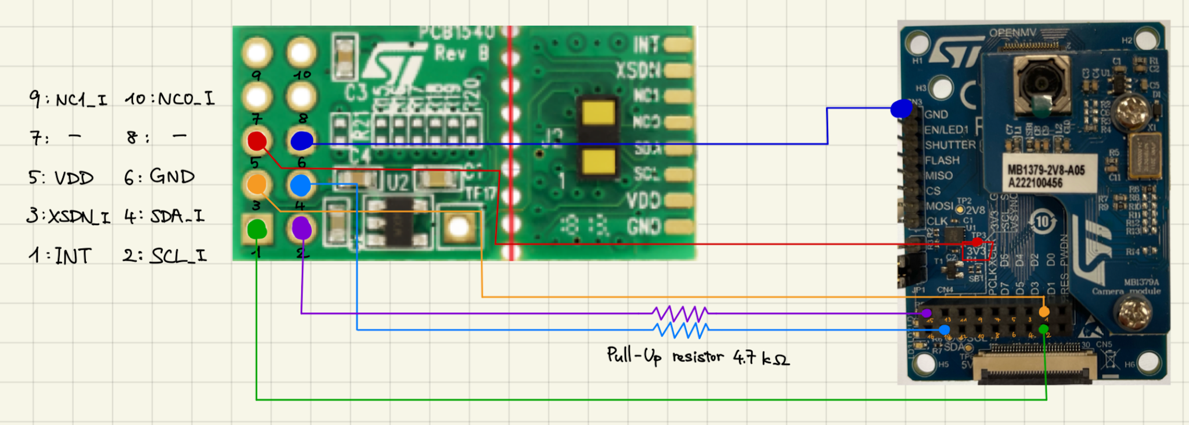

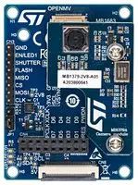
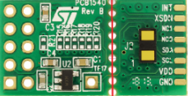
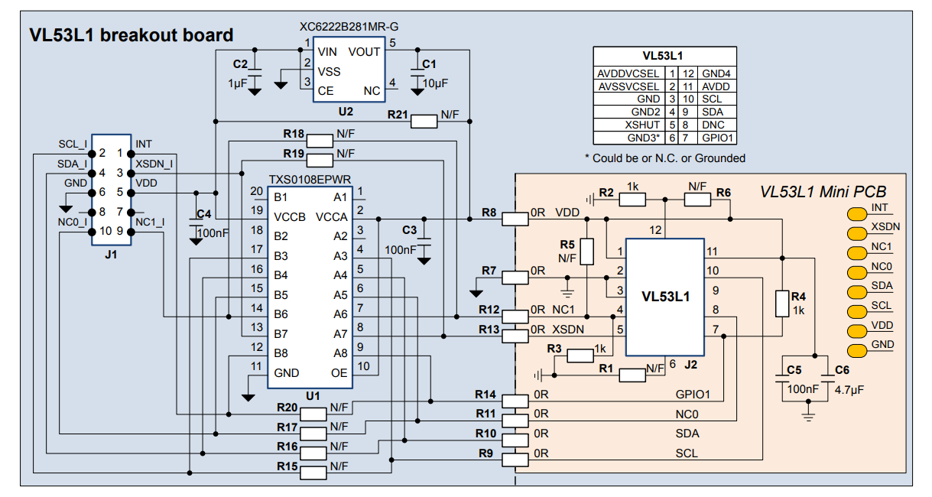

VIN (VL53L1X) → Alimentation 3.3V ou 5V sur le MB1379.
GND (VL53L1X) → GND sur le MB1379.
SCL (VL53L1X) → SCL (I2C) sur le MB1379.
SDA (VL53L1X) → SDA (I2C) sur le MB1379.

TX (MB1379) → RX (Arduino).
RX (MB1379) → TX (Arduino).
GND (MB1379) → GND (Arduino).

Code :
#include <Wire.h>
#include <VL53L1X.h> // Installer cette bibliothèque via le gestionnaire de bibliothèques Arduino

VL53L1X sensor;

void setup() {
Serial.begin(115200); // Démarrage de la communication série
Wire.begin(); // Initialisation de l'I2C

// Initialisation du capteur VL53L1X
if (!sensor.init()) {
Serial.println("Erreur : Impossible d'initialiser le capteur VL53L1X !");
while (1); // Blocage en cas d'erreur
}

// Configuration du mode de mesure
sensor.setDistanceMode(VL53L1X::Long); // Mode long (pour les distances maximales)
sensor.setMeasurementTimingBudget(50000); // 50 ms pour chaque mesure
sensor.startContinuous(); // Mode de mesure continue
}

void loop() {
// Lecture de la distance
int distance = sensor.read();

// Vérification des erreurs
if (sensor.timeoutOccurred()) {
Serial.println("Timeout du capteur !");
} else {
Serial.print("Distance mesurée : ");
Serial.print(distance);
Serial.println(" mm");
}

delay(100); // Petite pause avant la mesure suivante
}

