Mondrian Schema Workbench
The Mondrian Schema Workbench allows you to visually create and test Mondrian OLAP cube schemas.
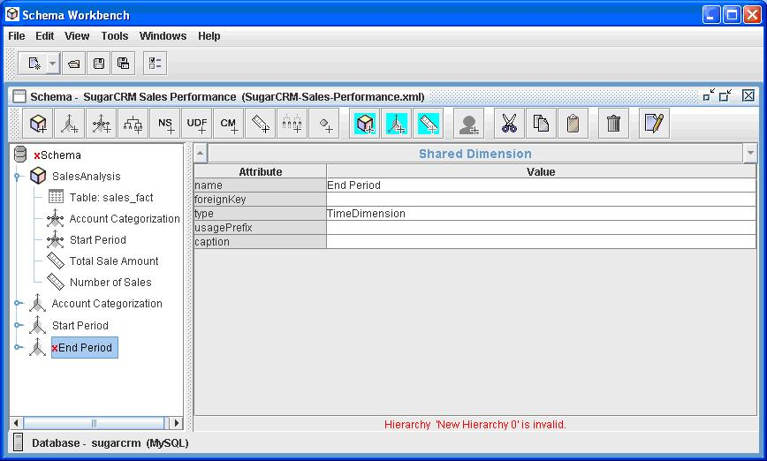
It provides the following functionality:
- Schema editor integrated with the underlying data source for validation. (See above)
- Test MDX queries against schema and database
- Browse underlying databases structure
See the Mondrian technical guide to understand schemas.
Once you have the schema file, you can upload this into your application.

Using the Workbench
Unzip the Workbench into a directory.

Include your cube database’s JDBC driver in the drivers directory, so the Workbench can use it.

Start the Workbench by running “workbench.bat” (Windows) or “workbench.sh” (for Unix/Linux) where you installed.

Set properties for connection to your cube database via Tools > Preferences.

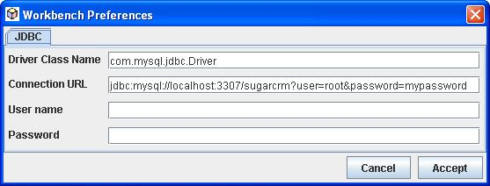

If you change the connection properties, you will need to close/save the existing schema editor(s) and restart to see the effects.

Create or edit elements in the schema. The Workbench validates your changes against the cube database tables and column names.

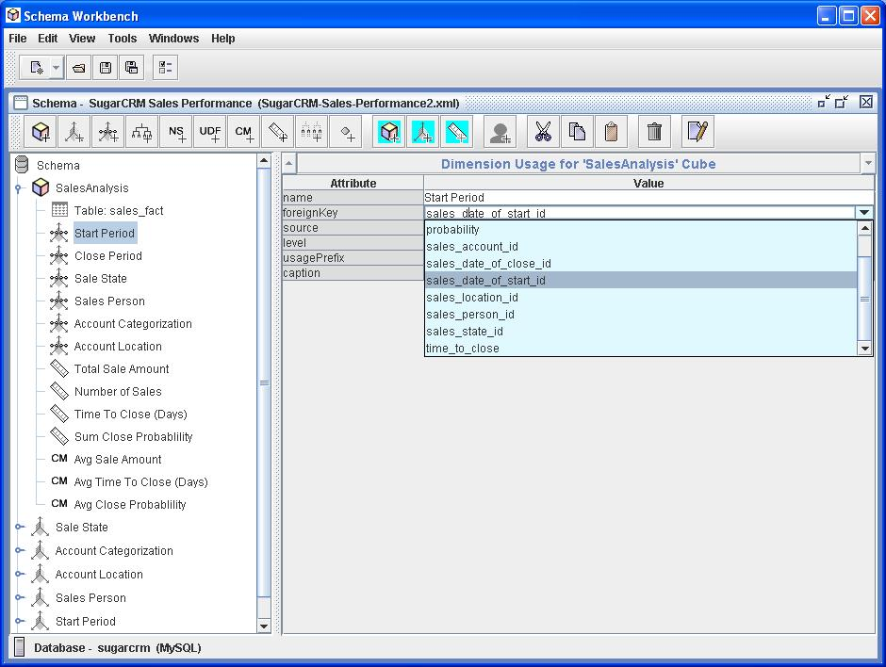

The Workbench validates edits against the Mondrian schema DTD.
Save your schema and run some MDX queries to test. Error messages or results are displayed.
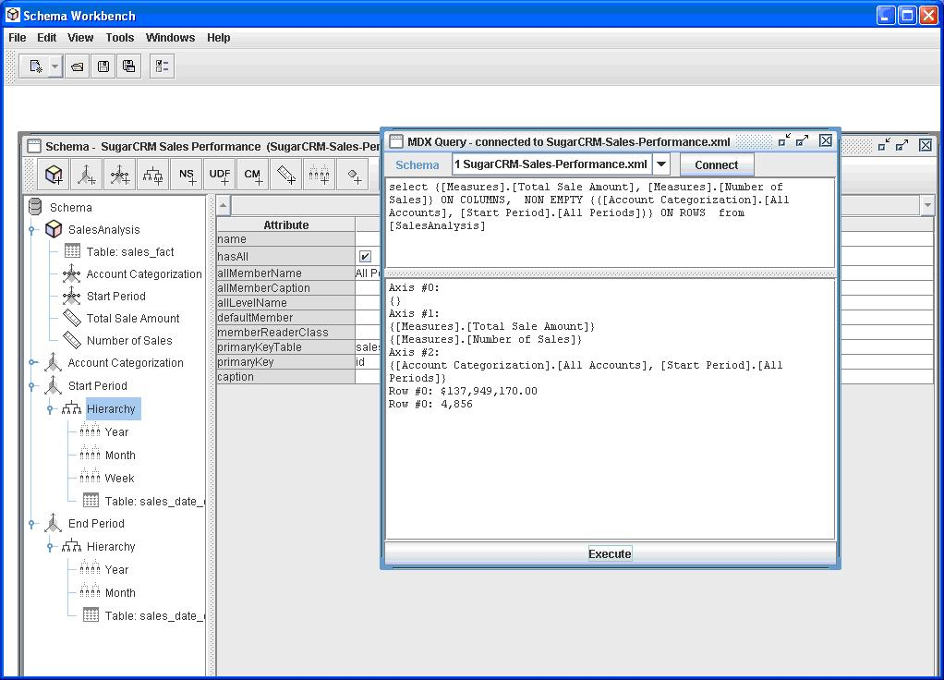
You can reopen an existing schema file. The schema will be validated as it is opened and errors indicated.

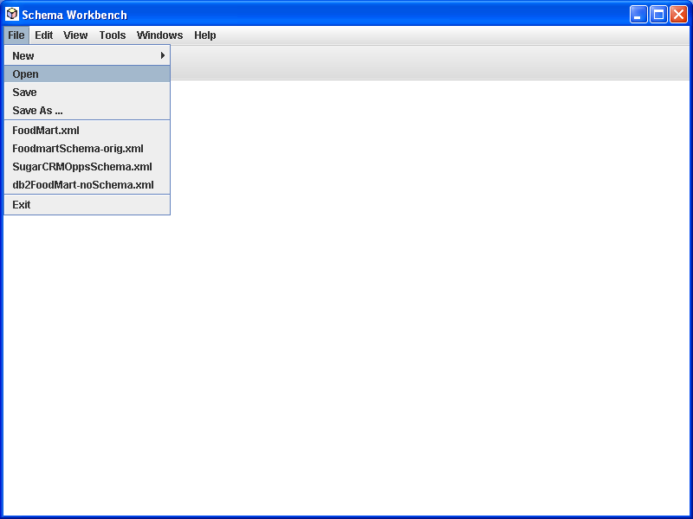

The previous 4 schemas you have saved are displayed to select easily. The directory the schemas were in is tracked behind the scenes.

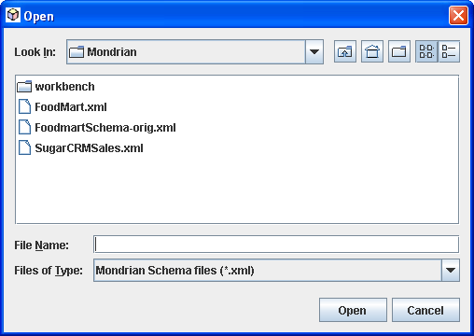
If you want to see the underlying XML that makes up the schema you are editing, select:
View > XML. The display will show the XML making up the element you have selected in the tree, including all sub elements. You can toggle this XML view on and off. You cannot edit the XML directly.

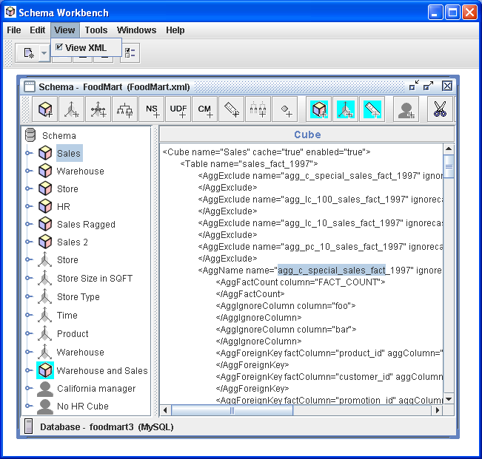

Configuring the Workbench
A variety of configuration files are kept under your user home directory in the “.schemaWorkbench” directory.
workbench.properties
The cube database preferences and the last 4 schema files that have been edited.
log4j.xml
Execution log file settings. Can be used to debug parsing and MDX. By default the log file is in “user home”/.schemaWorkbench/workbench.log.
mondrian.properties
Configuration of Mondrian run time properties used when the Workbench is running. Details of the effect of these settings are in the Mondrian technical guide.
If you are using a using a database which requires a JDBC driver that is not already installed, you will need to add the JDBC driver class name into the mondrian.jdbcDrivers property in mondrian.properties, and put the JDBC JAR files into the drivers directory.

