

Chef version 2.2

© 2001 - 2006 i-Bridge

www.kettle.be

Table of contents
1 Chef 4
1.1 What is Chef? 4
1.2 Installation 4
1.3 Launching Chef 4
1.4 Screen shot 5
1.5 Command line options 6
1.6 Repository 7
1.7 License 7
1.8 Notes 7
1.9 Definitions 8
1.10 Toolbar 9
1.11 Options 10
1.11.1 General tab 10
1.11.2 Look & Feel tab 11
2 Database Connections 13
2.1 Description 13
2.2 Screen shot 13
2.3 Options 13
2.4 Database Usage Grid 14
2.5 Usage 15
2.5.1 Create a new connection 15
2.5.2 Edit a connection 15
2.5.3 Duplicate a connection 15
2.5.4 Delete a connection 15
2.5.5 SQL Editor 16
2.5.6 Clear DB Cache option 16
2.5.7 Explore 16
2.6 Unsupported databases 16
3 SQL editor 17
3.1 Description 17
3.2 Screen shot 17
4 Database Explorer 18
4.1Screen shot 18
4.2Description 18
5 Job Hops 19
5.1 Description 19
5.2 Screen shot 19
5.3 Creating A Hop 19
5.4 Splitting A Hop 19
5.5 Loops 19
6 Job settings 20
6.1 Description 20
6.2 Screen shot 20
6.3 Options 20
6.4 Extra 20
7 JOB ENTRIES 21
7.1 Description 21
7.2Job Entry Types 21
7.2.1 Special Job Entries 21
7.2.2 Transformation 22
7.2.3 Job 23
7.2.4 Shell 25
7.2.5 Mail 26
7.2.6 SQL 27
7.2.7 FTP 28
7.2.8 Table Exists 29
7.2.9 File Exists 30
7.2.10 Evaluation 31
7.2.11 SFTP 32
7.2.12 HTTP 33
8 Graphical View 34
8.1 Description 34
8.2 Adding job entries 34
8.2.1 Dragging 34
8.2.2 Hiding and deleting a job entry 34
8.2.3 Job entry options (right click popup menu) 34
8.3 Adding hops 35
9 Log View 36
9.1 Description 36
9.2 Screen shot 36
9.3 Log Grid 36
9.4 Buttons 36
9.4.1 Start transformation 36
9.4.2 Refresh log 37
9.4.3 Clear log 37
9.4.4 Log Settings 37
10 Grids 38
10.1 Description 38
10.2 Functions 38
10.3 Navigating 38
11 Repository Explorer 39
11.1 Description 39
11.2 Screen shot 39
11.3 Functions 39
11.4 Backup / Recovery 40
12 Apendix A 41

Chef

What is Chef?
Kettle is an acronym for “Kettle E.T.T.L. Environment”. This means it has been designed to help you with your ETTL needs: the Extraction, Transformation, Transportation and Loading of data.

Chef is a graphical user interface for that allows you to design jobs that can be executed with the Kettle tool Kitchen. Kitchen is a job execution engine that is capable of performing a multitude of functions such as: execute transformations, execute jobs, verify file existence, get files using FTP, SFTP, HTTP, ...

NOTE: For a complete description of Kitchen, please check out the Kitchen documentation.

Jobs can describe themselves using an XML file or can be put in a Kettle database repository. This information can then be read by Kitchen to execute the described job entries in the job.

In short: Kettle makes data warehouses easier to build, update and maintain!

Installation
The first step is the installation of Sun Microsystems Java Runtime Environment version 1.4 or higher. You can download a JRE for free at http://www.javasoft.com/.

After this, you can simply unzip the zip-file: Kettle-2.2.zip in a directory of your choice.
In the Kettle directory where you unzipped the file, you will find a number of files.
Under Unix-like environments (Solaris, Linux, MacOS, …) you will need to make the shell scripts executable. Execute these commands to make all shell scripts in the Kettle directory executable:

cd Kettle
chmod +x *.sh

Launching Chef
To launch Chef on the different platforms these are the scripts that are provided:

- Chef.bat: launch Chef on the Windows platform.
- chef.sh: launch Chef on a Unix-like platform: Linux, Solaris, AIX, HP- UX, MacOS X

If you want to make a shortcut under the Windows platform an Icon is provided: “chef.ico” to set the correct icon. Simply point the shortcut to the Chef.bat file.

Screen shot

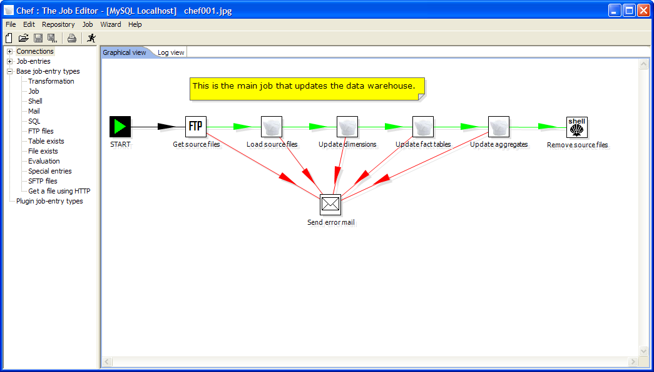

The following items are visible in Chef: Connections, Job-entries, job-entry types, Graphical View and the Log View.
These items are described in detailed in the chapters below: Connections in §2, Job entries in §7, the Graphical View in §8 and the Log View in §9.

Command line options
These are the command line options that you can use.
Fields in italic represent the values that the options use.

-file=filename

This option runs the transformation defined in the XML file. (.kjb : Kettle Job)

-log=Logging Filename

Specifies the log file. The default is the standard output.

-rep=Repository name

Connect to the repository with name “Repository name”.
You also need to specify the options –user, –pass and –trans.
The repository details are loaded from the file repositories.xml in the local directory or in the Kettle directory: <homedirectory>/.kettle/

-user=Username

This is the username with which you want to connect to the repository.

-pass=Password

The password to use to connect to the repository

-trans=Transformation Name

Use this option to select the transformation to run from the repository

NOTE: It’s important that if spaces are present in the option values, you use quotes or double quotes to keep them together. This behavior is OS and Shell dependent.

Repository
A Kettle repository can contain among other things transformations. This means that in order to load a transformation from a database repository, you need to connect to this repository.
To do this, you need to define a database connection to this repository. You can do this using the repositories dialog you are presented with when you start up Chef.

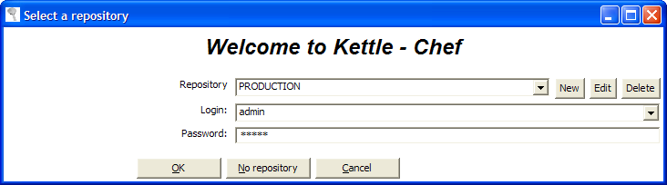

The information concerning repositories in stored in file called “repositories.xml”. This file resides in the hidden directory “.kettle” in your default home directory.

HINT: The complete path and filename of this file is displayed on the Chef console.

IMPORTANT: The default password for the admin user is also admin. You should change this default password right after the creation of the repository. You can change the password using “Edit current user” or with the Repository Explorer (see §11)

License
Starting with version 2.2.0 Kettle is released into the public domain under the LGPL license.
Please refer to Appendix A for the full text of this license.

Copyright (C) 2005 Matt Casters i-Bridge bvba
Kettle is free software; you can redistribute it and/or
modify it under the terms of the GNU Lesser General Public
License as published by the Free Software Foundation; either
version 2.1 of the License, or (at your option) any later version.
Kettle is distributed in the hope that it will be useful,
but WITHOUT ANY WARRANTY; without even the implied warranty of
MERCHANTABILITY or FITNESS FOR A PARTICULAR PURPOSE. See the GNU
Lesser General Public License for more details.
You should have received a copy of the GNU Lesser General Public
License along with the Kettle distribution; if not, write to the Free Software
Foundation, Inc., 51 Franklin St, Fifth Floor, Boston, MA 02110-1301 USA

Notes
You can put notes on the graphical view everywhere simply by clicking right on the canvas and selecting “Add note”.
Later these notes can be edited by double clicking on them and dragged around the screen by dragging on them with the mouse using the left button.
Removing a note can be done by a right click on the note and by selecting “Delete note”.

Definitions
- Job Entry: A job entry is one part of a job and performs a certain
- Hop: a hop is a graphical representation of one or more data streams between 2 steps. A hop always represents the link between two job entries and can be set (depending on the type of originating job entry) to execute the next job entry unconditionally, after successful execution or failed execution.
- Note: a note is a piece of information that can be added to a job

A note

A hop

A job entry

Toolbar

The icons on the toolbar of the main screen are from left to right:

Icon | Meaning
 | New job
 | Open job from file if you’re not connected to a repository or from the repository if you are connected to one.
 | Save the job to a file or to the repository.
 | Save the job under a different name or filename.
 | Print: you will be presented with a print-dialog asking you to specify the number of pages, margins etc.
 | Run the job: runs the current job from XML file or repository.

Options
There are a number of options that you can change to enhance the graphical user interface, such as the fonts and the colors of the screens.
To change these options, please check out the Edit menu option “Options”.
These are screen shots of the options:

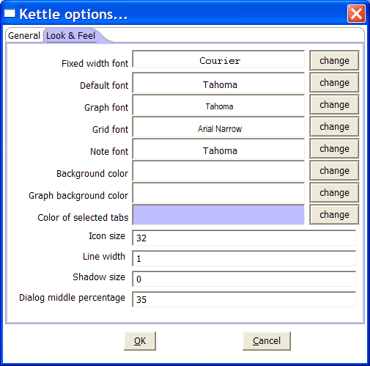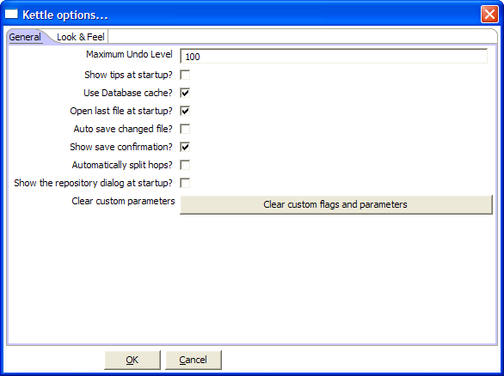

General tab

Maximum Undo Level
This parameter sets the maximum number of steps that can be undone (or redone) by Chef.

Show tips at startup
This option sets the display of tips at startup.

Use database cache
Chef caches information that is stored on source and target databases. In some cases this can lead to incorrect results when you’re in the process of changing those very databases. In those cases it is possible to disable the cache altogether in stead of clearing the caches every time.
NOTE: Chef automatically clears the database cache when you launch DDL (Data Definition Language) statements towards a database connection. However, when using 3rd party tools, clearing the database cache manually may be necessary.

Open last file at startup
Enable this option to automatically (try to) load the last transformation you used (opened or saved) from XML or repository.

auto save changed file
This option automatically saves a changed transformation before running.

show save confirmation
This flag allows you to turn off the confirmation dialogs you receive when a transformation has been changed.

automatically split hops
This option turns off the confirmation dialogs you get when you want to split a hop. (see also §5.4)

show the repositories dialog at startup
This option controls whether or not the repositories dialog shows up at startup.

Clear custom flags and parameters
This option clears all parameters and flags that where set in the plugin or step dialogs.

Look & Feel tab

Default font
This is the font that’s used in the dialog boxes, trees, input fields, etc.

Graph font
This is the font that’s used on the graphical view.

Grid font
This font is used in all the grids that are used in Chef.

Note font
This font is used in the notes that are displayed in the Graphical View.

Background color
Sets the background color in Chef. It affects all dialogs too.

Graph background color
Sets the background color in the Graphical View of Chef.

Color of selected tabs
This is the color that's being used to indicate tabs that are active/selected.

Icon size
This affects the size of the icons in the graph window. The original size of an icon is 32x32 pixels. The best results (graphically) are probably at sizes 16,24,32,48,64 and other multiples of 32.

Line width
This affects the line width of the hops on the Graphical View and the border around the steps.

Shadow size
If this size is larger then 0, a shadow of the steps, hops and notes is drawn on the canvas, making it look like the transformation floats above the canvas.

Dialog middle percentage
By default, a parameter is drawn at 35% of the width of the dialog, counted from the left.
You can change this with this parameter. Perhaps this can be useful in cases where you use unusually large fonts.

Database Connections

Description
A connection describes the method by which Kettle can connect to a database. The top entries in the tree on the left describe the available connections.

Screen shot
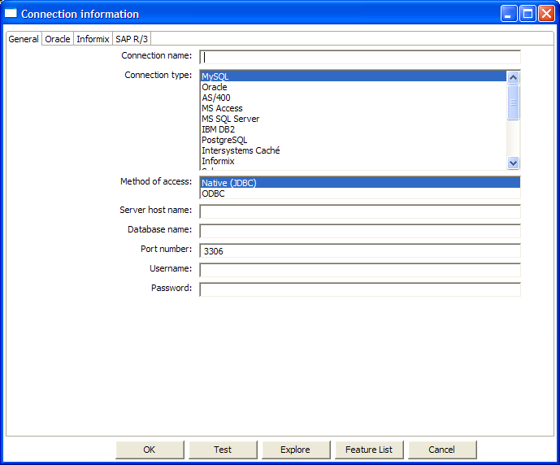

Options
- Connection name: a connection name uniquely name defines a connection across transformations.
- Connection type: the type of database you’re connecting to.
- Method of access: This can be either Native (JDBC), ODBC, or OCI.
- Server host name: specify the host name of the server on which the database resides. You can also specify it’s IP-address.
- Database name: identifies the database name you want to connect to. In case of ODBC specify the DSN name here. (see also §2.4)
- Port number: sets the TCP/IP port number on which the database listens.
- Username/password: optionally specifies the username and password to connect to the database.

EXTRA:

- For Oracle you can specify the default tablespaces in which Kettle will places objects generating SQL for tables and indexes.
- For Informix, you need to specify the Informix Server name in the Informix tab in order for a connection to be useable.
- For SAP R/3 connections, extra parameters Language, System Number and SAP Client can be specified in the SAP R/3 tab.
- Feature list: exposes the jdbc URL, class and various database settings for the connection such as the list of reserved words.

Database Usage Grid
Database | Access Method | Server name or address | Database name | Port nr (default) | Username & password
Oracle | Native | Required | Oracle database SID | Required (1521) | Required
 | ODBC |  | ODBC DSN name |  | Required
 | OCI |  | Database TNS name |  | Required
MySQL | Native | Required | MySQL database name | Required (3306) | Required
 | ODBC |  | ODBC DSN name |  | Required
AS/400 | Native | Required | AS/400 Library name | Optional | Required
 | ODBC |  | ODBC DSN name |  | Required
MS Access | ODBC |  | ODBC DSN name |  | Optional
MS SQL Server | Native | Required | Database name | Required (1433) | Required
 | ODBC |  | ODBC DSN name |  | Required
IBM DB2 | Native | Required | Database name | Required (50000) | Required
 | ODBC |  | ODBC DSN name |  | Required
PostgreSQL | Native | Required | Database name | Required (5432) | Required
 | ODBC |  | ODBC DSN name |  | Required
Intersystems Caché | Native | Required | Database name | Required (1972) | Required
 | ODBC |  | ODBC DSN name |  | Required
Informix | Native | Required | Database name | Required (1526) | Required
 | ODBC |  | ODBC DSN name |  | Required
Sybase | Native | Required | Database name | Required (5001) | Required
 | ODBC |  | ODBC DSN name |  | Required
Gupta SQL Base | Native | Required | Database name | Required (2155) | Required
 | ODBC |  | ODBC DSN name |  | Required
Dbase III, IV or 5.0 | ODBC |  | ODBC DSN name |  | Optional
Firebird SQL | Native | Required | Database name | Required (3050) | Required
 | ODBC |  | ODBC DSN name |  | Required
Hypersonic | Native | Required | Database name | Required (9001) | Required
MaxDB (SAP DB) | Native | Required | Database name |  | Required
 | ODBC |  | ODBC DSN name |  | Required
CA Ingres | Native | Required | Database name |  | Required
 | ODBC |  | ODBC DSN name |  | Required
Generic | ODBC |  | ODBC DSN name |  | Optional

Usage

Create a new connection
You can create a new connection by clicking right on the "Connections" tree entry and selecting "new".

Or double click on the Connections tree entry.
Or press F3 to start the “new connection” wizard.

Edit a connection
Double click on the connection name in the left tree. Or right click on the name and select "Edit connection".

Duplicate a connection
Right click on the connection name and select "Duplicate ".

Delete a connection
Right click on the connection name and select "Delete".

SQL Editor
Executes SQL commands on a connection. Right click on the connection name and select "SQL Editor". See also §3 for more information.

Clear DB Cache option
To speed up connections Chef uses a database cache. Use this option when the information in the cache no longer represents the layout of the database. This is the case when databases tables have been changed, created or deleted.

Explore
This option will start the database explorer for the selected database connection.
Please see §4 for more information.

Unsupported databases
If you want to access a database type that is not yet supported, let us know and we will try to find a solution. A few database types are not supported in this release because of the lack of sample database and/or software.
Please note that it is usually still possible to read from these databases by using the Generic database driver through an ODBC connection.

SQL editor

Description
Sometimes a simple SQL Editor can be nice to have. Especially when you're creating tables, dropping indexes and modifying fields. The simple SQL editor supplied in Chef, allows you to do this. In fact, most of the DDL (Data Definition Language) such as “create/alter table”, “create index” and “create sequence” SQL commands are created automatically for you via the SQL Editor window.

NOTE: Multiple SQL Statements have to be separated by semi-colons (;).
NOTE: Before these SQL Statements are sent to the database to be executed, Chef removes returns, line-feeds and the separating semi-colons.
NOTE: Kettle clears the database cache for the database connection on which you launch DDL statements.

Screen shot
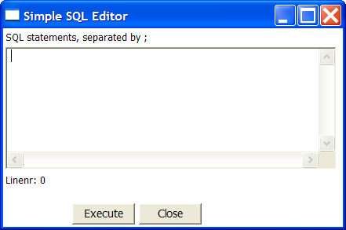

Database Explorer

Screen shot
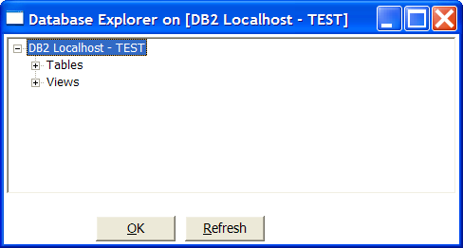

Description
The database explorer allows you to explore the database to which the database connection points. At the moment, it only shows available tables and the catalog and/or schema to which the table belongs.
It is possible to click right on a shown table or view (lowest level in the tree) and select one of the following options:

- Display the first 100 rows of the table (also available through double-click on table name)
- Display the first … lines of the table
- Show the size (in rows) of the table.
- Show layout of the table
- Generate the DDL statement (create table ...) for this table.
- Generate the DDL statement (create table ...) for this table on another database connection
- Show the SQL statement to read from this table. (in SQL Editor)

Job Hops

Description
A job hop connects one job entry with another. The execution order is indicated with an arrow on the graphical view pane. A job hop can be enabled or disabled. (For testing purposes for example).
Besides the execution order, it also specifies the condition on which the next job entry will be executed. You can specify the evaluation mode by right clicking on the job hop:
- “Unconditional” specifies that the next job entry will be executed regardless of the result of the originating job entry.
- “Follow when result is true” specifies that the next job entry will only be executed when the result of the originating job entry was true, meaning successful execution, file found, table found, without error, evaluation was false, ...
- “Follow when result is false” specifies that the next job entry will only be executed when the result of the originating job entry was false, meaning unsuccessful execution, file not found, table not found, error(s) occurred, evaluation was false, ...

Screen shot

Creating A Hop
You can easily create a new hop between 2 job entries by one of the following options:
- Dragging on the Graphical View between 2 job entries while using the middle mouse button.
- Dragging on the Graphical View between 2 job entries while pressing the SHIFT key and using the left mouse button.
- Selecting 2 job entries in the graphical view (CTRL + left mouse click), clicking right on a job entry and selecting "new hop"

Splitting A Hop
You can easily insert a new job entry into a hop between 2 job entries by dragging the job entry (in the Graphical View) over a hop until the hop becomes drawn in bold. Release the left button and you will be asked if you want to split the hop. This works only with job entries that have not yet been connected other job entries.

Loops
Loops are allowed in jobs because Chef executes job entries sequentially. Just make sure you don't build endless loops. Please check out Evaluation job entry in §7. This job entry can help you exit closed loops based on the number of times a job entry was executed.

Job settings

Description
There are a few options that control how a job is behaving and how it is logging what it is doing.

Screen shot
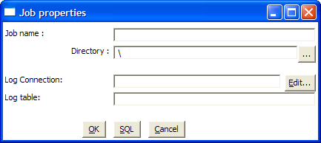

Options
Option | Description
job name | the name of the job. This is required information if you want to save to a repository.
Directory | the directory in the repository in which you want to save the job.
Log connection | Use this connection to write to a log table
Log table | specifies the name of the log table (for example L_ETL)

Extra
- SQL button: generates the SQL needed to create the logging table and allows you to execute this SQL statement.

JOB ENTRIES

Description
A job entry is one part of a job. Job entries can provide you with a wide range of functionality ranging from executing transformations to getting files from a web server.
Please see below for a complete list of all available job entry types.

Job Entry Types

Special Job Entries

Screen shot
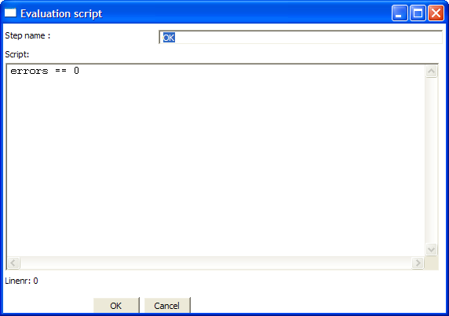

Icons

General description

Start
Start is where the job starts to execute and is required before the job can be executed.
Only unconditional job hops are available from a Start job entry.

Dummy
Use the Dummy job entry to do nothing in a job. This can be useful to make job drawings clearer or for looping. Dummy performs no evaluation.

OK
Checks if the number of errors from a previous job entry was 0 and results to true if this is the case.
See also the “Evaluation” job entry.

ERROR
Checks if the number of errors from a previous job entry was different from 0 and results to true if this is the case. See also the “Evaluation” job entry.

Transformation

Screen shot
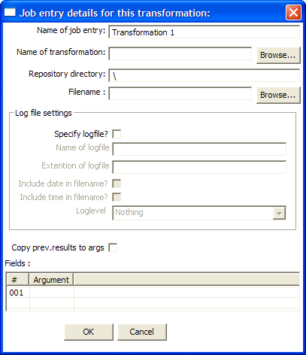

Icon

General Description
You can use the Transformation job entry to execute a previously defined transformation.

Options
Option | Description
Name of the job entry | The name of the job entry. This name has to be unique in a single job. A job entry can be placed several times on the canvas, however it will be the same job entry.
Name of transformation | The name of the transformation to start.
Repository directory | The directory in the repository where the transformation is located.
Filename | If you're not working with a repository, specify the XML filename of the transformation to start.
Specify log file | Check this if you want to specify a separate logging file for the execution of this transformation.
Name of log file | The directory and base name of the log file (for example C:\logs)
Extension of the log file | The filename extension (for example: log or txt)
Include date in filename | Adds the system date to the filename. (_20051231)
Include time in filename | Adds the system time to the filename. (_235959)
Logging level | Specifies the logging level for the execution of the transformation. See also the logging window in §9.4.4
Copy previous results to arguments | The results from a previous transformation can be sent to this one using the “Copy rows to result” step.
Arguments | Specify the strings to use as arguments for the transformation.

Job

Screen shot
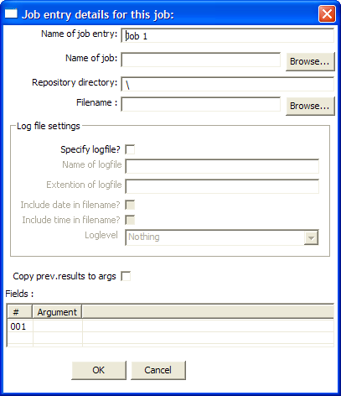

Icon

General Description
You can use the Job job entry to execute a previously defined job.

WARNING! Although it is possible to create a recursive, never ending job that points to itself, you should be aware. This job will probably eventually fail with an out of memory or stack error.

Options
Option | Description
Name of the job entry | The name of the job entry. This name has to be unique in a single job. A job entry can be placed several times on the canvas, however it will be the same job entry.
Name of transformation | The name of the job to start.
Repository directory | The directory in the repository where the job is located.
Filename | If you're not working with a repository, specify the XML filename of the job to start.
Specify log file | Check this if you want to specify a separate logging file for the execution of this job.
Name of log file | The directory and base name of the log file (for example C:\logs)
Extension of the log file | The filename extension (for example: log or txt)
Include date in filename | Adds the system date to the filename. (_20051231)
Include time in filename | Adds the system time to the filename. (_235959)
Logging level | Specifies the logging level for the execution of the job. See also the logging window in §9.4.4
Copy previous results to arguments | The results from a previous transformation can be sent to this job using the “Copy rows to result” step in a transformation.
Arguments | Specify the strings to use as arguments for the job.

Shell

Screen shot
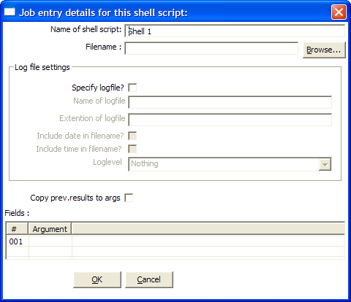

Icon

General Description
You can use the Shell job entry to execute a shell script on the host where the job is running.
NOTE: On windows, batch files (.bat) can not under any condition output text to the console window because of certain shell execution issues on that platform. Otherwise, the batch files will stall.

Options
Option | Description
Name of the job entry | The name of the job entry. This name has to be unique in a single job. A job entry can be placed several times on the canvas, however it will be the same job entry.
Filename | The filename of the shell script to start.
Specify log file | Check this if you want to specify a separate logging file for the execution of this shell script.
Name of log file | The directory and base name of the log file (for example C:\logs)
Extension of the log file | The filename extension (for example: log or txt)
Include date in filename | Adds the system date to the filename. (_20051231)
Include time in filename | Adds the system time to the filename. (_235959)
Logging level | Specifies the logging level for the execution of the shell. See also the logging window in §9.4.4
Copy previous results to arguments | The results from a previous transformation can be sent to the shell script using the “Copy rows to result” step. (as arguments)
Arguments | Specify the strings to use as arguments for the shell script.

Mail

Screen shot
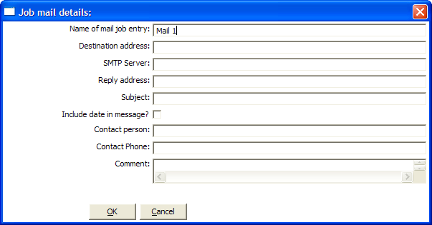

Icon

General Description
You can use the Mail job entry to send an e-Mail.

Options
Option | Description
Name of the job entry | The name of the job entry. This name has to be unique in a single job. A job entry can be placed several times on the canvas, however it will be the same job entry.
Destination address | The destination for the e-Mail
SMTP server | The mail server to which the mail has to be sent.
Reply address | The reply address for this e-Mail
Subject | The subject of the e-Mail
Include date in message | Check this if you want to include the date in the e-Mail
Contact person | The name of the contact person to be placed in the e-Mail
Contact phone | The contact telephone number to be placed in the e-Mail
Comment | Additional comment to be placed in the e-Mail

SQL

Screen shot
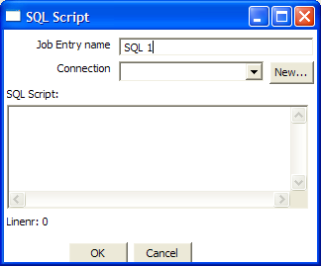

Icon

General Description
You can use the SQL job entry to execute an SQL script.
This means a number of SQL statements separated by ;

Options
Option | Description
Name of the job entry | The name of the job entry. This name has to be unique in a single job. A job entry can be placed several times on the canvas, however it will be the same job entry.
Connection | The database connection to use
SQL script | The SQL script to execute

FTP

Screen shot
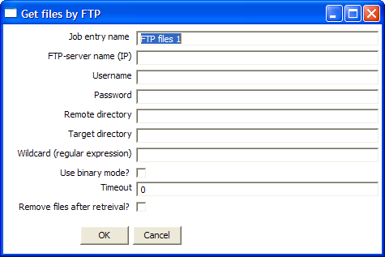

Icon

General Description
You can use the FTP job entry to get one or more files from an FTP server

Options
Option | Description
Name of the job entry | The name of the job entry. This name has to be unique in a single job. A job entry can be placed several times on the canvas, however it will be the same job entry.
FTP server name | The name of the server or the IP address
User name | The user name to log into the FTP server
Password | The password to log into the FTP server
Remote directory | The remote directory on the FTP server from which we get the files
Target directory | The directory on the machine on which Kettle runs in which you want to place the transferred files
Wildcard | Specify a regular expression here if you want to select multiple files.  For example:  .*txt$ : get all text files  A.*[0-9]\.txt : files tarting with A  ending with a number and .txt
Use binary mode? | Check this if the files need to be transferred in binary mode.
Timeout | The FTP server timeout in seconds
Remove files after retrieval? | Remove the files on the FTP server, but only after all selected files have been successfully transferred.

Table Exists

Screen shot
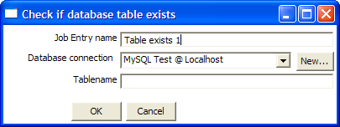

Icon

General Description
You can use the Table Exists job entry to verify if a certain table exists on a database.

Options
Option | Description
Name of the job entry | The name of the job entry. This name has to be unique in a single job. A job entry can be placed several times on the canvas, however it will be the same job entry.
Database connection | The database connection to use
Table name | The name of the database table to check

File Exists

Screen shot
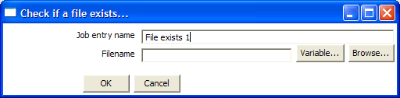

Icon

General Description
You can use the File Exists job entry to verify if a certain file exists on the server on which Kettle runs.

Options
Option | Description
Name of the job entry | The name of the job entry. This name has to be unique in a single job. A job entry can be placed several times on the canvas, however it will be the same job entry.
Filename | The name and path of the file to check for

Extra
- Variable: select the variable to use as filename
- Browse: look for the file on the file system

Evaluation

Screen shot
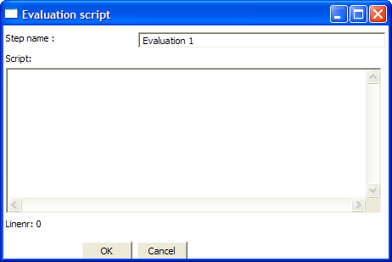

Icon

General Description
You can use the Evaluation job entry to calculate a boolean variable. This variable can then be used to determine which next step will be executed.
The following variables are available to the user:

- errors : number of errors in the previous job entry (long)
- lines_input : number of rows read from database or file (long)
- lines_output : number of rows written to database or file (long)
- lines_updated : number of rows updated in a database table (long)
- lines_read : number of rows read from a previous transformation step (long)
- lines_written : number of rows written to a next transformation step (long)
- files_retrieved : number of files retrieved from an FTP server (long)
- exit_status : the exit status of a shell script (integer)
- nr : the job entry number. Increments at every next job entry. (integer)
- is_windows : true if Kettle runs on MS Windows (boolean)

Options
Option | Description
Name of the job entry | The name of the job entry. This name has to be unique in a single job. A job entry can be placed several times on the canvas, however it will be the same job entry.
Script | The Javascript that needs to be run to evaluate.  The last statement in the script needs to result in a boolean

SFTP

Screen shot
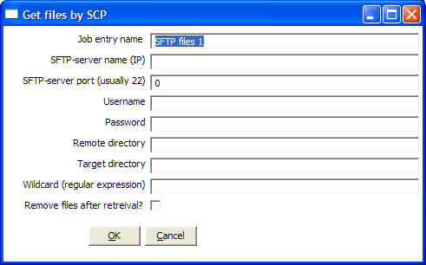

Icon

General Description
You can use the SFTP job entry to get one or more files from an FTP server using the Secure FTP protocol.

Options
Option | Description
Name of the job entry | The name of the job entry. This name has to be unique in a single job. A job entry can be placed several times on the canvas, however it will be the same job entry.
SFTP-server name (IP) | The name of the SFTP server or the IP address
SFTP port | The TCP port to use. This is usually 22
User name | The user name to log into the SFTP server
Password | The password to log into the SFTP server
Remote directory | The remote directory on the SFTP server from which we get the files
Target directory | The directory on the machine on which Kettle runs in which you want to place the transferred files
Wildcard | Specify a regular expression here if you want to select multiple files.  For example:  .*txt$ : get all text files  A.*[0-9]\.txt : files tarting with A  ending with a number and .txt
Remove files after retrieval? | Remove the files on the SFTP server, but only after all selected files have been successfully transferred.

HTTP

Screen shot
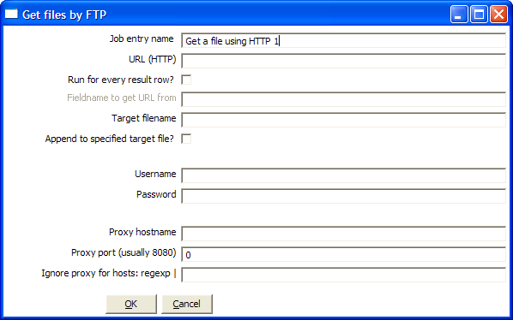

Icon

General Description
You can use the HTTP job entry to get a file from a web server using the HTTP protocol.

Options
Option | Description
Name of the job entry | The name of the job entry. This name has to be unique in a single job. A job entry can be placed several times on the canvas, however it will be the same job entry.
URL (HTTP) | The URL to use (for example: http://www.kettle.be/index.html)
Run for every result row | Check this if you want to run this job entry for every row that was generated by a previous transformation. Use the “Copy rows to result”
Fieldname to get URL from | The fieldname in the result rows to get the URL from
Target filename | The target filename
Append to target file | Append to the target file if it already exists
Username | The username to authenticate with. For Windows Domains, put the Domain in from of the user like this DOMAIN\Username
Password | The password to authenticate with.
Proxy server | The HTTP proxy server name or IP address
Proxy port | The HTTP proxy port to use (usually 8080)
Ignore proxy for hosts | Specify a regular expression matching the hosts you want to ignore, | separated. For example 127\.0\..*

Graphical View

Description
The Graphical View is the canvas on which jobs are drawn.
It shows an easy to understand representation of the work that needs to be done and the flow of the data.

Adding job entries

Dragging
Adding steps to a transformation on the canvas is easy: simply select a step type from the tree on the left and drag in onto the canvas:

At the location of the mouse you will see a square that represents the location of the job entries when you let go of the button.
When you let go of the mouse button the selected job entry (Transformation) will become part of the job.

Hiding and deleting a job entry
A single job entry can be placed multiple times on the canvas.
A job entry can be removed from the job (hidden), but can only be deleted when all copies have been hidden. Click right on a job entry on the canvas to hide it.

Job entry options (right click popup menu)

Launch Spoon/Chef
This opens a Spoon or Chef window displaying the selected transformation or job.

Edit job entry
This opens the dialog for the job entry allow you to change the settings

Edit job entry description
This opens a dialog that allows you to enter a textual description of the job entry.

Duplicate job entry
This option will create a copy, positioned a bit lower to the right of the original job entry.

Delete step
This will permanently remove the step from the transformation.

Copy selected entries to clipboard (CTRL-C)
Copies the XML describing the selected job entries to the clipboard.

align / distribute
This option allows you to keep the graph clean by aligning job entries with each other.

Adding hops
On the graphical view the quickest way to create a new hop is by dragging with the mouse from one job entry to another using the middle button.
You can also drag the left button and press the SHIFT key at the same time.

For a more complete explanation regarding hops, please check out §5 ( Job Hops)

Log View

Description
The Log View shows what’s happening when a job is running.
First of all it shows all the details of the completed job entries. Secondly, it shows the log as it would be shown if the job would be launched by Kitchen.

Screen shot

Log Grid
The log grid shows the following columns:
- The icon of the job entry that has been completed
- The name of the running job
- The name of the job entry that has finished
- The result (true/false) of the job entry
- The name of the previous job entry
- A description explaining why the job entry was executed

Buttons

Start transformation
This button starts the job you’re designing. Please note that Chef tries to launch this as Kitchen would: from XML-file or repository. It is therefore necessary that the job is saved. The output of the execution is displayed in the Log Text part of the Log View.

Refresh log
Refreshes the log window.

Clear log
This clears the text in the Log Text Window.

Log Settings
This is the “Log Settings” dialog:

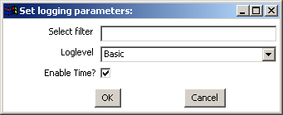

If you put a text in the filter field, only the lines that contain this text will be shown in the Log Text window.
The “Log level” setting allows you to select the logging level. You can choose one of these:

- Error: Only show errors
- Nothing: Don’t show any output
- Minimal: Only use minimal logging
- Basic: This is the default basic logging level
- Detailed: Give detailed logging output
- Debug: For debugging purposes, very detailed output.
- Row level: Logging at a row level, this can generate a lot of data.

If the “Enable time” option is enabled, all lines in the logging will be preceded by the time of day.

Grids

Description
Grids are used everywhere in Chef & Kettle. They are used to enter or display information.

Functions
Most of the functions available in a grid (that is not read-only) are available by right clicking with the mouse on a grid:
- Insert before this row: inserts an empty row before the row you clicked on
- Insert after this row: inserts an empty row after the row you clicked on
- Move the row up: move the row you clicked on up. The keyboard shortcut for this is CTRL-UP
- Move the row down: move the row you clicked on down. The keyboard shortcut for this is CTRL-DOWN
- Optimal column size including header: resize all columns so that it displays all values completely, including the header. The keyboard shortcut for this function is function key F3.
- Optimal column size excluding header: resize all columns so that it displays all values completely. The keyboard shortcut for this function is function key F4.
- Clear all: clears all information in the grid. You will be asked to confirm this operation.
- Select all rows: selects all rows in the grid. The keyboard shortcut for this function is CTRL-A
- Clear selection: clears the selection of rows in the grid. The keyboard shortcut for this function is ESC
- Copy selected lines to clipboard: Copies the selected lines to the clipboard in a textual representation. These lines can then be exchanged with other programs such as spreadsheets or even other Chef & Kettle dialogs. The keyboard shortcut for this function is CTRL-C
- Paste clipboard to table: Insert the lines that are on the clipboard to the grid, right after the line on which you clicked. The keyboard shortcut for this function is CTRL-V
- Cut selected lines: Copies the selected lines to the clipboard in a textual representation. After that, the lines are deleted from the grid. The keyboard shortcut for this function is CTRL-X
- Delete selected lines: deletes all selected lines from the grid. The keyboard shortcut for this function is DEL
- Keep only selected lines: if there are more lines to delete then there are to keep, simply select the lines you want to keep and use this function. They keyboard shortcut for this function is CTRL-K
- Copy field values to all rows: if all rows in the grid need to have the same value for a certain column, you can use this function to do this.
- Undo: undo the previous grid operation. The keyboard shortcut for this function is CTRL-Z
- Redo: redo the next grid operation. The keyboard shortcut for this function is CTRL-Y

Navigating
If you click on a cell in a grid, you can edit this field.
After pressing enter, you can navigate the grid by using the cursor keys.
Pressing enter again allows you to edit a field.

Repository Explorer

Description
The repository Explorer shows you a tree view on the database repository to which you are connected. It allows you to examine and modify the content.

Screen shot
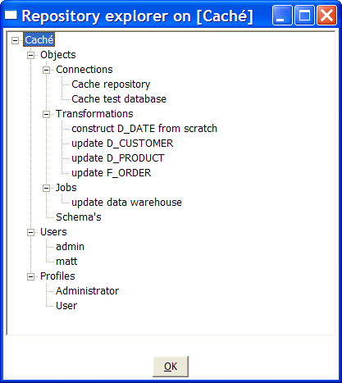

Functions
Check out the different functions when right clicking in the tree. It’s fairly straightforward.

Backup / Recovery
It is possible to export the complete repository in XML: click right on “Objects” in the repository and select one of these options.

NOTE: you can restore the objects from a backed up repository anywhere in the target repository directory tree.

Apendix A
GNU LESSER GENERAL PUBLIC LICENSE
Version 2.1, February 1999
Copyright (C) 1991, 1999 Free Software Foundation, Inc.
51 Franklin St, Fifth Floor, Boston, MA 02110-1301 USA
Everyone is permitted to copy and distribute verbatim copies
of this license document, but changing it is not allowed.
[This is the first released version of the Lesser GPL. It also counts
as the successor of the GNU Library Public License, version 2, hence
the version number 2.1.]
Preamble
The licenses for most software are designed to take away your
freedom to share and change it. By contrast, the GNU General Public
Licenses are intended to guarantee your freedom to share and change
free software--to make sure the software is free for all its users.
This license, the Lesser General Public License, applies to some
specially designated software packages--typically libraries--of the
Free Software Foundation and other authors who decide to use it. You
can use it too, but we suggest you first think carefully about whether
this license or the ordinary General Public License is the better
strategy to use in any particular case, based on the explanations below.
When we speak of free software, we are referring to freedom of use,
not price. Our General Public Licenses are designed to make sure that
you have the freedom to distribute copies of free software (and charge
for this service if you wish); that you receive source code or can get
it if you want it; that you can change the software and use pieces of
it in new free programs; and that you are informed that you can do
these things.
To protect your rights, we need to make restrictions that forbid
distributors to deny you these rights or to ask you to surrender these
rights. These restrictions translate to certain responsibilities for
you if you distribute copies of the library or if you modify it.
For example, if you distribute copies of the library, whether gratis
or for a fee, you must give the recipients all the rights that we gave
you. You must make sure that they, too, receive or can get the source
code. If you link other code with the library, you must provide
complete object files to the recipients, so that they can relink them
with the library after making changes to the library and recompiling
it. And you must show them these terms so they know their rights.
We protect your rights with a two-step method: (1) we copyright the
library, and (2) we offer you this license, which gives you legal
permission to copy, distribute and/or modify the library.
To protect each distributor, we want to make it very clear that
there is no warranty for the free library. Also, if the library is
modified by someone else and passed on, the recipients should know
that what they have is not the original version, so that the original
author's reputation will not be affected by problems that might be
introduced by others.
Finally, software patents pose a constant threat to the existence of
any free program. We wish to make sure that a company cannot
effectively restrict the users of a free program by obtaining a
restrictive license from a patent holder. Therefore, we insist that
any patent license obtained for a version of the library must be
consistent with the full freedom of use specified in this license.
Most GNU software, including some libraries, is covered by the
ordinary GNU General Public License. This license, the GNU Lesser
General Public License, applies to certain designated libraries, and
is quite different from the ordinary General Public License. We use
this license for certain libraries in order to permit linking those
libraries into non-free programs.
When a program is linked with a library, whether statically or using
a shared library, the combination of the two is legally speaking a
combined work, a derivative of the original library. The ordinary
General Public License therefore permits such linking only if the
entire combination fits its criteria of freedom. The Lesser General
Public License permits more lax criteria for linking other code with
the library.
We call this license the "Lesser" General Public License because it
does Less to protect the user's freedom than the ordinary General
Public License. It also provides other free software developers Less
of an advantage over competing non-free programs. These disadvantages
are the reason we use the ordinary General Public License for many
libraries. However, the Lesser license provides advantages in certain
special circumstances.
For example, on rare occasions, there may be a special need to
encourage the widest possible use of a certain library, so that it becomes
a de-facto standard. To achieve this, non-free programs must be
allowed to use the library. A more frequent case is that a free
library does the same job as widely used non-free libraries. In this
case, there is little to gain by limiting the free library to free
software only, so we use the Lesser General Public License.
In other cases, permission to use a particular library in non-free
programs enables a greater number of people to use a large body of
free software. For example, permission to use the GNU C Library in
non-free programs enables many more people to use the whole GNU
operating system, as well as its variant, the GNU/Linux operating
system.
Although the Lesser General Public License is Less protective of the
users' freedom, it does ensure that the user of a program that is
linked with the Library has the freedom and the wherewithal to run
that program using a modified version of the Library.
The precise terms and conditions for copying, distribution and
modification follow. Pay close attention to the difference between a
"work based on the library" and a "work that uses the library". The
former contains code derived from the library, whereas the latter must
be combined with the library in order to run.
GNU LESSER GENERAL PUBLIC LICENSE
TERMS AND CONDITIONS FOR COPYING, DISTRIBUTION AND MODIFICATION
0. This License Agreement applies to any software library or other
program which contains a notice placed by the copyright holder or
other authorized party saying it may be distributed under the terms of
this Lesser General Public License (also called "this License").
Each licensee is addressed as "you".
A "library" means a collection of software functions and/or data
prepared so as to be conveniently linked with application programs
(which use some of those functions and data) to form executables.
The "Library", below, refers to any such software library or work
which has been distributed under these terms. A "work based on the
Library" means either the Library or any derivative work under
copyright law: that is to say, a work containing the Library or a
portion of it, either verbatim or with modifications and/or translated
straightforwardly into another language. (Hereinafter, translation is
included without limitation in the term "modification".)
"Source code" for a work means the preferred form of the work for
making modifications to it. For a library, complete source code means
all the source code for all modules it contains, plus any associated
interface definition files, plus the scripts used to control compilation
and installation of the library.
Activities other than copying, distribution and modification are not
covered by this License; they are outside its scope. The act of
running a program using the Library is not restricted, and output from
such a program is covered only if its contents constitute a work based
on the Library (independent of the use of the Library in a tool for
writing it). Whether that is true depends on what the Library does
and what the program that uses the Library does.
1. You may copy and distribute verbatim copies of the Library's
complete source code as you receive it, in any medium, provided that
you conspicuously and appropriately publish on each copy an
appropriate copyright notice and disclaimer of warranty; keep intact
all the notices that refer to this License and to the absence of any
warranty; and distribute a copy of this License along with the
Library.
You may charge a fee for the physical act of transferring a copy,
and you may at your option offer warranty protection in exchange for a
fee.
2. You may modify your copy or copies of the Library or any portion
of it, thus forming a work based on the Library, and copy and
distribute such modifications or work under the terms of Section 1
above, provided that you also meet all of these conditions:
a) The modified work must itself be a software library.
b) You must cause the files modified to carry prominent notices
stating that you changed the files and the date of any change.
c) You must cause the whole of the work to be licensed at no
charge to all third parties under the terms of this License.
d) If a facility in the modified Library refers to a function or a
table of data to be supplied by an application program that uses
the facility, other than as an argument passed when the facility
is invoked, then you must make a good faith effort to ensure that,
in the event an application does not supply such function or
table, the facility still operates, and performs whatever part of
its purpose remains meaningful.
(For example, a function in a library to compute square roots has
a purpose that is entirely well-defined independent of the
application. Therefore, Subsection 2d requires that any
application-supplied function or table used by this function must
be optional: if the application does not supply it, the square
root function must still compute square roots.)
These requirements apply to the modified work as a whole. If
identifiable sections of that work are not derived from the Library,
and can be reasonably considered independent and separate works in
themselves, then this License, and its terms, do not apply to those
sections when you distribute them as separate works. But when you
distribute the same sections as part of a whole which is a work based
on the Library, the distribution of the whole must be on the terms of
this License, whose permissions for other licensees extend to the
entire whole, and thus to each and every part regardless of who wrote
it.
Thus, it is not the intent of this section to claim rights or contest
your rights to work written entirely by you; rather, the intent is to
exercise the right to control the distribution of derivative or
collective works based on the Library.
In addition, mere aggregation of another work not based on the Library
with the Library (or with a work based on the Library) on a volume of
a storage or distribution medium does not bring the other work under
the scope of this License.
3. You may opt to apply the terms of the ordinary GNU General Public
License instead of this License to a given copy of the Library. To do
this, you must alter all the notices that refer to this License, so
that they refer to the ordinary GNU General Public License, version 2,
instead of to this License. (If a newer version than version 2 of the
ordinary GNU General Public License has appeared, then you can specify
that version instead if you wish.) Do not make any other change in
these notices.
Once this change is made in a given copy, it is irreversible for
that copy, so the ordinary GNU General Public License applies to all
subsequent copies and derivative works made from that copy.
This option is useful when you wish to copy part of the code of
the Library into a program that is not a library.
4. You may copy and distribute the Library (or a portion or
derivative of it, under Section 2) in object code or executable form
under the terms of Sections 1 and 2 above provided that you accompany
it with the complete corresponding machine-readable source code, which
must be distributed under the terms of Sections 1 and 2 above on a
medium customarily used for software interchange.
If distribution of object code is made by offering access to copy
from a designated place, then offering equivalent access to copy the
source code from the same place satisfies the requirement to
distribute the source code, even though third parties are not
compelled to copy the source along with the object code.
5. A program that contains no derivative of any portion of the
Library, but is designed to work with the Library by being compiled or
linked with it, is called a "work that uses the Library". Such a
work, in isolation, is not a derivative work of the Library, and
therefore falls outside the scope of this License.
However, linking a "work that uses the Library" with the Library
creates an executable that is a derivative of the Library (because it
contains portions of the Library), rather than a "work that uses the
library". The executable is therefore covered by this License.
Section 6 states terms for distribution of such executables.
When a "work that uses the Library" uses material from a header file
that is part of the Library, the object code for the work may be a
derivative work of the Library even though the source code is not.
Whether this is true is especially significant if the work can be
linked without the Library, or if the work is itself a library. The
threshold for this to be true is not precisely defined by law.
If such an object file uses only numerical parameters, data
structure layouts and accessors, and small macros and small inline
functions (ten lines or less in length), then the use of the object
file is unrestricted, regardless of whether it is legally a derivative
work. (Executables containing this object code plus portions of the
Library will still fall under Section 6.)
Otherwise, if the work is a derivative of the Library, you may
distribute the object code for the work under the terms of Section 6.
Any executables containing that work also fall under Section 6,
whether or not they are linked directly with the Library itself.
6. As an exception to the Sections above, you may also combine or
link a "work that uses the Library" with the Library to produce a
work containing portions of the Library, and distribute that work
under terms of your choice, provided that the terms permit
modification of the work for the customer's own use and reverse
engineering for debugging such modifications.
You must give prominent notice with each copy of the work that the
Library is used in it and that the Library and its use are covered by
this License. You must supply a copy of this License. If the work
during execution displays copyright notices, you must include the
copyright notice for the Library among them, as well as a reference
directing the user to the copy of this License. Also, you must do one
of these things:
a) Accompany the work with the complete corresponding
machine-readable source code for the Library including whatever
changes were used in the work (which must be distributed under
Sections 1 and 2 above); and, if the work is an executable linked
with the Library, with the complete machine-readable "work that
uses the Library", as object code and/or source code, so that the
user can modify the Library and then relink to produce a modified
executable containing the modified Library. (It is understood
that the user who changes the contents of definitions files in the
Library will not necessarily be able to recompile the application
to use the modified definitions.)
b) Use a suitable shared library mechanism for linking with the
Library. A suitable mechanism is one that (1) uses at run time a
copy of the library already present on the user's computer system,
rather than copying library functions into the executable, and (2)
will operate properly with a modified version of the library, if
the user installs one, as long as the modified version is
interface-compatible with the version that the work was made with.
c) Accompany the work with a written offer, valid for at
least three years, to give the same user the materials
specified in Subsection 6a, above, for a charge no more
than the cost of performing this distribution.
d) If distribution of the work is made by offering access to copy
from a designated place, offer equivalent access to copy the above
specified materials from the same place.
e) Verify that the user has already received a copy of these
materials or that you have already sent this user a copy.
For an executable, the required form of the "work that uses the
Library" must include any data and utility programs needed for
reproducing the executable from it. However, as a special exception,
the materials to be distributed need not include anything that is
normally distributed (in either source or binary form) with the major
components (compiler, kernel, and so on) of the operating system on
which the executable runs, unless that component itself accompanies
the executable.
It may happen that this requirement contradicts the license
restrictions of other proprietary libraries that do not normally
accompany the operating system. Such a contradiction means you cannot
use both them and the Library together in an executable that you
distribute.
7. You may place library facilities that are a work based on the
Library side-by-side in a single library together with other library
facilities not covered by this License, and distribute such a combined
library, provided that the separate distribution of the work based on
the Library and of the other library facilities is otherwise
permitted, and provided that you do these two things:
a) Accompany the combined library with a copy of the same work
based on the Library, uncombined with any other library
facilities. This must be distributed under the terms of the
Sections above.
b) Give prominent notice with the combined library of the fact
that part of it is a work based on the Library, and explaining
where to find the accompanying uncombined form of the same work.
8. You may not copy, modify, sublicense, link with, or distribute
the Library except as expressly provided under this License. Any
attempt otherwise to copy, modify, sublicense, link with, or
distribute the Library is void, and will automatically terminate your
rights under this License. However, parties who have received copies,
or rights, from you under this License will not have their licenses
terminated so long as such parties remain in full compliance.
9. You are not required to accept this License, since you have not
signed it. However, nothing else grants you permission to modify or
distribute the Library or its derivative works. These actions are
prohibited by law if you do not accept this License. Therefore, by
modifying or distributing the Library (or any work based on the
Library), you indicate your acceptance of this License to do so, and
all its terms and conditions for copying, distributing or modifying
the Library or works based on it.
10. Each time you redistribute the Library (or any work based on the
Library), the recipient automatically receives a license from the
original licensor to copy, distribute, link with or modify the Library
subject to these terms and conditions. You may not impose any further
restrictions on the recipients' exercise of the rights granted herein.
You are not responsible for enforcing compliance by third parties with
this License.
11. If, as a consequence of a court judgment or allegation of patent
infringement or for any other reason (not limited to patent issues),
conditions are imposed on you (whether by court order, agreement or
otherwise) that contradict the conditions of this License, they do not
excuse you from the conditions of this License. If you cannot
distribute so as to satisfy simultaneously your obligations under this
License and any other pertinent obligations, then as a consequence you
may not distribute the Library at all. For example, if a patent
license would not permit royalty-free redistribution of the Library by
all those who receive copies directly or indirectly through you, then
the only way you could satisfy both it and this License would be to
refrain entirely from distribution of the Library.
If any portion of this section is held invalid or unenforceable under any
particular circumstance, the balance of the section is intended to apply,
and the section as a whole is intended to apply in other circumstances.
It is not the purpose of this section to induce you to infringe any
patents or other property right claims or to contest validity of any
such claims; this section has the sole purpose of protecting the
integrity of the free software distribution system which is
implemented by public license practices. Many people have made
generous contributions to the wide range of software distributed
through that system in reliance on consistent application of that
system; it is up to the author/donor to decide if he or she is willing
to distribute software through any other system and a licensee cannot
impose that choice.
This section is intended to make thoroughly clear what is believed to
be a consequence of the rest of this License.
12. If the distribution and/or use of the Library is restricted in
certain countries either by patents or by copyrighted interfaces, the
original copyright holder who places the Library under this License may add
an explicit geographical distribution limitation excluding those countries,
so that distribution is permitted only in or among countries not thus
excluded. In such case, this License incorporates the limitation as if
written in the body of this License.
13. The Free Software Foundation may publish revised and/or new
versions of the Lesser General Public License from time to time.
Such new versions will be similar in spirit to the present version,
but may differ in detail to address new problems or concerns.
Each version is given a distinguishing version number. If the Library
specifies a version number of this License which applies to it and
"any later version", you have the option of following the terms and
conditions either of that version or of any later version published by
the Free Software Foundation. If the Library does not specify a
license version number, you may choose any version ever published by
the Free Software Foundation.
14. If you wish to incorporate parts of the Library into other free
programs whose distribution conditions are incompatible with these,
write to the author to ask for permission. For software which is
copyrighted by the Free Software Foundation, write to the Free
Software Foundation; we sometimes make exceptions for this. Our
decision will be guided by the two goals of preserving the free status
of all derivatives of our free software and of promoting the sharing
and reuse of software generally.
NO WARRANTY
15. BECAUSE THE LIBRARY IS LICENSED FREE OF CHARGE, THERE IS NO
WARRANTY FOR THE LIBRARY, TO THE EXTENT PERMITTED BY APPLICABLE LAW.
EXCEPT WHEN OTHERWISE STATED IN WRITING THE COPYRIGHT HOLDERS AND/OR
OTHER PARTIES PROVIDE THE LIBRARY "AS IS" WITHOUT WARRANTY OF ANY
KIND, EITHER EXPRESSED OR IMPLIED, INCLUDING, BUT NOT LIMITED TO, THE
IMPLIED WARRANTIES OF MERCHANTABILITY AND FITNESS FOR A PARTICULAR
PURPOSE. THE ENTIRE RISK AS TO THE QUALITY AND PERFORMANCE OF THE
LIBRARY IS WITH YOU. SHOULD THE LIBRARY PROVE DEFECTIVE, YOU ASSUME
THE COST OF ALL NECESSARY SERVICING, REPAIR OR CORRECTION.
16. IN NO EVENT UNLESS REQUIRED BY APPLICABLE LAW OR AGREED TO IN
WRITING WILL ANY COPYRIGHT HOLDER, OR ANY OTHER PARTY WHO MAY MODIFY
AND/OR REDISTRIBUTE THE LIBRARY AS PERMITTED ABOVE, BE LIABLE TO YOU
FOR DAMAGES, INCLUDING ANY GENERAL, SPECIAL, INCIDENTAL OR
CONSEQUENTIAL DAMAGES ARISING OUT OF THE USE OR INABILITY TO USE THE
LIBRARY (INCLUDING BUT NOT LIMITED TO LOSS OF DATA OR DATA BEING
RENDERED INACCURATE OR LOSSES SUSTAINED BY YOU OR THIRD PARTIES OR A
FAILURE OF THE LIBRARY TO OPERATE WITH ANY OTHER SOFTWARE), EVEN IF
SUCH HOLDER OR OTHER PARTY HAS BEEN ADVISED OF THE POSSIBILITY OF SUCH
DAMAGES.
END OF TERMS AND CONDITIONS
How to Apply These Terms to Your New Libraries
If you develop a new library, and you want it to be of the greatest
possible use to the public, we recommend making it free software that
everyone can redistribute and change. You can do so by permitting
redistribution under these terms (or, alternatively, under the terms of the
ordinary General Public License).
To apply these terms, attach the following notices to the library. It is
safest to attach them to the start of each source file to most effectively
convey the exclusion of warranty; and each file should have at least the
"copyright" line and a pointer to where the full notice is found.
<one line to give the library's name and a brief idea of what it does.>
Copyright (C) <year> <name of author>
This library is free software; you can redistribute it and/or
modify it under the terms of the GNU Lesser General Public
License as published by the Free Software Foundation; either
version 2.1 of the License, or (at your option) any later version.
This library is distributed in the hope that it will be useful,
but WITHOUT ANY WARRANTY; without even the implied warranty of
MERCHANTABILITY or FITNESS FOR A PARTICULAR PURPOSE. See the GNU
Lesser General Public License for more details.
You should have received a copy of the GNU Lesser General Public
License along with this library; if not, write to the Free Software
Foundation, Inc., 51 Franklin St, Fifth Floor, Boston, MA 02110-1301 USA
Also add information on how to contact you by electronic and paper mail.
You should also get your employer (if you work as a programmer) or your
school, if any, to sign a "copyright disclaimer" for the library, if
necessary. Here is a sample; alter the names:
Yoyodyne, Inc., hereby disclaims all copyright interest in the
library `Frob' (a library for tweaking knobs) written by James Random Hacker.
<signature of Ty Coon>, 1 April 1990
Ty Coon, President of Vice
That's all there is to it!

