

Spoon version 2.3.0

© 2001 - 2006 Pentaho

http://www.pentaho.org

Table of contents
1. Spoon 5
1.1. What is spoon? 5
1.2. Installation 5
1.3. Launching spoon 5
1.4. Screen shot 6
1.5. Command line options 7
1.6. Repository 8
1.7. License 8
1.8. Notes 8
1.9. Definitions 9
1.10. Toolbar 10
1.11. Options 11
1.11.1. General tab 11
1.11.2. Look & Feel tab 12
3. Database Connections 14
3.1. Description 14
3.2. Screen shot 14
3.3. Options 14
3.4. Database Usage Grid 15
3.5. Usage 16
3.5.1. Create a new connection 16
3.5.2. Edit a connection 16
3.5.3. Duplicate a connection 16
3.5.4. Copy to clipboard 16
3.5.5. Delete a connection 16
3.5.6. Test a connection 16
3.5.7. Execute SQL commands on a connection 17
3.5.8. Clear DB Cache option 17
3.5.9. Explore 17
3.6. Unsupported databases 17
4. SQL editor 18
4.1. Description 18
4.2. Screen shot 18
5. Database Explorer 19
5.1. Screen shot 19
5.2. Description 19
6. Hops 20
6.1. Description 20
6.2. Screen shot 20
6.3. Creating A Hop 20
6.4. Splitting A Hop 20
6.5. Loops 20
7. Transformation settings 21
7.1. Description 21
7.2. Screen shots 21
7.3. Options 23
7.4. Extra 24
8. Steps 25
8.1. Description 25
8.2. Launching several copies of a step 25
8.3. Distribute or copy? 26
8.4. Step Types 27
8.4.1. Text File Input 27
8.4.2. Text File Output 33
8.4.3. Table input 36
8.4.4. Table output 39
8.4.5. Select values 41
8.4.6. Filter rows 43
8.4.7. Database lookup 45
8.4.8. Sort rows 46
8.4.9. Stream lookup 47
8.4.10. Add sequence 49
8.4.11. Dimension update/lookup 51
8.4.12. Combination update/lookup 55
8.4.13. Dummy (do nothing) 57
8.4.14. Join Rows (Cartesian product) 59
8.4.15. Aggregate Rows 61
8.4.16. Get System Info 62
8.4.17. Generate Rows 64
8.4.18. Java Script Value 65
8.4.19. Call DB Procedure 75
8.4.20. Insert / Update 76
8.4.21. Update 77
8.4.22. Row Normaliser 78
8.4.23. Denormaliser 81
8.4.24. Flattener 82
8.4.25. Split Fields 84
8.4.26. Unique rows 86
8.4.27. Group By 87
8.4.28. Copy rows to result 88
8.4.29. Get rows from result 88
8.4.30. XBase input 89
8.4.31. Excel input 90
8.4.32. Database Join 92
8.4.33. Cube output 93
8.4.34. Cube input 93
8.4.35. Calculator 94
8.4.36. Merge rows 96
8.4.37. Add constants 97
8.4.38. Execute SQL script 98
8.4.39. Mapping 100
8.4.40. XML Input 103
8.4.41. XML Output 106
9. Graphical View 108
9.1. Description 108
9.2. Adding steps 108
9.2.1. Create steps by drag and drop 108
9.2.2. Create steps from the step types tree 109
9.2.3. Create steps on the place where you like them 110
9.3. Hiding a step 110
9.4. Step options (popup menu) 110
9.5. Edit step 110
9.6. Edit description 110
9.7. Copy data / distribute data 110
9.8. Copies 110
9.9. Duplicate step 110
9.10. Delete step 110
9.11. Show input fields 110
9.12. Show output fields 110
9.13. Adding hops 112
10. Log View 113
10.1. Description 113
10.2. Screenshot 113
10.3. Log Grid 113
10.4. Buttons 114
10.4.1. Start transformation 114
10.4.2. Preview 115
10.4.3. Show error lines 115
10.4.4. Clear log 115
10.4.5. Log Settings 116
11. Grids 117
11.1. Description 117
11.2. Functions 117
11.3. Navigating 117
12. Repository Explorer 118
12.1. Description 118
12.2. Screenshot 118
12.3. Functions 118
12.4. Backup / Recovery 119
13. Apendix A 120

Spoon

What is spoon?
Kettle is an acronym for “Kettle E.T.T.L. Environment”. This means it has been designed to help you with your ETTL needs: the Extraction, Transformation, Transportation and Loading of data.

Spoon is a graphical user interface for that allows you to design transformations that can be run with the Kettle tool Pan. Pan is a data transformation engine that is capable of performing a multitude of functions such as: reading, manipulating and writing data to and from various data sources.

NOTE: For a complete description of Pan, please check out the Pan documentation.

Transformations can describe themselves using an XML file or can be put in a Kettle database repository. This information can then be read by Pan to execute the described steps in the transformation.

In short: Kettle makes data warehouses easier to build, update and maintain!

Installation
The first step is the installation of Sun Microsystems Java Runtime Environment version 1.4 or higher. You can download a JRE for free at http://www.javasoft.com/.

After this, you can simply unzip the zip-file: Kettle-2.2.2.zip in a directory of your choice.
In the Kettle directory where you unzipped the file, you will find a number of files.
Under Unix-like environments (Solaris, Linux, MacOS, …) you will need to make the shell scripts executable. Execute these commands to make all shell scripts in the Kettle directory executable:

cd Kettle
chmod +x *.sh

Launching spoon
To launch Spoon on the different platforms these are the scripts that are provided:

- Spoon.bat: launch Spoon on the Windows platform.
- spoon.sh: launch Spoon on a Unix-like platform: Linux, Solaris, AIX, HP- UX, MacOS X

If you want to make a shortcut under the Windows platform an icon is provided: “spoon.ico” to set the correct icon. Simply point the shortcut to the Spoon.bat file.

Screen shot

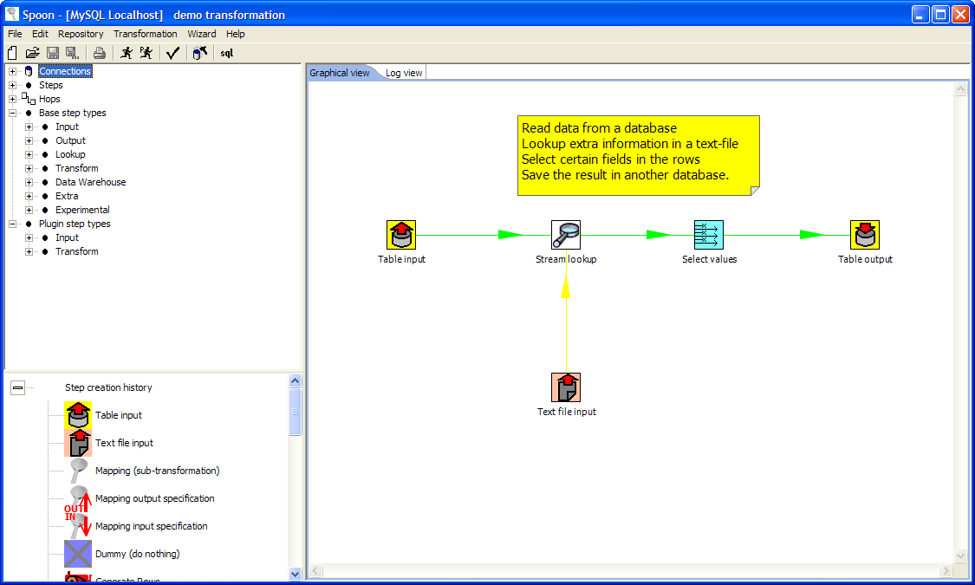

The following items are visible in Spoon: Connections, Steps, Hops, Base Step Types, Graphical View and the Log View.
These items are described in detailed in the chapters below: Connections in §3, Hops in §6, Steps in §8, the Graphical View in §9

Command line options
These are the command line options that you can use.
Fields in italic represent the values that the options use.

-file=filename

This option runs the transformation defined in the XML file. (.ktr : Kettle Transformation)

-log=Logging Filename

Specifies the log file. The default is the standard output.

-level=Logging Level

The level option sets the log level for the transformation that’s being run.
These are the possible values:

- Error: Only show errors
- Nothing: Don’t show any output
- Minimal: Only use minimal logging
- Basic: This is the default basic logging level
- Detailed: Give detailed logging output
- Debug: For debugging purposes, very detailed output.
- Rowlevel: Logging at a row level, this can generate a lot of data.

-rep=Repository name

Connect to the repository with name “Repository name”.
You also need to specify the options –user, –pass and –trans.
The repository details are loaded from the file repositories.xml in the local directory or in the Kettle directory: <homedirectory>/.kettle/

-user=Username

This is the username with which you want to connect to the repository.

-pass=Password

The password to use to connect to the repository

-trans=Transformation Name

Use this option to select the transformation to run from the repository

NOTE: It’s important that if spaces are present in the option values, you use quotes or double quotes to keep them together.

Repository
A Kettle repository can contain among other things transformations. This means that in order to load a transformation from a database repository, you need to connect to this repository.
To do this, you need to define a database connection to this repository. You can do this using the repositories dialog you are presented with when you start up Spoon.

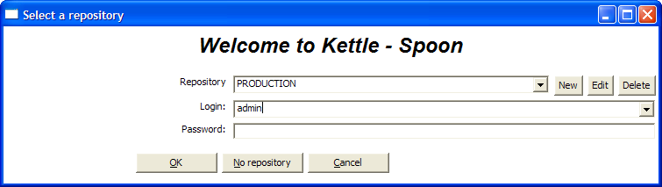

The information concerning repositories in stored in file called “repositories.xml”. This file resides in the hidden directory “.kettle” in your default home directory.

HINT: The complete path and filename of this file is displayed on the Spoon console.

IMPORTANT: The default password for the admin user is also admin. You should change this default password right after the creation using the Repository Explorer.

License
Starting with version 2.2.0 Kettle is released into the public domain under the LGPL license.
Please refer to Appendix A for the full text of this license.

Copyright (C) 2005 Matt Casters i-Bridge bvba
Kettle is free software; you can redistribute it and/or
modify it under the terms of the GNU Lesser General Public
License as published by the Free Software Foundation; either
version 2.1 of the License, or (at your option) any later version.
Kettle is distributed in the hope that it will be useful,
but WITHOUT ANY WARRANTY; without even the implied warranty of
MERCHANTABILITY or FITNESS FOR A PARTICULAR PURPOSE. See the GNU
Lesser General Public License for more details.
You should have received a copy of the GNU Lesser General Public
License along with the Kettle distribution; if not, write to the Free Software
Foundation, Inc., 51 Franklin St, Fifth Floor, Boston, MA 02110-1301 USA

Notes
You can put notes on the graphical view everywhere simply by clicking right on the canvas and selecting “Add note”.
Later these notes can be edited by double clicking on them and dragged around the screen by dragging on them with the mouse using the left button.
Removing a note can be done by a right click on the note and by selecting “Delete note”.

Definitions
- Value: a value is part of a row and can contain a String, a floating point Number, an Integer, a Date or a Boolean value.
- Row: a row exists of 0 or more values
- Output stream: an output stream is a stack of rows that leaves a step.
- Input streams: an input stream is a stack of rows that enters a step.
- Hop: a hop is a graphical representation of one or more data streams between 2 steps. A hop always represents the output stream of one step and the input stream of another.
The number of streams is equal to the copies of the destination step. (1 or more)
- Note: a note is a piece of information that can be added to a transformation

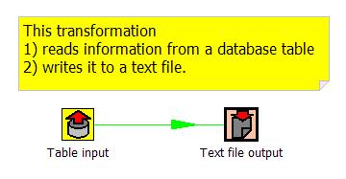
A note

A hop

A step

Toolbar

The icons on the toolbar of the main screen are from left to right:

Icon | Meaning
 | New transformation
 | Open transformation from file if you’re not connected to a repository or from the repository if you are connected to one.
 | Save the transformation to a file or to the repository.
 | Save the transformation under a different name or filename.
 | Print: you will be presented with a print-dialog asking you to specify the number of pages, margins etc.
 | Run transformation: runs the current transformation from XML file or repository.
 | Preview transformation: runs the current transformation from memory. You can preview the rows that are produced by selected steps.
 | Verify transformation: Spoon runs a number of checks for every step to see if everything is going to run as it should.
 | Run an impact analyses: what impact does the transformation have on the used databases.
 | Generate the SQL that's needed to run the loaded transformation.

Options
There are a number of options that you can change to enhance the graphical user interface, such as the fonts and the colors of the screens.
To change these options, please check out the Edit menu option “Options”.
These are screen shots of the options:

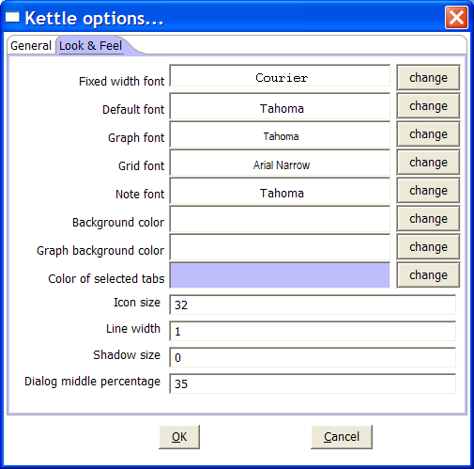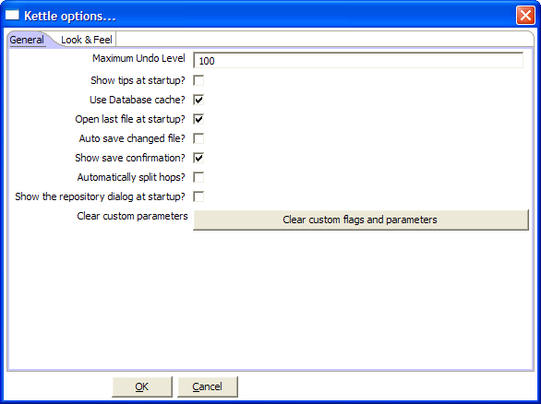

General tab

Maximum Undo Level
This parameter sets the maximum number of steps that can be undone (or redone) by Spoon.

Show tips at startup
This option sets the display of tips at startup.

Use database cache
Spoon caches information that is stored on source and target databases. In some cases this can lead to incorrect results when you’re in the process of changing those very databases. In those cases it is possible to disable the cache altogether in stead of clearing the caches every time.
NOTE: Spoon automatically clears the database cache when you launch DDL (Data Definition Language) statements towards a database connection. However, when using 3rd party tools, clearing the database cache manually may be necessary.

Open last file at startup
Enable this option to automatically (try to) load the last transformation you used (opened or saved) from XML or repository.

auto save changed file
This option automatically saves a changed transformation before running.

show save confirmation
This flag allows you to turn off the confirmation dialogs you receive when a transformation has been changed.

automatically split hops
This option turns off the confirmation dialogs you get when you want to split a hop. (see also §6.4)

show the repositories dialog at startup
This option controls whether or not the repositories dialog shows up at startup.

Clear custom flags and parameters
This option clears all parameters and flags that where set in the plugin or step dialogs.

Look & Feel tab

Default font
This is the font that’s used in the dialog boxes, trees, input fields, etc.

Graph font
This is the font that’s used on the graphical view.

Grid font
This font is used in all the grids that are used in Spoon.

Note font
This font is used in the notes that are displayed in the Graphical View.

Background color
Sets the background color in Spoon. It affects all dialogs too.

Graph background color
Sets the background color in the Graphical View of Spoon.

Color of selected tabs
This is the color that's being used to indicate tabs that are active/selected.

Icon size
This affects the size of the icons in the graph window. The original size of an icon is 32x32 pixels. The best results (graphically) are probably at sizes 16,24,32,48,64 and other multiples of 32.

Line width
This affects the line width of the hops on the Graphical View and the border around the steps.

Shadow size
If this size is larger then 0, a shadow of the steps, hops and notes is drawn on the canvas, making it look like the transformation floats above the canvas.

Dialog middle percentage
By default, a parameter is drawn at 35% of the width of the dialog, counted from the left.
You can change this with this parameter. Perhaps this can be useful in cases where you use unusually large fonts.

Database Connections

Description
A connection describes the method by which Kettle can connect to a database. The top entries in the tree on the left describe the available connections.

Screen shot
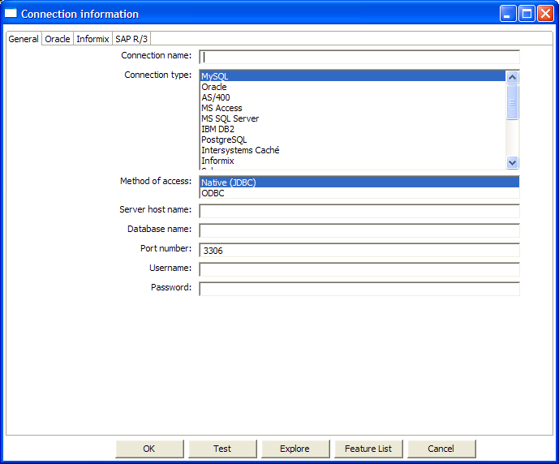

Options
- Connection name: a connection name uniquely name defines a connection across transformations.
- Connection type: the type of database you’re connecting to.
- Method of access: This can be either Native (JDBC), ODBC, or OCI.
- Server host name: specify the host name of the server on which the database resides. You can also specify it’s IP-address.
- Database name: identifies the database name you want to connect to. In case of ODBC specify the DSN name here. (see also §3.4)
- Port number: sets the TCP/IP port number on which the database listens.
- Username/password: optionally specifies the username and password to connect to the database.

EXTRA:

- For Oracle you can specify the default tablespaces in which Kettle will places objects generating SQL for tables and indexes.
- For Informix, you need to specify the Informix Server name in the Informix tab in order for a connection to be useable.
- For SAP R/3 connections, extra parameters Language, System Number and SAP Client can be specified in the SAP R/3 tab.
- Feature list: exposes the jdbc URL, class and various database settings for the connection such as the list of reserved words.

Database Usage Grid
Database | Access Method | Server name or address | Database name | Port nr (default) | Username & password
Oracle | Native | Required | Oracle database SID | Required (1521) | Required
 | ODBC |  | ODBC DSN name |  | Required
 | OCI |  | Database TNS name |  | Required
MySQL | Native | Required | MySQL database name | Required (3306) | Required
 | ODBC |  | ODBC DSN name |  | Required
AS/400 | Native | Required | AS/400 Library name | Optional | Required
 | ODBC |  | ODBC DSN name |  | Required
MS Access | ODBC |  | ODBC DSN name |  | Optional
MS SQL Server | Native | Required | Database name | Required (1433) | Required
 | ODBC |  | ODBC DSN name |  | Required
IBM DB2 | Native | Required | Database name | Required (50000) | Required
 | ODBC |  | ODBC DSN name |  | Required
PostgreSQL | Native | Required | Database name | Required (5432) | Required
 | ODBC |  | ODBC DSN name |  | Required
Intersystems Caché | Native | Required | Database name | Required (1972) | Required
 | ODBC |  | ODBC DSN name |  | Required
Informix | Native | Required | Database name | Required (1526) | Required
 | ODBC |  | ODBC DSN name |  | Required
Sybase | Native | Required | Database name | Required (5001) | Required
 | ODBC |  | ODBC DSN name |  | Required
Gupta SQL Base | Native | Required | Database name | Required (2155) | Required
 | ODBC |  | ODBC DSN name |  | Required
Dbase III, IV or 5.0 | ODBC |  | ODBC DSN name |  | Optional
Firebird SQL | Native | Required | Database name | Required (3050) | Required
 | ODBC |  | ODBC DSN name |  | Required
Hypersonic | Native | Required | Database name | Required (9001) | Required
MaxDB (SAP DB) | Native | Required | Database name |  | Required
 | ODBC |  | ODBC DSN name |  | Required
CA Ingres | Native | Required | Database name |  | Required
 | ODBC |  | ODBC DSN name |  | Required
Generic | ODBC |  | ODBC DSN name |  | Optional

Usage

Create a new connection
You can create a new connection by clicking right on the "Connections" tree entry and selecting "new".

Or : simply double click on the Connections tree entry.
Or : press F3 to start the “new connection” wizard.

Edit a connection
Double click on the connection name in the left tree. Or right click on the name and select "Edit connection".

Duplicate a connection
Right click on the connection name and select "Duplicate ".

Copy to clipboard
Copies the XML describing the connection to the clipboard.

Delete a connection
Right click on the connection name and select "Delete".

Test a connection
In the edit window (see above), select the "Test" button. If Spoon can connect, an OK message is displayed after a short delay.

Execute SQL commands on a connection
Right click on the connection name and select "SQL Editor". See also §4 for more information.

Clear DB Cache option
To speed up connections Spoon uses a database cache. Use this option when the information in the cache no longer represents the layout of the database. This is the case when databases tables have been changed, created or deleted.

Explore
This option will start the database explorer for the selected database connection.
Please see §5 for more information.

Unsupported databases
If you want to access a database type that is not yet supported, let us know and we will try to find a solution. A few database types are not supported in this release because of the lack of sample database and/or software.
Please note that it is usually still possible to read from these databases by using the Generic database driver through an ODBC connection.

SQL editor

Description
Sometimes a simple SQL Editor can be nice to have. Especially when you're creating tables, dropping indexes and modifying fields. The simple SQL editor supplied in Spoon, allows you to do this. In fact, most of the DDL (Data Definition Language) such as “create/alter table”, “create index” and “create sequence” SQL commands are created automatically for you via the SQL Editor window.

NOTE: Multiple SQL Statements have to be separated by semi-colons (;).
NOTE: Before these SQL Statements are sent to the database to be executed, Spoon removes returns, line-feeds and the separating semi-colons.
NOTE: Kettle clears the database cache for the database connection on which you launch DDL statements.

Screen shot
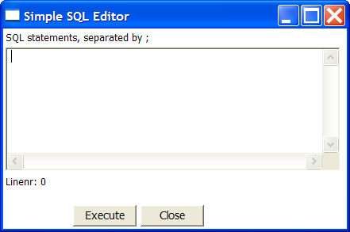

Database Explorer

Screen shot
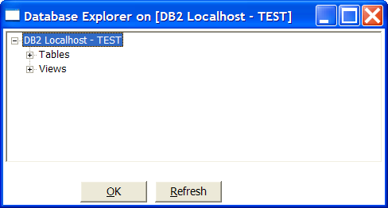

Description
The database explorer allows you to explore the database to which the database connection points. At the moment, it only shows available tables and the catalog and/or schema to which the table belongs.
It is possible to click right on a shown table or view (lowest level in the tree) and select one of the following options:

- Display the first 100 rows of the table (also available through double-click on table name)
- Display the first … lines of the table
- Show the size (in rows) of the table.
- Show layout of the table
- Generate the DDL statement (create table ...) for this table.
- Generate the DDL statement (create table ...) for this table on another database connection
- Show the SQL statement to read from this table. (in SQL Editor)

Hops

Description
A hop connects one step with another. The direction of the data flow is indicated with an arrow on the graphical view pane. A hop can be enabled or disabled. (For testing purposes for example).

Screen shot
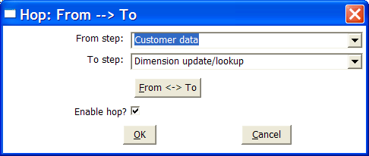

Creating A Hop
You can easily create a new hop between 2 steps by one of the following options:
- Dragging on the Graphical View between 2 steps while using the middle mouse button.
- Dragging on the Graphical View between 2 steps while pressing the SHIFT key and using the left mouse button.
- Selecting 2 steps in the tree, clicking right and selecting "new hop"
- Selecting 2 steps in the graphical view (CTRL + left mouse click), clicking right on a step and selecting "new hop"

Splitting A Hop
You can easily insert a new step into a new hop between 2 steps by dragging the step (in the Graphical View) over a hop until the hop becomes drawn in bold. Release the left button and you will be asked if you want to split the hop. This works only with steps that have not yet been connected to another step.

Loops
Loops are not allowed in transformations because Spoon depends heavily on the previous steps to determine the field values that are passed from one step to another. If we would allow loops in transformations we often would get endless loops and undetermined results.

Transformation settings

Description
There are a few options that control how a transformation is behaving and how it is logging what it is doing.
A number of settings also define how a transformation acquires data from source tables. To be more precise, the settings in this dialog define the date range for the source table.

Screen shots

The “Transformation” tab
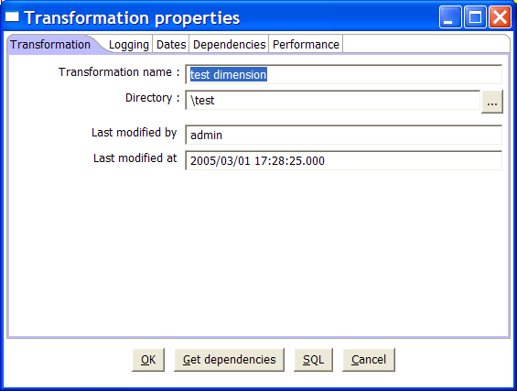

The “Logging” tab
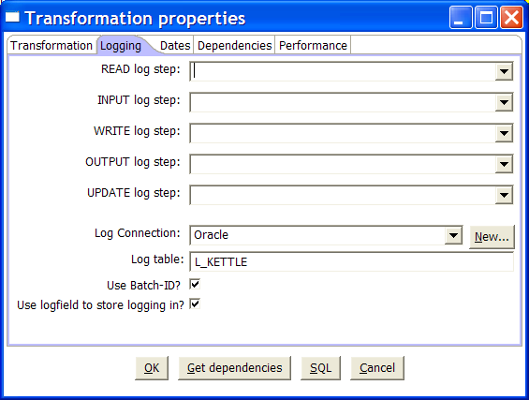

The “Dates” tab
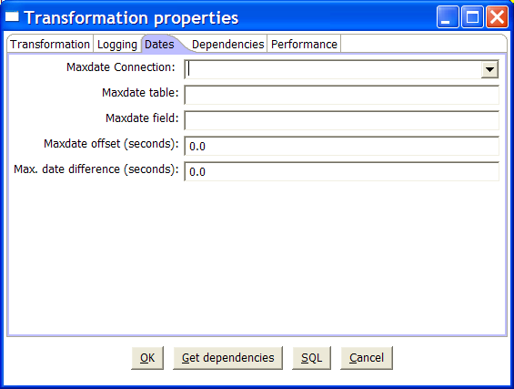

The “Dependencies” tab.
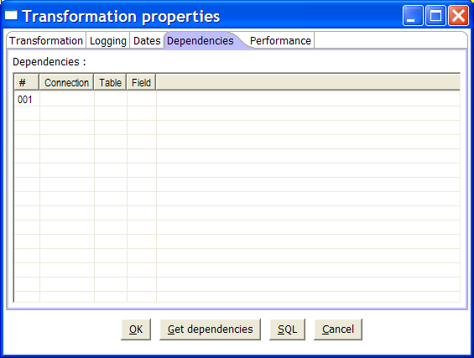

The “Performance” tab.
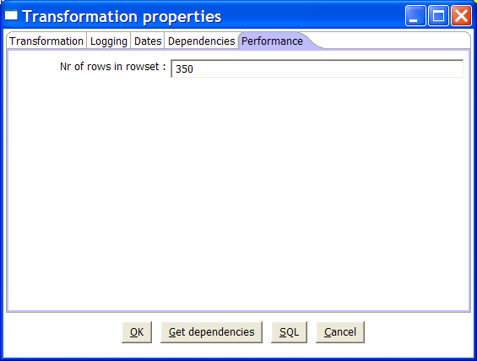

Options
Option | Description
Transformation name | the name of the transformation. Required information if you want to save to a repository.
Directory | the directory in the repository in which you want to save the transformation.
READ log step | use the number of read lines from this step to write to the log table. Read means: read from source steps.
INPUT log step | use the number of input lines from this step to write to the log table. Input means: input from file or database.
WRITE log step | use the number of written lines from this step to write to the log table. Written means: written to target steps.
OUTPUT log step | use the number of output lines from this step to write to the log table. Output means: output to file or database.
UPDATE log step | use the number of updated lines from this step to write to the log table. Update means: updated in a database.
Log connection | Use this connection to write to a log table
Log table | specifies the name of the log table (for example L_ETL)
Use Batch-ID? | enable this if you want to have a batch ID in the L_ETL file. Disable for backward compatibility with Spoon/Pan version < 2.0.
Use logfield to store logging in | this option stores the logging text in a CLOB field in the logging table. This allows you to have the logging text together with the run results in the same table. Disable for backward compatibility with Spoon/Pan version < 2.1
Maxdate connection | Get the upper limit for a date range on this connection.
Maxdate table | get the upper limit for a date range in this table.
Maxdate field | get the upper limit for a date range in this field.
Maxdate offset | increases the upper date limit with this amount. Use this for example, If you find that the field DATE_LAST_UPD has a maximum value of 2004-05-29 23:00:00, but you know that the values for the last minute are not complete. In this case, simply set the offset to -60.
Maximum date difference | Sets the maximum date difference in the obtained date range. This will allow you to limit job sizes.
Dependencies | This table will allow you to enter all the dependencies. For example if a dimension is depending on 3 lookup tables, we have to make sure that these lookup tables have not changed. If the values in these lookup tables have changed, we need to extend the date range to force a full refresh of the dimension. The dependencies allow you to look up whether a table has changed in case you have a “data last changed” column in the table.
Number of rows in rowsets | this option allows you to change the size of the buffers between the connected steps in a transformation. You will rarely/never need to change this parameter. Only when you run low on memory it might be an option to lower this parameter.

Extra
- Get dependencies button: Tries to automatically detect dependencies.
- SQL button: generates the SQL needed to create the logging table and allows you to execute this SQL statement.

Steps

Description
A step is one part of a transformation. Steps can provide you with a wide range of functionality ranging from reading text-files to implementing slowly changing dimensions.
Please see below for a complete list of all available step-types.

Launching several copies of a step
Sometimes it can be useful to launch the same step several times. For example, for performance reasons it can be useful to launch a database lookup step 3 times or more. That is because database connections usually have a certain latency. Launching the same step several times keeps the database busy on different connections, effectively lowering the latency.
You can launch several copies of step in a transformation simply by clicking right on a step in the graphical view and then by selecting “change number of copies to start…”

You will get this dialog:

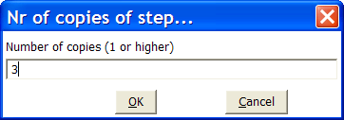

If you enter 3 this will be shown:

It is technically the equivalent of this:

Distribute or copy?
In the example above green lines are shown between the steps. This indicates that rows are distributed among the target steps. In this case it means that the first row coming from step “A” goes to step “database lookup 1”, the second to “database lookup 2”, the third to “Database lookup 3”, the fourth back to “database lookup 1”, etc.

However, if we click right on step “A”, and select “Copy data”, you will get the hops drawn in red:
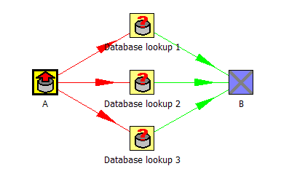

“Copy data” means that all rows from step “A” are copied to all 3 the target steps.
In this case it means that step “B” gets 3 copies of all the rows that “A” has sent out.

NOTE: Because of the fact that all these steps are run as different threads, the order in which the single rows arrive at step “B” is probably not going to be the same as they left step “A”.

Step Types

Text File Input

Screen shots
The “File” tab:
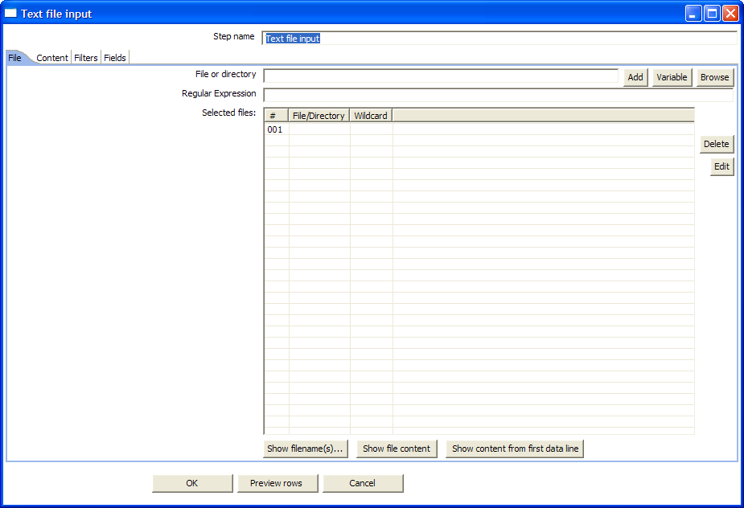

The “Content” tab:
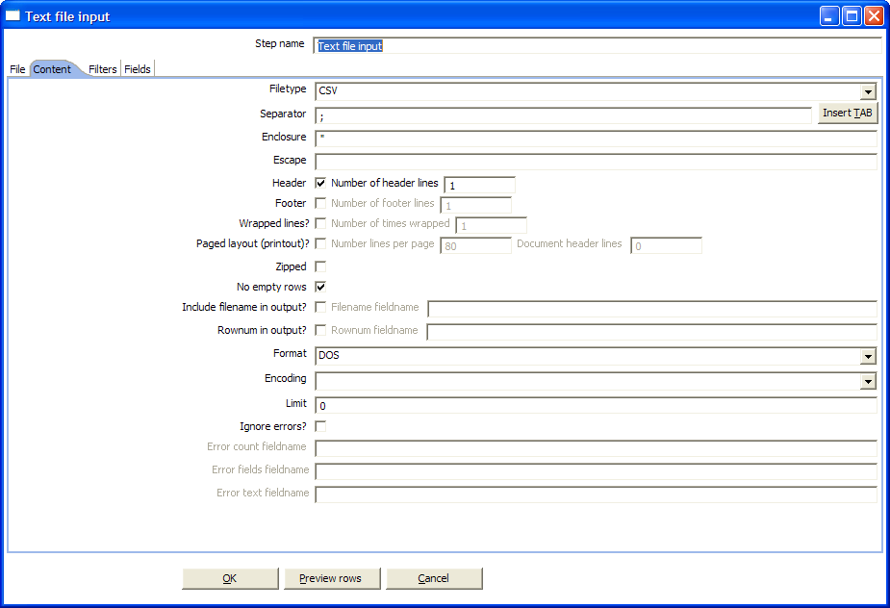

The “Filters” tab:
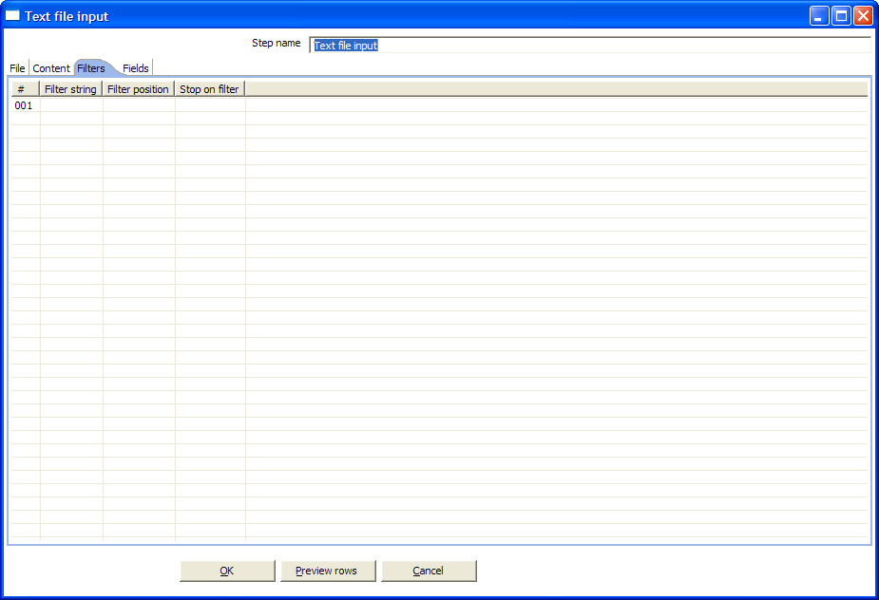

The “Fields” tab:
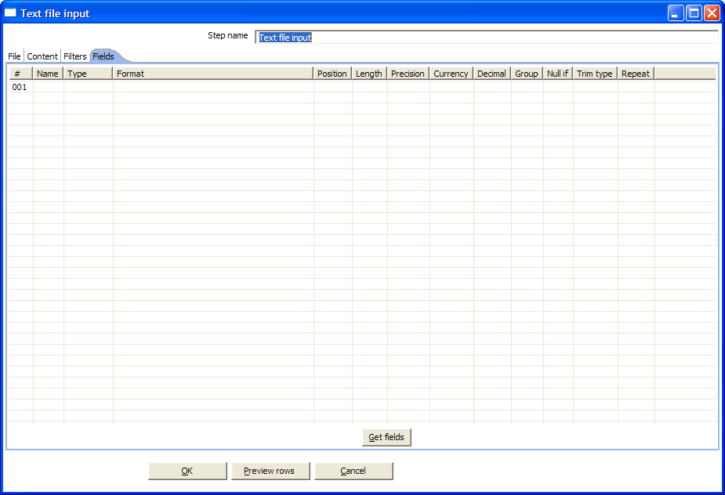

Icon

General description
You can use the Text File Input step to read a large number of different text-files.
Most commonly these are Comma Separated Values (CSV files) generated by spreadsheets and the like.
From version 2.1 on you can specify a list of files to read, or a list of directories with wildcards in the form of regular expressions.

Options
Option | Description
Step name | Name of the step. This name has to be unique in a single transformation.
File or directory | This field specifies the location and/or name of the input text file. NOTE: press the “add” button to add the file/directory/wildcard combination to the list of selected files (grid) below.
Regular expression | Specify the regular expression you want to use to select the files in the directory specified in the previous option.
File type | This can be either CSV or Fixed length. Based on this selection, Spoon will launch a different helper GUI when you press the “get fields” button in the last “fields” tab.
Separator | One or more characters that separate the fields in a single line of text. Typically this is ; or a tab
Enclosure | Some fields can be enclosed by a pair of strings to allow separator characters in fields. The enclosure string is optional. If you use repeat an enclosures allow text line 'Not the nine o''clock news.'. With ' the enclosure string, this gets parsed as Not the nine o'clock news.
Escape | Specify an escape character (or characters) if you have escaped characters in your data. If you have \ as an escape character, the text 'Not the nine o\'clock news.' (with ' the enclosure) will get parsed as Not the nine o'clock news.
Header & number of header lines | Enable this option if your text file has a header row. (First lines in the file)  You can specify the number of times the header lines appears.
Footer & number of footer lines | enable this option if your text file has a footer row. (Last lines in the file)  You can specify the number of times the footer row appears.
Wrapped lines & number of wraps | Use this if you deal with data lines that have wrapped beyond a certain page limit. Note that headers & footers are never considered wrapped.
Paged layout & page size & doc header | You can use these options as a last resort when dealing with texts meant for printing on a line printer. Use the number of document header lines to skip introductory texts and the number of lines per page to position the data lines.
Zipped | enable this option if your text file is placed in a Zip archive. NOTE: At the moment, only the first file in the archive is read.
No empty rows | Don't send empty rows to the next steps
Include filename in output | Enable this if you want the filename to be part of the output
Filename fieldname | The name of the field that will contain the filename
Row number in output | Enable this if you want the row number to be part of the output
Row number fieldname | The name of the field that will contain the row number
Format | This can be either DOS or UNIX. UNIX files have lines are separated by line feeds. DOS files have lines separated by carriage returns and line feeds.
Encoding | Specify the text file encoding to use. Leave blank to use the default encoding on your system. To use Unicode specify UTF-8 or UTF-16.  On first use, Spoon will search your system for available encodings.
Limit | Sets the number of lines that is read from the file. 0 means: read all lines.
Fields grid | - Name: name of the field  - Type: Type of the field can be either String, Date or Number  - Format: See 8.4.1.5 for a complete description of format symbols.  - Length:  - Number: Total number of significant figures in a number  - String: total length of string  - Date: length of printed output of the string (e.g. 4 only gives back the year)  - Precision:  - Number: Number of floating point digits.  - String: unused.  - Date: unused.  - Currency: used to interpret numbers like $10,000.00 or €5.000,00  - Decimal: A decimal point can be a "." (10;000.00) or "," (5.000,00)  - Grouping: A grouping can be a dot "," (10;000.00) or "." (5.000,00)  - Null if: treat this value as NULL.  - Trim type: trim this field (left, right, both) before processing.  - Repeat: Y/N: If the corresponding value in this row is empty: repeat the one from the last time it was not empty.
Filter grid | The filter grid allows you to enter any number of filters so that you can filter out unwanted lines from a text file.  These are the possible filter settings:  - Filter string: the string to look for in the line  - Filter position: the position on which the string has to appear. If the position is empty or less then 0, the filter will work for any position of the string in the line.  - Stop on filter: set this to Y if you want to stop reading from the text file when the conditions for this filter match.

Formats

Number formats
Symbol | Location | Localized | Meaning
0 | Number | Yes | Digit
# | Number | Yes | Digit, zero shows as absent
. | Number | Yes | Decimal separator or monetary decimal separator
- | Number | Yes | Minus sign
, | Number | Yes | Grouping separator
E | Number | Yes | Separates mantissa and exponent in scientific notation. Need not be quoted in prefix or suffix.
; | Sub pattern boundary | Yes | Separates positive and negative sub patterns
% | Prefix or suffix | Yes | Multiply by 100 and show as percentage
\u2030 | Prefix or suffix | Yes | Multiply by 1000 and show as per mille
¤ (\u00A4) | Prefix or suffix | No | Currency sign, replaced by currency symbol. If doubled, replaced by international currency symbol. If present in a pattern, the monetary decimal separator is used instead of the decimal separator.
' | Prefix or suffix | No | Used to quote special characters in a prefix or suffix, for example, "'#'#" formats 123 to "#123". To create a single quote itself, use two in a row: "# o''clock".

Scientific Notation

In a pattern, the exponent character immediately followed by one or more digit characters indicates scientific notation. Example: "0.###E0" formats the number 1234 as "1.234E3".

Date formats

Letter | Date or Time Component | Presentation | Examples
G | Era designator | Text | AD
y | Year | Year | 1996; 96
M | Month in year | Month | July; Jul; 07
w | Week in year | Number | 27
W | Week in month | Number | 2
D | Day in year | Number | 189
d | Day in month | Number | 10
F | Day of week in month | Number | 2
E | Day in week | Text | Tuesday; Tue
a | Am/pm marker | Text | PM
H | Hour in day (0-23) | Number | 0
k | Hour in day (1-24) | Number | 24
K | Hour in am/pm (0-11) | Number | 0
h | Hour in am/pm (1-12) | Number | 12
m | Minute in hour | Number | 30
s | Second in minute | Number | 55
S | Millisecond | Number | 978
z | Time zone | General time zone | Pacific Standard Time; PST; GMT-08:00
Z | Time zone | RFC 822 time zone | -0800

Extras
Function/Button | Description
Show filenames | This option shows a list of all the files selected. Please note that if the transformation is to be run on a separate server, the result might be incorrect.
Show file content | The “View” button shows the first lines of the text-file. Make sure that the file-format is correct. When in doubt, try both DOS and UNIX formats.
Show content from first data line | This button helps you in positioning the data lines in complex text files with multiple header lines, etc.
Get fields | This button allows you to guess the layout of the file. In case of a CSV file, this is done pretty much automatically. When you selected a file with fixed length fields, you need to specify the field boundaries using a wizard.
Preview rows | Press this button to preview the rows generated by this step.

Text File Output

Screen shots
The “File” tab:
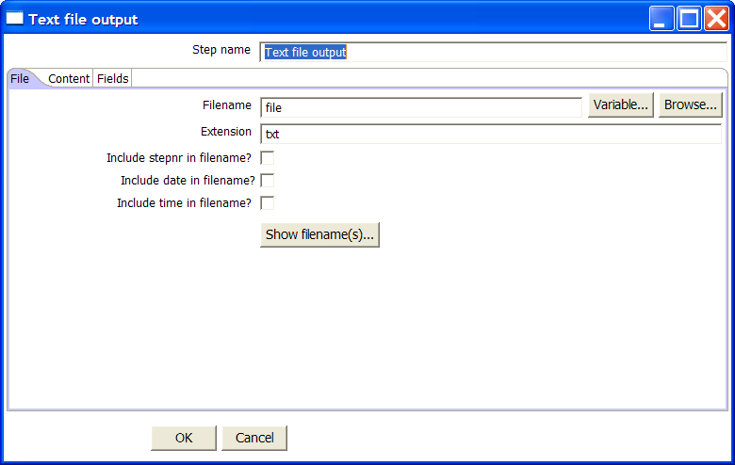

The “Content” tab:
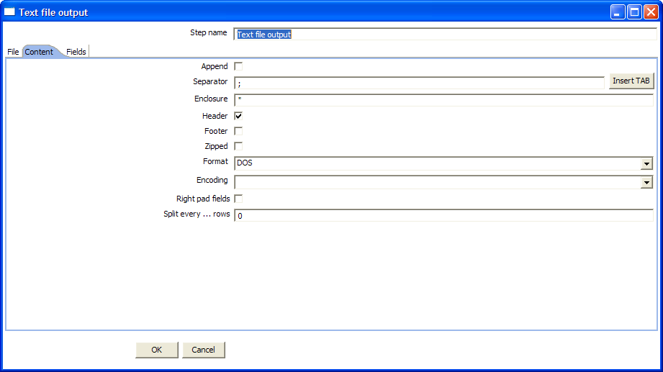

The “Fields” tab:
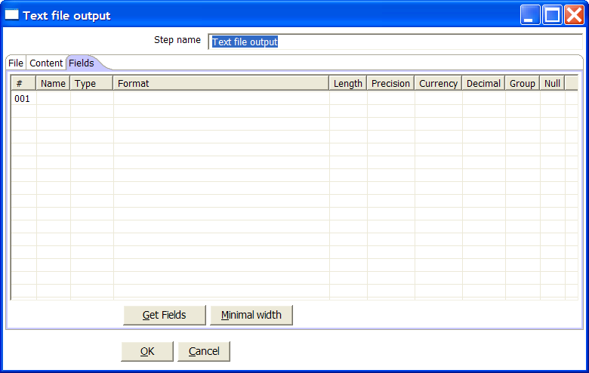

Icon

General Description
You can use the Text File Output step to export data to text file format.
Most commonly these are Comma Separated Values (CSV files) that can be read by spreadsheets and the like.

Options
Option | Description
Step name | Name of the step. This name has to be unique in a single transformation.
Filename | This field specifies the filename and location of the output text file
Extension | adds a point and the extension to the end of the filename. (.txt)
Include stepnr in filename | If you run the step in multiple copies (see §8.2), the copy number is included in the filename, before the extension. (_0)
Include date in filename | includes the system date in the filename. (_20041231)
Include time in filename | includes the system date in the filename. (_235959)
Append | check this if you want to append lines to the end of the specified file.
Separator | Here you can specify the character that separates the fields in a single line of text. Typically this is ; or a tab
Enclosure | A pair of strings can enclose some fields. This allows separator characters in fields. The enclosure string is optional.
Header | enable this option if you want the text file to have a header row. (First line in the file)
Footer | enable this option if you want the text file to have a footer row. (Last line in the file)
Zipped | Check this box if you want the text file(s) to be zipped. NOTE: At the moment, only one file is placed in a single archive.
Format | This can be either DOS or UNIX. UNIX files have lines are separated by linefeeds. DOS files have lines separated by carriage returns and line feeds.
Encoding | Specify the text file encoding to use. Leave blank to use the default encoding on your system. To use Unicode specify UTF-8 or UTF-16.  On first use, Spoon will search your system for available encodings.
Right pad fields | add spaces to the end of the fields (or remove characters at the end) until they have the specified length.
Split every … rows | If this number N is larger than zero, split the resulting text-file into multiple parts of N rows.
Fields | - Name: name of the field  - Type: Type of the field can be either String, Date or Number  - Format: See 8.4.1.5 for a complete description of format specifiers.  - Length:  - Number: Total number of significant figures in a number  - String: total length of string  - Date: length of printed output of the string (e.g. 4 only gives back the year)  - Precision:  - Number: Number of floating point digits.  - String: unused.  - Date: unused.  - Currency: Symbol used to represent currencies like $10,000.00 or €5.000,00  - Decimal: A decimal point can be a "." (10,000.00) or "," (5.000,00)  - Grouping: A grouping can be a "," (10,000.00) or "." (5.000,00)  - Null: If the value of the field is null, insert this string into the text-file.

Extras

Function/Button | Description
Show filenames | This option shows a list of the files the will be generated. NOTE: This is a simulation and somethimes depends on the number of rows in each file, etc.
Minimal width | Alter the options in the fields tab in such a way that the resulting width of lines in the text file is minimal. So instead of save 0000001, we write 1, etc.  String fields will no longer be padded to their specified length.

Table input

Screen shot
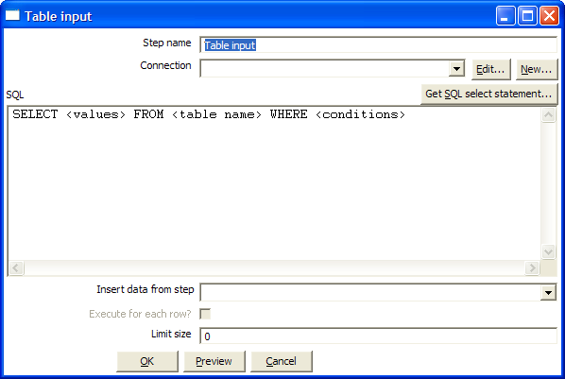

Icon

General description
This step is used to read information from a database, using a connection and SQL. Basic SQL statements are generated automatically.

Options

Option | Description
Step name | Name of the step. This name has to be unique in a single transformation.
Connection | The database connection used to read data from.
SQL | The SQL statement used to read information from the database connection.
Insert data from step | Specify the input step name where we can expect information to come from. This information can then be inserted into the SQL statement. The locators where we insert information is indicated by ? (question marks).
Limit | Sets the number of lines that is read from the database. 0 means: read all lines.

Example

Consider for example the following SQL statement:

SELECT * FROM customers WHERE changed_date BETWEEN ? AND ?

This statement needs 2 dates that are read on the "Insert data from" step.

NOTE: The dates can be provided using the "Get System Info" step type.
For example if you want to read all customers that have had their data changed yesterday, you might do it like this:

The “read customer data” step looks like this:

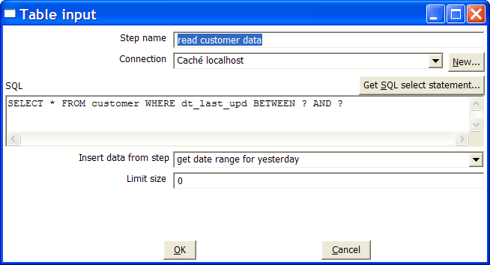

And the “get date range for yesterday” looks like this:

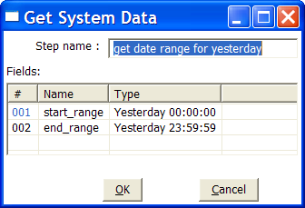

See also: Get System Data step §8.4.16.

Extras

Function/Button | Description
Preview | This option previews this step. It is done by preview of a new transformation with 2 steps: this one and a Dummy step. You can see the detailed logging of that execution by clicking on the logs button in the the preview window.

Table output

Screen dump
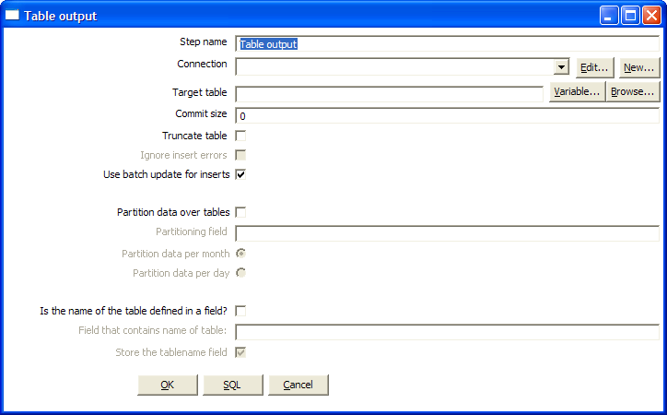

Icon

General description
This step type allows you to store information in a database table.

Options
Option | Description
Step name | Name of the step. This name has to be unique in a single transformation.
Connection | The database connection used to write data to
Target table | the name of the table to write data to
Commit size | use transactions to insert rows in the database table. Commit the connection every N rows if N is larger than 0. Otherwise, don't use transactions. (Slower)  NOTE: Transactions are not supported on all database platforms.
Truncate table | Select this if you want the table to be truncated before the first row is inserted into the table
Ignore insert errors | Makes Kettle ignore all insert errors such as violated primary keys. A maximum of 20 warnings will be logged however. This option is not available for batch inserts.
Use batch update for inserts | Enable this option if you want to use batch inserts. This feature groups inserts statements to limit round trips to the database. This is the fastest option and is enabled by default.
Partition data over tables | Use these options to split the data over multiple tables. For example in stead of inserting all data into table SALES, put the data into tables SALES_200510, SALES_200511, SALES_200512, ...  Use this on systems that don't have partitioned tables and/or don't allow inserts into UNION ALL views or the master of inherited tables.  The view SALES allows you to report on the complete sales:  CREATE OR REPLACE VIEW SALES AS  SELECT * FROM SALES_200501  UNION ALL  SELECT * FROM SALES_200502  UNION ALL  SELECT * FROM SALES_200503  UNION ALL  SELECT * FROM SALES_200504  ...
Is the name of the table defined in a field. | Use these options to split the data over one or more tables. The name of the target table is defined in the field you specify. For example if you store customer data in the field gender, the data might end up in tables M and F (Male and Female).  There is an option to exclude the field containing the tablename from being inserted into the tables.

Extras

Function/Button | Description
SQL | Generate the SQL to create the output table automatically.
Check | Verifies that all fields are available in the target table and vice-versa

Select values

Screen dump
The “Select & Alter” tab:
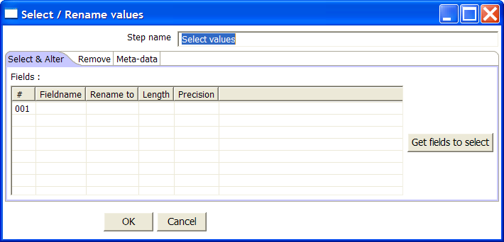
The “Remove” tab:
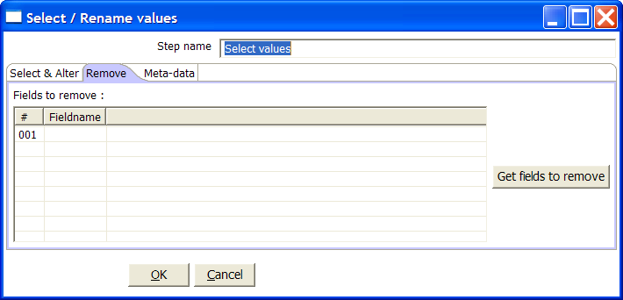
The “Meta-data” tab:
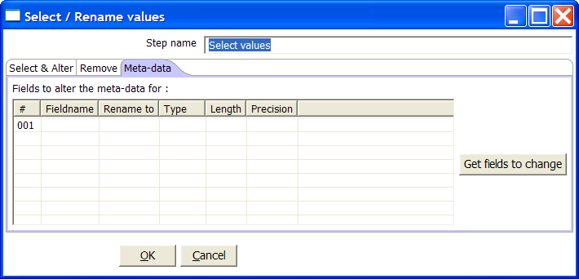

Icon

General description
This step type is useful to
- Select fields
- Rename fields
- Specify the length and/or precision of the fields

These are the functions of the 3 different tabs:
- Select & Alter: Specify the exact order and name in which the fields have to be placed in the output rows.
- Remove: Specify the fields that have to be removed from the output rows
- Meta-data: Change the name, type, length and precision (the meta-data) of one or more fields.

Options
- Step name: Name of the step. This name has to be unique in a single transformation.
- Fields of the table:
  - Fieldname: The fieldname to select or change
  - Rename to: leave blank if you don't want to rename
  - Length: enter number to specify the length. (-1: no length specified)
  - Precision: enter number to specify the precision. (-1: no precision specified)

Filter rows

Screen shot
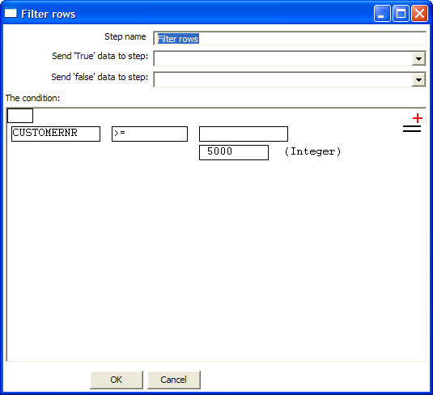

Icon

General description
This step type allows you to filter rows based upon conditions and comparisons.
Once this step is connected to a previous step (one or more and receiving input), you can simply click on the “<field>”, “=” and “<value>” areas to construct a condition.
In the example in the screen shot, it is possible to click on the following icon to add more conditions:

It will convert the original condition to a subcondition and add one more.
A subcondition can be edited simply by clicking on it. (going down one level into the condition tree)

For example, this is a more complex example:

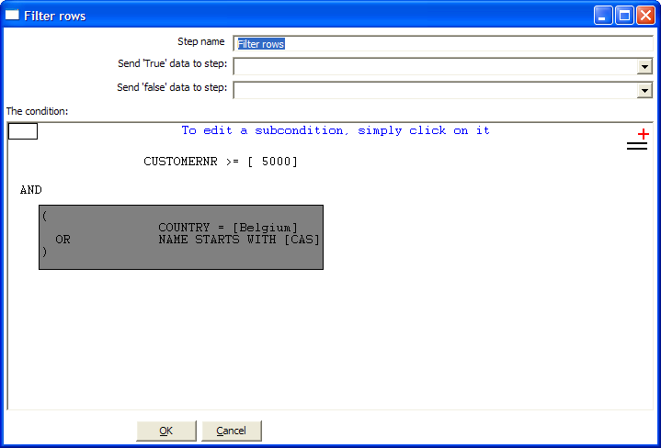

Options
- Step name: Name of the step. This name has to be unique in a single transformation.
- Send “true” data to step: The rows for which the condition specified evaluates to true are send to this step.
- Send “false” data to step: The rows for which the condition specified evaluates to false are send to this step.

Database lookup

Screen dump
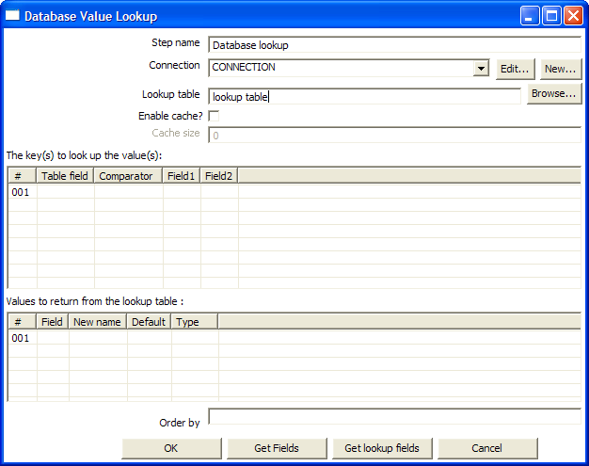

Icon

General description
This step type allows you to look up values in a database table.

Options
- Step name: Name of the step. This name has to be unique in a single transformation.
- Connection: The database connection used to write data to.
- Lookup table: the name of the table where we do the lookup.
- Enable cache: This option caches database lookups. This means that we expect the database to return the same value all the time for a certain lookup value.

IMPORTANT: if other processes are changing values in the table where you do the lookup, it might be unwise to cache values. However, in all other cases, enabling this option can seriously increase the performance because database lookups are relatively slow. If you find that you can’t use the cache, consider launching several copies of this step at the same time. This will keep the database busy via different connections. To see how to do this, please see §8.2

Sort rows

Screen shot
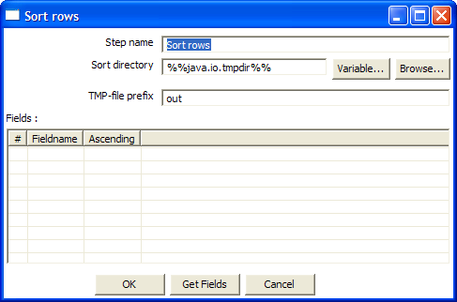

Icon

General description
This step type sorts rows based upon the fields you specify and whether or not they should be sorted ascending or descending.
NOTE: Kettle has to sort rows using temporary files when the number of rows exceeds 5000.

Options
- Step name: Name of the step. This name has to be unique in a single transformation.
- Sort directory: This is the directory in which the temporary files are stored in case it is needed. The default is the standard temporary directory for the system.
- The TMP-file prefix: Choose a recognizable prefix in order to recognize the files when they show up in the temp directory.
- A list of fields and whether they should be sorted ascending or not.

Extras
- The “Get fields” button inserts the fields into the “Fields” grid if the step is connected to the previous ones.

Stream lookup

Screen shot
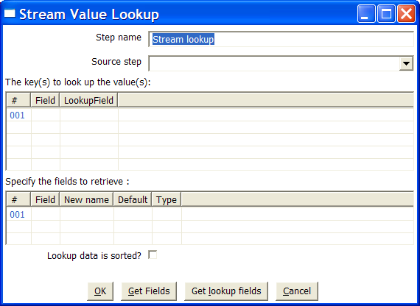

Icon

General description
This step type allows you to look up data using information coming from other steps in the transformation. The data coming from the “Source step” is first read into memory and is then used to look up data from the main stream.

For example, this transformation add information coming from a text-file to data coming from a database table:

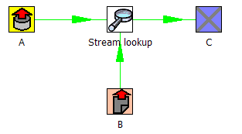

The fact that we use information from B to do the lookups is indicated by the option: “Source step” (see below):

Options
- Step name: Name of the step. This name has to be unique in a single transformation.
- Source step: This is the step name where the lookup data is coming from
- The key(s) to lookup value(s): Allows you to specify the names of the fields that are used to lookup values. Values are always searched using the “equal” comparison.
- Fields to retrieve: You can specify the names of the fields to retrieve here, as well as the default value in case the value was not found or a new fieldname in case you didn’t like the old one.

Extra
- “Get Fields”: This will automatically fill in the names of all the available fields on the source side (A). You can then delete all the fields you don’t want to use for lookup.
- “Get lookup fields”: This will automatically insert the names of all the available fields on the lookup side (B). You can then delete the fields you don’t want to retrieve.

Add sequence

Screen dump
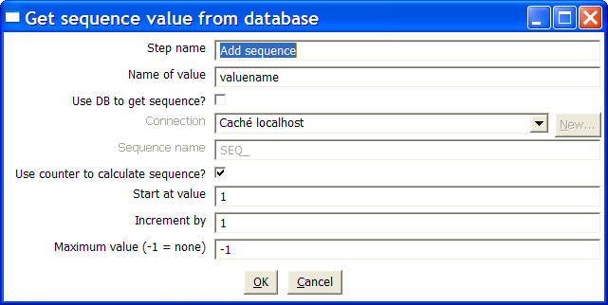

Icon

General description
Steps based on this step type will add a sequence to the stream. A sequence is an ever-changing integer value with a certain start and increment value.
You can either use a database (Oracle) sequence to determine the value of the sequence, or let Kettle decide.

NOTE: Kettle sequences are only unique when used in the same transformation. Also, they are not stored, so the values start back at the same value every time the transformation is launched.

Options
- Step name: Name of the step. This name has to be unique in a single transformation.
- Name of value: name of the new sequence value that is added to the stream.
- Use DB to get sequence: Enable this option if you want the sequence to be driven by a database sequence.
  - Connection name: choose the name of the connection on which the database sequence resides.
  - Sequence name: allows you to enter the name of the database sequence.
- Use counter to calculate sequence: Enable this option if you want the sequence to be generated by Kettle.
  - Start at: give the start value of the sequence.
  - Increment by : give the increment of the sequence.
  - Maximum value: this is the maximum value after which the sequence will start back at the start value. (Start At)

Examples:

Start at = 1, increment by = 1, maximum value = 3
→ This will produce: 1, 2, 3, 1, 2, 3, 1, 2, 3, …

Start at = 0, increment by = -1, maximum value = -5
→ This will produce: 0, -1, -2, -3, -4, -5, 0, -1, -2, …

Dimension update/lookup

Screen shots
The table tab:
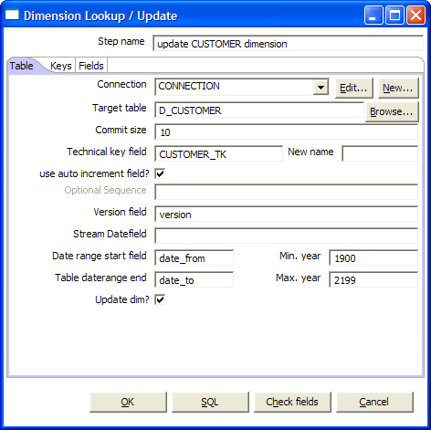

The customer tab:
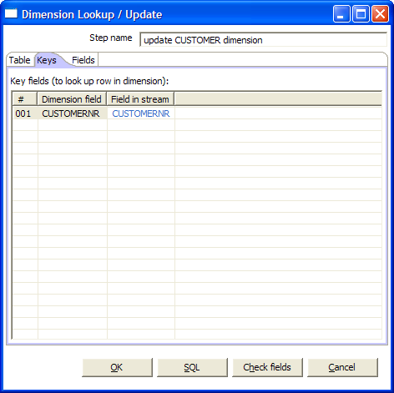

The fields tab:
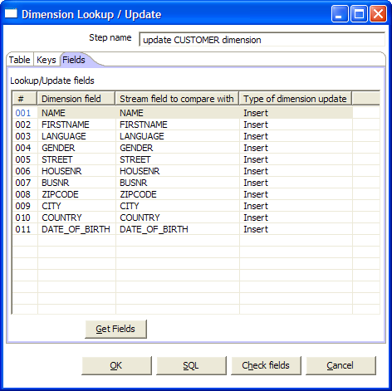

Icon

General description
This step type allows you to implement Ralph Kimball’s slowly changing dimension for both types: Type I (insert) and Type II (update). Not only can you use this dimension for updating a dimension table, it can also be used for looking up values in a dimension.
In our dimension implementation each entry in the dimension table has the following fields:

- Technical key: this is the primary key of the dimension
- Version field: shows the version of the dimension entry. (a revision number)
- Start of date range: this is the fieldname containing the validity starting date.
- End of date range: this is the fieldname containing the validity ending date.
- Keys: these are the keys used in your source systems. For example: customer numbers, product id, etc.
- Fields: these fields contain the actual information of a dimension.

As a result of the lookup or update operation of this step type, a field is added to the stream containing the technical key of the dimension. In case the field is not found, the value of the dimension entry for not found (0 or 1) is returned.

NOTE: This dimension entry is added automatically to the dimension table when the update is first run.

Options
- Step name: Name of the step. This name has to be unique in a single transformation.
- Connection: name of the database connection on which the dimension table resides.
- Target table: name of the dimension table
- Commit size: setting this to 10 will generate a commit every 10 inserts or updates.
- Technical Key field: this indicates the primary key of the dimension. It is also referred to as Surrogate Key.
- Technical key, new name: rename the technical key after a lookup, for example, if you need to lookup different types of products like ORIGINAL_PRODUCT_TK, REPLACEMENT_PRODUCT_TK, ...
- Use auto-increment field: Some databases support auto-increment, auto-number or identity fields that determine automatically the next value for a primary key. Enable this option if the field in the table you use is auto-incremented.
NOTE: This field is not enabled if the database doesn’t support auto increment fields.
- Optional sequence: if the database you use supports sequences, you can fill in the name of the sequence to use:
NOTE: This field is not enabled if the database doesn’t support sequences.
- Version field: specifies the name of the field to store the version (revision number) in.
- Stream date field: If you have the date at which the dimension entry was last changed, you can specify the name of that field here. It allows the dimension entry to be accurately described for what the date range concerns. If you don’t have such a date, the system date will be taken.
NOTE: Consider adding an extra date field from System Info if you don’t want the date ranges to be different all the time. For example if you have extracts from a source system being done every night at midnight, consider adding date “Yesterday 23:59:59” as a field to the stream by using a Join step.
- Date range start and end fields: specify the names of the dimension entries validity range.
- Keys: Specify the names of the keys in the stream and in the dimension table. This will enable the step to do the lookup.
- Update dimension: Check this option if you want to update the dimension based on the information in the input stream. If this option is not enabled, the dimension only does lookups and only adds the technical key field to the streams.
- Fields: For each of the fields you need to have in the dimension, you can specify whether you want the values to be updated (for all versions, this is a Type II operation) or you want to have the values inserted into the dimension as a new version. In the example we used in the screen shot the birth date is something that’s not variable in time, so if the birth date changes, it means that it was wrong in previous versions. It’s only logical then, that the previous values are corrected in all versions of the dimension entry.

Extra
- Get fields: fills in all the available fields on the input stream, except for the keys you specified.
- Check fields: Checks whether everything is filled in correctly
- SQL: generates the SQL to build the dimension and allows you to execute this SQL.
Version 1: -∝ → 14/02/1999

Version 2: 14/02/1999 → 20/03/2001

Version 3: 20/03/2001 → 05/12/2003

Version 4: 05/12/2003 → +∝
Key: customer number
Fields: name, address, …
Each dimension entry can be represented by a stack of papers containing the information valid during a certain period of time.
Insert then means that we add a new piece of paper containing the new information. (Type II)
Punch through means that we overwrite certain data on all pieces of paper for that certain customer number. (Type I)

Combination update/lookup

Screen shot
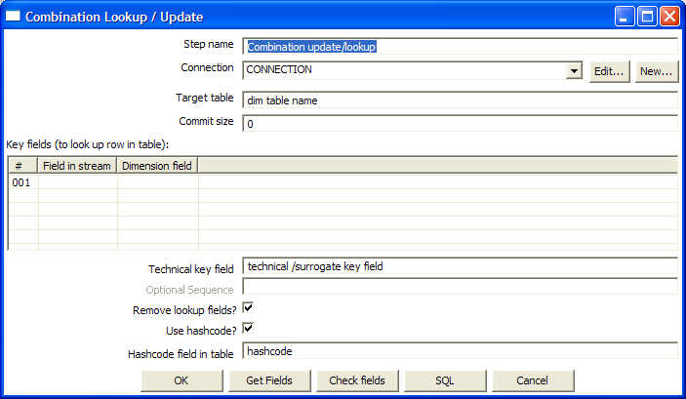

Icon

General description
The generally accepted theory of data warehousing and multi-dimensional modeling suggests that only keys and facts can be present in a fact table. This can present you with a problem if you have information that doesn’t have a primary key. This step type then comes to the rescue by allowing you to store information in a junk-dimension table.
For example if you have an address of a customer, but you don’t have a customer number, you can use this step type.

Kettle will store the information in a table where the primary key is the combination of all fields in the table. Because this process can be very slow in case you have a large number of fields, Kettle also supports a “hash code” field representing all fields in the dimension.
This can speed up lookup performance dramatically while limiting the fields to index to 1.

Options
- Step name: Name of the step. This name has to be unique in a single transformation.
- Connection: name of the database connection on which the dimension table resides.
- Target table: name of the dimension table
- Commit size: setting this to 10 will generate a commit every 10 inserts or updates.
- Key fields: Specify all the fields you want to store in the dimension.
- Technical Key field: this indicates the primary key of the dimension. It is also referred to as Surrogate Key.
- Optional sequence: Specify the sequence name if you want to use a database sequence on the table connection to generate the technical key.
- Remove lookup fields: Enable this option if you want to remove all the lookup fields from the input stream in the output. The only extra fields added is then the technical key.
- Use hash code: This option allows you to generate a hash code, representing all values in the key fields in a numerical form (a signed 64 bit integer). This hash code has to be stored in the table.

6.4.11.5 Extra
- Get fields: fills in all the available fields on the input stream, except for the keys you specified.
- Check fields: Checks whether everything is filled in correctly
- SQL: generates the SQL to build the dimension and allows you to execute this SQL.

Dummy (do nothing)

Screenshot
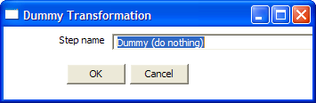

Icon

General description
This step doesn’t do anything. It’s main function is perform as a placeholder in case you want to test something. For example, to have a transformation, you need at least 2 steps connected to each other. If you want to test for example a test file input step, you can connect it to a dummy step.
The placeholder function also comes into play in the following case:

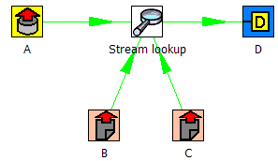

Unfortunately, the “Stream Lookup” step can only read lookup information from one stream, so we need to redo the transformation like this:

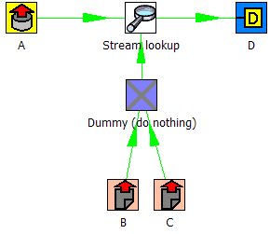

Options
- Step name: Name of the step. This name has to be unique in a single transformation.

Join Rows (Cartesian product)

Screenshot
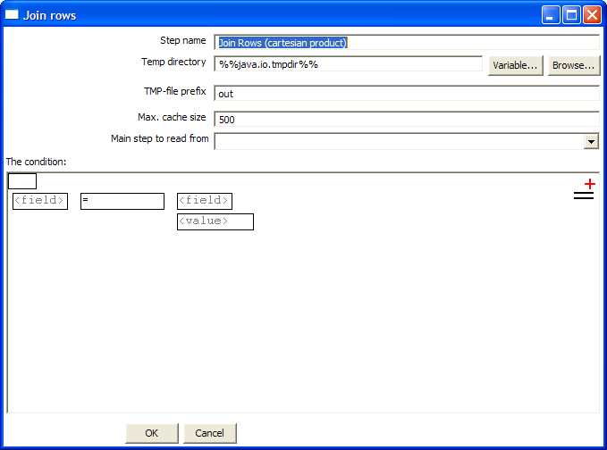

Icon


General description

This step allows you to produce combinations (Cartesian product) of all rows on the input streams.
This is an example:

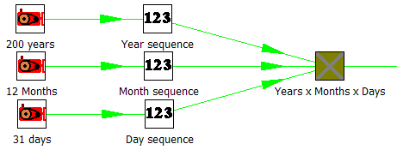

The “Years x Months x Days” step outputs all combinations of Year, Month and Day. (1900, 1, 1 → 2100, 12, 31) and can be used to create a date dimension.

Options

- Step name: Name of the step. This name has to be unique in a single transformation.
- Temp directory: specify the name of the directory where the system stores temporary files in case you want to combine more then the cached number of rows.
- Temporary file prefix: this is the prefix of the temporary files that will be generated.
- Max. cache size: the number of rows to cache before the systems reads data from temporary files. This is needed in case you want to combine large row sets that don’t fit into memory.
- Main step to read from: Specifies the step to read the most data from. This step is not cached or spooled to disk, the others are.
- The condition: you can enter a complex condition to limit the number of output rows.
See also: §

Aggregate Rows

Screenshot
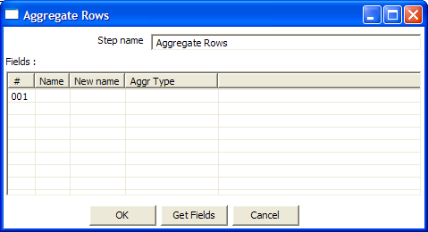

Icon

General description
This step type allows you to quickly aggregate rows based upon all the rows.
These are the available aggregation types:
SUM: the sum of a field
AVERAGE: the average of a field
COUNT: the number of (not null) values
MIN: the minimum value of a field
MAX: the maximum value of a field
FIRST: the first value of a field
LAST: the last value of a field

NOTE: This step type is deprecated. See the “Group By” step in § for a more powerfull way of aggregating rows of data.

Options
- Step name: Name of the step. This name has to be unique in a single transformation.
- Fields: the fields and the aggregation type

Get System Info

Screenshot
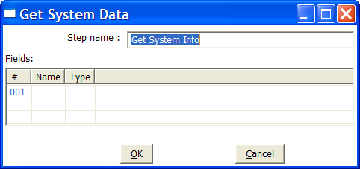

Icon

General description
This step type retrieves information from the Kettle environment.
These are the possible pieces of information you can retrieve:

Option | Description
system date (variable) | System time, changes every time you ask a date.
system date (fixed) | System time, determined at the start of the transformation
start date range | Start of date range, based upon information in ETL log table
end date range | End of date range, based upon information in ETL log table
Yesterday 00:00:00 | start of yesterday
Yesterday 23:59:59 | end of yesterday
Today 00:00:00 | start of today
Today 23:59:59 | end of today
Tomorrow 00:00:00 | start of tomorrow
Tomorrow 23:59:59 | end of tomorrow
First day of last month 00:00:00 | start of last month
Last day of last month 23:59:59 | end of last month
First day of this month 00:00:00 | start of this month
Last day of this month 23:59:59 | end of this month
First day of next month 00:00:00 | start of next month
Last day of next month 23:59:59 | end of next month
copy of step | Copy nr of the step (see also: §8.2)
transformation name | Name of the transformation
transformation file name | File name of the transformation (XML only)
User that modified the transformation last
Date when the transformation was modified last
transformation batch ID | ID_BATCH value in the logging table, see §7
Hostname | returns the hostname of the server
IP address | returns the IP address of the server
command line argument 1 | Argument 1 on the command line
command line argument 2 | Argument 2 on the command line
command line argument 3 | Argument 3 on the command line
command line argument 4 | Argument 4 on the command line
command line argument 5 | Argument 5 on the command line
command line argument 6 | Argument 6 on the command line
command line argument 7 | Argument 7 on the command line
command line argument 8 | Argument 8 on the command line
command line argument 9 | Argument 9 on the command line
command line argument 10 | Argument 10 on the command line

Options
- Step name: Name of the step. This name has to be unique in a single transformation.
- Fields: the fields to output.

Generate Rows

Screenshot

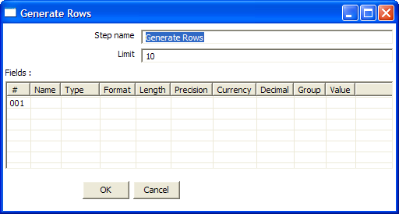

Icon

General description
This step type outputs a number of rows, empty but optionally a number of static fields.

Options
- Step name: Name of the step. This name has to be unique in a single transformation.
- Limit: The number of rows you want to output.
- Fields: static fields you might want to include in the output row.

Java Script Value

Screenshot
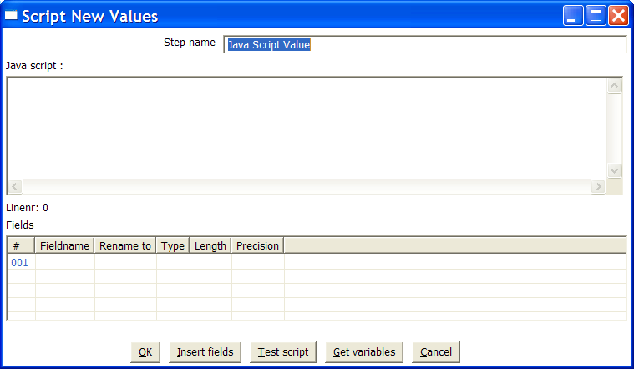

Icon

General description
This step type allows you to do complex calculations using the JavaScript language.

Options
- Step name: Name of the step. This name has to be unique in a single transformation.
- Java Script: the script in question.
- Fields: these are the fields that we want to add to the output stream.

Extra
- Insert fields: inserts the fields and the standard method to grab the value of the field.
- Test script: tests whether or not the script compiles.
- Get variables: gets the newly created variables and inserts them into the “Fields” grid.

Value functions
This is a list of functions that you can use to manipulate values…

- Value Clone()
Builds a copy of a value and returns a Value.

- void setName(String name)
Sets the name of a value

- String getName()
Get the name of a value

- void setValue(double num)
Set the value to a floating point value

- void setValue(String str)
Set the value to a floating point value

- void setValue(Date dat)
Set the value to a Date value

- void setValue(boolean bool)
Set the value to a Boolean value

- void setValue(long l)
Set the value to an integer value

- void setValue(Value v)
Set the value to the value contained in another field

- double getNumber()
Gets the value of a field as a floating point value

- String getString()
Gets the value of a field as a textual string representation

- int getStringLength()
Gets the length of the string representation

- Date getDate()
Gets the value of the field as a date value

- boolean getBoolean()
Gets the value of a field as a Boolean.
NOTE: String “Y” or “true” is converted to true.
NOTE: Numeric value 0 is converted to false, everything else is true.

- long getInteger()
Gets the value of a field as an integer.
NOTE: Date fields are converted to the number of milliseconds since January 1st 1970 00:00:00 GMT.

- boolean isEmpty()
If the value has no type, this function returns true.

- boolean isString()
If the value is of type String, this function returns true.

- boolean isDate()
If the value is of type String, this function returns true.

- boolean isNumber()
If the value is of type Number, this function returns true.

- boolean isBoolean()
If the value is of type Boolean, this function returns true.

- boolean isInteger()
If the value is of type Integer, this function returns true.

- boolean isNumeric()
If the value is of type Number or Integer, this function returns true.

- String toString()
Returns the textual representation of the value.

- String toString(boolean pad)
Returns the textual representation of the value, padded to the length of the string if pad = true.

- String toStringMeta()
Returns the meta-data information of the value as a string.

- void setLength(int l)
Sets the length of the value
- void setLength(int l, int p)
Sets the length and precision of the value

- int getLength()
Returns the length of the value

- int getPrecision()
Returns the precision of the value

- void setPrecision(int p)
Sets the precision of a value

- String getTypeDesc()
Returns the description of a value as a string. (e.g. “String”, “Number”, “Date”, “Integer”, “Boolean”)

- void setNull()
Sets the value to Null.

- void clearNull()
Removes the null setting.

- void setNull(boolean n)

- boolean isNull()
Returns true if the value is null.

- int compare(Value v)
Compares two values and returns 1 if the first value is larger than the second, -1 if it is smaller and 0 if they are equal.

- boolean equals(Object v)
Compares two values and returns true if the two values have the same value.

- int hashCode()
Returns a signed 64 values representing the value in the form of a hash code.

- Value negate()
If the value is numeric, multiplies the value by -1, in all other cases it doesn’t do anything.

- Value and(Value v)
Calculates the bitwise AND of two integer values.

- Value xor(Value v)
Calculates the bitwise XOR of two integer values.

- Value or(Value v)
Calculates the bitwise OR of two integer values.

- Value bool_and(Value v)
Calculates the boolean AND of two boolean values.

- Value bool_or(Value v)
Calculates the boolean OR of two boolean values.

- Value bool_xor(Value v)
Calculates the boolean XOR of two boolean values.

- Value bool_not()
Calculates the boolean NOT of a boolean value.

- Value greater_equal(Value v)
Compares two values and sets the first to true if the second is greater or equal to the first.

- Value smaller_equal(Value v)
Compares two values and sets the first to true if the second is smaller or equal to the first.

- Value different(Value v)
Compares two values and sets the first to true if the second is different from the first.

- Value equal(Value v)
Compares two values and sets the first to true if the second is equal to the first.

- Value like(Value v)
Sets the first value to true if the second string is part of the first.

- Value greater(Value v)
Compares two values and sets the first to true if the second is greater than the first.

- Value smaller(Value v)
Compares two values and sets the first to true if the second is smaller than the first.

- Value minus(double v)
- Value minus(long v)
- Value minus(int v)
- Value minus(byte v)
- Value minus(Value v)
Subtracts v from the field value.

- Value plus(double v)
- Value plus(long v)
- Value plus(int v)
- Value plus(byte v)
- Value plus(Value v)
Adds v to the field value.

- Value divide(double v)
- Value divide(long v)
- Value divide(int v)
- Value divide(byte v)
- Value divide(Value v)
Divides the field value by v.

- Value multiply(double v)
- Value multiply(long v)
- Value multiply(int v)
- Value multiply(byte v)
- Value multiply(Value v)
Multiplies the field value by v.
NOTE: Strings can be multiplied as well: the result is v times the string concatenated.

- Value abs()
Sets the field value to the –field value if the value was negative.

- Value acos()
Sets the field value to the cosine of the number value.

- Value asin()
Sets the field value to the arc sine of the number value.

- Value atan()
Sets the field value to the arc tangents of the number value.

- Value atan2(Value arg0)
- Value atan2(double arg0)
Sets the field value to the second arc tangents of the number value.

- Value ceil()
Sets the field value to the ceiling of a number value.

- Value cos()
Sets the field value to the cosine of a number value.

- Value cosh()
Sets the field value to the hyperbolic cosine of a number value.

- Value exp()
Sets the field value to the exp of a number value.

- Value floor()
Sets the field value to the floor of a number value.

- Value initcap()
Sets the all first characters of words in a string to uppercase.
“matt casters” → “Matt Casters”

- Value length()
Sets the value of the field to the length of the String value.

- Value log()
Sets the field value to the log of a number value.

- Value lower()
Sets the field value to the string value in lowercase.

- Value lpad(Value len)
- Value lpad(Value len, Value padstr)
- Value lpad(int len)
- Value lpad(int len, String padstr)
Sets the field value to the string value, left padded to a certain length.
Default the padding string is a single space.
Optionally, you can specify your own padding string.

- Value ltrim()
Sets the field value to the string, without spaces to the left of the string.

- Value mod(Value arg)
- Value mod(double arg0)
Sets the value to the modulus of the first and the second number.

- Value nvl(Value alt)
If the field value is Null, set the value to alt

- Value power(Value arg)
- Value power(double arg0)
Raises the field value to the power arg

- Value replace(Value repl, Value with)
- Value replace(String repl, String with)
Replaces a string in the field value with another.

- Value round()
Rounds the field value to the nearest integer.

- Value rpad(Value len)
- Value rpad(Value len, Value padstr)
- Value rpad(int len)
- Value rpad(int len, String padstr)
Sets the field value to the string value, right padded to a certain length.
Default the padding string is a single space.
Optionally, you can specify your own padding string.

- Value rtrim()
Remove the spaces to the right of the field value.

- Value sign()
Sets the value of the string to -1, 0 or 1 in case the field value is negative, zero or positive.

- Value sin()
Sets the value of the field to the sine of the number value.

- Value sqrt()
Sets the value of the field to the square root of the number value.

- Value substr(Value from, Value to)
- Value substr(Value from)
- Value substr(int from)
- Value substr(int from, int to)
Sets the value of the field to the substring of the string value.

- Value sysdate()
Sets the field value to the system date.

- Value tan(Value args[])
Sets the field value to the tangents of the number value

- Value num2str()
- Value num2str(String arg0)
- Value num2str(String arg0, String arg1)
- Value num2str(String arg0, String arg1, String arg2)
- Value num2str(String arg0, String arg1, String arg2, String arg3)
Converts a number to a string.
Arg0: format pattern, see also §8.4.1.5.1
Arg1: Decimal separator (either . or ,)
Arg2: Grouping separator (either . or ,)
Arg3: Currency symbol

For example converting value:
1234.56 using num2str(“###,##0.00”, “,”, “.”) gives 1.234,56
.23 using num2str(“###,##0.00”, “,”, “.”) gives 0,23
1234.56 using num2str(“000,000.00”, “,”, “.”) gives 001.234,56

- Value dat2str()
- Value dat2str(String arg0)
- Value dat2str(String arg0, String arg1)
Converts a date into a string
Arg0: format pattern, see also §8.4.1.5.1
Arg1: localized date-time pattern characters (u, t)

- Value num2dat()
Converts a number to a date based upon the number of milliseconds since January 1st, 1970 00:00:00 GMT.

- Value str2dat(String arg0)
- Value str2dat(String arg0, String arg1)
Converts a string to a date
Arg0: format pattern, see also §8.4.1.5.1
Arg1: localized date-time pattern characters (u, t)
- Value str2num()
- Value str2num(String arg0)
- Value str2num(String arg0, String arg1)
- Value str2num(String arg0, String arg1, String arg2)
- Value str2num(String arg0, String arg1, String arg2, String arg3)
Converts a string into a number
Arg0: format pattern, see also §8.4.1.5.1
Arg1: Decimal separator (either . or ,)
Arg2: Grouping separator (either . or ,)
Arg3: Currency symbol

- Value dat2num()
Converts a date into a number being the number of milliseconds since January 1st, 1970 00:00:00 GMT.

- Value trim()
Remove spaces left and right of the string value.

- Value upper()
Sets the field value to the uppercase string value.

- Value e()
Sets the value to e

- Value pi()
Sets the value to π

- Value add_months(int months)
Adds a number of months to the date value.

- Value last_day()
Sets the field value to the last day of the month of the date value.

- Value first_day()
Sets the field value to the first day of the month of the date value.

- Value trunc()
- Value trunc(double level)
- Value trunc(int level)
Set the field value to the truncated number or date value.
Level means the number of positions behind the comma or in the case of a date, 5=months, 4=days, 3=hours, 2=minutes, 1=seconds

JavaScript Examples

Remember the previous row:
Sometimes it can be useful to know the value of the previous row.
This can be accomplished by this piece of code:

var prev_row;
if (prev_row == null) prev_row = row;

...
String previousName = prev_row.getString(“Name”, “-”);
...

prev_row = row;

row is a special field that contains all values in the current row.

Sets the location name of an address to uppercase

location.upper();

Extract information from a date field

// Year/Month/Day representation:
ymd = date_field.Clone().dat2str("yyyy/MM/dd").getString();

// Day/Month/Year representation:
dmy = date_field.Clone().dat2str("dd/MM/yyyy").getString();

// Year/Month :
ym = date_field.Clone().dat2str("yyyy/MM").getString();

// Long description of the month in the local language:
month_long_desc= date_field.Clone().dat2str("MMMM").initcap().getString();

// Week of the year (1-53)
week_of_year = date_field.Clone().dat2str("w").getInteger();

// day of week, short description (MON-SUN)
day_of_week_short_desc =date_field.Clone().dat2str("EEE").upper().getString();

// Day of the week (Monday-Sunday)
day_of_week_desc = date_field.Clone().dat2str("EEEE").initcap().getString();

// Day of week (1-7)
day_of_week = date_field.Clone().dat2str("F").getInteger();

See also: §8.4.1.5.1

NOTE: If you don’t use Clone(), the original value will be overwritten by the methods that work on the Kettle Values.

Call DB Procedure

Screenshot
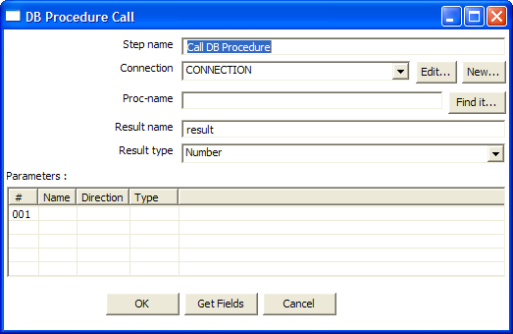

Icon

General description
This step type allows you to execute a database procedure (or function) and get the result(s) back.

Options
- Step name: Name of the step. This name has to be unique in a single transformation.
- Connection: name of the database connection on which the procedure resides.
- Proc-name: name of the procedure or function to call.
- Result name: name of the result of the function call, leave this empty in case of procedure.
- Result type: type of the result of the function call. Not used in case of a procedure.
- Parameters: List of parameters that the procedure or function needs
  - Field name
  - Direction: can be either IN (input only), OUT (output only), INOUT (value is changed on the database)
  - Type: used for output parameters so that Kettle knows what comes back.

Extra
- “Find it...” button: searches on the specified database connection for available procedures and functions. (at the moment only on Oracle and SQLServer)
- “Get fields” button: this function fills in all the fields in the input streams to make your life easier. Simply delete the lines you don’t need and re-order the ones you do need.

Insert / Update

Screenshot
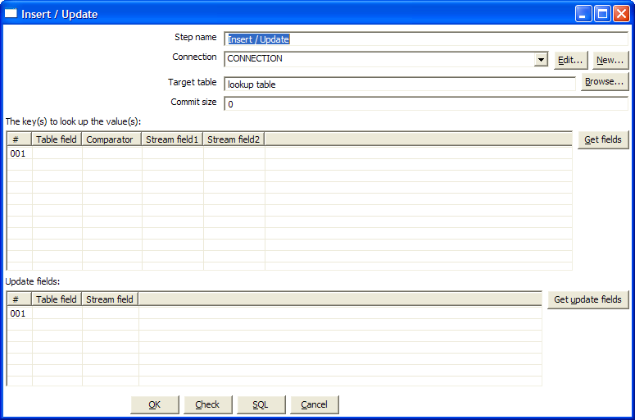

Icon

General description
This step type first looks up a row in a table using one or more lookup keys. If the row can’t be found, it inserts the row. If it can be found and the fields to update are the same, nothing is done. If they are not all the same, the row in the table is updated.

Options
- Step name: Name of the step. This name has to be unique in a single transformation.
- Connection: name of the database connection on which the target table resides.
- Target table: name of the table in which you want to do the insert or update
- Keys: here you can specify a list of field values and comparators.
You can use the following comparators:
  - =
  - <>
  - <
  - <=
  - >
  - >=
  - LIKE
  - BETWEEN
  - IS NULL
  - IS NOT NULL

Extra
- “Get fields” button: get the fields from the input stream(s) and fills them in into the keys grid.
- “Get update fields” button: gets the update fields from the input streams and fills them in into the update grid.
- “Check” button: checks whether or not all fields are available in the target table.
- “SQL” button: generates the SQL to create the table and indexes for correct operation.

Update

Screenshot
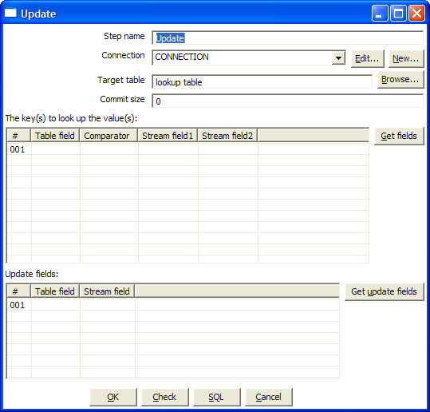

Icon


General description
This step is the same as the Insert/Update step, except that no insert is ever done in the database table. ONLY updates are performed ever.

Row Normaliser

Screenshot
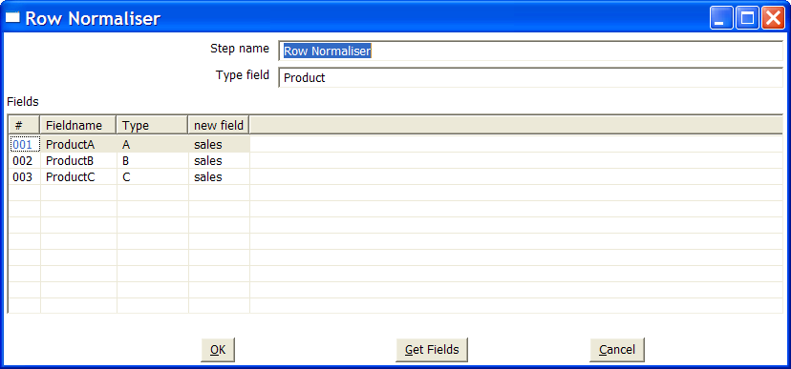

Icon

General description
This step normalizes data back from pivoted tables for example.
Take this example of product sales data:

Month | Product A | Product B | Product C
2003/01 | 10 | 5 | 17
2003/02 | 12 | 7 | 19
… | … | … | …

If you want to convert this data into:

Month | Product | sales
2003/01 | A | 10
2003/01 | B | 5
2003/01 | C | 17
2003/02 | A | 12
2003/02 | B | 7
2003/02 | C | 19
… | … | …

For example if you want to update a fact table, this form of data is a lot easier to handle.
Well, that’s what this step type does.

Options
- Step name: Name of the step. This name has to be unique in a single transformation.
- Type field: the name of the type field. (Product in our example)
- Fields: a list of fields to normalize:
  - Fieldname: name of the fields to normalize (Product A → C in our example)
  - Type: give a string to classify the field (A, B or C in our example)
  - New field: you can give one or more fields where the new value should transferred to. (sales in our example).

NOTE: It is possible to normalize more then on field at a time.
Consider this example:

DATE | PR1_NR | PR1_SL | PR2_NR | PR2_SL | PR3_NR | PR3_SL
20030101 | 5 | 100 | 10 | 250 | 4 | 150
… | … | … | … | … | … | …

You can convert this into:

DATE | Type | Product Sales | Product Number
20030101 | Product1 | 100 | 5
20030101 | Product2 | 250 | 10
20030101 | Product3 | 150 | 4
… | … | … | …

This would be the setup to do it with:

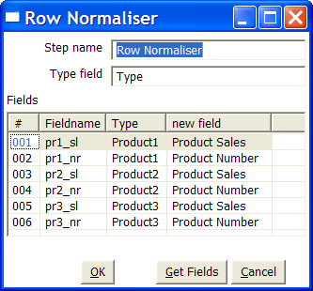

Extra
- “Get fields” button: this fills in all fields that are available on the input stream(s).

Denormaliser

Screenshot
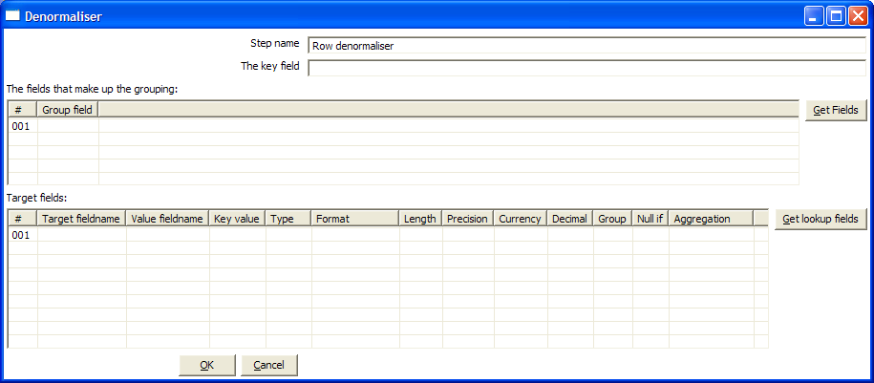

Icon

General description
This step allows you de-normalise data by looking up key-value pairs.
It also allows you to immediately convert data types.

Options

Option | Description
Step name | Name of the step. This name has to be unique in a single transformation.
Key field | The field that defined the key
Group fields | Specify the fields that make up the grouping here.
Target fields | Specify the fields to denormalise. You do it by specifying the String value for the key field (see above).  Options are provided to convert data types. Mostly people use Strings as key-value pairs so you often need to convert to Integer, Number or Date.  In case you get key-value pair collissions (key is not unique for the group specified) you can specify the aggregation method to use.
Row XML element | The name of the row element to use in the XML document.

Flattener

Screenshot
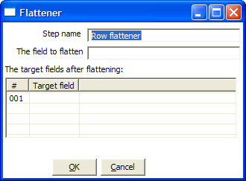

Icon

General description
This step allows you flatten sequentially provided data.

Options

Option | Description
Step name | Name of the step. This name has to be unique in a single transformation.
The field to flatten | The field that needs to be flattened into different target fields.
Target fields | The name of the target field to flatten to.

Example

Field1 | Field2 | Field3 | Flatten
A | B | C | One
A | B | C | Two
D | E | F | Three
D | E | F | Four

Can be flattened to:

Field1 | Field2 | Field3 | Target1 | Target2
A | B | C | One | Two
D | E | F | Three | Four

In the example above, this is what the dialog looks like:

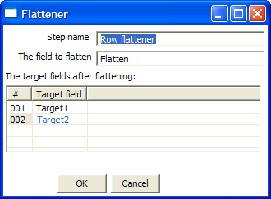

Split Fields

Screenshot
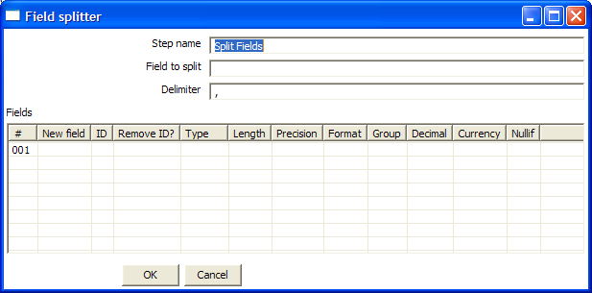

Icon

General description
This step allows you to split fields based upon delimiter information.

Options
- Step name: Name of the step. This name has to be unique in a single transformation.
- Field to split: the name of the field you want to split
- Delimiter: Delimiter that determines the end of a field.
- Fields: list of fields to split into.

Example: SALES_VALUES field containing: “500,300,200,100”

Use these settings to split the field into 4 new fields:

  - Delimiter: ,
  - Field: SALES1, SALES2, SALES3, SALES4
  - Id:
  - remove ID no, no, no, no
  - type: Number, Number, Number, Number
  - format: ###.##, ###.##, ###.##, ###.##
  - group:
  - decimal: .
  - currency:
  - length: 3, 3, 3, 3
  - precision: 0, 0, 0, 0

Example: SALES_VALUES field containing “Sales2=310.50, Sales4=150.23”

Use these settings to split the field into 4 new fields:

  - Delimiter: ,
  - Field: SALES1, SALES2, SALES3, SALES4
  - Id: Sales1=, Sales2=, Sales3=, Sales4=
  - remove ID yes, yes, yes, yes
  - type: Number, Number, Number, Number
  - format: ###.##, ###.##, ###.##, ###.##
  - group:
  - decimal: .
  - currency:
  - length: 7, 7, 7, 7
  - precision: 2, 2, 2, 2

Unique rows

Screenshot
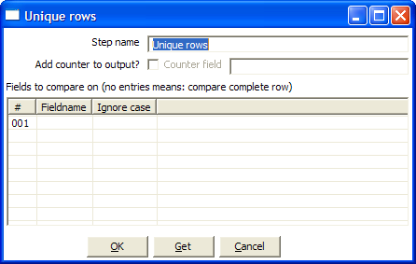

Icon


General description
This step removes double rows from the input stream(s).
IMPORTANT: Make sure that the input stream is sorted! Otherwise only consecutive double rows are evaluated correctly. (sometimes this can be the whole idea but just be careful :-))

Options
- Step name: Name of the step. This name has to be unique in a single transformation.
- Add counter to output?: Enable this if you want to know how many rows were doubles for each row in the output.
- Counter fields: name of the numeric field containing the number of rows
- Fieldnames: a list of fieldnames on which the uniqueness is compared. Data in the other fields of the row is ignored.
- A flag allowing you to indicate whether or not the uniqueness has to be verified by comparing (in the case of String fields) case sensitive or not.
For example: Kettle,KETTLE, kettle all will be the same in case the compare is done case insensitve. In this case, the first occurance (Kettle) will be passed to the next step(s).

Extra
- “Get” button to automatically fill in the fields that are available to the step.

Group By

Screenshot
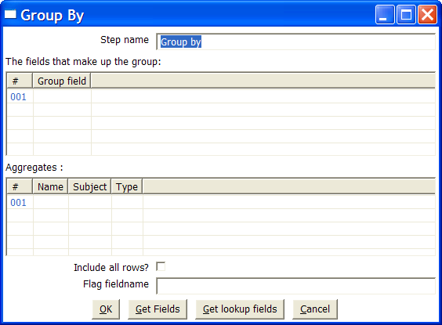

Icon
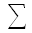

General description
This step allows you to calculate values over a defined group of fields.
Examples that are common are: calculate the average sales per product, get the number of yellow shirts that we have in stock, etc.

Options
- Step name: Name of the step. This name has to be unique in a single transformation.
- Group fields: specify the fields over which you want to group.
- Aggregates: specify the fields that need to be aggregated, the method and the name of the resulting new field.
- Include all rows: check this if you want all rows in the output, not just the aggregation. To differentiate between the 2 types of rows in the output, we need a flag in the output. You need to specify the name of the flag field in that case. (the type is boolean)

Copy rows to result

Screenshot
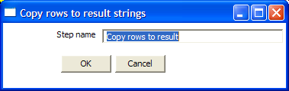

Icon


General description
This step allows you to transfer rows of data (in memory) to the next transformation (job entry) in a job. (see also: Chef user documentation)

Get rows from result

Screenshot
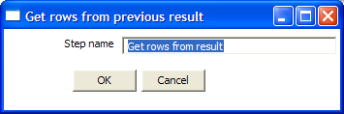

Icon


General description
This step returns rows that were previously generated by another transformation in a job.
The rows were passed on to this step using the “Copy rows to result” step.

XBase input

Screenshot
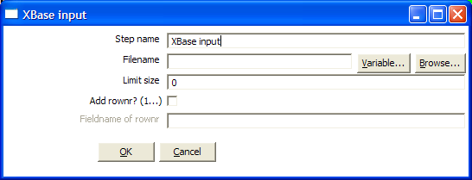

Icon


General description
With this step it is possible to read data from most types of DBF file derivates called the XBase family. (dBase III/IV, Foxpro, Clipper, ...)

Options
- Step name: Name of the step. This name has to be unique in a single transformation.
- The filename, with variable support
- Limit size: only read this number of rows, 0 means: unlimited
- Add rownr?: This option adds a field to the output with the specified name that contains the row number.

Excel input

Screenshots
The “Files” tab:
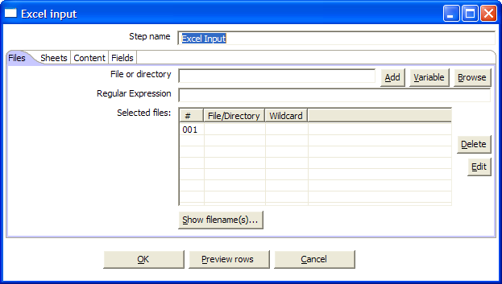

The “Sheets” tab:
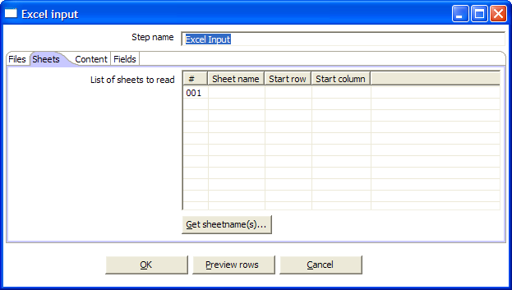

The “Content” tab:
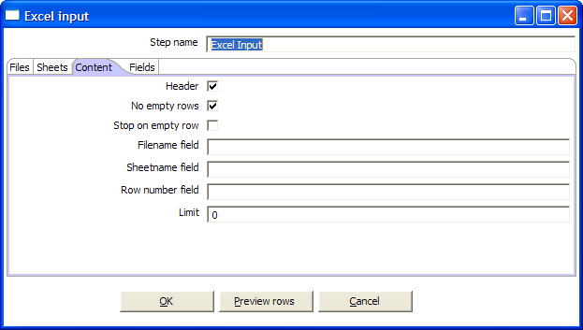

The “Fields” tab:
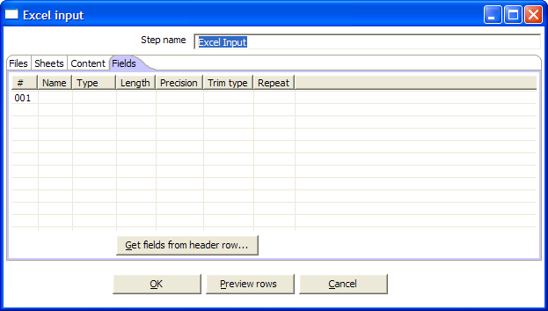

Icon
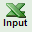

General description
With this step you can read data from one or more Excel files.
Note that it is not possible to convert calculated cells in the sheets as that would require Excel to be rewritten.

Options

- Step name: Name of the step. This name has to be unique in a single transformation.

File tab:
- The filenames, with variable support

Sheets tab:
- The sheets to import. Use the “Get sheetname(s)” button to fill in the available sheets automatically. Please note that you need to specify the start row and column, the coordinate where the step should start reading.

Content tab:
- Header: check if the sheets specified have a header row that we need to skip.
- No empty rows: check this if you don't want empty rows in the output of this step.
- Stop on empty rows: this will make the step stop reading the current sheet of a file when a empty line is encountered.
- Filename field: specify a field name to include the filename in the output of this step.
- Sheetname field: specify a field name to include the sheetname in the output of this step.
- Row number field: specify a field name to include the row number in the output of the step.
- Limit: limit the number of rows to this number, 0 means: all rows.

Fields tab:
- Here you can specify the fields that need to be read from the Excel files. A button “Get fields from header row” is provided to automatically fill in the available fields if the sheets have a header row.

Database Join

Screenshot
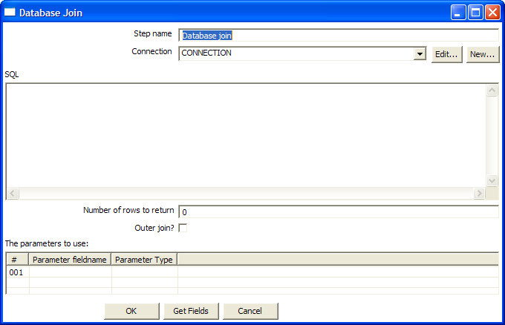

Icon


General description
Using data from previous steps, this step allows you to run a query against a database.
The parameters for this query can be specified:
- as question marks (?) in the SQL query
- as fields in the data grid.
The two need to be in the same order.

For example, this step allows you to run queries looking up the oldest person that bought a certain product like this:

SELECT customernr
FROM product_orders, customer
WHERE orders.customernr = customer.customernr
AND orders.productnr = ?
ORDER BY customer.date_of_birth

All you then need to specify as a parameter is the productnr and you'll get the customernr included in the result.

Options

- Step name: Name of the step. This name has to be unique in a single transformation.
- The database connection to use
- The SQL query to launch towards the database. (use question marks (?) as parameter placeholders.
- Number of rows to return: 0 means all, any other number limits the number of rows.
- Outer join?: check this to allways return a result, even if the query didn't return a result.
- The parameters to use in the query.

Cube output

Screenshot
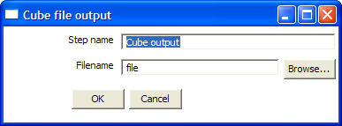

Icon


General description
This step stores rows of data in a binary form in a file.
It has the advantage over a text (flat) file that the content doesn't have to be parsed when read back. This is because the meta-data is stored in the cube file as well.

Cube input

Screenshot
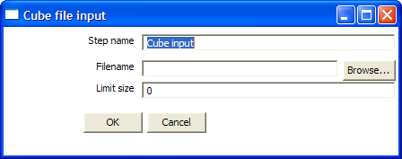

Icon


General description
Read rows of data from a binary Kettle cube file. (see also “Cube output”)

Calculator

Screenshot

The list of calculation types:
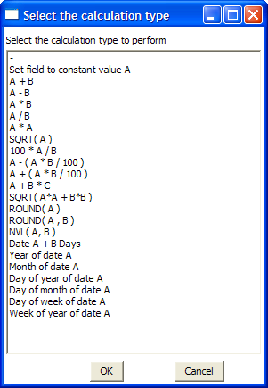

Icon

General description
This calculator step is making your life easier by providing a list of functions that can be executed on field values. Version 2.1 of Spoon is the first version to include this (short) list of functions. If you have a need for other (generic, often used) functions, simple write an e-mail to requests@kettle.be specifying the needed functionality.

An important advantage Calculator has over custom JavaScript scripts is that the execution speed of Calculator is many times that of a script.

Besides the arguments (Field A, Field B and Field C) you also need to specify the return type of the function. You can also opt to remove the field from the result (output) after all values where calculated. This is useful for removing temporary values.

This is the current list of functions:

Function | Description | Required fields
Set field to constant A | Create a field with a constant value | A
A + B | A plus B | A and B
A - B | A minus B | A and B
A * B | A multiplied by B | A and B
A / B | A divided by B | A and B
A * A | The square of A | A
SQRT( A ) | The square root of A | A
100 * A / B | Percentage of A in B | A and B
A - ( A * B / 100 ) | Subtract B% of A | A and B
A + ( A * B / 100 ) | Add B% to A | A and B
A + B *C | Add A and B times C | A, B and C
SQRT( A*A + B*B ) | Calculate √(A²+B²) | A and B
ROUND( A ) | Round A to the nearest integer | A
ROUND( A, B ) | Round A to B decimal positions | A and B
Set field to constant A | Create a field with a constant value | A
Date A + B days | Add B days to Date field A | A and B
Year of date A | Calculate the year of date A | A
Month of date A | Calculate number the month of date A | A
Day of year of date A | Calculate the day of year (1-365) | A
Day of month of date A | Calculate the day of month (1-31) | A
Day of week of date A | Calculate the day of week (1-7) | A
Week of year of date A | Calculate the week of year (1-53) | A

Merge rows

Screenshot
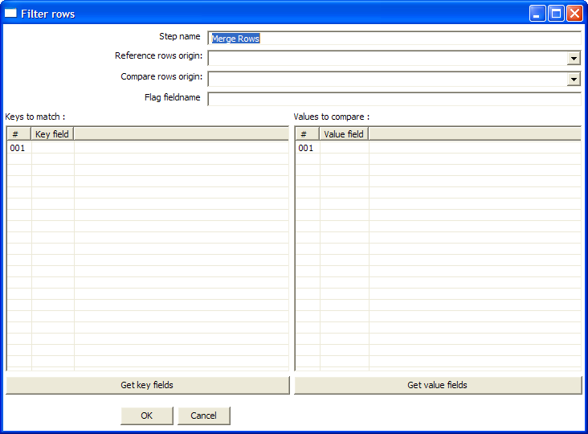

Icon

General description
This step simply allows you to compare 2 streams of rows. This is useful if you want compare data from 2 different times. It is often used in situations where the source system of a data warehouse doesn't contain a data of last update.
The 2 streams of rows, a reference stream and a compare stream, are merged. Each time only the last version of a row is passed onto the next steps. The row is marked as follows:

- “identical” : the key was found in both streams and the values to compare were identical.
- “changed” : they key was found in both streams but one or more values is different.
- “new” : the key was not found in the reference stream
- “deleted” : the key was not found in the compare stream

IMPORTANT: both streams need to be sorted on the specified key(s).

Add constants

Screenshot
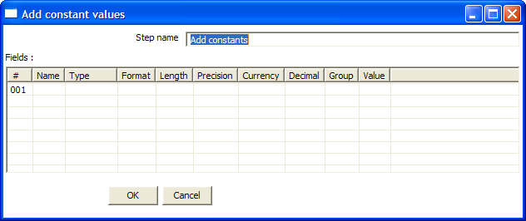

Icon

General description and usage
This step is the easiest and most performing way to add constants to a stream.
The use is very simple: specify the name, type and value in the form of a string.
Then specify the formats to convert the value into the chosen data type.

Execute SQL script

Screenshot
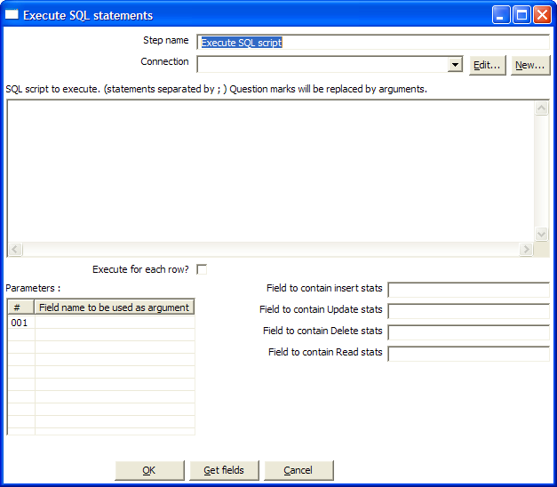

Icon

General description
You can execute SQL script with this step, either once, during the initalisation fase of the transformation, or once for every input-row that the step is given.
The second option can be used to use parameters in SQL scripts.
For example if you want to create 5 tables (tab1, tab2, tab3, tab4 and tab5) you could make such a transformation:

The SQL script to execute might look like this:

CREATE TABLE tab?
(
a INTEGER
)
;

The field name to specify as parameter is then the “count” sequence we defined in the second step.

NOTE: The execution of the transformation will halt when a statement in the script fails.

As extra option, you can return the total number of inserts (INSERT INTO statements), updates (UPDATE table), deletes (DELETE FROM table) and reads (SELECT statements) by specifying the field names in the lower right of the dialog.

Mapping

Screenshot
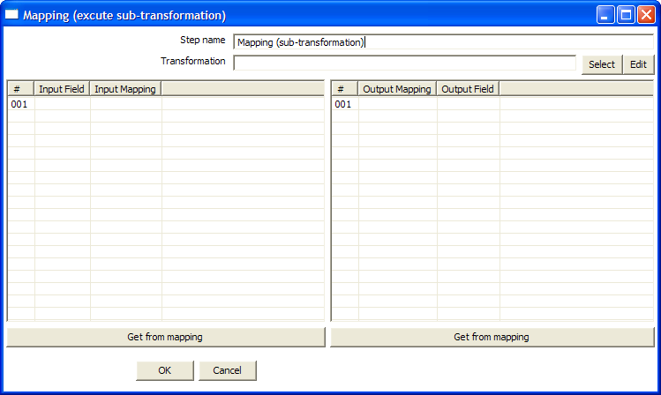

Icon

General description & use
When you need to do a certain transformation over and over again, you can turn the repetitive part into a mapping. A mapping is a transformation that
- specifies how the input is going to be using a MappingInput step
- specified how the input fields are transformed: the field that are added and deleted

For example you can create mappings for dimension lookups so that you don't need to enter the natural keys etc. every time again.

In the dialog, you can specify the transformation name and even launch another Spoon window to edit the selected transformation.

Example:
Suppose we want to create a mappings that does a lookup in the customer slowly changing dimension. In a larger warehouse, you need to specify the details for the dimension in question every time again. To get better re-use we want to create a mapping.
The details needed for the dimension lookup are in this case the customer number and the lookup reference date. These 2 input we specify in the mapping input step:

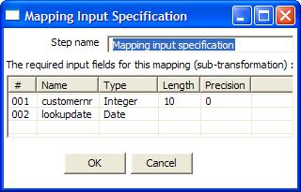

After this we can perform any calculation in our reusable transformation (Mapping), in our case we do a lookup in the dimension:

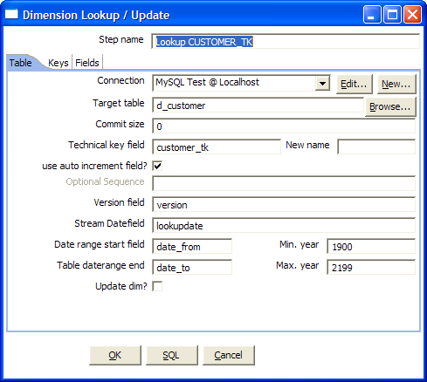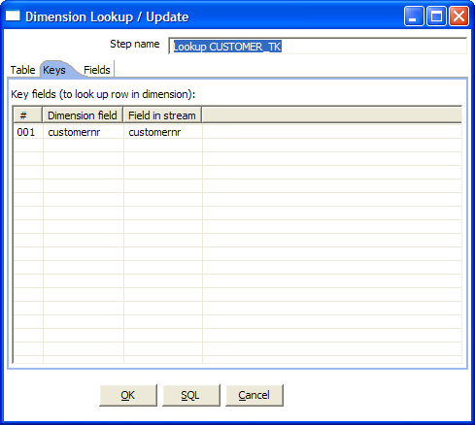

This dimension lookup step adds one field to the equation: customer_tk.
We can specify the fields that were in the Mapping Output step:

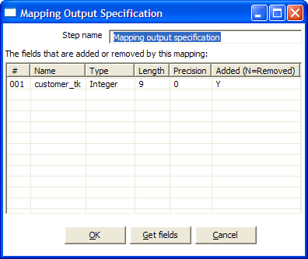

The complete mapping looks like this:

When we want to re-use this mapping, this is how we can do it:

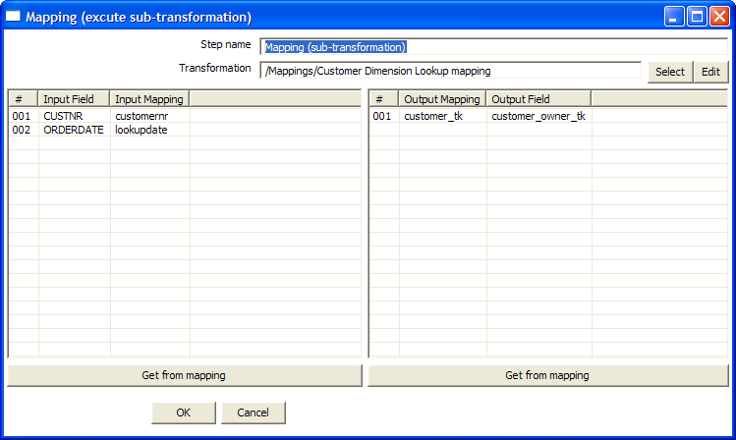

As you can see, the way we do it is by “mapping” the stream fields of our choice to the required input fields of the mapping. Any added fields we can re-name on the ouput side.

XML Input

Screenshot
The “files” tab:
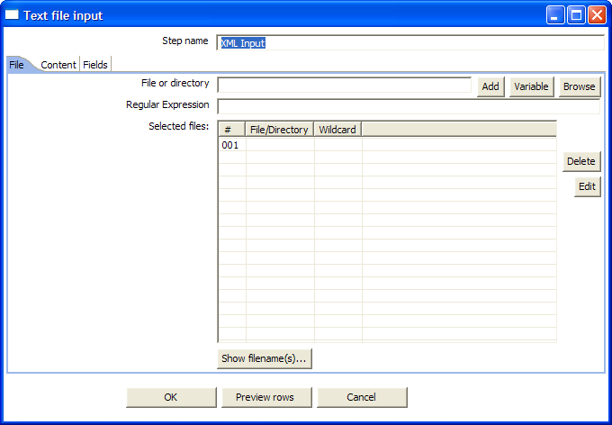

The “Content” tab:
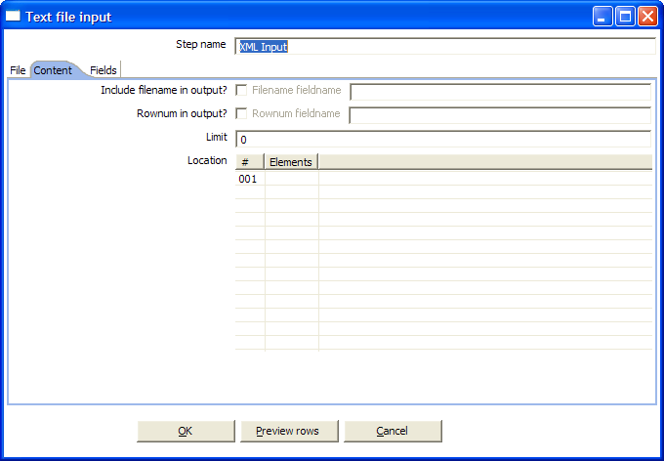

The “Fields” tab:

Icon

General description
This step allows you to read any possible XML file or files.
It does so by giving you an interface to define the filenames you want to read, the repeating part of the data part of the XML file and the fields to retrieve.
You specify the fields by

Options

Option | Description
Step name | Name of the step. This name has to be unique in a single transformation.
File or directory | This field specifies the location and/or name of the input text file.  NOTE: press the “add” button to add the file/directory/wildcard combination to the list of selected files (grid) below.
Regular expression | Specify the regular expression you want to use to select the files in the directory specified in the previous option.
Include filename in output & fieldname | Check this option if you want to have the name of the XML file to which the row belongs in the output stream. You can specify the name of the field where the filename will end up in.
Rownum in output & fieldname | Check this option if you want to have a row number (starts at 1) in the output stream. You can specify the name where the integer will end up in.
Include time in filename | includes the system date in the filename. (_235959)
Limit | You can specify the maximum number of rows to read here.
Location | Specify the path by way of elements to the repeating part of the XML file.  For example if you are reading rows from this XML file:  <Rows>  <Row>  <Field1>...</Field1> ...  </Row>  ...  </Rows>  Then you set the location to Rows, Row
Fields | - Name: name of the field  - Type: Type of the field can be either String, Date or Number  - Format mask to convert with: See 8.4.1.5 for a complete description of format specifiers.  - Length:  - Number: Total number of significant figures in a number  - String: total length of string  - Date: length of printed output of the string (e.g. 4 only gives back the year)  - Precision:  - Number: Number of floating point digits.  - String: unused.  - Date: unused.  - Currency: Symbol used to represent currencies like $10,000.00 or €5.000,00  - Decimal: A decimal point can be a "." (10,000.00) or "," (5.000,00)  - Grouping: A grouping can be a "," (10,000.00) or "." (5.000,00)  - Trim type: the trimming method to apply on the string found in the XML.  - Repeat: check this if you want to repeat empty values with the corresponding value from the previous row.  - Position: the position of the XML element or attribute. You use the following syntax to specify the position of an element:  The first element called “element”:  E=element/1  The first attribute called “attribute”:  A=attribute/1  The first attribute called “attribute” in the second “element” tag:  E=element/2, A=attribute/1  NOTE: You can auto-generate all the possible positions in the XML file supplied by using the “Get Fields” button.

XML Output

Screenshot
The “files” tab:
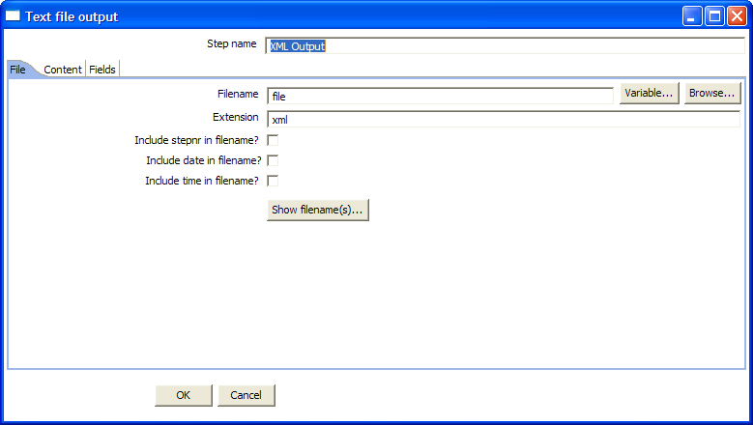

The “Content” tab:
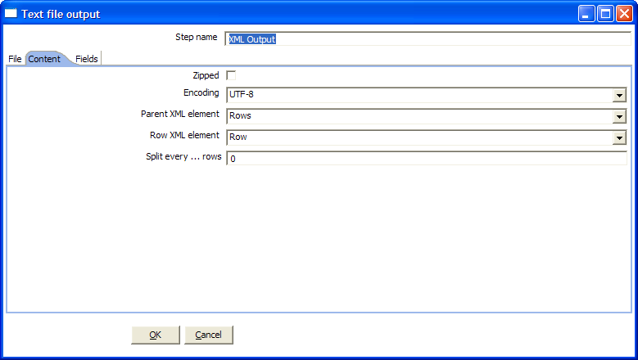

The “Fields” tab:
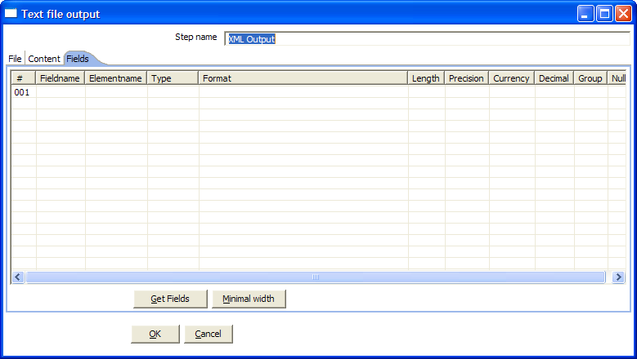

Icon

General description
This step allows you to write rows from any source to one or more XML files.

Options

Option | Description
Step name | Name of the step. This name has to be unique in a single transformation.
Filename | This field specifies the filename and location of the output text file
Extension | adds a point and the extension to the end of the filename. (.xml)
Include stepnr in filename | If you run the step in multiple copies (see §8.2), the copy number is included in the filename, before the extension. (_0)
Include date in filename | includes the system date in the filename. (_20041231)
Include time in filename | includes the system date in the filename. (_235959)
Split every ... rows | The maximum number of rows of data to put in a single XML file before another is created.
Zipped | Check this if you want the XML file to be stored in a ZIP archive.
Encoding | The encoding to use. This encoding is specified in the header of the XML file.
Parent XML element | The name of the root element in the XML document.
Row XML element | The name of the row element to use in the XML document.
Fields | - Fieldname: name of the field  - Elementname: the name of the element in the XML file to use.  - Type: Type of the field can be either String, Date or Number  - Format mask to convert with: see 8.4.1.5 for a complete description of format specifiers.  - Length: output string is padded to this length if it is specified.  - Precision: the precision to use  - Currency: Symbol used to represent currencies like $10,000.00 or €5.000,00  - Decimal: A decimal point can be a "." (10,000.00) or "," (5.000,00)  - Grouping: A grouping can be a "," (10,000.00) or "." (5.000,00)  - Null: the string to use in case the field value is null.

Graphical View

Description
The Graphical View is the canvas on which transformations are drawn.
It shows an easy to understand representation of the work that needs to be done and the flow of the data.

Adding steps

Create steps by drag and drop
Adding steps to a transformation on the canvas is easy: simply select a step type from the tree on the left and drag in onto the canvas:

At the location of the mouse you will see a square that represents the location of the steps when you let go of the button.
When you let go of the mouse button the selected step (Text file input) will become part of the transformation.

Create steps from the step types tree
Another way to create an extra step for your transformation is by selecting “New” step when you click right on the step type in the tree on the left.
You can also just double-click on the step type.

After this, you will be shown a dialog where you can enter the settings. For the complete description of the dialogs and settings, please check out §8.4.
When you press OK in the dialog a new step is created in the transformation.
You will see in this case however that the step is not drawn. That is of-course because we haven’t told Spoon where to put it. We say that the step is not drawn but hidden.

If you drag this step onto the canvas, it will become drawn.

Create steps on the place where you like them
You can also just click right on the canvas and select “New step...”.

Hiding a step
If you click right on a step that is drawn on the graphical view, you will get a popup-menu that allows you to select the option: “Hide step”. This will remove the step from the graphical view, but not delete it.

Step options (popup menu)

Edit step
This opens the step dialog so that you can change its settings.

Edit description
This opens a dialog that allows you to enter a textual description of the step.

Copy data / distribute data
See §8.3 (Distribute or copy)

Copies
See §8.2 (Launching several copies of a step)

Duplicate step
This option will create a copy, positioned a bit lower to the right of the original step.

Delete step
This will permanently remove the step from the transformation.

Show input fields
This option tries to determine all the fields and their origin by tracing the input-streams back to their source.

Show output fields
This option adds the fields of the current step to the ones of the input fields.

For example this might be an example:

The result could then possibly be:

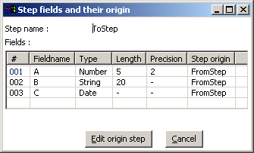

Adding hops
On the graphical view the quickest way to create a new hop is by dragging with the mouse from one step to another using the middle button.
You can also drag the left button and press the control key at the same time.

For a more complete explanation regarding hops, please check out §6 (Hops)

Log View

Description
The Log View shows what’s happening when a transformation is running.
First of all it shows all the (copies of) the steps that are launched as a part of the transformation.
Secondly, it shows the log as it would be shown if the transformation would be launched by Pan.

Screenshot

Log Grid
Log Text
Buttons

Log Grid
The log grid shows the following columns:
- The name of the step
- Copy number of the step
- Number of lines read from input-streams
- Number of lines written to output-streams
- Number of lines read from file or database
- Number of lines written to file or database
- Number of lines updated in the database
- Number of errors that occurred
- The status of the step: running, finished or stopped
- The number of seconds that the step has been running.
- The speed in rows per second at which the step processes rows.
- Priority of the step (10=highest, 1=lowest), nr of rows in the input-stream(s), nr of rows in the output-stream(s).

NOTE: The system is tuning the steps priority in such a way that the slowest steps get the highest priority.

Buttons

Start transformation
This button starts the transformation you’re designing. Please note that Spoon tries to launch this as Pan would: from XML-file or repository. It is therefore necessary that the transformation is saved. The output of the execution is displayed in the Log Text part of the Log View.

Preview
This buttons starts the transformation as it is defined in memory at the time you press the Preview button. The output of the execution is displayed in the Log Text part of the Log View. After you press the button you will be presented with a dialog like this:

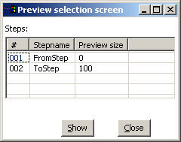

Here you can enter the rows per step you want to preview. The preview size is automatically set to 100 rows for the steps that are selected. If no step is selected, the previous setting is taken.
After the requested rows are obtained from the different steps, the transformation is ended.
After the transformation has ended, the result is shown.

Show error lines
This option will show you all lines of the Log Text that contain the word ERROR (lower- or uppercase). You can then choose to edit the source step of the error.

Clear log
This clears the text in the Log Text Window.

Log Settings
This is the “Log Settings” dialog:

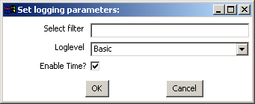

If you put a text in the filter field, only the lines that contain this text will be shown in the Log Text window.
The “Log level” setting allows you to select the logging level. You can choose one of these:

- Error: Only show errors
- Nothing: Don’t show any output
- Minimal: Only use minimal logging
- Basic: This is the default basic logging level
- Detailed: Give detailed logging output
- Debug: For debugging purposes, very detailed output.
- Row level: Logging at a row level, this can generate a lot of data.

If the “Enable time” option is enabled, all lines in the logging will be preceded by the time of day.

Grids

Description
Grids are used everywhere in Spoon & Kettle. They are used to enter or display information.

Functions
Most of the functions available in a grid (that is not read-only) are available by right clicking with the mouse on a grid:
- Insert before this row: inserts an empty row before the row you clicked on
- Insert after this row: inserts an empty row after the row you clicked on
- Move the row up: move the row you clicked on up. The keyboard shortcut for this is CTRL-UP
- Move the row down: move the row you clicked on down. The keyboard shortcut for this is CTRL-DOWN
- Optimal column size including header: resize all columns so that it displays all values completely, including the header. The keyboard shortcut for this function is function key F3.
- Optimal column size excluding header: resize all columns so that it displays all values completely. The keyboard shortcut for this function is function key F4.
- Clear all: clears all information in the grid. You will be asked to confirm this operation.
- Select all rows: selects all rows in the grid. The keyboard shortcut for this function is CTRL-A
- Clear selection: clears the selection of rows in the grid. The keyboard shortcut for this function is ESC
- Copy selected lines to clipboard: Copies the selected lines to the clipboard in a textual representation. These lines can then be exchanged with other programs such as spreadsheets or even other Spoon & Kettle dialogs. The keyboard shortcut for this function is CTRL-C
- Paste clipboard to table: Insert the lines that are on the clipboard to the grid, right after the line on which you clicked. The keyboard shortcut for this function is CTRL-V
- Cut selected lines: Copies the selected lines to the clipboard in a textual representation. After that, the lines are deleted from the grid. The keyboard shortcut for this function is CTRL-X
- Delete selected lines: deletes all selected lines from the grid. The keyboard shortcut for this function is DEL
- Keep only selected lines: if there are more lines to delete then there are to keep, simply select the lines you want to keep and use this function. They keyboard shortcut for this function is CTRL-K
- Copy field values to all rows: if all rows in the grid need to have the same value for a certain column, you can use this function to do this.
- Undo: undo the previous grid operation. The keyboard shortcut for this function is CTRL-Z
- Redo: redo the next grid operation. The keyboard shortcut for this function is CTRL-Y

Navigating
If you click on a cell in a grid, you can edit this field.
After pressing enter, you can navigate the grid by using the cursor keys.
Pressing enter again allows you to edit a field.

Repository Explorer

Description
The repository Explorer shows you a tree view on the database repository to which you are connected. It allows you to examine and modify the content.

Screenshot
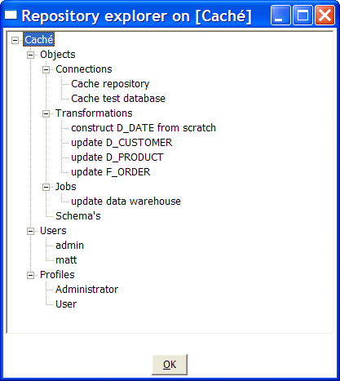

Functions
Check out the different functions when right clicking in the tree. It’s fairly straightforward.

Backup / Recovery
It is possible to export the complete repository in XML: click right on “Objects” in the repository and select one of these options.

NOTE: you can restore the objects from a backed up repository anywhere in the target repository directory tree.

Apendix A
GNU LESSER GENERAL PUBLIC LICENSE
Version 2.1, February 1999
Copyright (C) 1991, 1999 Free Software Foundation, Inc.
51 Franklin St, Fifth Floor, Boston, MA 02110-1301 USA
Everyone is permitted to copy and distribute verbatim copies
of this license document, but changing it is not allowed.
[This is the first released version of the Lesser GPL. It also counts
as the successor of the GNU Library Public License, version 2, hence
the version number 2.1.]
Preamble
The licenses for most software are designed to take away your
freedom to share and change it. By contrast, the GNU General Public
Licenses are intended to guarantee your freedom to share and change
free software--to make sure the software is free for all its users.
This license, the Lesser General Public License, applies to some
specially designated software packages--typically libraries--of the
Free Software Foundation and other authors who decide to use it. You
can use it too, but we suggest you first think carefully about whether
this license or the ordinary General Public License is the better
strategy to use in any particular case, based on the explanations below.
When we speak of free software, we are referring to freedom of use,
not price. Our General Public Licenses are designed to make sure that
you have the freedom to distribute copies of free software (and charge
for this service if you wish); that you receive source code or can get
it if you want it; that you can change the software and use pieces of
it in new free programs; and that you are informed that you can do
these things.
To protect your rights, we need to make restrictions that forbid
distributors to deny you these rights or to ask you to surrender these
rights. These restrictions translate to certain responsibilities for
you if you distribute copies of the library or if you modify it.
For example, if you distribute copies of the library, whether gratis
or for a fee, you must give the recipients all the rights that we gave
you. You must make sure that they, too, receive or can get the source
code. If you link other code with the library, you must provide
complete object files to the recipients, so that they can relink them
with the library after making changes to the library and recompiling
it. And you must show them these terms so they know their rights.
We protect your rights with a two-step method: (1) we copyright the
library, and (2) we offer you this license, which gives you legal
permission to copy, distribute and/or modify the library.
To protect each distributor, we want to make it very clear that
there is no warranty for the free library. Also, if the library is
modified by someone else and passed on, the recipients should know
that what they have is not the original version, so that the original
author's reputation will not be affected by problems that might be
introduced by others.
Finally, software patents pose a constant threat to the existence of
any free program. We wish to make sure that a company cannot
effectively restrict the users of a free program by obtaining a
restrictive license from a patent holder. Therefore, we insist that
any patent license obtained for a version of the library must be
consistent with the full freedom of use specified in this license.
Most GNU software, including some libraries, is covered by the
ordinary GNU General Public License. This license, the GNU Lesser
General Public License, applies to certain designated libraries, and
is quite different from the ordinary General Public License. We use
this license for certain libraries in order to permit linking those
libraries into non-free programs.
When a program is linked with a library, whether statically or using
a shared library, the combination of the two is legally speaking a
combined work, a derivative of the original library. The ordinary
General Public License therefore permits such linking only if the
entire combination fits its criteria of freedom. The Lesser General
Public License permits more lax criteria for linking other code with
the library.
We call this license the "Lesser" General Public License because it
does Less to protect the user's freedom than the ordinary General
Public License. It also provides other free software developers Less
of an advantage over competing non-free programs. These disadvantages
are the reason we use the ordinary General Public License for many
libraries. However, the Lesser license provides advantages in certain
special circumstances.
For example, on rare occasions, there may be a special need to
encourage the widest possible use of a certain library, so that it becomes
a de-facto standard. To achieve this, non-free programs must be
allowed to use the library. A more frequent case is that a free
library does the same job as widely used non-free libraries. In this
case, there is little to gain by limiting the free library to free
software only, so we use the Lesser General Public License.
In other cases, permission to use a particular library in non-free
programs enables a greater number of people to use a large body of
free software. For example, permission to use the GNU C Library in
non-free programs enables many more people to use the whole GNU
operating system, as well as its variant, the GNU/Linux operating
system.
Although the Lesser General Public License is Less protective of the
users' freedom, it does ensure that the user of a program that is
linked with the Library has the freedom and the wherewithal to run
that program using a modified version of the Library.
The precise terms and conditions for copying, distribution and
modification follow. Pay close attention to the difference between a
"work based on the library" and a "work that uses the library". The
former contains code derived from the library, whereas the latter must
be combined with the library in order to run.
GNU LESSER GENERAL PUBLIC LICENSE
TERMS AND CONDITIONS FOR COPYING, DISTRIBUTION AND MODIFICATION
0. This License Agreement applies to any software library or other
program which contains a notice placed by the copyright holder or
other authorized party saying it may be distributed under the terms of
this Lesser General Public License (also called "this License").
Each licensee is addressed as "you".
A "library" means a collection of software functions and/or data
prepared so as to be conveniently linked with application programs
(which use some of those functions and data) to form executables.
The "Library", below, refers to any such software library or work
which has been distributed under these terms. A "work based on the
Library" means either the Library or any derivative work under
copyright law: that is to say, a work containing the Library or a
portion of it, either verbatim or with modifications and/or translated
straightforwardly into another language. (Hereinafter, translation is
included without limitation in the term "modification".)
"Source code" for a work means the preferred form of the work for
making modifications to it. For a library, complete source code means
all the source code for all modules it contains, plus any associated
interface definition files, plus the scripts used to control compilation
and installation of the library.
Activities other than copying, distribution and modification are not
covered by this License; they are outside its scope. The act of
running a program using the Library is not restricted, and output from
such a program is covered only if its contents constitute a work based
on the Library (independent of the use of the Library in a tool for
writing it). Whether that is true depends on what the Library does
and what the program that uses the Library does.
1. You may copy and distribute verbatim copies of the Library's
complete source code as you receive it, in any medium, provided that
you conspicuously and appropriately publish on each copy an
appropriate copyright notice and disclaimer of warranty; keep intact
all the notices that refer to this License and to the absence of any
warranty; and distribute a copy of this License along with the
Library.
You may charge a fee for the physical act of transferring a copy,
and you may at your option offer warranty protection in exchange for a
fee.
2. You may modify your copy or copies of the Library or any portion
of it, thus forming a work based on the Library, and copy and
distribute such modifications or work under the terms of Section 1
above, provided that you also meet all of these conditions:
a) The modified work must itself be a software library.
b) You must cause the files modified to carry prominent notices
stating that you changed the files and the date of any change.
c) You must cause the whole of the work to be licensed at no
charge to all third parties under the terms of this License.
d) If a facility in the modified Library refers to a function or a
table of data to be supplied by an application program that uses
the facility, other than as an argument passed when the facility
is invoked, then you must make a good faith effort to ensure that,
in the event an application does not supply such function or
table, the facility still operates, and performs whatever part of
its purpose remains meaningful.
(For example, a function in a library to compute square roots has
a purpose that is entirely well-defined independent of the
application. Therefore, Subsection 2d requires that any
application-supplied function or table used by this function must
be optional: if the application does not supply it, the square
root function must still compute square roots.)
These requirements apply to the modified work as a whole. If
identifiable sections of that work are not derived from the Library,
and can be reasonably considered independent and separate works in
themselves, then this License, and its terms, do not apply to those
sections when you distribute them as separate works. But when you
distribute the same sections as part of a whole which is a work based
on the Library, the distribution of the whole must be on the terms of
this License, whose permissions for other licensees extend to the
entire whole, and thus to each and every part regardless of who wrote
it.
Thus, it is not the intent of this section to claim rights or contest
your rights to work written entirely by you; rather, the intent is to
exercise the right to control the distribution of derivative or
collective works based on the Library.
In addition, mere aggregation of another work not based on the Library
with the Library (or with a work based on the Library) on a volume of
a storage or distribution medium does not bring the other work under
the scope of this License.
3. You may opt to apply the terms of the ordinary GNU General Public
License instead of this License to a given copy of the Library. To do
this, you must alter all the notices that refer to this License, so
that they refer to the ordinary GNU General Public License, version 2,
instead of to this License. (If a newer version than version 2 of the
ordinary GNU General Public License has appeared, then you can specify
that version instead if you wish.) Do not make any other change in
these notices.
Once this change is made in a given copy, it is irreversible for
that copy, so the ordinary GNU General Public License applies to all
subsequent copies and derivative works made from that copy.
This option is useful when you wish to copy part of the code of
the Library into a program that is not a library.
4. You may copy and distribute the Library (or a portion or
derivative of it, under Section 2) in object code or executable form
under the terms of Sections 1 and 2 above provided that you accompany
it with the complete corresponding machine-readable source code, which
must be distributed under the terms of Sections 1 and 2 above on a
medium customarily used for software interchange.
If distribution of object code is made by offering access to copy
from a designated place, then offering equivalent access to copy the
source code from the same place satisfies the requirement to
distribute the source code, even though third parties are not
compelled to copy the source along with the object code.
5. A program that contains no derivative of any portion of the
Library, but is designed to work with the Library by being compiled or
linked with it, is called a "work that uses the Library". Such a
work, in isolation, is not a derivative work of the Library, and
therefore falls outside the scope of this License.
However, linking a "work that uses the Library" with the Library
creates an executable that is a derivative of the Library (because it
contains portions of the Library), rather than a "work that uses the
library". The executable is therefore covered by this License.
Section 6 states terms for distribution of such executables.
When a "work that uses the Library" uses material from a header file
that is part of the Library, the object code for the work may be a
derivative work of the Library even though the source code is not.
Whether this is true is especially significant if the work can be
linked without the Library, or if the work is itself a library. The
threshold for this to be true is not precisely defined by law.
If such an object file uses only numerical parameters, data
structure layouts and accessors, and small macros and small inline
functions (ten lines or less in length), then the use of the object
file is unrestricted, regardless of whether it is legally a derivative
work. (Executables containing this object code plus portions of the
Library will still fall under Section 6.)
Otherwise, if the work is a derivative of the Library, you may
distribute the object code for the work under the terms of Section 6.
Any executables containing that work also fall under Section 6,
whether or not they are linked directly with the Library itself.
6. As an exception to the Sections above, you may also combine or
link a "work that uses the Library" with the Library to produce a
work containing portions of the Library, and distribute that work
under terms of your choice, provided that the terms permit
modification of the work for the customer's own use and reverse
engineering for debugging such modifications.
You must give prominent notice with each copy of the work that the
Library is used in it and that the Library and its use are covered by
this License. You must supply a copy of this License. If the work
during execution displays copyright notices, you must include the
copyright notice for the Library among them, as well as a reference
directing the user to the copy of this License. Also, you must do one
of these things:
a) Accompany the work with the complete corresponding
machine-readable source code for the Library including whatever
changes were used in the work (which must be distributed under
Sections 1 and 2 above); and, if the work is an executable linked
with the Library, with the complete machine-readable "work that
uses the Library", as object code and/or source code, so that the
user can modify the Library and then relink to produce a modified
executable containing the modified Library. (It is understood
that the user who changes the contents of definitions files in the
Library will not necessarily be able to recompile the application
to use the modified definitions.)
b) Use a suitable shared library mechanism for linking with the
Library. A suitable mechanism is one that (1) uses at run time a
copy of the library already present on the user's computer system,
rather than copying library functions into the executable, and (2)
will operate properly with a modified version of the library, if
the user installs one, as long as the modified version is
interface-compatible with the version that the work was made with.
c) Accompany the work with a written offer, valid for at
least three years, to give the same user the materials
specified in Subsection 6a, above, for a charge no more
than the cost of performing this distribution.
d) If distribution of the work is made by offering access to copy
from a designated place, offer equivalent access to copy the above
specified materials from the same place.
e) Verify that the user has already received a copy of these
materials or that you have already sent this user a copy.
For an executable, the required form of the "work that uses the
Library" must include any data and utility programs needed for
reproducing the executable from it. However, as a special exception,
the materials to be distributed need not include anything that is
normally distributed (in either source or binary form) with the major
components (compiler, kernel, and so on) of the operating system on
which the executable runs, unless that component itself accompanies
the executable.
It may happen that this requirement contradicts the license
restrictions of other proprietary libraries that do not normally
accompany the operating system. Such a contradiction means you cannot
use both them and the Library together in an executable that you
distribute.
7. You may place library facilities that are a work based on the
Library side-by-side in a single library together with other library
facilities not covered by this License, and distribute such a combined
library, provided that the separate distribution of the work based on
the Library and of the other library facilities is otherwise
permitted, and provided that you do these two things:
a) Accompany the combined library with a copy of the same work
based on the Library, uncombined with any other library
facilities. This must be distributed under the terms of the
Sections above.
b) Give prominent notice with the combined library of the fact
that part of it is a work based on the Library, and explaining
where to find the accompanying uncombined form of the same work.
8. You may not copy, modify, sublicense, link with, or distribute
the Library except as expressly provided under this License. Any
attempt otherwise to copy, modify, sublicense, link with, or
distribute the Library is void, and will automatically terminate your
rights under this License. However, parties who have received copies,
or rights, from you under this License will not have their licenses
terminated so long as such parties remain in full compliance.
9. You are not required to accept this License, since you have not
signed it. However, nothing else grants you permission to modify or
distribute the Library or its derivative works. These actions are
prohibited by law if you do not accept this License. Therefore, by
modifying or distributing the Library (or any work based on the
Library), you indicate your acceptance of this License to do so, and
all its terms and conditions for copying, distributing or modifying
the Library or works based on it.
10. Each time you redistribute the Library (or any work based on the
Library), the recipient automatically receives a license from the
original licensor to copy, distribute, link with or modify the Library
subject to these terms and conditions. You may not impose any further
restrictions on the recipients' exercise of the rights granted herein.
You are not responsible for enforcing compliance by third parties with
this License.
11. If, as a consequence of a court judgment or allegation of patent
infringement or for any other reason (not limited to patent issues),
conditions are imposed on you (whether by court order, agreement or
otherwise) that contradict the conditions of this License, they do not
excuse you from the conditions of this License. If you cannot
distribute so as to satisfy simultaneously your obligations under this
License and any other pertinent obligations, then as a consequence you
may not distribute the Library at all. For example, if a patent
license would not permit royalty-free redistribution of the Library by
all those who receive copies directly or indirectly through you, then
the only way you could satisfy both it and this License would be to
refrain entirely from distribution of the Library.
If any portion of this section is held invalid or unenforceable under any
particular circumstance, the balance of the section is intended to apply,
and the section as a whole is intended to apply in other circumstances.
It is not the purpose of this section to induce you to infringe any
patents or other property right claims or to contest validity of any
such claims; this section has the sole purpose of protecting the
integrity of the free software distribution system which is
implemented by public license practices. Many people have made
generous contributions to the wide range of software distributed
through that system in reliance on consistent application of that
system; it is up to the author/donor to decide if he or she is willing
to distribute software through any other system and a licensee cannot
impose that choice.
This section is intended to make thoroughly clear what is believed to
be a consequence of the rest of this License.
12. If the distribution and/or use of the Library is restricted in
certain countries either by patents or by copyrighted interfaces, the
original copyright holder who places the Library under this License may add
an explicit geographical distribution limitation excluding those countries,
so that distribution is permitted only in or among countries not thus
excluded. In such case, this License incorporates the limitation as if
written in the body of this License.
13. The Free Software Foundation may publish revised and/or new
versions of the Lesser General Public License from time to time.
Such new versions will be similar in spirit to the present version,
but may differ in detail to address new problems or concerns.
Each version is given a distinguishing version number. If the Library
specifies a version number of this License which applies to it and
"any later version", you have the option of following the terms and
conditions either of that version or of any later version published by
the Free Software Foundation. If the Library does not specify a
license version number, you may choose any version ever published by
the Free Software Foundation.
14. If you wish to incorporate parts of the Library into other free
programs whose distribution conditions are incompatible with these,
write to the author to ask for permission. For software which is
copyrighted by the Free Software Foundation, write to the Free
Software Foundation; we sometimes make exceptions for this. Our
decision will be guided by the two goals of preserving the free status
of all derivatives of our free software and of promoting the sharing
and reuse of software generally.
NO WARRANTY
15. BECAUSE THE LIBRARY IS LICENSED FREE OF CHARGE, THERE IS NO
WARRANTY FOR THE LIBRARY, TO THE EXTENT PERMITTED BY APPLICABLE LAW.
EXCEPT WHEN OTHERWISE STATED IN WRITING THE COPYRIGHT HOLDERS AND/OR
OTHER PARTIES PROVIDE THE LIBRARY "AS IS" WITHOUT WARRANTY OF ANY
KIND, EITHER EXPRESSED OR IMPLIED, INCLUDING, BUT NOT LIMITED TO, THE
IMPLIED WARRANTIES OF MERCHANTABILITY AND FITNESS FOR A PARTICULAR
PURPOSE. THE ENTIRE RISK AS TO THE QUALITY AND PERFORMANCE OF THE
LIBRARY IS WITH YOU. SHOULD THE LIBRARY PROVE DEFECTIVE, YOU ASSUME
THE COST OF ALL NECESSARY SERVICING, REPAIR OR CORRECTION.
16. IN NO EVENT UNLESS REQUIRED BY APPLICABLE LAW OR AGREED TO IN
WRITING WILL ANY COPYRIGHT HOLDER, OR ANY OTHER PARTY WHO MAY MODIFY
AND/OR REDISTRIBUTE THE LIBRARY AS PERMITTED ABOVE, BE LIABLE TO YOU
FOR DAMAGES, INCLUDING ANY GENERAL, SPECIAL, INCIDENTAL OR
CONSEQUENTIAL DAMAGES ARISING OUT OF THE USE OR INABILITY TO USE THE
LIBRARY (INCLUDING BUT NOT LIMITED TO LOSS OF DATA OR DATA BEING
RENDERED INACCURATE OR LOSSES SUSTAINED BY YOU OR THIRD PARTIES OR A
FAILURE OF THE LIBRARY TO OPERATE WITH ANY OTHER SOFTWARE), EVEN IF
SUCH HOLDER OR OTHER PARTY HAS BEEN ADVISED OF THE POSSIBILITY OF SUCH
DAMAGES.
END OF TERMS AND CONDITIONS
How to Apply These Terms to Your New Libraries
If you develop a new library, and you want it to be of the greatest
possible use to the public, we recommend making it free software that
everyone can redistribute and change. You can do so by permitting
redistribution under these terms (or, alternatively, under the terms of the
ordinary General Public License).
To apply these terms, attach the following notices to the library. It is
safest to attach them to the start of each source file to most effectively
convey the exclusion of warranty; and each file should have at least the
"copyright" line and a pointer to where the full notice is found.
<one line to give the library's name and a brief idea of what it does.>
Copyright (C) <year> <name of author>
This library is free software; you can redistribute it and/or
modify it under the terms of the GNU Lesser General Public
License as published by the Free Software Foundation; either
version 2.1 of the License, or (at your option) any later version.
This library is distributed in the hope that it will be useful,
but WITHOUT ANY WARRANTY; without even the implied warranty of
MERCHANTABILITY or FITNESS FOR A PARTICULAR PURPOSE. See the GNU
Lesser General Public License for more details.
You should have received a copy of the GNU Lesser General Public
License along with this library; if not, write to the Free Software
Foundation, Inc., 51 Franklin St, Fifth Floor, Boston, MA 02110-1301 USA
Also add information on how to contact you by electronic and paper mail.
You should also get your employer (if you work as a programmer) or your
school, if any, to sign a "copyright disclaimer" for the library, if
necessary. Here is a sample; alter the names:
Yoyodyne, Inc., hereby disclaims all copyright interest in the
library `Frob' (a library for tweaking knobs) written by James Random Hacker.
<signature of Ty Coon>, 1 April 1990
Ty Coon, President of Vice
That's all there is to it!

