Quick “Pimper” HOWTO
Obtaining the code: extract it from the repository

svn+ssh://username@prosource.pentaho.org/svnroot/PentahoMetaData

Building it:

ant

Running it:

cd distrib/

sh -C pmenu.sh (Linux/OSX)
Pmenu.bat (Windows)

Start screen: this is what you get when you just started:

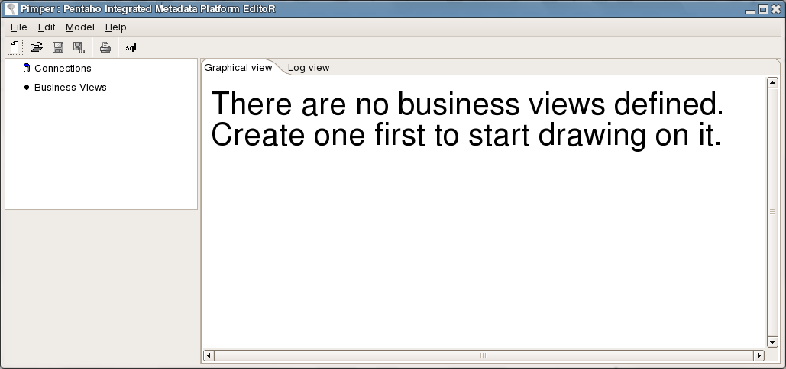

OK, before we start, let's create a database connection and import some physical tables.
Click right on Connections and select “New”. (any similarities with existing other tools are completely coincidental, really!)
Specify the connection parameters, test, etc, etc.
When you're done with that, you can “Import” physical tables from that connection.
To do that, click right on the connection and select “Import...”.

From the database explorer (that looks familiar again) select the table to import and press OK:

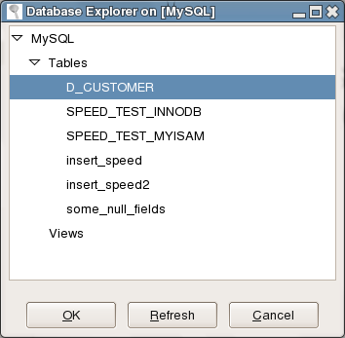

After the import, this is what we have:

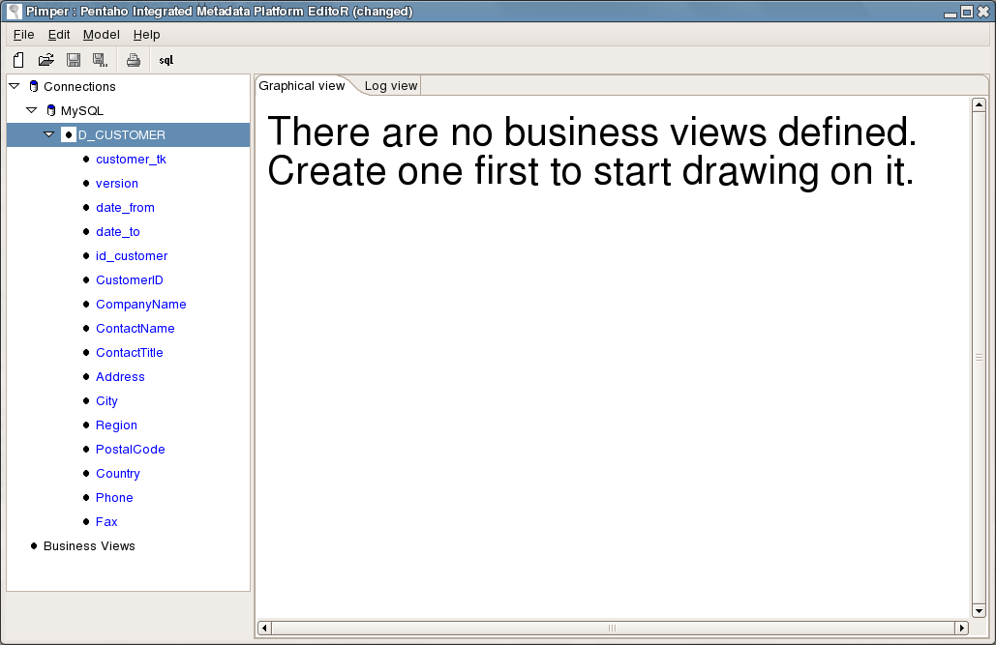

We can also edit the properties of the physical table by double clicking on the table name:

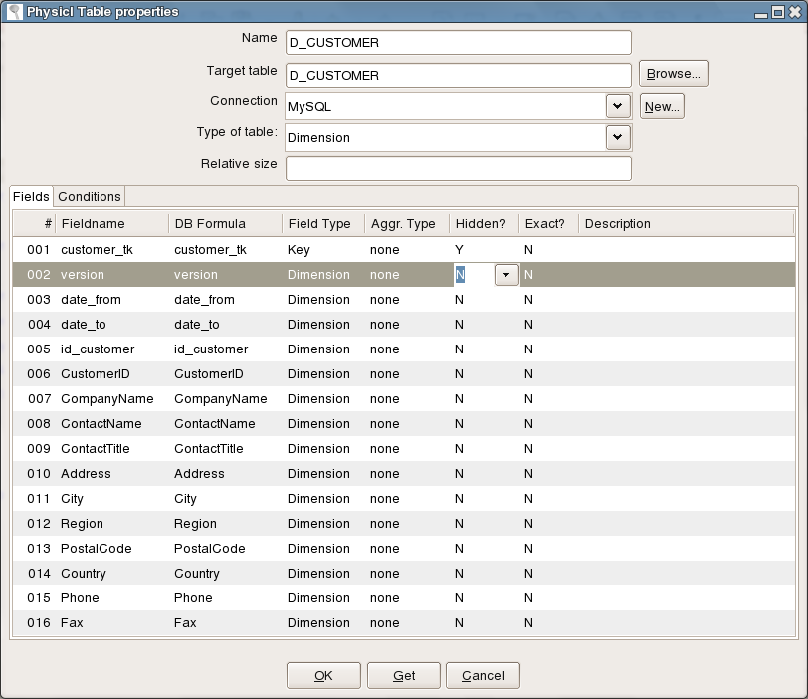
Please note that the “Conditions” tab doesn't do anything and will probably go away in the future.

Important: as blogged before, the Name of this table is used as an ID/key further on in this story.

To place this table into a Business View, simply drag it onto the canvas. You will be asked for the name of the new business view:

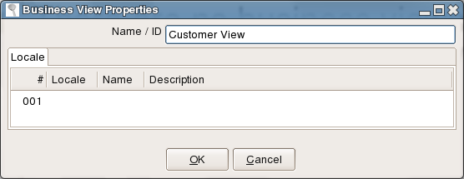

And then you'll be asked to give a business name to the table:

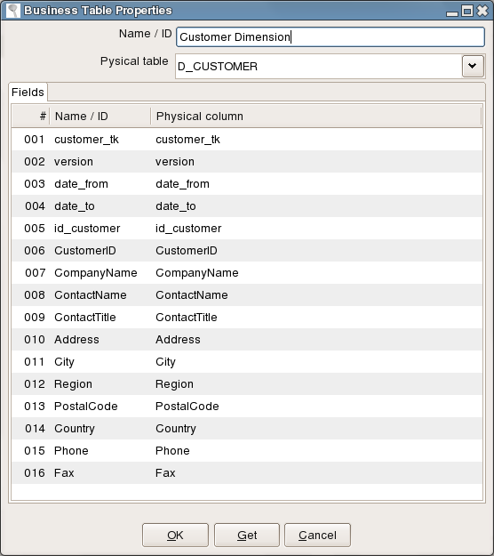

As I don't have a complex star schema to test with on this tiny Linux box, I'll import the same table twice to the same model. (note to self: get your hands on Nick's new Bugzilla goodies)

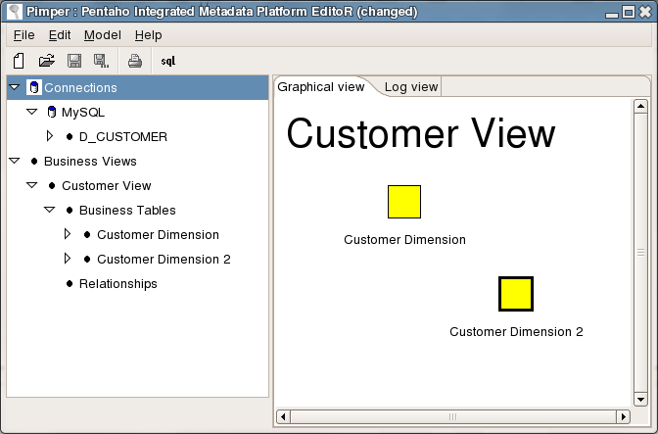

To end this introduction, we can create a relationship between the two Business Tables by dragging the middle button from one table to another on the canvas. (or by selecting “New relationship” here and there)
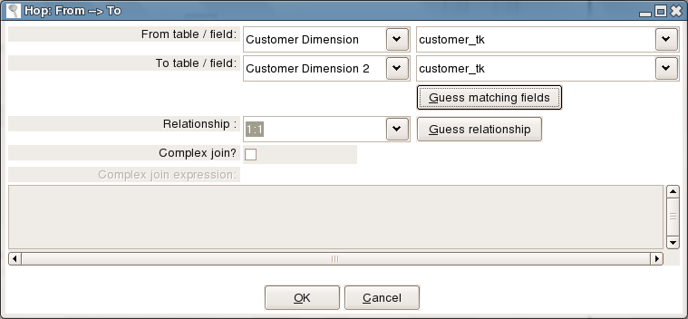

This is the resulting business view:

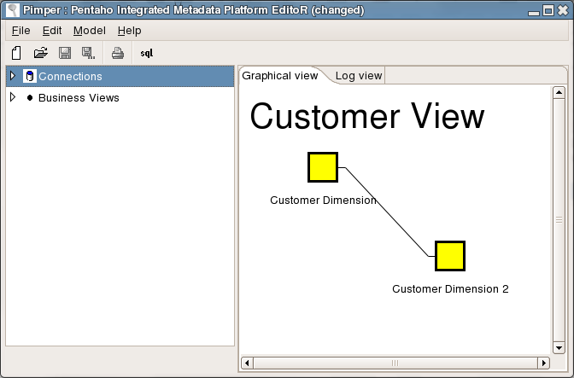

To save the model for eternity or until the next development snapshot release (which ever comes first), you can select File/Save or click on the Save icon. You'll be presented with a dialog asking you to name the model you just built:

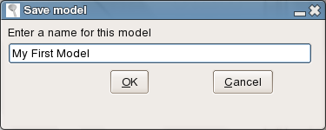

(Note to self: find a different name for that “model” too...)

The model (barring a couple of details like localization information) is then stored into the Meta-Data Repository based on the CWM (Common Warehouse Model)

Notes:
- If you have several business views defined, you can simply click in the tree on the left somewhere on or below a business view to select it and show the content on the Graphical View.
- You can delete test-models using File/Delete model
- The SQL generator is currently broken due to the severe re-modeling of the software that is going on.

