Data Dungeon
The Linked Labyrinth
Chapter 10
The Awakening Traps
Ancillary Resources for Pat Morin’s Open Data Structures in Java
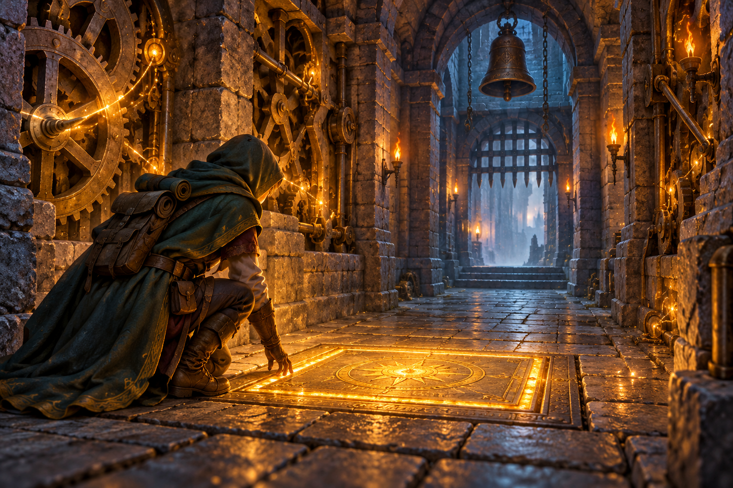
The labyrinth’s clockwork has awakened. A pressure plate releases darts, a bell sounds, and a gate opens before the corridor seals. These events were not registered in the order they must happen. Some events also create new events while the adventure is running.
You will complete an array-based minimum heap so the scheduler always selects the earliest pending event. You will trace upward and downward repairs, test equal-time events, and evaluate an AI recommendation against the operations this program actually needs.
This independent three-file Java project includes the event model, simulation clock, command loop, and array growth. Your implementation work is limited to two heap-repair methods. The simulation advances one event at a time; it does not use wall-clock delays or background threads.
AI-created, human-prompted, human-edited, and human-verified using ChatGPT (OpenAI). Artwork: OpenAI image generation. Original contributions: CC0 1.0. See Publication License and AI Disclosure at the end.

Preparation and Code Investigation
Read Morin’s Section 10.1, BinaryHeap. Focus on the array representation and the repair paths after insertion and removal. This workshop uses a minimum heap with a supplied ordering by event time, then registration sequence. Meldable heaps, cancellation, priority changes, and automatic shrinking are outside the assignment.
Reading: https://opendatastructures.org/ods-java/10_1_BinaryHeap_Implicit_Bi.html

Learning Goals
- Map a complete binary tree to array indices.
- Restore heap order by following one path upward or downward.
- Distinguish event priority from arrival order and physical array order.
- Evaluate a structure recommendation using operations, costs, and a counterexample.

Run the Starter
Use a JDK for Java 11 or later. Check java -version and javac -version. Save the appendix listings as TrapEvent.java, TrapQueue.java, and TrapGame.java in one folder, or use starter/chapter10 from the repository. Run these commands inside that folder.
javac TrapEvent.java TrapQueue.java TrapGame.java
java TrapGame
Enter peek and state. The starter reports 8:seal as next, even though an event at time 2 is pending. The two repair methods are empty, so insertion leaves events in registration order and removal does not restore priority order. This is a runnable but deliberately incorrect scheduler.
Registration order | Time | Name
0 | 8 | seal
1 | 2 | pressure_plate
2 | 6 | gate_opens
3 | 4 | bell

Locate the clock in TrapGame and the nextSequence counter in TrapQueue. Explain why these are different quantities. Find where a pressure plate schedules two follow-up events and where the console rejects a time earlier than the current clock.

Heap Order and Event Order
The active array occupies indices 0 through size - 1 with no gaps. It represents a complete binary tree filled level by level, left to right. For a node at index i, the left child is 2*i + 1 and the right child is 2*i + 2. A non-root node’s parent is (i - 1)/2 using integer division.
Index | Parent | Left child | Right child
0 | none | 1 | 2
1 | 0 | 3 | 4
2 | 0 | 5 | 6

A child index is usable only when it is less than size. The root has no parent; guard index > 0 before computing an upward move. For downward repair, index < size / 2 identifies nodes that have at least one child and avoids computing child indices for leaves.

Use the Supplied Ordering
earlier(first, second) compares event time first. When times match, it compares the sequence assigned at successful registration. The lower sequence wins. Thus equal-time events run in registration order, even when they occupy different branches. A heap alone does not promise this tie behavior; the secondary key supplies it.
Heap order means no child is earlier than its parent. The root is therefore the earliest pending event. Siblings are not required to be sorted, and heapState displays array order, not execution order. Use repeated poll operations on a separate test queue to observe execution order.

Trace the Initial Repairs
After scheduling | Active array shown as times
8:seal | [8]
2:pressure_plate | [2, 8]
6:gate_opens | [2, 8, 6]
4:bell | [2, 4, 6, 8]

Draw the four-node tree for the final array. For the insertion at time 4, identify the appended index, its parent index, the swap, and the comparison that stops further movement. Explain why [2, 4, 6, 8] happens to be sorted here but sorted array order is not the heap invariant.

Workshop Restore the Repair Paths
Edit only the bodies of bubbleUp and trickleDown in TrapQueue.java. Preserve all fields, signatures, helpers, validation, growth code, TrapEvent.java, and TrapGame.java. Use earlier and swap. Do not sort, scan the whole array for a minimum, use a library priority queue, rebuild the heap, or change the event objects. Follow one tree path with O(1) extra space.

Repair Upward After Insertion
schedule validates the inputs, grows a full array, appends one event, increases size, and calls bubbleUp at the new last index. While the current node has a parent and is earlier than that parent, swap them and continue from the parent index. Stop at the root or as soon as the pair is in order. No other part of the heap needs repair.

Repair Downward After Removal
poll saves the root, moves the last event to index 0, reduces size, clears the unused slot, and calls trickleDown when events remain. At each step, identify the earlier existing child. Compare the right child only if it exists. Swap with that child only when the child is earlier than the current event, then continue from the child index. Stop at a leaf or when no swap is needed.
Choosing the left child unconditionally is incorrect: the right child may be earlier. Compare full events with earlier, not just times, so equal-time removals preserve registration order. The supplied empty and singleton handling means trickleDown is never asked to repair an empty array.

Contracts You Must Preserve
peek and poll return null when empty. schedule returns false for negative times, null or blank names, or exhausted sequence numbers; otherwise it accepts duplicate names and times. It stores the original name string. The array starts at capacity 4, doubles when full, and does not shrink. The active prefix contains every pending event exactly once; unused slots are null.
The queue does not know simulation time. TrapGame permits scheduling at the current clock or later and refuses the past. On processing pressure_plate, it schedules darts one time unit later and echo four units later. Follow-ups beyond Integer.MAX_VALUE are refused without wrapping to a negative time. These policies are supplied; do not move them into your repair methods.

Submit
Submit the three Java files, your small check class and results, the required adventure transcript, two repair traces with indices, and your evaluated AI recommendation or no-AI alternative. Explain why array order and execution order need not match.

Required Adventure and Boundary Evidence
Restart the completed program. Enter peek, next, state, schedule 1 late, and peek. Predict the following results before running them.
Command | Expected result
peek | Next: 2:pressure_plate
next | Time 2: pressure_plate; schedules 3:darts and 6:echo
state | [3:darts, 4:bell, 6:gate_opens, 8:seal, 6:echo]
state metadata | Clock 2, size 5, capacity 8
schedule 1 late | Cannot schedule.; state is preserved
peek | Next: 3:darts

Enter next six more times. The first five process the events below; the sixth prints No events. The clock remains 8. Run state to confirm an empty queue, then schedule 8 lantern and next to prove the queue can be reused at the current time.
Execution order | Time | Name
1 | 3 | darts
2 | 4 | bell
3 | 6 | gate_opens
4 | 6 | echo
5 | 8 | seal

Explain why the new darts event executes before the older bell event, why gate_opens precedes echo at time 6, and why five pending events require capacity 8. The initial gate event has sequence 2; echo receives sequence 5.

Small Direct Tests
Create TrapCheck.java with a main method and explicit AssertionError checks. Test empty peek and poll, one event, two events, a removal with only one child, a case where the right child is earlier, equal-time events, growth beyond four entries, and reuse after draining. Add invalid time/name tests and confirm they leave size unchanged. Compile with the project files and run java TrapCheck; explicit checks require no -ea flag.

AI Learning Practice Evaluate a Recommendation
Before using AI, list the required operations and choose a candidate structure. The scheduler repeatedly inserts events, inspects the earliest event, and removes it. New events can arrive between removals. It needs predictable equal-time behavior but does not need sorted iteration, cancellation, or lookup by event name.
Recommend a structure for this Java event scheduler.
Events arrive while the simulation runs. I repeatedly
insert, inspect the earliest event, and remove it.
Equal-time events must run in registration order.
Compare a FIFO queue, an unsorted array, a sorted array,
and a binary min-heap. State operation costs and any
array-growth assumptions. Do not write implementation
code. Give one input trace that tests your recommendation.

Check the Recommendation
Evaluate the answer against the actual workload. A FIFO queue preserves arrival order, which is not the same as event-time order. An unsorted array can accept a late arrival quickly but must search for the earliest event. A sorted array makes the earliest item easy to locate but must maintain order during insertion. Specify which end holds the earliest item when discussing removal costs.
Check whether a heap recommendation explains equal-time ordering and distinguishes heap repair from occasional array growth. Compare the proposed trace with the pressure-plate adventure. Then run your own four-event test: schedule 8 late, 2 early, 4 first, and 4 second. The execution order must be early, first, second, late.

Evidence to Submit
Include your initial choice, prompt, a short relevant response excerpt, and a corrected comparison of the four structures. State whether the recommendation fits this workload and why. Support your decision with predicted and actual results from the four-event test. Identify one missing assumption or incorrect claim; if the response is accurate, explain which assumptions you verified.

Equivalent Exercise Without AI Access
Evaluate these claims: “A FIFO queue works because events arrive in a sequence”; “Sorting once before play is enough”; and “A min-heap automatically preserves arrival order for ties.” Give a counterexample or missing condition for each, compare the four structures, and run the same four-event test. No external service or paid account is required.
Use AI as a design reviewer. Your implementation must still use the supplied heap and only the two allowed method edits; the design comparison does not authorize replacing the assignment with a library collection.

Starter Listing TrapEvent
Save as TrapEvent.java. The event fields are immutable; registration assigns sequence.
public class TrapEvent {
public final int time;
public final String name;
public final long sequence;
TrapEvent(int time, String name, long sequence) {
this.time = time;
this.name = name;
this.sequence = sequence;
}
public String toString() { return time + ":" + name; }
}

Read Across the Files
TrapEvent holds one pending action. TrapQueue owns the array and assigns a unique sequence to each accepted event. TrapGame owns the simulation clock and the pressure-plate behavior. Trace the call from the next command to poll and then to followUp; the newly scheduled event returns through schedule and bubbleUp.
The implementation uses no earlier chapter solution. Keep these files in their own folder and compile them together. You may add a separate check class, but leave the supplied event and game classes unchanged.

Starter Listing TrapQueue
Combine this page and its continuation into TrapQueue.java. Copy code only.
import java.util.Arrays;
public class TrapQueue {
private TrapEvent[] events = new TrapEvent[4];
private int size;
private long nextSequence;
public int size() { return size; }
public int capacity() { return events.length; }
public TrapEvent peek() { return size == 0 ? null : events[0]; }
public boolean schedule(int time, String name) {
if (time < 0 || name == null || name.trim().isEmpty()) return false;
if (nextSequence == Long.MAX_VALUE) return false;
if (size == events.length) {
events = Arrays.copyOf(events, events.length * 2);
}
events[size] = new TrapEvent(time, name, nextSequence++);
size++;
bubbleUp(size - 1);
return true;
}
public TrapEvent poll() {
if (size == 0) return null;
TrapEvent first = events[0];
size--;
events[0] = events[size];
events[size] = null;
if (size > 0) trickleDown(0);
return first;
}

TrapQueue Continued
private void bubbleUp(int index) {
// TODO: restore heap order along the path to the root.
}
private void trickleDown(int index) {
// TODO: restore heap order along one downward path.
}
private boolean earlier(TrapEvent first, TrapEvent second) {
if (first.time != second.time) return first.time < second.time;
return first.sequence < second.sequence;
}
private void swap(int first, int second) {
TrapEvent saved = events[first];
events[first] = events[second];
events[second] = saved;
}
public String heapState() {
return Arrays.toString(Arrays.copyOf(events, size));
}
}

Repair Checkpoints
After completing bubbleUp, restart and confirm that peek reports 2:pressure_plate. This alone does not verify removal. After completing trickleDown, run the entire adventure and the right-child test. Inspect the active prefix after every operation in your hand trace.
For a focused downward trace, schedule times 1, 4, 2, 9, 6 with any names. Removing 1 moves 6 to the root; the earlier child is 2 at index 2. After repair, the times are [2, 4, 6, 9]. Continue removing until empty and check the order 2, 4, 6, 9.

Starter Listing TrapGame
Combine this page and its continuation into TrapGame.java. Leave it unchanged.
import java.util.Scanner;
public class TrapGame {
private static void followUp(TrapQueue queue, int now,
int delay, String name) {
long time = (long) now + delay;
if (time > Integer.MAX_VALUE
|| !queue.schedule((int) time, name)) {
System.out.println("Cannot schedule follow-up: " + name);
} else {
System.out.println("Scheduled: " + time + ":" + name);
}
}
public static void main(String[] args) {
TrapQueue queue = new TrapQueue();
queue.schedule(8, "seal");
queue.schedule(2, "pressure_plate");
queue.schedule(6, "gate_opens");
queue.schedule(4, "bell");
int now = 0;
Scanner input = new Scanner(System.in);
System.out.println("The Awakening Traps");
System.out.println("next, peek, state, schedule <time> <name>, quit");
while (input.hasNextLine()) {
String line = input.nextLine().trim();
String[] parts = line.split("\\s+", 3);
if (line.equals("quit")) break;
try {
if (line.equals("next")) {
TrapEvent event = queue.poll();
if (event == null) {
System.out.println("No events.");
} else {
now = event.time;
System.out.println("Time " + now + ": " + event.name);
if (event.name.equals("pressure_plate")) {
followUp(queue, now, 1, "darts");
followUp(queue, now, 4, "echo");
}
}

TrapGame Continued
} else if (line.equals("peek")) {
System.out.println("Next: " + queue.peek());
} else if (line.equals("state")) {
System.out.println(queue.heapState());
System.out.println("Clock: " + now + "; size: "
+ queue.size() + "; capacity: " + queue.capacity());
} else if (parts[0].equals("schedule")
&& parts.length == 3) {
int time = Integer.parseInt(parts[1]);
boolean added = time >= now
&& queue.schedule(time, parts[2]);
System.out.println(added
? "Scheduled." : "Cannot schedule.");
} else {
System.out.println("Use next, peek, state, "
+ "schedule, or quit.");
}
} catch (NumberFormatException exception) {
System.out.println("Use an integer time.");
}
}
}
}

Publication License and AI Disclosure

Open Reuse
To the extent the project rights holders own copyright or related rights, they dedicate the original contributions to Data Dungeon: The Linked Labyrinth to the public domain under CC0 1.0 Universal. This includes original teaching materials, Java code, verification code, and project artwork. You may copy, modify, redistribute, and use these contributions commercially. Attribution is appreciated but is not required for these CC0 contributions.
CC0 1.0 Universal: https://creativecommons.org/publicdomain/zero/1.0/

Source Attribution and Exceptions
Pat Morin, Open Data Structures, Java edition: https://opendatastructures.org/ods-java/. The textbook and its accompanying source code are released under Creative Commons Attribution 2.5 Canada: https://creativecommons.org/licenses/by/2.5/ca/. Any reproduced or adapted Morin material retains that license and attribution requirement; this project’s CC0 dedication does not waive his rights. The companion adds a dungeon setting, focused workshops, renamed and simplified implementations, tests, instructor guidance, and AI learning activities. No endorsement by Pat Morin is implied.
Format inspiration: Michael Penta, Companion Materials for OpenStax: Introduction to Python Programming, Chapter 5 (2025), supplied under CC0 1.0. Other third-party material retains its applicable terms. CC0 applies only to rights held by the project rights holders and does not assert that AI-generated material is copyrightable.

AI Disclosure
This work was AI-created, human-prompted, human-edited, and human-verified. Text, instructional activities, and code were generated using ChatGPT (OpenAI). Decorative artwork was generated using OpenAI image generation.
AI tool citation: OpenAI. (2026). ChatGPT [large language model]. https://chatgpt.com/. Exact model-version identifiers were not recorded. Human prompting, editing, and verification do not imply that the work is error-free or that classroom trials have been completed.

