Data Dungeon
The Linked Labyrinth
Chapter 11
The Treasure Catalogue
Ancillary Resources for Pat Morin’s Open Data Structures in Java
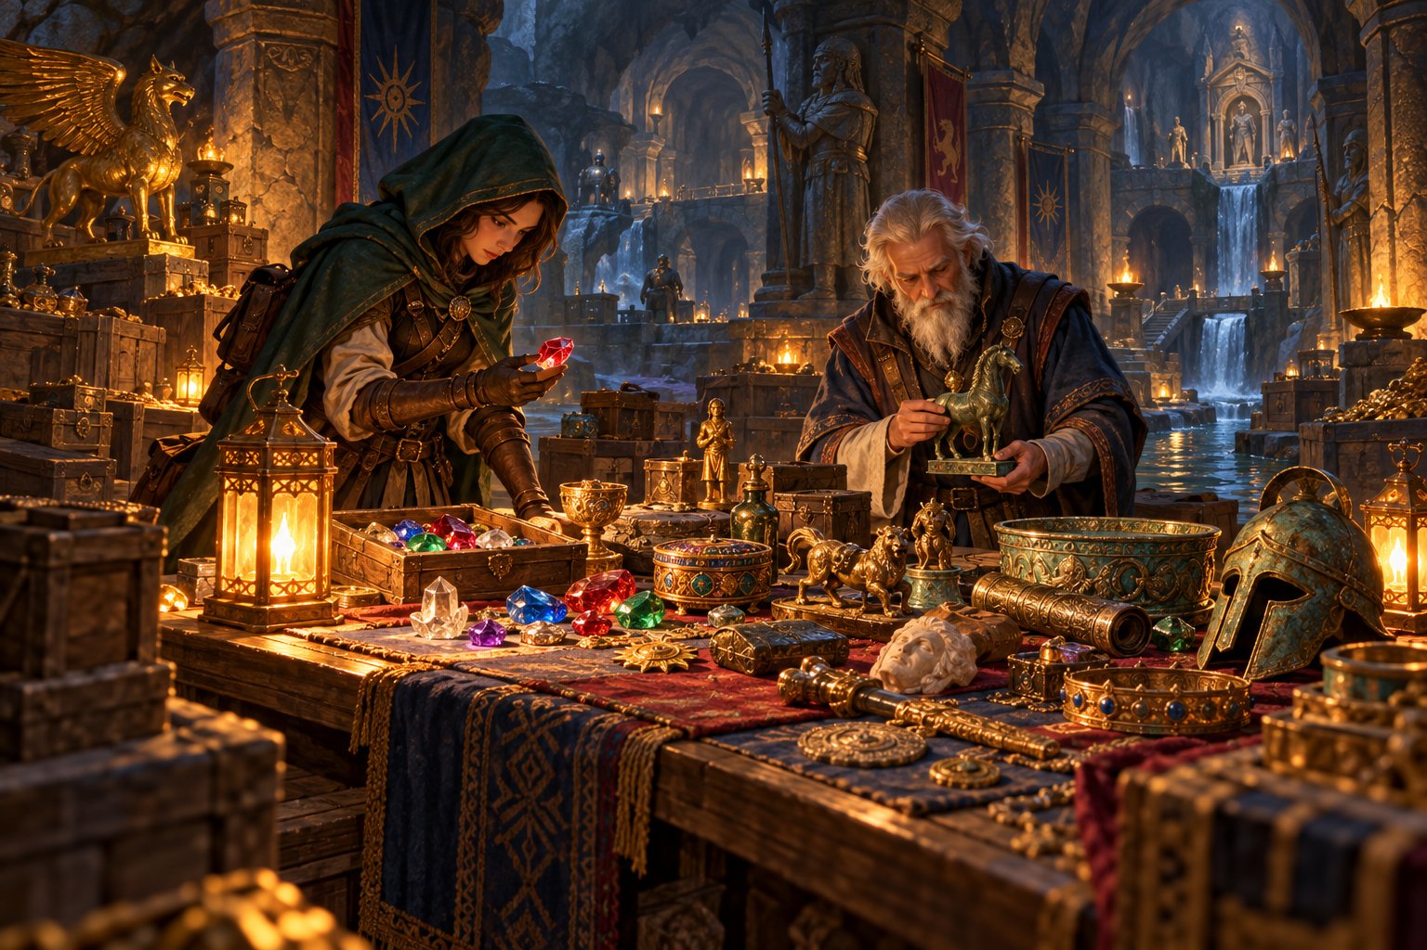
The recovered treasure arrives at the keeper’s desk in discovery order. The catalogue must list items from lowest to highest value. When two treasures have the same value, their discovery order must remain visible. Sorting values correctly while mixing up the corresponding treasures is not a successful repair.
You will implement stable insertion sort and the merging step of merge sort, then compare their key-comparison counts on controlled inputs. The supplied experiment driver gives each algorithm its own copy of the same records. Your evidence will include both correct ordering and measured work.
This independent three-file Java project supplies the record class, comparison counter, recursive splitting, buffer allocation, and experiment runner. You will change only two method bodies. Timing benchmarks, quicksort, heapsort, and non-comparison sorts are outside this workshop.
AI-created, human-prompted, human-edited, and human-verified using ChatGPT (OpenAI). Artwork: OpenAI image generation. Original contributions: CC0 1.0. See Publication License and AI Disclosure at the end.

Preparation and Code Investigation
Read Morin’s Section 11.1.1 on merge sort. Follow how sorted halves are combined and how comparisons guide the next choice. This workshop uses index ranges and one reusable buffer instead of allocating two subarrays at each split. Insertion sort is included as a small-input baseline for comparison.
Reading: https://opendatastructures.org/ods-java/11_1_Comparison_Based_Sorti.html

Learning Goals
- Sort records without losing their identity or association with values.
- Preserve input order among equal keys in both algorithms.
- Merge two sorted ranges while respecting their boundaries.
- Compare independently predicted counts with reproducible experiments.

Run the Starter
Use a JDK for Java 11 or later. Check java -version and javac -version. Save the appendix listings as Treasure.java, CatalogueSort.java, and CatalogueGame.java in one folder, or use starter/chapter11. Run these commands inside that folder.
javac Treasure.java CatalogueSort.java CatalogueGame.java
java CatalogueGame
The program runs five experiments and exits; it does not wait for commands. In the starter, both algorithms leave the input unchanged and return zero comparisons. Find the two TODO methods and trace how mergeSort reaches merge through sortRange.
Record | Value | Original position
A | 40 | 0
B | 10 | 1
C | 30 | 2
D | 10 | 3
E | 50 | 4
F | 20 | 5

Each record has immutable id and value fields. The letters identify records; they are not sort keys. The correct sample order is B, D, F, C, A, E. B must remain before D because both have value 10 and B appeared first.

Stable Sorting and Range Boundaries

Insertion Sort Builds a Sorted Prefix
At index 1 and each later index, save the current Treasure reference. Move earlier records one position right while their values are strictly greater than the saved value. Place the saved reference into the resulting gap. The prefix through the current index is then sorted. Stop shifting on equality so equal-value records retain their order.

Merge Sort Combines Sorted Halves
sortRange uses half-open ranges: low is included and high is excluded. Its two children are [low, middle) and [middle, high). By the time merge is called, both halves are sorted. Maintain separate left, right, and output indices. Compare the two available candidates, copy the chosen reference into buffer, and advance only that candidate’s index.
When values tie, choose the left candidate. After either half is exhausted, copy the remainder of the other half without more key comparisons. Finally copy buffer[low..high) back into the same range of items. Do not overwrite unread input while choosing candidates.
Final sample merge | Sorted records
Left half | B:10, C:30, A:40
Right half | D:10, F:20, E:50
Merged result | B:10, D:10, F:20, C:30, A:40, E:50

The final merge makes five key comparisons. Trace each pair and selected record. The earlier recursive merges make five more, so the whole sample merge sort makes ten. The textbook’s displayed merge chooses the right side on equality; our explicit stability requirement changes that choice to the left.

What the Counter Measures
compare increments comparisons once and compares only integer values. Count calls to this helper, including the insertion-sort comparison that stops a shift. Loop-bound checks, copying, allocation, and method calls are not key comparisons. A smaller comparison count does not by itself prove a smaller elapsed time.

Workshop Complete the Sorting Methods
Edit only insertionSort and merge in CatalogueSort.java. Keep all other methods, fields, class definitions, and the driver unchanged. Use compare for every key comparison. Do not compare ids, add a secondary key, call a library sort, change Treasure objects, or create replacement records.

Insertion Contract
Retain the counter reset and returned count in insertionSort. Process indices from 1 upward. Use a saved reference and rightward shifts, comparing the preceding record with the saved record only while position > 0. Shift only when compare returns a positive value. Stop at the first non-greater record and place the saved reference. Do not perform extra comparisons for validation inside the algorithm.

Merge Contract
In merge, start left at low, right at middle, and output at low. Compare candidates only while both ranges are nonempty. Choose left when compare is zero or negative, otherwise choose right. Copy the remaining references and then copy back exactly [low, high). Use the supplied buffer; do not allocate another array, re-sort a half, or add an early-exit optimization.
Both public sort methods mutate the supplied array into ascending order and preserve the relative input order of equal values. Empty and singleton arrays need no key comparisons. Inputs must be non-null arrays containing non-null Treasure references. Every int value is allowed, including negative values and integer extremes. Null-input validation is not part of this workshop.

Work in Checkpoints
- Complete insertionSort and verify the sample order and count 11.
- Complete merge and verify the same sample order and count 10.
- Check odd lengths, empty inputs, singleton inputs, and repeated values.
- Run all five driver experiments and explain any prediction mismatch.

Submit
Submit all three Java files, a small check class with results, the five-experiment output, an insertion trace and a final-merge trace, and your AI prediction review or no-AI alternative. Include one test that would reject a correctly value-sorted but unstable result.

Required Experiments and Boundary Evidence
The supplied driver clones the original reference array separately for each algorithm. Because Treasure fields are immutable, both methods receive the same records in the same initial order without sharing a mutable array. Never run the second algorithm on the first algorithm’s sorted output when comparing input arrangements.
Dataset | Values in input order | Insertion | Merge
sample | 40,10,30,10,50,20 | 11 | 10
sorted | 10,20,30,40,50,60,70,80 | 7 | 12
reverse | 80,70,60,50,40,30,20,10 | 28 | 12
equal | 10 repeated eight times | 7 | 12
mixed | 40,10,70,20,80,30,60,50 | 17 | 17

Counts assume the exact required loops and supplied recursive split. The sorted and reverse cases contain the same eight distinct values; only their arrangement changes. The equal case changes the values too, so it tests stability and tie handling rather than isolating arrangement alone.

Explain the Results
Why does insertion sort make seven comparisons on the sorted input but twenty-eight on the reverse input? Why does merge sort still compare records on an already sorted input? Why can two algorithms make seventeen comparisons on the mixed input while performing different copying work? Use traces and the code to support your explanations.

Extend One Controlled Experiment
In a separate CatalogueCheck.java, build increasing and decreasing arrays of length 16. Predict insertion counts before running: 15 and 120. For this merge implementation, each arrangement makes 32 comparisons. Keep record creation and any correctness checks outside the counted sort. Explain why these two sizes support an observation but do not prove a general complexity bound.

Boundary and Stability Checks
Use explicit checks that throw AssertionError. Include empty and singleton arrays, an odd length, repeated values, and Integer.MIN_VALUE and Integer.MAX_VALUE. For equal values, retain references to the original records and verify their output order with ==. Use distinct ids so an unstable swap is visible. Check that no record is lost or duplicated. Compile the check class with the project and run java CatalogueCheck; no -ea flag is needed.

AI Learning Practice Test Predictions
Write your own predictions for sorted, reverse, and equal inputs before asking AI. Provide the algorithm rules and the counter definition. Ask for a reasoned prediction, not completed Java methods. Compare the response with an actual run and your hand trace.
Predict key-comparison counts for these exact algorithms.
Insertion sort shifts only on compare(previous, saved) > 0.
It compares only while position > 0. Merge sort splits
at floor(length/2), compares while both halves remain,
and chooses the left side on equality. No early exits.
Only calls to compare count. For eight sorted distinct
values, eight reverse values, and eight equal values,
predict counts and explain the reasoning. Do not write code.

Evaluate the Answer
Separate a claim about asymptotic growth from an exact count. If AI says merge sort takes n log n comparisons, ask whether that is an upper-order description or an exact formula for this input. Check whether it counted loop tests or remainder copies that never call compare.
Record your prediction, the AI prediction, the measured count, and a short explanation for each input. When a prediction is wrong, identify the first step where its reasoning differs from your code. If all predictions match, explain the counter definition and the tie rule that made the agreement meaningful.

Equivalent Exercise Without AI Access
Evaluate these proposed predictions: “Both algorithms make zero comparisons on sorted input”; “Insertion sort makes 28 comparisons on eight equal values”; and “Merge sort always makes exactly n log2(n) comparisons.” Correct each using the required implementation and a trace, then run the same experiments.
Submit a short relevant excerpt if you use AI, along with your independent reasoning and program output. No paid account or external service is required. The goal is to test claims with controlled evidence, not to obtain implementation code.

Starter Listing Treasure and CatalogueSort
Save the first listing as Treasure.java and the second as CatalogueSort.java. Copy code only.
public class Treasure {
public final String id;
public final int value;
public Treasure(String id, int value) {
this.id = id;
this.value = value;
}
public String toString() { return id + ":" + value; }
}
public class CatalogueSort {
private long comparisons;
private int compare(Treasure first, Treasure second) {
comparisons++;
return Integer.compare(first.value, second.value);
}
public long insertionSort(Treasure[] items) {
comparisons = 0;
// TODO: stable insertion sort using compare for key comparisons.
return comparisons;
}
public long mergeSort(Treasure[] items) {
comparisons = 0;
Treasure[] buffer = new Treasure[items.length];
sortRange(items, buffer, 0, items.length);
return comparisons;
}
private void sortRange(Treasure[] items, Treasure[] buffer,
int low, int high) {
if (high - low < 2) return;
int middle = low + (high - low) / 2;
sortRange(items, buffer, low, middle);
sortRange(items, buffer, middle, high);
merge(items, buffer, low, middle, high);
}
private void merge(Treasure[] items, Treasure[] buffer,
int low, int middle, int high) {
// TODO: merge the sorted half-open ranges and copy back.
}
}

Starter Listing CatalogueGame
Save as CatalogueGame.java. Leave this experiment driver unchanged.
import java.util.Arrays;
public class CatalogueGame {
private static Treasure[] treasures(int[] values) {
Treasure[] result = new Treasure[values.length];
for (int index = 0; index < values.length; index++) {
result[index] = new Treasure("" + (char) ('A' + index),
values[index]);
}
return result;
}
private static void experiment(String name, int[] values) {
Treasure[] original = treasures(values);
Treasure[] insertion = original.clone();
Treasure[] merged = original.clone();
CatalogueSort sorter = new CatalogueSort();
long first = sorter.insertionSort(insertion);
long second = sorter.mergeSort(merged);
System.out.println(name + " input: " + Arrays.toString(original));
System.out.println("Insertion: " + Arrays.toString(insertion));
System.out.println("Merge: " + Arrays.toString(merged));
System.out.println("Comparisons: insertion=" + first
+ ", merge=" + second);
}
public static void main(String[] args) {
experiment("sample", new int[]{40, 10, 30, 10, 50, 20});
experiment("sorted", new int[]{10, 20, 30, 40, 50, 60, 70, 80});
experiment("reverse", new int[]{80, 70, 60, 50, 40, 30, 20, 10});
experiment("equal", new int[]{10, 10, 10, 10, 10, 10, 10, 10});
experiment("mixed", new int[]{40, 10, 70, 20, 80, 30, 60, 50});
}
}

Publication License and AI Disclosure

Open Reuse
To the extent the project rights holders own copyright or related rights, they dedicate the original contributions to Data Dungeon: The Linked Labyrinth to the public domain under CC0 1.0 Universal. This includes original teaching materials, Java code, verification code, and project artwork. You may copy, modify, redistribute, and use these contributions commercially. Attribution is appreciated but is not required for these CC0 contributions.
CC0 1.0 Universal: https://creativecommons.org/publicdomain/zero/1.0/

Source Attribution and Exceptions
Pat Morin, Open Data Structures, Java edition: https://opendatastructures.org/ods-java/. The textbook and its accompanying source code are released under Creative Commons Attribution 2.5 Canada: https://creativecommons.org/licenses/by/2.5/ca/. Any reproduced or adapted Morin material retains that license and attribution requirement; this project’s CC0 dedication does not waive his rights. The companion adds a dungeon setting, focused workshops, renamed and simplified implementations, tests, instructor guidance, and AI learning activities. No endorsement by Pat Morin is implied.
Format inspiration: Michael Penta, Companion Materials for OpenStax: Introduction to Python Programming, Chapter 5 (2025), supplied under CC0 1.0. Other third-party material retains its applicable terms. CC0 applies only to rights held by the project rights holders and does not assert that AI-generated material is copyrightable.

AI Disclosure
This work was AI-created, human-prompted, human-edited, and human-verified. Text, instructional activities, and code were generated using ChatGPT (OpenAI). Decorative artwork was generated using OpenAI image generation.
AI tool citation: OpenAI. (2026). ChatGPT [large language model]. https://chatgpt.com/. Exact model-version identifiers were not recorded. Human prompting, editing, and verification do not imply that the work is error-free or that classroom trials have been completed.

