Data Dungeon
The Linked Labyrinth
Ancillary Resources for Pat Morin’s
Open Data Structures in Java
Chapter 1 Companion
At the Threshold
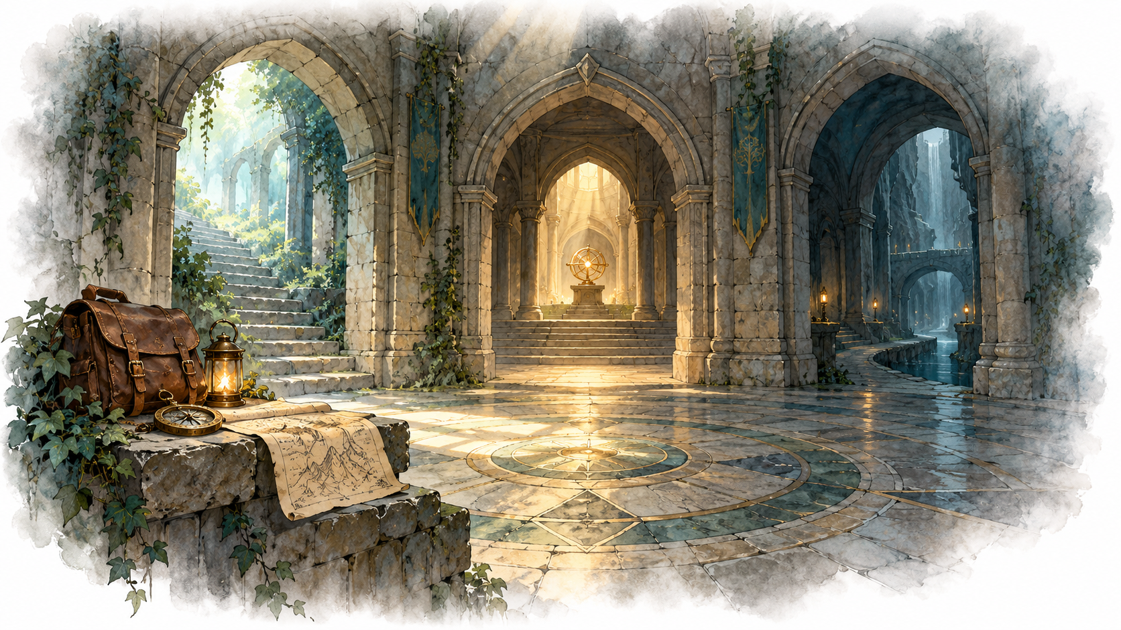
Working draft for instructor review • October 2026
AI-created, human-prompted, human-edited, and human-verified using ChatGPT (OpenAI). Artwork: OpenAI image generation. Original contributions: CC0 1.0. See Publication License and AI Disclosure at the end.
Format reference: Michael Penta, Companion Materials for OpenStax: Introduction to Python Programming, Chapter 5 (2025), supplied Word document marked CC0 1.0. This companion uses original Java activities. Original contributions are dedicated under CC0 1.0.

Chapter Overview and Learning Objectives

Chapter Overview
You have reached the entrance of the Linked Labyrinth. Before restoring its archives and inventories, you must learn how the existing program represents rooms and passages. You will trace the supplied code, investigate it with AI assistance, and connect a new wing to the world.
Reading: Morin, Open Data Structures in Java, Chapter 1, especially the discussion of interfaces and implementations. Review Java classes, arrays, object references, and null. This activity develops the Java foundation needed for later structure implementations; it does not cover all of Chapter 1.

Learning Objectives
- Distinguish a Room object from a variable that references it.
- Trace movement through an array of room references.
- Explain shared destinations, one-way passages, cycles, and empty exit slots.
- Locate and modify the world-building code while preserving navigation behavior.
- Ask a focused AI question and support your explanation using code and execution.

Getting Started
The appendix contains four complete Java files. Copy each listing into a plain-text file with the displayed filename, all in one folder. Use an installed Java development kit, not only a Java runtime. Your instructor may supply the same files directly.
javac Room.java Player.java WorldBuilder.java Game.java
java Game
Enter look to inspect the current room, go 0 to take exit 0, and quit to stop. Exit numbers are zero-based array indices, not compass directions. This first activity uses navigation only; collecting items begins in the next chapter.

Code Investigation Activity

Explore the Existing Program
Read WorldBuilder.build and Player.move before consulting AI. Room stores a name and an exit array. Player stores the current-room reference. WorldBuilder creates and connects objects. Game reads commands and displays results.

A Worked Reference Example
Room hall = new Room("Hall", 2);
Room study = new Room("Study", 1);
hall.setExit(0, study);
Player explorer = new Player(hall);
explorer.move(0);
The last statement changes explorer’s currentRoom reference from the Hall object to the Study object. It does not copy the Study object, move the Hall object, or change hall’s exit array. A return passage requires its own assignment, such as study.setExit(0, hall).

Your Investigation
- Draw one box for each room created in WorldBuilder.build. Add the exit slots, destination arrows, and null slots. Show the player separately.
- Starting at Entrance, predict the room after each command: go 0, go 1, go 0, go 1, go 1. Do not reset between commands.
- Identify two exit slots that reference the same Archive object. Explain why this does not create two archives.
- Find the exact assignment that changes the player’s location. Explain why the exit array remains unchanged.
- Predict the behavior of go -1, go 99, and go two. Then run the commands and check your predictions.
Keep a short trace with columns for command, room before, room after, and explanation. When a command fails, record whether the player remains in the same room. Complete the AI activity on the next page before building your extension.

AI Skill Building Activity

Practical AI Tip
An explanation is more useful when you supply the relevant code and ask about one relationship. Your goal is to understand how references behave, then use that understanding to design your own room connections.

Your Task
- Choose a free AI chat tool available to you. Paste Room and Player from the appendix and your own prediction about movement.
- Ask a specific question about currentRoom, the exit array, or a shared destination. Use the scaffold below if helpful.
- Ask one follow-up that requests a smaller example, a diagram, or an explanation of an unclear step.
- Select one claim from the response. Point to the method or assignment that supports or contradicts it, and demonstrate a confirming run.
Prompt scaffold: “I am tracing movement in this Java program. Explain which reference changes when move(0) succeeds. Distinguish currentRoom from the references in exits. Use the supplied code and ask me one question to check my understanding. Do not write my new rooms or connections.”

Apply the Explanation
Return to your room diagram. Correct it if necessary and explain one design decision you will make when connecting your new wing. If your original understanding was already correct, explain how the evidence confirmed it.

Responsible Use and Alternative
You may request explanations, diagrams, and diagnostic hints. Write the extension yourself. Identify the tool used and retain only the useful prompt, follow-up, and short response excerpt. Do not submit private information or a complete chat history.
If AI is unavailable, compare these two claims: “Moving copies the destination room” and “Moving assigns a destination reference to currentRoom.” Explain which is supported by the code. Write the question you would ask a tutor, answer it with a partner or instructor, and submit the same trace evidence. Label this the alternative route.

The Data Dungeon Adventure Project

Adventure Activity The Uncharted Wing
An old inscription describes a wing beyond the Entrance. Its rooms exist only in the keeper’s notes. Restore the connections so an explorer can enter the wing, reach its final chamber, and return safely.
Modify WorldBuilder.build. Preserve the original rooms and existing passages. Create three new Room objects with distinct, descriptive names. Give them enough exit slots for your design.
- Connect Entrance exit 2 to one new room.
- Make all three new rooms reachable from Entrance.
- Provide a route through the new wing that returns to Entrance and therefore creates a cycle.
- Make two different exit slots in your extension refer to the same new Room object.
- Leave at least one exit slot empty and explain why it contains null.
- Include at least one passage without a direct reverse passage. A longer return route must still exist.
Plan your connections on paper first, then implement them. Choose room names and exit counts yourself. You do not need to change Player, Room, or Game. Do not add combat, inventory, or a new command parser for this activity.

Testing and Submission
Test a route visiting all three new rooms and returning to Entrance. Test both entrances to the shared destination, an empty slot, an invalid index, and a nonnumeric movement command. For each check, record the commands, expected result, actual result, and pass or fail.
Submit your four Java files; a labeled reference diagram; the original prediction trace; the compact test record; and the AI evidence or alternative. In 100–150 words, explain which reference changes during movement and why a one-way passage does not necessarily trap the player.

Starter Code Room and Player
Save each class in its own file. Room expects nonnegative exit counts and valid indices when the world is constructed; Player checks indices supplied during movement.

Room.java
public class Room {
private final String name;
private final Room[] exits;
public Room(String name, int exitCount) {
this.name = name;
exits = new Room[exitCount];
}
public String getName() { return name; }
public int getExitCount() { return exits.length; }
public Room getExit(int index) {
return exits[index];
}
public void setExit(int index, Room destination) {
exits[index] = destination;
}
}

Player.java
public class Player {
private Room currentRoom;
public Player(Room startingRoom) {
currentRoom = startingRoom;
}
public Room getCurrentRoom() { return currentRoom; }
public boolean move(int exitIndex) {
if (exitIndex < 0 ||
exitIndex >= currentRoom.getExitCount()) {
return false;
}
Room destination = currentRoom.getExit(exitIndex);
if (destination == null) { return false; }
currentRoom = destination;
return true;
}
}

Starter Code WorldBuilder
This is the only class you need to change for the required extension. An unassigned array slot contains null. Every setExit call creates one directed connection.

WorldBuilder.java
public class WorldBuilder {
public static Room build() {
Room entrance = new Room("Entrance", 3);
Room gallery = new Room("Gallery", 2);
Room well = new Room("Well", 2);
Room archive = new Room("Archive", 1);
entrance.setExit(0, gallery);
entrance.setExit(1, well);
gallery.setExit(0, entrance);
gallery.setExit(1, archive);
well.setExit(0, archive);
archive.setExit(0, entrance);
// Add your new rooms and connections here.
return entrance;
}
}

Before You Edit
Run the supplied world once and save a copy. In this world, both Gallery and Well can lead to Archive. Archive returns to Entrance. Entrance exit 2 and Well exit 1 are initially empty.
The illustration is atmospheric artwork, not a map. Your reference diagram and Java connections define the actual room layout.

Reading and Credits
Pat Morin, Open Data Structures in Java, Chapter 1:
https://opendatastructures.org/ods-java/
Document organization follows the supplied Chapter 5 companion by Michael Penta. The activities and starter code here are new. Illustrations are AI-generated decorative artwork; they do not explain or validate algorithms.

Starter Code Game
This class supplies the console interface. Read enough to locate the move call and the room display; the required assignment does not change this file.
import java.util.Scanner;
public class Game {
public static void main(String[] args) {
Player player = new Player(WorldBuilder.build());
Scanner input = new Scanner(System.in);
System.out.println("Use look, go <index>, or quit.");
while (true) {
System.out.print("> ");
if (!input.hasNextLine()) { break; }
String command = input.nextLine().trim();
if (command.equals("quit")) { break; }
if (command.equals("look")) {
describe(player.getCurrentRoom());
} else if (command.startsWith("go ")) {
try {
int index = Integer.parseInt(
command.substring(3).trim());
if (player.move(index)) {
describe(player.getCurrentRoom());
} else {
System.out.println("No passage there.");
}
} catch (NumberFormatException error) {
System.out.println("Use an integer index.");
}
} else {
System.out.println("Use look, go <index>, or quit.");
}
}
}
private static void describe(Room room) {
System.out.println(room.getName());
for (int i = 0; i < room.getExitCount(); i++) {
Room destination = room.getExit(i);
if (destination != null) {
System.out.println(i + ": " + destination.getName());
}
}
}
}

Publication License and AI Disclosure

Open Reuse
To the extent the project rights holders own copyright or related rights, they dedicate the original contributions to Data Dungeon: The Linked Labyrinth to the public domain under CC0 1.0 Universal. This includes original teaching materials, Java code, verification code, and project artwork. You may copy, modify, redistribute, and use these contributions commercially. Attribution is appreciated but is not required for these CC0 contributions.
CC0 1.0 Universal: https://creativecommons.org/publicdomain/zero/1.0/

Source Attribution and Exceptions
Pat Morin, Open Data Structures, Java edition: https://opendatastructures.org/ods-java/. The textbook and its accompanying source code are released under Creative Commons Attribution 2.5 Canada: https://creativecommons.org/licenses/by/2.5/ca/. Any reproduced or adapted Morin material retains that license and attribution requirement; this project’s CC0 dedication does not waive his rights. The companion adds a dungeon setting, focused workshops, renamed and simplified implementations, tests, instructor guidance, and AI learning activities. No endorsement by Pat Morin is implied.
Format inspiration: Michael Penta, Companion Materials for OpenStax: Introduction to Python Programming, Chapter 5 (2025), supplied under CC0 1.0. Other third-party material retains its applicable terms. CC0 applies only to rights held by the project rights holders and does not assert that AI-generated material is copyrightable.

AI Disclosure
This work was AI-created, human-prompted, human-edited, and human-verified. Text, instructional activities, and code were generated using ChatGPT (OpenAI). Decorative artwork was generated using OpenAI image generation.
AI tool citation: OpenAI. (2026). ChatGPT [large language model]. https://chatgpt.com/. Exact model-version identifiers were not recorded. Human prompting, editing, and verification do not imply that the work is error-free or that classroom trials have been completed.

