Data Dungeon
The Linked Labyrinth
Chapter 3 Instructor Guide
The Shifting Procession
Ancillary Resources for Pat Morin’s Open Data Structures in Java
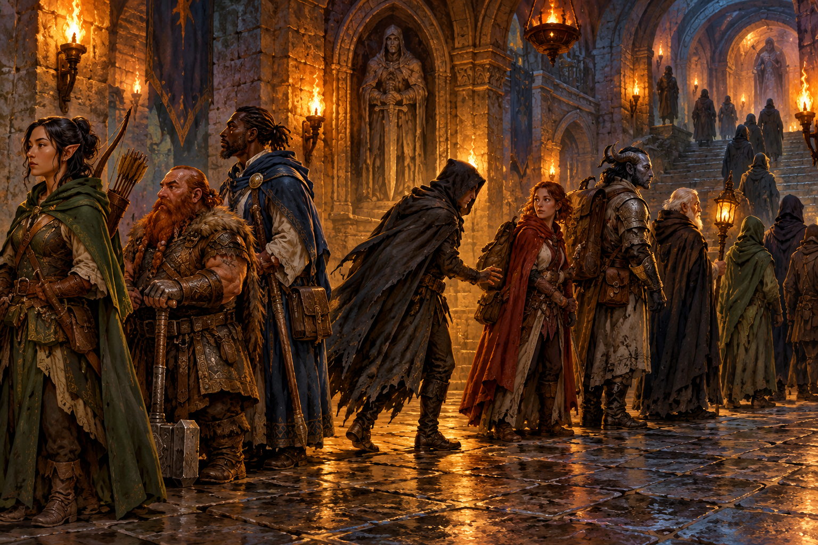
This guide supports the independent linked-list workshop. Students complete exactly two method bodies while the supplied cursor navigation, display methods, sample builder, and console driver remain unchanged. The reference solution demonstrates that the required activity is achievable within that edit boundary.
The student chapter, starter/chapter03, instructor/chapter03, and verification/ProcessionCompletion.java form one package. Instructor files are in the public repository; use course-controlled distribution if students should not see solutions before submission.
AI-created, human-prompted, human-edited, and human-verified using ChatGPT (OpenAI). Artwork: OpenAI image generation. Original contributions: CC0 1.0. See Publication License and AI Disclosure at the end.

Teaching Sequence and Expected Reasoning
Suggested allocation is 90 to 120 minutes plus reading. This is a planning estimate, not a measured classroom completion time. Allow additional time for students who have not traced Java object references.
Stage | Suggested minutes | Evidence to request
Run and investigate | 10–15 | Baseline cursor trace and starter failures
Model the links | 15–20 | Node identities and reciprocal fields
Implement both edits | 30–40 | Working mission and boundary cases
Audit AI or supplied claim | 15–20 | Checked claim with trace evidence
Explain and submit | 20–25 | Complexity comparison and transcript

Instructor Prompts
Ask students to identify the four fields changed by an insertion before writing assignments. If they update current.prev too early, ask which predecessor reference they have lost. During removal, ask why current cannot simply move to removed.next in every case: the tail points to dummy, which is not selectable while encounters remain.
Preserving current is an identity requirement. Rebuilding nodes with the same labels can produce correct printed output while violating the contract. Duplicate names are intentionally allowed, so names cannot serve as node identity.

Complexity and Reading Alignment
The exercise follows Morin’s Section 3.2 dummy-node model and focuses on editing at a known node. Insertion and removal use O(1) time and O(1) auxiliary space per call, with one allocated node per successful insertion. Finding a name by traversal and displaying the full list take O(n). No search operation is implemented here. In an array list, insertion near the front shifts a linear number of elements; indexed access remains an advantage of arrays.
Reading: https://opendatastructures.org/ods-java/3_2_DLList_Doubly_Linked_Li.html

Reference Trace and Troubleshooting
Checkpoint | Expected result
Start; next | scout selected initially; then ogre selected
Insert healer | [scout, healer, ogre, gate]; size 4; same ogre selected
Resolve ogre | [scout, healer, gate]; size 3; gate selected
Back after ogre | [gate, healer, scout]
Resolve gate | [scout, healer]; healer selected
First; resolve | [healer]; healer selected
Resolve; resolve | Empty; null selected; second call changes nothing
Insert torchbearer | One node; selected; both boundary moves refuse

Common Defects
- Correct forward order but missing healer backward: the successor’s prev link was not repaired.
- A loop that never reaches dummy: a link points into an unintended cycle. Stop the run and inspect identities.
- Cursor becomes dummy while encounters remain: tail removal did not select its predecessor.
- Insertion into empty list fails: the method assumed current was a real encounter.
- Size is correct but links are not: size bookkeeping cannot validate structure.

AI Review Answer
The supplied flawed claim omits healer.prev = scout and ogre.prev = healer. If those fields remain unset or unchanged, backward traversal from gate goes to ogre and then directly to scout, skipping healer. The final structure must have scout.next = healer, healer.prev = scout, healer.next = ogre, and ogre.prev = healer, with current still ogre. Dummy links stay unchanged for this middle insertion.
For the initial investigation, selected names after list, back, prev, next, next, next are scout, scout, scout, ogre, gate, gate. The cursor intentionally does not wrap through dummy.

Reference Solution
Replace only the two method bodies shown below. The complete independent solution is in instructor/chapter03. The remainder of EncounterList.java and the complete ProcessionGame.java are identical to the starter.
public boolean insertBefore(String name) {
if (name == null || name.trim().isEmpty()) return false;
Node node = new Node(name);
node.prev = current.prev;
node.next = current;
node.prev.next = node;
current.prev = node;
if (size == 0) current = node;
size++;
return true;
}
public String removeSelected() {
if (current == dummy) return null;
Node removed = current;
removed.prev.next = removed.next;
removed.next.prev = removed.prev;
current = removed.next != dummy ? removed.next : removed.prev;
size--;
removed.next = null;
removed.prev = null;
return removed.name;
}
Insertion captures the old predecessor through node.prev before changing current.prev. Empty insertion uses dummy as both neighbor positions. Removal saves the selected object and chooses its replacement before clearing the removed links. The last removal naturally chooses dummy.

Assessment and Verification
Criterion | Points | Full-credit evidence
Insertion | 25 | Correct links, identity, size, empty case, invalid names
Removal | 25 | Correct return, links, selection, detachment, empty no-op
Execution evidence | 20 | Required trace plus duplicates and boundary tests
Reference reasoning | 15 | Accurate before/after fields and O(1) versus search cost
AI or equivalent audit | 10 | Specific claim checked against trace or execution
Edit scope and clarity | 5 | Only permitted method bodies changed; readable code

Award partial credit by demonstrated behavior and explanation. A polished animation is not evidence of correct Java links. A solution that uses a collection or rebuilds the list misses the required reference-editing objective even if its console transcript matches.

Reproduce the Checks
python3 verification/verify_starters.py
python3 verification/verify_completion.py
Run from the repository root with Python 3 and a JDK available. GitHub Actions runs the same suite on Java 11 and Java 21. The completion harness checks the required adventure, invalid inputs, empty and singleton states, duplicate names, cursor identity, detached nodes, and 2,000 seeded mixed operations against an independent sequence model. Each mixed operation checks reciprocal links and traversal count. Subprocess timeouts detect hangs.
Additional checks compile and exercise the unfinished starter, confirm protected source remains unchanged, and compare the Word starter listings with the Java files used by verification. These checks establish a working completion path; they do not establish classroom timing or guarantee the quality of a future AI response. Assess the student’s actual AI review or the equivalent no-AI exercise.

Publication License and AI Disclosure

Open Reuse
To the extent the project rights holders own copyright or related rights, they dedicate the original contributions to Data Dungeon: The Linked Labyrinth to the public domain under CC0 1.0 Universal. This includes original teaching materials, Java code, verification code, and project artwork. You may copy, modify, redistribute, and use these contributions commercially. Attribution is appreciated but is not required for these CC0 contributions.
CC0 1.0 Universal: https://creativecommons.org/publicdomain/zero/1.0/

Source Attribution and Exceptions
Pat Morin, Open Data Structures, Java edition: https://opendatastructures.org/ods-java/. The textbook and its accompanying source code are released under Creative Commons Attribution 2.5 Canada: https://creativecommons.org/licenses/by/2.5/ca/. Any reproduced or adapted Morin material retains that license and attribution requirement; this project’s CC0 dedication does not waive his rights. The companion adds a dungeon setting, focused workshops, renamed and simplified implementations, tests, instructor guidance, and AI learning activities. No endorsement by Pat Morin is implied.
Format inspiration: Michael Penta, Companion Materials for OpenStax: Introduction to Python Programming, Chapter 5 (2025), supplied under CC0 1.0. Other third-party material retains its applicable terms. CC0 applies only to rights held by the project rights holders and does not assert that AI-generated material is copyrightable.

AI Disclosure
This work was AI-created, human-prompted, human-edited, and human-verified. Text, instructional activities, and code were generated using ChatGPT (OpenAI). Decorative artwork was generated using OpenAI image generation.
AI tool citation: OpenAI. (2026). ChatGPT [large language model]. https://chatgpt.com/. Exact model-version identifiers were not recorded. Human prompting, editing, and verification do not imply that the work is error-free or that classroom trials have been completed.

