Data Dungeon
The Linked Labyrinth
Chapter 4 Instructor Guide
The Ordered Directory
Ancillary Resources for Pat Morin’s Open Data Structures in Java
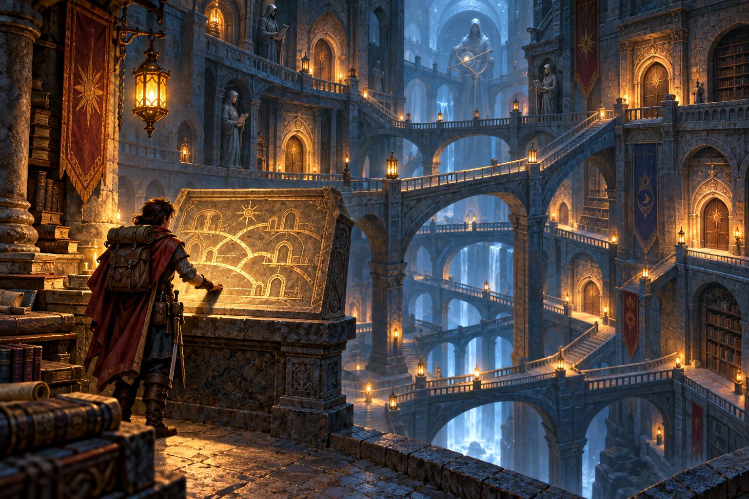
This optional workshop develops ordered search and insertion using explicit skiplist heights. Students improve a correct linear search and complete registration without changing the driver or query wrappers. The reference solution uses only the two permitted method bodies.
The package includes the student Word chapter, starter/chapter04, instructor/chapter04, and verification/DirectoryCompletion.java. It is independent of earlier projects. Instructor solutions are visible in the public repository; use course-controlled distribution when solutions should be withheld.
AI-created, human-prompted, human-edited, and human-verified using ChatGPT (OpenAI). Artwork: OpenAI image generation. Original contributions: CC0 1.0. See Publication License and AI Disclosure at the end.

Teaching Notes and Search Answers
Plan approximately 100 to 140 minutes plus reading: 15 minutes for investigation, 20–30 for hand traces, 40–55 for implementation, 15–25 for AI review or its alternative, and 10–15 for evidence and reflection. These are planning estimates, not observed classroom timings.
Assign the structural part of Section 4.1 and the search and insertion parts of Section 4.2. Omit indexed SkiplistList operations and formal probability analysis. This variant keeps four levels and accepts explicit heights. It does not justify a general expected O(log n) claim: all-height-zero input requires a linear walk.
Reading: https://opendatastructures.org/ods-java/4_2_SkiplistSSet_Efficient_.html
Level | Starting current | Decision for target 35
3 | sentinel | Next 40 is too large; drop
2 | sentinel | Move to 20; next 40 too large; drop
1 | 20 | Move to 30; next 40 too large; drop
0 | 30 | Next 40 too large; finish at predecessor 30

There are two horizontal moves. ceiling returns 40:archive and exact returns null. The starter produces the same answers using three moves at level 0. For target 40, the predecessor remains 30 and the ceiling candidate is the exact matching room 40.

Questions to Ask
Why can current safely use next[level] after moving right on that level? The reached node participates at that level and therefore has that array position. Dropping is also safe. Why can we compare integer keys directly? Subtraction can overflow for extreme int values, but < and == preserve the intended ordering.
A Chapter 1 adjacency index chooses a passage; it does not imply sorted keys or shorter search routes. Here each index denotes an ordered level. The visual similarity of link arrays does not make the original room graph a skiplist.

Insertion Trace and Common Defects
Level | Predecessor | Old successor | After inserting 35 at height 2
0 | 30 | 40 | 30 points to 35; 35 points to 40
1 | 30 | 40 | 30 points to 35; 35 points to 40
2 | 20 | 40 | 20 points to 35; 35 points to 40
3 | sentinel | 40 | Unchanged

All three references to 35 must refer to the same new Node. Its next array length is 3. Existing nodes retain their identities. The duplicate attempt returns false and leaves sanctuary at height 2. Size changes from 6 to 7 only on the successful insertion.
L3: 40
L2: 20 35 40
L1: 20 30 35 40 60
L0: 10 20 30 35 40 50 60

Expected Adventure
Before insertion: ceiling 35 gives 40:archive, exact 35 gives No room., each with 2 horizontal steps. After insertion: ceiling 31 and exact 35 both give 35:sanctuary with 2 steps. The repeated registration fails. ceiling 61 gives No room. with 2 steps, moving to 40 and then 60.

Diagnose the Structure
- Exact queries miss existing keys: inspect whether the search uses <= instead of <.
- Level 0 is correct but upper rows omit 35: inspect the splice loop’s upper bound.
- An insertion loses the suffix or creates a cycle: the old successor was overwritten before being saved.
- A tall insertion fails in an empty directory: predecessors for all levels must start from sentinel.
- A negative room number is missed: sentinel’s placeholder number was incorrectly treated as a real key.
The no-AI trace fails immediately: moving to 40 overshoots 35. The correct predecessor is 30, and ceiling returns 40. “Closest” is not the search rule; the requested answer must be the smallest key greater than or equal to the target.

Reference Solution
Replace only the bodies of these methods. Complete runnable files are in instructor/chapter04. searchSteps is reset and changed only by query search; insertion leaves the most recent query count intact.
private Node findBefore(int target) {
searchSteps = 0;
Node current = sentinel;
for (int level = MAX_HEIGHT; level >= 0; level--) {
while (current.next[level] != null
&& current.next[level].number < target) {
current = current.next[level];
searchSteps++;
}
}
return current;
}
public boolean add(int number, String name, int height) {
if (name == null || name.trim().isEmpty()
|| height < 0 || height > MAX_HEIGHT) return false;
Node[] predecessors = new Node[MAX_HEIGHT + 1];
Node current = sentinel;
for (int level = MAX_HEIGHT; level >= 0; level--) {
while (current.next[level] != null
&& current.next[level].number < number) {
current = current.next[level];
}
predecessors[level] = current;
}
Node candidate = current.next[0];
if (candidate != null && candidate.number == number) return false;
Node added = new Node(number, name, height);
for (int level = 0; level <= height; level++) {
added.next[level] = predecessors[level].next[level];
predecessors[level].next[level] = added;
}
size++;
return true;
}

Assessment and Completion Verification
Criterion | Points | Full-credit evidence
Top-down search | 25 | Correct predecessor, null/equality handling, accurate step count
Insertion | 30 | All required levels, one new object, size and duplicate behavior
Boundary evidence | 20 | Empty, extremes, invalid inputs, before/after endpoints
Reference reasoning | 10 | Correct predecessor table and interpretation of costs
AI or equivalent audit | 10 | Specific claim checked against the fixture and execution
Scope and clarity | 5 | Only two method bodies changed; clear names and readable code

Give partial credit by behavior and explanation. Correct ceiling answers from the unchanged linear scan do not satisfy the top-down search requirement. Review the implementation as well as the printed step counts: counters are reported evidence, not proof of an algorithm’s complexity.

Reproduce the Checks
python3 verification/verify_starters.py
python3 verification/verify_completion.py
Run at the repository root with Python 3 and a JDK. GitHub Actions runs on Java 11 and Java 21. The Chapter 4 harness checks the adventure and exact top-down counts, then performs 1,000 seeded insertion attempts with queries compared against TreeMap. It verifies each level’s sorted membership, node height, shared identity across levels, preservation of existing objects, and size. Fixtures include minimum and maximum int keys and key 0.
Other checks exercise the unfinished starter, confirm only permitted method bodies changed, and compare the Word starter listings to tested source. Invalid names and heights, duplicates, empty queries, and insertion at boundaries are covered. These checks establish a working completion path; classroom timing and the quality of future AI responses still require observation.
The cap of four levels is deliberate. Search and insertion can be O(n) in this variant. Splicing a node requires height + 1 link pairs once predecessors are known. Avoid assigning the fixed fixture a blanket logarithmic performance guarantee.

Publication License and AI Disclosure

Open Reuse
To the extent the project rights holders own copyright or related rights, they dedicate the original contributions to Data Dungeon: The Linked Labyrinth to the public domain under CC0 1.0 Universal. This includes original teaching materials, Java code, verification code, and project artwork. You may copy, modify, redistribute, and use these contributions commercially. Attribution is appreciated but is not required for these CC0 contributions.
CC0 1.0 Universal: https://creativecommons.org/publicdomain/zero/1.0/

Source Attribution and Exceptions
Pat Morin, Open Data Structures, Java edition: https://opendatastructures.org/ods-java/. The textbook and its accompanying source code are released under Creative Commons Attribution 2.5 Canada: https://creativecommons.org/licenses/by/2.5/ca/. Any reproduced or adapted Morin material retains that license and attribution requirement; this project’s CC0 dedication does not waive his rights. The companion adds a dungeon setting, focused workshops, renamed and simplified implementations, tests, instructor guidance, and AI learning activities. No endorsement by Pat Morin is implied.
Format inspiration: Michael Penta, Companion Materials for OpenStax: Introduction to Python Programming, Chapter 5 (2025), supplied under CC0 1.0. Other third-party material retains its applicable terms. CC0 applies only to rights held by the project rights holders and does not assert that AI-generated material is copyrightable.

AI Disclosure
This work was AI-created, human-prompted, human-edited, and human-verified. Text, instructional activities, and code were generated using ChatGPT (OpenAI). Decorative artwork was generated using OpenAI image generation.
AI tool citation: OpenAI. (2026). ChatGPT [large language model]. https://chatgpt.com/. Exact model-version identifiers were not recorded. Human prompting, editing, and verification do not imply that the work is error-free or that classroom trials have been completed.

