Data Dungeon
The Linked Labyrinth
Chapter 4
The Ordered Directory
Ancillary Resources for Pat Morin’s Open Data Structures in Java
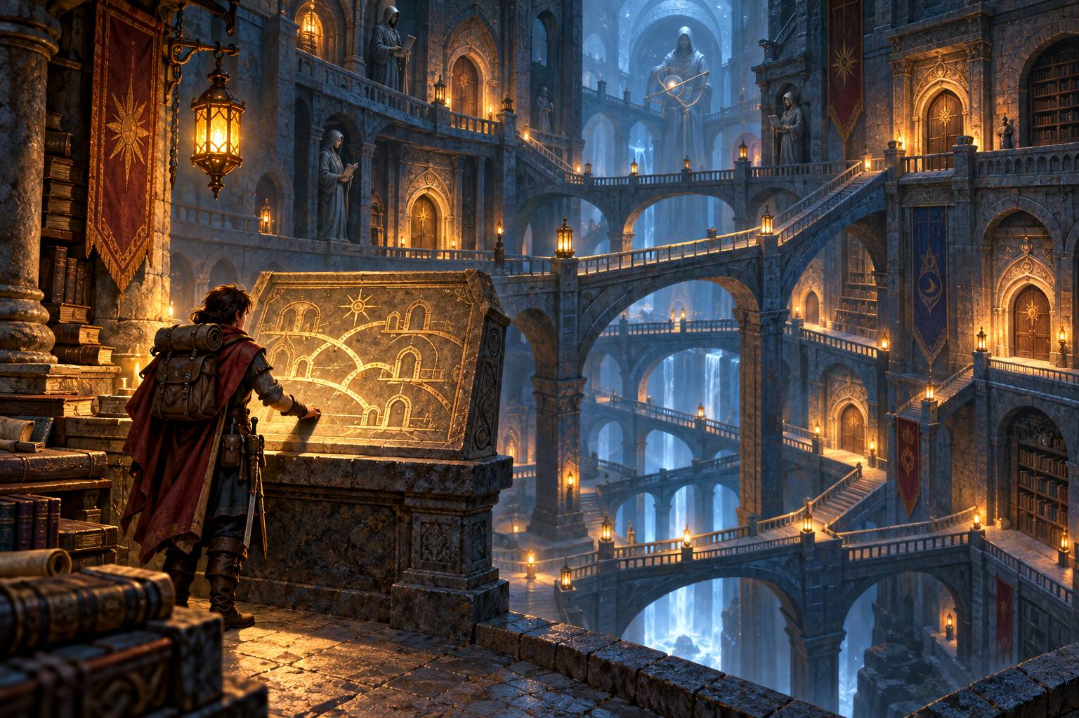
The labyrinth’s directory lists rooms by number. You need a sanctuary near room 31, but that exact number may not exist. The keeper can offer the first registered room at or beyond your request. Upper-level links let the search pass over groups of rooms instead of checking every entry.
Your task is to improve the directory’s search and register a newly discovered sanctuary. You will trace a skiplist, preserve its ordered links during insertion, and distinguish an exact lookup from a ceiling lookup.
This optional chapter is a complete two-file Java project. Earlier chapter solutions are not prerequisites. It focuses on ordered-set search and insertion; indexed access, deletion, random height generation, and probability analysis are outside this workshop.
AI-created, human-prompted, human-edited, and human-verified using ChatGPT (OpenAI). Artwork: OpenAI image generation. Original contributions: CC0 1.0. See Publication License and AI Disclosure at the end.

Preparation and Code Investigation
Read the structural explanation in Morin’s Section 4.1 and the search and insertion portions of Section 4.2, SkiplistSSet. This workshop uses explicit heights from 0 through 3 so every student can reproduce the same links. It is a teaching variant, not a complete implementation of the textbook SSet interface.
Reading: https://opendatastructures.org/ods-java/4_2_SkiplistSSet_Efficient_.html

Learning Goals
- Follow a top-down search without overshooting a requested key.
- Explain why exact and ceiling queries can return different answers.
- Record one predecessor per level and splice a single node into several chains.
- Check an AI walkthrough against actual keys, heights, and Java output.

Run the Independent Starter
Use a JDK for Java 11 or later. Confirm java -version and javac -version work. Save the appendix listings as RoomDirectory.java and DirectoryGame.java in one folder, or use starter/chapter04 from the repository. Compile and run inside that folder.
javac RoomDirectory.java DirectoryGame.java
java DirectoryGame
The starter already answers queries correctly using a level-zero scan. Registration always prints Cannot add. Run levels, ceiling 35, exact 35, and add 35 2 sanctuary. Explain why the two queries differ and why the failed registration leaves size at 6.
Number | Name | Height
10 | entrance | 0
20 | well | 2
30 | forge | 1
40 | archive | 3
50 | bridge | 0
60 | vault | 1

Reading the Links
Every room has one Node object. Its next array holds references to later rooms at different levels. A node of height 2 participates at levels 0, 1, and 2, so its array has length 3. Higher rows contain a subset of the same objects; they are not copies of room records.
Level | Initial room numbers in traversal order
3 | 40
2 | 20, 40
1 | 20, 30, 40, 60
0 | 10, 20, 30, 40, 50, 60

sentinel is the starting node at every level. Its stored number is a placeholder and must never participate in comparisons. All int room numbers, including 0 and negative numbers, are legal. A null link marks the end of a level. Unlike Chapter 3, these chains are not circular.

Search Before Choosing the Answer
findBefore(target) must return the last node with a number strictly less than target, or sentinel when none exists. Start at the highest level. Move right only when the next node is non-null and its number is less than target. Otherwise drop one level without restarting at sentinel. After level 0, the next node is the ceiling candidate.
For target 35, predict the rightward moves and the points where the search drops. Compare your path with the starter’s level-zero visits to 10, 20, and 30. The searchSteps counter counts only successful rightward moves, not level drops, comparisons, or elapsed time.

Exact and Ceiling Queries
ceiling(35) returns 40:archive before insertion. exact(35) returns null because room 35 is missing. ceiling(40) returns 40:archive: ceiling includes equality. A request above the maximum produces null. The console prints No room. for a null result. These supplied query methods use findBefore and must remain unchanged.

Why the Heights Matter
The fixed four-level structure may still require O(n) work in the worst case. If all nodes have height 0, the useful search is a linear scan. A small horizontal-step count on one fixture is evidence about that trace, not a general logarithmic guarantee. You do not need probability calculations for this activity.

Workshop Restore the Directory
Change only the bodies of findBefore and add in RoomDirectory.java. Preserve all fields, signatures, other methods, and DirectoryGame.java. Work with the supplied nodes and their next arrays. Do not use a library map or set, sort or rebuild the directory, or replace existing nodes.

Implement Top Down Search
Reset searchSteps to 0 for every findBefore call. Carry one current reference from level 3 down through level 0. At each level, follow links while the next number is strictly less than target, incrementing searchSteps once for each successful rightward move. Return the final predecessor. Null must be checked before reading a next node’s number; compare integers directly rather than subtracting them.

Register a New Room
add(number, name, height) returns false without changing any state when name is null or trim() is empty, height is outside 0 through MAX_HEIGHT, or number already exists. Preserve the original supplied name, including surrounding spaces, for a valid insertion. Duplicate room numbers must not replace the old name or height.
For a valid new room, perform a top-down search and record the last smaller node at each level in a local Node[] predecessors array. Reject a duplicate before changing links. Allocate one new Node using the requested height. At every level from 0 through that height, point the new node to the former successor and the predecessor to the new node. Increase size once and return true. Leave searchSteps unchanged in add; it describes the most recent query.

Plan Before Editing
Before inserting 35 at height 2, write predecessors[0] through predecessors[3]. For each affected level, record the old successor, the new node’s next reference, and the predecessor’s replacement reference. Explain why level 3 is unchanged even though the insertion search starts there.

Boundary Checks
Use a temporary Check.java main method to exercise new RoomDirectory(). Check empty queries, one insertion at height 3, insertion before the first and after the last key, duplicate rejection, null and whitespace-only names, and heights -1 and 4. Include keys Integer.MIN_VALUE, 0, and Integer.MAX_VALUE. Compile it with the supplied files. The driver trims command input, so null and preserved-space names require direct method calls.

Required Adventure and Evidence
Restart the completed program and enter this sequence. The sanctuary must appear at every requested level, and searching from 31 must lead to it. Commands do not simulate travel; they query or update the room directory.
Command | Expected output or effect
ceiling 35 | 40:archive; Horizontal steps: 2
exact 35 | No room.; Horizontal steps: 2
add 35 2 sanctuary | Added.; size becomes 7
ceiling 31 | 35:sanctuary; Horizontal steps: 2
exact 35 | 35:sanctuary; Horizontal steps: 2
add 35 3 replacement | Cannot add.; original room unchanged
levels | The four rows below; Size: 7
ceiling 61 | No room.; Horizontal steps: 2

L3: 40
L2: 20 35 40
L1: 20 30 35 40 60
L0: 10 20 30 35 40 50 60

Explain What Changed
Draw the insertion using one identity for room 35 across all three affected levels. Show why setting the predecessor’s link first can lose the old successor. Explain why using <= instead of < during search would skip an exact match and could defeat duplicate detection.

Submit
Submit the two Java files; the required adventure transcript; boundary-test results; the search path for 35 before insertion; the predecessor table and changed links for insertion; and a short explanation of what searchSteps measures. Include your AI review or equivalent exercise from the next page. Identify the two method bodies you changed.
A completion check must inspect every level. A correctly sorted level-zero chain alone does not prove that a tall node was linked correctly above it.

AI Learning Practice
Draw your own path for ceiling 35 before using an AI tool. Then provide the exact fixture and ask a tutor to walk through it. Request a trace you can audit, rather than an answer based on an unspecified random skiplist.
Act as a tutor, not a code generator.
My room keys and heights are 10:0, 20:2, 30:1,
40:3, 50:0, 60:1. Heights include levels 0 through h.
Trace a top-down predecessor search for target 35.
Move right only when the next key is strictly smaller.
At each decision show current key, level, next key,
and whether to move right or drop. Ask me to predict
the next decision before explaining it.
If useful, ask for an HTML animation with Next step and Reset controls. Supply the same fixture, require stable node identities, and ask it to highlight only real links. Verify the initial four levels before trusting the search animation. No paid tool or API is required, and an animation is optional.

Check the Result
- Verify that the level-3 link to 40 is not followed for target 35.
- Check that dropping a level keeps the current node instead of restarting.
- Count rightward moves separately from drops and compare with Java output.
- Repeat with target 40 to check that equality does not cause overshooting.
Submit your prompt, a short relevant excerpt or screenshot, and two specific checks against your hand trace or execution. Correct any error you find. If the answer is accurate, explain why your evidence supports it. Keep the final Java implementation your own work under your course’s AI rules.

Equivalent Exercise Without AI Access
Audit this proposed trace: “For target 35, move from sentinel to 40 at level 3 because 40 is the closest room. Drop to level 0 and return 50.” Identify the first invalid decision, construct the correct path, and explain which room ceiling should return. Use this route when AI access is unavailable or disallowed.

Reflection
How does a node’s array of links differ from a room’s adjacency array in Chapter 1? Why does sorted order justify skipping intermediate rooms here? What would happen to the search work if every node had height 0?

Starter Listing RoomDirectory
Combine this page and the continuation into RoomDirectory.java. Copy code only.
public class RoomDirectory {
public static final int MAX_HEIGHT = 3;
private static class Node {
final int number;
final String name;
final Node[] next;
Node(int number, String name, int height) {
this.number = number;
this.name = name;
next = new Node[height + 1];
}
}
private final Node sentinel = new Node(0, null, MAX_HEIGHT);
private int size;
private int searchSteps;
public int size() { return size; }
public int searchSteps() { return searchSteps; }
private Node findBefore(int target) {
searchSteps = 0;
Node current = sentinel;
// TODO: replace this level-zero scan with a top-down search.
while (current.next[0] != null
&& current.next[0].number < target) {
current = current.next[0];
searchSteps++;
}
return current;
}
public String ceiling(int target) {
Node candidate = findBefore(target).next[0];
return describe(candidate);
}
public String exact(int target) {
Node candidate = findBefore(target).next[0];
return candidate != null && candidate.number == target
? describe(candidate) : null;
}
public boolean add(int number, String name, int height) {
// TODO: search, record predecessors, and splice one new node.
return false;
}

RoomDirectory Continued
private String describe(Node node) {
return node == null ? null : node.number + ":" + node.name;
}
public String levels() {
StringBuilder text = new StringBuilder();
for (int level = MAX_HEIGHT; level >= 0; level--) {
if (text.length() > 0) text.append("\n");
text.append("L").append(level).append(":");
for (Node node = sentinel.next[level]; node != null;
node = node.next[level]) {
text.append(" ").append(node.number);
}
}
return text.toString();
}
public static RoomDirectory sample() {
RoomDirectory directory = new RoomDirectory();
int[] numbers = {10, 20, 30, 40, 50, 60};
int[] heights = {0, 2, 1, 3, 0, 1};
String[] names = {"entrance", "well", "forge",
"archive", "bridge", "vault"};
Node[] tails = new Node[MAX_HEIGHT + 1];
java.util.Arrays.fill(tails, directory.sentinel);
for (int i = 0; i < numbers.length; i++) {
Node node = new Node(numbers[i], names[i], heights[i]);
for (int level = 0; level < node.next.length; level++) {
tails[level].next[level] = node;
tails[level] = node;
}
directory.size++;
}
return directory;
}
}

Starter Listing DirectoryGame
Save as DirectoryGame.java in the same folder. Leave this supplied driver unchanged.
import java.util.Scanner;
public class DirectoryGame {
public static void main(String[] args) {
RoomDirectory directory = RoomDirectory.sample();
Scanner input = new Scanner(System.in);
System.out.println("The Ordered Directory");
System.out.println("Commands: levels, exact <number>,");
System.out.println("ceiling <number>, "
+ "add <number> <height> <name>, quit");
while (input.hasNextLine()) {
String line = input.nextLine().trim();
if (line.equals("quit")) break;
String[] parts = line.split("\\s+", 4);
try {
if (line.equals("levels")) {
System.out.println(directory.levels());
System.out.println("Size: " + directory.size());
} else if (parts.length == 2
&& (parts[0].equals("exact")
|| parts[0].equals("ceiling"))) {
int number = Integer.parseInt(parts[1]);
String result = parts[0].equals("exact")
? directory.exact(number) : directory.ceiling(number);
System.out.println(result == null ? "No room." : result);
System.out.println("Horizontal steps: "
+ directory.searchSteps());
} else if (parts.length == 4 && parts[0].equals("add")) {
int number = Integer.parseInt(parts[1]);
int height = Integer.parseInt(parts[2]);
System.out.println(directory.add(number, parts[3], height)
? "Added." : "Cannot add.");
} else {
System.out.println("Unknown command.");
}
} catch (NumberFormatException exception) {
System.out.println("Use integer numbers and heights.");
}
}
}
}

Publication License and AI Disclosure

Open Reuse
To the extent the project rights holders own copyright or related rights, they dedicate the original contributions to Data Dungeon: The Linked Labyrinth to the public domain under CC0 1.0 Universal. This includes original teaching materials, Java code, verification code, and project artwork. You may copy, modify, redistribute, and use these contributions commercially. Attribution is appreciated but is not required for these CC0 contributions.
CC0 1.0 Universal: https://creativecommons.org/publicdomain/zero/1.0/

Source Attribution and Exceptions
Pat Morin, Open Data Structures, Java edition: https://opendatastructures.org/ods-java/. The textbook and its accompanying source code are released under Creative Commons Attribution 2.5 Canada: https://creativecommons.org/licenses/by/2.5/ca/. Any reproduced or adapted Morin material retains that license and attribution requirement; this project’s CC0 dedication does not waive his rights. The companion adds a dungeon setting, focused workshops, renamed and simplified implementations, tests, instructor guidance, and AI learning activities. No endorsement by Pat Morin is implied.
Format inspiration: Michael Penta, Companion Materials for OpenStax: Introduction to Python Programming, Chapter 5 (2025), supplied under CC0 1.0. Other third-party material retains its applicable terms. CC0 applies only to rights held by the project rights holders and does not assert that AI-generated material is copyrightable.

AI Disclosure
This work was AI-created, human-prompted, human-edited, and human-verified. Text, instructional activities, and code were generated using ChatGPT (OpenAI). Decorative artwork was generated using OpenAI image generation.
AI tool citation: OpenAI. (2026). ChatGPT [large language model]. https://chatgpt.com/. Exact model-version identifiers were not recorded. Human prompting, editing, and verification do not imply that the work is error-free or that classroom trials have been completed.

