Data Dungeon
The Linked Labyrinth
Chapter 10 Instructor Guide
The Awakening Traps
Ancillary Resources for Pat Morin’s Open Data Structures in Java
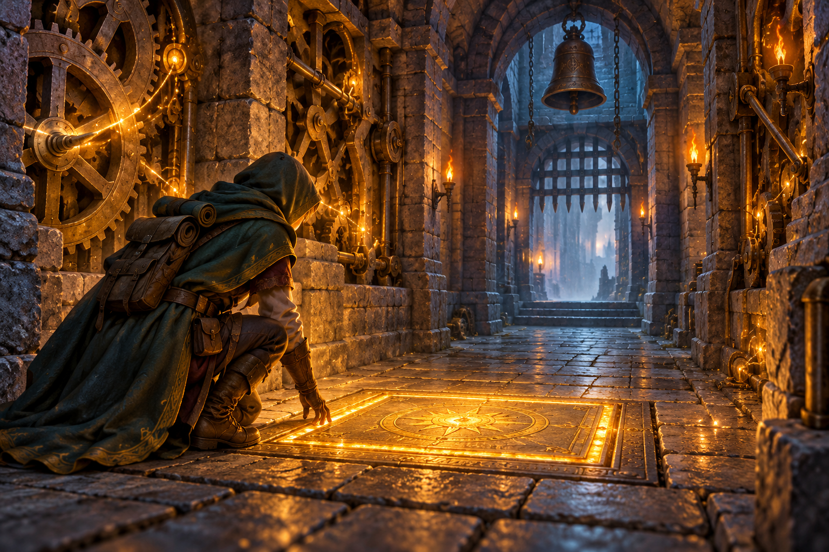
Students complete the two repair paths of a minimum heap and use it to run a small event simulation. The pressure plate adds events during execution, making the priority-queue requirement visible. Equal-time events use a secondary registration key, giving a deterministic trace for testing.
Use the student chapter with starter/chapter10, instructor/chapter10, and verification/TrapCompletion.java. The reference solution changes only bubbleUp and trickleDown. TrapChecks.java is a compact model of student testing. Reference solutions are already public on GitHub. Treat them as open exemplars; use new assessment variants if independent work is required. Course-only distribution does not make existing public solutions private.
AI-created, human-prompted, human-edited, and human-verified using ChatGPT (OpenAI). Artwork: OpenAI image generation. Original contributions: CC0 1.0. See Publication License and AI Disclosure at the end.

Teaching Sequence and Representation
Suggested allocation is 100–140 minutes plus reading: 15–20 for code investigation, 20–30 for repair traces, 30–40 for implementation, 20–30 for testing, and 15–20 for structure evaluation. These are planning estimates, not observed completion times.
Assign Morin’s Section 10.1 on BinaryHeap. This activity retains the array-based complete-tree representation and two repair paths, adds a sequence tie-breaker, and supplies growth without shrinking. It does not cover meldable heaps or cancellation.
Reading: https://opendatastructures.org/ods-java/10_1_BinaryHeap_Implicit_Bi.html

Conceptual Answers
The clock records the most recently processed time. Sequence records successful registration order and does not reset when the queue empties. Ordering is lexicographic by time and sequence. Distinct events can have the same name and time; registration sequence still distinguishes them.
bubbleUp repairs the only possibly invalid path after appending a leaf. trickleDown repairs the path beginning at the replacement root. Selecting the earlier child prevents the other child from violating heap order after the swap. A right-child bounds check is necessary when only a left child exists.

Costs and Assumptions
For n pending events, peek is O(1). The two repair paths take O(log n) time and O(1) extra space for nonempty heaps. A schedule that grows the array also copies O(n) references; doubling makes this copying amortized O(1) per insertion, so scheduling is amortized O(log n). A growth insertion has O(n) worst-case time. Removal does not shrink, so its repair is O(log n) worst case.
heapState copies and formats the active array; it is a diagnostic operation, not a constant-time view. The fixed-width numeric comparisons are constant time. Event-name validation and diagnostic formatting additionally depend on string length. Sequence exhaustion is guarded, and follow-up arithmetic uses long before checking the int time range.

Scope of the Simulation
A next command removes exactly one event and advances directly to its time. The game rejects manually scheduled past times but accepts the current time. The queue itself permits any nonnegative time, independently of the clock. A broken starter may process times out of order; that is evidence of the intended defect, not correct simulation behavior.

Expected Adventure and Repair Traces
Checkpoint | Expected state or output
Initial heap | [2:pressure_plate, 4:bell, 6:gate_opens, 8:seal]
After first next | Clock 2; darts at 3 and echo at 6 are scheduled
Pending heap | [3:darts, 4:bell, 6:gate_opens, 8:seal, 6:echo]
Storage | Size 5, capacity 8
schedule 1 late | Rejected; clock and pending events unchanged
Next five events | 3:darts, 4:bell, 6:gate_opens, 6:echo, 8:seal
One more next | No events.; clock remains 8
schedule 8 lantern | Accepted; next processes lantern at time 8

Upward Trace
The sample inserts times 8, 2, 6, 4. Inserting 2 swaps indices 1 and 0. Inserting 6 stops at index 2. Inserting 4 starts at index 3, swaps with parent 1 holding 8, then stops below root 2. Final times are [2, 4, 6, 8].

Downward Trace
For [1, 4, 2, 9, 6], removing 1 moves 6 from index 4 to index 0 and clears index 4. Compare children 4 and 2; choose index 2, then swap 6 with 2. That index is now a leaf. Final times are [2, 4, 6, 9]. An implementation that always chooses the left child leaves 2 below a later parent.

Common Defects
- Repeatedly swaps the same pair: index is not updated after the swap.
- Fails with only one child: reads events[right] without checking right < size.
- Ties appear in a different order: compares only time instead of using earlier.
- Stops after one swap: repair must continue along the path when necessary.
- Finds the next event by scanning: behavior may appear correct, but it misses the required heap implementation and cost.

Reference Solution
Replace only these two method bodies. The full runnable solution is in instructor/chapter10. The supplied queue operations handle validation, allocation, size changes, and removal of stale references.
private void bubbleUp(int index) {
while (index > 0) {
int parent = (index - 1) / 2;
if (!earlier(events[index], events[parent])) break;
swap(index, parent);
index = parent;
}
}
private void trickleDown(int index) {
while (index < size / 2) {
int child = 2 * index + 1;
int right = child + 1;
if (right < size && earlier(events[right], events[child])) {
child = right;
}
if (!earlier(events[child], events[index])) break;
swap(index, child);
index = child;
}
}

Why the Boundaries Work
Upward repair checks index > 0 before using the parent formula. Downward repair checks index < size / 2, which means a left child exists. The right child may still be missing. After selecting the earlier existing child, an ordered parent-child pair ends the loop. Both methods swap existing event references without creating or changing events.
For a singleton poll, the supplied method saves the root, reduces size to zero, and clears index zero without calling trickleDown. A later schedule can reuse that slot. The array capacity is retained after removals; this avoids introducing a second resizing policy into the workshop.

Structure Evaluation and Assessment
A heap fits this workload because insertion and minimum removal occur throughout play. Other representations can be correct if they implement priority selection, but their costs differ. The required implementation remains the supplied heap.
Representation | Insert | Inspect min | Remove min
FIFO queue | O(1) amort. | Not supported | Not supported
Unsorted array | O(1) amort. | O(n) | O(n)
Sorted array with min at end | O(n) | O(1) | O(1)
Binary min-heap | O(log n) amort. | O(1) | O(log n)

Here n is the number of pending events. Array insertion bounds include doubling; the sorted array shifts to preserve order and removes its last item without shrinking. FIFO front operations are constant time but do not select the minimum for arbitrary event times. A FIFO queue needs an additional search/reordering strategy to meet this contract.
Reject “sort once” using the pressure plate: darts is added later yet must run before bell. Reject automatic heap stability: time alone does not order equal-time events; sequence supplies the missing comparison. A satisfactory AI review states these conditions, verifies the four-event order early, first, second, late, and distinguishes occasional growth from heap repair.
Criterion
Upward repair follows the parent path and stops correctly
Downward repair selects the earlier existing child
Tie ordering, boundary tests, and heap invariant
Adventure trace and array-index explanations
Structure comparison and evaluated AI or no-AI evidence

The no-AI exercise targets the same reasoning. Assess independently predicted output and operation-based justification, not the length or polish of an AI response.

Executable Checks and Completion Evidence
This small checker is supplied as TrapChecks.java. Compile it with TrapEvent.java and the completed TrapQueue.java, then run java TrapChecks. It rejects the starter at earliest time and passes with the reference solution.
public class TrapChecks {
public static void main(String[] args) {
TrapQueue queue = new TrapQueue();
queue.schedule(8, "late");
queue.schedule(2, "early");
check(queue.poll().name.equals("early"), "earliest time");
queue.schedule(4, "first tie");
queue.schedule(4, "second tie");
check(queue.poll().name.equals("first tie"),
"first equal-time event");
check(queue.poll().name.equals("second tie"),
"second equal-time event");
check(queue.poll().name.equals("late"), "remaining event");
check(queue.poll() == null, "empty queue");
System.out.println("Trap checks passed");
}
private static void check(boolean condition, String message) {
if (!condition) throw new AssertionError(message);
}
}
The maintainer suite also runs 1,500 seeded mixed operations against Java PriorityQueue with an independent comparator. It checks the heap invariant, active-slot membership, empty slots, growth, ties, integer boundaries, one-child and right-child cases, and empty reuse. Console checks cover the complete adventure, rejection of past times, and follow-up overflow.
Verification compares source outside the two permitted method bodies, checks the event and game classes are unchanged, and matches every Word starter listing to its Java file. Projects compile with javac --release 11 and run in GitHub Actions on Java 11 and Java 21.
python3 verification/verify_starters.py
python3 verification/verify_completion.py
Run those commands from a repository checkout with a JDK and Python 3. Students need only a JDK and editor or IDE. The checks demonstrate completion within the allowed edits; they are not a general grading suite and do not measure student completion time.

Publication License and AI Disclosure

Open Reuse
To the extent the project rights holders own copyright or related rights, they dedicate the original contributions to Data Dungeon: The Linked Labyrinth to the public domain under CC0 1.0 Universal. This includes original teaching materials, Java code, verification code, and project artwork. You may copy, modify, redistribute, and use these contributions commercially. Attribution is appreciated but is not required for these CC0 contributions.
CC0 1.0 Universal: https://creativecommons.org/publicdomain/zero/1.0/

Source Attribution and Exceptions
Pat Morin, Open Data Structures (Java edition 0.1G): https://opendatastructures.org/ods-java/. The textbook and source code are licensed under CC BY 2.5 Canada: https://creativecommons.org/licenses/by/2.5/ca/. This companion adapts selected topics for dungeon workshops with renamed and simplified structures, new contracts, tests, and AI learning activities. Morin material retains its license, attribution, copyright notices, and warranty disclaimers; CC0 covers only original project contributions. Keep this credit and the license link with redistributed adaptations, including extracted code. No endorsement by Pat Morin is implied.
Format inspiration: Michael Penta, Companion Materials for OpenStax: Introduction to Python Programming, Chapter 5 (2025), supplied under CC0 1.0. Other third-party material retains its applicable terms. CC0 applies only to rights held by the project rights holders and does not assert that AI-generated material is copyrightable.

AI Disclosure
This work was AI-created, human-prompted, human-edited, and human-verified. Text, instructional activities, and code were generated using ChatGPT (OpenAI). Decorative artwork was generated using OpenAI image generation.
AI tool citation: OpenAI. (2026). ChatGPT [large language model]. https://chatgpt.com/. Exact model-version identifiers were not recorded. Human prompting, editing, and verification do not imply that the work is error-free or that classroom trials have been completed.

