Data Dungeon
The Linked Labyrinth
Chapter 12 Instructor Guide
The Labyrinth Revealed
Ancillary Resources for Pat Morin’s Open Data Structures in Java
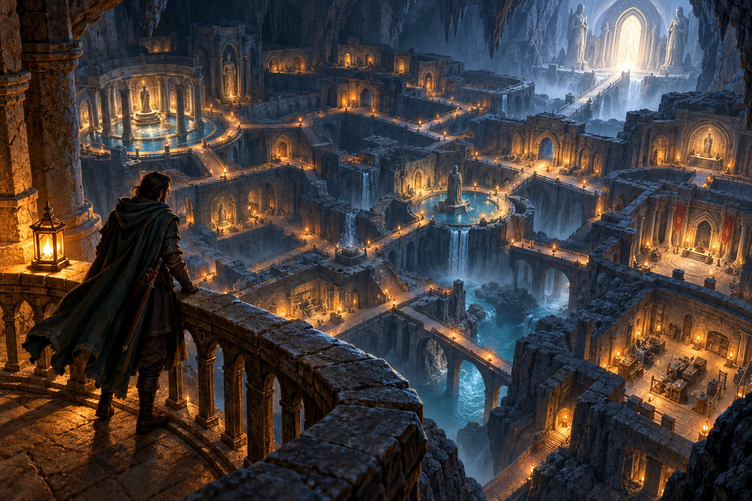
This final chapter turns the adventure’s room connections into an explicit graph traversal. Students complete one BFS method while the supplied result class reconstructs routes. The sample includes cycles, competing shortest routes, and a disconnected room.
Use starter/chapter12, instructor/chapter12, and verification/GraphCompletion.java with the student chapter. The reference solution changes only search. Reference solutions are already public on GitHub. Treat them as open exemplars; use new assessment variants if independent work is required. Course-only distribution does not make existing public solutions private.
AI-created, human-prompted, human-edited, and human-verified using ChatGPT (OpenAI). Artwork: OpenAI image generation. Original contributions: CC0 1.0. See Publication License and AI Disclosure at the end.

Teaching Sequence and Reference Trace
Allow approximately 90–130 minutes plus reading: 15–20 for map investigation, 20–30 for queue tracing, 25–35 for implementation and tests, and 30–45 for visualization verification and explanation. These are estimates, not measured completion times.
Read Sections 12.2 and 12.3.1: https://opendatastructures.org/ods-java/12_3_Graph_Traversal.html
The frontier is a FIFO queue. Discovery occurs before enqueueing, so each vertex enters the queue once. Queue distance layers ensure the first discovery gives a shortest passage count. The graph interface supplies ordered outgoing neighbors; the algorithm must not assume reverse passages.
Processed room | New discoveries | Frontier afterward
0 | 1, 2 | [1, 2]
1 | 3 | [2, 3]
2 | 4 | [3, 4]
3 | 5 | [4, 5]
4 | none | [5]
5 | 6 | [6]
6 | none | []

Room: 0 1 2 3 4 5 6 7
Distance: 0 1 1 2 2 3 4 -1
Parent: -1 0 0 1 2 3 5 -1
Room 3 is discovered from 1. When 2 later inspects 3, its distance is already set and its parent must not change. The first route to 6 is [0, 1, 3, 5, 6], length 4. Room 7 remains unreachable from 0. Starting at 7 yields only [7]; starting at 2 yields [2, 3, 5, 6] to the exit.

Reference Solution and Reasoning
public SearchResult search(MazeGraph graph, int start) {
int[] distance = new int[graph.size()];
int[] parent = new int[graph.size()];
Arrays.fill(distance, -1);
Arrays.fill(parent, -1);
if (start < 0 || start >= graph.size()) {
return new SearchResult(distance, parent);
}
distance[start] = 0;
ArrayDeque<Integer> frontier = new ArrayDeque<>();
frontier.addLast(start);
while (!frontier.isEmpty()) {
int room = frontier.removeFirst();
for (int neighbor : graph.neighbors(room)) {
if (distance[neighbor] == -1) {
distance[neighbor] = distance[room] + 1;
parent[neighbor] = room;
frontier.addLast(neighbor);
}
}
}
return new SearchResult(distance, parent);
}

Complexity and Boundaries
For V rooms and E adjacency entries, search takes O(V + E) time, including array initialization. The queue and result arrays use O(V) space. neighbors returns a copied adjacency array; those temporary copies add work proportional to scanned adjacency entries. With repeated parallel entries, a temporary neighbor array may contain more than V entries. Graph storage itself is O(V + E).
Path reconstruction takes O(L) time and space for a returned route containing L rooms. An invalid start returns all-unreachable arrays; the console instead refuses an invalid start and retains its previous result. Invalid targets return distance -1 and an empty route. A valid start reaches itself at distance zero.
Changing neighbor order may change the chosen parent among equal-length routes, but cannot improve or worsen the minimum passage count. DFS can find a route, but its first route need not be shortest. This workshop deliberately uses BFS only.

Testing Visualization and Assessment
For a compact directed test, construct rooms A and B with edges {{1}, {}}. From A, B has distance 1 and route [0, 1]. From B, A is unreachable. Adding a reverse edge merely to make the test pass changes the problem. A one-room self-loop must still yield only [0] and distance 0.
MazeGraph graph = new MazeGraph(
new String[]{"A", "B"}, new int[][]{{1}, {}});
RouteFinder finder = new RouteFinder();
if (finder.search(graph, 0).distanceTo(1) != 1
|| finder.search(graph, 1).distanceTo(0) != -1) {
throw new AssertionError("directed passage");
}
Place these statements in a main method in RouteCheck.java. Add empty, singleton, cyclic, disconnected, and invalid-index cases. Require valid edges for every step of a returned path, not only correct endpoints.

Evaluate the Visualization
Use the reference frontier table as the frame oracle. Check queue order after processing 0, 2, and 5; parent[3] remains 1, distance[6] becomes 4, and room 7 stays undiscovered. Distinguish discovery from processing. An animation using a stack or marking only on removal may look orderly while representing a different algorithm.
Criterion
FIFO traversal and marking before enqueueing
Distances and first-discovery parents
Cycles, direction, invalid inputs, and independent searches
Adventure and hand trace
Verified AI visualization or equivalent storyboard

The no-AI storyboard addresses the same learning goals. Students should explain checked state transitions and any correction, rather than being assessed on animation polish or tool availability.

Completion Verification and Release Scope
The maintainer suite uses 120 seeded directed graphs and an independent all-pairs shortest-path calculation. For every start and target it compares reachability and distance, checks route length and endpoints, and verifies that each step follows an actual directed edge. Separate cases include empty graphs, self-loops, duplicate adjacency entries, cycles, invalid indices, and disconnected vertices.
The exact console route verifies the sample’s neighbor-order tie-breaking. Repeated searches must leave earlier results and the graph unchanged. Source comparisons enforce the single-method edit boundary and unchanged graph/driver. Word listings must match the tested starter files. GitHub Actions compiles for Java 11 and runs on Java 11 and Java 21.
python3 verification/verify_starters.py
python3 verification/verify_completion.py

Common Defects
- Marking on removal allows multiple enqueues of a shared destination.
- Overwriting a parent on every edge can create incorrect or cyclic routes.
- Using removeLast changes the frontier to a stack.
- Counting rooms instead of edges gives a distance off by one.
- Reusing visited state across searches hides reachable rooms from a new start.
- Adding inferred reverse edges produces routes absent from a directed graph.
This completes the agreed chapter coverage: 1–6 and 10–12, including the separate Chapter 2 circular-queue workshop. Chapters 7–9 and 13–14 are not part of this release. The materials remain instructor-review drafts; completion tests establish feasibility, while classroom timing and accessibility in the chosen course platform still require review.

Publication License and AI Disclosure

Open Reuse
To the extent the project rights holders own copyright or related rights, they dedicate the original contributions to Data Dungeon: The Linked Labyrinth to the public domain under CC0 1.0 Universal. This includes original teaching materials, Java code, verification code, and project artwork. You may copy, modify, redistribute, and use these contributions commercially. Attribution is appreciated but is not required for these CC0 contributions.
CC0 1.0 Universal: https://creativecommons.org/publicdomain/zero/1.0/

Source Attribution and Exceptions
Pat Morin, Open Data Structures (Java edition 0.1G): https://opendatastructures.org/ods-java/. The textbook and source code are licensed under CC BY 2.5 Canada: https://creativecommons.org/licenses/by/2.5/ca/. This companion adapts selected topics for dungeon workshops with renamed and simplified structures, new contracts, tests, and AI learning activities. Morin material retains its license, attribution, copyright notices, and warranty disclaimers; CC0 covers only original project contributions. Keep this credit and the license link with redistributed adaptations, including extracted code. No endorsement by Pat Morin is implied.
Format inspiration: Michael Penta, Companion Materials for OpenStax: Introduction to Python Programming, Chapter 5 (2025), supplied under CC0 1.0. Other third-party material retains its applicable terms. CC0 applies only to rights held by the project rights holders and does not assert that AI-generated material is copyrightable.

AI Disclosure
This work was AI-created, human-prompted, human-edited, and human-verified. Text, instructional activities, and code were generated using ChatGPT (OpenAI). Decorative artwork was generated using OpenAI image generation.
AI tool citation: OpenAI. (2026). ChatGPT [large language model]. https://chatgpt.com/. Exact model-version identifiers were not recorded. Human prompting, editing, and verification do not imply that the work is error-free or that classroom trials have been completed.

