Data Dungeon
The Linked Labyrinth
Chapter 12
The Labyrinth Revealed
Ancillary Resources for Pat Morin’s Open Data Structures in Java
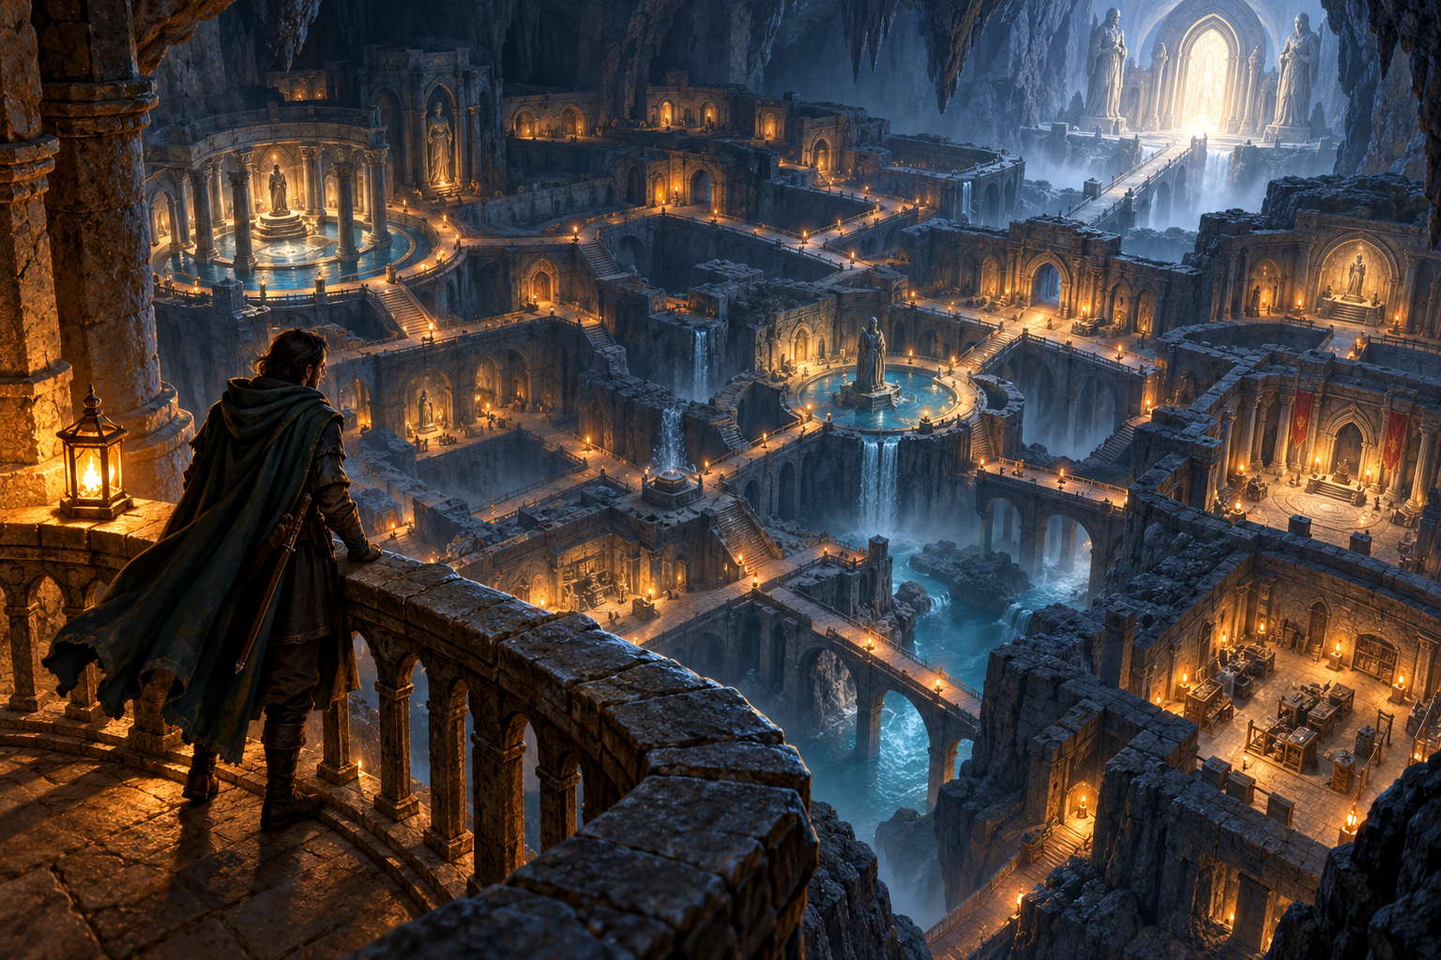
The labyrinth’s rooms are finally mapped. Several passages lead back to rooms already visited, and more than one route reaches the exit. A sealed chamber remains disconnected. The explorer needs to know which rooms are reachable and how to reach a destination using the fewest passages.
You will complete breadth-first search, record a predecessor when each room is first discovered, and use the supplied path reconstruction to recover a shortest route. Then you will check a visualization of the queue and discovery process against the actual map and Java results.
This independent three-file Java project supplies the graph, route-result class, path reconstruction, and console interface. All passages have equal cost. Weighted shortest paths, depth-first search implementation, and graph editing are outside this workshop.
AI-created, human-prompted, human-edited, and human-verified using ChatGPT (OpenAI). Artwork: OpenAI image generation. Original contributions: CC0 1.0. See Publication License and AI Disclosure at the end.

Preparation and the Room Map
Read Morin’s Section 12.2 on adjacency lists and Section 12.3.1 on breadth-first search. Our fixed graph stores each adjacency list as an int array and returns copies. It does not implement the book’s mutable Graph interface. Room numbers are vertex indices; neighboring numbers identify outgoing passages.
Reading: https://opendatastructures.org/ods-java/12_3_Graph_Traversal.html

Learning Goals
- Use a FIFO frontier to explore rooms in increasing distance.
- Mark discovery before enqueueing to handle cycles and shared destinations.
- Recover a shortest path from predecessor links.
- Verify a traversal visualization using queue states, distances, and source code.
Room | Name | Outgoing neighbors in order
0 | Entrance | 1, 2
1 | Gallery | 0, 3
2 | Well | 0, 3, 4
3 | Archive | 1, 2, 5
4 | Forge | 2, 5
5 | Vault | 3, 4, 6
6 | Exit | 5
7 | Sealed chamber | none

The sample lists both directions of each passage, so it acts as an undirected map. The search must nevertheless follow only the outgoing neighbors provided; custom tests can contain one-way passages. Do not infer a reverse connection or invent a passage to room 7.

Run and Investigate the Starter
Use a JDK for Java 11 or later. Check java -version and javac -version. Save MazeGraph.java, RouteFinder.java, and LabyrinthGame.java from the appendix in one folder, or use starter/chapter12. Run:
javac MazeGraph.java RouteFinder.java LabyrinthGame.java
java LabyrinthGame
The program starts at room 0. Enter map, reach, route 0, and route 6. The starter knows only the start room: reach reports 1, route 0 reports [0] with zero passages, and route 6 reports [] with -1 passages. The missing breadth-first traversal must discover the other reachable rooms.
Command | Meaning
map | Show room indices, names, and outgoing neighbors.
reach | Count reachable rooms, including the start.
route <room> | Print the route and its number of passages.
start <room> | Compute a new search from a valid room.
quit | Exit the program.

Discovery Is Not Processing
A room is discovered when first assigned a distance and queued. It is processed later when removed from the front. The start is discovered at distance 0. When processing a room, inspect its neighbors in their stored order. For each undiscovered neighbor, assign distance one greater than the current room’s distance, record the current room as parent, and enqueue at the back.
Use distance == -1 to mean undiscovered. Set the distance before enqueueing so a second incoming passage cannot enqueue the same room again. Leave the parent unchanged after first discovery. The sample contains a cycle and two ways to discover room 3; neither should cause repeated processing.

What Shortest Means
Each passage counts as one step. BFS minimizes that count, not travel time, danger, or geometric length. Several equally short routes can exist. Stored neighbor order determines which predecessor is found first; changing that order may change the chosen route without changing its length.

Workshop Complete Breadth First Search
Edit only the body of search in RouteFinder.java. Preserve the graph and game classes, SearchResult, pathTo, fields, and method signatures. Use ArrayDeque<Integer> as a FIFO queue with addLast and removeFirst. Do not use recursion, a stack, a priority queue, a library path-finding routine, or repeated scans of every room to locate the frontier.

Initialize a New Search
Keep the supplied fresh distance and parent arrays filled with -1. If start is outside the graph, return that all-unreachable result. Otherwise set distance[start] to 0, enqueue start, and leave parent[start] at -1. Each call must be independent of earlier calls. The graph argument must be non-null and its adjacency entries must be valid room indices.

Process the Frontier
Until the queue is empty, remove its first room. Iterate through graph.neighbors(room) in the supplied order. Only if distance[neighbor] is -1, assign distance[room] + 1, assign parent[neighbor] = room, and enqueue the neighbor. Do not overwrite already discovered distances or parents. Return SearchResult after all reachable rooms have been processed.

Preserve the Result Contract
distanceTo returns the fewest number of passages, or -1 for an unreachable or invalid target. pathTo returns a fresh array including both start and target, or an empty array when no route exists. A route from the start to itself contains one room and zero passages. reachableCount includes the start when valid. The supplied helpers derive these results from your arrays; do not edit them to hide traversal defects.
Cycles, self-loops, and repeated adjacency entries must terminate without repeated discovery. The graph must remain unchanged. An empty graph has no valid start and produces no routes. MazeGraph’s constructor assumes matching name/adjacency lengths and valid destinations; malformed graph construction is outside this task.

Reflection
Explain why first discovery gives a shortest distance and why marking a room only when it is removed from the queue is too late.

Required Adventure and Trace Evidence
Restart the completed program at room 0. Run these commands in order. Routes are arrays of room indices, and passage counts are one less than the number of rooms in a nonempty route.
Command | Expected result
reach | Reachable: 7
route 6 | [0, 1, 3, 5, 6]; 4 passages
route 4 | [0, 2, 4]; 2 passages
route 7 | []; -1 passages
route 0 | [0]; 0 passages
start 7 | Start: Sealed chamber
reach | Reachable: 1
route 7 | [7]; 0 passages
route 0 | []; -1 passages
start 2 | Start: Well
route 6 | [2, 3, 5, 6]; 3 passages

Hand Trace Before Visualization
Starting at 0, record the frontier before each removal, the room removed, each newly discovered neighbor, and the frontier afterward. Queue order is front to back. Record when room 3 first gets its parent and why processing room 2 cannot change it. Finish with distance and parent arrays indexed 0 through 7.

Direct Boundary Tests
Create RouteCheck.java with a main method and explicit AssertionError checks. Test a singleton graph, an empty graph, a directed passage with no reverse, a cycle, a self-loop, and an unreachable room. Also test invalid start and target indices and a new search after an earlier result. Check that every returned consecutive pair is a real outgoing passage and that the earlier result remains usable. Compile with the project files and run java RouteCheck; no -ea flag is needed.

AI Learning Practice Verify a Traversal Visualization
Complete your hand trace before asking AI for a visualization. Provide the exact adjacency table and the completed search method. Ask for a step-by-step diagram, animation, or storyboard that distinguishes queued rooms from processed rooms. A static storyboard is acceptable and requires no hosting or executable download.
Visualize BFS for the adjacency table and Java method below.
Start at 0. Preserve each adjacency list order. Use FIFO.
Mark discovery and set distance and parent before enqueueing.
Show the queue front to back after each removal and expansion.
Distinguish undiscovered, queued, and processed rooms.
Include isolated room 7 and the recovered route to 6.
Do not add edges or substitute depth-first search.
Provide a storyboard if animation is unavailable.

Check Three Specific Frames
After processing 0, the frontier must be [1, 2]. After processing 2, it must be [3, 4], with parent[3] still 1. After processing 5, it must be [6], with distance[6] equal to 4. Room 7 must remain undiscovered. A picture can look plausible while violating these exact states.
Compare the final route shown with route 6 in your program. The visualization must use [0, 1, 3, 5, 6] under this neighbor order. Explain that [0, 2, 4, 5, 6] is also a shortest route in the graph, but is not the predecessor route produced by this specific traversal order.

Evaluate the Visualization
Check whether the visualization matches the graph and method. Correct any inaccurate frame. If no correction is needed, identify the queue, parent, and distance facts that confirm its accuracy.

Equivalent Exercise Without AI Access
Create the same storyboard by hand or in a drawing tool, with one frame per processed room. Annotate the three required checkpoints, the final route, and the isolated chamber. Verify it against your program output. This has the same learning goals, with no paid account or external service required.

Starter Listing MazeGraph
Save as MazeGraph.java. Preserve the sample and neighbor order.
public class MazeGraph {
private final String[] names;
private final int[][] exits;
// Inputs must have matching lengths and valid destination indices.
public MazeGraph(String[] names, int[][] exits) {
this.names = names.clone();
this.exits = new int[exits.length][];
for (int room = 0; room < exits.length; room++) {
this.exits[room] = exits[room].clone();
}
}
public int size() { return names.length; }
public String name(int room) { return names[room]; }
public int[] neighbors(int room) { return exits[room].clone(); }
public static MazeGraph sample() {
String[] names = {"Entrance", "Gallery", "Well", "Archive",
"Forge", "Vault", "Exit", "Sealed chamber"};
int[][] exits = {{1, 2}, {0, 3}, {0, 3, 4}, {1, 2, 5},
{2, 5}, {3, 4, 6}, {5}, {}};
return new MazeGraph(names, exits);
}
}

Starter Listing RouteFinder
Combine this page and its continuation into RouteFinder.java. Copy code only.
import java.util.ArrayDeque;
import java.util.Arrays;
public class RouteFinder {
public static class SearchResult {
private final int[] distance;
private final int[] parent;
private SearchResult(int[] distance, int[] parent) {
this.distance = distance;
this.parent = parent;
}
public int distanceTo(int target) {
return target < 0 || target >= distance.length
? -1 : distance[target];
}
public int[] pathTo(int target) {
int length = distanceTo(target);
if (length < 0) return new int[0];
int[] path = new int[length + 1];
for (int index = length; index >= 0; index--) {
path[index] = target;
target = parent[target];
}
return path;
}
public int reachableCount() {
int count = 0;
for (int steps : distance) if (steps >= 0) count++;
return count;
}
}

RouteFinder Continued
public SearchResult search(MazeGraph graph, int start) {
int[] distance = new int[graph.size()];
int[] parent = new int[graph.size()];
Arrays.fill(distance, -1);
Arrays.fill(parent, -1);
if (start < 0 || start >= graph.size()) {
return new SearchResult(distance, parent);
}
distance[start] = 0;
// TODO: breadth-first search using a FIFO queue.
return new SearchResult(distance, parent);
}
}

Read the Reconstruction
pathTo allocates distance + 1 slots and fills them backward, following parent references from target toward start. The start’s parent is -1, but it is never used as an array index after the final slot is filled. Incorrect distances or overwritten parents can therefore break reconstruction even when reachability looks plausible.

Starter Listing LabyrinthGame
Combine this page and its continuation into LabyrinthGame.java. Copy code only. Leave this driver unchanged.
import java.util.Arrays;
import java.util.Scanner;
public class LabyrinthGame {
public static void main(String[] args) {
MazeGraph graph = MazeGraph.sample();
RouteFinder finder = new RouteFinder();
RouteFinder.SearchResult result = finder.search(graph, 0);
Scanner input = new Scanner(System.in);
System.out.println("The Labyrinth Revealed");
System.out.println("map, reach, route <room>, start <room>, quit");
while (input.hasNextLine()) {
String line = input.nextLine().trim();
String[] parts = line.split("\\s+");
if (line.equals("quit")) break;
try {
if (line.equals("map")) {
for (int room = 0; room < graph.size(); room++) {
System.out.println(room + " " + graph.name(room)
+ ": " + Arrays.toString(graph.neighbors(room)));
}
} else if (line.equals("reach")) {
System.out.println("Reachable: "
+ result.reachableCount());

LabyrinthGame Continued
} else if (parts.length == 2 && parts[0].equals("start")) {
int start = Integer.parseInt(parts[1]);
if (start < 0 || start >= graph.size()) {
System.out.println("Invalid start.");
} else {
result = finder.search(graph, start);
System.out.println("Start: " + graph.name(start));
}
} else if (parts.length == 2 && parts[0].equals("route")) {
int target = Integer.parseInt(parts[1]);
System.out.println("Route: "
+ Arrays.toString(result.pathTo(target)));
System.out.println("Passages: "
+ result.distanceTo(target));
} else {
System.out.println(
"Use map, reach, route, start, or quit.");
}
} catch (NumberFormatException exception) {
System.out.println("Use an integer room number.");
}
}
}
}

Publication License and AI Disclosure

Open Reuse
To the extent the project rights holders own copyright or related rights, they dedicate the original contributions to Data Dungeon: The Linked Labyrinth to the public domain under CC0 1.0 Universal. This includes original teaching materials, Java code, verification code, and project artwork. You may copy, modify, redistribute, and use these contributions commercially. Attribution is appreciated but is not required for these CC0 contributions.
CC0 1.0 Universal: https://creativecommons.org/publicdomain/zero/1.0/

Source Attribution and Exceptions
Pat Morin, Open Data Structures (Java edition 0.1G): https://opendatastructures.org/ods-java/. The textbook and source code are licensed under CC BY 2.5 Canada: https://creativecommons.org/licenses/by/2.5/ca/. This companion adapts selected topics for dungeon workshops with renamed and simplified structures, new contracts, tests, and AI learning activities. Morin material retains its license, attribution, copyright notices, and warranty disclaimers; CC0 covers only original project contributions. Keep this credit and the license link with redistributed adaptations, including extracted code. No endorsement by Pat Morin is implied.
Format inspiration: Michael Penta, Companion Materials for OpenStax: Introduction to Python Programming, Chapter 5 (2025), supplied under CC0 1.0. Other third-party material retains its applicable terms. CC0 applies only to rights held by the project rights holders and does not assert that AI-generated material is copyrightable.

AI Disclosure
This work was AI-created, human-prompted, human-edited, and human-verified. Text, instructional activities, and code were generated using ChatGPT (OpenAI). Decorative artwork was generated using OpenAI image generation.
AI tool citation: OpenAI. (2026). ChatGPT [large language model]. https://chatgpt.com/. Exact model-version identifiers were not recorded. Human prompting, editing, and verification do not imply that the work is error-free or that classroom trials have been completed.

