Data Dungeon
The Linked Labyrinth
Chapter 2 Circular Queue Workshop
The Waiting Encounters
Ancillary Resources for Pat Morin’s Open Data Structures in Java
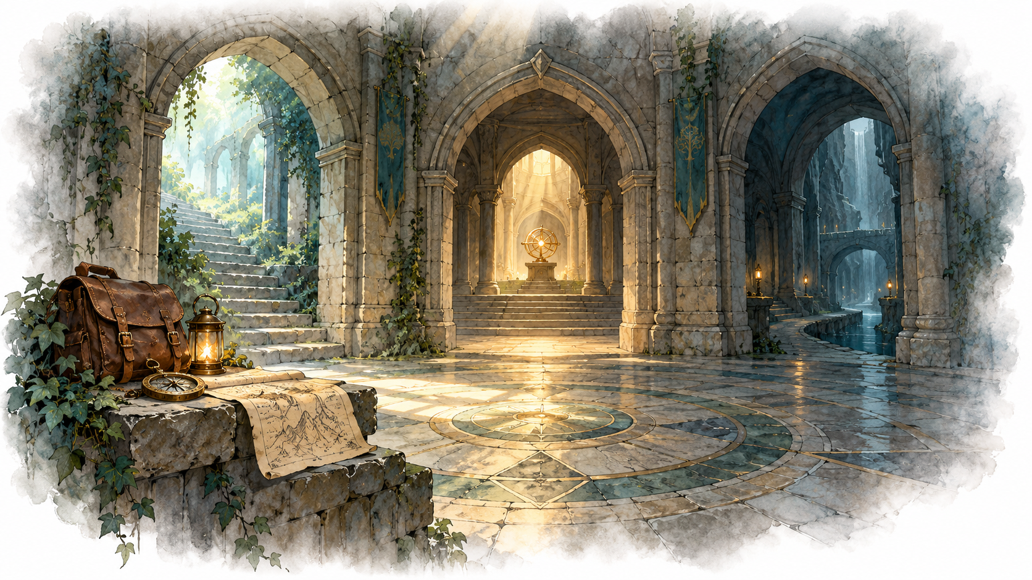
At the encounter desk, visitors are waiting to enter the labyrinth. A scout, a merchant, and a wandering creature should be processed in the order they arrive. Your task is to keep that order while making room for later arrivals and avoiding a shift of every remaining entry after each departure.
This workshop supplements The Adventurer’s Pack. It is a separate, complete two-file program and can also be assigned independently. It uses encounter names as String values so the work stays focused on queue behavior.
AI-created, human-prompted, human-edited, and human-verified using ChatGPT (OpenAI). Artwork: OpenAI image generation. Original contributions: CC0 1.0. See Publication License and AI Disclosure at the end.

Workshop Overview and Code Investigation
Read Section 2.3, ArrayQueue, in Morin’s Java edition. Focus on the front index, size, modular indexing, and copying a wrapped queue into a larger array. This workshop doubles a full array and does not shrink it.
Reading: https://opendatastructures.org/ods-java/2_3_ArrayQueue_Array_Based_.html

What You Will Learn
- Explain how FIFO order differs from physical array order.
- Use a front index and size to locate the next removal and insertion.
- Preserve order when a wrapped queue grows.
- Check an AI explanation or visualization against a hand trace and execution.

Run the Supplied Program
Use Java 11 or later. Save the appendix listings as EncounterQueue.java and EncounterDesk.java in one folder, or use starter/chapter02_queue from the repository.
javac EncounterQueue.java EncounterDesk.java
java EncounterDesk
join <name> adds an encounter. next processes the oldest waiting encounter. peek shows it without removing it. queue displays logical waiting order. state displays the physical array, front index, and size. quit exits.

Investigate Before Editing
Run join A, join B, join C, join D, join E, next, state. Explain why E is refused and why B moves to index 0. Find the loop responsible for that movement. How many references does next shift when four encounters are waiting?
The starter is a working linear queue. Its frontIndex remains 0. get already supports circular indexing, and EncounterDesk uses get to display logical order. Your changes belong only in EncounterQueue.

Connect the Names to the Book
Our name | Morin’s name | Meaning
events | a | Backing array
frontIndex | j | Physical index of the oldest encounter
size | n | Number of waiting encounters

Trace and AI Learning Practice

A Worked Wraparound Step
Suppose capacity is 4, frontIndex is 3, size is 2, and physical storage is [B, null, null, A]. The logical order is A, B. The insertion index for C is (3 + 2) % 4 = 1. After insertion the storage is [B, C, null, A], size is 3, and frontIndex is still 3.
A successful dequeue reads and clears the front slot, advances frontIndex with wraparound, and decreases size. It does not shift other encounters. In this workshop, even when the queue becomes empty, retain the advanced frontIndex. Empty dequeue changes nothing.

Your Prediction Before AI
Start empty with capacity 4 and frontIndex 0. Trace enqueue A, B, C, D; dequeue twice; enqueue E, F; enqueue G; then dequeue until empty. Include one extra dequeue. For every step, record physical slots, logical waiting order, frontIndex, size, capacity, and the returned value. Predict the intended circular implementation, not the supplied linear starter.
The G insertion forces growth while the occupied entries cross the end of the old array. Show the old and new arrays separately. Mark each copied reference. Do not consult AI until you have attempted this step.

Ask for a Checkable Explanation
Use an available free AI chat tool. Supply the queue code, the required circular behavior, and your trace. Ask for a step-by-step explanation or an optional HTML animation. AI may generate the animation; write the Java queue changes yourself.
Prompt scaffold: “This starter shifts on removal. I am replacing that with a circular queue. Use capacity 4 and the exact operations below. Show physical slots and logical order separately. Ask me a question about the first wrapped insertion. Do not write my Java solution.”
Follow up about the G insertion: ask how copying physical slots in order differs from copying the waiting order. Verify a wraparound step, a removal, and the resize against your own trace. Correct any mismatch and explain which representation rule settles it.

If AI Is Unavailable
Evaluate this claim: “When [E, F, C, D] has frontIndex 2, copying indices 0 through 3 into a larger array and setting the front to 0 preserves FIFO.” Write the next two expected removals, diagnose the claim, and correct it with a hand diagram. Discuss your explanation with a partner or instructor. This route addresses the same learning goals.

Build and Test

Required Changes
- Rewrite enqueue to place an encounter at (frontIndex + size) % capacity. If full, double capacity first. Reject null without changing state; accept every non-null encounter at classroom input sizes.
- Rewrite dequeue to remove and clear the front slot, advance the front modulo capacity, and decrease size. Return null on an empty queue. Do not shift entries or shrink storage.
- Add a private resize(int newCapacity) helper. Copy size entries in logical order into indices 0 through size − 1 of the new array, replace events, and set frontIndex to 0. Preserve size.
- Keep the public methods and EncounterDesk unchanged. Use a raw String array and loops for storage and copying. Do not use a collection or an array-copy utility in your queue methods. Keep the supplied debug display.

Rules to Maintain
Keep 0 ≤ size ≤ capacity and 0 ≤ frontIndex < capacity. Logical offset k is stored at (frontIndex + k) % capacity. Exactly size slots are occupied; all other slots are null. Duplicate names are allowed and represent separate encounters. The array starts at length 4.

Required Demonstration
Run your entire prediction sequence using join and next. After each operation use state and, when needed, queue. Confirm the processed order is A through G. Check empty dequeue and peek, one-element removal, repeated wraparound without growth, wrapped growth, and enqueue after completely emptying the queue. In a small test driver, check enqueue(null) returns false without changing state.
Explain why dequeue is O(1), why an enqueue that grows is O(n), and why a sequence of enqueues has amortized O(1) cost under doubling. Exclude the display methods from these operation costs. Identify the work that a physical array picture can hide.

Starter Code EncounterQueue
Save as EncounterQueue.java. This version shifts on removal and refuses an insertion when full. Your completed version must support circular storage and growth.
public class EncounterQueue {
private String[] events = new String[4];
private int frontIndex;
private int size;
public int size() { return size; }
public int capacity() { return events.length; }
public int frontIndex() { return frontIndex; }
public boolean enqueue(String event) {
if (event == null) { return false; }
// Replace fixed capacity and linear placement.
if (size == events.length) { return false; }
events[size] = event;
size++;
return true;
}
public String dequeue() {
if (size == 0) { return null; }
String removed = events[0];
// Replace shifting with a circular front index.
for (int index = 1; index < size; index++) {
events[index - 1] = events[index];
}
size--;
events[size] = null;
return removed;
}
public String peek() {
return size == 0 ? null : events[frontIndex];
}
public String get(int offset) {
if (offset < 0 || offset >= size) {
throw new IndexOutOfBoundsException(offset);
}
return events[(frontIndex + offset) % events.length];
}
public String debugState() {
return java.util.Arrays.toString(events)
+ " front=" + frontIndex + " size=" + size;
}
}

Starter Code EncounterDesk
Save as EncounterDesk.java. The console program is supplied infrastructure; the workshop does not require changes to this class.
import java.util.Scanner;
public class EncounterDesk {
public static void main(String[] args) {
EncounterQueue queue = new EncounterQueue();
Scanner input = new Scanner(System.in);
System.out.println("join <name>, next, peek, queue, state, quit");
while (true) {
System.out.print("> ");
if (!input.hasNextLine()) { break; }
String command = input.nextLine().trim();
if (command.equals("quit")) { break; }
if (command.startsWith("join ")) {
String name = command.substring(5).trim();
if (!name.isEmpty() && queue.enqueue(name)) {
System.out.println("Waiting: " + name);
} else { System.out.println("Cannot join."); }
} else if (command.equals("next")) {
String event = queue.dequeue();
System.out.println(event == null ? "No encounters."
: "Encounter: " + event);
} else if (command.equals("peek")) {
String event = queue.peek();
System.out.println(event == null ? "No encounters."
: "Next: " + event);
} else if (command.equals("queue")) {
for (int offset = 0; offset < queue.size(); offset++) {
System.out.println(queue.get(offset));
}
System.out.println("Waiting count: " + queue.size());
} else if (command.equals("state")) {
System.out.println(queue.debugState());
} else { System.out.println("Unknown command."); }
}
}
}

Publication License and AI Disclosure

Open Reuse
To the extent the project rights holders own copyright or related rights, they dedicate the original contributions to Data Dungeon: The Linked Labyrinth to the public domain under CC0 1.0 Universal. This includes original teaching materials, Java code, verification code, and project artwork. You may copy, modify, redistribute, and use these contributions commercially. Attribution is appreciated but is not required for these CC0 contributions.
CC0 1.0 Universal: https://creativecommons.org/publicdomain/zero/1.0/

Source Attribution and Exceptions
Pat Morin, Open Data Structures (Java edition 0.1G): https://opendatastructures.org/ods-java/. The textbook and source code are licensed under CC BY 2.5 Canada: https://creativecommons.org/licenses/by/2.5/ca/. This companion adapts selected topics for dungeon workshops with renamed and simplified structures, new contracts, tests, and AI learning activities. Morin material retains its license, attribution, copyright notices, and warranty disclaimers; CC0 covers only original project contributions. Keep this credit and the license link with redistributed adaptations, including extracted code. No endorsement by Pat Morin is implied.
Format inspiration: Michael Penta, Companion Materials for OpenStax: Introduction to Python Programming, Chapter 5 (2025), supplied under CC0 1.0. Other third-party material retains its applicable terms. CC0 applies only to rights held by the project rights holders and does not assert that AI-generated material is copyrightable.

AI Disclosure
This work was AI-created, human-prompted, human-edited, and human-verified. Text, instructional activities, and code were generated using ChatGPT (OpenAI). Decorative artwork was generated using OpenAI image generation.
AI tool citation: OpenAI. (2026). ChatGPT [large language model]. https://chatgpt.com/. Exact model-version identifiers were not recorded. Human prompting, editing, and verification do not imply that the work is error-free or that classroom trials have been completed.

