Data Dungeon
The Linked Labyrinth
Ancillary Resources for Pat Morin’s
Open Data Structures in Java
Complete Scope and Chapter Alignment
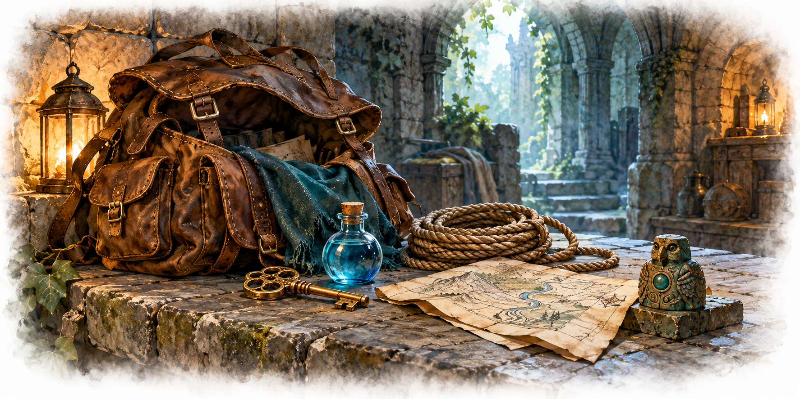
Working draft for instructor review • October 2026
AI-created, human-prompted, human-edited, and human-verified using ChatGPT (OpenAI). Artwork: OpenAI image generation. Original contributions: CC0 1.0. See Publication License and AI Disclosure at the end.
This companion uses original Java activities. Original contributions are dedicated under CC0 1.0.

Book Overview and Learning Objectives

Book Overview
Students restore the systems of a connected labyrinth while learning how data structures affect program behavior and efficiency. Each chapter combines textbook reading, investigation of existing Java code, a focused programming assignment, and purposeful AI practice.
The companion contains editable Word student chapters and instructor guides, plus runnable Java starter and reference projects. Each activity supplies its own complete starting point. Chapters 1–6 and 10–12, plus the circular-queue workshop, are the entire planned collection.

Learning Objectives
- Trace object references and explain changes to program state.
- Implement and test selected data structures from Morin’s Java edition.
- Choose representations using required operations and their costs.
- Navigate an unfamiliar codebase and modify the relevant components.
- Use AI for tutoring, visualization, testing, and debugging, while supporting conclusions with evidence.

The Data Dungeon Adventure Project
A dormant labyrinth contains disconnected passages, disorganized supplies, incomplete registries, and unreliable event systems. Students repair one subsystem at a time. The room world contains arrays of references to adjacent rooms; those arrays do not make the world a skiplist. Formal graph algorithms arrive later.

A Consistent Chapter Pattern
Each chapter opens with an overview and objectives, followed by code investigation, a narrative adventure activity, an AI skill-building activity, testing, and reflection. The AI task is placed where it helps the programming work. Instructors may adapt the activities to their course and choose their own assessment and submission arrangements.

Chapter Alignment and Student Work

1 At the Threshold
Morin: Introduction. Trace room references and extend the supplied world.
AI practice: Ask precise questions about unfamiliar code and verify answers in methods.

2 The Adventurer’s Pack
Morin: Array-Based Lists. Build an inventory with growth and ordered removal; add a circular-queue workshop.
AI practice: Use tutoring and a resizing or wraparound visualization.

3 The Shifting Procession
Morin: Linked Lists. Manage encounters with insertion and removal at a known position.
AI practice: Animate the actual reference assignments in a method.

4 The Ordered Directory
Morin: Skiplists — optional. Complete selected ordered-directory operations and successor searches.
AI practice: Refine and check a search walkthrough across levels.

5 The Keeper’s Registry
Morin: Hash Tables. Implement identifier lookup and investigate collisions and deletion.
AI practice: Propose, select, and implement meaningful edge-case tests.

Remaining Chapters and Publication Scope

6 The Archive of Doors
Morin: Binary Trees. Maintain ordered records and investigate the effect of insertion order. AI practice: Use diagnostic questions to find and repair a defect.

10 The Awakening Traps
Morin: Heaps. Schedule events by time and handle events added during play. AI practice: Evaluate a structure recommendation against required operations.

11 The Treasure Catalogue
Morin: Sorting Algorithms. Compare sorting behavior, ties, and measured performance. AI practice: Compare predictions with controlled experiments.

12 The Labyrinth Revealed
Morin: Graphs. Find reachable rooms and shortest routes in an unweighted dungeon. AI practice: Create and check a BFS visualization.
The complete scope is Chapters 1–6 and 10–12, plus the Chapter 2 circular-queue workshop. No additional chapters are planned. Numbering follows Morin; coverage is selective.

Instructor Materials and Review
For each finished chapter, provide a solution, assessment criteria, expected traces, common misconceptions, and an alternative when AI access is unavailable. Confirm exact reading sections, accessibility and tool availability before classroom use. No paid subscription or API key should be required.
Chapter 1 includes a runnable navigation foundation and a Word code appendix. Item and inventory classes enter with Chapter 2. All other activities include supporting implementations, so earlier assignments are not prerequisites.
Textbook: https://opendatastructures.org/ods-java/
Format inspiration: https://oercommons.org/courseware/lesson/139005

Publication License and AI Disclosure

Open Reuse
To the extent the project rights holders own copyright or related rights, they dedicate the original contributions to Data Dungeon: The Linked Labyrinth to the public domain under CC0 1.0 Universal. This includes original teaching materials, Java code, verification code, and project artwork. You may copy, modify, redistribute, and use these contributions commercially. Attribution is appreciated but is not required for these CC0 contributions.
CC0 1.0 Universal: https://creativecommons.org/publicdomain/zero/1.0/

Source Attribution and Exceptions
Pat Morin, Open Data Structures (Java edition 0.1G): https://opendatastructures.org/ods-java/. The textbook and source code are licensed under CC BY 2.5 Canada: https://creativecommons.org/licenses/by/2.5/ca/. This companion adapts selected topics for dungeon workshops with renamed and simplified structures, new contracts, tests, and AI learning activities. Morin material retains its license, attribution, copyright notices, and warranty disclaimers; CC0 covers only original project contributions. Keep this credit and the license link with redistributed adaptations, including extracted code. No endorsement by Pat Morin is implied.
Format inspiration: Michael Penta, Companion Materials for OpenStax: Introduction to Python Programming, Chapter 5 (2025), supplied under CC0 1.0. Other third-party material retains its applicable terms. CC0 applies only to rights held by the project rights holders and does not assert that AI-generated material is copyrightable.

AI Disclosure
This work was AI-created, human-prompted, human-edited, and human-verified. Text, instructional activities, and code were generated using ChatGPT (OpenAI). Decorative artwork was generated using OpenAI image generation.
AI tool citation: OpenAI. (2026). ChatGPT [large language model]. https://chatgpt.com/. Exact model-version identifiers were not recorded. Human prompting, editing, and verification do not imply that the work is error-free or that classroom trials have been completed.

