Data Dungeon
The Linked Labyrinth
Ancillary Resources for Pat Morin’s
Open Data Structures in Java
Book Plan and Chapter Alignment
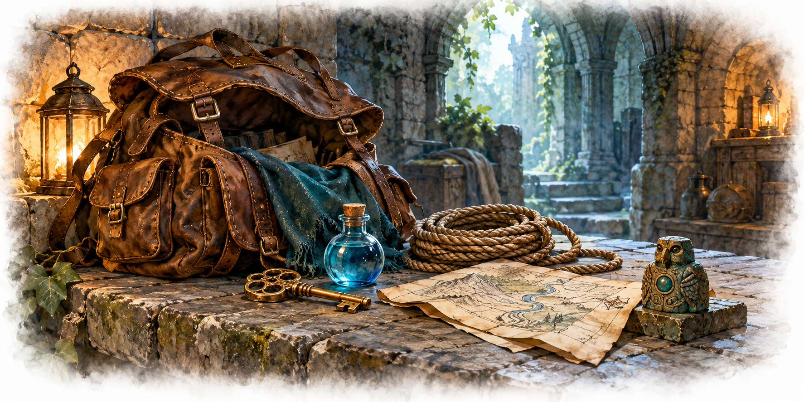
Working draft for instructor review • October 2026
AI-created, human-prompted, human-edited, and human-verified using ChatGPT (OpenAI). Artwork: OpenAI image generation. Original contributions: CC0 1.0. See Publication License and AI Disclosure at the end.
Format reference: Michael Penta, Companion Materials for OpenStax: Introduction to Python Programming, Chapter 5 (2025), supplied Word document marked CC0 1.0. This companion uses original Java activities. Original contributions are dedicated under CC0 1.0.

Book Overview and Learning Objectives

Book Overview
Students restore the systems of a connected labyrinth while learning how data structures affect program behavior and efficiency. Each chapter combines textbook reading, investigation of existing Java code, a focused programming assignment, and purposeful AI practice.
The companion will be distributed as editable Word chapter documents with a separate Word instructor guide. Code listings appear in the chapter materials; runnable Java projects can accompany the final release. Each chapter supplies its own complete starting point.

Learning Objectives
- Trace object references and explain changes to program state.
- Implement and test selected data structures from Morin’s Java edition.
- Choose representations using required operations and their costs.
- Navigate an unfamiliar codebase and modify the relevant components.
- Use AI for tutoring, visualization, testing, and debugging, while supporting conclusions with evidence.

The Data Dungeon Adventure Project
A dormant labyrinth contains disconnected passages, disorganized supplies, incomplete registries, and unreliable event systems. Students repair one subsystem at a time. The room world contains arrays of references to adjacent rooms; those arrays do not make the world a skiplist. Formal graph algorithms arrive later.

A Consistent Chapter Pattern
Each chapter opens with an overview and objectives, followed by code investigation, a narrative adventure activity, an AI skill-building activity, testing, and reflection. The AI task is placed where it helps the programming work. Instructors may adapt the activities to their course and choose their own assessment and submission arrangements.

Chapter Alignment and Student Work

1 At the Threshold
Morin: Introduction. Trace room references and extend the supplied world.
AI practice: Ask precise questions about unfamiliar code and verify answers in methods.

2 The Adventurer’s Pack
Morin: Array-Based Lists. Build an inventory with growth and ordered removal; add a circular-queue workshop.
AI practice: Use tutoring and a resizing or wraparound visualization.

3 The Shifting Procession
Morin: Linked Lists. Manage encounters with insertion and removal at a known position.
AI practice: Animate the actual reference assignments in a method.

4 The Ordered Directory
Morin: Skiplists — optional. Complete selected ordered-directory operations and successor searches.
AI practice: Refine and check a search walkthrough across levels.

5 The Keeper’s Registry
Morin: Hash Tables. Implement identifier lookup and investigate collisions and deletion.
AI practice: Propose, select, and implement meaningful edge-case tests.

Later Adventures and Publication Plan

6 The Archive of Doors
Morin: Binary Trees. Maintain ordered records and investigate the effect of insertion order. AI practice: Use diagnostic questions to find and repair a defect.

10 The Awakening Traps
Morin: Heaps. Schedule events by time and handle events added during play. AI practice: Evaluate a structure recommendation against required operations.

11 The Treasure Catalogue
Morin: Sorting Algorithms. Compare sorting behavior, ties, and measured performance. AI practice: Compare predictions with controlled experiments.

12 The Labyrinth Revealed
Morin: Graphs. Find reachable rooms and shortest routes in an unweighted dungeon. AI practice: Create and check a BFS or DFS visualization.
Chapters 7–9 are candidates for optional archive extensions. Chapters 13–14 are outside the first release. Numbering follows the textbook; coverage within each chapter is selective.

Instructor Materials and Review
For each finished chapter, provide a solution, assessment criteria, expected traces, common misconceptions, and an alternative when AI access is unavailable. Confirm exact reading sections, accessibility and tool availability before classroom use. No paid subscription or API key should be required.
The first draft includes a runnable navigation foundation in its Word appendix. Item and inventory classes enter with Chapter 2. Later chapters receive complete supporting implementations so earlier assignments are not prerequisites.
Textbook: https://opendatastructures.org/ods-java/
Format inspiration: https://oercommons.org/courseware/lesson/139005

Publication License and AI Disclosure

Open Reuse
To the extent the project rights holders own copyright or related rights, they dedicate the original contributions to Data Dungeon: The Linked Labyrinth to the public domain under CC0 1.0 Universal. This includes original teaching materials, Java code, verification code, and project artwork. You may copy, modify, redistribute, and use these contributions commercially. Attribution is appreciated but is not required for these CC0 contributions.
CC0 1.0 Universal: https://creativecommons.org/publicdomain/zero/1.0/

Source Attribution and Exceptions
Pat Morin, Open Data Structures, Java edition: https://opendatastructures.org/ods-java/. The textbook and its accompanying source code are released under Creative Commons Attribution 2.5 Canada: https://creativecommons.org/licenses/by/2.5/ca/. Any reproduced or adapted Morin material retains that license and attribution requirement; this project’s CC0 dedication does not waive his rights. The companion adds a dungeon setting, focused workshops, renamed and simplified implementations, tests, instructor guidance, and AI learning activities. No endorsement by Pat Morin is implied.
Format inspiration: Michael Penta, Companion Materials for OpenStax: Introduction to Python Programming, Chapter 5 (2025), supplied under CC0 1.0. Other third-party material retains its applicable terms. CC0 applies only to rights held by the project rights holders and does not assert that AI-generated material is copyrightable.

AI Disclosure
This work was AI-created, human-prompted, human-edited, and human-verified. Text, instructional activities, and code were generated using ChatGPT (OpenAI). Decorative artwork was generated using OpenAI image generation.
AI tool citation: OpenAI. (2026). ChatGPT [large language model]. https://chatgpt.com/. Exact model-version identifiers were not recorded. Human prompting, editing, and verification do not imply that the work is error-free or that classroom trials have been completed.

