Data Dungeon
The Linked Labyrinth
Chapter 11 Instructor Guide
The Treasure Catalogue
Ancillary Resources for Pat Morin’s Open Data Structures in Java
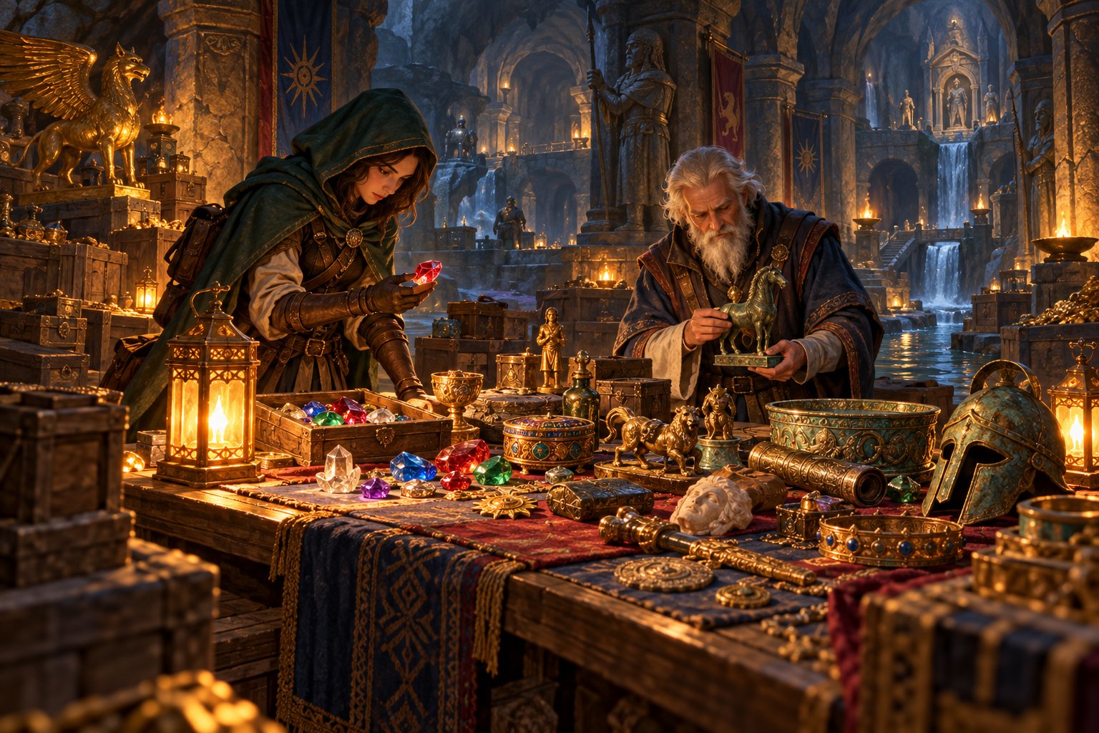
Students implement stable insertion sort and a stable merge, then use counted key comparisons to test predictions. The exercise separates record identity, ordering correctness, and measured work. The reference solution changes only the two permitted method bodies.
Use starter/chapter11, instructor/chapter11, and verification/SortingCompletion.java with the student chapter. Each project is independent. The public repository contains solutions; use course-controlled distribution when solutions should be withheld.
AI-created, human-prompted, human-edited, and human-verified using ChatGPT (OpenAI). Artwork: OpenAI image generation. Original contributions: CC0 1.0. See Publication License and AI Disclosure at the end.

Teaching Sequence and Expected Results
Allow approximately 100–140 minutes plus reading: 20–25 for investigation and traces, 35–50 for implementation, 25–35 for tests and experiments, and 20–30 for prediction review. These are planning estimates, not measured completion times.
Read Section 11.1.1: https://opendatastructures.org/ods-java/11_1_Comparison_Based_Sorti.html
Our range-based merge uses one shared buffer. The left-on-equality choice explicitly adds stability to the displayed textbook merge, which takes from the right on a tie. Insertion sort is a comparison baseline rather than an attempt to reproduce every algorithm in Chapter 11.
Dataset | Insertion comparisons | Merge comparisons
sample | 11 | 10
sorted eight | 7 | 12
reverse eight | 28 | 12
equal eight | 7 | 12
mixed eight | 17 | 17
sorted sixteen | 15 | 32
reverse sixteen | 120 | 32

The stable sample order is B:10, D:10, F:20, C:30, A:40, E:50. The final merge chooses B, D, F, C, A in five comparisons, then copies E without a key comparison. Earlier merges contribute five. A result beginning D:10, B:10 is value-sorted but violates stability.

Complexity and Interpretation
Insertion sort has linear best-case work on already ordered input and quadratic worst-case work on reverse distinct values. It uses constant auxiliary space. This merge sort uses O(n log n) time, an O(n) buffer, and O(log n) recursion depth for n greater than one. Counting key comparisons excludes copying and allocation, so avoid translating a count directly into elapsed-time claims.
For increasing n, insertion uses n - 1 comparisons; reverse distinct input uses n(n - 1)/2. For sorted or reverse input of power-of-two length, this merge implementation uses (n/2) log2(n) comparisons. These formulas depend on the stated algorithms and inputs, not merely their names.

Reference Solution
public long insertionSort(Treasure[] items) {
comparisons = 0;
for (int index = 1; index < items.length; index++) {
Treasure saved = items[index];
int position = index;
while (position > 0
&& compare(items[position - 1], saved) > 0) {
items[position] = items[position - 1];
position--;
}
items[position] = saved;
}
return comparisons;
}
private void merge(Treasure[] items, Treasure[] buffer,
int low, int middle, int high) {
int left = low;
int right = middle;
int output = low;
while (left < middle && right < high) {
if (compare(items[left], items[right]) <= 0) {
buffer[output++] = items[left++];
} else {
buffer[output++] = items[right++];
}
}
while (left < middle) buffer[output++] = items[left++];
while (right < high) buffer[output++] = items[right++];
for (int index = low; index < high; index++) {
items[index] = buffer[index];
}
}
Strict shifting preserves equal records during insertion. Choosing left on equality preserves the order across halves during merging. Copying into buffer before copying back prevents unread candidates from being overwritten.

Testing and Assessment
A small student test can retain two equal records and check their identities after sorting. Repeat the test separately for each public method, creating a fresh input array each time.
Treasure first = new Treasure("first", 10);
Treasure second = new Treasure("second", 10);
Treasure[] items = {first, new Treasure("small", 1), second};
new CatalogueSort().mergeSort(items);
if (items[1] != first || items[2] != second) {
throw new AssertionError("equal records changed order");
}
Place these statements in a main method in CatalogueCheck.java. A value-only assertion misses this defect. Also require empty, singleton, odd-size, repeated-value, and integer-boundary cases. Tests should check preservation of every record, not only ascending values.
Criterion
Stable insertion sort and required comparison behavior
Stable range merge with safe boundaries and copy-back
Correct records and boundary tests
Controlled experiments and interpretation
Evaluated AI predictions or equivalent no-AI reasoning

Common Misconceptions
- Shifting on >= reverses equal records in insertion sort.
- Taking right on equality loses stability across merge halves.
- Treating high as inclusive skips or overreads a range boundary.
- Copying into items while still reading both halves can overwrite a candidate.
- Running merge sort after insertion on the same array changes the experiment.
- A correct count with incorrect output is not a successful sort.

Verification and AI Review
The maintainer checks compare both algorithms with a stable reference ordering over 300 seeded inputs, including many ties and odd lengths. They verify original object identities, preservation, integer extremes, count reset, empty behavior, exact experiment counts, and growth-case formulas for lengths 8, 16, 32, and 64.
Source comparisons enforce the two-method edit boundary and unchanged driver and record class. The suite also matches the student Word listings to the Java starter files. Compile targets Java 11; GitHub Actions runs all checks on Java 11 and Java 21.
python3 verification/verify_starters.py
python3 verification/verify_completion.py
The no-AI claims are all false for this implementation: sorted eight gives 7 and 12, equal eight gives insertion count 7, and 8 log2(8) = 24 is not the measured merge count 12. Reward a trace that explains a mismatch, not a copied number. A correct AI prediction still needs independent confirmation and a clear counting convention.
These checks establish a completion path within the permitted edits. They are maintainer evidence rather than a general grading suite for arbitrary student algorithms. Classroom timing and the quality of individual AI interactions still require observation.

Publication License and AI Disclosure

Open Reuse
To the extent the project rights holders own copyright or related rights, they dedicate the original contributions to Data Dungeon: The Linked Labyrinth to the public domain under CC0 1.0 Universal. This includes original teaching materials, Java code, verification code, and project artwork. You may copy, modify, redistribute, and use these contributions commercially. Attribution is appreciated but is not required for these CC0 contributions.
CC0 1.0 Universal: https://creativecommons.org/publicdomain/zero/1.0/

Source Attribution and Exceptions
Pat Morin, Open Data Structures, Java edition: https://opendatastructures.org/ods-java/. The textbook and its accompanying source code are released under Creative Commons Attribution 2.5 Canada: https://creativecommons.org/licenses/by/2.5/ca/. Any reproduced or adapted Morin material retains that license and attribution requirement; this project’s CC0 dedication does not waive his rights. The companion adds a dungeon setting, focused workshops, renamed and simplified implementations, tests, instructor guidance, and AI learning activities. No endorsement by Pat Morin is implied.
Format inspiration: Michael Penta, Companion Materials for OpenStax: Introduction to Python Programming, Chapter 5 (2025), supplied under CC0 1.0. Other third-party material retains its applicable terms. CC0 applies only to rights held by the project rights holders and does not assert that AI-generated material is copyrightable.

AI Disclosure
This work was AI-created, human-prompted, human-edited, and human-verified. Text, instructional activities, and code were generated using ChatGPT (OpenAI). Decorative artwork was generated using OpenAI image generation.
AI tool citation: OpenAI. (2026). ChatGPT [large language model]. https://chatgpt.com/. Exact model-version identifiers were not recorded. Human prompting, editing, and verification do not imply that the work is error-free or that classroom trials have been completed.

