Data Dungeon
The Linked Labyrinth
Chapter 1 Instructor Guide
At the Threshold
Ancillary Resources for Pat Morin’s Open Data Structures in Java
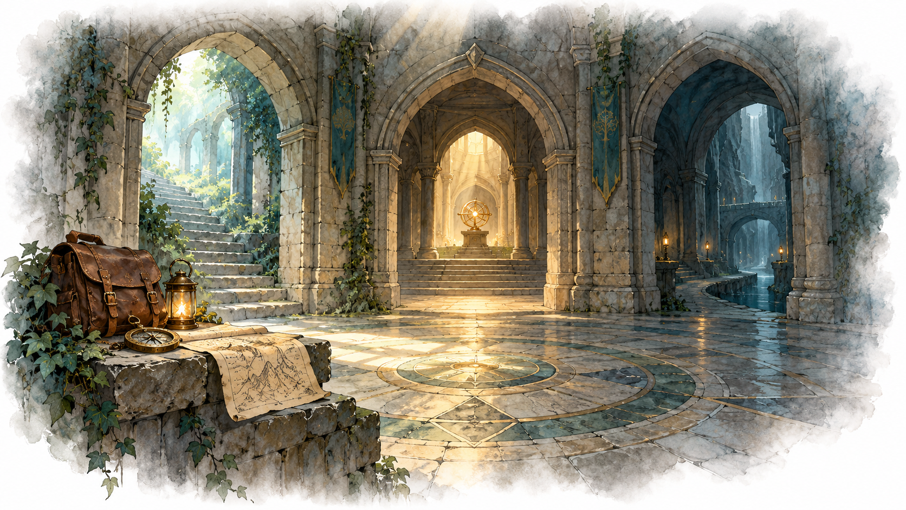
Students investigate direct object references and extend the world by changing only WorldBuilder. This guide supplies a complete example, expected answers, assessment guidance, and a completion checklist. Accept other maps that satisfy the same constraints.

Teaching Sequence
Begin with a room box and its array of references. Ask students to point to the object and then to each reference to it. Have them trace the original world before running it, complete the focused AI exchange or alternative, and plan the new wing before editing.
Suggested pacing, to be adjusted after a classroom pilot: 15 minutes for code investigation, 15 for tracing, 10 for AI practice, and 30–45 for construction and checking. Students need basic Java classes, arrays, null, and method calls.
The reference project is instructor/chapter01. Compile its four Java files together and run Game. Starter files remain in starter/chapter01. Instructor folders in this public repository are visible to students; use the guide as an open exemplar or distribute assessment variants separately.
AI-created, human-prompted, human-edited, and human-verified using ChatGPT (OpenAI). Artwork: OpenAI image generation. Original contributions: CC0 1.0. See Publication License and AI Disclosure at the end.

Expected Investigation Answers
WorldBuilder.build creates and connects the rooms. Room.setExit stores a destination reference in one array slot. Player.move checks the selected slot and assigns currentRoom = destination. Game parses the command and calls move. Successful movement changes the player’s field, not the room objects or their exit arrays.
Command | Before | After | Reason
go 0 | Entrance | Gallery | Entrance exit 0
go 1 | Gallery | Archive | Gallery exit 1
go 0 | Archive | Entrance | Archive exit 0
go 1 | Entrance | Well | Entrance exit 1
go 1 | Well | Well | Well exit 1 is null

Gallery exit 1 and Well exit 0 both reference the same Archive. They do not create copies. In the starter, Entrance exit 2 and Well exit 1 are null. Other slots hold the connections explicitly assigned in WorldBuilder.
go -1 and go 99 return false from move, print “No passage there.”, and leave location unchanged. go two is rejected by integer parsing before move is called. A one-way passage has no direct reverse link; a longer path may still return to the starting room.

Expected AI Evidence
A strong answer identifies currentRoom as the changed reference and points to its assignment. A useful follow-up asks whether two exits create two archives, or whether setting a reverse link is automatic. A diagram is acceptable only when checked against the code. For the alternative, the claim that movement assigns a destination reference is correct; the claim that it copies a room is false.

Common Misconceptions
If students draw two Archive objects, ask where the second constructor call occurs. If they expect an automatic return passage, ask which setExit establishes it. If they think the player changes an exit, ask them to name the left side of the movement assignment. Numbered exits are local array indices; exit 0 has no universal direction.

Reference Extension and Demonstration
This is the complete WorldBuilder.java for the example solution. Room, Player, and Game are byte-for-byte copies of the starter classes. The added objects are Vestibule, Bridge, and Vault.
public class WorldBuilder {
public static Room build() {
Room entrance = new Room("Entrance", 3);
Room gallery = new Room("Gallery", 2);
Room well = new Room("Well", 2);
Room archive = new Room("Archive", 1);
entrance.setExit(0, gallery);
entrance.setExit(1, well);
gallery.setExit(0, entrance);
gallery.setExit(1, archive);
well.setExit(0, archive);
archive.setExit(0, entrance);
Room vestibule = new Room("Vestibule", 2);
Room bridge = new Room("Bridge", 2);
Room vault = new Room("Vault", 2);
entrance.setExit(2, vestibule);
vestibule.setExit(0, bridge);
vestibule.setExit(1, vault);
bridge.setExit(0, vault);
vault.setExit(0, entrance);
return entrance;
}
}
From Entrance, go 2, go 0, go 0, go 0 visits all three new rooms and returns to Entrance. The alternate route go 2, go 1 reaches that same Vault. Vestibule exit 1 and Bridge exit 0 share the Vault object. Bridge exit 1 and Vault exit 1 remain null.
Bridge leads to Vault without a direct reverse passage. Vault returns through Entrance and Vestibule to Bridge. This satisfies the one-way passage requirement without trapping the player.

Assessment and Completion Evidence
Criterion | Evidence
Reference investigation | Correct original trace and explanation of the changed reference
Working extension | Three new rooms, preserved original links, cycle, shared target, one-way passage, null slot
Verification | Successful routes and failed moves with expected and actual outcomes
AI learning or alternative | Focused question, follow-up, and code-supported conclusion

Use the criteria to guide feedback on observable behavior and understanding. Consider both the working map and the explanation of its references. The access alternative addresses the same learning goals.

Completion Checks
Chapter1Completion checks object identity, original links, three new rooms, both paths to Vault, the return cycle, null and invalid exits, and unchanged links after movement. The verification script also confirms that the three protected classes match the starter. The original starter command trace is covered by the existing smoke tests.
The Word-listing check verifies that every starter source listing appears verbatim in the student document. The reference implementation is a constructive demonstration that the programming requirements can be met within the permitted edit scope. It does not establish the time required for a typical student; pacing remains a classroom-pilot question.

Standard for Every Chapter
Before moving a chapter beyond draft status, provide a complete student starting point, a reference solution limited to the permitted changes, expected traces and demonstrations for every required feature, tests of boundary behavior, an AI activity with checkable evidence and an access alternative, and instructor assessment notes. Compile and run both versions and compare the Word listings with the tested source files.

Publication License and AI Disclosure

Open Reuse
To the extent the project rights holders own copyright or related rights, they dedicate the original contributions to Data Dungeon: The Linked Labyrinth to the public domain under CC0 1.0 Universal. This includes original teaching materials, Java code, verification code, and project artwork. You may copy, modify, redistribute, and use these contributions commercially. Attribution is appreciated but is not required for these CC0 contributions.
CC0 1.0 Universal: https://creativecommons.org/publicdomain/zero/1.0/

Source Attribution and Exceptions
Pat Morin, Open Data Structures, Java edition: https://opendatastructures.org/ods-java/. The textbook and its accompanying source code are released under Creative Commons Attribution 2.5 Canada: https://creativecommons.org/licenses/by/2.5/ca/. Any reproduced or adapted Morin material retains that license and attribution requirement; this project’s CC0 dedication does not waive his rights. The companion adds a dungeon setting, focused workshops, renamed and simplified implementations, tests, instructor guidance, and AI learning activities. No endorsement by Pat Morin is implied.
Format inspiration: Michael Penta, Companion Materials for OpenStax: Introduction to Python Programming, Chapter 5 (2025), supplied under CC0 1.0. Other third-party material retains its applicable terms. CC0 applies only to rights held by the project rights holders and does not assert that AI-generated material is copyrightable.

AI Disclosure
This work was AI-created, human-prompted, human-edited, and human-verified. Text, instructional activities, and code were generated using ChatGPT (OpenAI). Decorative artwork was generated using OpenAI image generation.
AI tool citation: OpenAI. (2026). ChatGPT [large language model]. https://chatgpt.com/. Exact model-version identifiers were not recorded. Human prompting, editing, and verification do not imply that the work is error-free or that classroom trials have been completed.

