Data Dungeon
The Linked Labyrinth
Chapter 3
The Shifting Procession
Ancillary Resources for Pat Morin’s Open Data Structures in Java
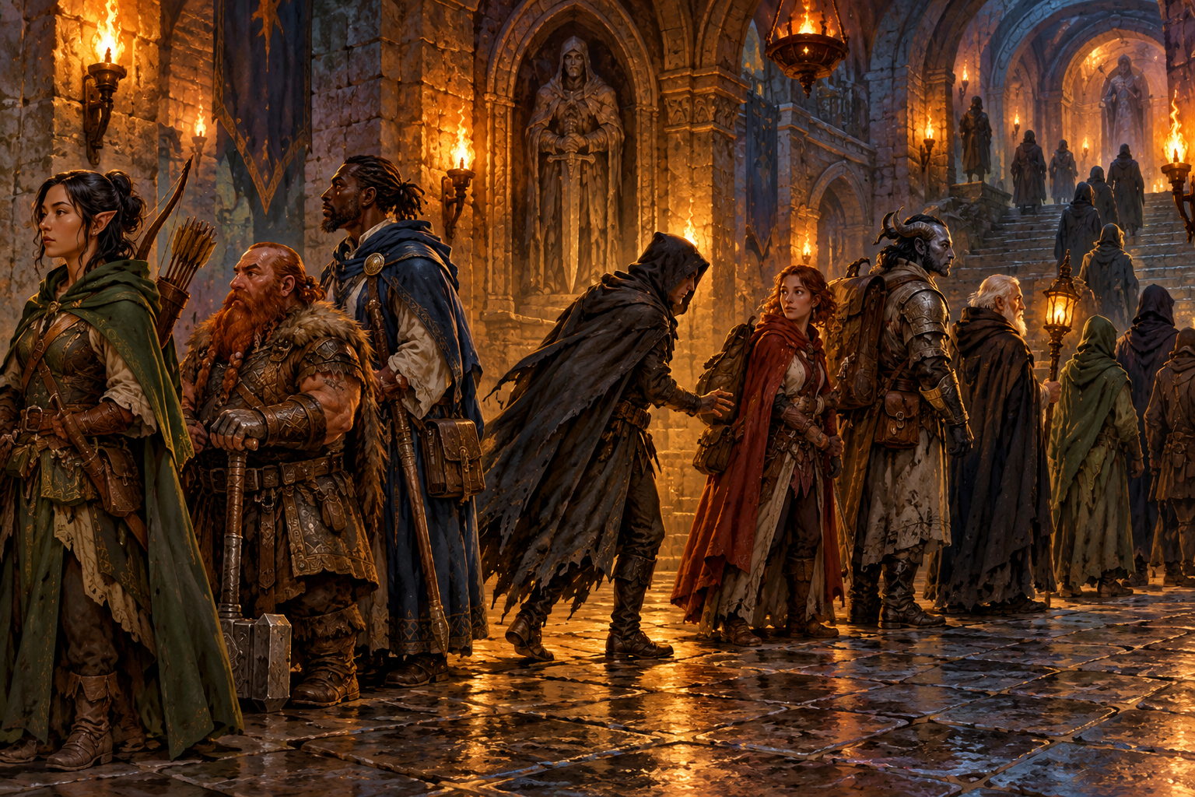
Beyond the pack room, a procession waits to cross the next gate. A scout goes first, an ogre blocks the middle, and the gate marks the final encounter. A healer arrives just before the ogre. When the ogre is resolved, the remaining encounters must stay connected in both directions.
You will repair a small encounter editor built from linked nodes. Your program will insert and remove encounters without shifting an array, preserve the selected encounter when a new one arrives, and keep the procession usable after it becomes empty.
This is an independent two-file Java project. It requires no code or saved game from Chapters 1 or 2.
ChatGPT assisted with drafting, instructional design, and code. Decorative artwork was generated with OpenAI image generation. Format reference: Michael Penta’s supplied Python companion chapter. Publication licensing remains to be finalized.

Overview and Preparation
Read Morin’s Chapter 3 introduction and Section 3.2, DLList. Review Section 3.1 if singly linked nodes are unfamiliar. The workshop uses a circular dummy node and a cursor, but does not implement the full Java List interface or Morin’s indexed getNode operation.
Reading: https://opendatastructures.org/ods-java/3_2_DLList_Doubly_Linked_Li.html

Learning Goals
- Trace object references independently of encounter names.
- Insert and remove a node while maintaining reciprocal next and prev links.
- Explain how a dummy node simplifies empty, first, and last positions.
- Distinguish constant-time editing at a known node from the cost of finding that node.
- Evaluate an AI explanation against your own reference trace and running program.

Start the Program
Use a JDK for Java 11 or later. Confirm that both java -version and javac -version work. Save the complete appendix listings as EncounterList.java and ProcessionGame.java in one folder, or use starter/chapter03 in the repository. Run these commands inside that folder.
javac EncounterList.java ProcessionGame.java
java ProcessionGame
The starter compiles and runs. It begins with [scout, ogre, gate], with scout selected and size 3. list and back display the sequence; first, next, and prev move the selection. insert and resolve are deliberately unfinished. Their failure messages are your baseline, not an installation error.

First Investigation
Run list, back, prev, next, next, next, quit. Predict each selected name before entering the command. Explain why prev at scout and next at gate leave the cursor unchanged even though the underlying links form a cycle.

How the Procession Holds Together
An encounter name is data. A node is the object that holds that name and two references. Two nodes may have the same name while remaining different objects. current refers to the selected node; changing a neighboring link should not replace that selected object.
dummy is a permanent node with no encounter name. Its next reference leads to the first encounter and its prev reference leads to the last. In an empty list both references point back to dummy, and current is dummy. In a nonempty list current must refer to a real encounter.
Node in the starting list | prev points to | next points to
dummy | gate | scout
scout | dummy | ogre
ogre | scout | gate
gate | ogre | dummy

For every linked node u, including dummy, u.next.prev must be u and u.prev.next must be u. A forward walk returns to dummy after exactly size encounter nodes. A backward walk visits the same objects in reverse order. The display methods stop at dummy; they never print it as an encounter.

Plan an Insertion
Select ogre and sketch a new healer node between scout and ogre. Record the predecessor before changing any links. The new node needs two references, and both old neighbors must point back to it. Keep current on ogre. Write a table of all changed fields before implementing the method.

Plan a Removal
To remove ogre, its predecessor must lead directly to its successor, and the successor must lead back to the predecessor. Save the removed node before changing current. Select its successor when there is one; otherwise select its predecessor. When the only encounter leaves, that predecessor is dummy.
Java does not require you to free the removed object manually. Clearing its two links makes the detached state explicit and is part of this exercise’s contract.

Workshop Repair the Encounter Editor
Edit only the bodies of insertBefore and removeSelected in EncounterList.java. Preserve every other method, field, signature, and ProcessionGame.java. Use the supplied Node objects and references; do not use arrays, collection classes, traversal loops, or rebuild the list inside either method. Each edit must do a fixed amount of work regardless of list size.

Insert Before the Selected Encounter
insertBefore(name) returns false for null or a name whose trim() is empty, without changing any state. Otherwise create one new node storing the original name, link it immediately before current, increase size once, and return true. Duplicate names are allowed. For a nonempty list keep the same selected object. For an empty list insert between dummy and itself and select the new node.

Resolve the Selected Encounter
removeSelected() returns null without changes when empty. Otherwise return the selected name, reconnect its two neighbors, and reduce size once. Select the next encounter if it exists; when removing the tail, select the preceding encounter. If the list becomes empty, select dummy. Set both links of the removed node to null after preserving any references you need.

Work in Small Checkpoints
- Complete insertion, compile, and confirm inserting healer before ogre preserves the ogre selection.
- Complete removal, compile, and confirm resolving ogre selects gate.
- Display list and back after each edit. A successful forward display alone is insufficient.
- Drain the list, try one extra resolve, and insert a new encounter into the empty list.

Explain the Cost
Count the reference assignments in each edit. Explain why these methods take O(1) time once current is known. Then explain why finding an arbitrary encounter by scanning names would take O(n) in the worst case. Compare inserting before the second item in an array-backed list: which remaining elements would have to move?

Required Trace and Completion Evidence
Restart the completed program. Enter the commands in the first column in order. Each row reports the state after that command. Between edits, use list and back to check both directions; those commands do not change selection.
Command | Forward order | Selected | Size
start | [scout, ogre, gate] | scout | 3
next | [scout, ogre, gate] | ogre | 3
insert healer | [scout, healer, ogre, gate] | ogre | 4
resolve | [scout, healer, gate] | gate | 3
resolve | [scout, healer] | healer | 2
first | [scout, healer] | scout | 2
resolve | [healer] | healer | 1
resolve | [] | null | 0
resolve | [] | null | 0
insert torchbearer | [torchbearer] | torchbearer | 1
prev then next | [torchbearer] | torchbearer | 1

After the first resolve, back must show [gate, healer, scout]. After reinserting torchbearer, both list and back show [torchbearer]. An extra resolve on the empty list prints No encounter. Boundary movement prints a refusal and leaves selection unchanged.

Check Cases Beyond the Adventure
The console trims command input, so direct method calls are needed for null and whitespace-only arguments. In a temporary Check.java main method, create new EncounterList(), call insertBefore(null), insertBefore(" "), and removeSelected(), and print their results plus size. Expect false, false, null, and 0. Insert the same name twice, then remove both; size must pass through 2, 1, and 0. Do not submit Check.java as a replacement for either supplied file.

Submit
Submit the two Java files, your required-trace transcript, reference diagrams or tables before and after inserting healer and removing ogre, the additional edge-case results, a short complexity comparison, and the AI review described next. Clearly identify which two method bodies you changed.

AI Learning Practice and Reflection
First complete your own healer insertion trace, including every changed reference and the final value of current. Then ask an AI tutor to explain the same operation or produce a step-by-step visualization. Supply the Node fields, dummy convention, and cursor contract so the answer addresses this program.
Act as a tutor. Do not write my Java solution.
I have a circular doubly linked list with a dummy node.
The order is scout, ogre, gate; current refers to ogre.
I must insert healer before ogre and keep current on ogre.
Ask me to predict each reference change. Then show a
field table after each assignment, including dummy links.
Explain how I can verify the backward walk.
An optional extension is to request a small HTML animation with Next step and Reset controls. Require stable node identities and separate prev and next arrows. The animation must show reference changes rather than merely moving labeled boxes. It is a learning aid; the Java output and your reference table remain the evidence of correctness.

Audit the Explanation
- Does the explanation keep current on the original ogre object after insertion?
- Does it update both neighbors, including a dummy neighbor at a boundary?
- Does it distinguish final invariants from temporary states during assignments?
- Does it separate finding a node from editing at an already known node?
Submit the prompt, a short relevant excerpt or screenshot, one checked claim, and any correction supported by your trace or execution. If no correction is needed, explain which two checks established that. Do not submit an unexamined AI-generated solution.

Equivalent Practice Without AI Access
Audit this claim: “To insert healer before ogre, set healer.next to ogre and scout.next to healer; no other links need to change.” Identify what is missing, predict the backward display, and supply a corrected field table. Use this route if AI access is unavailable or your course does not permit it.

Reflection
Why can forward output look correct while backward output is wrong? What changes when you remove the only encounter? When would an array-backed list be a better choice? Answer each question using a specific operation from your program.

Starter Listing EncounterList
Save this page and the continuation as a single file named EncounterList.java. Copy code only, without headings or page numbers.
public class EncounterList {
private static class Node {
String name;
Node prev, next;
Node(String name) { this.name = name; }
}
private final Node dummy = new Node(null);
private Node current = dummy;
private int size;
public EncounterList() {
dummy.next = dummy;
dummy.prev = dummy;
}
public int size() { return size; }
public String selected() {
return current == dummy ? null : current.name;
}
public boolean first() {
current = dummy.next;
return current != dummy;
}
public boolean next() {
if (current == dummy || current.next == dummy) return false;
current = current.next;
return true;
}
public boolean previous() {
if (current == dummy || current.prev == dummy) return false;
current = current.prev;
return true;
}
public boolean insertBefore(String name) {
// TODO: link a new node before current; select it if empty.
return false;
}
public String removeSelected() {
// TODO: unlink current and choose its successor or predecessor.
return null;
}

EncounterList Continued
public String forward() {
StringBuilder text = new StringBuilder("[");
for (Node node = dummy.next; node != dummy; node = node.next) {
if (text.length() > 1) text.append(", ");
text.append(node.name);
}
return text.append("]").toString();
}
public String backward() {
StringBuilder text = new StringBuilder("[");
for (Node node = dummy.prev; node != dummy; node = node.prev) {
if (text.length() > 1) text.append(", ");
text.append(node.name);
}
return text.append("]").toString();
}
public static EncounterList sample() {
EncounterList list = new EncounterList();
for (String name : new String[] {"scout", "ogre", "gate"}) {
Node node = new Node(name);
node.prev = list.dummy.prev;
node.next = list.dummy;
node.prev.next = node;
list.dummy.prev = node;
list.size++;
}
list.first();
return list;
}
}

Starter Listing ProcessionGame
Save as ProcessionGame.java in the same folder. This supplied driver is not part of the required edits.
import java.util.Scanner;
public class ProcessionGame {
public static void main(String[] args) {
EncounterList list = EncounterList.sample();
Scanner input = new Scanner(System.in);
System.out.println("The Shifting Procession");
System.out.println("Commands: list, back, first, next, prev,");
System.out.println("insert <name>, resolve, quit");
show(list);
while (input.hasNextLine()) {
String command = input.nextLine().trim();
if (command.equals("quit")) break;
if (command.equals("list")) {
System.out.println(list.forward());
} else if (command.equals("back")) {
System.out.println(list.backward());
} else if (command.equals("first")) {
System.out.println(list.first()
? "Selected first." : "Empty.");
} else if (command.equals("next")) {
System.out.println(list.next()
? "Moved." : "No next encounter.");
} else if (command.equals("prev")) {
System.out.println(list.previous()
? "Moved." : "No previous encounter.");
} else if (command.startsWith("insert ")) {
String name = command.substring(7).trim();
System.out.println(list.insertBefore(name)
? "Inserted." : "Cannot insert.");
} else if (command.equals("resolve")) {
String name = list.removeSelected();
System.out.println(name == null
? "No encounter." : "Resolved: " + name);
} else {
System.out.println("Unknown command.");
}
show(list);
}
}
private static void show(EncounterList list) {
System.out.println("Selected: " + list.selected()
+ "; size=" + list.size());
}
}

