

ADO.NET has 6 important component

1. Connection
2. Command
3. Data Reader
4. Data Adapter
5. Data Set
6. Data View

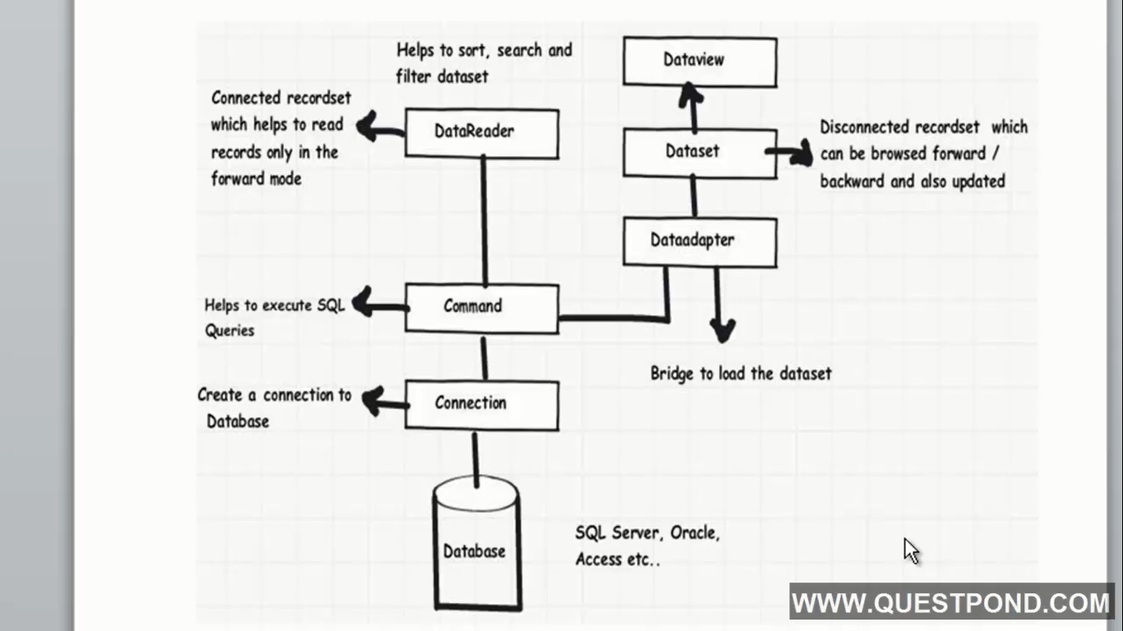

Connection and Command objects are compulsory.

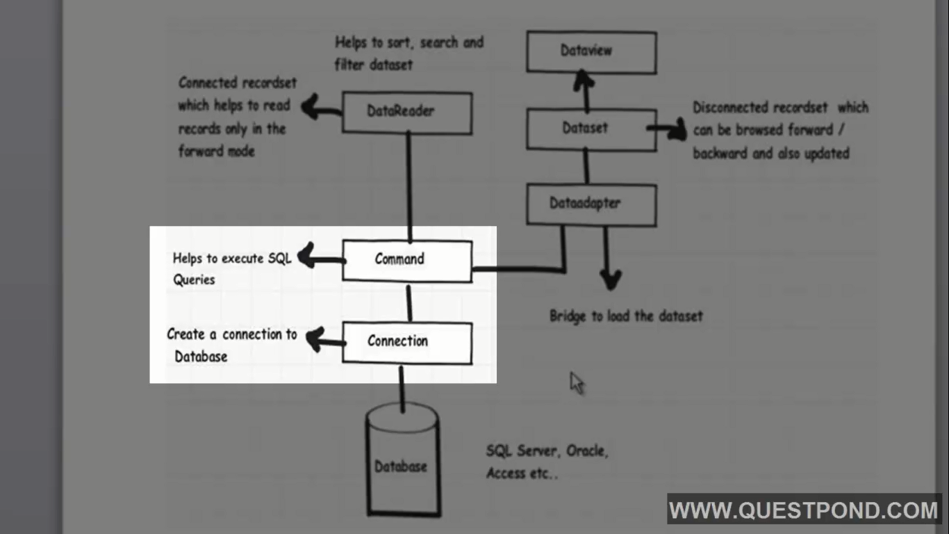

Data Reader – Connected, Forward Only and Read Only Object

