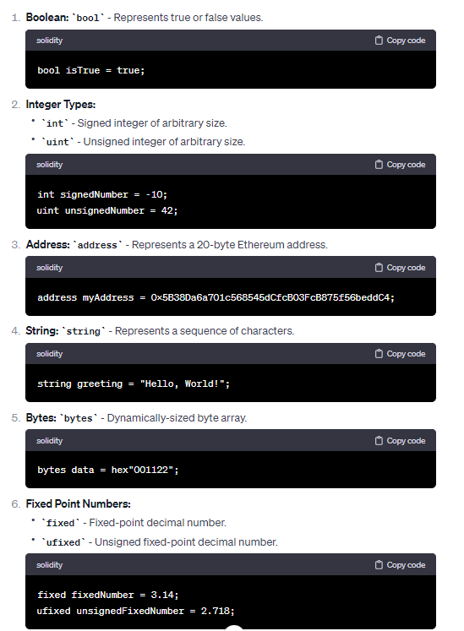

**What is the difference between signed and unsigned integers?**

The key difference between signed and unsigned integers is that signed integers can store both positive and negative values, while unsigned integers can store only non-negative values.

**Bytes:**

In Solidity, the term “bytes” refers to a dynamically-sized byte array. Solidity provides two types of byte arrays: fixed-size arrays (called “bytesN”, where N is a number between 1 and 32) and dynamic arrays (simply called “bytes”).