**Events:**

In Solidity, events are a way to emit information from a smart contract that can be captured by external applications or user interfaces. They are typically used to notify the outside world about specific state changes within the contract.

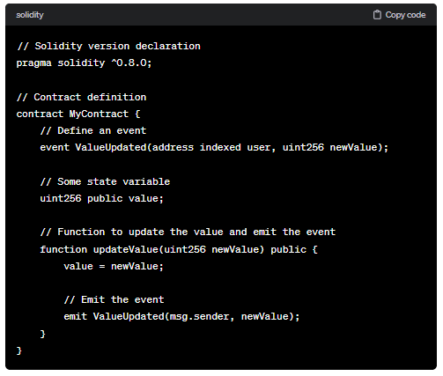

External applications or user interfaces can listen for this event and react accordingly, providing a way for decentralized applications to communicate with the external world.

**Code:**

//SPDX-License-Identifier: GPL-3.0

pragma solidity ^0.8.0;

contract Event{

    event bal(address acc, string content, uint value);

    function setValue(uint _value) public {

        emit bal(msg.sender,"has value", _value);

    }

}

contract Apps {

    event App(address indexed _from, address _to, string _content);

    function NewMessage(address to_, string memory content_) public {

        emit App(msg.sender,to_,content_);

    }

}

**Output:**

