**Array in Solidity | Fixed Size Array:**

fixed-size arrays are arrays with a predefined and fixed number of elements. These arrays have a specific size that is determined at the time of declaration and cannot be changed during the execution of the contract. Fixed-size arrays are denoted by specifying the size in square brackets when declaring the array.

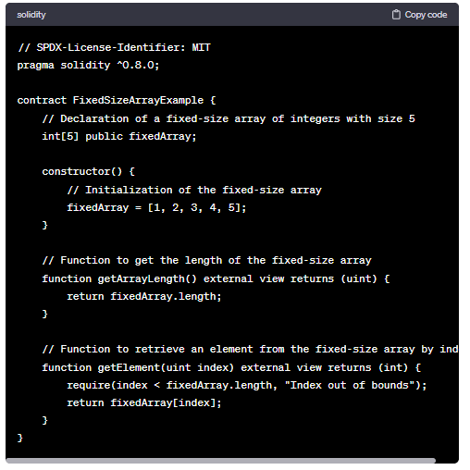

Fixed-size arrays are useful when you know the exact number of elements you need, and you want to enforce a specific size for the array. They are efficient in terms of gas costs because the size is known at compile time, and no dynamic resizing is required.

Keep in mind that using fixed-size arrays may not be suitable in situations where you need a dynamic size or if the size of the array depends on external factors. In such cases, you may want to consider using dynamic arrays (**uint[]**) or other data structures based on your requirements.

**Code:**

//SPDX-License-Identifier: GPL-3.0

pragma solidity ^0.8.0;

contract Array{

    uint[4] public arr= [10,20,30,40];

    function setter(uint index,uint value) public

    {

        arr[index]=value;

    }

}

**Output:**

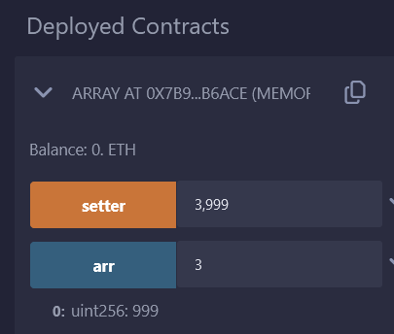

If we type 5 in front of are no response we are getting as it’s out of bound. Even if we try -1 we are not getting any value in response

**Add below mention line in previous code**

    function length() public view returns(uint)

    {

        return arr.length;

    }

}

Output:

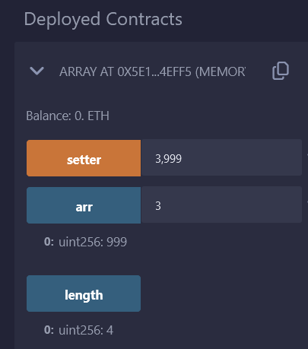

//SPDX-License-Identifier: GPL-3.0

pragma solidity ^0.8.0;

contract FixedSizeArray{

    uint[5] public arr = [10,20,30,40,50];

    function array() public view returns(uint) {

        //get

        uint temp;

        temp = arr[3];

        //update

        //arr[2] = 3000;

        //delete

        //delete arr[4];

        //len

        //uint len = arr.length;

        //return len;

        return temp;

    }

}

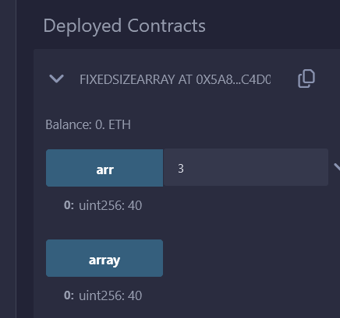

//SPDX-License-Identifier: GPL-3.0

pragma solidity ^0.8.0;

contract FixedSizeArray{

    uint[5] public arr = [10,20,30,40,50];

    function array() public view returns(uint) {

        //get

        //uint temp;

        //temp = arr[3];

        //update

        //arr[2] = 3000;

        //delete

        //delete arr[4];

        //len

        uint len = arr.length;

        return len;

        //return temp;

    }

}

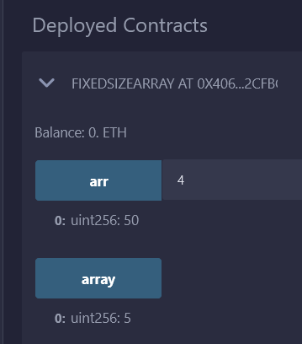

//SPDX-License-Identifier: GPL-3.0

pragma solidity ^0.8.0;

contract FixedSizeArray {

    uint[5] arr;

    constructor(){

        arr = [10,20,30,40,50];

    }

    function returnArray() public view returns(uint[5] memory){

        return arr;

    }

}

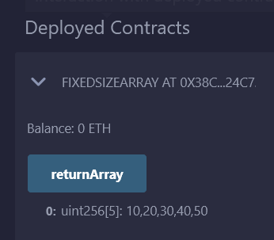

We try to avoid return array as it increase the gas cost.