**Functions | Getter and Setter Function**

In Solidity, a programming language for developing smart contracts on the Ethereum blockchain, getter and setter functions are commonly used to access and modify the state variables of a contract.

**Getter Function:**

* A getter function is a function that allows you to retrieve the current value of a state variable from a smart contract.
* Getter functions are typically defined with the **view** or **pure** modifier to indicate that they do not modify the state of the contract.
* Example of a getter function:

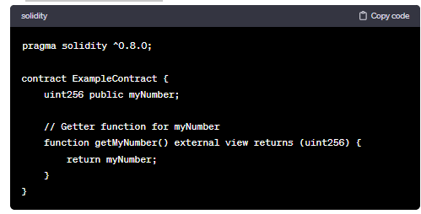

**Setter Function:**

* A setter function is a function that allows you to update or modify the value of a state variable in a smart contract.
* Setter functions often include additional logic to ensure that the new value being set complies with certain conditions.
* Example of a setter function:

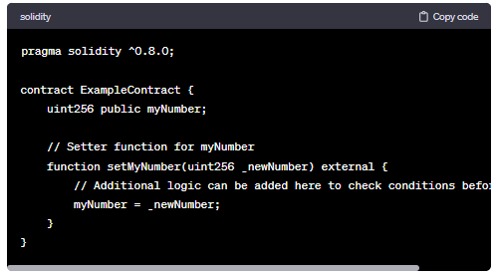

**Example:**

