**If-Else:**

In Solidity, **if-else** statement for conditional execution of code.

Here's a basic example:

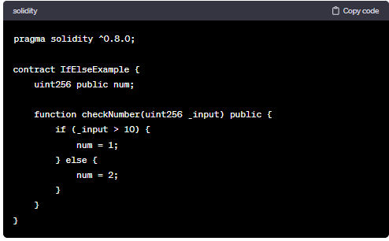

In this example, the **checkNumber** function takes an input **_input** and sets the **num** variable based on the condition. If **_input** is greater than 10, **num** is set to 1; otherwise, it is set to 2.

Solidity also supports additional conditional constructs, such as the ternary operator. Here's an example:

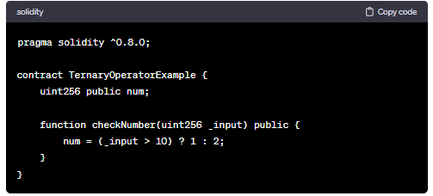

In this example, the ternary operator **(_input > 10) ? 1 : 2** is used to achieve the same result as the **if-else** statement. If **_input** is greater than 10, **num** is set to 1; otherwise, it is set to 2.

Remember to check the Solidity version specified in the pragma statement, as newer versions may have changes in syntax or features.

**Code:**

//SPDX-License-Identifier: GPL-3.0

pragma solidity >= 0.5.0 < 0.9.0;

contract conditional {

    function check(int a) public pure returns(string memory)

    {

        string memory value;

        if(a>0)

        {

            value="greater than zero";

        }

        else if(a==0)

        {

            value="equal to zero";

        }

        else

        {

            value="less than zero";

        }

        return value;

    }

}

