**Strings:**

String by default store on blockchain.

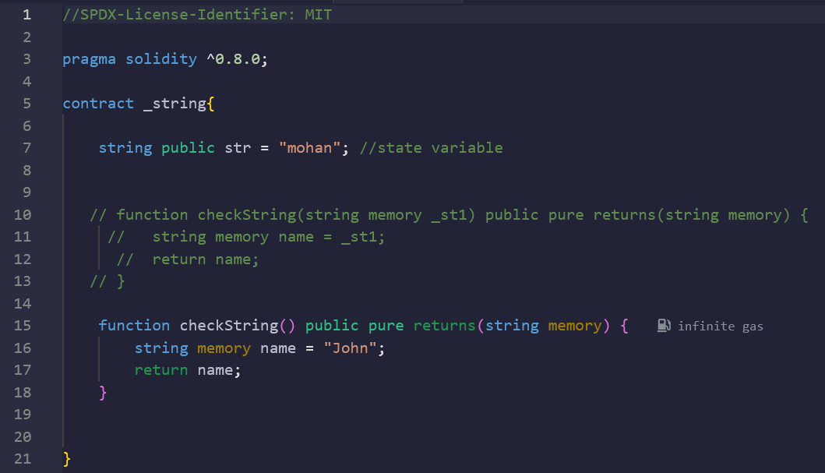

**Code:**

//SPDX-License-Identifier: MIT

pragma solidity ^0.8.0;

contract _string{

    string public str = "mohan"; //state variable

    function checkString(string memory _st1) public pure returns(string memory) {

        string memory name = _st1;

        return name;

    }

}

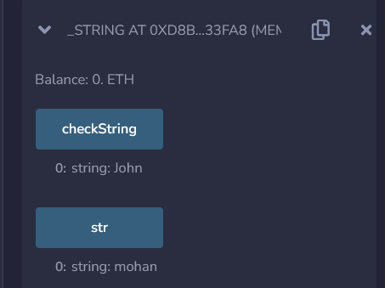

When we are using a string in the function we need to use memory along with string characters.

But in the case of state variables, we are not required to use memory with string as by default string stored in storage (blockchain).

**Constants: & Default Values:**

If we don’t want to change the state variable value then we can use “Constants”

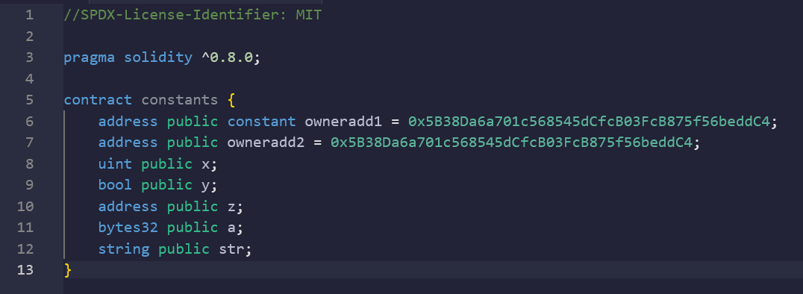

**Code:**

//SPDX-License-Identifier: MIT

pragma solidity ^0.8.0;

contract constants {

    address public constant owneradd1 = 0x5B38Da6a701c568545dCfcB03FcB875f56beddC4;

    address public owneradd2 = 0x5B38Da6a701c568545dCfcB03FcB875f56beddC4;

    uint public x;

    bool public y;

    address public z;

    bytes32 public a;

    string public str;

}

