Cs 537

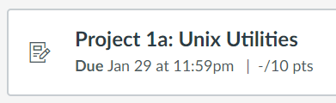

CS 559

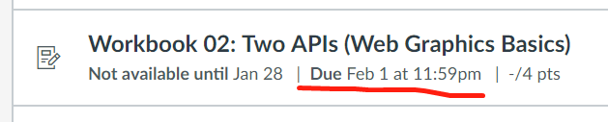

changed to 8th

MATH 431

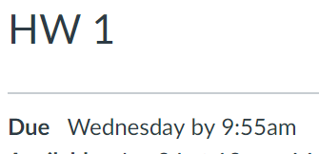

LIS 500

