FROM CRUDE OIL TO CONSUMER INFLATION: TRANSMISSION AND ATTENUATION ACROSS INDIA’S PRICE SYSTEM

A dissertation submitted to the Jawaharlal Nehru University
in partial fulfilment of the requirements
for the award of the degree of

MASTER OF SCIENCE
IN
ECONOMICS

By
ANIKET PANDEY
(21/11/EE/025)

Under the guidance of
PROFESSOR SHAKTI KUMAR
(CESP)

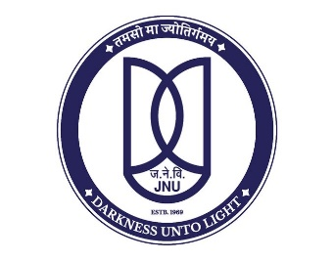
SCHOOL OF ENGINEERING
JAWAHARLAL NEHRU UNIVERSITY
NEW DELHI-110067

MAY 2026

 | SCHOOL OF ENGINEERING  JAWAHARLAL NEHRU UNIVERSITY  NEW DELHI-110067

DECLARATION

This is to certify that the dissertation entitled “FROM CRUDE OIL TO CONSUMER INFLATION: TRANSMISSION AND ATTENUATION ACROSS INDIA’S PRICE SYSTEM” is being submitted to the School of Engineering, Jawaharlal Nehru University, New Delhi, in partial fulfilment of the requirements for the award of the degree of Master of Science in Economics, as part of the dual degree programme in the School of Engineering, is a record of bona fide work carried out by me under the supervision of Prof. Shakti Kumar.
The matter embodied in the dissertation has not been submitted in part or full to any university or institution for the award of any degree or diploma.

Aniket Pandey
(21/11/EE/025)

 | SCHOOL OF ENGINEERING  JAWAHARLAL NEHRU UNIVERSITY  NEW DELHI-110067

CERTIFICATE

This is to certify that this dissertation entitled “FROM CRUDE OIL TO CONSUMER INFLATION: TRANSMISSION AND ATTENUATION ACROSS INDIA’S PRICE SYSTEM” submitted by Aniket Pandey to the School of Engineering, Jawaharlal Nehru University, New Delhi for the award of the degree of Master of Science in Economics as part of the dual degree programme in the School of Engineering, is a research work carried out by him under the supervision of Shakti Kumar .

Shakti Kumar
(Supervisor)

Dean’s Name
(Dean

