FROM WHOLESALE PRICES TO CONSUMER INFLATION: LAYERED PASS-THROUGH OF GLOBAL OIL SHOCKS IN INDIA
Aniket Pandey¹, Shakti Kumar², Utkarsh Srivastav³
Abstract
This paper studies how global oil-price shocks travel through India's domestic price system. Rather than estimate only oil price effect on headline CPI, it tracks shock across wholesale, retail fuel, fuel-sensitive consumer and headline consumer price layers. Monthly log-difference ADL models are estimated by Newey-West HAC inference with bootstrap symmetry checks. Results show layered attenuation. Retail petrol responds strongly to Brent shocks. The preferred post-2010 WPI Fuel and Power model responds strongly to rupee oil shocks and passes the diagnostic gate. CPI Fuel and Light shows smaller bridge evidence and headline WPI shows moderate pass-through. Pass-through is weak and statistically insignificant at the headline CPI endpoint. Except for a marginal retail petrol result, strong short-run asymmetry is not supported. In general, oil shocks are still visible in fuel layers but weaken in broad consumer inflation.
Keywords: Oil-price pass-through; inflation; India; wholesale price index; consumer price index; retail fuel prices.
JEL codes: C22; E31; Q43; F31.

1. Introduction
India buys most of its crude oil and pays for it in US dollars. So how much of a push on prices we have at home depends on the price of Brent crude, and the value of the rupee against the dollar. A good way to measure the impact of oil on our economy is the price of oil in rupees, oil^{INR}_{t} = Brent^{USD}_{t} × INR_{t}/USD_{t}, which is calculated by multiplying Brent's dollar price by the rupee/dollar exchange rate. If Brent goes up, or the rupee gets weaker, the rupee price of oil increases, and this cost pressure should show up most strongly in the layers closest to fuel, and then weaken (attenuate) as we move out to broader price aggregates (Mandal et al., 2012; Bhanumurthy et al., 2012).
However, something odd happens when these costs are passed on. Petrol and diesel costs are very close to the crude oil price, and wholesale inflation for fuel changes with the price of oil in rupees. But overall consumer price inflation doesn't go up in exact proportion to oil. The Wholesale Price Index (WPI) is a better indicator of price increases for producers, while the Consumer Price Index (CPI), the inflation figure for households, is most heavily influenced by food, housing, services, healthcare and education. As fuel is just one component of what people buy in the CPI, even a large oil price increase can be lessened by the time it's reflected in the final CPI inflation figure.
Much of the Indian evidence on how oil price changes affect prices has looked at equations linking oil to either WPI or CPI inflation (Mandal et al., 2012; Bhanumurthy et al., 2012; Pradeep, 2022). This gives one measure of price sensitivity, but it doesn't tell us where the effect gets weaker. This paper looks at oil price changes and how they are passed on as a problem of costs at different levels of the economy, instead of a single figure. We follow the impact from the price of oil in rupees, to wholesale prices, then from Brent crude to the retail petrol price in Delhi as calculated by the Petroleum Planning and Analysis Cell (PPAC), from PPAC's retail petrol price as a proxy for retail fuel pressure to the CPI Fuel and Light category, and finally from the price of oil in rupees to overall CPI. Each of these steps is estimated using a 'short-run asymmetric autoregressive distributed lag' model with monthly changes in values expressed as logarithms.
How fuel is managed by the government is important to understanding this. For a long time, what you pay for petrol and diesel at the pump didn't perfectly reflect what was happening to oil prices globally, and the times the system was changed altered how international oil price changes affected petrol and diesel prices. Pradeep (2022) studies these changes with asymmetry as a central issue. This paper uses that policy history only in a limited way; it does not say deregulation alone caused the post-2010 estimates. Instead, it looks at that reform period as a setting for more accurately seeing how much of the wholesale and retail fuel price changes with the world price, now that prices are set by the market.
Looking at the Wholesale Price Index (WPI) and the Consumer Price Index (CPI) is helpful, because they look at different parts of the price process. The WPI is more concerned with costs for producers and at the wholesale level. CPI is the overall figure for what consumers pay, and is what the government uses for keeping inflation in check; however, many of the things it includes won't necessarily move up and down with oil prices. Therefore, a 'layered' look at prices is more careful than just looking at the overall CPI. If oil's effect on fuel prices is strong but on the overall CPI it's weak, then we are seeing attenuation (a lessening of the effect), and oil isn't as unimportant as it might seem.
To draw conclusions, Newey-West (HAC) standard errors are used to deal with heteroskedasticity and autocorrelation (Newey & West, 1987), and CPT⁺ and CPT⁻, which are cumulative pass-through statistics, are used to summarise the response to oil price increases and decreases. Bootstrap resampling is done as a robustness check on whether prices respond differently to increases versus decreases. Serial correlation, the correct mathematical form for the calculations, and whether the relationships hold over time are all tested to check the work. And a 'model-gate' rule decides which equations are the main ones, which have caveats, and which are left out. Bai and Perron's method (2003) for finding structural breaks and a range of unit root tests, including the KPSS test (Kwiatkowski et al., 1992), are used to evaluate the 'differenced specification'.
The results show the expected layered attenuation. Retail petrol gives the strongest direct fuel-side response for consumers, with CPT⁺ = 0.3459 (p < 0.001). The preferred post-2010 WPI Fuel and Power model comes in higher at CPT⁺ = 0.5205 (p < 0.001) and clears the diagnostic gate without any complications. CPI Fuel and Light is used as a bridge between retail fuel pressure and a fuel-sensitive consumer component, and drops to CPT⁺ = 0.1777 (p = 0.0021). As the index gets broader, the response becomes weaker: headline WPI reports a statistically significant but small CPT⁺ = 0.0301 (p = 0.0240), and headline CPI comes in at CPT⁺ = 0.0213 with p = 0.1220, which is positive in sign but not statistically significant at conventional levels. A formal Wald test, with F = 14.3499, p = 0.0002, rejects equality between the retail petrol and headline CPI positive pass-through estimates. Strong asymmetry is not supported; retail petrol is the only layer showing marginal CPT⁺ = CPT⁻ rejection at the ten per cent level (p = 0.0999).
This paper is divided into six sections. Section 2 outlines the data and the variables used. A detailed explanation of the method is in Section 3. The results across price levels are in Section 4. Section 5 addresses the reliability of the results, the tests conducted to audit the work and the limits of what can be said. Section 6 discusses what the results mean and concludes.

2. Data and variables
This monthly dataset combines official Indian price series with international oil and exchange-rate data. Headline WPI and WPI Fuel and Power are from the Office of the Economic Adviser (OEA), chained to the 2011-12 base (Office of the Economic Adviser, 2017). The headline CPI source file is the OECD all-items India CPI series accessed via FRED (INDCPIALLMINMEI), and CPI Fuel and Light is the processed all-India MoSPI component series. Delhi retail petrol prices are from the Petroleum Planning and Analysis Cell (PPAC, 2024). Brent crude is from the World Bank Pink Sheet (World Bank, 2026). The CPI pipeline uses the FRED EXINUS file, and the WPI pipeline uses the updated FRED EXINUS_{l}atest file. All series are monthly.
The domestic oil shock is constructed as oil^{INR}_{t} = Brent^{USD}_{t} × INR_{t}/USD_{t}, where INR_{t}/USD_{t} is the monthly average exchange rate. This rupee oil price captures both the Brent component and the exchange-rate component of cost pressure on Indian importers and refiners. For the retail petrol model, the regressor is the Brent shock directly, because domestic retail fuel prices are administered with reference to international product prices and the rupee component is partially absorbed by tax and pricing rules. For the CPI Fuel and Light bridge model, the regressor is the PPAC petrol shock, because it gives a practical retail fuel measure for that bridge.
The samples are deliberately allowed to differ by layer. The headline WPI series gives the longest window, from 1983-05 to 2026-03. WPI Fuel and Power begins later, in 1995-05. The PPAC Delhi petrol and headline CPI equations run from 2004-08 to 2024-12 and therefore give the main 20-year consumer-side window. CPI Fuel and Light begins only in 2011-05, so it is used as a bridge between retail fuel and consumer inflation rather than as a mandatory headline result. This is why the title does not state one common date range for every layer.
${Δx}_{t}=100×\left(ln\left(x_{t}\right)-ln\left(x_{t-1}\right)\right)$ (1)
Equation (1) defines the monthly log difference of any series x_{t}. The factor of 100 means coefficients on Δx_{t} can be read approximately as percentage responses. The positive and negative shock components are defined as Δx⁺_{t} = max(Δx_{t}, 0) and Δx⁻_{t} = min(Δx_{t}, 0). The negative-shock variable is non-positive by construction, so the cumulative pass-through CPT⁻, which is the sum of coefficients on lagged Δx⁻ terms, should not be interpreted as the response to a positive shock with the opposite sign.

Table 1. Data, transformations, and model role.
Series | Source | Transformation | Sample | Role
Brent crude price | World Bank Pink Sheet monthly | Monthly log difference | Matched to layer | Global oil shock
INR/USD exchange rate | FRED EXINUS / EXINUS_latest | Monthly log difference | Matched to layer | Exchange-rate component
Rupee oil price | Brent × FRED INR/USD | Monthly log difference | Matched to layer | Domestic oil shock
Headline WPI | OEA WPI files, base 2011-12 | Monthly log difference | 1983-05 to 2026-03 | Wholesale endpoint
WPI Fuel and Power | OEA WPI files, base 2011-12 | Monthly log difference | 1995-05 to 2026-03 | Wholesale fuel layer
PPAC Delhi retail petrol | PPAC RSP pre/post-2017 files | Monthly log difference | 2004-08 to 2024-12 | Retail fuel layer
CPI Fuel and Light | MoSPI all-India Fuel and Light | Monthly log difference | 2011-05 to 2024-12 | Consumer fuel bridge
Headline CPI | FRED/OECD INDCPIALLMINMEI | Monthly log difference | 2004-08 to 2024-12 | Consumer endpoint
Note: All transformations are multiplied by 100, so coefficients can be read approximately as percentage responses. Samples differ because the official series are available over different periods. Source: Author's compilation from cited official sources.

3. Methodology
Each price layer is modelled with a short-run asymmetric ADL specification in monthly log differences. Let Δy_{t} denote the monthly log change of the layer-specific dependent variable and Δx_{t} denote the relevant shock variable. The estimating equation is
${Δy}_{t}=α+\sum_{i_{=1}}^{p}{φ_{i}{Δy}_{t-i}}+\sum_{j_{=0}}^{q}{β_{j}^{+}{Δx}_{t-j}^{+}}+\sum_{j_{=0}}^{q}{β_{j}^{-}{Δx}_{t-j}^{-}}+γ^{'}Z_{t}+μ_{m}+ε_{t}$ (2)
Here Δy_{t} is monthly inflation in the relevant price index and Δx_{t} is the layer-appropriate shock. The lag choices are model-specific and are fixed before interpreting the results. In the CPI pipeline, the autoregressive lag is p = 3, selected by AIC over p = 1 to 4, and the oil-shock lag window is q = 3. In the WPI pipeline, the headline and Fuel and Power models use AR(12) terms and oil-shock lags 0 to 6. The vector Z_{t} contains only the controls used in each estimated equation, and μ_{m} denotes month fixed effects where they are included. The innovation term ε_{t} is allowed to be heteroskedastic and serially correlated.
The exact specifications used for the main and contextual rows are: headline WPI, ADL(12,6) with month fixed effects; preferred WPI Fuel and Power, ADL(12,6) with exchange-rate controls and month fixed effects, estimated from April 2010 onward while excluding April to September 2020; PPAC retail petrol, ADL(3,3) with IIP growth, petrol and diesel deregulation dummies, a COVID dummy, and month fixed effects; PPAC petrol to CPI Fuel and Light, ADL(3,3) without extra controls; and headline CPI M1, ADL(3,3) with IIP growth, petrol and diesel deregulation dummies, a COVID dummy, and month fixed effects. Full lag coefficient outputs are retained in the replication material. The article reports cumulative pass-through and compact diagnostic summaries in the main text to keep the argument readable.
Variables across layers match the channel each layer represents. The headline WPI model employs rupee oil shocks as Δx_{t}. The WPI Fuel and Power model also uses rupee oil shocks. Brent shocks are used in the PPAC retail petrol model. PPAC petrol shocks are used in the CPI Fuel and Light bridge model. In the headline CPI model, rupee oil shocks are used. This matching keeps each regression interpretable as a pass-through equation for its layer.
Cumulative pass-through is summarised by CPT⁺ = Σ_{j} β⁺_{j} and CPT⁻ = Σ_{j} β⁻_{j}. Hypothesis tests are reported for CPT⁺ = 0, CPT⁻ = 0, and CPT⁺ = CPT⁻. Inference uses Newey-West HAC standard errors with bandwidth floor(0.75N^{1/3}) (Newey & West, 1987). A restricted-residual circular block bootstrap with 4,999 replications gives a robustness check on the asymmetry test. Predictive precedence between oil and the dependent variable is examined using Granger-style tests on lagged shock terms; these are reported as predictive precedence rather than structural causality. Tests for structural-break behaviour are performed using Bai and Perron (2003) tests, and KPSS tests confirm stationarity of log-differenced series (Kwiatkowski et al., 1992).
A model is deemed claim-bearing only if it passes a mandatory diagnostic gate, specifically a Breusch-Godfrey test for residual serial correlation, a HAC-robust RESET test for functional form, and a recursive cumulative sum test for parameter stability. Models that fail one of these checks are reported with an explicit caveat or excluded from the main claims. The full-sample pooled WPI Fuel and Power model fails this gate and is retained only as transparency context. The preferred post-2010 excluding-COVID Fuel and Power specification passes the gate and carries the wholesale fuel mechanism claim. ADF and Phillips-Perron tests confirm the first-differenced design; KPSS passes the CPI differenced variables and most WPI differenced variables, while WPI inflation carries a KPSS break-related caveat handled through the Bai-Perron check. The framework is short-run by design. Since the interest is in monthly transmission rather than long-run equilibrium adjustment, the article makes no long-run pass-through claims.

4. Results

4.1 Cumulative pass-through across price layers
Table 2 reports the central estimates. The reading is layer by layer. The retail petrol model uses Brent shocks over 2004-08 to 2024-12. The wholesale models use rupee oil shocks over the longest available samples. The CPI Fuel and Light bridge uses PPAC petrol shocks over 2011-05 to 2024-12. The headline CPI model uses rupee oil shocks over 2004-08 to 2024-12. Sample sizes vary across layers because the official series are available over different periods, so the full five-layer ranking is descriptive rather than a single common-sample estimate.

Table 2. Cumulative pass-through by price layer.
Layer | Sample | N | CPT+ | p | CPT- | p | Asym. p | Verdict
PPAC retail petrol | 2004-08 to 2024-12 | 245 | 0.3459 | <0.001 | 0.1912 | 0.0002 | 0.0999 | Strong direct fuel; marginal asymmetry
WPI Fuel and Power* | 2010-04 to 2026-03 | 186 | 0.5205 | <0.001 | 0.4195 | <0.001 | 0.1642 | Preferred wholesale fuel; diagnostics pass
CPI Fuel and Light | 2011-05 to 2024-12 | 164 | 0.1777 | 0.0021 | 0.1058 | 0.1741 | 0.4554 | Bridge evidence; shorter sample
Headline WPI | 1983-05 to 2026-03 | 515 | 0.0301 | 0.0240 | 0.0374 | 0.0012 | 0.6727 | Modest but significant
Headline CPI | 2004-08 to 2024-12 | 245 | 0.0213 | 0.1220 | 0.0006 | 0.9375 | 0.2408 | Weak; not significant
Note: CPT+ and CPT- are sums of positive- and negative-shock coefficients across the ADL lag window. P-values use Newey-West HAC inference. Asym. p is the p-value for the test CPT+ = CPT-. WPI models use rupee oil shocks; the retail petrol model uses Brent shocks; the CPI Fuel and Light row is the PPAC-to-Fuel bridge. The preferred WPI Fuel and Power row excludes April to September 2020. Samples differ by data availability, so the table is descriptive; the consumer-chain common-sample check is reported below. Source: Author's estimates from model outputs.

4.2 Wholesale layer
Headline WPI does respond to rupee oil shocks, though not extensively. The positive shocks' response is CPT⁺ = 0.0301, p = 0.0240, and the negative shocks' response is CPT⁻ = 0.0374, p = 0.0012. This indicates that there is a small but statistically significant response. The asymmetry test cannot reject equality of the two at the 0.05 level (p = 0.6727), meaning that at the wholesale endpoint there is no evidence of short-run asymmetry. Over 515 observations, an adjusted R² of 0.4207 indicates that lagged inflation, the oil shock and the seasonal structure together explain a fair share of the monthly variation in headline WPI. The model passes all the required tests (Breusch-Godfrey, HAC-RESET and recursive CUSUM), so we retain it as a claim-bearing model.
The response becomes even more pronounced once we zoom into the fuel component. The preferred WPI Fuel and Power model gives a stronger oil signal, with CPT⁺ = 0.5205 (p < 0.001) and CPT⁻ = 0.4195 (p < 0.001) on 186 observations. Asymmetry in response between positive and negative shocks is again difficult to establish; the p-value of the asymmetry test is 0.1642, so symmetry is retained for the positive and negative cumulative cases. The required diagnostics indicate that the model clears the gate cleanly, with Breusch-Godfrey p = 0.0746, HAC-RESET p = 0.5443 and recursive CUSUM p = 0.6999.
The older full-sample pooled Fuel and Power model is still useful as background, but it is no longer where we draw the preferred inference. On 371 observations it gives CPT⁺ = 0.2866 and CPT⁻ = 0.2677, but it fails the HAC-RESET functional-form test. That failure makes sense once you remember that the full sample mixes the administered and market-linked pricing periods together and also includes the unusual COVID pricing months. Restricting the preferred model to the post-2010 period and dropping April to September 2020 is therefore an economic choice about specification, not a cosmetic sample trim.
In Figure 1 the preferred wholesale fuel result is read through the regime lens. WPI Fuel and Power pass-through post-2010 is much larger than the pre-2010 estimate. This is consistent with a trend towards more market-linked fuel pricing, but it is not a clean causal estimate of deregulation. The Table 2 preferred excluding-COVID estimate is close to the post-2010 split in the figure and has cleaner functional-form diagnostics.
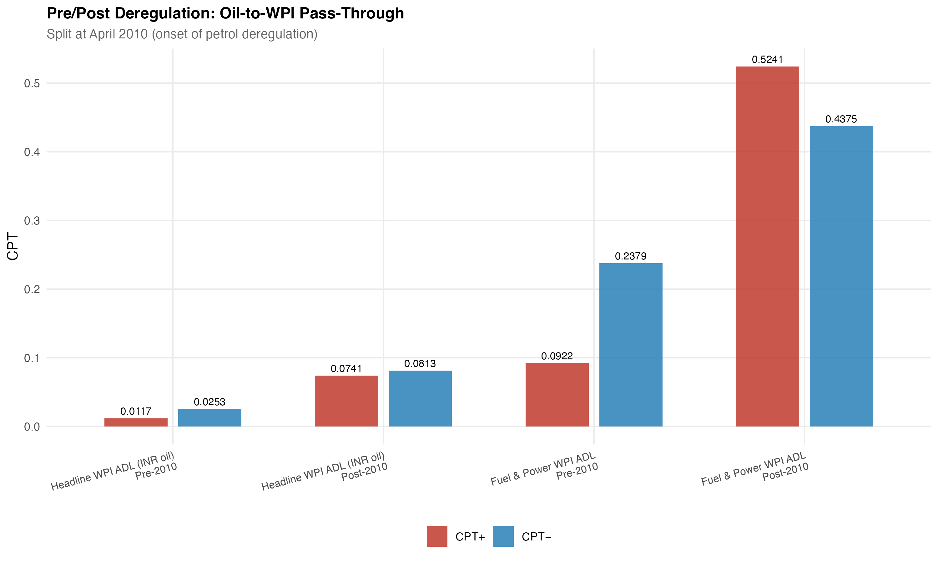
Figure 1. Pre/post-2010 wholesale oil pass-through for headline WPI and WPI Fuel and Power. Source: Author's estimates from WPI model outputs.

4.3 Retail petrol and the consumer fuel bridge
The PPAC Delhi retail petrol equation is the most directly connected fuel link to consumers in this chain. Over 245 observations with Brent as the shock variable, CPT⁺ = 0.3459 (p < 0.001) and CPT⁻ = 0.1912 (p = 0.0002). The asymmetry p-value is 0.0999, so equality is rejected only at the ten per cent significance level. The result should therefore be viewed as indicative of greater upward than downward pass-through for retail petrol, but not as conclusive evidence of asymmetric pricing. The retail petrol model meets the mandatory mechanism gate criteria; hence, it may carry the channel claim.
CPI Fuel and Light is used as a bridge between retail fuel pressure and broad consumer inflation. With the PPAC petrol shock as the regressor, CPT⁺ = 0.1777 (p = 0.0021) and CPT⁻ = 0.1058 (p = 0.1741) over 164 observations. The positive pass-through is statistically significant; the negative side is not. The result is treated as bridge evidence rather than as a primary consumer-price result, because the sample only begins in 2011-05 and is therefore considerably shorter than the headline CPI sample. The estimate is consistent with retail fuel pressure entering the fuel-sensitive consumer layer with attenuation.
The contrast between these two consumer-side layers is useful. Retail petrol is a narrow, policy-sensitive retail price and can move sharply when international prices are passed on. CPI Fuel and Light is already a basket component. It reflects household fuel and lighting items rather than only petrol, so the decline from 0.3459 in the retail petrol equation to 0.1777 in the bridge equation is consistent with attenuation across related fuel-sensitive prices rather than a strict one-to-one movement. Because the bridge sample is short, the estimate is not used to make a 20-year headline claim.

4.4 Headline CPI endpoint and integrated attenuation
Headline CPI is where the oil signal becomes weak. The positive cumulative pass-through is CPT⁺ = 0.0213 with p = 0.1220, and the negative side is CPT⁻ = 0.0006 with p = 0.9375. The positive coefficient has the expected sign, but it is not statistically significant at conventional levels. Asymmetry is not rejected (p = 0.2408). The model passes the mandatory M1 diagnostic gate, so the failure to find significant pass-through is an empirical result, not an artefact of a rejected specification.
The ranking of positive pass-through estimates gives the central result, but it must be read carefully. The preferred WPI Fuel and Power estimate is numerically the largest, and retail petrol is the largest consumer-side direct fuel response. CPI Fuel and Light is smaller, while the broad headline indices are much smaller, especially headline CPI. The formal Wald test for equality of retail petrol and headline CPI positive pass-through rejects the null at F = 14.3499, p = 0.0002. The evidence is therefore best read as attenuation across price layers rather than absence of oil-price transmission. Because not every layer shares the same sample window or shock variable, the ranking is supported most directly for the consumer chain. Figure 2 visualises that chain.
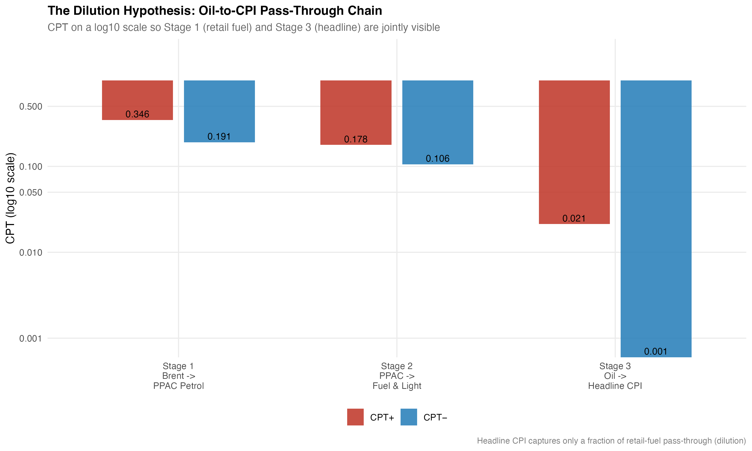
Figure 2. Cumulative positive pass-through across the consumer-price chain. Source: Author's estimates from PPAC and CPI model outputs.
The consumer chain is re-estimated on the overlapping consumer-side window, with small N differences caused by lag construction, in a common-sample exercise that reduces the risk of sample composition driving the ranking. Stage 1 (Brent to PPAC petrol) gives CPT⁺ = 0.4007 (p = 0.0001). Stage 2 (PPAC petrol to CPI Fuel and Light) gives CPT⁺ = 0.1777 (p = 0.0021). Stage 3 (rupee oil to headline CPI) gives CPT⁺ = 0.0064 (p = 0.6355). The qualitative pattern is able to survive the common-sample restriction.
Predictive-precedence tests provide supporting evidence but are not used as structural causality tests. In the WPI system, lagged rupee oil changes forecast headline WPI inflation (F = 7.4288, p < 0.001) and WPI Fuel and Power inflation (F = 15.2231, p < 0.001), while the reverse WPI-to-oil direction is not supported. On the consumer side, Brent predicts PPAC petrol (F = 10.7127, p < 0.001). Lagged rupee oil terms predict headline CPI only at the ten per cent level (F = 2.2861, p = 0.0794), and PPAC petrol does not clearly predict CPI Fuel and Light in the bridge equation (p = 0.1126). This matches the main estimates: the oil signal is easier to pick up near fuel prices than in broad CPI.

5. Robustness, diagnostics, and limitations
The WPI result holds up even when the rupee oil shock is broken down into a Brent component and an exchange-rate component. Decomposing leads to CPT⁺ = 0.0309 (p = 0.0234) and CPT⁻ = 0.0375 (p < 0.001), with an asymmetry p-value of 0.7039. These figures sit very close to the rupee-shock benchmark and confirm that the small wholesale endpoint result does not rely on combining the two components. Bootstrap symmetry tests with 4,999 iterations do not reject CPT⁺ = CPT⁻ for headline WPI and for WPI Fuel and Power, which is consistent with the HAC-based asymmetry tests shown in Table 2.
The diagnostics are summarised in Table 3. The headline WPI model clears the Breusch-Godfrey test for serial correlation, the HAC-RESET test for functional form, and the recursive CUSUM test for parameter stability, and the preferred WPI Fuel and Power model clears the same gate. The older full-sample pooled Fuel and Power model fails HAC-RESET and is retained only for context. The headline CPI M1 model clears the mandatory gate, and the PPAC retail petrol model clears the mechanism gate. The two CPI alternatives, M2 and M3, are not claim-bearing because their diagnostics are rejected, so they did not pass and are left outside the main conclusions. Where the symmetry checks do not reject symmetry in the main wholesale and consumer endpoint models, asymmetry is not the key finding of the paper. The unit-root tests favour the use of log differences, with the WPI inflation KPSS caveat read alongside the Bai-Perron break evidence.
Table 3. Diagnostics and robustness summary.
Check | Result | Interpretation
Headline WPI diagnostics | BG, HAC-RESET, Rec-CUSUM pass | Main WPI model accepted
Preferred WPI Fuel and Power | BG, HAC-RESET, Rec-CUSUM pass | Wholesale fuel mechanism accepted
Pooled WPI Fuel and Power | BG, Rec-CUSUM pass; HAC-RESET fails | Context only, not preferred inference
Headline CPI M1 gate | Pass | Main CPI endpoint accepted
PPAC mechanism gate | Pass | Direct fuel channel accepted
CPI M2, M3 gates | Diagnostics fail | Excluded from main claims
Bootstrap symmetry (WPI, CPI) | Symmetry not rejected | Asymmetry not central
Note: BG = Breusch-Godfrey; HAC-RESET = HAC-robust Ramsey RESET; Rec-CUSUM = recursive cumulative sum stability test. Source: Author's diagnostic outputs.
A pre/post-2010 split of the wholesale models offers a fourth piece of context. For headline WPI, CPT⁺ rises from 0.0117 (p = 0.3812) in the pre-2010 sample to 0.0741 (p = 0.0043) in the post-2010 sample. For WPI Fuel and Power, CPT⁺ rises from 0.0922 (p = 0.1679) to 0.5241 (p < 0.001). The post-2010 estimates are consistent with stronger pass-through around the period of more market-linked fuel pricing, including petrol deregulation in June 2010 and diesel deregulation in October 2014. The split is not a clean causal estimate of deregulation, because other macroeconomic and policy changes occurred over the same window. The preferred Fuel and Power model is the stricter post-2010 version that excludes April to September 2020 and gives CPT⁺ = 0.5205. The split is reported as institutional evidence.
The limitations are stated plainly. The estimates are reduced-form short-run projections, not structural causal effects. Different layers have different sample spans, although the common-sample exercise reproduces the qualitative ranking. CPI Fuel and Light has a shorter sample than headline CPI and WPI, and is therefore used as bridge rather than primary evidence. PPAC retail petrol uses Delhi prices, which are treated as a retail fuel-channel proxy rather than a complete national retail measure. The preferred WPI Fuel and Power model uses a shorter post-2010 sample that excludes the COVID months, and the full-sample pooled model is shown only as caveated comparative context. The pre/post-2010 split is not intended to establish a clean or experimental deregulation result; it reflects institutional evidence. The layered map is not a single mechanical WPI-to-CPI causal chain; it is made up of layer-by-layer pass-through equations that share a common interpretation.

6. Discussion and conclusion
The result of this paper is not that oil is unimportant for Indian inflation. Retail petrol tracks Brent strongly, the wholesale fuel layer responds firmly to rupee oil shocks, and CPI Fuel and Light shows a smaller but statistically significant bridge response. The result is that headline CPI absorbs and dilutes oil shocks because the CPI basket is broad. Food, housing, services, health, and education together dominate the index, and the direct fuel weight, even augmented by indirect cost effects, is too small for the oil signal to dominate the headline figure on a monthly basis.
For inflation monitoring, the implication is narrow but useful. A reader who monitors only headline CPI may miss near-fuel price pressure, because the oil signal is small at that layer and is statistically insignificant in the present sample. Monitoring a small set of fuel-sensitive layers, such as retail petrol, WPI Fuel and Power, and CPI Fuel and Light, carries more information about short-run pass-through than the headline aggregate alone. This is consistent with earlier work on Indian oil pass-through (Mandal et al., 2012; Bhanumurthy et al., 2012; Pradeep, 2022), and adds the layered organisation as a way to read those results.
In conclusion, we asked whether oil-price shocks manifest uniformly across the layers of Indian pricing, or whether their effects dissipate as we move to broader indices. The estimates provide evidence for the second case. WPI Fuel and Power and retail petrol sit at the top as the high-pass-through fuel layers, CPI Fuel and Light comes in smaller, headline WPI is moderate, and headline CPI is weak and statistically insignificant. The formal consumer-chain Wald test rejects equality between retail petrol and headline CPI, which we consider the cleanest piece of evidence for the attenuation story. The preferred WPI Fuel and Power estimate makes it through the diagnostic gate, and the full-sample pooled version is kept only as context. Asymmetry is not the headline finding here; only retail petrol shows a marginal asymmetry result, and only at the ten per cent level. The pre/post-2010 split is consistent with stronger pass-through once fuel pricing became more market-linked, but we read this as institutional context rather than a clean causal estimate.
The main takeaway is straightforward: oil shocks do not disappear in India, but they lose force as they travel from fuel prices to broad consumer inflation.

References
Bai, J., & Perron, P. (2003). Computation and analysis of multiple structural change models. Journal of Applied Econometrics, 18(1), 1‑22. https://doi.org/10.1002/jae.659
Bhanumurthy, N. R., Das, S., & Bose, S. (2012). Oil price shock, pass-through policy and its impact on India (NIPFP Working Paper No. 2012-99). National Institute of Public Finance and Policy.
Kwiatkowski, D., Phillips, P. C. B., Schmidt, P., & Shin, Y. (1992). Testing the null hypothesis of stationarity against the alternative of a unit root. Journal of Econometrics, 54(1‑3), 159‑178. https://doi.org/10.1016/0304-4076(92)90104-Y
Mandal, K., Bhattacharyya, I., & Bhoi, B. B. (2012). Is the oil price pass-through in India any different? Journal of Policy Modeling, 34(6), 832‑848. https://doi.org/10.1016/j.jpolmod.2012.06.001
Ministry of Statistics and Programme Implementation. (2015). Consumer Price Index: Changes in the revised series. Government of India.
Newey, W. K., & West, K. D. (1987). A simple, positive semi-definite, heteroskedasticity and autocorrelation consistent covariance matrix. Econometrica, 55(3), 703‑708. https://doi.org/10.2307/1913610
Office of the Economic Adviser. (2017). Manual on Wholesale Price Index: Base 2011‑12 = 100. Department for Promotion of Industry and Internal Trade, Ministry of Commerce and Industry, Government of India.
Petroleum Planning and Analysis Cell. (2024). Ready reckoner: India's oil and gas. Ministry of Petroleum and Natural Gas, Government of India.
Pradeep, S. (2022). Impact of diesel price reforms on asymmetricity of oil price pass-through to inflation: Indian perspective. The Journal of Economic Asymmetries, 26, e00249. https://doi.org/10.1016/j.jeca.2022.e00249
World Bank. (2026). Commodity price data: The Pink Sheet. World Bank Commodity Markets.

