Layered Oil-Price Pass-Through in India: Evidence from Wholesale, Retail Fuel, and Consumer Prices
Aniket Pandey
Abstract
This paper studies how global oil-price shocks pass through India's domestic price system. Instead of estimating only the effect of oil prices on headline CPI, it follows the shock across wholesale, retail fuel, fuel-sensitive consumer, and headline consumer price layers. Monthly log-difference ADL models are estimated with Newey-West HAC inference and bootstrap symmetry checks. The results show a layered attenuation pattern. Retail petrol responds strongly to Brent shocks. The preferred post-2010 WPI Fuel and Power model responds strongly to rupee oil shocks and passes the diagnostic gate. CPI Fuel and Light gives smaller bridge evidence, and headline WPI shows modest pass-through. At the headline CPI endpoint, positive pass-through is weak and statistically insignificant. Strong short-run asymmetry is not supported, except for a marginal retail petrol result. Overall, oil shocks remain visible in fuel layers but lose force in broad consumer inflation.
Keywords: Oil-price pass-through; inflation; India; wholesale price index; consumer price index; retail fuel prices.
JEL codes: C22; E31; Q43; F31.

1. Introduction
India imports a large share of its crude oil and prices that crude in United States dollars. Domestic oil pressure therefore depends on the Brent price and on the rupee-dollar exchange rate, so a useful measure of the domestic oil shock is the rupee-denominated oil price, oil^{INR}_{t} = Brent^{USD}_{t} × INR_{t}/USD_{t}. When Brent rises or the rupee weakens, the rupee oil price rises, and the cost pressure should appear first in the layers closest to fuel and then, with attenuation, in broader price aggregates (Mandal et al., 2012; Bhanumurthy et al., 2012).
There is a familiar puzzle in this transmission. Petrol and diesel prices visibly track crude, and wholesale fuel inflation moves with rupee oil prices, but headline consumer inflation does not move one-for-one with oil. The Wholesale Price Index (WPI) is closer to producer cost pressure, while the Consumer Price Index (CPI) is the household-facing inflation index and is weighted heavily towards food, housing, services, health, and education. Fuel is only one component of the CPI basket, so even a strong oil shock can be diluted by the time it reaches headline CPI inflation.
Most existing studies on Indian oil pass-through estimate a single equation linking oil to either WPI or CPI inflation (Mandal et al., 2012; Bhanumurthy et al., 2012; Pradeep, 2022). That approach gives one elasticity, but it does not show where the signal weakens. The contribution of this paper is to treat oil-price pass-through as a layered price-system problem rather than a single elasticity. The chain studied here moves from the rupee oil price to wholesale prices, from Brent to the Petroleum Planning and Analysis Cell (PPAC) Delhi retail petrol price, from PPAC retail petrol to CPI Fuel and Light, and from rupee oil to headline CPI. Each layer is estimated as a short-run asymmetric autoregressive distributed lag (ADL) model in monthly log differences.
The institutional background also matters. Domestic fuel prices were not always fully linked to international prices, and reform episodes changed the way international oil movements entered petrol and diesel prices. Pradeep (2022) studies this reform setting and places asymmetry at the centre of the question. This paper uses that background more narrowly. It does not claim that deregulation caused the post-2010 estimates. It treats the reform period as useful context for reading stronger wholesale and retail fuel pass-through after pricing became more market-linked.
The WPI and CPI distinction is useful for this question because the two indices measure different layers of the price system. WPI is closer to producer and wholesale cost pressure. CPI is the consumer-facing aggregate used for inflation targeting, but it contains many items whose monthly movements need not follow oil prices. A layered design therefore gives a more cautious interpretation than a single headline CPI equation. If oil is strong in fuel layers but weak in headline CPI, the correct conclusion is attenuation, not irrelevance.
Inference uses Newey-West heteroskedasticity and autocorrelation consistent (HAC) standard errors (Newey & West, 1987), and the cumulative pass-through statistics CPT⁺ and CPT⁻ summarise the response to positive and negative shock terms. Bootstrap resampling provides a robustness check on asymmetry. Diagnostic tests cover serial correlation, functional form, and recursive stability, and a model-gate rule separates main, caveated, and excluded equations. Bai and Perron (2003) structural-break logic and the unit-root test battery, including KPSS checks (Kwiatkowski et al., 1992), are used to assess the differenced specification.
The estimates suggest a layered attenuation pattern. Retail petrol shows the strongest direct consumer-side fuel response, with CPT⁺ = 0.3459 (p < 0.001). The preferred post-2010 WPI Fuel and Power model shows CPT⁺ = 0.5205 (p < 0.001) and passes the diagnostic gate. CPI Fuel and Light, the consumer fuel bridge, shows CPT⁺ = 0.1777 (p = 0.0021). Headline WPI shows a statistically significant but modest CPT⁺ = 0.0301 (p = 0.0240). Headline CPI shows CPT⁺ = 0.0213 with p = 0.1220, which is positive in sign but not statistically significant at conventional levels. A formal Wald test rejects equality of the retail petrol and headline CPI positive pass-through estimates at F = 14.3499, p = 0.0002. Asymmetry is mostly weak, with only retail petrol showing a marginal CPT⁺ = CPT⁻ rejection at the ten per cent level (p = 0.0999).
The remainder of the paper is organised as follows. Section 2 describes the data and variables. Section 3 sets out the methodology. Section 4 reports results across price layers. Section 5 covers robustness, diagnostics, and limitations. Section 6 discusses implications and concludes.

2. Data and variables
The dataset is monthly and combines official Indian price series with international oil and exchange-rate data. Headline WPI and WPI Fuel and Power are from the Office of the Economic Adviser (OEA), chained to the 2011-12 base (Office of the Economic Adviser, 2017). The headline CPI source file is the OECD all-items India CPI series accessed through FRED (INDCPIALLMINMEI), while CPI Fuel and Light is the processed all-India MoSPI component series. Delhi retail petrol prices are from the Petroleum Planning and Analysis Cell (PPAC, 2024). Brent crude is from the World Bank Pink Sheet (World Bank, 2026). The CPI pipeline uses the FRED EXINUS file, and the WPI pipeline uses the updated FRED EXINUS_{l}atest file. All series are monthly.
The domestic oil shock is constructed as oil^{INR}_{t} = Brent^{USD}_{t} × INR_{t}/USD_{t}, where INR_{t}/USD_{t} is the monthly average exchange rate. This rupee oil price captures both the Brent component and the exchange-rate component of cost pressure on Indian importers and refiners. For the retail petrol model, the regressor is the Brent shock directly, because domestic retail fuel prices are administered with reference to international product prices and the rupee component is partially absorbed by tax and pricing rules. For the CPI Fuel and Light bridge model, the regressor is the PPAC petrol shock, because that is the price the fuel-sensitive consumer layer faces.
The samples are deliberately allowed to differ by layer. The headline WPI series gives the longest window, from 1983-05 to 2026-03. WPI Fuel and Power begins later, in 1995-05. The PPAC Delhi petrol and headline CPI equations run from 2004-08 to 2024-12 and therefore give the main 20-year consumer-side window. CPI Fuel and Light begins only in 2011-05, so it is used as a bridge between retail fuel and consumer inflation rather than as a mandatory headline result. This is why the title does not state one common date range for every layer.
${Δx}_{t}=100×\left(ln\left(x_{t}\right)-ln\left(x_{t-1}\right)\right)$ (1)
Equation (1) defines the monthly log difference of any series x_{t}. The factor of 100 means coefficients on Δx_{t} can be read approximately as percentage responses. The positive and negative shock components are defined as Δx⁺_{t} = max(Δx_{t}, 0) and Δx⁻_{t} = min(Δx_{t}, 0). The negative-shock variable is non-positive by construction, so the cumulative pass-through CPT⁻, which is the sum of coefficients on lagged Δx⁻ terms, should not be interpreted as the response to a positive shock with the opposite sign.
Table 1. Data, transformations, and model role.
Series | Source | Transformation | Sample | Role
Brent crude price | World Bank Pink Sheet monthly | Monthly log difference | Matched to layer | Global oil shock
INR/USD exchange rate | FRED EXINUS / EXINUS_latest | Monthly log difference | Matched to layer | Exchange-rate component
Rupee oil price | Brent × FRED INR/USD | Monthly log difference | Matched to layer | Domestic oil shock
Headline WPI | OEA WPI files, base 2011-12 | Monthly log difference | 1983-05 to 2026-03 | Wholesale endpoint
WPI Fuel and Power | OEA WPI files, base 2011-12 | Monthly log difference | 1995-05 to 2026-03 | Wholesale fuel layer
PPAC Delhi retail petrol | PPAC RSP pre/post-2017 files | Monthly log difference | 2004-08 to 2024-12 | Retail fuel layer
CPI Fuel and Light | MoSPI all-India Fuel and Light | Monthly log difference | 2011-05 to 2024-12 | Consumer fuel bridge
Headline CPI | FRED/OECD INDCPIALLMINMEI | Monthly log difference | 2004-08 to 2024-12 | Consumer endpoint
Note: All transformations are multiplied by 100, so coefficients can be read approximately as percentage responses. Samples differ because the official series are available over different periods. Source: Author's compilation from cited official sources.

3. Methodology
Each price layer is modelled with a short-run asymmetric ADL specification in monthly log differences. Let Δy_{t} denote the monthly log change of the layer-specific dependent variable and Δx_{t} denote the relevant shock variable. The estimating equation is
${Δy}_{t}=α+\sum_{i_{=1}}^{p}{φ_{i}{Δy}_{t-i}}+\sum_{j_{=0}}^{q}{β_{j}^{+}{Δx}_{t-j}^{+}}+\sum_{j_{=0}}^{q}{β_{j}^{-}{Δx}_{t-j}^{-}}+γ^{'}Z_{t}+μ_{m}+ε_{t}$ (2)
Here Δy_{t} is monthly inflation in the relevant price index and Δx_{t} is the layer-appropriate shock. The lag choices are model-specific and are fixed before interpreting the results. In the CPI pipeline, the autoregressive lag is p = 3, selected by AIC over p = 1 to 4, and the oil-shock lag window is q = 3. In the WPI pipeline, the headline and Fuel and Power models use AR(12) terms and oil-shock lags 0 to 6. The vector Z_{t} contains only the controls used in each estimated equation, and μ_{m} denotes month fixed effects where they are included. The innovation term ε_{t} is allowed to be heteroskedastic and serially correlated.
The exact specifications used for the main and contextual rows are: headline WPI, ADL(12,6) with month fixed effects; preferred WPI Fuel and Power, ADL(12,6) with exchange-rate controls and month fixed effects, estimated from April 2010 onward while excluding April to September 2020; PPAC retail petrol, ADL(3,3) with IIP growth, petrol and diesel deregulation dummies, a COVID dummy, and month fixed effects; PPAC petrol to CPI Fuel and Light, ADL(3,3) without extra controls; and headline CPI M1, ADL(3,3) with IIP growth, petrol and diesel deregulation dummies, a COVID dummy, and month fixed effects. Full lag coefficient outputs are retained in the replication material. The article reports cumulative pass-through and compact diagnostic summaries in the main text to keep the argument readable.
Variables across layers are matched to the channel each layer represents. The headline WPI model uses rupee oil shocks as Δx_{t}. The WPI Fuel and Power model also uses rupee oil shocks. The PPAC retail petrol model uses Brent shocks. The CPI Fuel and Light bridge model uses PPAC petrol shocks. The headline CPI model uses rupee oil shocks. This matching keeps each regression interpretable as a pass-through equation for its layer.
Cumulative pass-through is summarised by CPT⁺ = Σ_{j} β⁺_{j} and CPT⁻ = Σ_{j} β⁻_{j}. Hypothesis tests are reported for CPT⁺ = 0, CPT⁻ = 0, and CPT⁺ = CPT⁻. Inference uses Newey-West HAC standard errors with bandwidth floor(0.75N^{1/3}) (Newey & West, 1987). A restricted-residual circular block bootstrap with 4,999 replications provides a robustness check on the asymmetry test. Predictive precedence between oil and the dependent variable is examined with Granger-style tests on lagged shock terms; these are reported as predictive precedence rather than structural causality. Structural-break behaviour is examined through Bai and Perron (2003) tests, and stationarity of log-differenced series is verified by KPSS tests (Kwiatkowski et al., 1992).
A model is treated as claim-bearing only if it passes a mandatory diagnostic gate, specifically a Breusch-Godfrey test for residual serial correlation, a HAC-robust RESET test for functional form, and a recursive cumulative sum test for parameter stability. Models that fail one of these checks are reported with an explicit caveat or excluded from the main claims. The full-sample pooled WPI Fuel and Power model fails this gate and is retained only as transparency context. The preferred post-2010 excluding-COVID Fuel and Power specification passes the gate and carries the wholesale fuel mechanism claim. ADF and Phillips-Perron tests support the first-differenced design; KPSS passes the CPI differenced variables and most WPI differenced variables, while WPI inflation carries a KPSS break-related caveat handled through the Bai-Perron check. The framework is short-run by design. There are no NARDL bounds tests, no error-correction terms, and no long-run pass-through claims, because the object of interest is monthly transmission rather than long-run equilibrium adjustment.

4. Results

4.1 Cumulative pass-through across price layers
Table 2 reports the central estimates. The reading is layer by layer. The retail petrol model uses Brent shocks over 2004-08 to 2024-12. The wholesale models use rupee oil shocks over the longest available samples. The CPI Fuel and Light bridge uses PPAC petrol shocks over 2011-05 to 2024-12. The headline CPI model uses rupee oil shocks over 2004-08 to 2024-12. Sample sizes vary across layers because the official series are available over different periods, so the full five-layer ranking is descriptive rather than a single common-sample estimate.
Table 2. Cumulative pass-through by price layer.
Layer | Sample | N | CPT+ | p | CPT- | p | Asym. p | Verdict
PPAC retail petrol | 2004-08 to 2024-12 | 245 | 0.3459 | <0.001 | 0.1912 | 0.0002 | 0.0999 | Strong direct fuel; marginal asymmetry
WPI Fuel and Power* | 2010-04 to 2026-03 | 186 | 0.5205 | <0.001 | 0.4195 | <0.001 | 0.1642 | Preferred wholesale fuel; diagnostics pass
CPI Fuel and Light | 2011-05 to 2024-12 | 164 | 0.1777 | 0.0021 | 0.1058 | 0.1741 | 0.4554 | Bridge evidence; shorter sample
Headline WPI | 1983-05 to 2026-03 | 515 | 0.0301 | 0.0240 | 0.0374 | 0.0012 | 0.6727 | Modest but significant
Headline CPI | 2004-08 to 2024-12 | 245 | 0.0213 | 0.1220 | 0.0006 | 0.9375 | 0.2408 | Weak; not significant
Note: CPT+ and CPT- are sums of positive- and negative-shock coefficients across the ADL lag window. P-values use Newey-West HAC inference. Asym. p is the p-value for the test CPT+ = CPT-. WPI models use rupee oil shocks; the retail petrol model uses Brent shocks; the CPI Fuel and Light row is the PPAC-to-Fuel bridge. The preferred WPI Fuel and Power row excludes April to September 2020. Samples differ by data availability, so the table is descriptive; the consumer-chain common-sample check is reported below. Source: Author's estimates from model outputs.

4.2 Wholesale layer
Headline WPI shows statistically significant but modest pass-through from rupee oil shocks. The cumulative response to positive shocks is CPT⁺ = 0.0301 with p = 0.0240, and the cumulative response to negative shock terms is CPT⁻ = 0.0374 with p = 0.0012. The asymmetry test does not reject equality (p = 0.6727), so the wholesale endpoint does not support short-run asymmetry. The adjusted R² of 0.4207 over 515 observations indicates that the lagged inflation, oil shock, and seasonal structure together explain a substantial share of monthly headline WPI variation. The model passes the Breusch-Godfrey, HAC-RESET, and recursive CUSUM checks, so it is treated as claim-bearing.
The preferred WPI Fuel and Power model carries a much stronger oil signal, with CPT⁺ = 0.5205 (p < 0.001) and CPT⁻ = 0.4195 (p < 0.001) over 186 observations. The point estimates imply that the wholesale fuel layer responds strongly within the lag window. The asymmetry p-value of 0.1642 does not reject equality of positive and negative cumulative effects. The model passes the mandatory diagnostic gate: Breusch-Godfrey p = 0.0746, HAC-RESET p = 0.5443, and recursive CUSUM p = 0.6999.
The older full-sample pooled Fuel and Power model is still useful context but no longer carries the preferred inference. It gives CPT⁺ = 0.2866 and CPT⁻ = 0.2677 over 371 observations, but fails the HAC-RESET functional-form test. The failure is consistent with mixing administered and market-linked pricing periods and with the unusual COVID pricing months. Restricting the preferred model to the post-2010 period and excluding April to September 2020 is therefore an economic specification choice, not a cosmetic sample trim.
Figure 1 shows why the preferred wholesale fuel result should be read through the regime lens. Post-2010 WPI Fuel and Power pass-through is much larger than the pre-2010 estimate. This is consistent with the move towards more market-linked fuel pricing, although it is not a clean causal estimate of deregulation. The preferred excluding-COVID estimate in Table 2 is close to the post-2010 split shown in the figure and has cleaner functional-form diagnostics.
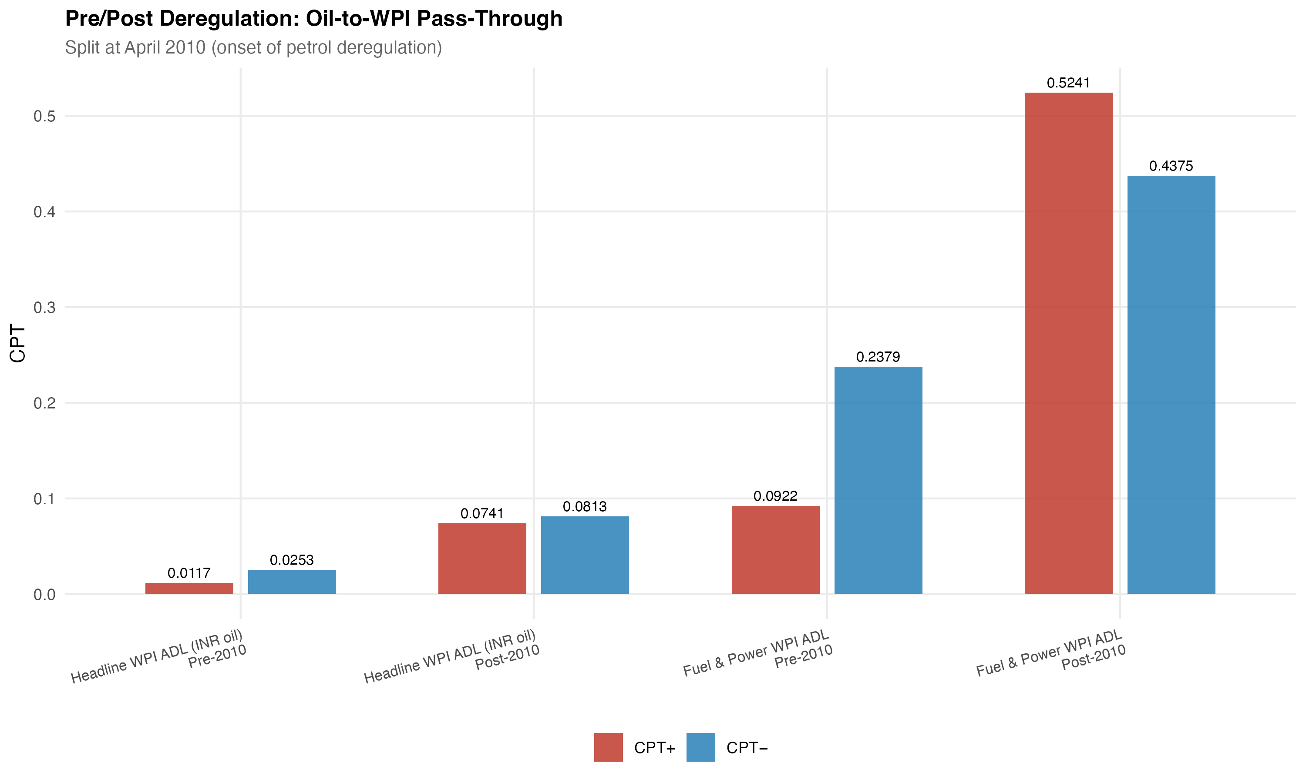
Figure 1. Pre/post-2010 wholesale oil pass-through for headline WPI and WPI Fuel and Power. Source: Author's estimates from WPI model outputs.

4.3 Retail petrol and the consumer fuel bridge
The PPAC Delhi retail petrol equation is the strongest direct fuel layer in the consumer-side chain. With Brent as the shock variable, CPT⁺ = 0.3459 (p < 0.001) and CPT⁻ = 0.1912 (p = 0.0002) over 245 observations. The asymmetry p-value is 0.0999, which rejects equality only at the ten per cent level. The result should therefore be read as suggestive of stronger upward than downward pass-through in retail petrol, but not as decisive evidence of asymmetric pricing. The retail petrol model passes the mandatory mechanism gate, so it can carry the channel claim.
CPI Fuel and Light is the consumer fuel layer that sits between retail fuel prices and broad consumer inflation. With the PPAC petrol shock as the regressor, CPT⁺ = 0.1777 (p = 0.0021) and CPT⁻ = 0.1058 (p = 0.1741) over 164 observations. The positive pass-through is statistically significant; the negative side is not. The result is treated as bridge evidence rather than as a primary consumer-price result, because the sample only begins in 2011-05 and is therefore considerably shorter than the headline CPI sample. The estimate is consistent with retail fuel pressure entering the fuel-sensitive consumer layer with attenuation.
The contrast between these two consumer-side layers is useful. Retail petrol is a narrow, policy-sensitive retail price and can move sharply when international prices are passed on. CPI Fuel and Light is already a basket component. It includes household fuel items and therefore smooths the retail petrol shock. The decline from 0.3459 in the retail petrol equation to 0.1777 in the bridge equation is consistent with partial transmission rather than a full one-for-one movement. Because the bridge sample is short, the estimate is not used to make a 20-year headline claim.

4.4 Headline CPI endpoint and integrated attenuation
Headline CPI is where the oil signal becomes weak. The positive cumulative pass-through is CPT⁺ = 0.0213 with p = 0.1220, and the negative side is CPT⁻ = 0.0006 with p = 0.9375. The positive coefficient has the expected sign, but it is not statistically significant at conventional levels. Asymmetry is not rejected (p = 0.2408). The model passes the mandatory M1 diagnostic gate, so the failure to find significant pass-through is an empirical result, not an artefact of a rejected specification.
The ranking of positive pass-through estimates gives the central result, but it must be read carefully. The preferred WPI Fuel and Power estimate is numerically the largest, and retail petrol is the largest consumer-side direct fuel response. CPI Fuel and Light is smaller, while the broad headline indices are much smaller, especially headline CPI. The formal Wald test for equality of retail petrol and headline CPI positive pass-through rejects the null at F = 14.3499, p = 0.0002. The evidence is therefore best read as attenuation across price layers rather than absence of oil-price transmission. Because not every layer shares the same sample window or shock variable, the ranking is supported most directly for the consumer chain. Figure 2 visualises that chain.
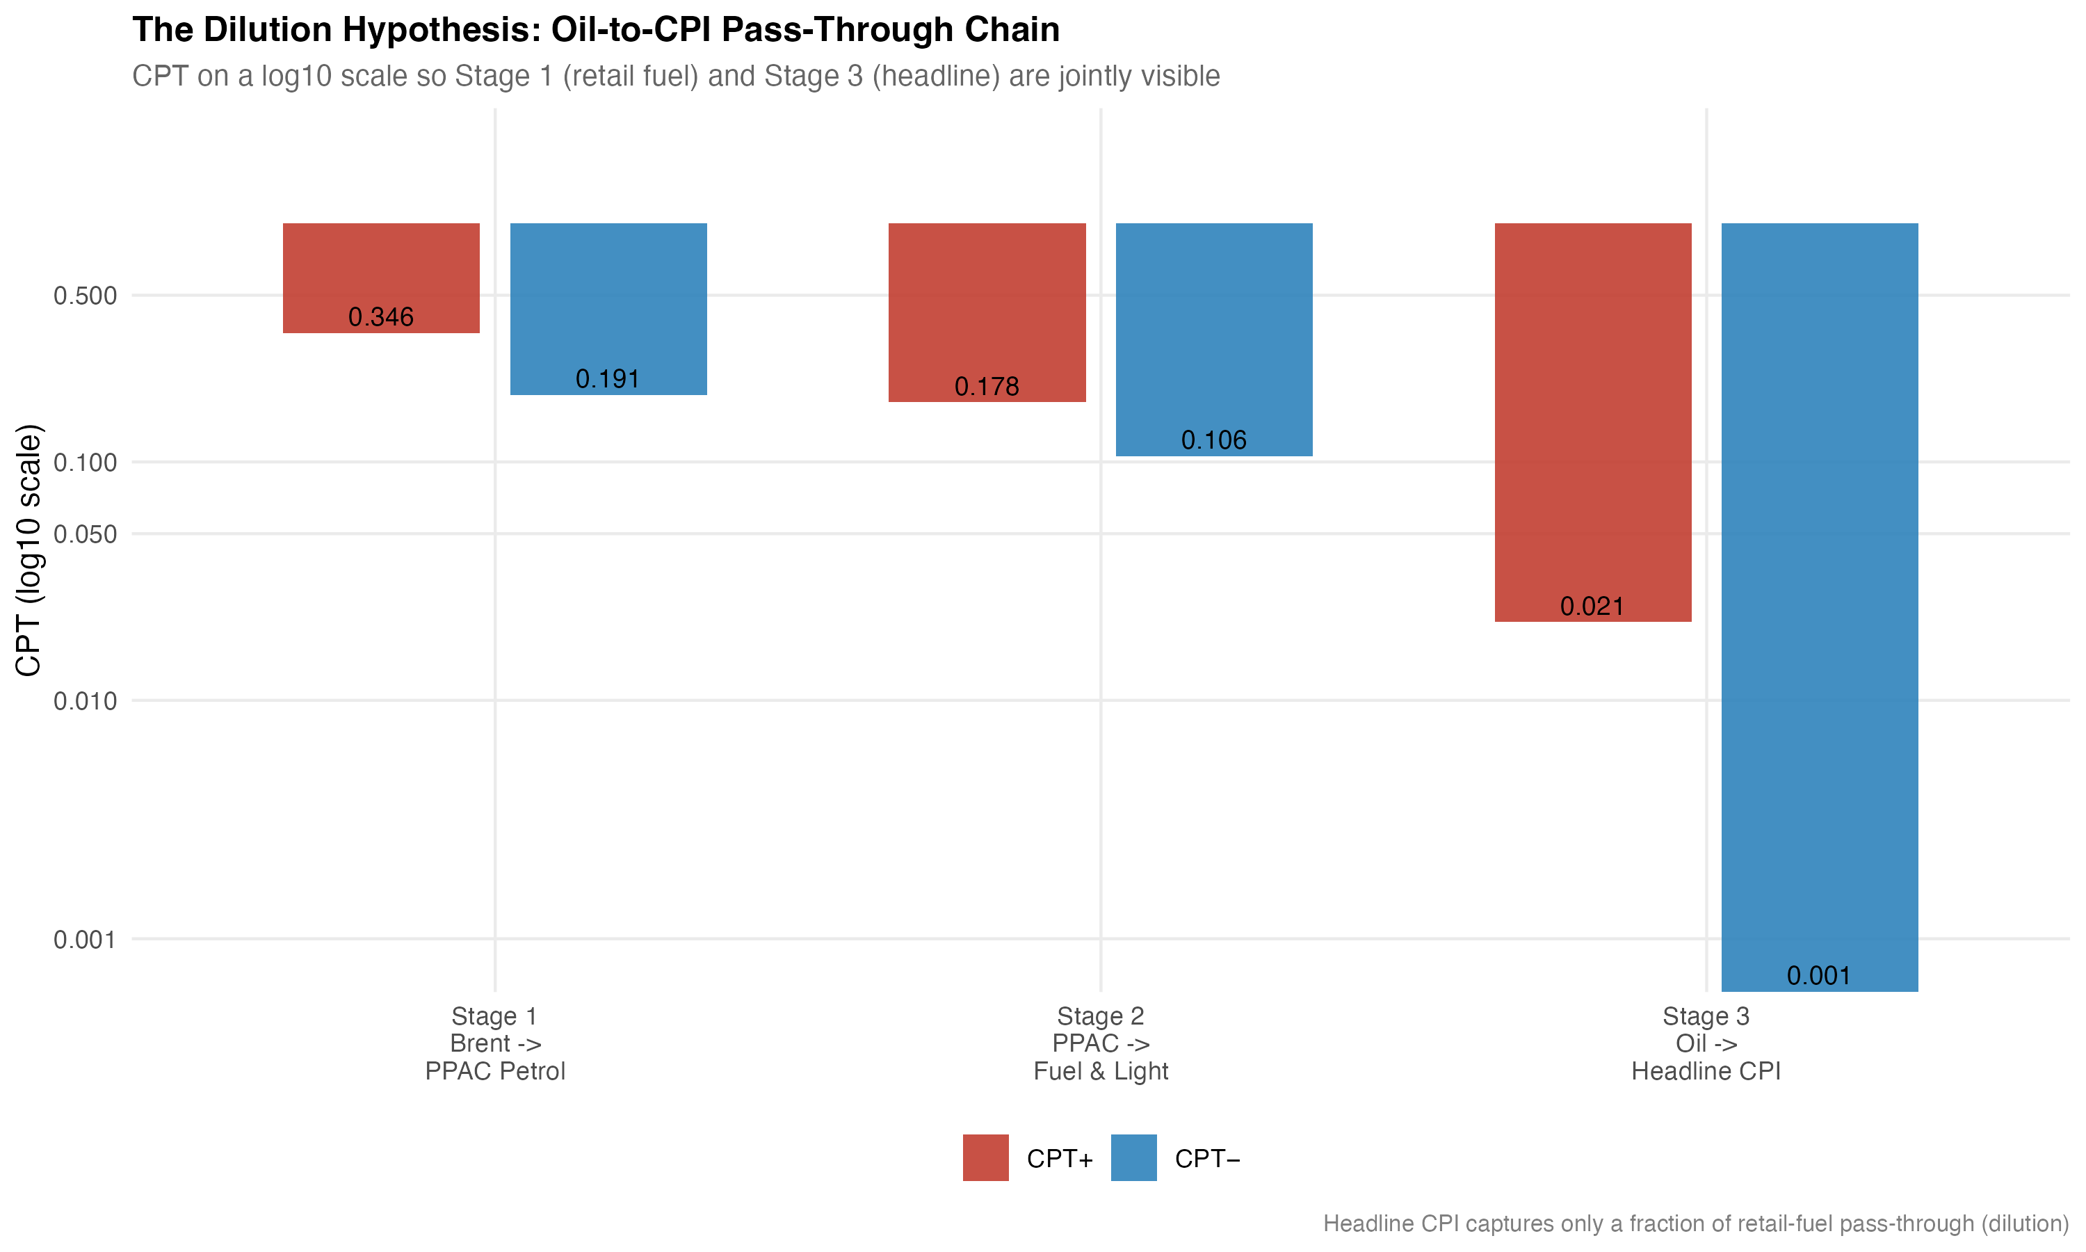
Figure 2. Cumulative positive pass-through across the consumer-price chain. Source: Author's estimates from PPAC and CPI model outputs.
A common-sample exercise re-estimates the consumer chain on the overlapping consumer-side window, with small N differences caused by lag construction, to reduce the risk that sample composition drives the ranking. Stage 1 (Brent to PPAC petrol) gives CPT⁺ = 0.4007 (p = 0.0001). Stage 2 (PPAC petrol to CPI Fuel and Light) gives CPT⁺ = 0.1777 (p = 0.0021). Stage 3 (rupee oil to headline CPI) gives CPT⁺ = 0.0064 (p = 0.6355). The qualitative pattern survives the common-sample restriction.
Predictive-precedence tests give supporting evidence, but they are not used as structural causality tests. In the WPI system, lagged rupee oil changes predict headline WPI inflation (F = 7.4288, p < 0.001) and WPI Fuel and Power inflation (F = 15.2231, p < 0.001), while the reverse WPI-to-oil direction is not supported. On the consumer side, Brent strongly predicts PPAC petrol (F = 10.7127, p < 0.001). Lagged rupee oil terms predict headline CPI only at the ten per cent level (F = 2.2861, p = 0.0794), and PPAC petrol does not clearly predict CPI Fuel and Light in the bridge equation (p = 0.1126). This pattern matches the main estimates: the oil signal is easier to detect near fuel prices than in broad CPI.

5. Robustness, diagnostics, and limitations
The headline WPI result is robust to decomposing the rupee oil shock into a Brent component and an exchange-rate component. The decomposition gives CPT⁺ = 0.0309 (p = 0.0234) and CPT⁻ = 0.0375 (p < 0.001), with an asymmetry p-value of 0.7039. These figures are within rounding distance of the rupee-shock benchmark and confirm that the modest wholesale endpoint result does not depend on combining the two components. Bootstrap symmetry tests with 4,999 replications fail to reject CPT⁺ = CPT⁻ for headline WPI and for WPI Fuel and Power, which is consistent with the HAC-based asymmetry tests in Table 2.
The diagnostics are summarised in Table 3. The headline WPI model passes the Breusch-Godfrey test for serial correlation, the HAC-RESET test for functional form, and the recursive CUSUM test for parameter stability. The preferred WPI Fuel and Power model passes the same gate. The older full-sample pooled Fuel and Power model fails HAC-RESET and is retained only as context. The headline CPI M1 model passes the mandatory gate. The PPAC retail petrol model passes the mechanism gate. Two alternative CPI specifications explored in the supporting work, M2 and M3, are not claim-bearing because their diagnostics are rejected. The symmetry checks do not reject symmetry in the main wholesale and consumer endpoint models, so asymmetry is not the central finding of the paper. Unit-root tests support using log differences, with the WPI inflation KPSS caveat read alongside the Bai-Perron break evidence.
Table 3. Diagnostics and robustness summary.
Check | Result | Interpretation
Headline WPI diagnostics | BG, HAC-RESET, Rec-CUSUM pass | Main WPI model accepted
Preferred WPI Fuel and Power | BG, HAC-RESET, Rec-CUSUM pass | Wholesale fuel mechanism accepted
Pooled WPI Fuel and Power | BG, Rec-CUSUM pass; HAC-RESET fails | Context only, not preferred inference
Headline CPI M1 gate | Pass | Main CPI endpoint accepted
PPAC mechanism gate | Pass | Direct fuel channel accepted
CPI M2, M3 gates | Diagnostics fail | Excluded from main claims
Bootstrap symmetry (WPI, CPI) | Symmetry not rejected | Asymmetry not central
Note: BG = Breusch-Godfrey; HAC-RESET = HAC-robust Ramsey RESET; Rec-CUSUM = recursive cumulative sum stability test. Source: Author's diagnostic outputs.
A pre/post-2010 split of the wholesale models offers a fourth piece of context. For headline WPI, CPT⁺ rises from 0.0117 (p = 0.3812) in the pre-2010 sample to 0.0741 (p = 0.0043) in the post-2010 sample. For WPI Fuel and Power, CPT⁺ rises from 0.0922 (p = 0.1679) to 0.5241 (p < 0.001). The post-2010 estimates are consistent with stronger pass-through around the period of more market-linked fuel pricing, including petrol deregulation in June 2010 and diesel deregulation in October 2014. The split is not a clean causal estimate of deregulation, because other macroeconomic and policy changes occurred over the same window. The preferred Fuel and Power model is the stricter post-2010 version that excludes April to September 2020 and gives CPT⁺ = 0.5205. The split is reported as institutional evidence.
The limitations are stated plainly. The estimates are reduced-form short-run projections, not structural causal effects. Different layers have different sample spans, although the common-sample exercise reproduces the qualitative ranking. CPI Fuel and Light has a shorter sample than headline CPI and WPI, and is therefore used as bridge rather than primary evidence. PPAC retail petrol uses Delhi prices, which are treated as a retail fuel-channel proxy rather than a complete national retail measure. The preferred WPI Fuel and Power model uses a shorter post-2010 excluding-COVID sample; the full-sample pooled model is shown only as caveated context. The pre/post-2010 split is suggestive institutional evidence, not a clean deregulation experiment. The layered map is not a single mechanical WPI-to-CPI causal chain; it is a set of layer-by-layer pass-through equations that share a common interpretation.

6. Discussion and conclusion
The result of this paper is not that oil is unimportant for Indian inflation. Retail petrol tracks Brent strongly, the wholesale fuel layer responds firmly to rupee oil shocks, and CPI Fuel and Light shows a smaller but statistically significant bridge response. The result is that headline CPI absorbs and dilutes oil shocks because the CPI basket is broad. Food, housing, services, health, and education together dominate the index, and the direct fuel weight, even augmented by indirect cost effects, is too small for the oil signal to dominate the headline figure on a monthly basis.
For inflation monitoring, the implication is narrow but useful. A reader who monitors only headline CPI may miss near-fuel price pressure, because the oil signal is small at that layer and is statistically insignificant in the present sample. Monitoring a small set of fuel-sensitive layers, such as retail petrol, WPI Fuel and Power, and CPI Fuel and Light, carries more information about short-run pass-through than the headline aggregate alone. This is consistent with earlier work on Indian oil pass-through (Mandal et al., 2012; Bhanumurthy et al., 2012; Pradeep, 2022), and adds the layered organisation as a way to read those results.
The conclusion can be stated compactly. The research question is whether oil-price shocks transmit uniformly across Indian price layers or whether they attenuate as the index becomes broader. The estimates support a descriptive attenuation reading: WPI Fuel and Power and retail petrol are the high-pass-through fuel layers, CPI Fuel and Light is smaller, headline WPI is modest, and headline CPI is weak and statistically insignificant. The formal consumer-chain test rejects equality between retail petrol and headline CPI. The preferred WPI Fuel and Power estimate passes the diagnostic gate, while the full-sample pooled version is retained only as context. Asymmetry is not the main finding; only retail petrol shows a marginal asymmetry result at the ten per cent level. The post-2010 split is consistent with stronger pass-through under more market-linked fuel pricing, but it is institutional rather than causal evidence.
The main lesson is that oil shocks do not disappear in India, but they lose force as they move from fuel prices to broad consumer inflation.

References
Bai, J., & Perron, P. (2003). Computation and analysis of multiple structural change models. Journal of Applied Econometrics, 18(1), 1‑22. https://doi.org/10.1002/jae.659
Bhanumurthy, N. R., Das, S., & Bose, S. (2012). Oil price shock, pass-through policy and its impact on India (NIPFP Working Paper No. 2012-99). National Institute of Public Finance and Policy.
Kwiatkowski, D., Phillips, P. C. B., Schmidt, P., & Shin, Y. (1992). Testing the null hypothesis of stationarity against the alternative of a unit root. Journal of Econometrics, 54(1‑3), 159‑178. https://doi.org/10.1016/0304-4076(92)90104-Y
Mandal, K., Bhattacharyya, I., & Bhoi, B. B. (2012). Is the oil price pass-through in India any different? Journal of Policy Modeling, 34(6), 832‑848. https://doi.org/10.1016/j.jpolmod.2012.06.001
Ministry of Statistics and Programme Implementation. (2015). Consumer Price Index: Changes in the revised series. Government of India.
Newey, W. K., & West, K. D. (1987). A simple, positive semi-definite, heteroskedasticity and autocorrelation consistent covariance matrix. Econometrica, 55(3), 703‑708. https://doi.org/10.2307/1913610
Office of the Economic Adviser. (2017). Manual on Wholesale Price Index: Base 2011‑12 = 100. Department for Promotion of Industry and Internal Trade, Ministry of Commerce and Industry, Government of India.
Petroleum Planning and Analysis Cell. (2024). Ready reckoner: India's oil and gas. Ministry of Petroleum and Natural Gas, Government of India.
Pradeep, S. (2022). Impact of diesel price reforms on asymmetricity of oil price pass-through to inflation: Indian perspective. The Journal of Economic Asymmetries, 26, e00249. https://doi.org/10.1016/j.jeca.2022.e00249
World Bank. (2026). Commodity price data: The Pink Sheet. World Bank Commodity Markets.

