From wholesale prices to consumer inflation: layered pass-through of global oil shocks in India, 1983-2026

Abstract
This dissertation studies how global oil-price shocks pass through India's domestic price system. India imports most of its crude oil, and crude is priced in dollars, so movements in Brent and the INR/USD exchange rate form the external cost shock. Rather than estimating one oil-to-headline-CPI elasticity, the dissertation follows the shock across several layers: headline WPI, WPI Fuel and Power, PPAC Delhi retail petrol, CPI Fuel and Light, and headline CPI. The models use monthly data and short-run asymmetric ADL specifications in log differences. Inference relies on Newey-West HAC standard errors, cumulative pass-through tests, bootstrap symmetry checks, and diagnostic checks. The results show layered attenuation. Retail petrol responds strongly to Brent shocks, while WPI Fuel and Power responds strongly to rupee oil shocks. CPI Fuel and Light records a smaller but statistically significant bridge response. Headline WPI pass-through is statistically significant but modest. Headline CPI pass-through is positive, weak, and not statistically significant at conventional levels. A common-sample attenuation test rejects equality between retail-petrol and headline-CPI positive pass-through. The evidence does not say that oil shocks are irrelevant for Indian inflation. It says their measurable effect is strongest near fuel prices and much weaker in the broad consumer index. Short-run asymmetry is secondary: it is marginal in retail petrol and unsupported in headline WPI, WPI Fuel and Power, and headline CPI.

Chapter 1
Introduction

1.1 The puzzle in Indian inflation
India imports most of its crude oil. Because crude is invoiced in US dollars, the domestic cost shock from oil depends on both the Brent price and the rupee-dollar exchange rate. A rise in Brent and a depreciation of the rupee can amplify each other. A strong rupee can blunt a Brent rise. The rupee oil price therefore matters more for domestic inflation than Brent alone.
The puzzle starts from a simple observation. The same oil shock that visibly changes retail petrol prices at the pump can leave only a small mark on headline consumer inflation, the index that anchors monetary policy. This is not a contradiction. It is a sign that the shock weakens somewhere inside the price system. A rupee oil shock can reach prices directly through retail fuel and the fuel-sensitive sub-indices of WPI and CPI. It can also reach prices indirectly through transport, packaging, and industrial input costs. At the same time, taxes, margins, basket weights, and index construction absorb part of the shock at every stage. Treating oil pass-through as a single elasticity between Brent and headline CPI hides where this absorption happens.
WPI and CPI are also different by design. WPI is closer to producer-side and wholesale costs, with a non-trivial weight on fuel and power, mineral oils, and oil-intensive manufactured products. CPI is the household-facing index targeted by the inflation-targeting framework, and its basket is dominated by food, services, housing, and other non-fuel categories. Strong pass-through into wholesale fuel prices and weak pass-through into headline CPI can therefore coexist as a structural feature rather than as a model artefact.

1.2 Research question and contribution
The research question asks where the transmission weakens. How do global oil-price shocks transmit across India's wholesale, retail fuel, fuel-sensitive consumer, and headline consumer price layers, and where does this pass-through weaken? The framing is not limited to whether oil affects CPI or whether pass-through is asymmetric. Those questions remain important, but the primary framing is transmission and attenuation across layers.
The contribution is the combined map. The dissertation puts wholesale prices, retail petrol, fuel-sensitive consumer prices, and headline CPI in one India-specific frame, while keeping the differences in samples and shock variables visible.
The dissertation treats oil pass-through as a layered transmission problem rather than as a single elasticity between crude oil and headline inflation. The estimates use short-run asymmetric autoregressive distributed lag (ADL) models in log differences with Newey-West HAC inference. Positive and negative oil components are entered separately, and cumulative pass-through is summarised over the lag window. A Wald test asks whether the positive and negative cumulative effects are equal. Symmetry is also assessed using a restricted-residual circular block bootstrap with 4,999 replications. Granger causality tests and Bai-Perron break tests are used as supporting checks, not as structural causal evidence.

1.3 Preview of empirical results
Chapter 5 reports the full estimates. The main result can be previewed briefly here because it defines the contribution of the dissertation. Oil shocks are strongest at direct fuel-price layers, remain visible in fuel-sensitive wholesale and consumer components, and become much weaker in the broad headline indices. Positive cumulative pass-through is large for PPAC retail petrol (0.3459) and WPI Fuel and Power (0.2866), smaller for CPI Fuel and Light (0.1777), modest but statistically significant for headline WPI (0.0301), and weak and not statistically significant for headline CPI (0.0213). A common-sample attenuation test rejects equality between retail-petrol and headline-CPI positive pass-through, with F = 14.3499 and p = 0.0002.
The detailed p-values, diagnostics, and robustness checks are deferred to the results chapter. The important point for the introduction is the ordering. These estimates should not be read as one structural chain estimate. Each comes from the ADL equation suited to that layer. The common pattern is that oil shocks are strong in retail petrol and fuel-sensitive wholesale prices, smaller in CPI Fuel and Light, modest but statistically significant in headline WPI, and weak and not statistically significant in headline CPI. Short-run asymmetry is not the main finding. The retail petrol layer is the only layer where asymmetry is suggestive, and even there it is marginal at the 10 percent level.

1.4 Why the question matters
The layered framing speaks to two practical concerns. The first is how to interpret headline CPI as the monetary-policy anchor in an economy with large external cost shocks. If upstream prices respond but headline CPI responds weakly, CPI-based policy is not necessarily ignoring oil. It is observing the shock after basket weights, taxes, margins, and index construction have absorbed part of it. The second concern is fuel pricing policy. The pre/post-2010 wholesale split provides indirect evidence consistent with stronger pass-through under more market-linked pricing.

1.5 Roadmap
Chapter 2 places the empirical design inside India's oil pricing institutions and the existing literature. Chapter 3 describes the data, the chained WPI series, and the variable transformations. Chapter 4 sets out the asymmetric ADL specification and the inference strategy. Chapter 5 presents the layered results, the integrated attenuation result, and the pre/post-2010 wholesale split. Chapter 6 reports robustness checks, diagnostics, and limitations. The conclusion answers the research question directly.

Chapter 2
Background and literature

2.1 India's oil-price setting
Three institutional facts shape the empirical design. First, India imports most of its crude oil, so Brent price movements directly influence domestic refining costs. Second, the rupee price of oil matters more for domestic inflation than Brent alone, because crude is invoiced in dollars. The exchange rate is therefore part of the shock rather than an external control. Third, fuel pricing policy affects how quickly international prices reach consumers. Petrol pricing was deregulated in June 2010, and diesel pricing was deregulated in October 2014. Under administered pricing, the government set retail prices for long stretches and absorbed part of the shock through under-recoveries to oil marketing companies and through subsidy adjustments. Under market-linked pricing, oil marketing companies revise retail prices much more frequently, which raises the empirical pass-through that an econometric model can detect.
The dissertation reports a pre/post-2010 split for the wholesale models to capture this institutional shift. The split is informative, but it is not a clean experiment. Other changes also happened after 2010, including CPI rebasing in 2011, the move to flexible inflation targeting in 2016, the Goods and Services Tax in 2017, several rounds of fuel-tax adjustments, and the global commodity and pandemic episodes that followed. The post-2010 wholesale estimates are consistent with stronger pass-through under more market-linked fuel pricing. They should not be read as a clean causal estimate of deregulation.

2.2 Why WPI and CPI can differ
WPI and CPI answer different empirical questions. WPI is closer to producer and wholesale cost pressure. The Fuel and Power group within WPI covers mineral oils, electricity, and coal, so it is more exposed to energy-cost movements than the broad headline basket. CPI is the household-facing index. It includes food, services, housing, education, health, and other non-fuel items, and has been the inflation-targeting anchor since 2016. The direct weight of fuel in CPI is limited, while the weight of food and services is large.
This is the main economic reason why a fuel shock can be visible in WPI Fuel and Power and in retail petrol while staying small in headline CPI. Strong pass-through in fuel-sensitive layers and weak pass-through at the headline CPI level are not contradictory. They are consistent with the way the two indices are constructed and with the dilution that happens through tax and margin absorption between the wholesale layer and the consumer basket.

2.3 Literature
The literature most directly relevant to this dissertation can be summarised in a few studies. Mandal et al. (2012) examine oil-price pass-through in India and document how domestic adjustment depends on the pricing regime. Their evidence anticipates the institutional point that empirical pass-through is partly a function of how often retail prices are revised. Bhanumurthy et al. (2012) embed oil shocks in a broader macroeconomic frame and consider the trade-off between pass-through policy, inflation, and fiscal cost. Their work provides useful context for why the political economy of pass-through is complicated even when the engineering of pass-through is straightforward.
Pradeep (2022) studies the impact of diesel price reform on the asymmetricity of oil-price pass-through to disaggregated wholesale prices, retail diesel, and aggregate consumer prices. That study is the closest in spirit to the layered design used here, although the present dissertation extends the layered map to include retail petrol, the WPI Fuel and Power group, the CPI Fuel and Light bridge, and headline CPI inside a single empirical frame. On the methodological side, Newey and West (1987) provide the HAC covariance estimator used for inference in the ADL models. Bai and Perron (2003) provide the multiple-break test used in the structural-break diagnostics. Kwiatkowski et al. (1992) provide the stationarity test used in the unit root battery.
This dissertation fits that literature but uses a different frame. The results agree with Mandal et al. on pricing-regime dependence, with Bhanumurthy et al. on policy-mediated transmission, and with Pradeep's emphasis that reform can change both magnitude and asymmetry. Instead of leading with one aggregate inflation estimate, the dissertation asks how the same broad oil-price problem looks as the empirical object moves from wholesale and retail fuel prices to fuel-sensitive consumer prices and then to headline CPI.
The asymmetric split between positive and negative oil changes follows the applied pass-through literature. In this dissertation the asymmetric ADL specification is used as a transparent way of asking whether the cumulative response to positive and negative shocks differs in the short run. The study does not estimate long-run relationships; the focus is on short-run dynamics in log differences.

2.4 Gap and hypotheses
Existing Indian studies often answer one of these questions in isolation: does oil affect WPI, does oil affect CPI, do retail fuel prices adjust asymmetrically, and did deregulation alter pass-through. Each of these is a useful question, but together they leave the reader without a single map of where the shock survives and where it fades. This dissertation asks a different question. Where does the shock weaken as it moves through the price system?
The empirical hypotheses follow from this framing. H1: oil shocks pass through significantly to headline WPI, but the magnitude is small. H2: pass-through is stronger in retail fuel and fuel-sensitive layers than in the headline aggregates. H3: headline CPI shows attenuation relative to upstream and fuel-sensitive layers. H4: post-2010 wholesale pass-through is larger than pre-2010 pass-through, consistent with more market-linked fuel pricing. H5: if short-run asymmetry appears, it is expected to be more visible at the retail fuel layer than in the broad headline aggregates.

Chapter 3
Data and variables

3.1 Data sources
The empirical work uses monthly series drawn from official Indian statistical agencies and standard international macro databases. The wholesale price evidence is built from the Office of the Economic Adviser (OEA) WPI series, with the headline aggregate and the Fuel and Power group chained across successive base years to a common 2011-12 base. The retail fuel evidence is taken from the Petroleum Planning and Analysis Cell (PPAC) ready reckoner, which publishes monthly retail prices of petrol and diesel for the major Indian metropolitan markets. The international Brent crude price is obtained from the World Bank Pink Sheet and is cross-checked against the FRED POILBREUSDM series. The INR/USD exchange rate is obtained from FRED (series EXINUS). The all-India CPI is taken from the Ministry of Statistics and Programme Implementation (MoSPI), and the harmonised CPI Fuel and Light component is taken from the same source for the post-2011 period. The Index of Industrial Production is used as the activity control.
All series are merged at monthly frequency on common dates. Active samples are reported in Table 3.1 after inner joins on dates. The wholesale series carry a non-trivial chaining step that is documented separately in Section 3.3. The CPI Fuel and Light component is treated as bridge evidence rather than as a main mandate because the harmonised post-2011 series limits its sample to 164 months.
Table 3.1: Series, sources, transformations, and sample spans
Series | Source | Transformation | Active sample
Brent crude (USD/bbl) | World Bank Pink Sheet | Monthly log difference | Matched to layer
INR/USD exchange rate | FRED EXINUS | Monthly log difference | Matched to layer
Rupee oil price | Brent multiplied by INR/USD | Monthly log difference | Matched to layer
Headline WPI | OEA, chained to 2011-12 = 100 | Monthly log difference | 1983-05 to 2026-03
WPI Fuel and Power | OEA, chained to 2011-12 = 100 | Monthly log difference | 1995-05 to 2026-03
PPAC Delhi retail petrol | PPAC ready reckoner | Monthly log difference | 2004-08 to 2024-12
CPI Fuel and Light | MoSPI harmonised series | Monthly log difference | 2011-05 to 2024-12
Headline CPI (all-India) | MoSPI / FRED CPI source | Monthly log difference | 2004-08 to 2024-12
IIP (activity control) | MoSPI | Monthly log difference | Matched to layer
Notes: Wholesale series are chained to 2011-12 = 100 using official linking factors. Active samples are reported after inner joins on common monthly dates. CPI Fuel and Light is treated as bridge evidence because the harmonised series begins in 2011.

3.2 Variable construction
The rupee oil price is constructed by multiplying Brent in dollars per barrel by the monthly average INR/USD exchange rate. In symbols, oil_{INR} = Brent_{USD} * INR_{per USD}. This is the main shock variable for the headline WPI, WPI Fuel and Power, and headline CPI specifications. The PPAC retail petrol specification uses Brent as the shock variable because retail petrol movements are tightly linked to the dollar-denominated benchmark, especially after petrol pricing became more market-linked in 2010. The CPI Fuel and Light bridge specification uses the PPAC retail petrol price as the shock variable because it studies how retail fuel movements enter the fuel-sensitive consumer layer.
$Δx_{t} = 100 × [ ln\left(x_{t}\right) - ln\left(x_{t-1}\right) ]$ (3.1)
Equation (3.1) defines the monthly log difference of any series x_{t} scaled by 100. With this scaling, all main coefficients are approximately percentage responses. If CPT+ is 0.030, a one percent positive oil shock is associated with about a 0.030 percent cumulative change in the dependent price index over the lag window.
The asymmetric specification splits the rupee oil log difference into positive and negative parts. Equation (3.2) defines the two components.
${Δx_{t}}^{+} = max\left(Δx_{t}, 0\right), {Δx_{t}}^{-} = min\left(Δx_{t}, 0\right)$ (3.2)
By construction, the positive component is non-negative and the negative component is non-positive. Together they sum back to the original log difference. CPT+ is the sum of the lag coefficients on the positive component, and CPT- is the sum of the lag coefficients on the negative component. CPT- should not be read as if it were a separate positive shock, because the underlying regressor is non-positive by construction.

3.3 Chained WPI series
The Office of the Economic Adviser publishes WPI under successive base years, with the most recent base set at 2011-12 = 100. Earlier vintages used 1981-82, 1993-94, and 2004-05. To assemble a continuous monthly headline WPI series and a continuous Fuel and Power group from May 1983 to March 2026, the published vintages are linked using their official chain factors, and the splices are verified at the overlap dates so that they do not introduce visible level breaks. The chained series is rebased to 2011-12 = 100 so that all wholesale comparisons share one base.
Two practical points follow. First, the chained WPI series is the most extensive and methodologically consistent series available, and its long sample is what makes the pre/post-2010 split feasible. Second, where component definitions changed across base years, the dissertation prefers the longest internally consistent stretch over a shorter, perfectly homogeneous stretch.
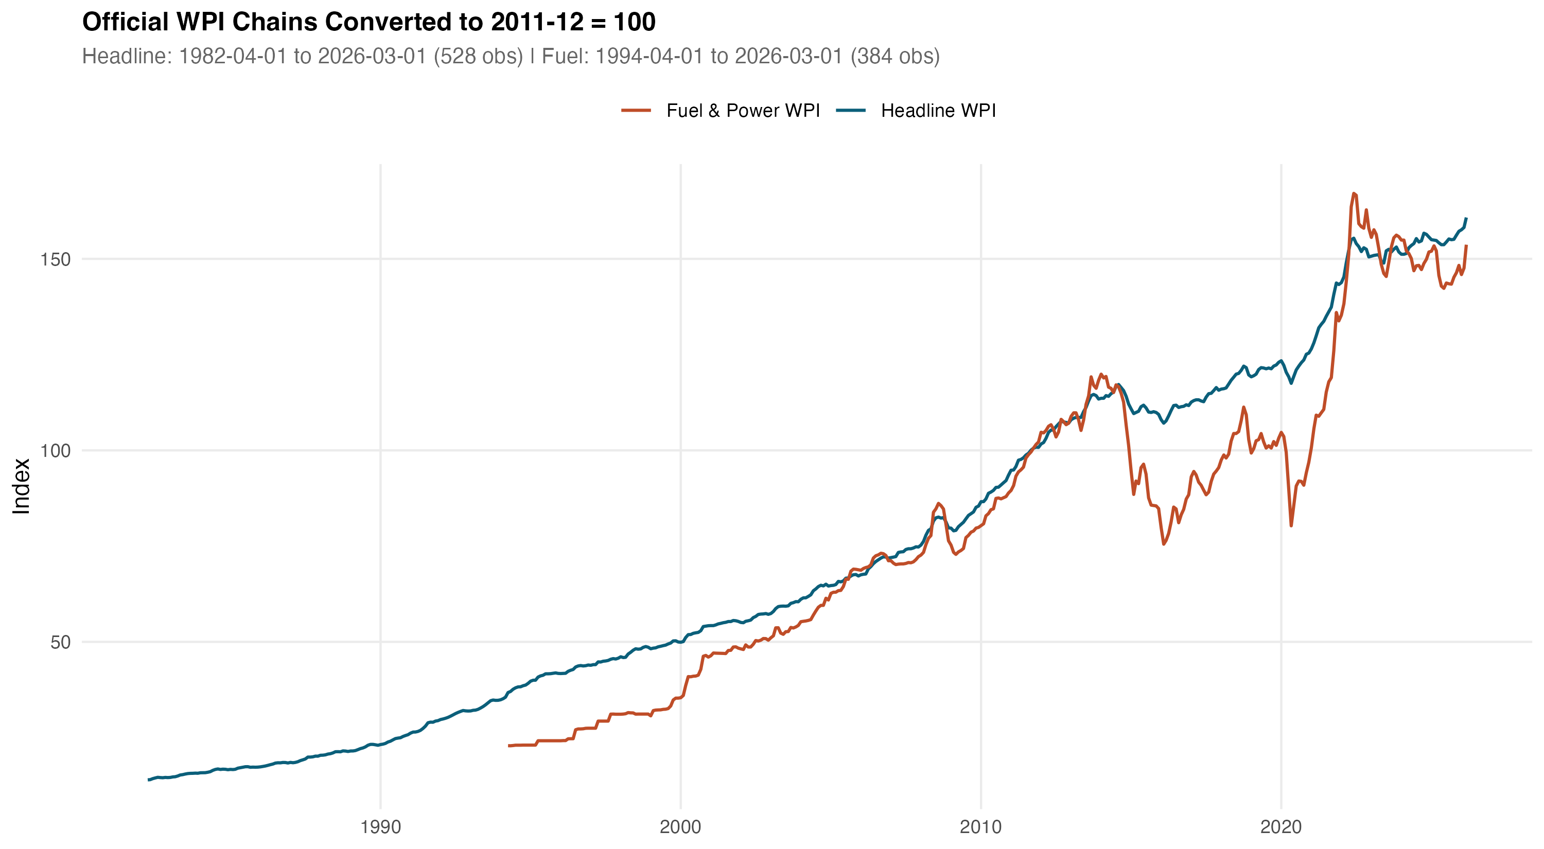
Figure 3.1: Chained headline WPI and Fuel and Power series, rebased to 2011-12 = 100.

3.4 The rupee oil shock
The rupee oil shock combines a Brent component and an exchange-rate component. The shock has visible negative tails during the 2008 commodity correction, the 2014-15 oil price collapse, and the early-2020 demand shock. It has visible positive tails during the 2007-08 commodity peak, the 2011-12 Brent surge, and the 2022 episode. These tails motivate the asymmetric specification used in the ADL models. Co-movement between the rupee oil log difference and WPI Fuel and Power log differences is visible to the eye across the long sample, while co-movement with headline CPI log differences is much weaker. This visual pattern is consistent with the layered attenuation result reported in Chapter 5.
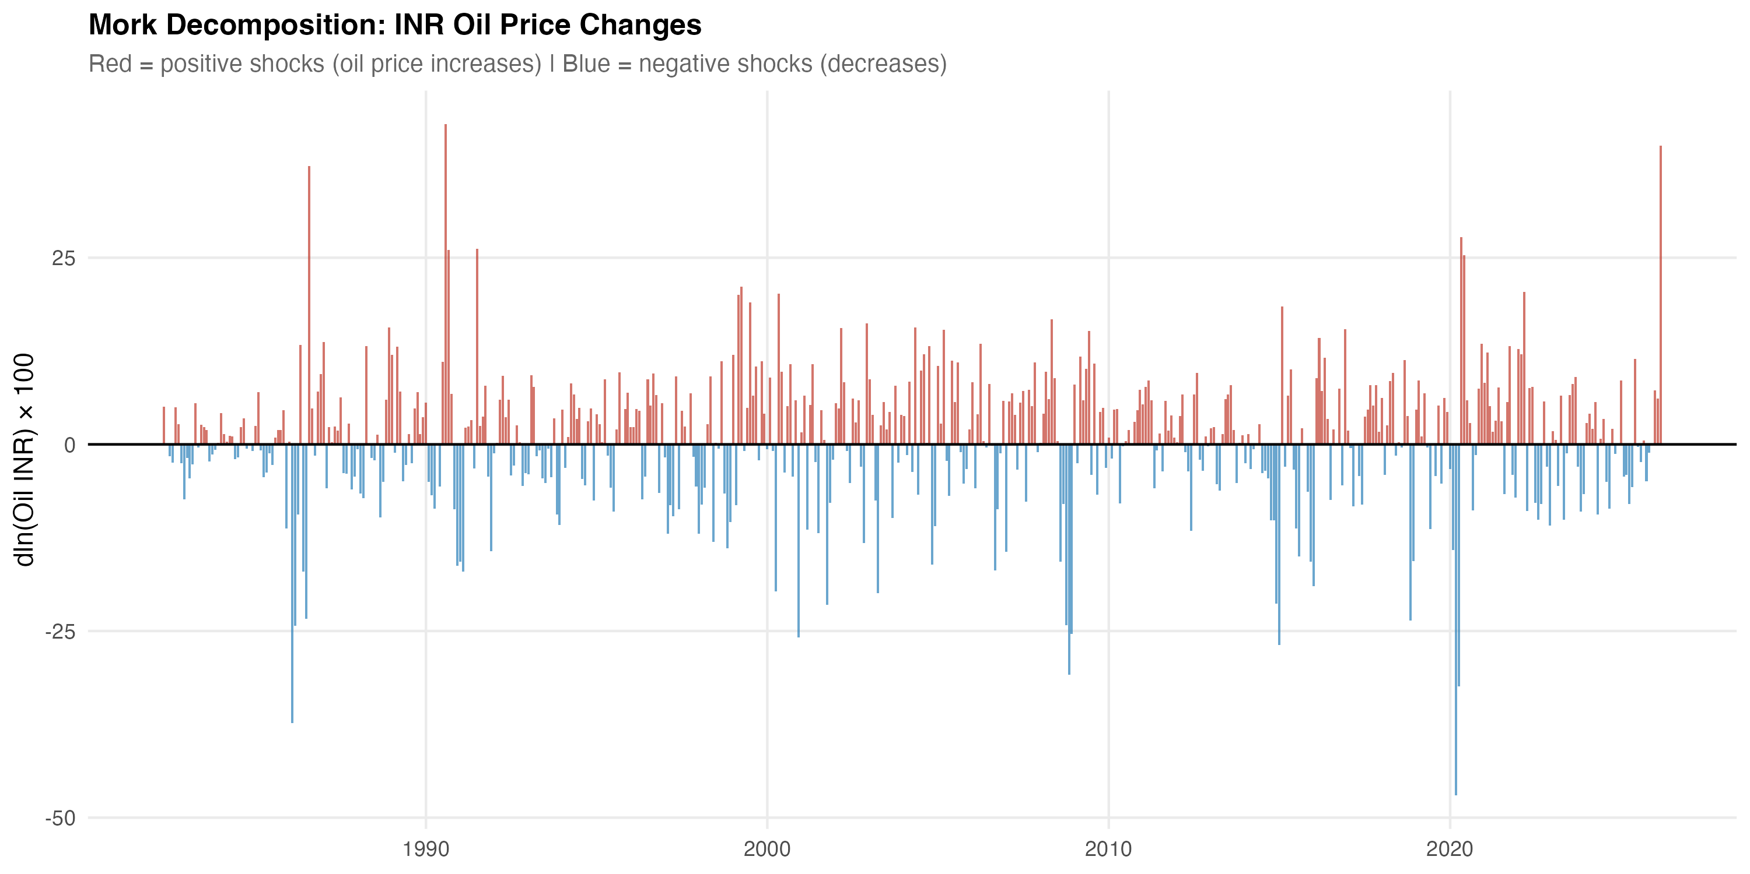
Figure 3.2: Decomposition of the rupee oil price into Brent and INR/USD contributions.

3.5 Stationarity
Because the main specifications operate on log differences rather than on levels, the integration order of the underlying series is less binding than it would be for a levels regression. The unit root battery is reported for completeness in the model outputs. The augmented Dickey-Fuller, Phillips-Perron, and KPSS tests of Kwiatkowski et al. (1992) are reported for each series in levels and in first differences. The combined evidence supports treating the rupee oil price, headline WPI, WPI Fuel and Power, PPAC retail petrol, and headline CPI as integrated of order one in levels and stationary in first differences. This supports the differenced ADL specification used in the next chapter.

Chapter 4
Methodology

4.1 Model specification
The empirical strategy is a short-run asymmetric autoregressive distributed lag (ADL) model in log differences. The dependent variable is monthly inflation in the relevant price index. The shock variable changes by layer. The asymmetry is introduced by splitting the shock variable into positive and negative components, as defined in Chapter 3. Both components are then entered with their own lag structure on the right-hand side.
Equation (4.1) sets out the general form of the model used at every layer.
$Δy_{t} = α + \sum_{i=1}^{p}{φ_{i} Δy_{t-i}} + \sum_{j=0}^{q}{{β_{j}}^{+} {{Δx}_{t-j}}^{+}} + \sum_{j=0}^{q}{{β_{j}}^{-} {{Δx}_{t-j}}^{-}} + {Z_{t}}^{'} γ + μ_{m} + ε_{t}$ (4.1)
In equation (4.1), Δy_{t} is the dependent log difference, the φ_{i} are own-lag coefficients with own-lag order p, the β_{j}⁺ and β_{j}⁻ coefficients are the asymmetric distributed-lag coefficients on the positive and negative shock components with distributed-lag order q, Z_{t} is a vector of controls, μ_{m} are calendar-month fixed effects, and ε_{t} is the residual. For the long WPI specifications the model uses twelve own lags and oil lags from zero to six. The same lag structure is retained for the WPI Fuel and Power specification. For the PPAC retail petrol, CPI Fuel and Light bridge, and headline CPI specifications, the lag structure follows the channel-mechanism model-gate specifications and is not re-tuned ex post.
Table 4.1: Model roles by layer
Layer | Dependent variable | Shock variable | Role
Headline WPI | Headline WPI inflation | Rupee oil shock | Main WPI result
WPI Fuel and Power | WPI Fuel and Power inflation | Rupee oil shock | Wholesale fuel mechanism
PPAC retail petrol | Delhi retail petrol inflation | Brent shock | Retail fuel mechanism
CPI Fuel and Light | CPI Fuel and Light inflation | PPAC petrol shock | Consumer fuel bridge
Headline CPI | Headline CPI inflation | Rupee oil shock | Consumer endpoint
Notes: Each row is a separate asymmetric ADL specification. The shock variable differs by layer: the rupee oil price for the headline WPI, WPI Fuel and Power, and headline CPI specifications; Brent for the retail petrol mechanism; and PPAC retail petrol for the CPI Fuel and Light bridge. The layered map is therefore an attenuation map across naturally ordered points in the price chain rather than a structural decomposition of one identical shock.

4.2 Inference
Inference uses Newey and West (1987) heteroscedasticity-and-autocorrelation-consistent standard errors with a Bartlett kernel and a data-dependent bandwidth. Three formal tests are reported for each layer. The first asks whether CPT+ differs from zero. The second asks whether CPT- differs from zero. The third asks whether CPT+ equals CPT-, which is the symmetry test.
${CPT}^{+} = \sum_{j=0}^{q}{{β_{j}}^{+}}, {CPT}^{-} = \sum_{j=0}^{q}{{β_{j}}^{-}}$ (4.2)
Equation (4.2) defines the cumulative pass-through coefficients used throughout the dissertation. CPT+ is the sum of the lag coefficients on the positive component. CPT- is the sum of the lag coefficients on the negative component. The symmetry test in equation (4.3) is the joint linear restriction tested under HAC inference.
$H_{0}: {CPT}^{+} = {CPT}^{-}$ (4.3)
Symmetry is also assessed using a restricted-residual circular block bootstrap with 4,999 replications. The bootstrap is restricted-residual to preserve the imposed null structure under resampling, and the circular block retains the within-block autocorrelation of the residual process. The bootstrap p-values are reported alongside the asymptotic Wald p-values. They are a robustness check on the asymptotic test, not a separate model. Where the asymptotic and bootstrap p-values disagree by a non-trivial margin, the bootstrap is treated as the more conservative reading.

4.3 Lag selection
Lag selection follows the model-gate and lag-selection tables produced for each layer. The own-lag order is set to twelve in the long WPI specifications to capture annual seasonality even after month fixed effects are imposed. The distributed-lag order on the oil components is set to six for the wholesale specifications. The retail petrol, CPI Fuel and Light, and headline CPI specifications inherit a shorter own-lag order and a distributed-lag order of about three to four, consistent with the shorter samples and faster pass-through dynamics in the retail and consumer layers. AIC, BIC, and HQIC support these choices, and lag-sensitivity checks reported in Chapter 6 confirm that the main results are stable when the distributed-lag order is varied between four and eight in the wholesale specifications.

4.4 Diagnostics and model roles
The diagnostic battery for each layer reports the Breusch-Godfrey serial correlation test, the Breusch-Pagan test for heteroscedasticity, the Ramsey RESET test for functional-form misspecification under the HAC covariance, and recursive and OLS CUSUM stability checks. Model roles are stated before estimation, not after. Headline WPI is accepted as the main WPI result. The WPI Brent plus exchange-rate decomposition is a robustness check rather than a competing model. WPI Fuel and Power is a strong mechanism result, but it is reported with a functional-form caveat because HAC-RESET fails. Headline CPI M1 is accepted as the main CPI endpoint. PPAC retail petrol is accepted as the mandatory first-stage mechanism model. CPI Fuel and Light is supporting bridge evidence because the harmonised sample begins in 2011 and is shorter than the 20-year mandatory sample. The CPI M2 and M3 specifications are not claim-bearing models because diagnostics reject them for main-text use.
Two supporting checks are used in the results chapter. Granger causality tests are reported for oil to WPI and oil to Fuel and Power, and for Brent to PPAC retail petrol. They support a predictive directional reading of the chain. They do not establish structural causality. Bai and Perron (2003) structural break tests are used to check whether the empirical samples are dominated by a single regime change. Where breaks are detected, the institutional pre/post-2010 split addresses them in the most policy-relevant way.

Chapter 5
Results

5.1 Headline WPI
The headline WPI specification is estimated on the chained WPI series from May 1983 to March 2026. The sample contains N = 515 monthly observations and spans 42.92 years. The model achieves an adjusted R-squared of 0.421. The cumulative pass-through estimates are CPT+ = 0.0301 with p = 0.0240 and CPT- = 0.0374 with p = 0.0012. Both cumulative effects are statistically distinguishable from zero at conventional levels. The asymmetry test gives p = 0.6727 under HAC inference and a bootstrap p of 0.7461. The Breusch-Godfrey, HAC-RESET, and recursive CUSUM diagnostics pass.
Headline WPI shows statistically significant but modest pass-through from rupee oil shocks. Positive and negative cumulative effects are close to each other, so the model does not support short-run asymmetry in headline WPI. A one percent positive rupee oil shock is associated with about a 0.030 percent cumulative response in headline WPI over the lag window. This is statistically visible but quantitatively small given that fuel and power, mineral oils, and oil-intensive manufactured products together account for a non-trivial share of the WPI basket.

5.2 WPI Fuel and Power
The WPI Fuel and Power specification is estimated from May 1995 to March 2026. The sample contains N = 371 monthly observations and spans 30.92 years. The model achieves an adjusted R-squared of 0.463. The cumulative pass-through estimates are CPT+ = 0.2866 with p < 0.001 and CPT- = 0.2677 with p < 0.001. Both cumulative effects are large and highly significant. The asymmetry test gives p = 0.7832 under HAC inference and a bootstrap p of 0.8196. The Breusch-Godfrey and recursive CUSUM diagnostics pass; the HAC-RESET test fails.
WPI Fuel and Power carries a much stronger oil signal than headline WPI. This fits the economics because the dependent variable is closer to the fuel channel. The Fuel and Power group covers mineral oils, electricity, and coal, which are more exposed to energy-cost movements than the headline basket. The reported coefficient size is large. The exact magnitude of CPT+ should be reported with a functional-form caveat because the linear specification does not fully capture the curvature of the relationship, especially during episodes when administered prices and market-linked prices coexisted in the sample. The sign and the order of magnitude are stable across specifications, lag windows, and sample trims.
Table 5.1: Headline WPI and WPI Fuel and Power cumulative pass-through
Layer | Sample | N | CPT+ (p) | CPT- (p) | Asym. p
Headline WPI | 1983-05 to 2026-03 | 515 | 0.0301 (0.0240) | 0.0374 (0.0012) | 0.6727
WPI Fuel and Power | 1995-05 to 2026-03 | 371 | 0.2866 (<0.001) | 0.2677 (<0.001) | 0.7832
Notes: Cumulative pass-through coefficients from asymmetric ADL models in log differences with Newey-West HAC inference. CPT+ is the sum of the lag coefficients on the positive rupee oil component, CPT- is the sum of the lag coefficients on the negative component, and the asymmetry p-value is from a Wald test of CPT+ = CPT-.
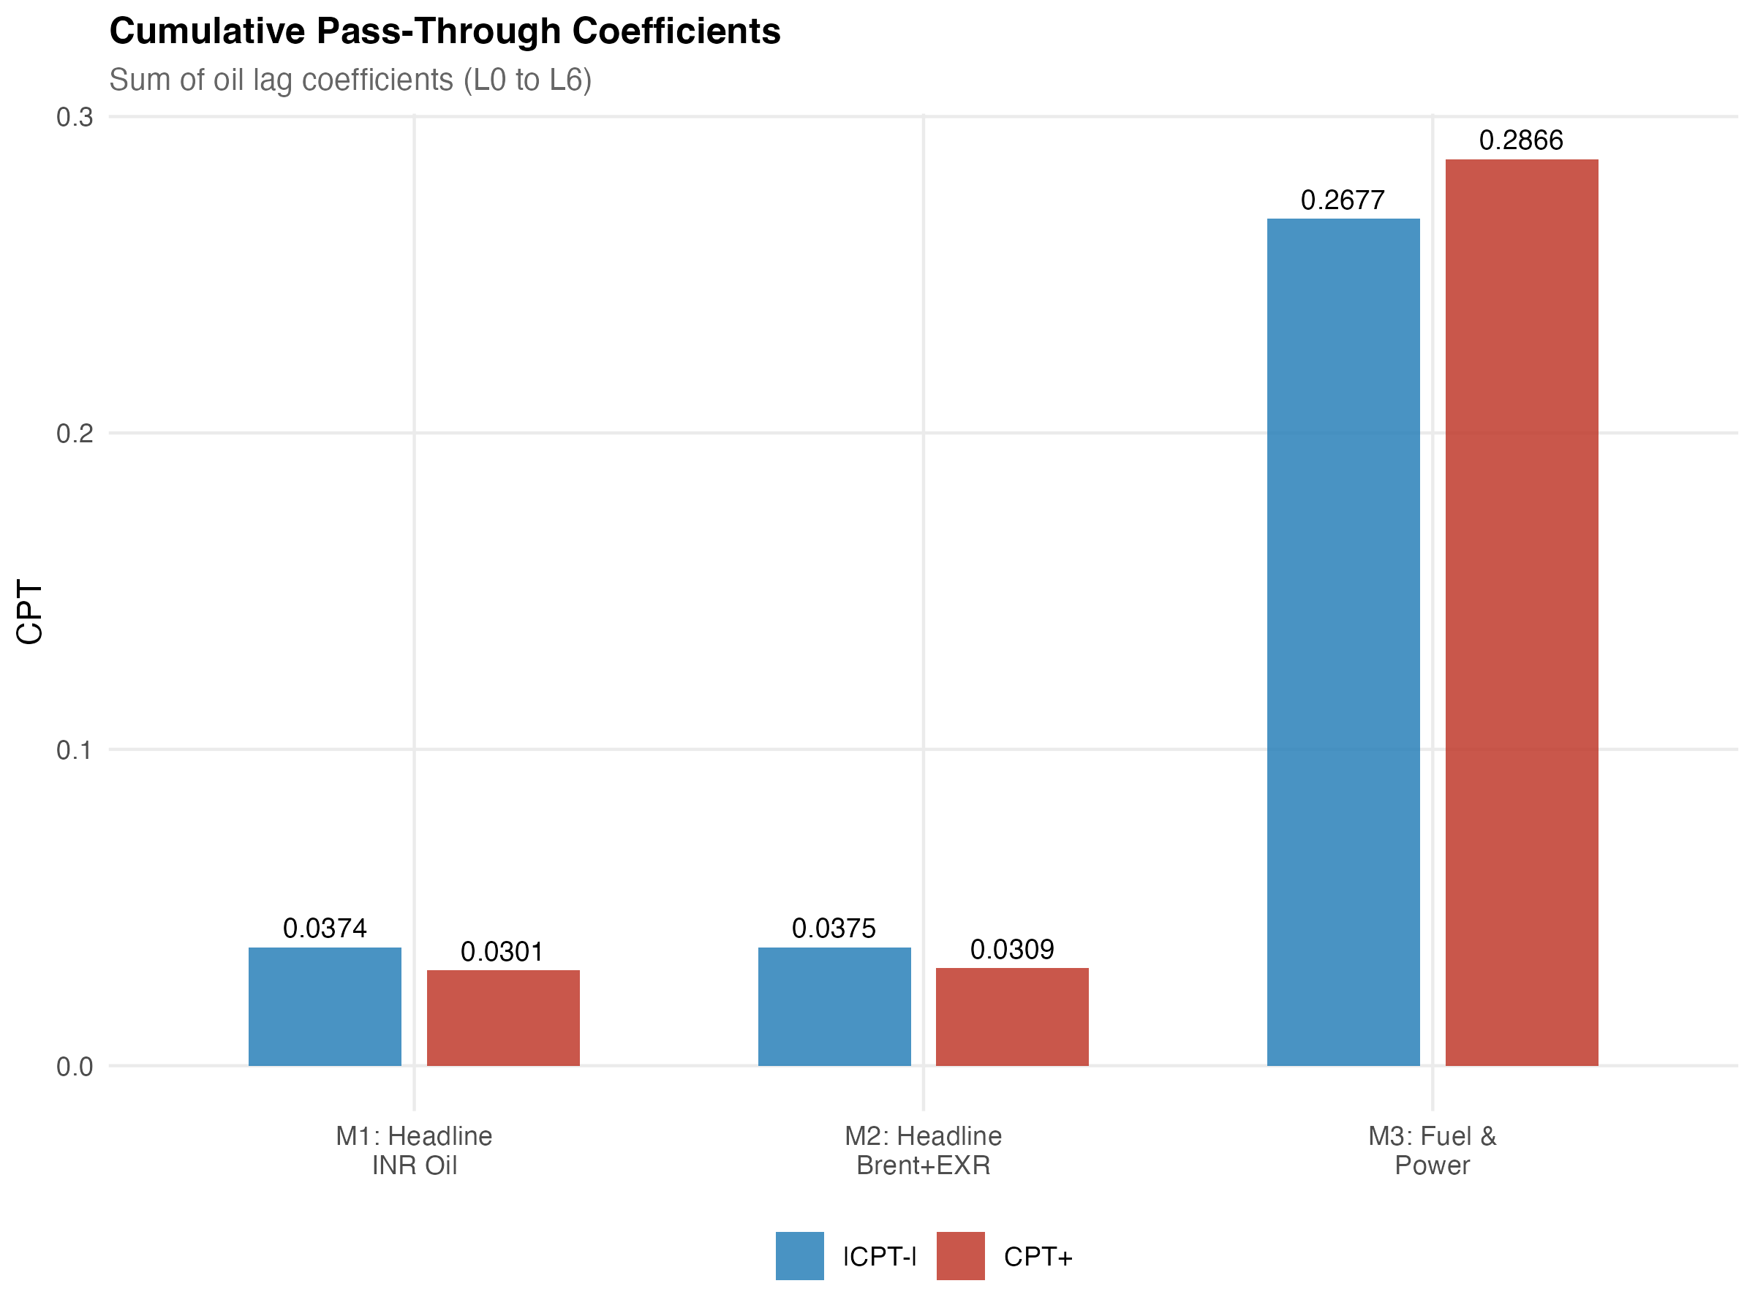
Figure 5.1: Wholesale cumulative pass-through for headline WPI, the Brent plus exchange-rate check, and WPI Fuel and Power.

5.3 PPAC retail petrol
The PPAC retail petrol mechanism is estimated from August 2004 to December 2024. The sample contains N = 245 monthly observations and spans 20.42 years. The cumulative pass-through estimates are CPT+ = 0.3459 with p < 0.001 and CPT- = 0.1912 with p = 0.0002. The asymmetry test gives p = 0.0999. The mandatory model gate passes for this specification, so it is reported in the main text as the first-stage mechanism model.
Retail petrol is the strongest direct fuel layer in the chain. A one percent positive Brent shock is associated with about a 0.346 percent cumulative response in Delhi retail petrol over the model's lag window. The asymmetry result is only marginal at the 10 percent level, so the dissertation describes it as suggestive evidence of asymmetric retail-price adjustment rather than as a decisive 5 percent result. The retail petrol layer is the layer where asymmetry, if it exists at all in the chain, is most plausibly located. Its location at this point in the chain rather than at the headline aggregates is itself an empirical regularity worth noting.

5.4 CPI Fuel and Light bridge
The CPI Fuel and Light bridge specification is estimated from May 2011 to December 2024. The sample contains N = 164 monthly observations and spans 13.67 years. The shorter sample is dictated by the harmonised post-2011 CPI series. The cumulative pass-through estimates are CPT+ = 0.1777 with p = 0.0021 and CPT- = 0.1058 with p = 0.1741. The asymmetry test gives p = 0.4554. The positive-shock cumulative coefficient is strongly significant; the negative-shock coefficient is not.
CPI Fuel and Light shows that retail fuel movements enter a fuel-sensitive consumer layer at a magnitude smaller than the retail petrol layer but larger than the headline CPI endpoint. Because the harmonised series begins in 2011, this evidence is treated as a bridge between PPAC retail petrol and headline CPI rather than as a headline mandate in its own right. The bridge Granger test for retail petrol to CPI Fuel and Light does not reject the null at conventional levels (p = 0.113), so the relationship is read as an estimated bridge response rather than as strict predictive precedence.
Table 5.2: PPAC retail petrol and CPI Fuel and Light bridge cumulative pass-through
Layer | Sample | N | CPT+ (p) | CPT- (p) | Asym. p
PPAC retail petrol | 2004-08 to 2024-12 | 245 | 0.3459 (<0.001) | 0.1912 (0.0002) | 0.0999
CPI Fuel and Light bridge | 2011-05 to 2024-12 | 164 | 0.1777 (0.0021) | 0.1058 (0.1741) | 0.4554
Notes: PPAC retail petrol is estimated with Brent as the shock variable. The CPI Fuel and Light bridge is estimated with PPAC retail petrol as the shock variable. Inference uses Newey-West HAC standard errors. The PPAC retail petrol model passes the mandatory model gate; the CPI Fuel and Light specification is reported as supporting bridge evidence because the harmonised sample begins in 2011.

5.5 Headline CPI
The headline CPI specification is estimated from August 2004 to December 2024. The sample contains N = 245 monthly observations and spans 20.42 years. The model achieves an adjusted R-squared of 0.4492. The cumulative pass-through estimates are CPT+ = 0.0213 with p = 0.1220 and CPT- = 0.0006 with p = 0.9375. The asymmetry test gives p = 0.2408 under HAC inference and a bootstrap p of 0.4997. The mandatory model gate passes, so the specification is the main CPI endpoint.
Headline CPI is the layer where the oil signal becomes weak. The positive coefficient has the expected sign, but it is not statistically significant at conventional levels. This supports the attenuation argument. It does not mean oil is irrelevant for consumers. It means that most of the shock is absorbed before it reaches the household-facing aggregate. The dissertation does not claim a strong headline CPI effect. The result is reported as suggestive of limited positive pass-through, with the formal reading that the cumulative pass-through is not statistically distinguishable from zero in the post-2004 sample.
Table 5.3: Headline CPI cumulative pass-through (main endpoint)
Layer | Sample | N | Adj. R² | CPT+ (p) | CPT- (p) | Asym. p
Headline CPI (M1) | 2004-08 to 2024-12 | 245 | 0.4492 | 0.0213 (0.1220) | 0.0006 (0.9375) | 0.2408
Notes: M1 is the asymmetric ADL specification with rupee oil as the shock variable. Diagnostics: Breusch-Godfrey passes; HAC-RESET passes; recursive CUSUM passes. The bootstrap symmetry p-value is 0.4997 from 4,999 restricted-residual circular block replications.

5.6 Integrated attenuation result
Bringing the layers together produces the central synthesis of the dissertation. Ordering the layers by the magnitude of CPT+, the empirical map is the following: PPAC retail petrol at 0.3459, WPI Fuel and Power at 0.2866, the CPI Fuel and Light bridge at 0.1777, headline WPI at 0.0301, and headline CPI at 0.0213 (not statistically significant). The ordering broadly follows each layer's closeness to direct fuel exposure, and the drop between the fuel-sensitive layers and the headline aggregates is roughly an order of magnitude.
A useful supporting view is the common-sample CPI chain, in which all three stages are estimated on the overlapping sample. Stage 1 (Brent to PPAC petrol) gives CPT+ = 0.4007 with p = 0.0001. Stage 2 (PPAC petrol to CPI Fuel and Light) gives CPT+ = 0.1777 with p = 0.0021. Stage 3 (oil to headline CPI) gives CPT+ = 0.0064 with p = 0.6355. A formal Wald test of equality between Stage 1 and Stage 3 is rejected, with F = 14.3499 and p = 0.0002. The verdict is that attenuation is present along the common-sample chain.
Table 5.4 should be read as a map, not as one mechanical equation. The rows use different dependent variables, shock variables, and active samples. The common-sample rows narrow the CPI-chain comparison, but the safest interpretation remains an attenuation map across related layers.
Table 5.4: Integrated attenuation map across the layered chain
Layer | N | CPT+ (p) | CPT- (p) | Asym. p
PPAC retail petrol | 245 | 0.3459 (<0.001) | 0.1912 (0.0002) | 0.0999
WPI Fuel and Power | 371 | 0.2866 (<0.001) | 0.2677 (<0.001) | 0.7832
CPI Fuel and Light bridge | 164 | 0.1777 (0.0021) | 0.1058 (0.1741) | 0.4554
Headline WPI | 515 | 0.0301 (0.0240) | 0.0374 (0.0012) | 0.6727
Headline CPI | 245 | 0.0213 (0.1220) | 0.0006 (0.9375) | 0.2408
Common sample, Stage 1 (Brent to PPAC petrol) | 165 | 0.4007 (0.0001) | 0.2263 (0.0007) | 0.1123
Common sample, Stage 2 (PPAC to CPI F&L) | 164 | 0.1777 (0.0021) | 0.1058 (0.1741) | 0.4554
Common sample, Stage 3 (oil to headline CPI) | 168 | 0.0064 (0.6355) | −0.0001 (0.9923) | 0.7340
Attenuation Wald: H0 Stage 1 CPT+ = Stage 3 CPT+ | n/a | F = 14.3499 | p = 0.0002 | Reject
Notes: The first five rows are layer-specific cumulative pass-through coefficients, each estimated from its own asymmetric ADL specification. Common-sample stages restrict each model to the common CPI-chain window; observation counts differ after lag construction. The attenuation Wald row tests equality of CPT+ at Stage 1 and Stage 3 under HAC inference. Inference uses Newey-West HAC standard errors throughout.
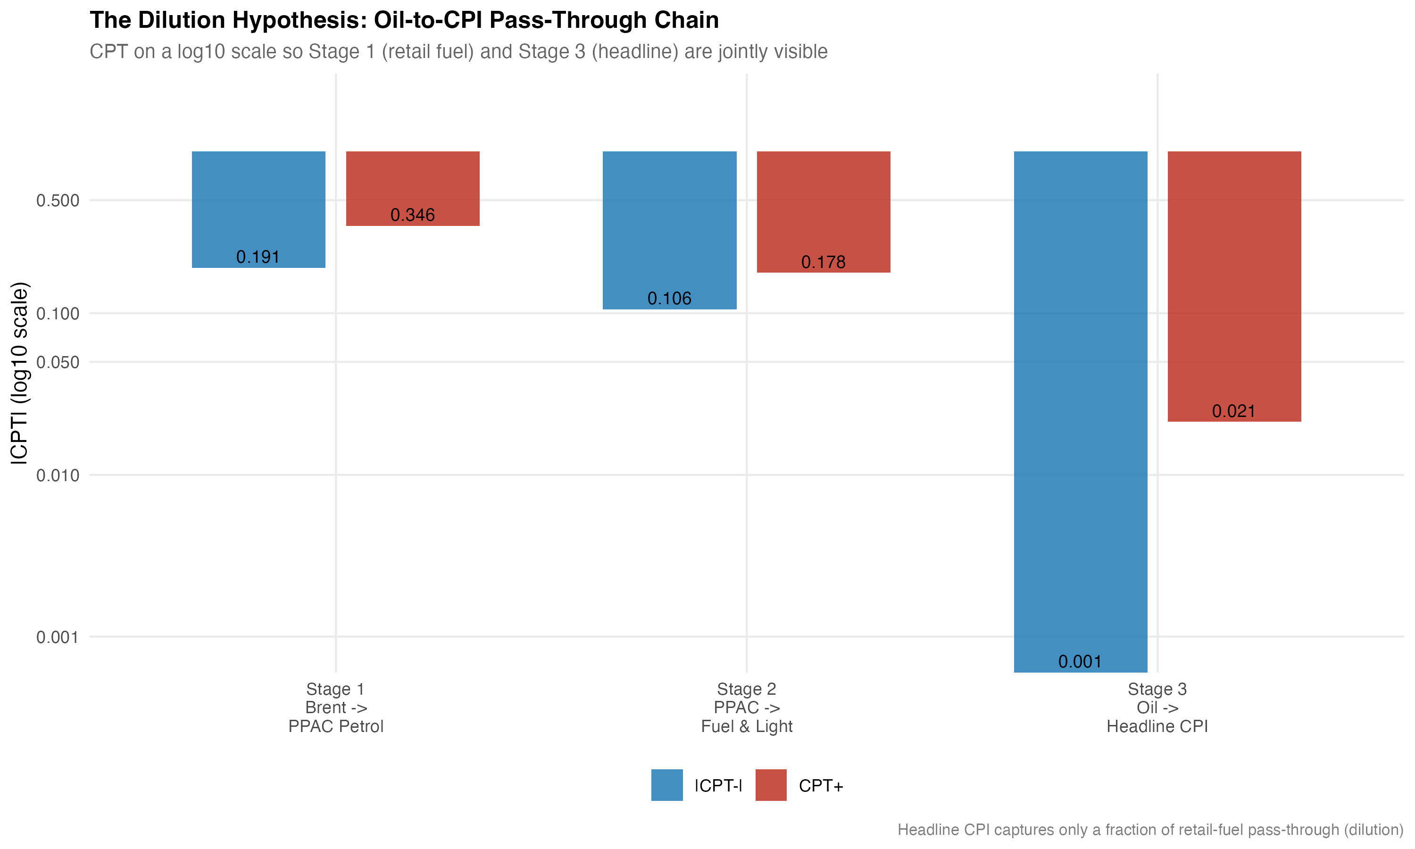
Figure 5.2: CPI attenuation chain from Brent to PPAC petrol, CPI Fuel and Light, and headline CPI.
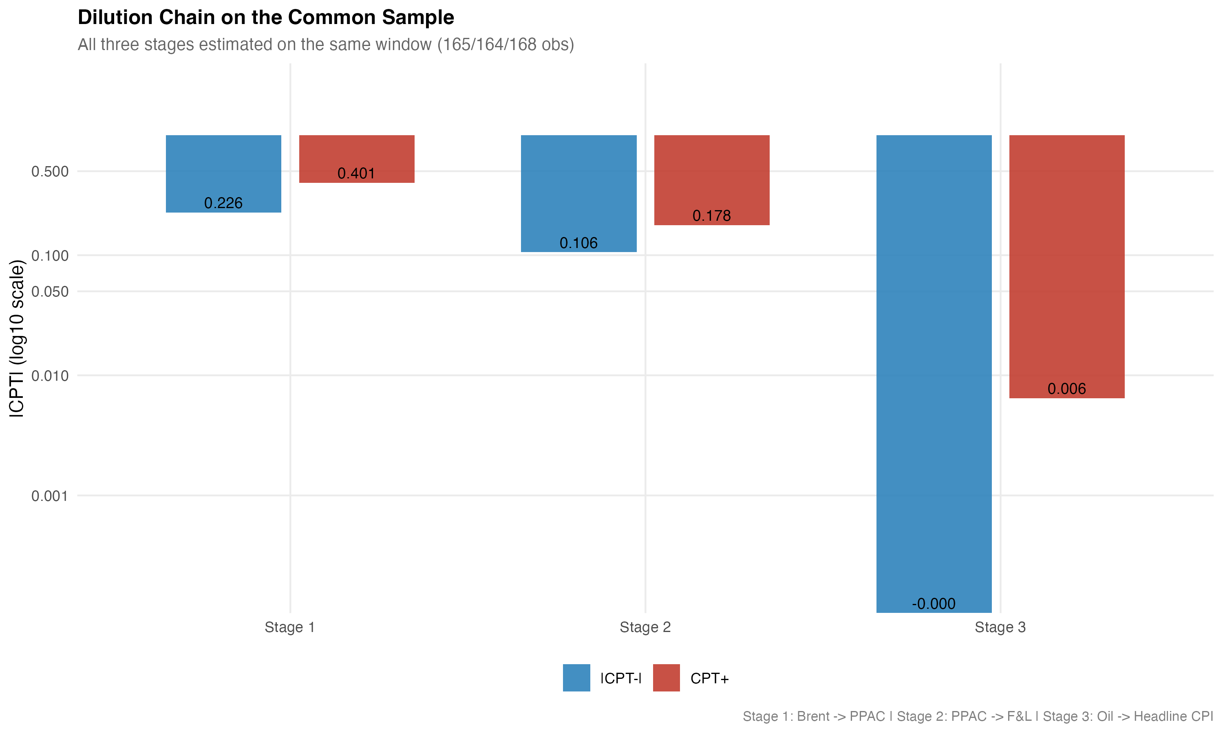
Figure 5.3: Common-sample CPI chain from Brent to headline CPI.
The layered pattern is clear. Oil-price shocks are strong in retail fuel and fuel-sensitive wholesale prices. They are still visible in CPI Fuel and Light. They are much smaller in the broad headline indices, especially headline CPI. This is attenuation, not absence. The cumulative coefficients in Table 5.4 are layer-specific responses, each estimated from its own ADL specification with its own dependent variable, its own shock variable, and its own sample. They are not five identical estimates of the same shock passing through five layers in sequence. The PPAC retail petrol equation uses Brent as the shock; the headline WPI, WPI Fuel and Power, and headline CPI equations use the rupee oil price; the CPI Fuel and Light bridge uses the PPAC retail petrol price. The table is therefore best read as an attenuation map across naturally ordered points in the price chain rather than as a structural decomposition of one elasticity. With that qualification, the evidence supports the attenuation interpretation.

5.7 Pre/post-2010 wholesale split
The pre/post-2010 split uses an April 2010 cutoff around the petrol deregulation episode. For headline WPI, the pre-2010 cumulative pass-through is CPT+ = 0.0117 with p = 0.3812, while the post-2010 cumulative pass-through is CPT+ = 0.0741 with p = 0.0043. For WPI Fuel and Power, the pre-2010 cumulative pass-through is CPT+ = 0.0922 with p = 0.1679, while the post-2010 cumulative pass-through is CPT+ = 0.5241 with p < 0.001. The post-2010 estimates are materially larger and statistically stronger than the pre-2010 estimates in both layers.
The post-2010 wholesale estimates are consistent with stronger pass-through under more market-linked fuel pricing, in which oil marketing companies revise retail prices much more frequently and pass on more of a given shock within the model's lag window. The split is not a clean causal estimate of deregulation. Other changes occurred in the post-2010 period as well, including the new CPI series in 2011, the move to flexible inflation targeting in 2016, the Goods and Services Tax in 2017, and a sequence of fuel-tax episodes.
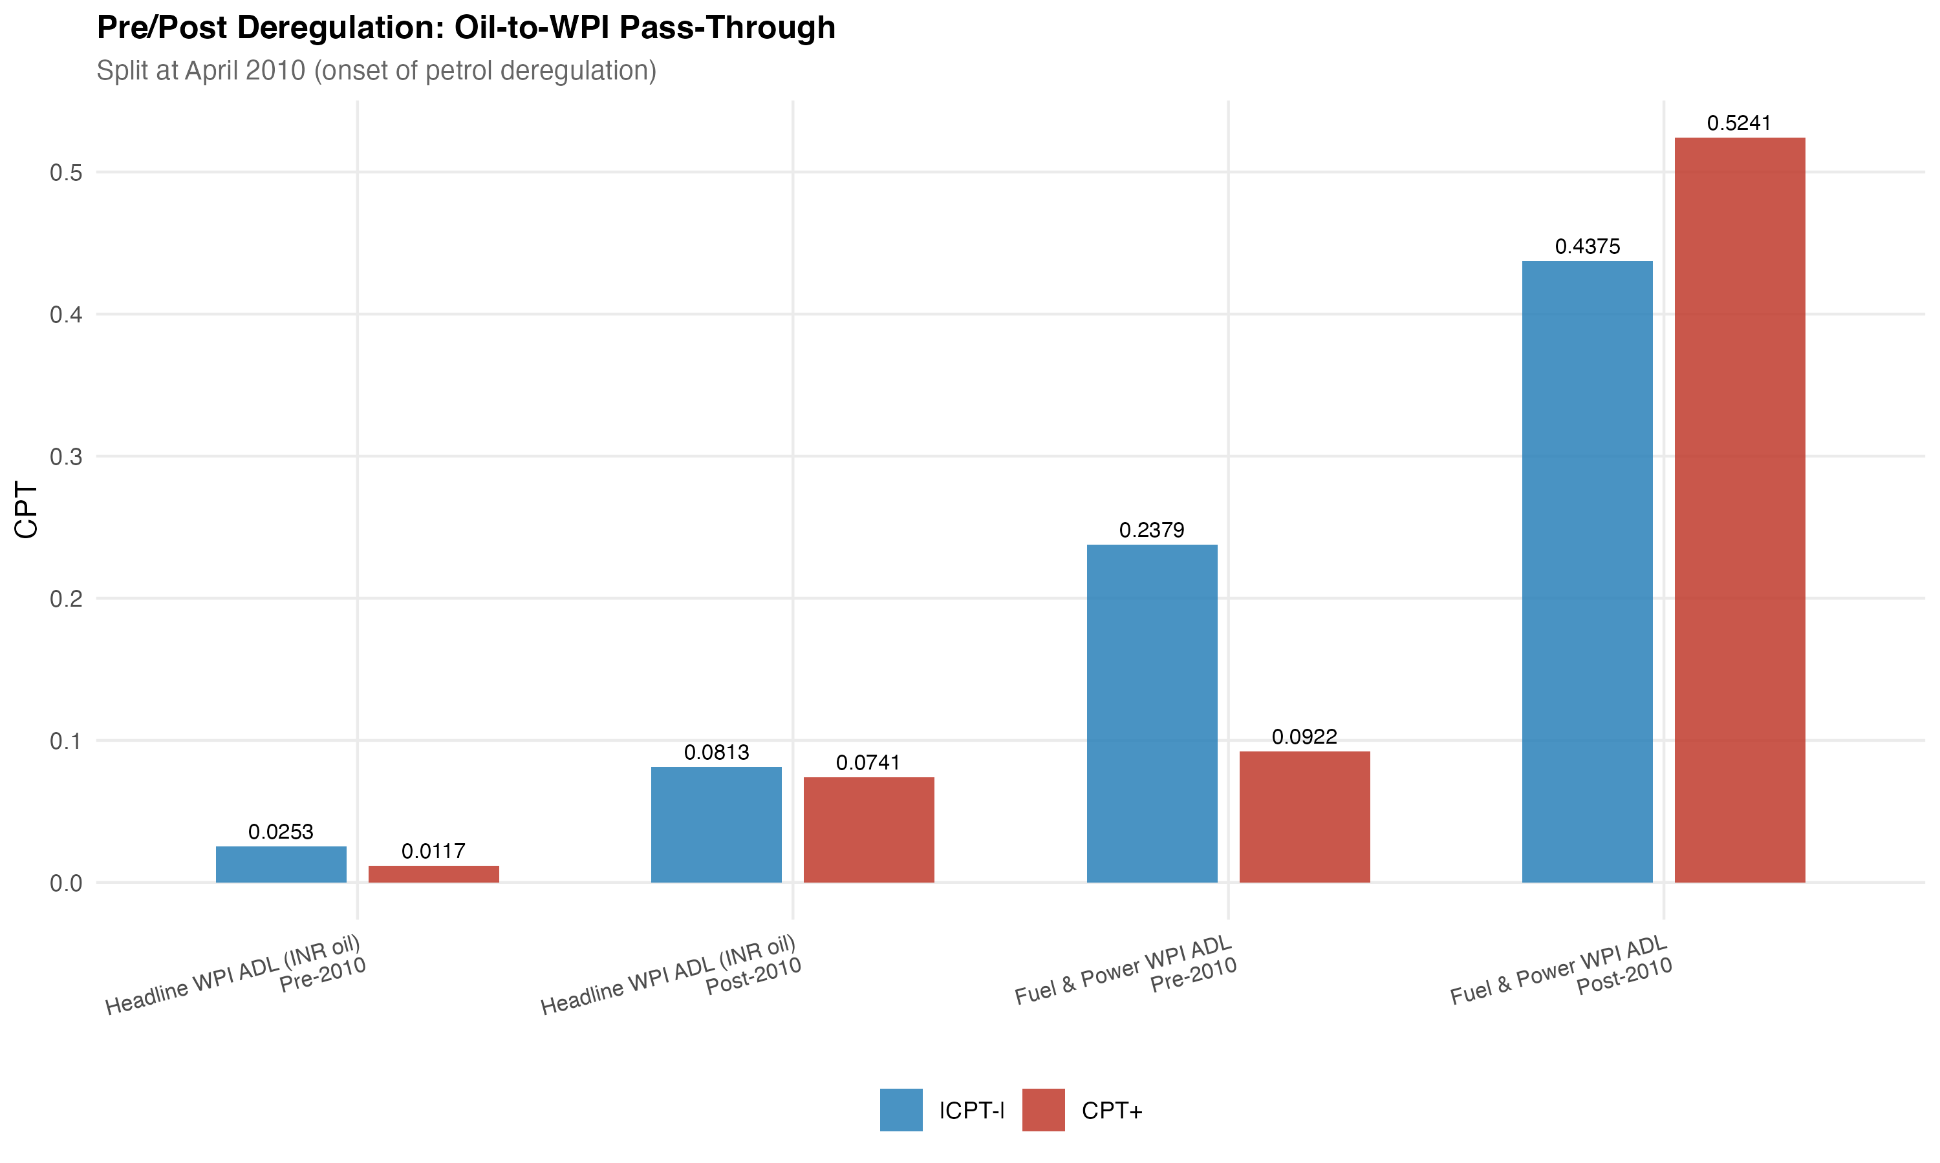
Figure 5.4: Pre/post-2010 cumulative pass-through for headline WPI and WPI Fuel and Power.

Chapter 6
Robustness and limitations

6.1 Robustness checks
The robustness checks are designed to test whether the layered attenuation result depends on a particular shock construction, on a particular sample, or on the asymptotic inference. The first check decomposes the rupee oil price into its Brent and exchange-rate components and re-estimates the headline WPI specification. The decomposition gives CPT+ = 0.0309 with p = 0.0234 and CPT- = 0.0375 with p < 0.001, with asymmetry p = 0.7039. This is very close to the rupee oil specification and suggests that the headline WPI conclusion does not depend on how the shock variable is built.
The second check uses the restricted-residual circular block bootstrap with 4,999 replications to assess short-run asymmetry. The bootstrap p-values are 0.7461 for headline WPI, 0.8196 for WPI Fuel and Power, and 0.4997 for headline CPI. None of these support a rejection of the null of symmetric short-run pass-through. The bootstrap and the asymptotic Wald tests therefore agree. Short-run asymmetry is not the central finding of the dissertation, and where the retail petrol layer hints at it the evidence is only marginal.
The third check uses Granger causality tests in the predictive sense. The tests support directional precedence from the rupee oil price to headline WPI (F = 7.43, p < 0.001) and to WPI Fuel and Power (F = 15.22, p < 0.001), and from Brent to PPAC retail petrol (F = 10.71, p < 0.001). The reverse directions do not reject the null. This is consistent with the layered design, but it is not a structural causality claim. The fourth check uses Bai and Perron (2003) structural break tests to check whether the layered relationships are dominated by a single regime change. Where breaks are detected for headline WPI inflation, the institutional pre/post-2010 wholesale split provides a policy-relevant comparison.
The fifth check addresses the COVID-19 window and outlier sensitivity. Excluding the COVID window from the headline CPI specification, and winsorising the dependent log differences at the one and ninety-nine percent tails, do not overturn the main CPI conclusion. The positive cumulative pass-through remains small and not statistically significant at conventional levels. Lag-sensitivity checks at oil lags from zero to four and from zero to eight do not change the qualitative ordering of Table 5.4. Rolling-window estimates of the headline CPI cumulative pass-through hover around the central estimate without crossing into a significant range at conventional levels.
The model-upgrade audit supports staying with the conservative headline specifications. In the CPI results, the Brent plus exchange-rate decomposition with q = 3 gives a somewhat larger positive coefficient, but its diagnostics fail; the AIC-favoured q = 0 version is safer but carries no meaningful oil signal. In the WPI results, the Brent plus exchange-rate decomposition confirms the headline WPI result, while WPI Fuel and Power remains a mechanism estimate that needs the functional-form caveat.
Table 6.1: Diagnostics and bootstrap symmetry summary
Layer | BG12 | RESET-HAC | Rec-CUSUM | Bootstrap symmetry p
Headline WPI | PASS | PASS | PASS | 0.7461
WPI Fuel and Power | PASS | FAIL | PASS | 0.8196
Headline CPI (M1) | PASS | PASS | PASS | 0.4997
Notes: BG12 is the Breusch-Godfrey serial correlation test at lag 12. RESET-HAC is the Ramsey functional form test under the HAC covariance. Rec-CUSUM is the recursive CUSUM stability check. Bootstrap symmetry p-values are from 4,999 restricted-residual circular block replications.

6.2 Limitations
The limitations of the design should be stated plainly. The models are reduced-form projections, not structural causal estimates. The pre/post-2010 split is institutional evidence consistent with stronger pass-through under more market-linked pricing, but it is not a clean policy experiment. The CPI Fuel and Light bridge sample begins in 2011 and is shorter than the headline CPI and headline WPI samples, which limits the power of the negative-shock test in that layer. The WPI Fuel and Power model fails the HAC-RESET functional-form test, so the exact magnitude of CPT+ in that layer should be reported with a functional-form caveat. The CPI M2 and M3 specifications are not claim-bearing models in the main text because their diagnostics reject them. Headline CPI pass-through should be described as weak and statistically insignificant, not as zero. The layered table is an attenuation map across naturally ordered points in the price chain. It is not a structural decomposition of one identical shock across all equations.

Conclusion
The dissertation set out to ask where oil-price pass-through weakens inside the Indian price system. The answer is that pass-through is layered, not flat. The shock is strongest at the points of the price system closest to direct fuel-price exposure, and it becomes weaker as the analysis moves toward broader household-facing aggregates. This answer is a reduced-form attenuation map, not a structural claim that one identical shock travels through five mechanically linked equations.
The empirical map can be read in five steps. Retail petrol and WPI Fuel and Power show strong pass-through, with cumulative coefficients of 0.3459 and 0.2866 for positive shocks. CPI Fuel and Light provides bridge evidence that fuel movements enter a fuel-sensitive consumer layer at a cumulative coefficient of 0.1777 for positive shocks. Headline WPI shows statistically significant but modest pass-through at 0.0301. Headline CPI shows weak and statistically insignificant pass-through at 0.0213 in the estimated post-2004 specification. Across all layers, short-run asymmetry is not the main finding. Where it is most plausibly located, in the retail petrol layer, the evidence is only marginal at the 10 percent level.
The pre/post-2010 wholesale split adds an institutional observation. Pass-through to both headline WPI and WPI Fuel and Power is materially larger in the post-2010 sample than in the pre-2010 sample. This is consistent with the move toward more market-linked fuel pricing, under which oil marketing companies revise retail prices much more frequently. The split is not a clean causal estimate of deregulation, because the post-2010 period also covers the new CPI series, the move to flexible inflation targeting, the Goods and Services Tax, and a sequence of fuel-tax episodes.
The policy interpretation is restrained. WPI is useful for tracking upstream cost pressure and is the index where oil shocks remain most visible at the headline level, even after dilution. CPI is the household-facing index and the inflation-targeting anchor, and it is the index where the oil signal is weakest at the headline level. Neither index should be treated as a substitute for the other when the question is about oil shocks. A monetary policy framework that uses CPI as its anchor is not insulated from oil shocks, but it sees the shock through a heavily diluted layer. A fiscal or producer-side analysis that uses WPI sees the shock at a magnitude that is small at the headline level but large in the fuel-sensitive sub-indices that drive intermediate input costs.
Two extensions are realistic. The first is a more disaggregated CPI decomposition that moves below the headline aggregate to the transport, housing, and miscellaneous services components, in order to trace where the small headline CPI signal is concentrated. The second is a time-varying pass-through model that allows the cumulative coefficients to evolve smoothly with the pricing regime rather than as a single break at June 2010. Both extensions remain inside the same architectural framing used here. They would extend rather than replace the layered map presented in this dissertation.
The main lesson is simple: oil shocks do not vanish in India, but they lose force as they move from fuel prices to headline consumer inflation.

