State-Dependent Oil-Price Pass-Through
to India's Wholesale Fuel Inflation, 1994–2026
Evidence from Monthly Local Projections

A Dissertation Submitted in Partial Fulfilment
of the Requirements for the Degree of
Master of Science in Economics

2026

Abstract
This dissertation examines the pass-through of rupee-denominated crude oil price shocks to India's Wholesale Price Index (WPI) Fuel and Power component over the period 1994 to 2026. The study constructs a chained monthly WPI Fuel and Power index from three official Office of the Economic Adviser base-year series and combines it with World Bank Brent crude oil prices and the INR/USD exchange rate to form a rupee oil price measure. Using Jordà (2005) local projections with Newey–West heteroskedasticity and autocorrelation consistent standard errors, the analysis estimates cumulative impulse responses at horizons from zero to twelve months. The main estimation sample runs from May 1995 to March 2026, spanning 30.92 years after accounting for twelve monthly dynamic controls. The all-sample six-month cumulative response of WPI Fuel and Power inflation to a one per cent rupee oil shock is 0.2963 per cent and is statistically significant at the one per cent level. A state-dependent specification interacting the shock with a post-2010 fuel-pricing reform indicator adds 0.1972 percentage points at the six-month horizon, with a p-value of 0.0220. The state-dependent specification passes functional-form and stability diagnostics, and a GLS AR(1) robustness check confirms the serial-correlation treatment. The findings suggest that fuel-price deregulation strengthened the wholesale fuel price channel, implying that inflation management should track the rupee oil price rather than Brent alone.

Chapter 1: Introduction
India is one of the world's largest importers of crude oil. More than 80 per cent of the country's petroleum requirement is met through imports, and these imports are priced in United States dollars on global commodity markets (Ministry of Petroleum and Natural Gas, 2023). Consequently, any movement in the international price of crude oil, or in the INR/USD exchange rate, translates directly into a change in the rupee cost of imported crude. This makes India's domestic price level inherently sensitive to what may be called the rupee oil price—the product of the dollar-denominated Brent crude price and the prevailing INR/USD exchange rate.
A large body of literature has examined the relationship between global oil prices and macroeconomic outcomes in India. However, many of these studies focus on headline consumer price inflation (CPI) or the aggregate wholesale price index (WPI), both of which combine energy costs with a wide array of food, manufactured goods, and services prices. The resulting estimates often dilute the direct fuel-price channel because the weight of fuel in headline indices is small relative to food and services. Furthermore, the CPI series with detailed component data begins only in January 2012, limiting the available sample for any study that wishes to exploit longer-term variation in oil prices, exchange rates, and pricing regimes.
This dissertation argues that the WPI Fuel and Power component is a more appropriate dependent variable for studying oil-price pass-through in India. This sub-index captures the prices of petroleum products, coal, and electricity at the wholesale level and is therefore directly exposed to imported crude oil costs. Crucially, the Office of the Economic Adviser (OEA) publishes official monthly WPI data across three successive base years—1993–94, 2004–05, and 2011–12—which, when properly chained, provide a consistent monthly series from April 1994 to the present. This yields more than three decades of monthly observations, a span long enough to cover both the administered-pricing era and the subsequent reforms that linked domestic fuel prices to international markets.
The research question addressed here is deliberately narrow:
To what extent do rupee-denominated Brent crude oil shocks transmit to India's WPI Fuel and Power inflation, and has this transmission strengthened after the fuel-pricing reforms of 2010?
The contribution of this study is threefold. First, by focusing on WPI Fuel and Power rather than headline WPI or CPI, the analysis isolates the most fuel-sensitive layer of India's price system and avoids mixing energy pass-through with unrelated food and services price movements. Second, by constructing the rupee oil price—rather than using dollar-denominated Brent alone—the study captures the joint effect of global oil price changes and exchange-rate movements as experienced by Indian refiners and consumers. Third, the study employs Jordà (2005) local projections with Newey–West heteroskedasticity and autocorrelation consistent (HAC) standard errors, which allow flexible, model-free estimation of cumulative impulse responses at each horizon without the specification constraints imposed by vector autoregressive (VAR) systems.
The empirical strategy also allows for state dependence. India deregulated petrol pricing around June 2010, allowing retail petrol prices to move with international benchmarks rather than being held constant through government subsidies. This reform plausibly altered the speed and magnitude of oil-price pass-through to wholesale fuel prices. The local-projection framework accommodates this by interacting the oil shock variable with a post-2010 indicator, enabling a direct test of whether the response strengthened after reform.
The conceptual transmission chain underlying this study is straightforward:
Brent USD × INR/USD → rupee oil shock → WPI Fuel and Power inflation
This chain does not require assumptions about second-round effects on core inflation or monetary policy responses. It simply tracks whether a change in the rupee cost of crude oil is reflected in the wholesale fuel price index over the following months.
The remainder of this dissertation is organised as follows. Chapter 2 reviews the background on India's fuel-pricing regime and the relevant empirical literature. Chapter 3 describes the data sources, the WPI chaining procedure, and the construction of the rupee oil price variable. Chapter 4 sets out the local-projection methodology, including the treatment of inference and diagnostics. Chapter 5 presents the main results for the all-sample and post-2010 state-dependent specifications. Chapter 6 reports robustness checks and discusses limitations. The conclusion summarises the findings and draws cautious policy implications.

Chapter 2: Background and Literature

2.1 India's Fuel-Pricing Regime
For much of the post-liberalisation period, India maintained an administered pricing mechanism (APM) for petroleum products. Under this system, the government set retail prices for petrol, diesel, kerosene, and liquefied petroleum gas, with public-sector oil marketing companies absorbing the difference between the administered price and the market-linked cost of crude oil and refining. The resulting under-recoveries were financed through a combination of government subsidies, upstream sharing by national oil companies, and oil bonds issued by the central government (Kelkar Committee, 2010). This arrangement effectively insulated domestic fuel consumers from international price volatility but imposed large and unpredictable fiscal costs.
The first significant reform came in June 2010, when the government deregulated the pricing of petrol, allowing oil marketing companies to revise petrol prices in line with international crude oil costs and the exchange rate. Diesel pricing followed in stages, with small monthly increases permitted from January 2013 and full deregulation achieved by October 2014. Kerosene and LPG remained partially subsidised, though subsidies were progressively rationalised through direct benefit transfers.
The implication for wholesale fuel price dynamics is direct. Before deregulation, administered prices meant that changes in global oil prices and the exchange rate were absorbed by the fiscal system rather than passed through to the wholesale price index. After deregulation, the WPI Fuel and Power component should, in principle, reflect international crude oil movements more quickly and more completely. This institutional shift provides the economic motivation for the state-dependent estimation strategy adopted in this dissertation.

2.2 WPI Versus CPI as a Measure of Fuel-Price Transmission
India publishes two principal price indices: the Wholesale Price Index (WPI) and the Consumer Price Index (CPI). The WPI measures price changes at the point of first bulk sale, while the CPI, compiled by the Central Statistics Office from January 2012 onward, measures retail prices faced by consumers.
For the purpose of studying oil-price pass-through, the WPI Fuel and Power sub-index has two advantages over headline CPI. First, the WPI Fuel and Power component has a direct compositional link to petroleum products, with crude oil and refined product prices accounting for a large share of the sub-index weight. Second, the WPI series extends back to 1994 under successive base years, providing three decades of monthly data. The CPI Fuel and Light component, by contrast, is available only from January 2012 with consistent sub-component detail, which severely limits the estimation sample and prevents meaningful analysis of the pre-reform period.
The trade-off is that WPI Fuel and Power captures only the wholesale layer and does not directly measure the prices faced by final consumers. However, for the research question posed here—whether oil shocks transmit to India's fuel price system—the wholesale layer is the economically appropriate starting point, since it is closest to the point of import and refining.

2.3 Oil-Shock Transmission: International Evidence
The modern literature on oil-price shocks and macroeconomic outcomes begins with Hamilton (1983), who documented the association between oil price increases and US recessions. Kilian (2009) refined this framework by distinguishing between supply-driven, demand-driven, and speculative oil price shocks, showing that the macroeconomic effects depend on the source of the price change. While this dissertation does not decompose oil shocks by source, the Kilian framework provides a useful reminder that not all oil price movements are alike and that estimated pass-through coefficients should be interpreted as average associations rather than structural causal effects.
Jordà (2005) introduced the local-projection method as an alternative to impulse responses derived from vector autoregressive (VAR) systems. Local projections estimate a separate reduced-form regression for each forecast horizon, avoiding the compounding of specification errors inherent in iterating a VAR forward. The method has become standard in applied macroeconomics for estimating cumulative responses, particularly when the researcher wishes to allow for flexible functional forms and state-dependent responses (Ramey, 2016).

2.4 Oil-Price Pass-Through: Indian Evidence
Several studies have examined the oil-inflation nexus in India. Mandal, Dutta, and Sarkar (2012) estimate oil-price pass-through to the WPI using a VAR framework and find significant effects at the aggregate level. Bhanumurthy, Das, and Bose (2012) examine the fiscal implications of administered pricing, documenting the large under-recoveries borne by the government during periods of high oil prices. Sarmah and Bal (2021) study the asymmetric effects of oil price changes on Indian inflation, finding some evidence of greater responsiveness to price increases. Deheri and Ramachandran (2023) provide more recent evidence on the oil–exchange-rate–inflation channel using post-2012 CPI data.
This dissertation builds on this literature by combining a long monthly WPI Fuel and Power sample, a rupee-denominated oil price measure, and a local-projection method that allows direct state-dependent estimation across the reform period. The narrower focus on WPI Fuel and Power—rather than headline WPI or CPI—is intended to sharpen the estimated pass-through by removing noise from non-fuel components.

Chapter 3: Data and Variables

3.1 Data Sources and Sample Coverage
The empirical analysis draws on three primary data sources, each available at monthly frequency. Table 3.1 summarises the series, their coverage, and the number of observations.
Series | Start | End | N | Span (years)
WPI Fuel & Power chained | 1994-04 | 2026-03 | 384 | 32.00
Brent USD | 1960-01 | 2026-03 | 795 | 66.25
INR/USD exchange rate | 1973-01 | 2026-03 | 639 | 53.25
Matched model data | 1994-04 | 2026-03 | 384 | 32.00

The WPI Fuel and Power data are sourced from the Office of the Economic Adviser (OEA), Ministry of Commerce and Industry. The OEA publishes monthly WPI figures for all major commodity groups, including the Fuel, Power, Light, and Lubricants sub-group, which is the wholesale-level measure most directly linked to petroleum product costs. The Brent crude oil price in US dollars per barrel is taken from the World Bank Pink Sheet, which reports monthly average commodity prices compiled from major international exchanges. The INR/USD exchange rate is sourced from the Federal Reserve Bank of St Louis (FRED) EXINUS series, which provides a monthly average of the bilateral exchange rate.

3.2 Chaining the WPI Fuel and Power Index
The OEA publishes the WPI under successive base years: 1993–94, 2004–05, and 2011–12. Each base-year revision changes the index weights and reference level, so the raw series from different base years are not directly comparable. To construct a continuous monthly series, the study chains the three base-year segments onto the most recent 2011–12 base using official linking factors.
The linking procedure divides older-base observations by the cumulative chain factor to express them on the 2011–12 scale. The 1993–94 base series covering April 1994 to December 2004 is divided by the product of the 1993–94-to-2004–05 factor (2.802) and the 2004–05-to-2011–12 factor (1.690), yielding a combined divisor of 4.735. The 2004–05 base series covering January 2005 to March 2012 is divided by the 2004–05-to-2011–12 factor (1.690). Observations from April 2012 onward, already on the 2011–12 base, require no adjustment. Figure 3.1 plots the resulting chained WPI Fuel and Power index from April 1994 to March 2026.
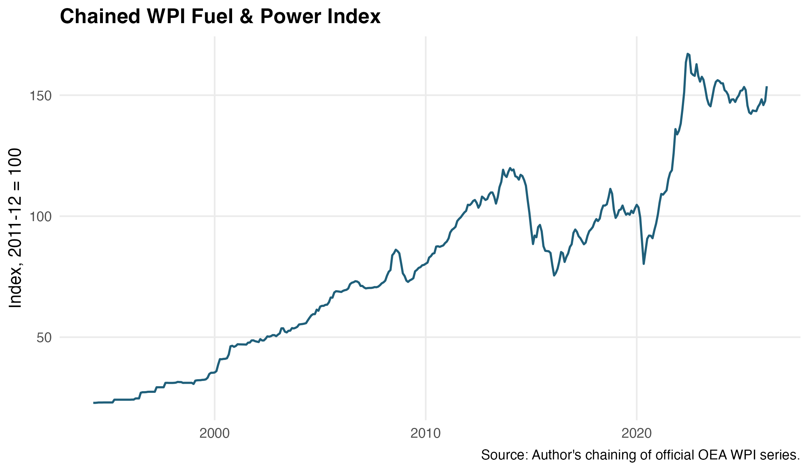
Figure 3.1: Chained WPI Fuel and Power Index — fig_01_wpi_fuel_chained.png
The chained series shows the broad pattern expected from India's fuel-price history: a gradual increase through the late 1990s and early 2000s under administered pricing, a sharp rise during the 2007–08 oil boom, a collapse during the 2008–09 global financial crisis, a recovery and plateau during the 2010–14 period of partial deregulation, a decline during the 2014–16 oil price downturn, and a volatile recovery culminating in the post-COVID surge of 2021–22.

3.3 Constructing the Rupee Oil Price
The key independent variable in this study is the rupee-denominated oil price, defined as:
oil_INR_t = Brent_USD_t × INR_per_USD_t
This formulation captures the cost of crude oil as faced by Indian refiners and, by extension, the wholesale fuel market. A rise in the dollar price of Brent, a depreciation of the rupee, or both simultaneously will increase the rupee oil price and create a cost-push impulse for WPI Fuel and Power.
The analysis uses monthly log differences of all variables, multiplied by 100 to express changes in percentage terms. Figure 3.2 plots the monthly rupee oil shock series, which displays high volatility with monthly changes ranging from approximately −47 to +40 per cent. Notable episodes include the 1998 Asian crisis, the 2008 global financial crisis, the 2014–15 oil price collapse, and the extreme movements in April 2020 during the initial COVID-19 lockdowns.
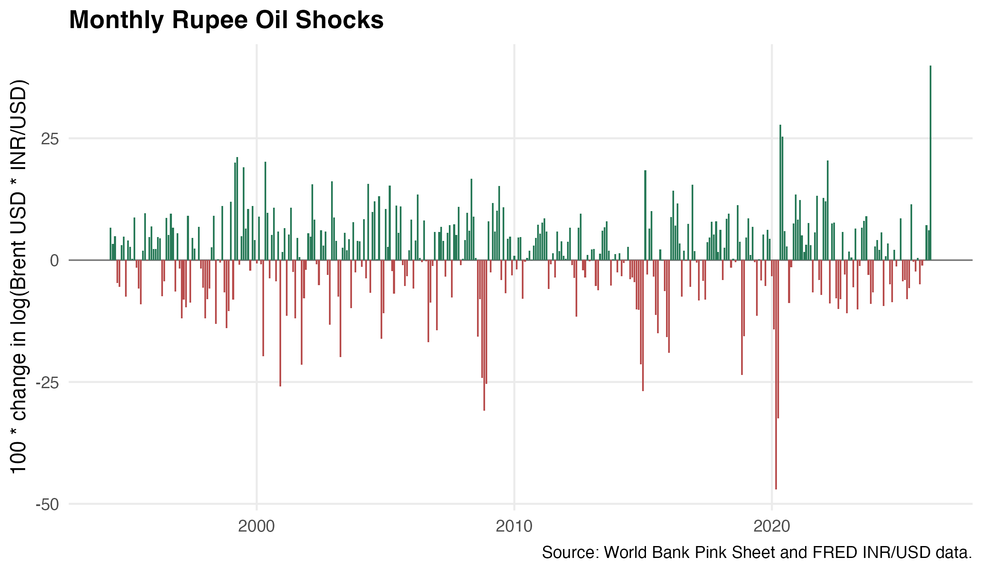
Figure 3.2: Monthly rupee oil shocks — fig_02_rupee_oil_shock.png

3.4 Additional Variables and Controls
The model includes the following additional variables: the change in the log INR/USD exchange rate, capturing exchange-rate movements not already embedded in the rupee oil price; a post-2010 indicator (d_post2010) equal to one from July 2010 onward, marking petrol price deregulation; a post-2014 indicator (d_post2014) equal to one from November 2014 onward, marking diesel deregulation; a COVID dummy equal to one from April 2020 to September 2020; and eleven monthly dummies to absorb systematic seasonal variation in fuel prices.

3.5 Descriptive Statistics
Table 3.2 reports summary statistics for the main variables in levels and log differences.
Variable | N | Mean | SD | Min | Median | Max
WPI Fuel & Power | 384 | 81.54 | 39.04 | 22.87 | 81.20 | 167.10
Brent USD | 384 | 58.06 | 31.86 | 9.80 | 58.43 | 133.87
INR/USD | 384 | 55.32 | 16.03 | 31.37 | 48.36 | 92.82
Rupee oil (INR) | 384 | 3432.55 | 2239.54 | 417.39 | 3208.35 | 9624.23
Δln WPI Fuel (%) | 383 | 0.50 | 2.33 | −11.18 | 0.29 | 9.06
Δln Rupee oil (%) | 383 | 0.79 | 9.25 | −47.01 | 1.78 | 39.97

The mean monthly rupee oil change is 0.79 per cent, reflecting a secular upward drift in both dollar oil prices and the INR/USD rate over the sample. The standard deviation of 9.25 per cent confirms the high volatility of this series. The WPI Fuel and Power index ranges from 22.87 (in the mid-1990s on the 2011–12 base) to 167.10 (in 2022), illustrating the wide variation available for estimation.

3.6 Unit Root Tests
Table 3.3 reports Augmented Dickey–Fuller (ADF) unit root tests for the log-level and first-difference forms of each variable.
Variable | Form | ADF stat | 5% CV | Stationary?
ln(WPI Fuel & Power) | Level | −2.07 | −3.42 | NO
ln(Rupee Brent oil) | Level | −3.02 | −3.42 | NO
ln(INR/USD) | Level | −2.18 | −3.42 | NO
Δln(WPI Fuel & Power) | First Diff | −12.05 | −2.87 | YES
Δln(Rupee Brent oil) | First Diff | −12.94 | −2.87 | YES
Δln(INR/USD) | First Diff | −12.87 | −2.87 | YES

All log-level series fail to reject the null of a unit root at the 5 per cent level, while all first-differenced series reject it decisively. This confirms that the variables are integrated of order one, I(1), and that monthly log differences are the appropriate transformation for estimation. The local-projection specification uses these first differences as both the dependent variable (in cumulative form) and the explanatory variables.

3.7 Estimation Sample
After constructing twelve monthly lags for dynamic controls, the main estimation sample runs from May 1995 to March 2026, comprising 371 observations and spanning 30.92 years. This exceeds the 30-year threshold commonly regarded as a minimum for reliable time-series inference at monthly frequency.

Chapter 4: Methodology

4.1 Local Projections
This study estimates impulse responses using the local-projection (LP) method introduced by Jordà (2005). Unlike a vector autoregressive (VAR) system, which estimates a single set of dynamic equations and iterates them forward to obtain impulse responses at successive horizons, the LP approach runs a separate regression for each horizon h = 0, 1, 2, …, H. The dependent variable at each horizon is the cumulative change in the outcome variable from the period before the shock to h periods after it.
The advantage of this approach is twofold. First, each horizon's regression is estimated independently, so any misspecification at one horizon does not propagate to others. Second, the LP framework accommodates state-dependent responses by simply interacting the shock variable with a state indicator, without requiring the researcher to estimate and invert a nonlinear VAR.
The baseline all-sample specification is:
100 × [ln(WPI Fuel_{t+h}) − ln(WPI Fuel_{t−1})] = α_h + β_h Δln(oil_INR_t) + lag controls + month FE + ε_{t+h}
where the left-hand side measures the cumulative percentage change in the chained WPI Fuel and Power index from month t−1 to month t+h. The coefficient β_h captures the cumulative response of WPI Fuel and Power inflation to a one per cent rupee oil shock at horizon h.

4.2 Lag Controls
The specification includes twelve monthly lags of three variables as dynamic controls: lagged WPI Fuel and Power inflation, lagged rupee oil shocks, and lagged exchange-rate changes. The inclusion of a full year of lagged controls serves two purposes. First, it absorbs serial dependence in the dependent variable and the regressors, reducing the risk of omitted-dynamics bias. Second, it ensures that the estimated contemporaneous response β_h reflects the marginal effect of the current-period shock, conditional on the recent history of fuel inflation, oil prices, and exchange rates.
The choice of twelve lags follows from the monthly frequency of the data: a full year of dynamic controls captures any annual cyclical pattern that might otherwise confound the estimated oil-shock response. Using twelve rather than six lags reduces the estimation sample by an additional six months, but the main sample remains above 30 years (30.92 years from May 1995 to March 2026), which is well above the threshold for reliable monthly time-series inference.
Additional controls include eleven month fixed effects to capture systematic seasonal patterns in fuel pricing, such as those associated with budget cycles or seasonal demand; a COVID dummy for April–September 2020 to absorb the extreme supply-chain disruption and demand collapse during the initial pandemic period; and a post-2010 level shift in the all-sample specification to absorb any structural change in the average rate of WPI fuel inflation after deregulation. This level control ensures that the oil-shock coefficient captures the marginal response to shocks rather than the difference in mean inflation between the two periods.

4.3 State-Dependent Specification
To test whether fuel-pricing reform altered the oil-price pass-through, the study estimates a state-dependent version of the local projection:
… + β_h Δln(oil_INR_t) + θ_h Δln(oil_INR_t) × Post2010_t + …
Here, β_h captures the pre-2010 response and θ_h captures the additional response in the post-2010 period. The total post-2010 response is β_h + θ_h. The post-2010 indicator equals one from July 2010 onward, corresponding to the month following the government's announcement of petrol price deregulation. The same state-dependent structure is applied with a post-2014 indicator (from November 2014, corresponding to diesel deregulation) as a robustness exercise. A high-volatility indicator, defined as months in which the absolute rupee oil shock exceeds the 75th percentile of the sample distribution, is also used to test whether pass-through differs during periods of large price movements.

4.4 Inference: Newey–West HAC Standard Errors
Local projections with multi-step-ahead dependent variables generate overlapping residuals that are serially correlated by construction. At horizon h, the dependent variable is the cumulative change from t−1 to t+h, so the residuals from adjacent observations share h overlapping months. Standard OLS standard errors, which assume independent residuals, are therefore inappropriate and would produce misleadingly narrow confidence intervals.
This study uses Newey–West heteroskedasticity and autocorrelation consistent (HAC) standard errors for all reported estimates. The Newey–West estimator allows for both heteroskedasticity and autocorrelation of unknown form in the residuals, producing valid inference even when the true error covariance structure is not known.
The bandwidth for the Newey–West kernel is set to max(4, h + 1) for each horizon h, following the recommendation that the bandwidth should be at least as large as the forecast horizon to account for the mechanical overlap in residuals. All reported confidence intervals are 95 per cent intervals constructed as the point estimate ± 1.96 × HAC standard error.

4.5 Diagnostics
The study reports a battery of diagnostic tests for the horizon-0 equations, which are the most important for detecting specification problems:
- Breusch–Godfrey test (order 12) for residual serial correlation. If the BG test rejects, this does not invalidate the LP estimates because HAC standard errors are designed to handle serial correlation, but it motivates the GLS robustness check described below.
- RESET test with HAC variance for functional-form misspecification, checking whether powers of the fitted values improve the model. A rejection suggests that a linear specification is too restrictive.
- Recursive CUSUM and OLS-CUSUM tests for parameter stability, checking whether estimated coefficients remain stable over the sample period.
- GLS with AR(1) residual correlation as a serial-correlation robustness check. This model directly accounts for first-order serial correlation in the residuals and is assessed using the Ljung–Box test on normalised residuals at lag 12.

4.6 Horizon Range
Impulse responses are estimated for horizons h = 0 through 12, corresponding to the contemporaneous month through twelve months after the shock. This range captures the short- to medium-run pass-through of oil shocks to wholesale fuel prices. The six-month horizon is used as the primary reporting benchmark, with the twelve-month horizon serving as the medium-run estimate.

Chapter 5: Results

5.1 All-Sample Local-Projection Response
Table 5.1 reports the estimated cumulative response of WPI Fuel and Power inflation to a one per cent rupee oil shock at selected horizons, using the full estimation sample of 371 observations from May 1995 to March 2026.
Horizon | Estimate | SE (HAC) | 95% CI | p-value
0 | 0.0453 | 0.0112 | [0.023, 0.067] | <0.001
3 | 0.2849 | 0.0366 | [0.213, 0.357] | <0.001
6 | 0.2963 | 0.0379 | [0.222, 0.371] | <0.001
9 | 0.3539 | 0.0542 | [0.248, 0.460] | <0.001
12 | 0.3461 | 0.0721 | [0.205, 0.487] | <0.001

The all-sample response is positive at every horizon and statistically significant at the one per cent level throughout. The contemporaneous (horizon-0) response is modest at 0.0453 per cent, consistent with the idea that wholesale fuel prices adjust gradually rather than instantaneously to oil shocks. This small but significant immediate effect suggests that some administered or market-linked price revisions take place within the same month, but the bulk of the adjustment occurs over subsequent months.
The cumulative response rises steeply over the first three months, reaching 0.2849 by horizon 3, and then stabilises around 0.28–0.35 for the remainder of the horizon window. This levelling-off pattern is important: it implies that the oil-price pass-through process is largely completed within four to six months, with only a modest additional increment at longer horizons. The timing is consistent with the institutional reality of India's fuel-pricing mechanism, where retail prices are revised at regular fortnightly or monthly intervals rather than continuously.
At the six-month benchmark, a one per cent rupee oil shock is associated with a cumulative 0.2963 per cent increase in WPI Fuel and Power. At twelve months, the cumulative response is 0.3461. Both estimates are highly significant with p-values below 0.001. The magnitude implies an incomplete but economically meaningful pass-through: a one per cent increase in the rupee cost of crude oil is associated with a roughly 0.30 per cent increase in the wholesale fuel price index. The less-than-proportional response reflects the fact that WPI Fuel and Power includes not only petroleum products but also coal and electricity, whose prices adjust on different schedules and are partially regulated.
The estimated standard errors widen modestly at longer horizons, as expected from the increasing Newey–West bandwidth, but the confidence intervals remain comfortably above zero through horizon 12.
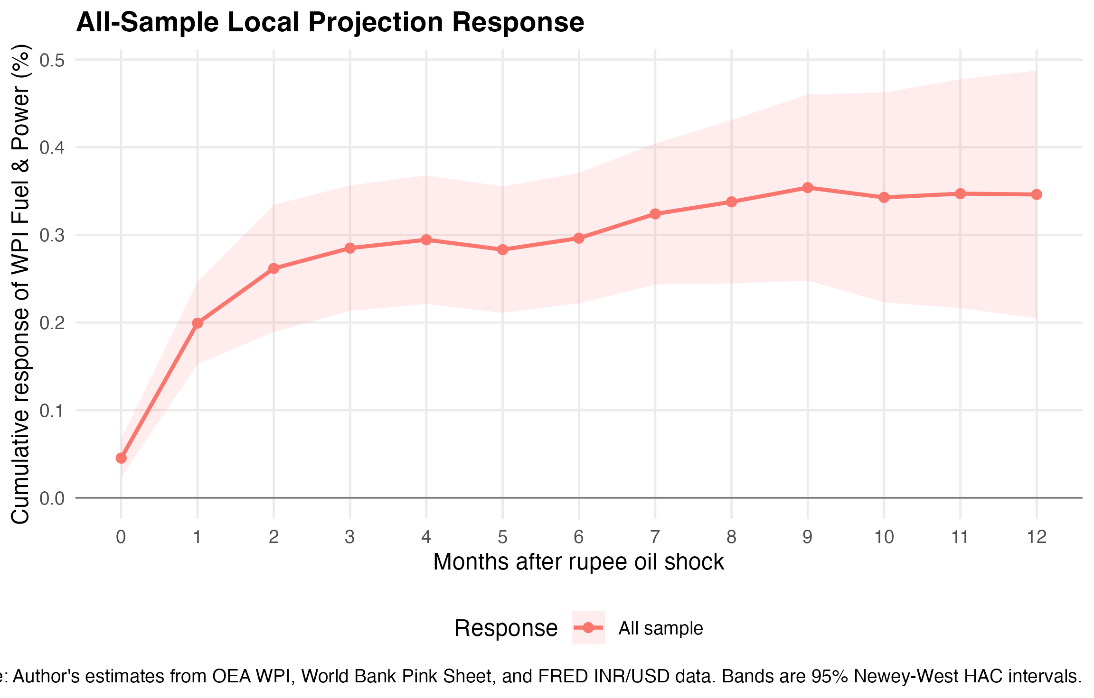
Figure 5.1: All-sample local-projection response — fig_03_lp_all_sample.png
Figure 5.1 confirms the visual pattern: a smooth, monotonically rising impulse response that levels off around horizon 4 and remains stable through horizon 12, with tight 95 per cent confidence bands that exclude zero at every point.

5.2 Post-2010 State-Dependent Response
Table 5.2 reports the state-dependent local-projection estimates, which allow the oil-price response to differ between the pre-2010 and post-2010 periods. The table shows the pre-2010 response (β_h), the total post-2010 response (β_h + θ_h), and the interaction term (θ_h) representing the additional post-2010 effect.
Horizon | Pre-2010 | Post-2010 | Interaction (θ) | θ p-value | Sig
0 | −0.0095 | 0.0929 | 0.1024 | <0.001 | ***
3 | 0.1369 | 0.4292 | 0.2924 | <0.001 | ***
6 | 0.1965 | 0.3937 | 0.1972 | 0.0220 | **
9 | 0.2060 | 0.4985 | 0.2925 | 0.0103 | **
12 | 0.2111 | 0.4803 | 0.2691 | 0.0840 | *

The results reveal a striking difference between the two regimes. In the pre-2010 period, the response at horizon 0 is slightly negative (−0.0095) and not statistically significant, suggesting that administered fuel prices effectively blocked contemporaneous pass-through of oil shocks to the wholesale index. Under the administered pricing mechanism, oil marketing companies absorbed cost increases through under-recoveries rather than passing them through to wholesale prices immediately. The pre-2010 response becomes positive from horizon 1 onward and stabilises around 0.19–0.21 at horizons 5 through 12, indicating that even under administered pricing, some oil-price pass-through eventually occurred, albeit at a slower pace and smaller magnitude. This delayed adjustment may reflect periodic price revisions that the government permitted to limit the accumulation of under-recoveries.
In the post-2010 period, the total response is substantially larger at every horizon. The contemporaneous post-2010 response is 0.0929, nearly ten times larger than the pre-2010 estimate, indicating that market-linked pricing allows wholesale fuel prices to begin adjusting within the same month as the oil shock. By horizon 3, the post-2010 response reaches 0.4292, more than three times the pre-2010 value of 0.1369 at the same horizon.
At the six-month benchmark, the total post-2010 response is 0.3937, approximately double the pre-2010 response of 0.1965. This doubling of pass-through is consistent with the removal of the administered-price buffer that previously absorbed a large share of oil-price movements. The post-2010 interaction θ_h is 0.1972 at horizon 6 with a p-value of 0.0220. This is statistically significant at the 5 per cent level, confirming that the fuel-pricing reform of 2010 is associated with a measurably stronger oil-price pass-through to wholesale fuel prices.
The interaction is positive and statistically significant at the 5 per cent level or better through horizons 0 to 11. At horizon 12, the interaction estimate is 0.2691 with a p-value of 0.0840, which is significant at the 10 per cent level but not at the conventional 5 per cent level. This slight loss of precision at the longest horizon is expected given the wider confidence bands that arise from the larger Newey–West bandwidth.
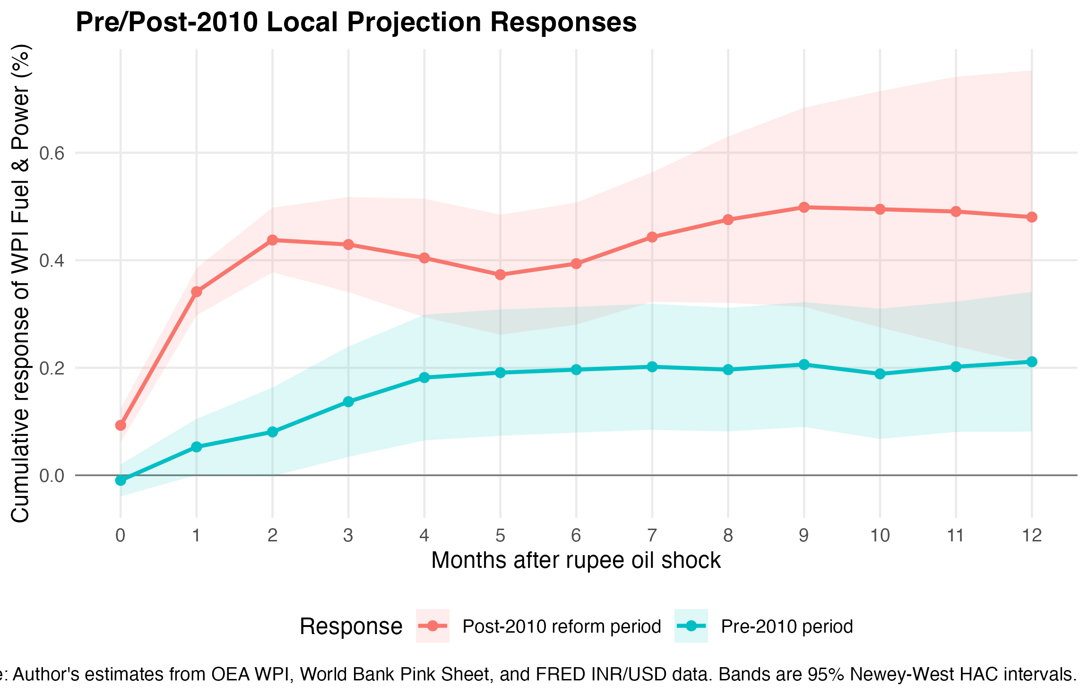
Figure 5.2: Pre/Post-2010 state comparison — fig_04_lp_state_comparison_post2010.png
Figure 5.2 reinforces the quantitative finding: the post-2010 response path lies clearly above the pre-2010 path at all horizons, and the confidence bands separate after the first month. The visual gap between the two response paths is economically substantial and statistically significant throughout the relevant horizon range.

5.3 Diagnostic Evidence
Table 5.3 summarises the diagnostic tests for the horizon-0 specifications, comparing the simple all-sample LP with the state-dependent post-2010 LP.
Diagnostic | Simple all-sample | State-dependent post-2010
BG (lag 12) p | 0.7279 (PASS) | 0.0003 (CONTROLLED_BY_HAC)
Breusch–Pagan p | 0.2280 | 0.1223
RESET (HAC) p | 0.0097 (REJECTED) | 0.3592 (PASS)
Rec-CUSUM p | 0.4293 (PASS) | 0.6459 (PASS)
OLS-CUSUM p | 0.9488 (PASS) | 0.8869 (PASS)

The simple all-sample horizon-0 equation is rejected by the HAC RESET benchmark (p = 0.0097). This result should not be hidden; rather, it supports the state-dependent design because it shows that a single linear response is too restrictive for the full sample that spans both the administered and market-linked pricing eras. The diagnostic rejection of the simple all-sample benchmark is treated as evidence against a single linear pass-through equation. The preferred specification therefore allows the oil response to differ after the 2010 fuel-pricing reform period.
The state-dependent post-2010 specification passes the RESET test (p = 0.3592), the recursive CUSUM test (p = 0.6459), the OLS-CUSUM test (p = 0.8869), and the Breusch–Pagan heteroskedasticity test (p = 0.1223). These results indicate that the state-dependent specification is well-specified in terms of functional form, structurally stable over the sample, and free from problematic heteroskedasticity.
The Breusch–Godfrey test rejects the null of no serial correlation (p = 0.0003), but this is expected in monthly local-projection settings where overlapping multi-step residuals generate mechanical serial dependence. This is precisely why Newey–West HAC inference is used for all reported estimates.
As a further robustness check, a GLS model with AR(1) residual correlation is estimated for the state-dependent horizon-0 specification. This model directly accounts for first-order serial correlation rather than relying on robust standard errors. The normalised residuals from the GLS model pass the Ljung–Box lag-12 test with a p-value of 0.9974, confirming that the AR(1) correction is sufficient. The post-2010 interaction estimate from the GLS model is 0.1117 and remains highly significant (p < 0.001). Because residual serial dependence is expected in monthly local-projection settings, all reported inference uses Newey–West HAC standard errors. The GLS robustness check confirms that the main finding is not an artefact of serial dependence in the OLS residuals.

Chapter 6: Robustness and Limitations

6.1 Post-2014 Diesel Deregulation
India completed diesel price deregulation in October 2014. To test whether this second reform further strengthened oil-price pass-through, the state-dependent local projection is re-estimated with a post-2014 indicator replacing the post-2010 indicator. Table 6.1 reports the results at selected horizons.
Horizon | Pre-2014 | Post-2014 | Interaction (θ) | θ p-value
0 | −0.0027 | 0.0937 | 0.0964 | <0.001
6 | 0.2509 | 0.3497 | 0.0988 | 0.2809
12 | 0.2981 | 0.4048 | 0.1067 | 0.4672

The post-2014 interaction is positive at the six-month horizon (0.0988) but not statistically significant at conventional levels (p = 0.2809). At shorter horizons, the interaction is significant, reflecting the rapid adjustment of recently deregulated diesel prices. However, at the medium-run benchmarks of six and twelve months, the effect becomes imprecise, possibly because the post-2014 sub-sample is shorter and includes the COVID period, which introduces substantial noise.
The post-2014 estimates are consistent in sign but weaker in precision, so this dissertation treats them as contextual robustness rather than as the main reform result. The evidence does not support the claim that diesel deregulation caused a separately identifiable strengthening of pass-through beyond the effect already captured by the post-2010 petrol deregulation indicator.
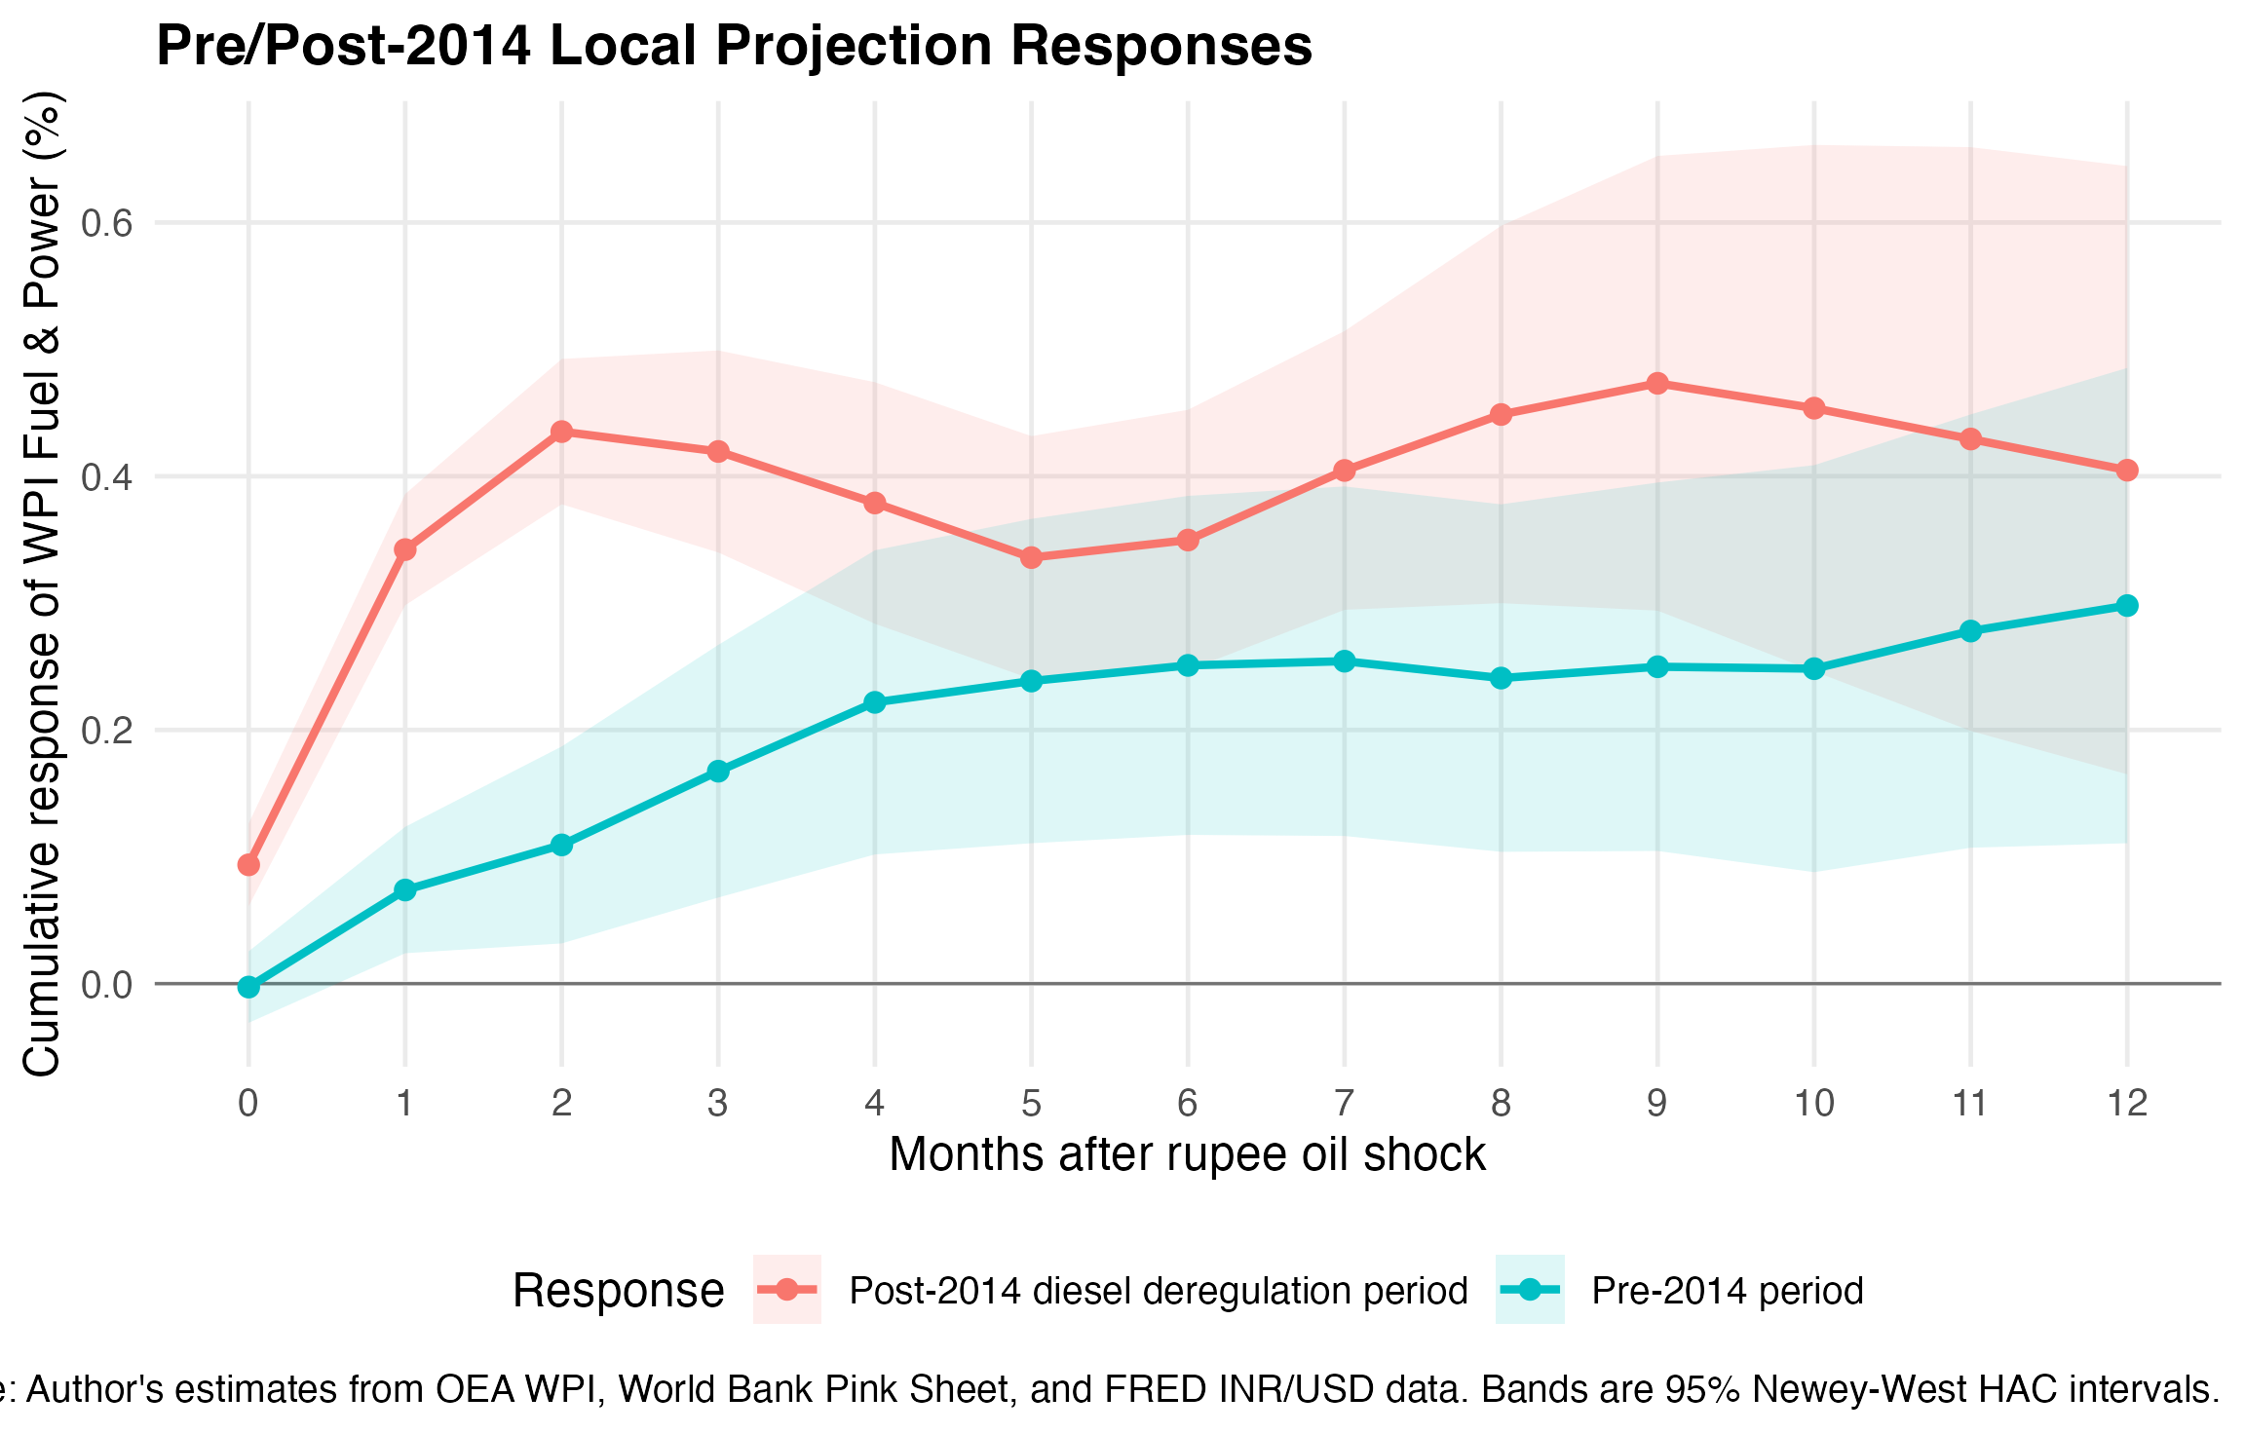
Figure 6.1: Pre/Post-2014 comparison — fig_05_lp_state_comparison_post2014.png

6.2 High Oil-Volatility Months
To test whether pass-through is larger during periods of extreme oil-price movements, the sample is split using a high-volatility indicator defined as months in which the absolute rupee oil shock exceeds the 75th percentile of the sample distribution. Table 6.2 reports the results.
Horizon | Normal vol. | High vol. | Interaction | θ p-value
0 | 0.0190 | 0.0523 | 0.0333 | 0.1332
6 | 0.2762 | 0.3083 | 0.0321 | 0.7541
12 | 0.4966 | 0.3230 | −0.1736 | 0.2783

The high-volatility interaction is small and statistically insignificant at the six-month benchmark (0.0321, p = 0.7541). At longer horizons, the interaction turns slightly negative, suggesting that extreme oil-price movements may initially produce faster adjustment but do not result in a permanently larger cumulative response. This pattern is consistent with a fuel-pricing mechanism that eventually adjusts fully regardless of the size of the initial shock.
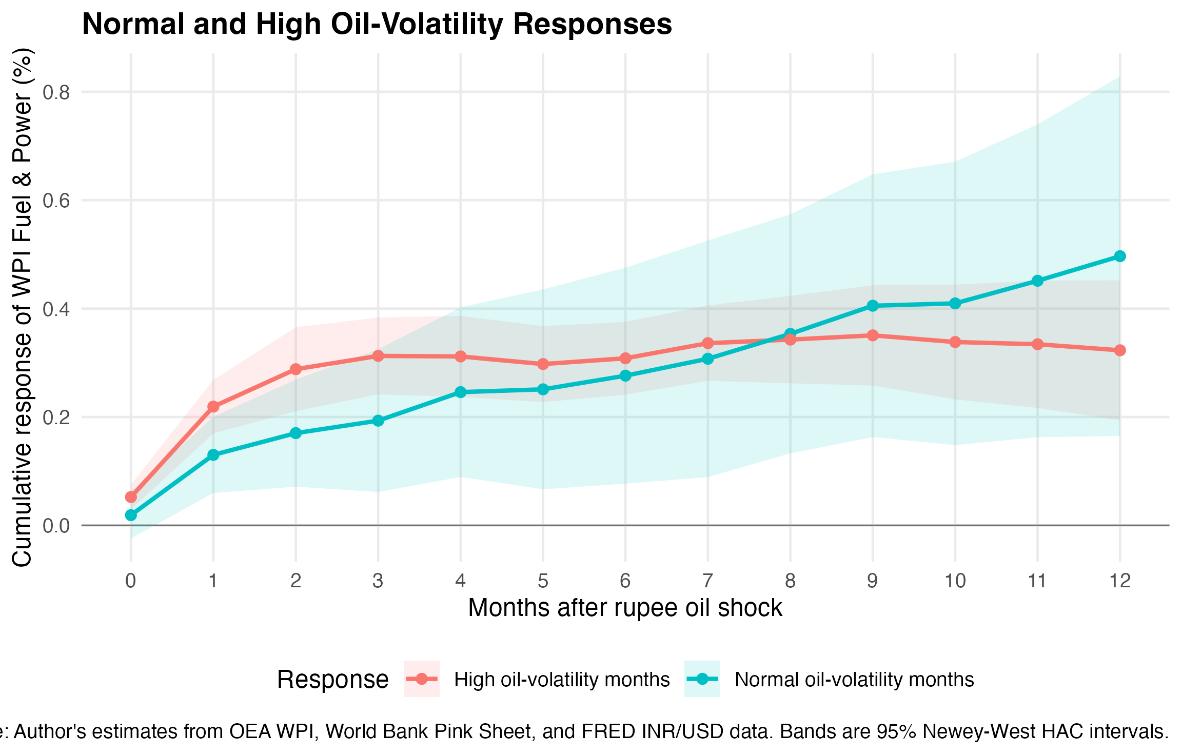
Figure 6.2: Normal vs high volatility — fig_06_lp_high_volatility.png

6.3 Asymmetry Between Positive and Negative Shocks
A specification separating positive and negative rupee oil shocks is estimated to test whether upward oil-price pass-through exceeds downward pass-through—the so-called rockets-and-feathers hypothesis. At the six-month horizon, the Wald test for equal responses gives F = 0.61 (p = 0.4357), failing to reject the null of symmetric pass-through. At the twelve-month horizon, the test rejects at the 5 per cent level (p = 0.0465), with the positive-shock response (0.6425) substantially exceeding the negative-shock response (0.1162). However, this single marginal rejection at the longest horizon, where confidence bands are widest, does not constitute strong evidence of systematic asymmetry. The asymmetry exercise is therefore reported as a secondary robustness table rather than as a main finding.

6.4 Limitations
Several limitations should be acknowledged. First, the local-projection estimates capture reduced-form associations and should not be interpreted as structural causal effects. The rupee oil price is not randomly assigned, and the estimated coefficients may reflect both direct cost-push effects and correlated macroeconomic conditions. Second, the chaining of WPI series across base years introduces a degree of measurement error, particularly around the splicing points. While the linking factors are official OEA ratios, the underlying commodity baskets differ across base years. Third, the post-2010 indicator is a binary variable that does not capture the gradual pace of actual reform implementation. Fourth, the COVID dummy may not fully capture pandemic effects on both oil markets and domestic fuel demand. Fifth, the analysis focuses on the wholesale fuel layer and does not trace pass-through to consumer prices or broader macroeconomic outcomes.
Despite these limitations, the main state-dependent local-projection specification passes the key diagnostic benchmarks—functional form, stability, and serial-correlation robustness—providing confidence that the estimated post-2010 effect is not driven by obvious specification errors.

Conclusion
This dissertation set out to answer whether rupee-denominated Brent crude oil shocks transmit to India's wholesale fuel inflation, and whether the transmission strengthened after the fuel-pricing reforms of 2010. Using monthly data from May 1995 to March 2026 and Jordà (2005) local projections with Newey–West HAC inference, the analysis provides clear evidence on both questions.
Rupee oil shocks have a positive and statistically significant cumulative association with WPI Fuel and Power inflation at every horizon from zero to twelve months. At the six-month benchmark, a one per cent rupee oil shock is associated with a 0.2963 per cent cumulative response, significant at the one per cent level. At twelve months, the estimate is 0.3461. The response profile suggests that most of the pass-through is completed within four to six months, consistent with the periodic adjustment of domestic fuel prices to global benchmarks.
The state-dependent specification reveals that the pass-through is substantially stronger in the post-2010 period. The post-2010 interaction adds 0.1972 percentage points to the six-month response, with a p-value of 0.0220. The total post-2010 six-month response is 0.3937, approximately double the pre-2010 response of 0.1965. The interaction remains significant through most horizons, and the state-dependent specification passes functional-form, stability, and serial-correlation robustness diagnostics.
The post-2014 diesel deregulation interaction is positive in sign but lacks statistical precision at the six-month horizon and is therefore treated as supporting robustness rather than as a headline claim. Similarly, the asymmetry and high-volatility exercises do not overturn the main finding and are reported as secondary checks.
The policy implication should be stated cautiously. The evidence suggests that fuel-price deregulation, by removing the administered-price buffer between global oil markets and domestic wholesale prices, has made India's wholesale fuel prices more responsive to rupee oil shocks. For inflation management purposes, policymakers and forecasters should monitor the rupee oil price—the product of Brent and the exchange rate—rather than tracking the dollar-denominated oil price alone. Exchange-rate movements amplify or dampen the pass-through of global oil shocks, and ignoring this channel would understate the effective oil-price impulse facing the Indian economy.
This study does not claim that oil shocks mechanically determine all Indian inflation. The WPI Fuel and Power component is one layer of a complex price system, and the pass-through from wholesale fuel prices to headline consumer inflation involves additional channels that are beyond the scope of this analysis. What the evidence does support is a narrower and more defensible claim: that rupee oil shocks transmit clearly and significantly to India's wholesale fuel price index, and that this transmission became stronger after the institutional shift from administered to market-linked fuel pricing.

References
Bhanumurthy, N. R., Das, S., and Bose, S. (2012). Oil prices and the macro economy in India. National Institute of Public Finance and Policy Working Paper No. 2012-100.
Deheri, A. and Ramachandran, M. (2023). Oil price shocks and exchange rate pass-through to domestic prices in India. Energy Economics, 119, 106564.
Hamilton, J. D. (1983). Oil and the macroeconomy since World War II. Journal of Political Economy, 91(2), 228–248.
Jordà, Ò. (2005). Estimation and inference of impulse responses by local projections. American Economic Review, 95(1), 161–182.
Kelkar Committee (2010). Report of the Expert Group on a Viable and Sustainable System of Pricing of Petroleum Products. Government of India.
Kilian, L. (2009). Not all oil price shocks are alike: Disentangling demand and supply shocks in the crude oil market. American Economic Review, 99(3), 1053–1069.
Mandal, K., Dutta, P., and Sarkar, S. (2012). Oil price shocks and macroeconomic fundamentals of the Indian economy. Reserve Bank of India Occasional Papers, 33(1–2), 1–38.
Ministry of Petroleum and Natural Gas (2023). Indian Petroleum and Natural Gas Statistics 2022–23. Government of India.
Newey, W. K. and West, K. D. (1987). A simple, positive semi-definite, heteroskedasticity and autocorrelation consistent covariance matrix. Econometrica, 55(3), 703–708.
Ramey, V. A. (2016). Macroeconomic shocks and their propagation. In J. B. Taylor and H. Uhlig (Eds.), Handbook of Macroeconomics (Vol. 2, pp. 71–162). Elsevier.
Sarmah, A. and Bal, D. P. (2021). Oil price shocks and macroeconomic performance of the Indian economy: An SVAR analysis. Resources Policy, 74, 102368.

