From crude oil to consumer inflation:
transmission and attenuation across India’s price system
Aniket Pandey
April 2026
Abstract
India imports more than four fifths of the crude oil it consumes, but the way this external cost shock moves through domestic prices is uneven. This paper studies oil pass-through as a layered process. It traces transmission across four price tiers: headline wholesale inflation, retail petrol prices at the pump, fuel-sensitive wholesale and consumer indices, and the headline consumer price index. The empirical core uses short-run asymmetric autoregressive distributed lag models with Newey–West inference, estimated on monthly series chained back to 1983 for headline WPI and to 1995 for the fuel and power component. A complementary battery of nonlinear ARDL models in levels is reported in the appendix. Three findings are stable across specifications. Pass-through into headline WPI is statistically detectable but modest (cumulative pass-through of about 0.030 for positive oil shocks); it is roughly an order of magnitude larger in retail petrol and in fuel-sensitive wholesale prices; and it weakens sharply before reaching headline CPI, where the cumulative effect is not significantly different from zero. A pre/post-2010 split shows materially larger headline pass-through in the post-deregulation period, which is broadly consistent with the institutional shift toward more market-linked pricing of transport fuels. Short-run asymmetry is not a robust feature of the preferred specifications. Taken together, the results suggest that imported oil inflation in India is best understood as a transmission-and-attenuation chain in which pricing institutions and consumer-basket composition absorb most of the upstream shock before it reaches household inflation.
Keywords: oil price pass-through; imported inflation; India; wholesale inflation; consumer inflation; retail fuel pricing; deregulation; asymmetry.

Introduction
India is a structural net importer of crude oil. In 2023–24, the country sourced close to 87 percent of its crude requirement from abroad, making the rupee value of a barrel of Brent one of the clearest external cost shocks absorbed by the domestic price system in any given month (Petroleum Planning and Analysis Cell 2024). The policy question that follows is straightforward and longstanding: when crude prices move, how much of that movement ultimately reaches the inflation rate faced by households?
Existing work on India usually answers that question one index at a time. Some studies focus on WPI in isolation (Bhoi et al. 2012; Suresh et al. 2026). Others examine CPI subgroups or aggregate CPI (Abu-Bakar and Masih 2018; Sek 2019). A further strand concentrates on the retail fuel pricing channel after petrol deregulation in 2010 and diesel deregulation in October 2014 (Pradeep 2022; Deheri and Carmel 2024). Each strand contributes something useful. Taken together, however, they leave an important gap. India’s pricing institutions operate as a chain (international crude $→$ exchange rate $→$ domestic refined products $→$ wholesale energy $→$ consumer fuel $→$ headline CPI), yet the literature rarely traces that chain end-to-end within a single empirical design. As a result, two statements coexist in policy discussion without being fully reconciled: oil shocks pass through to wholesale inflation, yet they barely move headline CPI. Both can be true at the same time. The relevant question is where along the chain the shock weakens.
This paper addresses that question by estimating pass-through at four points in the transmission process. The headline WPI series is constructed by chaining four official base years (1981–82, 1993–94, 2004–05, and 2011–12) into a single 528-observation monthly series from April 1982 to March 2026, giving the longest historically defensible wholesale inflation horizon currently available for India. The WPI Fuel and Power subindex is chained over three base years and runs from April 1994 to March 2026. The retail fuel layer uses the PPAC monthly Delhi retail selling price for petrol from August 2004 onward. Headline CPI on the All-India 2010=100 base is treated as the consumer endpoint. We also use the CPI Fuel and Light subgroup as a short bridge series. Because of the post-2011 CPI rebase, that fuel-and-light series is used as supporting evidence rather than as one of the paper’s headline mandates.
The empirical strategy is intentionally simple. The main specifications are short-run asymmetric ADL models in log-differences. Each equation includes twelve own lags, lags zero to six on positive and negative oil-change components, month fixed effects, and Newey–West HAC standard errors. Cumulative pass-through is reported as the sum of the positive (CPT$​^{+}$) and negative (CPT$​^{−}$) coefficients, with Wald tests for each sum and for the symmetry restriction CPT$​^{+}$ = CPT$​^{−}$. To strengthen finite-sample inference, the symmetry test is also evaluated using a restricted-residual circular block bootstrap. A nonlinear ARDL battery in levels, using the bounds-testing approach of Pesaran et al. (2001) and the asymmetric decomposition of Shin et al. (2014), is reported in the appendix as supplementary long-run evidence.
The main results tell a layered story. In the long historical sample, wholesale inflation responds to rupee oil shocks with CPT$​^{+}=0.030$ ($p=0.024$) and CPT$​^{−}=0.037$ ($p=0.001$). These estimates are small in magnitude but precisely estimated, and asymmetry is not rejected (asymptotic $p=0.673$, bootstrap $p=0.746$). A pre/post-2010 split shows that most of this signal is concentrated in the post-deregulation period, where CPT$​^{+}$ rises to $0.074$ and CPT$​^{−}$ to $0.081$. Moving down to the fuel-sensitive layer, the magnitudes change substantially. WPI Fuel and Power yields CPT$​^{+}=0.287$ and CPT$​^{−}=0.268$, both with $p<0.001$. PPAC retail petrol responds even more strongly, with CPT$​^{+}=0.346$ and CPT$​^{−}=0.191$ on a 245-month sample beginning in August 2004. By the time the shock reaches headline CPI, the picture is quite different from the wholesale fuel layer: CPT$​^{+}=0.021$ with $p=0.122$, while CPT$​^{−}$ is effectively zero ($p=0.94$). Most of the upstream movement has therefore been absorbed somewhere between the pump and the consumer basket.
The paper makes three contributions. First, it offers a single integrated map of where the oil-price signal is transmitted and where it fades, rather than treating WPI and CPI as competing answers to the same question. Second, the long historical wholesale sample anchors the central pass-through estimate in a 43-year window, which is uncommon in the India literature, where many wholesale studies stop in the 2010s. Third, the integrated framework shifts attention away from asymmetry as the central result. Short-run asymmetry is tested, but it is not the most robust feature of the data. Attenuation across layers is. The contribution is therefore one of integration rather than estimator innovation, and the paper is framed accordingly.
The rest of the paper proceeds as follows. Section 2 outlines the institutional setting and situates the analysis in the existing literature. Section 3 describes the data and empirical strategy. Section 4 presents the historical wholesale results. Section 5 traces the mechanism and the attenuation across the four layers. Section 6 reports robustness exercises and summarises the appendix NARDL evidence. Section 7 concludes with the main policy implications.

Institutional background and focused literature
Two institutional features shape the entry of oil shocks into Indian inflation. The first is the foreign-exchange channel. Brent is priced in dollars, and India pays for oil imports in dollars, so the rupee cost of a barrel is the product of Brent and the INR/USD exchange rate. A five percent rupee depreciation against an unchanged Brent price therefore has the same imported-cost implication as a five percent rise in Brent with the exchange rate held constant. The second is the domestic pricing regime for refined products, which changed materially over the sample period. From the 1970s into the early 2000s, India operated an Administered Pricing Mechanism under which the union government set retail prices for petrol, diesel, kerosene, and LPG, and absorbed the difference between domestic and import-parity prices through subsidies and oil bonds. That system was dismantled gradually. Petrol was deregulated in June 2010 and diesel in October 2014. Kerosene and LPG remained partly subsidised. Over time, tax components such as central excise and state VAT also became a large part of the pump price, giving the government a meaningful buffer against international price movements.
Taken together, these two features imply a clear empirical expectation. Under a market-linked retail fuel regime, an oil shock should move relatively quickly into retail petrol and diesel prices. From there it should pass into the fuel-sensitive components of wholesale and consumer inflation. Whether it reaches headline inflation depends on the weight of fuel-sensitive items in the index and on the co-movement of non-fuel components. Under an administered regime, by contrast, a larger share of the same shock should be absorbed at the retail stage through subsidy changes or excise adjustments. The pre- and post-2010 samples therefore provide a natural way to examine whether deregulation made the transmission chain more permissive.
Existing work on India’s oil-price pass-through provides a sequence of partial answers to this combined institutional setting. Early studies using linear vector autoregressions and cointegration tests on WPI generally reported small but significant pass-through coefficients (Bhoi et al. 2012; Bhanumurthy et al. 2012). A later strand turned to nonlinear ARDL methods to test for asymmetry. Abu-Bakar and Masih (2018) report long-run asymmetric pass-through to Indian inflation using NARDL. Chattopadhyay and Mitra (2015) and Pal and Mitra (2016) examine asymmetry in oil-product prices and find that such behaviour is concentrated in segments where market-linked pricing actually applies. Pandey and Shettigar (2019) document partial pass-through of crude to retail fuel in the early post-deregulation period. Pradeep (2022) focus on the diesel reform and find stronger asymmetric pass-through to disaggregated wholesale and consumer prices after the reform window. Deheri and Carmel (2024) also report asymmetric pass-through from crude to retail fuel. Two more recent contributions are particularly relevant for the present design. Suresh et al. (2026) estimate a NARDL system for Indian wholesale prices and find long-run asymmetry with weaker short-run asymmetry, which broadly matches the pattern suggested by the appendix evidence here. Sek (2019) provide cross-country panel evidence that the WPI–CPI gap in pass-through tends to be wider in oil-importing economies, which offers a useful comparative benchmark.
What this literature does not usually provide is a single empirical architecture that traces the full chain from crude to headline CPI on consistent monthly data. Most studies select one estimator family (such as NARDL, SVAR, or VECM) and one inflation index, then report a pass-through estimate together with an asymmetry result. The contrast between headline and fuel-sensitive indices is sometimes acknowledged, but attenuation across layers is rarely treated as the main object of inference. Sadath and Acharya (2021), using an SVAR, comes closest to this layered framing at the macro level, though the emphasis there is on real activity rather than pricing institutions. The present paper therefore contributes more in architecture than in method. It retains the now-standard short-run asymmetric ADL as the main tool, places NARDL in the appendix, and treats the gap between pass-through estimates across layers as the substantive issue of interest.
A short methodological clarification is useful here. Parts of the Indian pass-through literature have treated headline WPI as a proxy for input-cost inflation and headline CPI as a proxy for household-facing inflation, and have then disagreed on which is the more relevant policy measure. This paper does not frame the question that way. WPI and CPI answer different questions. WPI is more informative about upstream cost transmission and imported input-price pressures, whereas CPI is more informative about household-facing inflation. Studying both jointly makes it possible to distinguish where oil shocks enter the price system from whether they survive all the way to headline consumer inflation. The post-2014 monetary-policy framework that targets headline CPI (Reserve Bank of India 2014) makes the CPI endpoint the natural place to evaluate household impact, but it does not make wholesale evidence less relevant. If anything, the wholesale layer becomes more informative once it is clear that upstream cost pressure does not automatically appear in the target index.

Data and empirical strategy
The dataset is monthly. Brent crude in US dollars per barrel comes from the World Bank Commodity Markets Pink Sheet. The INR/USD spot rate comes from FRED (series EXINUS). The rupee oil price is constructed as the product of Brent and EXR. Wholesale prices come from the Office of the Economic Adviser (OEA) under the Department for Promotion of Industry and Internal Trade. Headline WPI and the WPI Fuel and Power subindex are constructed by chain-linking the four official OEA base series (1981–82, 1993–94, 2004–05 and 2011–12) using the official linking factors, with all series rebased to 2011–12 = 100. This gives a 528-observation headline series running April 1982 through March 2026 and a 384-observation Fuel and Power series running April 1994 through March 2026. The retail fuel layer is the PPAC monthly Delhi retail selling price for petrol, available from August 2004. The consumer endpoint is the All-India headline CPI series. The CPI Fuel and Light subgroup is taken from the post-2011 base and used as a supporting bridge series rather than as a primary index. After inner joins on common dates, the active estimation samples cover roughly 43 years for headline WPI, 31 years for WPI Fuel and Power, and 20 years for the PPAC and CPI specifications. Table 1 summarises the series.
Series, sources, transformations, and sample spans.
Series | Source | Transform. | Active sample
Brent crude (USD/bbl) | World Bank Pink Sheet | $Δln$ | 1983-05 to 2026-03
INR/USD spot rate | FRED EXINUS | $Δln$ | 1983-05 to 2026-03
Rupee oil price | Brent $×$ EXR (constructed) | $Δln$ | 1983-05 to 2026-03
Headline WPI (2011-12 = 100) | OEA, chained across four bases | $Δln$ | 1983-05 to 2026-03
WPI Fuel & Power (2011-12 = 100) | OEA, chained across three bases | $Δln$ | 1995-05 to 2026-03
PPAC retail petrol, Delhi | Petroleum Planning and Analysis Cell | $Δln$ | 2004-08 to 2024-12
Headline CPI (All-India, 2010 = 100) | MoSPI / FRED INDCPIALLMINMEI | $Δln$ | 2004-08 to 2024-12
CPI Fuel & Light (post-2011 base) | MoSPI | $Δln$ | 2011-05 to 2024-12
Notes: Wholesale series chained to a common 2011–12 = 100 base using OEA linking factors. Active samples reported after inner joins on common dates. The CPI Fuel & Light series begins in May 2011 because the post-2011 base is the longest harmonised consumer fuel index currently available.
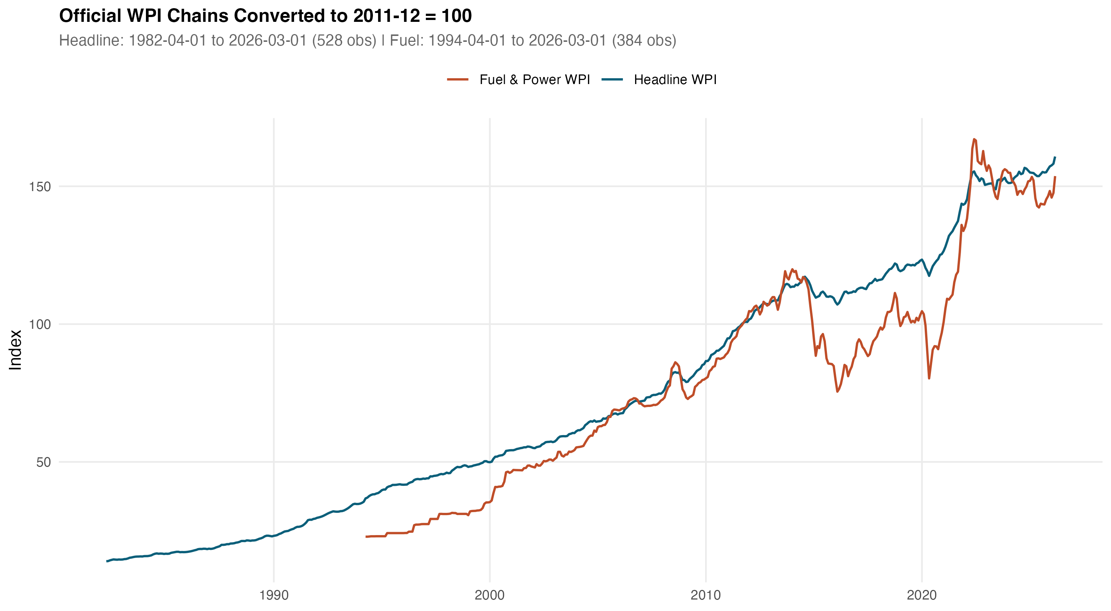
Chained WPI series, 2011-12 = 100. Headline WPI runs from April 1982 (528 monthly observations); Fuel & Power begins April 1994 (384 observations). Splice points across the four official OEA base years are marked.
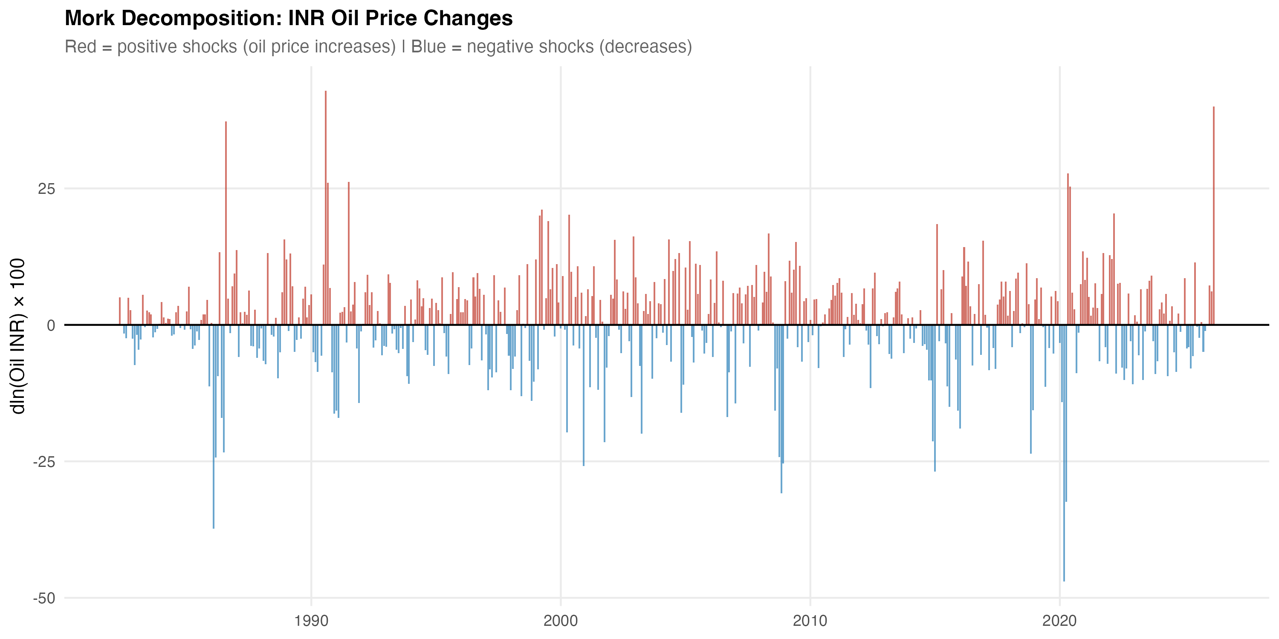
Decomposition of the rupee oil price into Brent (USD) and the INR/USD rate. Plotted in log levels with each series indexed to its January 2000 value. The two cost-side drivers move out of phase in some windows (notably 2003–2008 and 2014–2016), which is the variation the Brent + EXR robustness specification in Section 6 exploits.
All series are converted to month-on-month log differences. Let $Δy_{t}=lnY_{t}−lnY_{t−1}$ and $Δx_{t}=lnX_{t}−lnX_{t−1}$ where $X_{t}$ denotes the relevant oil measure. The asymmetric oil change is decomposed into a positive and a negative part:
$$Δx_{t}^{+}=max(Δx_{t},0), Δx_{t}^{−}=min(Δx_{t},0).$$
The main estimating equation is the short-run asymmetric ADL
$$Δy_{t}=α+\sum_{i=1}^{12}{ϕ_{i}}Δy_{t−i}+\sum_{j=0}^{6}{β_{j}^{+}}Δx_{t−j}^{+}+\sum_{j=0}^{6}{β_{j}^{−}}Δx_{t−j}^{−}+γ^{′}Z_{t}+μ_{m}+u_{t},$$
where $Z_{t}$ collects controls (notably $Δln{EXR}_{t}$ in the Brent decomposition), $μ_{m}$ are calendar-month fixed effects, and $u_{t}$ is an error process whose autocorrelation we accommodate through Newey–West standard errors with a Bartlett kernel and Newey–West lag truncation. The cumulative pass-through summaries are
$${CPT}^{+}=\sum_{j=0}^{6}{β_{j}^{+}}, {CPT}^{−}=\sum_{j=0}^{6}{β_{j}^{−}},$$
with significance assessed using HAC Wald tests on the linear restrictions ${CPT}^{+}=0$, ${CPT}^{−}=0$ and the symmetry restriction ${CPT}^{+}={CPT}^{−}$. For the symmetry test we also report a finite-sample $p$-value from a restricted-residual circular block bootstrap with 4,999 replications.
The choice of an ADL in differences rather than a NARDL in levels is deliberate. Standard unit-root tests reject I(1) for all of the differenced series used here; for $ΔlnWPI$, the ADF and Phillips–Perron statistics are $−12.22$ and $−14.39$, respectively. KPSS gives a borderline rejection of stationarity for $ΔlnWPI$ ($\hat{η}=0.90$ against a 5% critical value of $0.46$), which we interpret as the familiar KPSS tendency to over-reject in long samples with structural breaks rather than as evidence of a unit root in the differenced series (see Reserve Bank of India 2014). A Bai–Perron test identifies one break in $ΔlnWPI$ at September 2013, corresponding to the disinflationary regime shift associated with the inflation-targeting transition. In that setting, ADL in differences with Newey–West inference is the cleaner short-run specification. A NARDL battery in levels is nevertheless retained in the appendix for two reasons: it provides a long-run cointegration check, and it remains the dominant framework in the Indian pass-through literature.
The retail-fuel mechanism model uses $Δln{Petrol}_{t}^{Delhi}$ as the dependent variable and asymmetric Brent (in USD) as the regressor, with $q=3$ lags on each side. Although the petrol pricing regime moved to fortnightly in 2014 and to daily revisions in 2017, monthly averaging is appropriate for the cross-layer comparison and avoids the Brent–EXR averaging mismatch that a daily specification would inherit. The CPI bridge model regresses $Δln{Fuel\&Light}_{t}^{CPI}$ on asymmetric retail petrol changes; this is reported as a bridge equation only because the available CPI Fuel and Light series begins in May 2011 and falls below the 20-year window we treat as the minimum sample for headline mandates.
Granger predictive precedence is reported alongside the ADL evidence as a complementary check. We treat Granger statistics as evidence of lead–lag predictability rather than of structural causality, in line with the conservative reading common in the recent literature.

Historical wholesale pass-through
We start with the longest sample. Table 2 reports the headline WPI ADL on rupee oil for May 1983 through March 2026 ($N=515$, span 42.92 years).
Headline WPI ADL on rupee oil. Cumulative pass-through over lags 0–6.
Specification | $N$ | Span (yrs) | Adj. $R^{2}$ | CPT$​^{+}$ | CPT$​^{−}$ | Asym. $p$
Headline WPI ADL, INR oil | 515 | 42.92 | 0.421 | 0.030 | 0.037 | 0.673
$p$-value on cumulative coefficient |  |  |  | 0.024 | 0.001
Bootstrap symmetry ($B=4,999$, restricted-residual circular block):
Bootstrap $p$ on CPT$​^{+}$ = CPT$​^{−}$ |  |  |  |  |  | 0.746
Notes: Sample 1983-05 to 2026-03. Specification: $Δln{WPI}_{t}$ on twelve own lags, lags 0–6 of $Δln{Oil^{INR}}_{t}^{+}$ and $Δln{Oil^{INR}}_{t}^{−}$, and calendar-month fixed effects. Newey–West HAC standard errors. Cumulative pass-through CPT$​^{±}$ is the sum of the corresponding seven coefficients. Asymmetry $p$ is the HAC Wald test of CPT$​^{+}$ = CPT$​^{−}$.
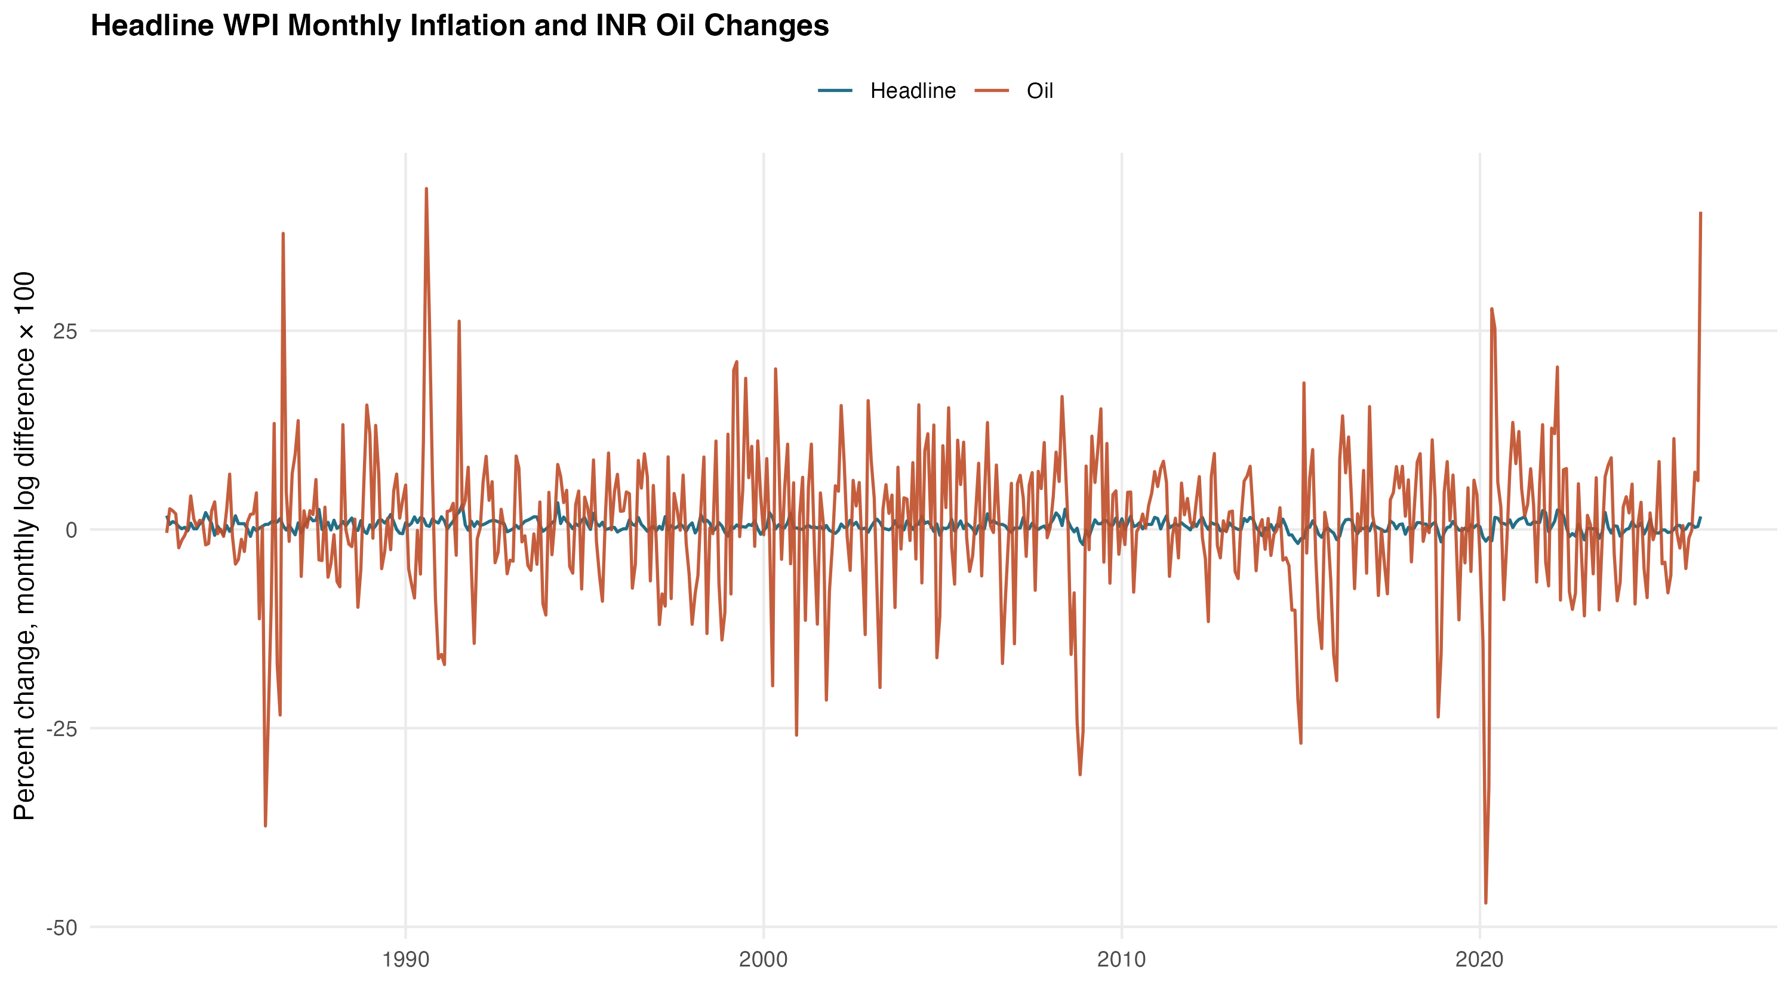
Headline WPI inflation and the rupee oil change, monthly, 1983–2026. Both series are plotted in $Δln$ form. The wholesale series tracks the rupee oil change visibly through the 1990s and from 2010 onward, with a quieter middle period that the subsample split picks up.
The picture is consistent across the two cumulative summaries. Positive oil shocks raise wholesale inflation by 3.0 percent of the shock over the seven-month window, with $p=0.024$. Negative shocks reduce wholesale inflation by 3.7 percent, with $p=0.001$. Both effects are modest in size but precisely estimated. The Wald symmetry test on the seven-lag restriction yields an asymptotic $p$-value of $0.673$ and a bootstrap $p$-value of $0.746$, so the data provide no evidence of short-run asymmetry in the full historical sample. The Brent + EXR decomposition, reported later as a robustness check, gives a near-identical CPT$​^{+}$ of $0.031$ and CPT$​^{−}$ of $0.037$, suggesting that the rupee-oil aggregate is not concealing offsetting movements in prices and the exchange rate. The headline ADL has an adjusted $R^{2}$ of $0.42$. A Breusch–Godfrey test at twelve lags returns $p=0.84$. The HAC RESET test passes ($p=0.35$), and the recursive CUSUM test also remains within conventional bounds ($p=0.39$).
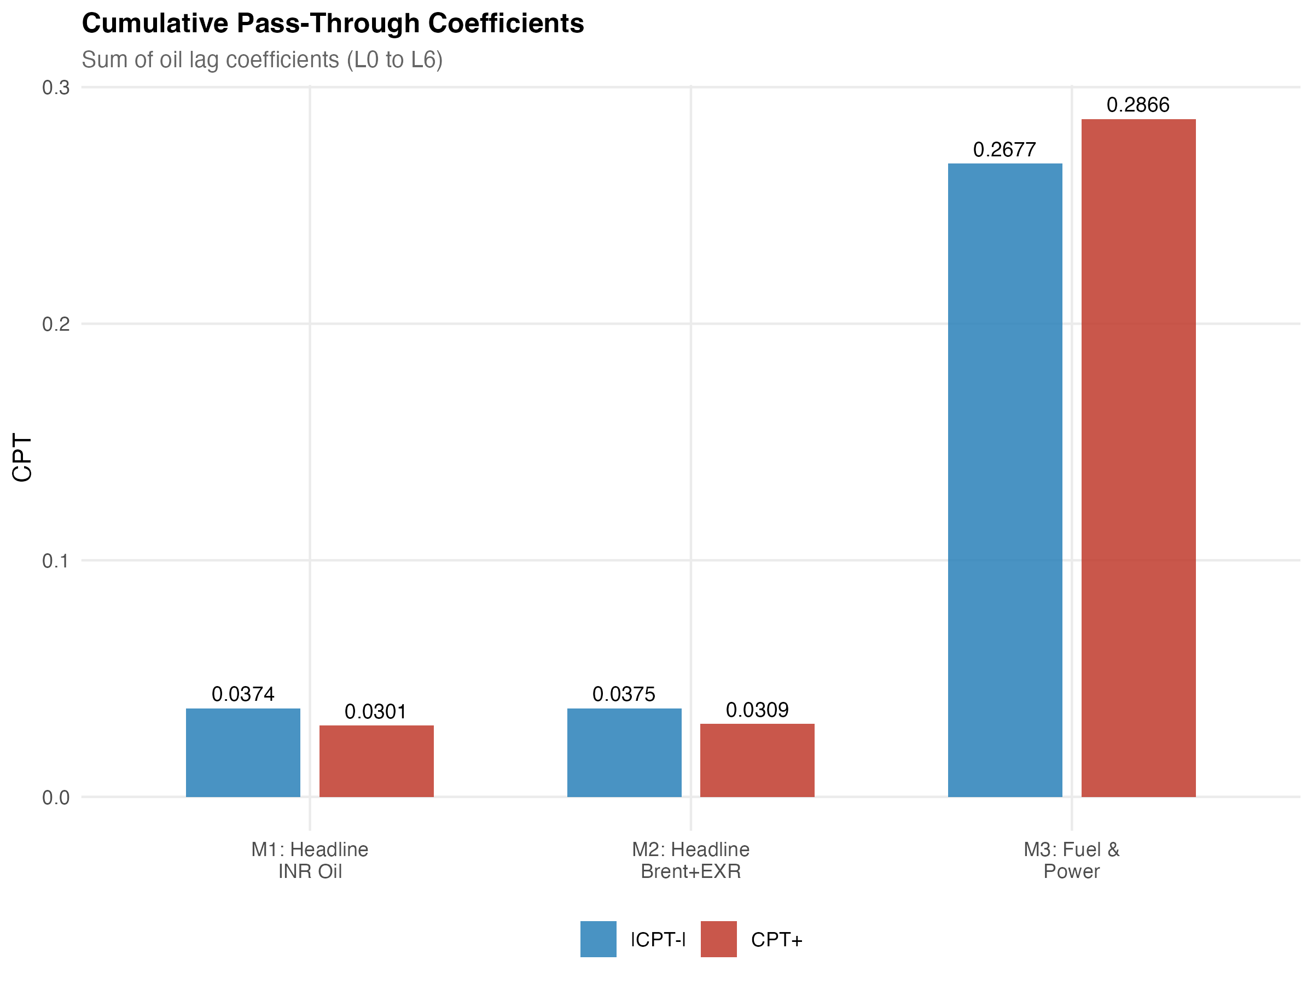
Cumulative pass-through profile for the headline WPI ADL. Lag-by-lag accumulation of the positive and negative rupee-oil coefficients from lag 0 through lag 6, with HAC bands. Most of the response is loaded onto the first three lags; the seven-lag sum stabilises at the values reported in Table 2.
The interesting result is the subsample split. Indian petrol prices were deregulated in June 2010 and diesel in October 2014. We split the sample at April 2010 to run a clean comparison and re-estimate the same ADL on the two windows.
Pre/post-2010 subsample comparison. Headline WPI and Fuel & Power ADL.
Model | Subsample | $N$ | CPT$​^{+}$ | $p$ | CPT$​^{−}$ | $p$
Headline WPI ADL | Pre-2010 (1983-05 to 2010-03) | 323 | 0.012 | 0.381 | 0.025 | 0.043
Headline WPI ADL | Post-2010 (2010-04 to 2026-03) | 192 | 0.074 | 0.004 | 0.081 | 0.000
Fuel & Power ADL | Pre-2010 (1995-05 to 2010-03) | 179 | 0.092 | 0.168 | 0.238 | 0.000
Fuel & Power ADL | Post-2010 (2010-04 to 2026-03) | 192 | 0.524 | 0.000 | 0.438 | 0.000
Notes: ADL specification as in Table 2. Split point April 2010, the month after India’s June 2010 petrol deregulation. The post-2010 window also contains the October 2014 diesel deregulation. The split should be read as descriptive of the post-deregulation regime and not as a causal identification of reform effects.
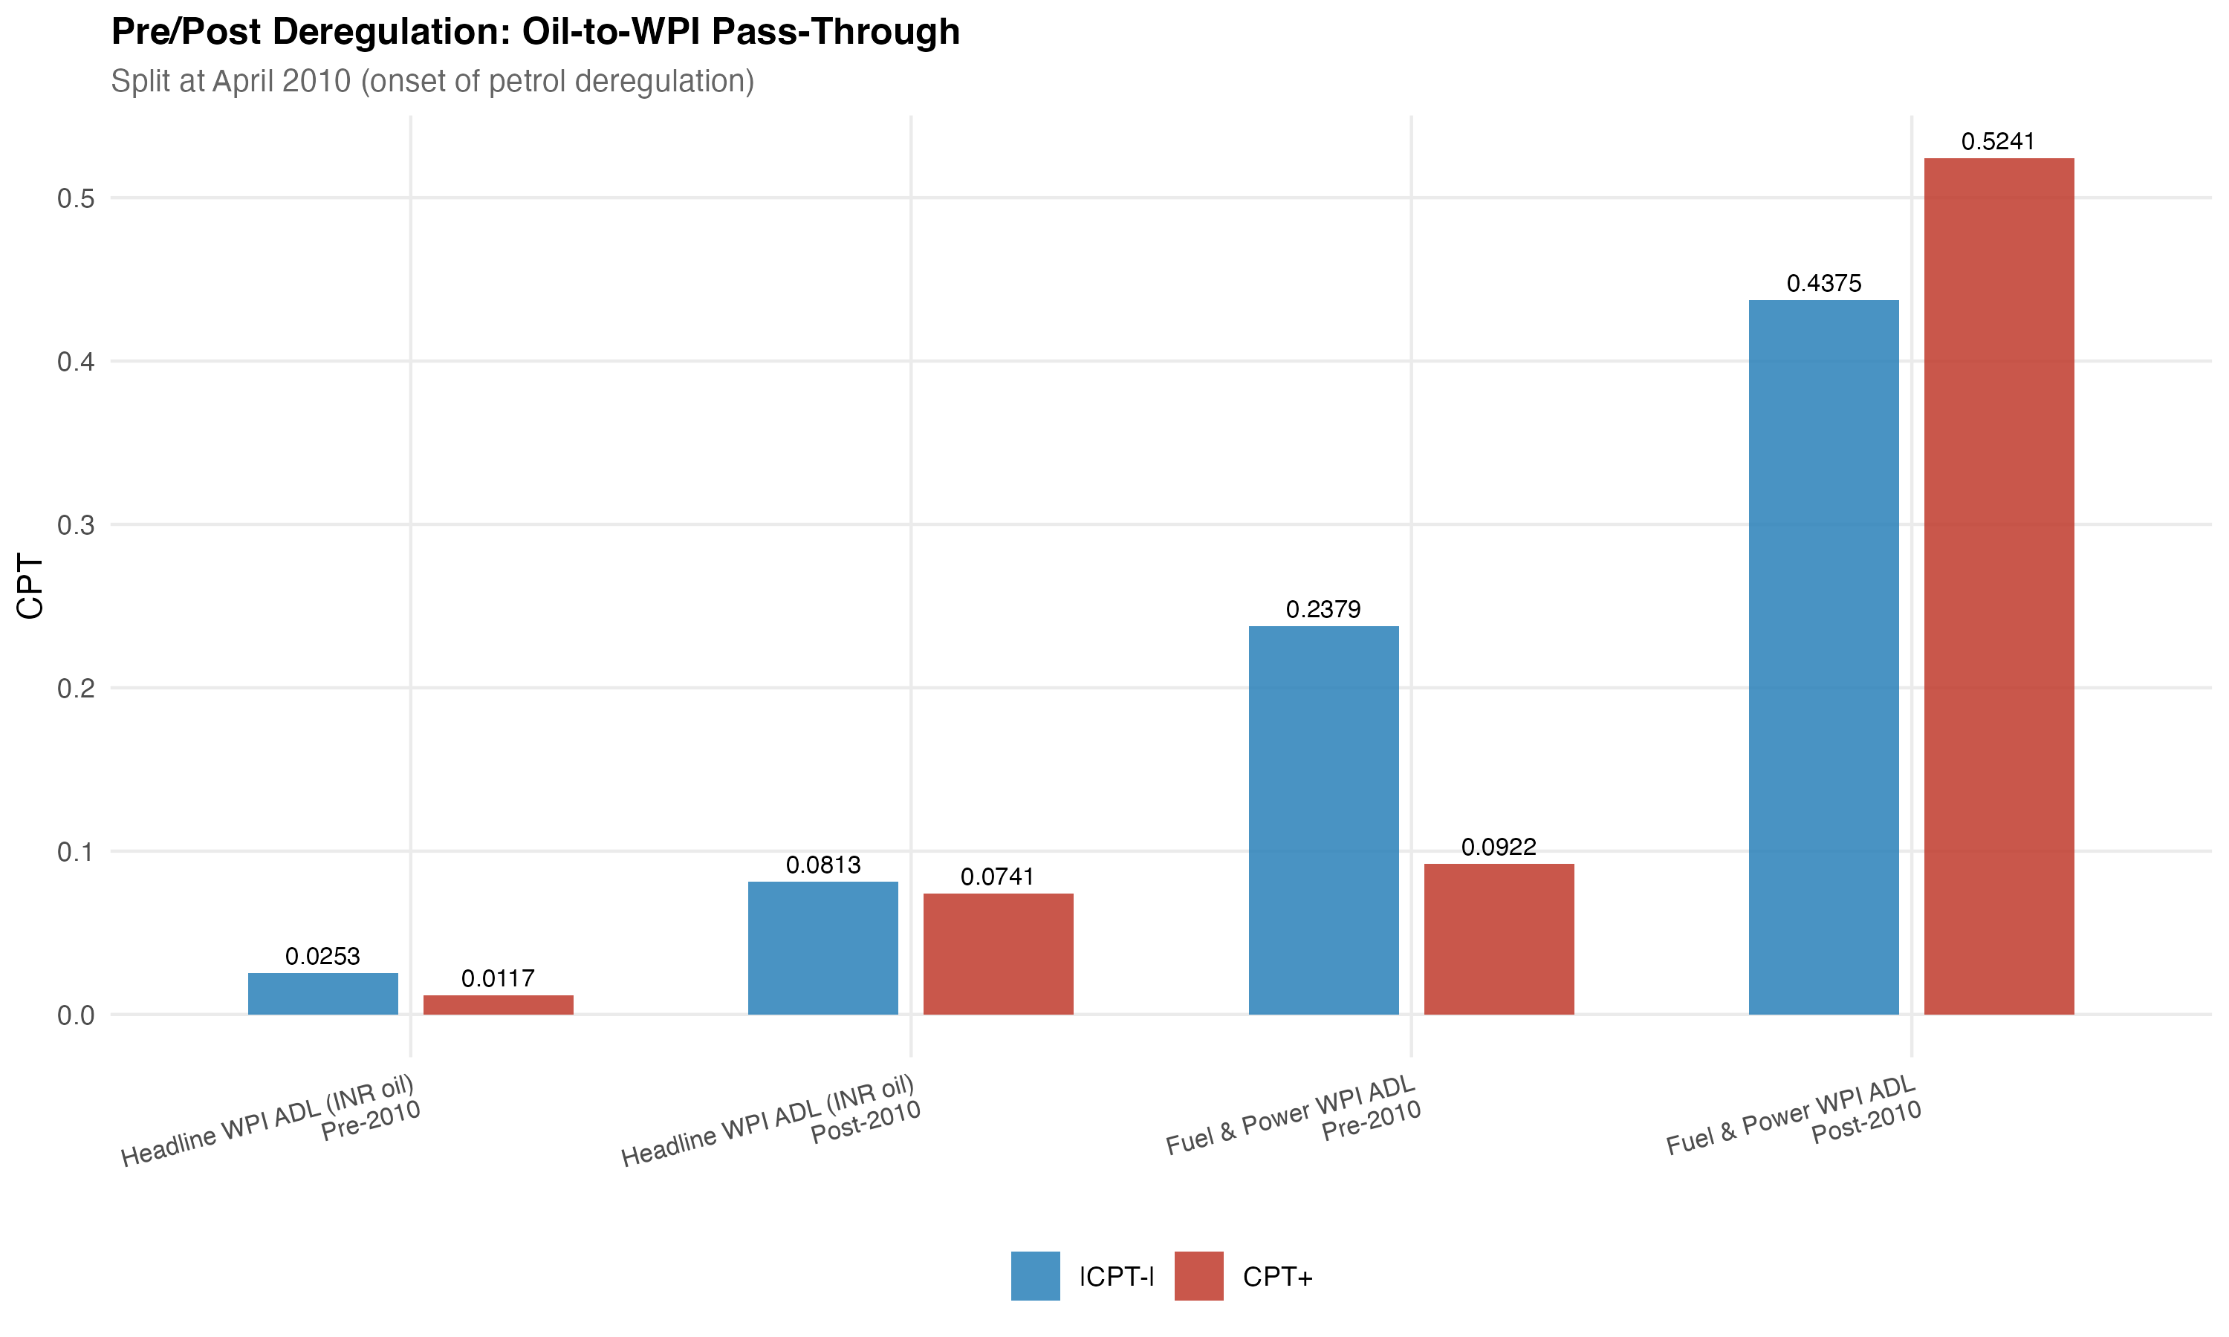
Pre/post-2010 subsample comparison of cumulative pass-through. Headline WPI and Fuel & Power ADL specifications, plotted as cumulative coefficient response over lags 0–6. The post-2010 magnitudes are visibly larger across both panels, broadly consistent with the institutional shift toward market-linked transport-fuel pricing.
The pre-2010 estimates are weak. Positive shocks pass through with CPT$​^{+}=0.012$ ($p=0.38$), while negative shocks yield CPT$​^{−}=0.025$ ($p=0.04$). In the post-2010 sample, the same model returns CPT$​^{+}=0.074$ ($p=0.004$) and CPT$​^{−}=0.081$ ($p<0.001$). The post-period magnitudes are therefore roughly six times larger on the positive side and about three times larger on the negative side. The fuel-and-power subindex tells the same story, but with larger coefficients. Before 2010, fuel CPT$​^{+}$ is $0.092$ and not statistically significant; after 2010 it rises to $0.524$ and is highly significant. These comparisons are consistent with the institutional shift toward more market-linked pricing, but they should not be read as a causal identification of reform effects. The 2010–2014 period also contains changes in monetary regime and major swings in global oil markets, and a split-sample comparison cannot disentangle those forces cleanly.
Two stylised observations help frame what follows. First, even at its full-sample maximum, headline WPI pass-through is small in absolute terms: a one percent rupee oil rise lifts wholesale inflation by about three basis points cumulatively over seven months. Second, the absence of short-run asymmetry in the headline series sits in tension with the asymmetric findings reported by parts of the Indian NARDL literature (Abu-Bakar and Masih 2018; Suresh et al. 2026). We pick that tension up explicitly in Section 6, where the appendix NARDL battery does detect long-run asymmetry while the short-run ADL does not. The two methods are not contradictory. They are pricing different things. ADL in differences is asking whether the seven-month sum of positive coefficients matches the seven-month sum of negative coefficients. NARDL in levels is asking whether the long-run multipliers from positive and negative cumulative oil shocks differ. Long-run asymmetry can coexist with short-run symmetry. Our preference for the short-run reading in the body of the paper is partly a matter of inferential transparency. The bootstrap distribution for the symmetry test is well-behaved on the differenced specifications, and the standard errors do not require an assumed cointegration structure to be valid.
The long-horizon wholesale evidence, taken together, supports a moderate but credible historical pass-through. It also points to where the action sits in the more recent data. The next section turns to the layers in which the same shock shows up an order of magnitude larger.

Mechanism and attenuation across layers
The point of the integrated design is in this section. We move along the chain from crude to consumer, and at each step we ask how much of the upstream signal is preserved.
Figure 6 sketches the chain we estimate. Brent and the rupee/dollar rate combine into the rupee oil price. The rupee oil price feeds into PPAC retail petrol at the pump. Retail fuel prices feed into the fuel-sensitive subindices of WPI (Fuel and Power) and CPI (Fuel and Light). The fuel-sensitive subindices, together with non-fuel cost pressures, feed into the two headline aggregates. The arrows in the diagram are weighted by the cumulative positive pass-through estimates from our ADL specifications. The CPI endpoint arrow is dashed and thinned to convey what the data say: by the time the shock reaches headline CPI, very little of it is left.
Conceptual transmission map. Edge labels are cumulative positive pass-through estimates (CPT$​^{+}$) from the ADL specifications reported in Tables 2–5. The headline CPI arrow is dashed to mark that the corresponding coefficient is not statistically distinguishable from zero.

Retail fuel and the wholesale fuel layer
Table 4 reports the two upstream mechanism models. Panel A is the PPAC Delhi retail petrol model on August 2004 to December 2024 ($N=245$). Panel B is the WPI Fuel and Power ADL on May 1995 to March 2026 ($N=371$).
Mechanism layer ADL models. Retail petrol and wholesale fuel.
Specification | $N$ | Span (yrs) | Adj. $R^{2}$ | CPT$​^{+}$ | CPT$​^{−}$ | Asym. $p$
Panel A. PPAC Delhi retail petrol on Brent (USD), $q=3$:
$Δln{Petrol}_{t}$ ADL | 245 | 20.42 | 0.236 | 0.346 | 0.191 | 0.100
$p$-value on cumulative coefficient |  |  |  | 0.000 | 0.000
Panel B. WPI Fuel & Power on rupee oil:
$Δln{Fuel\&Power}_{t}$ ADL | 371 | 30.92 | 0.463 | 0.287 | 0.268 | 0.783
$p$-value on cumulative coefficient |  |  |  | 0.000 | 0.000
Notes: Panel A sample 2004-08 to 2024-12. Panel B sample 1995-05 to 2026-03. Both panels report HAC (Newey–West) inference on the cumulative pass-through. Panel B includes a post-October-2014 diesel deregulation dummy and an April–September 2020 COVID dummy in addition to month fixed effects. The HAC RESET test fails on Panel B at $p<0.001$ (see Section 6); other diagnostics pass.
The retail petrol response is the largest in the chain. CPT$​^{+}=0.346$ ($p<0.001$) and CPT$​^{−}=0.191$ ($p<0.001$). Asymmetry is borderline ($p=0.10$), and it runs in the familiar rockets-and-feathers direction: positive shocks are passed through faster and more fully than negative ones. This pattern aligns most closely with the descriptive account of post-deregulation pump pricing in India. It is also broadly in line with the magnitudes reported by Deheri and Carmel (2024) and Pradeep (2022) for the petrol channel.
The WPI Fuel and Power subindex sits one step downstream and shows similar, though slightly smaller, magnitudes, with CPT$​^{+}=0.287$ and CPT$​^{−}=0.268$ (both $p<0.001$). Symmetry is not rejected here ($p=0.78$), which suggests that the wholesale fuel index may aggregate retail and bulk pricing channels in a way that dampens the asymmetry visible at the pump. One diagnostic caveat should be noted: the fuel-and-power model fails the HAC RESET test ($p<0.001$), most likely because a non-linearity in the level relationship remains even after differencing. The model is retained in the main results because the cumulative pass-through estimates remain stable across alternative lag lengths and COVID-window sensitivity checks reported in Section 6, but the fuel-and-power equation should still be regarded as the more fragile of the two upstream specifications.

The consumer endpoint
Now move to the bottom of the chain. Table 5 reports the headline CPI ADL.
Headline CPI ADL on rupee oil. Consumer endpoint.
Specification | $N$ | Span (yrs) | Adj. $R^{2}$ | CPT$​^{+}$ | CPT$​^{−}$ | Asym. $p$
Headline CPI ADL, INR oil | 245 | 20.42 | 0.449 | 0.021 | 0.001 | 0.241
$p$-value on cumulative coefficient |  |  |  | 0.122 | 0.938
Selected covariate effects (HAC $t$-tests on the levels coefficients):
Diesel deregulation step (October 2014) |  | $\hat{β}=−0.339$ |  | $p<0.001$
Petrol deregulation step (June 2010) |  | $\hat{β}=+0.116$ |  | $p=0.307$
COVID window (April–September 2020) |  | $\hat{β}=−0.345$ |  | $p=0.507$
Notes: Sample 2004-08 to 2024-12. Specification analogous to Table 2 with $q=3$ on the asymmetric oil components, an IIP control for industrial activity, and step dummies for the petrol and diesel deregulation events. The bootstrap $p$-value on the symmetry restriction is $0.500$.
The headline CPI estimates are the smallest and least precise in the chain. Positive shocks yield CPT$​^{+}=0.021$ with $p=0.12$. Negative shocks are essentially nil: CPT$​^{−}=0.001$, $p=0.94$. Symmetry is not rejected ($p=0.24$), and the bootstrap symmetry $p$-value is similar at $0.50$. Two interpretations are plausible. One is that headline CPI in India is genuinely insulated from oil shocks because the CPI basket carries a heavy food weight, with food and beverages together accounting for nearly half of the index. The other is that consumer-fuel pricing and tax buffers absorb much of the shock before it reaches the aggregate. Both mechanisms are likely at work, and the data do not permit a clean separation between them.
What the data do let us do is record one institutional fact that any policy reading should not lose. The October 2014 diesel-deregulation dummy in the headline CPI ADL is large and significant in the negative direction (estimate $−0.339$, $p<0.001$). The October 2014 step is, of course, one event, and a single dummy cannot identify a structural channel. But the sign and magnitude are consistent with the institutional reading that diesel-tax revisions have at times moved in a direction that offsets, rather than reinforces, the international price signal in the consumer index.

Putting it together
Table 6 stitches the four CPT$​^{+}$ estimates into a single layered comparison and adds the pre/post-2010 split for the two wholesale models.
Integrated attenuation across price layers and pre/post-2010 split.
Layer | Dependent variable | $N$ | Span | CPT$​^{+}$ | CPT$​^{+}$ $p$
Panel A. Layered cross-section (full available samples):
Retail fuel pump | $Δln{Petrol}_{t}^{Delhi}$ | 245 | 20.4 yrs | 0.346 | 0.000
Wholesale fuel | $Δln{WPI Fuel\&Power}_{t}$ | 371 | 30.9 yrs | 0.287 | 0.000
Consumer fuel (bridge) | $Δln{CPI Fuel\&Light}_{t}$ | 164 | 13.7 yrs | 0.178 | 0.002
Wholesale headline | $Δln{WPI}_{t}$ | 515 | 42.9 yrs | 0.030 | 0.024
Consumer headline | $Δln{CPI}_{t}$ | 245 | 20.4 yrs | 0.021 | 0.122
Panel B. Pre/post-2010 split (wholesale models):
Headline WPI, pre-2010 | $Δln{WPI}_{t}$ | 323 | 1983–2010 | 0.012 | 0.381
Headline WPI, post-2010 | $Δln{WPI}_{t}$ | 192 | 2010–2026 | 0.074 | 0.004
Fuel & Power, pre-2010 | $Δln{Fuel\&Power}_{t}$ | 179 | 1995–2010 | 0.092 | 0.168
Fuel & Power, post-2010 | $Δln{Fuel\&Power}_{t}$ | 192 | 2010–2026 | 0.524 | 0.000
Notes: All entries are cumulative pass-through estimates from short-run asymmetric ADL specifications, summed over lags 0–$q$ on the relevant positive component. Panel A uses each layer’s full active sample. The CPI Fuel & Light bridge equation is shown for completeness only; its sample begins in 2011 and falls below the 20-year window we treat as the minimum for headline mandates.
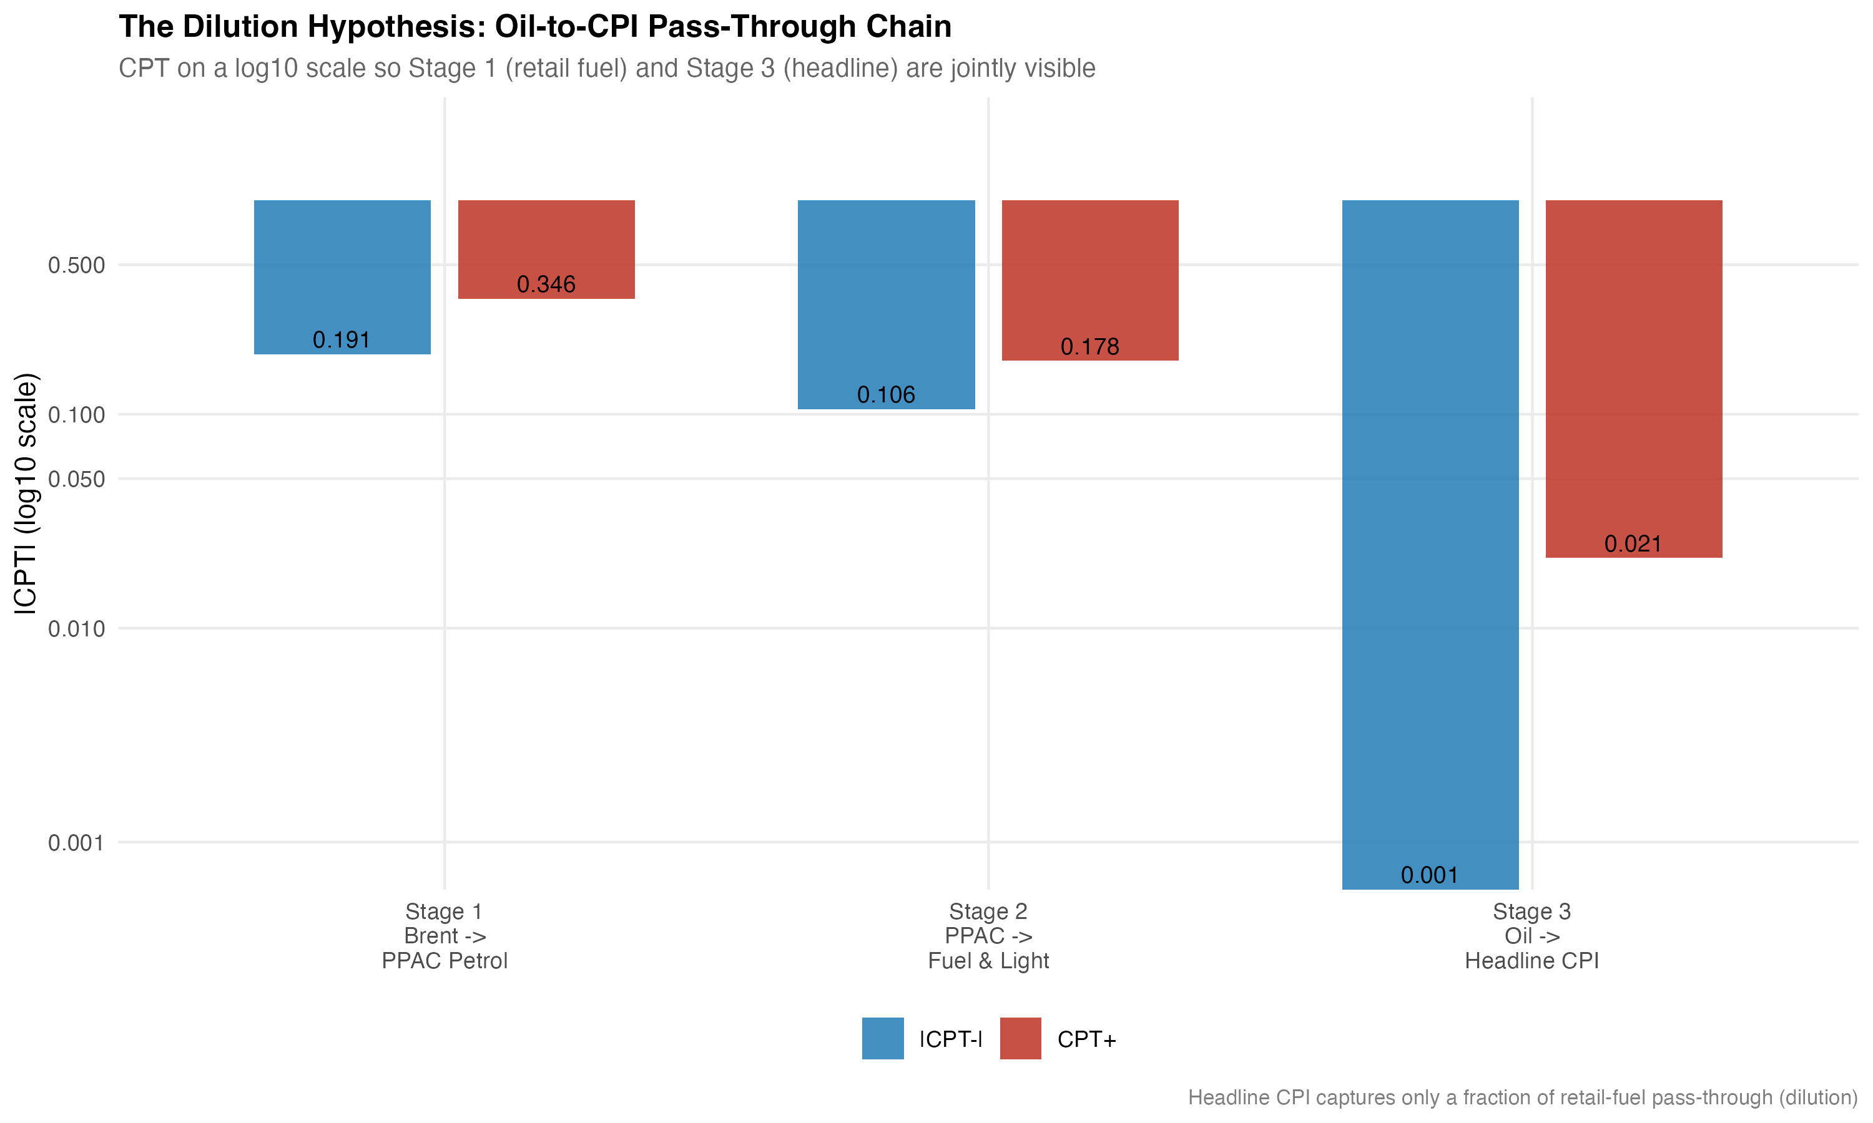
Attenuation across layers. Cumulative positive pass-through (CPT$​^{+}$) by stage, from rupee oil through retail petrol, wholesale and consumer fuel-sensitive subindices, and the two headline aggregates. The headline-CPI bar is the smallest and is not statistically distinguishable from zero in the underlying ADL.
The pattern is monotonic in the expected direction. Retail petrol records CPT$​^{+}=0.35$. The two fuel-sensitive subindices come next at $0.29$ (WPI Fuel and Power) and $0.18$ (CPI Fuel and Light). Headline WPI falls to $0.03$. Headline CPI is lower still at $0.02$, and that estimate is not statistically significant. Roughly an order of magnitude is lost between the pump and the consumer endpoint. Most of that loss occurs between the fuel-sensitive subindices and the headline aggregates, and there is a mechanical reason for that: fuel weights in the headline indices are small (about 13 percent in the WPI 2011–12 series and about 7 percent in the CPI 2010 base). A large movement in fuel prices therefore cannot produce more than a small movement in the aggregate unless non-fuel components move with it. The CPI Fuel and Light bridge equation, although based on a shorter sample (164 monthly observations beginning in May 2011 and therefore not suitable as a headline mandate), points in the same direction: PPAC petrol passes into CPI Fuel and Light with CPT$​^{+}=0.178$ ($p=0.002$) and a smaller negative-side response.
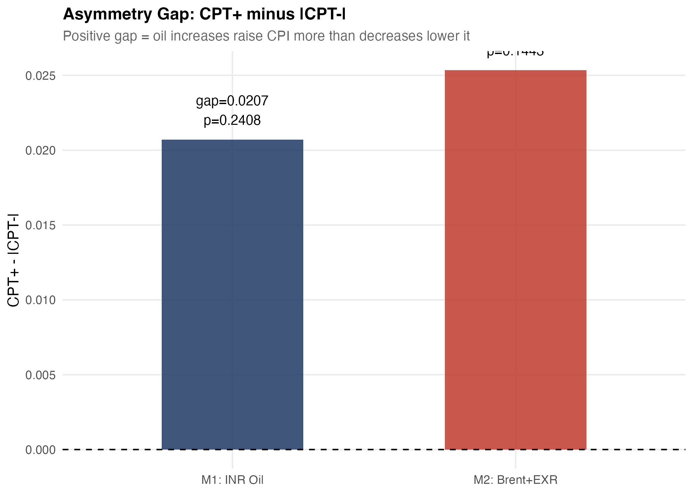
Asymmetry gap (CPT$​^{+}$ minus CPT$​^{−}$) by layer with HAC confidence bands. The gap is largest and signed positive at the retail-petrol stage, consistent with the conventional rockets-and-feathers reading. Both upstream-wholesale and headline-CPI gaps straddle zero.
We pick out one judgement call. The evidence here is more cautious about asymmetry than the recent Indian NARDL literature, which often headlines asymmetric long-run multipliers as the primary result. We do find asymmetry signals, but they are concentrated at the pump, are borderline at conventional significance ($p=0.10$), and are not robust to moving up the chain. The integrated reading is that the most stable and quantitatively meaningful empirical feature in this dataset is attenuation across layers, not asymmetry within any single layer.

Robustness and supplementary evidence
Three robustness exercises support the main interpretation.
First, the Brent + EXR decomposition. Replacing rupee oil with separate asymmetric Brent components and a contemporaneous EXR control yields CPT$​^{+}=0.031$ ($p=0.023$) and CPT$​^{−}=0.037$ ($p=0.001$) on the headline WPI sample. Adjusted $R^{2}$ rises to $0.42$ and the symmetry test is not rejected ($p=0.70$). The decomposition does not move the substantive conclusion, which suggests that the rupee oil aggregate used in the main specification is not masking offsetting movements in price and exchange rate components.
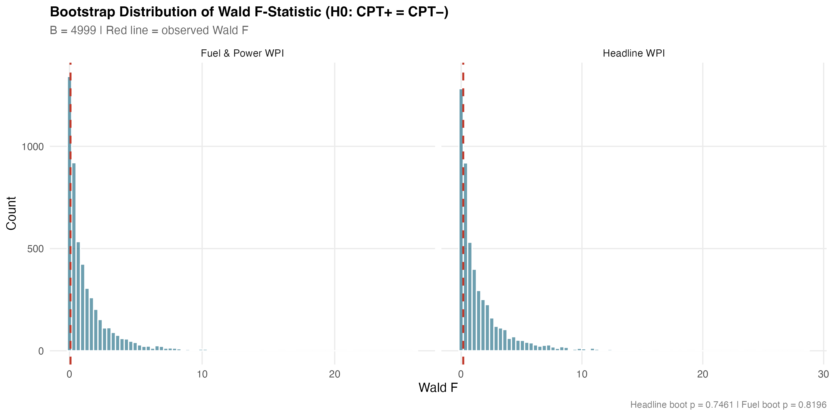
Bootstrap distribution of the symmetry Wald statistic for the headline WPI ADL. Restricted-residual circular block bootstrap, $B=4,999$. The observed Wald statistic sits near the centre of the simulated distribution, which gives a bootstrap symmetry $p$-value of $0.746$.
Second, the bootstrap symmetry tests. For both the headline WPI ADL and the WPI Fuel and Power ADL we resample residuals using a restricted-residual circular block bootstrap with 4,999 replications. The bootstrap symmetry $p$-values are $0.746$ for headline WPI and $0.820$ for fuel and power. There were no bootstrap failures. The asymptotic Wald conclusions hold up in finite samples on the wholesale models. The headline CPI bootstrap $p$-value is $0.50$, also consistent with the asymptotic test.
Third, predictive precedence. Granger tests at four lags reject the null of no Granger causation from rupee oil to headline WPI ($F=7.43$, HAC $p<0.001$), from rupee oil to WPI Fuel and Power ($F=15.22$, HAC $p<0.001$), and from Brent in USD to headline WPI ($F=7.38$, HAC $p<0.001$). The reverse direction is not Granger-significant for headline WPI ($p=0.43$). The exchange rate Granger-causes WPI at the 10% margin ($p=0.05$). We treat these statistics as predictive precedence rather than as structural identification, in the conservative reading we adopt throughout.
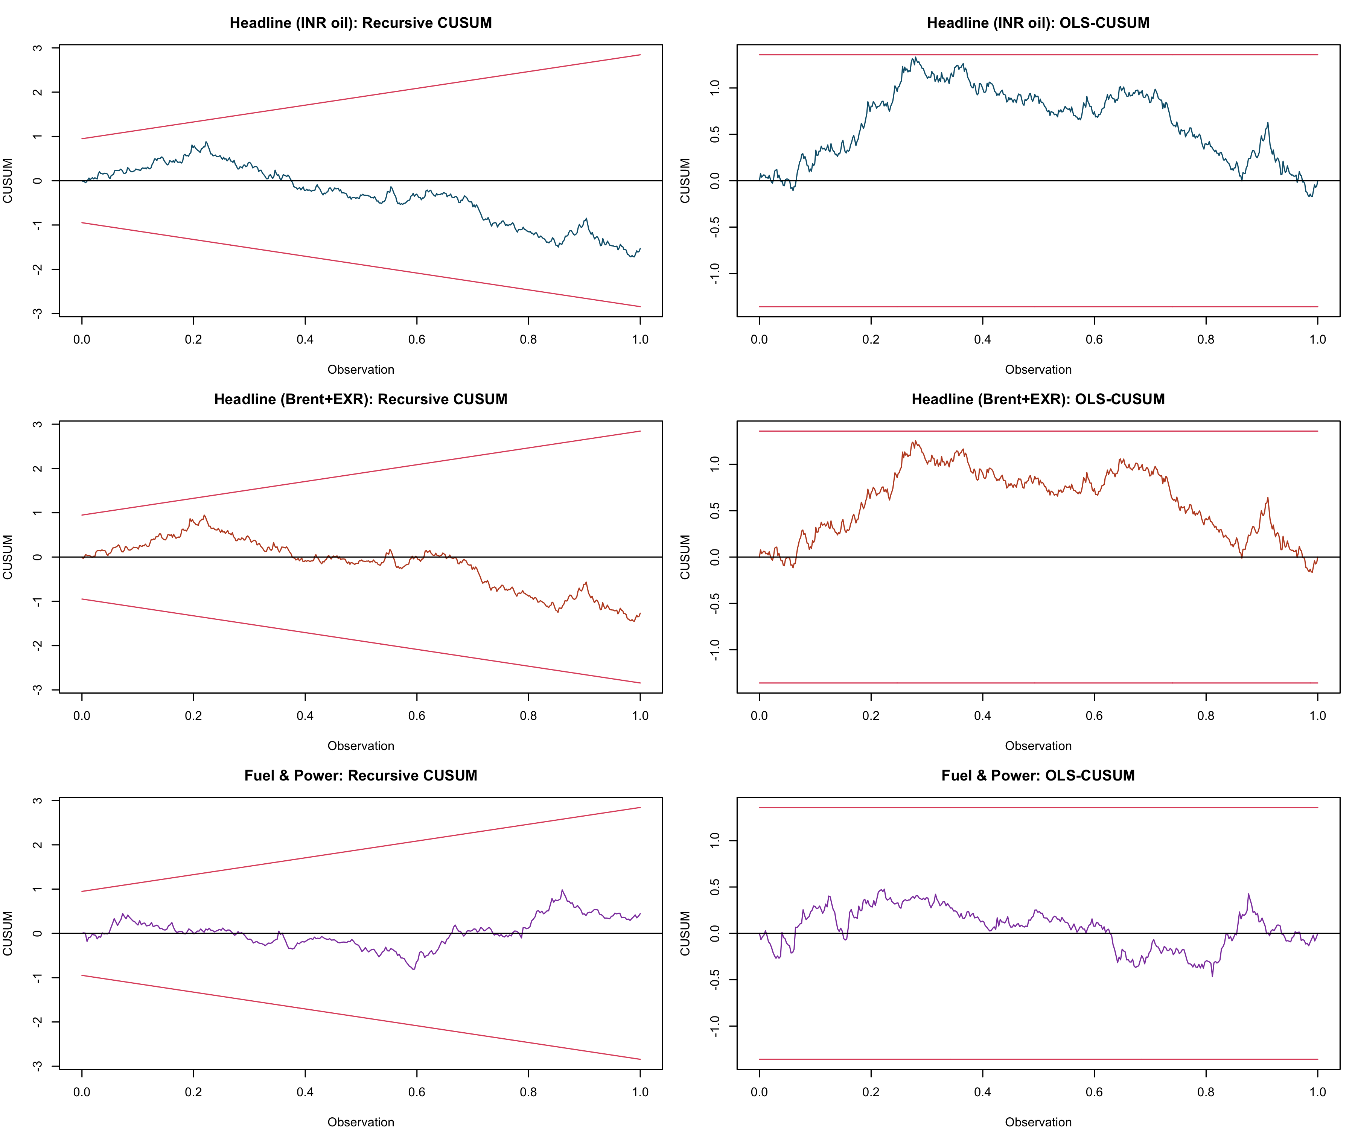
Recursive and OLS-CUSUM stability tests for the headline WPI ADL. Both test statistics stay inside their 5% bands across the 1983–2026 sample, consistent with parameter stability in the differenced specification despite the September 2013 break detected by the Bai–Perron test on the dependent variable.
A few sensitivity exercises round out the picture. Excluding the April–September 2020 COVID window does not materially change any of the headline pass-through estimates. Lag-sensitivity exercises moving the oil lag length between $q=4$ and $q=8$ leave the qualitative ranking of CPT$​^{+}$ across layers intact. Winsorising the rupee oil change at the 1st and 99th percentiles trims the negative-side coefficient for the WPI Fuel and Power model slightly but does not alter the conclusion.
The appendix battery of NARDL bounds models in levels gives the long-run perspective. All four NARDL specifications reject the no-cointegration null at the 1% upper bound of Pesaran et al. (2001). Each specification has a negative and significant error-correction coefficient. The long-run asymmetry tests of Shin et al. (2014) reject equality of long-run positive and negative multipliers in three of four specifications, with the headline INR-oil specification on the borderline ($p=0.023$). The fuel and power specification has the largest ECT magnitude (-0.081, $p<0.001$), which is consistent with the higher pass-through speed in that layer that the ADL also picks up. We read the appendix NARDL evidence as supplementary. It identifies asymmetry that the differenced ADL does not. But the long-run multiplier estimates are sensitive to the assumed lag structure and to the unit-root status of the level series, and we do not want the appendix tail to wag the main-text dog.
The diagnostics are not uniformly clean. The WPI Fuel and Power ADL fails the HAC RESET test at $p<0.001$. We have already flagged this. It is the model in which we would invest least in the precise point estimate, and it is one of two models for which the structural-break literature suggests the differenced specification still leaves curvature on the table. The headline WPI ADL passes Breusch–Godfrey at $p=0.84$, RESET at $p=0.35$ and recursive CUSUM at $p=0.39$. The headline CPI ADL passes its diagnostics. The bootstrap symmetry tests, taken together with the diagnostics, support the central empirical claim: the magnitudes of the upstream pass-through estimates are credible, the headline-CPI weakness is not an artefact, and the cross-layer attenuation pattern is the robust feature of the data.

Conclusion
This paper treats Indian oil pass-through as a chain rather than as a single coefficient. The chain starts with the rupee value of imported crude, moves through retail petrol pricing at the pump, enters the fuel-sensitive subindices of wholesale and consumer prices, and ends at the headline aggregates targeted by policy. The transmission is clearly uneven. It is large at the pump (cumulative pass-through of about 0.35 for positive oil shocks), similar in the wholesale fuel layer (0.29), moderate in the consumer fuel layer (0.18), and small to absent in the headline aggregates (0.03 for WPI, 0.02 and not significant for CPI). The contrast between the pre-2010 and post-2010 wholesale estimates is consistent with the institutional shift toward more market-linked pricing of transport fuels. Short-run asymmetry is detectable at the pump, but it does not emerge as a robust feature of headline pass-through. The appendix NARDL evidence recovers long-run asymmetry, which is in line with parts of the recent literature, but those results remain secondary to the integrated transmission account developed in the main text.
Several policy implications follow. WPI is more informative about upstream cost transmission and imported input-price pressure, whereas CPI is more informative about household-facing inflation. Treating the two indices as interchangeable, or as rival answers to the same policy question, would miss the upstream signal preserved in the wholesale data. Conversely, muted headline CPI responses should not be taken to mean that imported oil has ceased to matter. The mechanism evidence shows that a substantial share of the upstream shock is real, but is absorbed before it reaches the consumer basket. The channels of that absorption are visible in the pre/post-2010 comparison and in the diesel-deregulation dummy. Tax buffers, fuel subsidies, and the relatively small fuel weight in the CPI basket jointly shape how much of the international price movement households ultimately bear.
A short note on caveats is warranted. The estimates are predictive rather than structural, and the paper does not identify counterfactual policy effects. The pre/post-2010 comparison is suggestive of reform-era strengthening in pass-through, but it cannot separately identify the effects of pricing reform, changes in monetary regime, and shifts in the composition of global oil cycles. The retail-fuel sample begins in August 2004, which shortens the pre-deregulation window for the cleanest mechanism equation. Diagnostic concerns on the fuel-and-power equation should also be kept in mind when interpreting the precise magnitude of wholesale fuel pass-through. Finally, although the appendix NARDL battery provides a useful long-run check, it depends on a levels-based unit-root reading that the KPSS evidence at the 5% level advises treating with caution.
Two extensions follow naturally from the present design. The first is a finer disaggregation of the consumer basket. In this paper, the CPI Fuel and Light bridge equation is treated as supporting evidence because of its shorter sample, but the underlying CPI groups, including housing, transport, and miscellaneous items, contain indirect oil exposure that the headline number averages away. A longer harmonised sample would make it possible to separate attenuation due to mechanical weighting from attenuation due to behavioural or policy absorption. The second extension is a state-space approach to time-varying pass-through, which would allow reform-era strengthening to appear as a gradual coefficient shift rather than as a discrete subsample comparison. Both are left for future work.
The central contribution of the paper is to remove the implicit choice between WPI and CPI from the policy discussion of oil pass-through in India. The relevant issue is not which inflation measure is universally “correct.” It is where in the price system the shock travels and where it weakens. The data offer a clear answer. The shock is visible in wholesale and fuel-sensitive prices, but much of it is absorbed before it reaches the consumer aggregate. The empirical task, then, is to show how much survives, where it survives, and under which institutional conditions.

Appendix A. Supplementary nonlinear long-run evidence
The NARDL bounds battery reported in this appendix follows Pesaran et al. (2001) for the bounds test and Shin et al. (2014) for the asymmetric long-run decomposition. Models are estimated with case 3 (unrestricted intercept, no trend) and AIC lag selection up to four lags. All specifications cover April 1997 to March 2025. Table 7 summarises the bounds-F statistic, the error-correction coefficient and its $p$-value, and short- and long-run asymmetry $p$-values. Long-run multipliers are reported in the project output file wpi/outputs/tables/table_08_nardl_long_run.csv; we omit the levels coefficients here for space.
Appendix NARDL bounds battery. April 1997 to March 2025.
Specification | $N$ | Bounds-$F$ | ECT | ECT $p$ | LR asym. $p$
$lnWPI∼lnBrent$ | 333 | 27.66 | $−0.019$ | 0.005 | 0.001
$lnWPI∼lnBrent∣lnEXR$ | 333 | 21.40 | $−0.019$ | 0.006 | 0.000
$lnWPI∼lnOil^{INR}$ | 331 | 21.43 | $−0.017$ | 0.011 | 0.023
$lnFuel\&Power∼lnOil^{INR}$ | 331 | 34.15 | $−0.081$ | 0.000 | 0.000
Notes: NARDL with case 3 (unrestricted intercept, no trend), AIC lag selection up to four lags. Bounds test critical values from Pesaran et al. (2001); the 1% upper bound for case 3 with $k=1$ is $7.84$ and for $k=2$ is $6.36$. All four bounds-$F$ statistics exceed the 1% upper bound. ECT is the true error-correction coefficient (sum of all $y$-level-lag coefficients) with a Newey–West Wald $p$-value. LR asymmetry $p$ is the long-run Wald test on the equality of positive and negative cumulative multipliers in the spirit of Shin et al. (2014).
A short caveat on KPSS framing is appropriate. KPSS on $ΔlnWPI$ returns $\hat{η}=0.90$ against a 5% critical value of $0.46$, while ADF and Phillips–Perron strongly reject I(1) (statistics of $−12.22$ and $−14.39$ respectively). We follow the standard reading that KPSS is known to over-reject in long samples that contain structural breaks, of which the September 2013 Bai–Perron break in headline inflation is one example. A Bai–Perron test on the rupee oil change finds zero breaks. We retain the NARDL specifications because the bounds test is robust to ambiguous integration order, but we report long-run multipliers with caveats and prefer the differenced ADL for the body of the paper.
Abu-Bakar, Muhammad, and Mansur Masih. 2018. “Is the Oil Price Pass-Through to Domestic Inflation Symmetric or Asymmetric? New Evidence from India Based on NARDL.” MPRA Paper, no. 87569.
Bhanumurthy, N. R., Surajit Das, and Sukanya Bose. 2012. “Oil Price Shock, Pass-Through Policy and Its Impact on India.” NIPFP Working Paper, no. 99.
Bhoi, Barendra Kumar, Indranil Bhattacharyya, and Krishnamurthy Mandal. 2012. “The Relationship Between International Oil Prices and Inflation in India.” Reserve Bank of India Working Paper Series, nos. WP 09/2012.
Chattopadhyay, Mrinal, and Subrata Kumar Mitra. 2015. “Exploring Asymmetric Behaviour Pattern from Indian Oil Products Prices Using NARDL and GHSOM Approaches.” Energy Policy 86: 262–72.
Deheri, Anand, and M. Carmel. 2024. “Asymmetric Pass-Through of Crude Oil to Retail Fuel Prices in India.” OPEC Energy Review 48 (2): 88–110.
Pal, Debdatta, and Subrata K. Mitra. 2016. “Asymmetric Oil Product Pricing in India: Evidence from a Multiple Threshold Nonlinear ARDL Model.” Economic Modelling 59: 314–28.
Pandey, Radhika, and Jagadish Shettigar. 2019. “Pass-Through of Crude Oil Prices to Retail Fuel Prices in India.” Margin: The Journal of Applied Economic Research 13 (3): 296–314.
Pesaran, M. Hashem, Yongcheol Shin, and Richard J. Smith. 2001. “Bounds Testing Approaches to the Analysis of Level Relationships.” Journal of Applied Econometrics 16 (3): 289–326.
Petroleum Planning and Analysis Cell. 2024. Indian PNG Statistics 2023–24. Ministry of Petroleum; Natural Gas, Government of India.
Pradeep, V. 2022. “Asymmetric Pass-Through of Oil Prices to Inflation in India: Evidence After Diesel Price Reforms.” Journal of Economic Asymmetries 26: e00253.
Reserve Bank of India. 2014. Report of the Expert Committee to Revise and Strengthen the Monetary Policy Framework. Reserve Bank of India.
Sadath, Anver C., and Rajesh H. Acharya. 2021. “Oil Price Shocks and Indian Economy: An SVAR Analysis.” International Journal of Energy Sector Management 15 (2): 402–24.
Sek, Siok Kun. 2019. “Unveiling the Factors of Oil Versus Non-Oil Sources in Affecting the Global Commodity Prices: A Combination of ARDL-NARDL Approaches.” Panoeconomicus 66 (2): 189–206.
Shin, Yongcheol, Byungchul Yu, and Matthew Greenwood-Nimmo. 2014. “Modelling Asymmetric Cointegration and Dynamic Multipliers in a Nonlinear ARDL Framework.” In Festschrift in Honor of Peter Schmidt, edited by Robin C. Sickles and William C. Horrace. Springer.
Suresh, K., M. Naveen, and R. V. Naveenan. 2026. “Long-Run Asymmetric Oil Pass-Through to India’s Wholesale Prices: A NARDL Analysis.” Foreign Trade Review 61 (1): 45–72.

