**Pedro’s Journey: A Mobile Game Application**

A Capstone Project

Presented to the Faculty of the

Department of Computer and Information Sciences

University of San Carlos

In Partial Fulfillment

of the Requirements for the Degree

BACHELOR OF SCIENCE IN INFORMATION TECHNOLOGY

By

BRYAN Z. BISPO

PENUEL B. CALLE

NICOLAS ANDRE P. FERRAREN

KITT MICHAEL EDWARD P. YAP

ANGIE M. CENIZA, PhD

Faculty Adviser

June 2018

**ABSTRACT**

This research will be done to further improve the people’s National Youth Day experience and make it a unifying, fun, and engaging experience for everyone participating. Since the participants of National Youth Day predominantly consists of the youth from ages 16 to 39, the researchers will aim to create an application that is educational yet fun and immersive at the same time. This is to echo the specific contemporary characteristic of wanting to have fun that all the youths share so that they will have a more unifying, engaging, and spiritual progress. This research will also further the people’s understanding of the historical and religious places and events that have transpired here in Cebu to further their spiritual camaraderie and unity with one another. This research will aim to create such an impact to the people participating.

**TABLE OF CONTENTS**

**ABSTRACT ………………….....ii**

**TABLE OF CONTENTS …………………....iii**

**LIST OF FIGURES …………………....iv**

**LIST OF TABLES …………………….v**

**CHAPTER 1 INTRODUCTION ………………….....1**

**1.1 Rationale of the Study ………………….....1**

**1.2 Statement of the Problem ………………….....2**

**1.2.1 General Objective ………………….....2**

**1.2.2 Specific Objectives ………………….....2**

**1.3 Significance of the Study ………………….....2**

**1.4 Scope and Limitations ………………….....3**

**CHAPTER 2 RELATED SYSTEMS ………………….....5**

**CHAPTER 3 TECHNICAL BACKGROUND ………………….....8**

**CHAPTER 4 DESIGN AND METHODOLOGY …………………...10**

**4.1 Conceptual Framework …………………...10**

**4.2 Analysis and Design …………………...11**

**4.3 Development Method …………………...12**

**4.4 Development Approach …………………...13**

**4.5 Software Development Tools …………………...14**

**4.6 Project Management …………………...15**

**4.6.1 Schedule and Timeline …………………...15**

**4.6.2 Responsibilities …………………...15**

**4.6.3 Budget and Cost Management …………………...16**

**4.7 Verification, Validation, and Testing …………………...16**

**BIBLIOGRAPHY …………………...18**

**APPENDIX**

**Appendix A Transmittal Letter**

**Appendix B Interview Guide**

**Appendix C Software Requirements Specifications**

**CURRICULUM VITAE**

**LIST OF FIGURES**

**Figure 1. Conceptual Framework …………………...10**

**Figure 2. Use Case Diagram …………………...11**

**Figure 3. Incremental Model …………………...12**

**Figure 4. Bottom-up Approach …………………...13**

**LIST OF TABLES**

**Table 1. Related Game Applications …………………….7**

**Table 2. Software Development Tools …………………...14**

**Table 3. Schedule and Timeline …………………...15**

**Table 4. Responsibilities …………………...15**

**Table 5. Budget and Cost Management …………………...16**

**CHAPTER 1**

**INTRODUCTION**

**1.1 Rationale of the Study**

In this technological world, people seem to forget their own roots and the history of how their homeland came to existence. They need to realize that in order to learn from past mistakes, they must understand their own history.

Technology may be to blame for the modern people’s lack of historical knowledge, but the real problem is not utilizing such contraption to enhance their learning experience. The National Youth Day, which will be conducted in Cebu Province in 2019, is a way for the youth, called Pilgrims, to learn the country’s history and religion, more specifically, the history of Cebu Province.

Since owning smartphones and other technological peripherals are common and a necessity in this day and age, the researchers used this norm to develop a game application that will teach the participants about the history of Cebu Province. Their aim is to make this purpose as fun and engaging as possible.

Catholicism has been around since the Spanish Colonial period and has a long history, and learning this history traditionally can either be fun or boring depending on the person. One of the most fun, engaging, and effective ways of learning is through playing a game because through this medium, people will be entertained and will be driven to learn more because they find it fun.

According to a study found by Sharon K. who researched how companies train their employees, game-based learning has higher retention rates than traditional learning.  A study at Indiana University states that game-based learning increased retention by more than 300% in immediate post-testing, and by as much as 10 times when subjects were tested 6 weeks later. It also helped that competition encouraged the users to strive to learn more in order to be on the top scores against other users.

The main goal of this E-learning game application is to teach Pilgrims that are participating National Youth Day the history of Cebu through an educational gaming platform.

**1.2 Statement of the Problem**

**1.2.1 General Objective**

The research aims to develop an RPG application that will teach the Pilgrims that are participating in the National Youth Day.

**1.2.2 Specific Objectives**

The research aims to:

1. Determine the historical places of Cebu Province, and the history of saints.
2. Design and Develop the mobile application.
3. Integrate the QR code in the mobile application.
4. Test and evaluate the application
5. Deploy the mobile application in the Android Market.

**1.3 Significance of the Study**

The study proposes to develop a role playing game application for both Android and iOS to help the participants of National Youth Day that have come from different places all over the country to enjoy and learn the historical, religious places and events that have taken place in Cebu. This will further their understanding of Cebu’s religious culture through immersive and fun gameplay. Not only will this study further their learning, but also help people to connect with each other and have a more unifying and immersive experience, which is the aim of National Youth Day in the first place. Through immersive, fun, and engaging gameplay, the specific innate contemporary characteristic of wanting to have fun that all the youth share will lend itself into them having a unifying and spiritual experience.

**Delegates.** The output of this research will help further their understanding of Cebu’s religious culture and history through an immersive and fun gameplay.

**NYD Organizers.** This research will help making the event they organize more memorable and help people to connect with each other and have a more unifying and immersive experience, which is the aim of National Youth Day.

**Religious Groups.** The output of this research will also help them because this research is going to spread their religious beliefs and culture.

**Researchers.** This will help the researchers know the target demographics’ preferences on a mobile application and take notes from it.

**Future Researchers.** It will help the future researchers who plans or is developing a mobile application on what the demographic expects for a mobile application.

**1.4 Scope and Limitations**

This capstone has to produce an application that will be suited for the entertainment and education for the participants of National Youth Day and focuses on the vast and wonderful history that had taken place in Cebu.

The application will be built on Unity 3D and can be played offline on a mobile device. Both Android and iOS will be integrated and can be played on any of the two on this application. With the power and capacity of the mobile phones, the demand has been lessened to the Android Marshmallow and up, and the iOS will be the equivalent to iOS 9 and up.

Inside the application, there is one main game and 3 mini-games. The main game is the role playing game with QR Code functionality, while the 3 mini-games are Memory Match, WordScape Game, and the Quotation Exam game. They focus on the history of Cebu with some deviations to enhance the experience. The application focus is on the QR Code. It will be sent to multiple areas where the player scans the QR Code, and a scenario based on the history of the area will begin. But the number of the areas will be at most 20 due to each area being 40-50 minutes long in gameplay length. Memory Match is a card game where the player flips a card, find two cards that have a relationship with each other. There will be two types of cards. The first type is of the famous religious figures from history and the second type will be their quotes. The Quotation Exam game will consist of incomplete quotes from famous religious figures and the player has to fill in the blanks of those quotes and choose an answer. There will be 15 questions. It would be multiple choice to lessen the difficulty. Wordscape will be a game where there is a set of letters and to form words that are related to the history of Cebu. There are 3 sets of difficulties: easy, medium, and hard with each set of difficulties contain three levels.

**CHAPTER 2**

**RELATED SYSTEMS**

This chapter covers everything that is related for this research. A lot of elements from these related systems, like how the game functions, are used to make this research come into fruition.

**Duolingo**

Duolingo is a “freemium” language learning platform that includes a website and an Android or iOS application that can be download for free. It contains over 68 different language courses across 28 languages. The platform consists of questionnaires, fill in a blanks, matching types, and audio tests to measure the user’s performance. It also implements a structure that rewards the user for completing different sections of the course using an in-game currency called “Lingots,” which can be used to customize the platform’s mascot or unlock bonus levels. Duolingo provides features that can be allowed to be used for schools called “Duolingo for Schools,” designed to enable the teachers to track and measure the student’s performance.

**Pokémon Go**

Pokémon Go is an augmented reality game developed in collaboration of Niantic and Nintendo initially released to selected countries in June 2016. It uses the smartphone’s GPS to locate, catch, and train virtual creatures called Pokémon that appears on the player’s location. It popularized AR and location-based technology by promoting outside activities and local business nearby. However, several controversies were made due to possibility of accidents and concerns about security (Wikipedia).

The gameplay is revolved around locating and catching Pokémon through player’s geographical locations using a smartphone (Ungureanu, Horia). It also includes a hub called ‘Pokestop,’ which is based on places of interest like landmarks in order for the players to use items called ‘Lure Modules’ to attract and catch wild and rare Pokémon (Osworth, Ali). Players can take screenshots of the Pokémon they encounter either with or without the AR mode activated (IGN).

**Final Fantasy**

The Final Fantasy franchise is a science fiction or fantasy (or combined) role-playing game owned and developed by Square Enix, formerly known as Squaresoft. It centers around the series of fantasy and science fantasy role-playing games (RPGs). The series is well known for its visuals, music, photo-realistic character models, and popularizing the genre to the rest of the world. The plot of the series contains various themes like conflicts between the sovereign states, romantic interest, revenge, and so on. The gameplay of the series consists of turn-based combat, “open combat” system, and tactical combat.

**Persona 5**

Persona 5 is a Japanese role-playing game developed by Atlus for Playstation 3 and 4. The story takes place in modern-day Tokyo that follows a player-named protagonist after his transfer to a fictional school after being falsely accused of a crime. During the course of the school year, he and the other students awaken to their inner manifestation of their psyche called “Personas,” where they can utilize such powers to eliminate enemies in Metaverse, a supernatural realm consisting of physical manifestation of humanity’s subconscious desires, to change the malevolent intent from the hearts of the people inside. The game incorporates role-playing and dungeon crawling elements alongside social simulation scenarios.

Table 1

*Related Game Applications*

|  |  |  |  |  |  |  |  |
| --- | --- | --- | --- | --- | --- | --- | --- |
| Name of Application | Matching Types | Camera Usage | Quizzes | Turn-based Combat | Map | Story-driven | Levels |
| Pokemon Go  (Niantic) | C:\Users\penue\AppData\Local\Microsoft\Windows\INetCache\Content.Word\eks.png | C:\Users\penue\AppData\Local\Microsoft\Windows\INetCache\Content.Word\check.png | C:\Users\penue\AppData\Local\Microsoft\Windows\INetCache\Content.Word\eks.png | C:\Users\penue\AppData\Local\Microsoft\Windows\INetCache\Content.Word\check.png | C:\Users\penue\AppData\Local\Microsoft\Windows\INetCache\Content.Word\check.png | C:\Users\penue\AppData\Local\Microsoft\Windows\INetCache\Content.Word\eks.png | C:\Users\penue\AppData\Local\Microsoft\Windows\INetCache\Content.Word\eks.png |
| Duolingo  (Duolingo) | C:\Users\penue\AppData\Local\Microsoft\Windows\INetCache\Content.Word\check.png | C:\Users\penue\AppData\Local\Microsoft\Windows\INetCache\Content.Word\eks.png | C:\Users\penue\AppData\Local\Microsoft\Windows\INetCache\Content.Word\check.png | C:\Users\penue\AppData\Local\Microsoft\Windows\INetCache\Content.Word\eks.png | C:\Users\penue\AppData\Local\Microsoft\Windows\INetCache\Content.Word\eks.png | C:\Users\penue\AppData\Local\Microsoft\Windows\INetCache\Content.Word\eks.png | C:\Users\penue\AppData\Local\Microsoft\Windows\INetCache\Content.Word\check.png |
| Persona 5  (Atlus) | C:\Users\penue\AppData\Local\Microsoft\Windows\INetCache\Content.Word\eks.png | C:\Users\penue\AppData\Local\Microsoft\Windows\INetCache\Content.Word\eks.png | C:\Users\penue\AppData\Local\Microsoft\Windows\INetCache\Content.Word\eks.png | C:\Users\penue\AppData\Local\Microsoft\Windows\INetCache\Content.Word\check.png | C:\Users\penue\AppData\Local\Microsoft\Windows\INetCache\Content.Word\check.png | C:\Users\penue\AppData\Local\Microsoft\Windows\INetCache\Content.Word\check.png | C:\Users\penue\AppData\Local\Microsoft\Windows\INetCache\Content.Word\check.png |
| Concentration | C:\Users\penue\AppData\Local\Microsoft\Windows\INetCache\Content.Word\check.png | C:\Users\penue\AppData\Local\Microsoft\Windows\INetCache\Content.Word\eks.png | C:\Users\penue\AppData\Local\Microsoft\Windows\INetCache\Content.Word\eks.png | C:\Users\penue\AppData\Local\Microsoft\Windows\INetCache\Content.Word\eks.png | C:\Users\penue\AppData\Local\Microsoft\Windows\INetCache\Content.Word\eks.png | C:\Users\penue\AppData\Local\Microsoft\Windows\INetCache\Content.Word\eks.png | C:\Users\penue\AppData\Local\Microsoft\Windows\INetCache\Content.Word\check.png |
| Wordscapes  (PeopleFun) | C:\Users\penue\AppData\Local\Microsoft\Windows\INetCache\Content.Word\check.png | C:\Users\penue\AppData\Local\Microsoft\Windows\INetCache\Content.Word\eks.png | C:\Users\penue\AppData\Local\Microsoft\Windows\INetCache\Content.Word\eks.png | C:\Users\penue\AppData\Local\Microsoft\Windows\INetCache\Content.Word\eks.png | C:\Users\penue\AppData\Local\Microsoft\Windows\INetCache\Content.Word\eks.png | C:\Users\penue\AppData\Local\Microsoft\Windows\INetCache\Content.Word\eks.png | C:\Users\penue\AppData\Local\Microsoft\Windows\INetCache\Content.Word\check.png |
| Final Fantasy  (Square Enix) | C:\Users\penue\AppData\Local\Microsoft\Windows\INetCache\Content.Word\eks.png | C:\Users\penue\AppData\Local\Microsoft\Windows\INetCache\Content.Word\eks.png | C:\Users\penue\AppData\Local\Microsoft\Windows\INetCache\Content.Word\eks.png | C:\Users\penue\AppData\Local\Microsoft\Windows\INetCache\Content.Word\check.png | C:\Users\penue\AppData\Local\Microsoft\Windows\INetCache\Content.Word\check.png | C:\Users\penue\AppData\Local\Microsoft\Windows\INetCache\Content.Word\check.png | C:\Users\penue\AppData\Local\Microsoft\Windows\INetCache\Content.Word\check.png |
| Pedro’s Journey | C:\Users\penue\AppData\Local\Microsoft\Windows\INetCache\Content.Word\check.png | C:\Users\penue\AppData\Local\Microsoft\Windows\INetCache\Content.Word\check.png | C:\Users\penue\AppData\Local\Microsoft\Windows\INetCache\Content.Word\check.png | C:\Users\penue\AppData\Local\Microsoft\Windows\INetCache\Content.Word\check.png | C:\Users\penue\AppData\Local\Microsoft\Windows\INetCache\Content.Word\check.png | C:\Users\penue\AppData\Local\Microsoft\Windows\INetCache\Content.Word\check.png | C:\Users\penue\AppData\Local\Microsoft\Windows\INetCache\Content.Word\check.png |

**CHAPTER 3**

**TECHNICAL BACKGROUND**

**E-learning**

E-learning is to classroom learning as cell phones are to payphones. It allows you to learn information anytime and anywhere. It can come in the form of CD-ROMs, applications, or the Internet. Since it is available anywhere, learning can be done in the learners’ preferred pace, unlike traditional classrooms where if a person falls behind, he cannot re-learn what he missed (Obringer, Lee Ann). E-learning in some ways can be catered to every person’s educational needs.

**Game-based Learning**

Game-based learning (GBL) is a type of gameplay with certain learning outcomes. Generally, it is designed to balance subject matter with gameplay and the ability of the player to retain and apply said subject matter to the real world. Within its environment, the players work towards a goal, choose the right actions and experience those actions’ consequences in a risk-free setting (EdTechReview, 2018).

**Game Development**

People might think making video games is difficult and takes a lot of time. One way to alleviate that is by using an engine that reduces the need for the developers to code, and instead let the engine do its work by assigning tasks into it. A game engine allows the users without programming knowledge to develop a basic video game in order to understand how it works. It also provides the developers a wide variety of components to choose from and helps them simplify their work by letting the engine work for them (michaelenger, 2013). Different kinds of game engines can render either 2D or 3D graphics or both, and it will depend on the hardware if the game will run properly. Since different devices have different operating systems, porting the game without an engine is very difficult. This is why using a game engine is important for making your games cross-platform (Marsh, Jennifer, 2013).

**CHAPTER 4**

**DESIGN AND METHODOLOGY**

This chapter contains all the methods the researchers conducted to make this research possible. It is also used as a guideline when they’re developing the mobile application.

**4.1 Conceptual Framework**

This application is mainly for the Pilgrims that are participating in the National Youth Day. We aim that through this app, the people participating the event will experience all the quirks that the application offers, while learning the history of Cebu Province and the Saints. As they play the game, the researchers hope that the application will incentivize the Pilgrims learn more about the history of Cebu Province and the Saints. A visual representation of the Conceptual Framework is shown in Figure 1 below.

*Figure 1*: Conceptual Framework

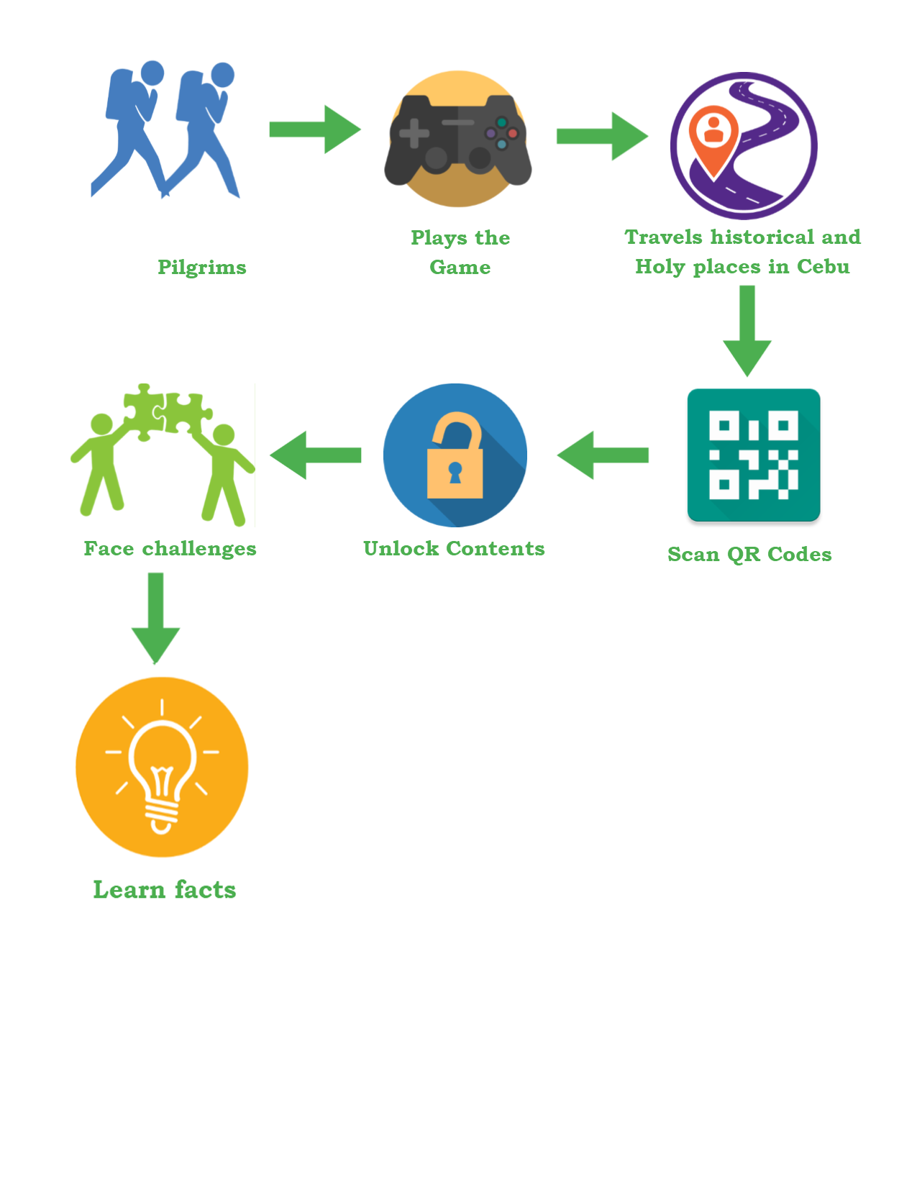

**4.2 Analysis and Design**

The application will only cater to one person at a time, which is the player. The player has an option to pick several game modes that the application provides, with the main attraction being the RPG. He has the option to start a new game or pick up where he left off by loading a save file. Upon starting the game, the players get introduced with a simple plot to set up the atmosphere, and can only progress if they go to a specific location and defeat the enemies lurking around that area.

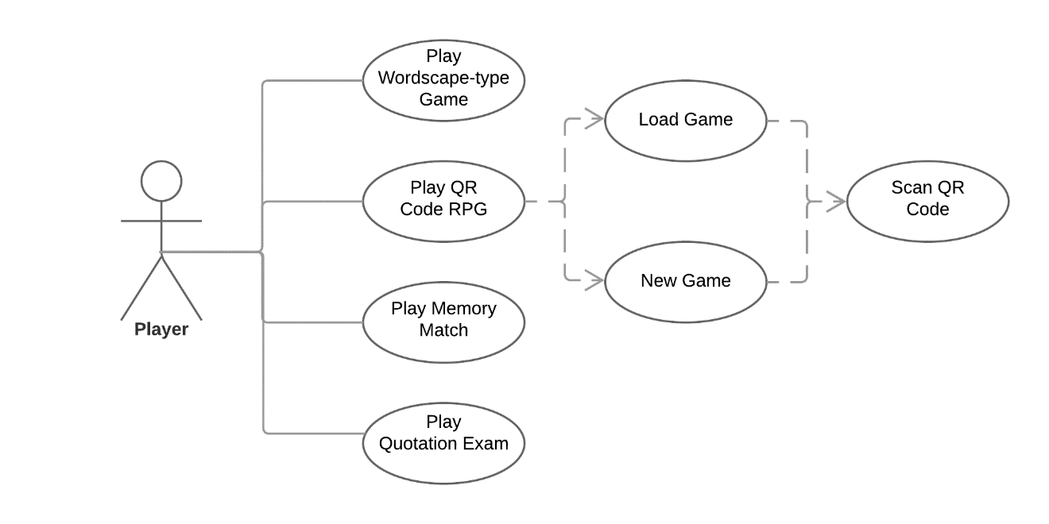

*Figure 2*: Use Case Diagram

**4.3 Development Method**

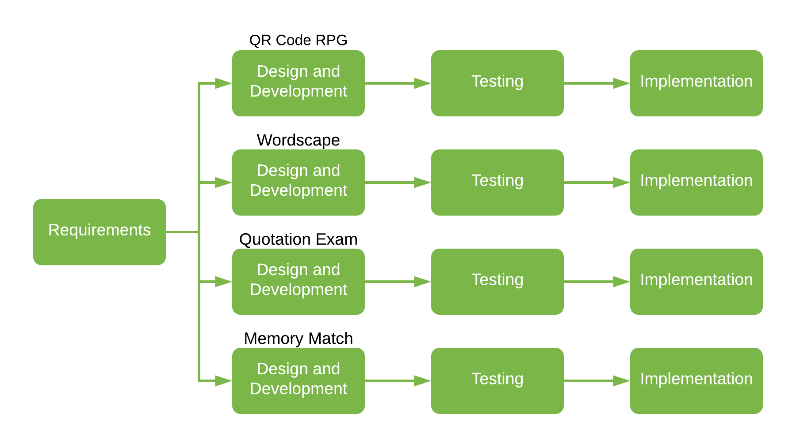

*Figure 3*: Incremental Model

The researchers use the incremental model in developing the system model. First, they decided what specification and modules they’d need to implement to the system. After all the brainstorms and documentations were conducted, the researchers will then start to develop the first module, which is the QR code RPG, out of the four planned modules of the system. After the 1st module was done, the researchers and the adviser will decide if the module is satisfactory, otherwise, the researchers will make revisions or improve it.

After the first module has been implemented and verified, the researchers will then start working at the second module. This process is repeated until all of the modules are implemented and verified.

**4.4 Development Approach**

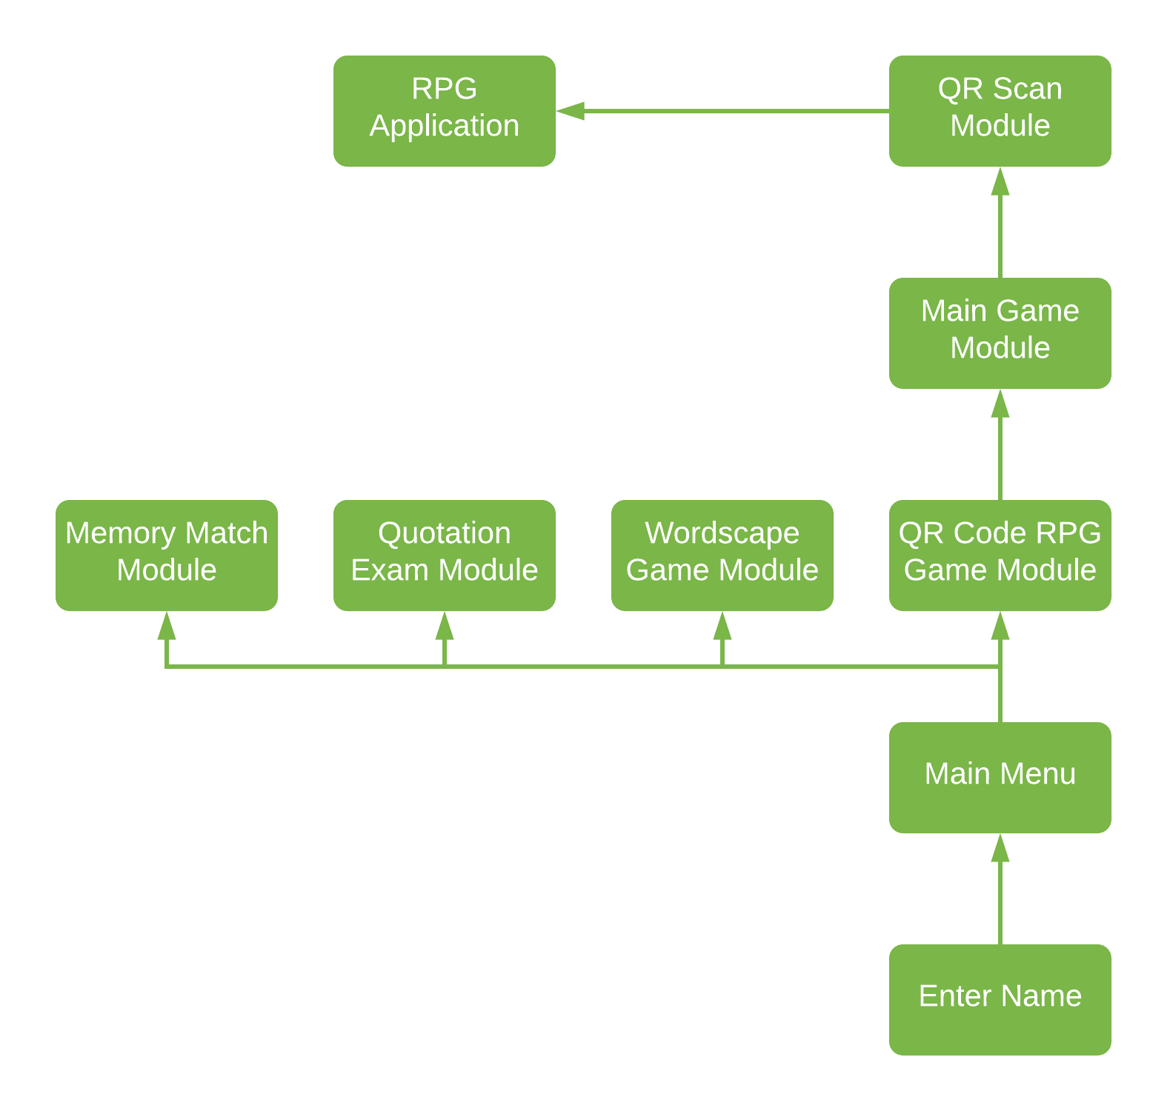

*Figure 4*: Bottom-up Approach

The main reason why the researchers used the Bottom-up approach is that this is not a very huge project that needs to borrow money from a large organization, it is a project where the people has a lot to say about it and is planned and controlled by local communities to help their local area.

**4.5 Software Development Tools**

These are the tools necessary for developing the mobile application. All of these softwares are free to use and are very flexible for their development.

Table 2

*Software Development Tools*

|  |  |  |  |
| --- | --- | --- | --- |
| **Software** | **Version** | **Source** | **Use** |
| **Unity 3D** | 2018.1.0f2 | https://unity3d.com/ | A game engine used to render 2D graphics. |
| **Adobe Photoshop** | 2016 | https://www.adobe.com/ | A photo manipulation tool to edit and enhance assets for the game. |
| **Paint Tool SAI** | 2016 | https://www.systemax.jp/en/sai/ | Painting software used to draw the assets of the game. |
| **Microsoft PowerPoint** | 2016 | https://office.live.com/start/PowerPoint.aspx | Software used to present the materials in an orderly manner. |

**4.6 Project Management**

These will be the development schedule and timeline for the mobile application.

**4.6.1 Schedule and Timeline**

Table 3

*Gantt Chart of Activities, 3rd and 1st Semester (SY 2017-2018)*

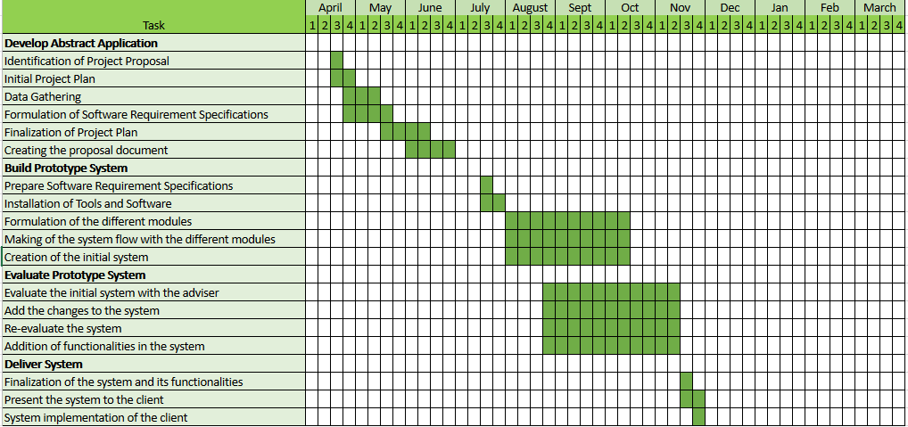

**4.6.2 Responsibilities**

Table 4

*Responsibilities*

|  |  |  |
| --- | --- | --- |
| **Name** | **Role** | **Purpose** |
| Penuel B. Calle | Back-end programmer | Lead programmer |
| Kitt Michael Edward Yap | Front-end programmer | In charge of art assets of the game. |
| Nicolas Andre Ferraren | Front-endProgrammer | Writer and game designer. |
| Bryan Bispo | Back-endProgrammer | Focuses on mini-games |

**4.6.3 Budget and Cost Management**

Table 5

*Budget and Costs*

|  |  |
| --- | --- |
| **Cost Description** | **Cost** |
| Printing | ₱ 1,000.00 |
| Laptop: Lenovo Legion Y720 | ₱ 80,000.00 |
| Graphics Tablet | ₱ 6,000.00 |
| Mouse | ₱ 1,000.00 |
| Electricity Bill | ₱ 10,000.00 |
| **Total** | **₱ 98,000.00** |

**4.7 Verification, Validation, and Testing**

The researchers have decided to implement Black Box Testing on the application. Black Box Testing is when the testers have little to no information about the design or implementation of the application in question. Basically being sent blind and no expectations to find out things such as ease of use: missing functions, missing user interface, performance issues, and vital things such as errors. Black Box Testing will be the researchers’ main verification. It required at least one hundred people to make sure that the validation results are varied within the sample size.

The researches have decided to have User Acceptance Testing. With it, the goal is to see if the users have a great time with the application or have easy time accessing the user interface and going about the process of the application. User Acceptance Testing will be the researchers’ main validation. Out of 15,000 delegates in National Youth Day, the expected number of users are about 100, with the researchers using the data to improve the system itself.

Testing will be done separately, both verification and validation being the important key factors in the success of testing, to see any mishaps or trends that to be noted from verification and validation. As stated above, this data will be critical in understanding the needs of the users.

**BIBLIOGRAPHY**

**Journals**

Nichols, M. (2007). "E-learning in context"

Squire, K. D. (2002). [“Video Games and Education: Designing Learning Systems](https://pdfs.semanticscholar.org/4f11/f96ec67d2f29e511206a80e865e8584fcfc3.pdf)

for an Interactive Age.”

Rosenberg, L.B. (1992). "The Use of Virtual Fixtures As Perceptual Overlays to

Enhance Operator Performance in Remote Environments". Technical

Report AL-TR-0089, USAF Armstrong Laboratory, Wright-Patterson AFB OH, 1992.

**Web Articles**

Advantages of the Unity Game Engine – The Ultimate Tool for Game Development. (n.d.). Retrieved from https://blog.udemy.com/unity-game-engine/

Author, G. (2018). Duolingo Review: The Quick, Easy and Free Way to Learn A Language - Fluent in 3 months - Language Hacking and Travel Tips. Retrieved from https://www.fluentin3months.com/duolingo/

Brothers, S. (2007). Game-based e-learning: The next level of staff training. Retrieved from <https://www.iadvanceseniorcare.com/article/game-based-e-learning-next-level-staff-training>

Final Fantasy. (2018). Retrieved from https://en.wikipedia.org/wiki/Final_Fantasy

Four ways smartphones are changing the world for the better. (2016, July 22). Retrieved from https://www.androidauthority.com/four-ways-smartphones-changing-world-better-685356/

Obringer, L. A. (2001, October 01). How E-learning Works. Retrieved from <https://people.howstuffworks.com/elearning1.htm>

Persona 5. (2018). Retrieved from https://en.wikipedia.org/wiki/Persona_5

Pokémon Go. (2018, May 03). Retrieved from https://en.wikipedia.org/wiki/Pokémon_Go

Role-playing video game. (2018, May 04). Retrieved from https://en.wikipedia.org/wiki/Role-playing_video_game

Stokes, P. J. (2018, March 01). How E-Learning Will Transform Education. Retrieved from <https://www.edweek.org/ew/articles/2000/09/13/02stokes.h20.html>

Team, E. (2018). What is GBL (Game-Based Learning)?. Retrieved from http://edtechreview.in/dictionary/298-what-is-game-based-learning

Times, H. U. (2016, September 19). Pokémon GO Tricks To Attract And Catch Pokémon: PokéStop Lure Module vs. Incense. Retrieved from http://www.techtimes.com/articles/170319/20160718/pokémon-go-tricks-to-attract-and-catch-pokémon-pokéstop-lure-module-vs-incense.htm

Video games in education. (2018, April 26). Retrieved from https://en.wikipedia.org/wiki/Video_games_in_education

What is E-Learning? (n.d.). Retrieved from https://community.articulate.com/series/getting-started/articles/what-is-e-learning

[. (n.d.). How Smartphones Revolutionized Society in Less than a Decade. Retrieved from <http://www.govtech.com/products/How-Smartphones-Revolutionized-Society-in-Less-than-a-Decade.html>

**APPENDIX A**  
**TRANSMITTAL LETTER**

June 4, 2018

Ms. Quitten Cacanog II

National Youth Day Staff Member

Dear Ms. Cacanog,

Greetings!

May we request from you the permission to gather information from you and the National Youth Day staff for our research study titled, “Pedro’s Journey: A Mobile Game Application”.

The above research study is a requirement for the completion of the degree in Bachelor of Science in Information Technology in the University of San Carlos. I am confident that the result of the study will be useful, helpful, and fruitful in the betterment of the overall experience of the participants of National Youth Day.

Thank you very much, and I am looking for a positive response.

Respectfully yours,

Bryan Bispo

Penuel Calle

Nicolas Ferraren

Kitt Yap

BSIT Students, University of San Carlos

Endorsed by:

Angie M. Ceniza, PhD

Capstone Adviser

Approved by:

Quitten Cacanog II

National Youth Day Staff Member

**APPENDIX B**  
**INTERVIEW GUIDE**

* What are the list of possible locations for National Youth Day?  
  __________________________________________________________
* What is the demographic for this system?  
  __________________________________________________________
* What are the requirements needed for this system to run on a smartphone?  
  __________________________________________________________
* When will the National Youth Day be held?  
  __________________________________________________________
* How many people are to be expected to join this event?  
  __________________________________________________________
* Is it possible that in one location it has more than one QR code or just one QR code to unlock a specific location?  
  __________________________________________________________
* Is there a system, similar to this, that was developed for National Youth Day?  
  __________________________________________________________

**APPENDIX C**

**SOFTWARE REQUIREMENTS SPECIFICATION**

**Pedro’s Journey: A Mobile Game Application**

By:

BRYAN Z. BISPO

PENUEL B. CALLE

NICOLAS ANDRE P. FERRAREN

KITT MICHAEL EDWARD P. YAP

ANGIE M. CENIZA, PhD

Faculty Adviser

**Introduction/Rationale of the Study**

A mobile application is an app for mobile devices. It provides limited functionality such as a simple game, a calculator, or mobile web browsing but that was due to the limited hardware resources of the early versions of mobile devices. Now, mobile applications have become more flexible because of mobile devices continuing to evolve every year and due to the continuous evolution, people can now easily access information and gain knowledge with the rapid technological evolution.

Learning history can be fun or tedious. Some people tend to get bored and some find it interesting. One of the most fun and engaging way of learning is through playing a game because through a game, people will be entertained and at the same time learn something out of it.

The main goal of this e-learning game application is to teach Pilgrims that are participating National Youth Day the history of Cebu through an educational gaming platform.

**System Description**

Project title is a game application where the user plays the role as a time traveler to go back in time, engage in historical events of certain landmarks, thus re-living the vast history of Cebu Province. The proponent decided that in order to make the game more immersive and involved to the real world, some parts of the game requires them to go to certain historical places to enhance their learning experience.

Types of User:

**Player** - can access the entirety of the game

## **Design Model**

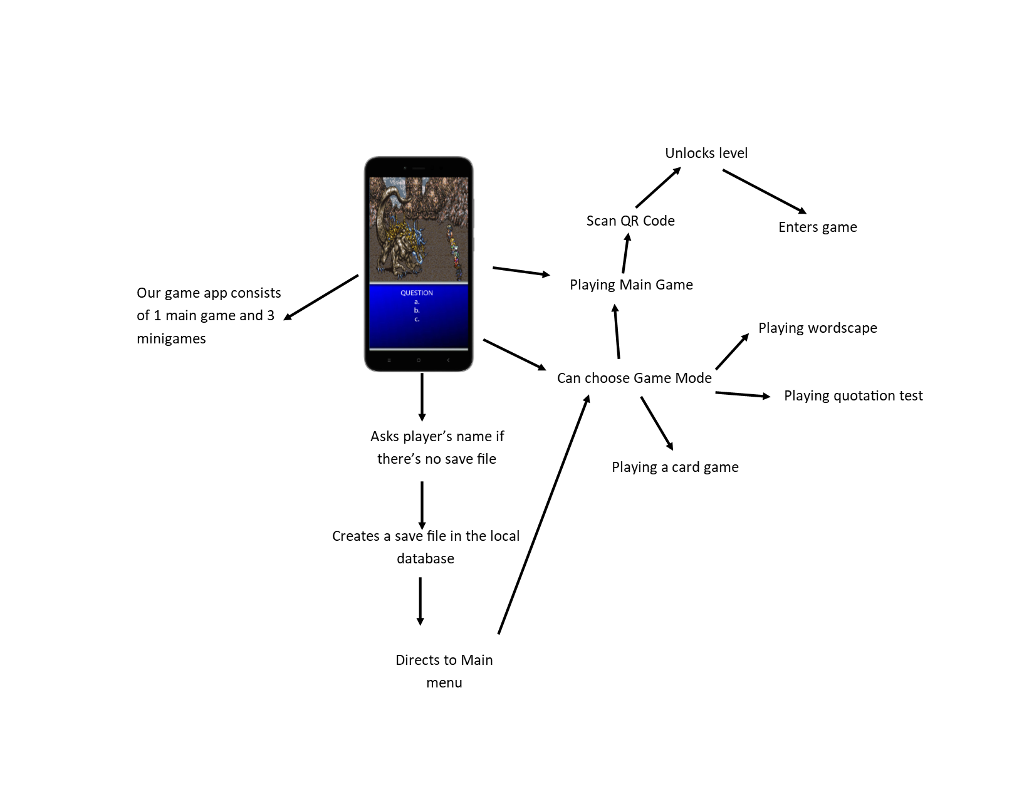

The game application implements the core gameplay of common role-playing games. It will let the user start the game application to familiarize themselves with the game’s goal and story. Afterwards, the game lets the user engage to historical events, making them the part of the history. It involves engaging into turn based battles where the outcome is based on how knowledgeable the users are related in that specific event.

***Gameplay***

*QR Code RPG*

The main game of the application that centers around the historical and religious events that have happened in Cebu. This game needs to scan QR codes to unlock different places in the given map. Each place is a level, where you experience the history of that specific place in Cebu. Since this is a RPG, the player gets to participate in battle where the player has to answer multiple choice questions related to the history of that place correctly for them to be able to launch an “attack” against the opponent. If the player gets the questions wrong, then the opponent gets to attack the player. If the player’s life points reach 0, he gets a “game over” and has to try again. Once they get all the questions right or get the opponent’s life points to 0, the player wins, levels up, and gets to progress through the game.

*Wordscape*

One of the three minigames in the application. In this minigame, the player holds and slides a given letter to form a word. Once they successfully form a word that fits in the crossword, they get points depending on the length of the word. The player has a time limit and if the time limit has passed, then the player loses the game. If the player wins, the game will move to the next level. This will have 3 levels of difficulties and each difficulty has three levels.

*Quotation Test*

One of the three minigames in the application. It’s a multiple choice examination game where the player is given an incomplete quote from a specific saint and has to complete the quote by answering the correct choice. The player is given three chances. If the player manages to answer all correctly, the player wins. If the player gets three wrong answers, then the player gets a “game over”, having to start all over again from the beginning. This contains 3 levels of difficulty and each difficulty has three levels, which is randomly generated.

*Memory Match*

One of the three minigames in the app. It is a card matching game which has a “saint” card which has the face and name of the saint. The cards are placed face down and the player can only lift two cards up at once. If the cards lifted don’t match, then they are faced back down. If the cards match, then they disappear from the field. Once all cards have disappeared, the player wins. The player loses if the timer reaches zero. This will have 3 levels of difficulties and each difficulty has three levels.

**System Flow/Development Process**

The game application starts up with a main menu that contains up to three game modes to choose from, the main attraction being the QR code RPG. When the user picks the QR code RPG, the game prompts the player to input their name when it’s their first time playing, otherwise, the game will pick up where the player left off. It revolves around the history of Cebu where the player will progress through the story that’s related to it, and engage into battles against a random or a familiar enemy. In order to progress, the player has to go to certain locations where they will find a QR code to scan from their smartphones.

In case the user is done with the QR code RPG or is not interested, the game has several minigames to choose from, where the content is still related to the history of Cebu.

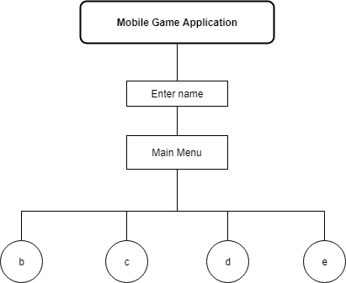

1. **Main Menu Module** - it enables to let the players to choose whether to play the main game or the mini games in the menu.
2. **QR Code RPG** - it enables the player to scan the QR Code and unlock the level and play.

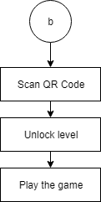

**C. Wordscape** - it enables the player to play the minigame Wordscape.

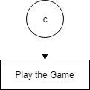

**D. Quotation Exam**- it enables the player to play the minigame that test the player’s knowledge of the quotes of famous people from the history of Cebu.

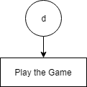

**E. Memory Match**- it enables the player to play the mini card game.

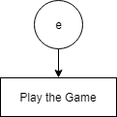

**Use Case Diagram**



**Wireframe of the Mobile Application**

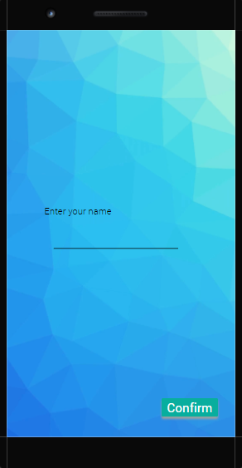

**2**

**1**

**1. Enter your name text field -** it’s where you input the name if no save file is stored inside.

**2. Confirm Button** - it’s where the player can click to store a new save file to the database.

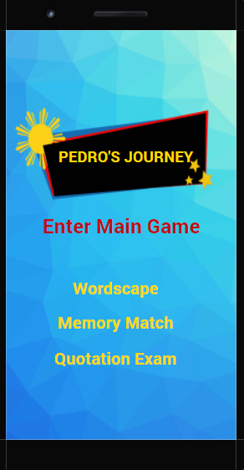

**7**

**Exit**

**6**

**5**

**4**

**3**

**3. Play Game button** - it lets you play the main game.

**4. Wordscape button** - it lets you play the minigame wordscape.

**5. Quotation test button** - it lets you play the minigame that test the player’s knowledge of the quotations of famous people from the history of Cebu.

**6. Card game button** - it lets you play the mini card game.

**7. Exit button** - it lets you exit the game.

A picture containing indoor, monitor

Description generated with high confidence

**9**

**10**

**8**

**8. Command or Answer Area** - it allows the player to input their answer of the given questions, if the player input the correct answer it later changes the choices into commands to attack an enemy in the screen else you will take damage if the answer is incorrect.

**9. Pause Button** – it lets the player pause the game

**10. Back Button** – it allows the player to go back

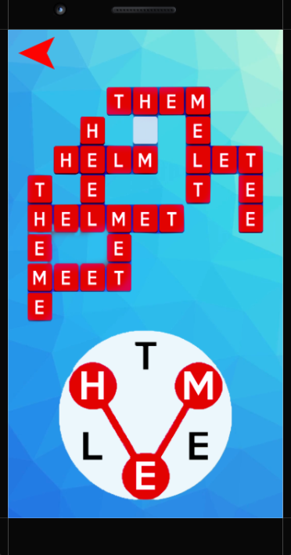

**13**

**12**

**11**

**10**

**10. Form a word slider** - where the player will hold and slide to form a word.

**11. Answer** - where the player can see his or her progress.

**12. Back Button** - it allows the player to go back

**13. Settings Button** – it directs the player to go to a settings screen where you can set the game’s volume.

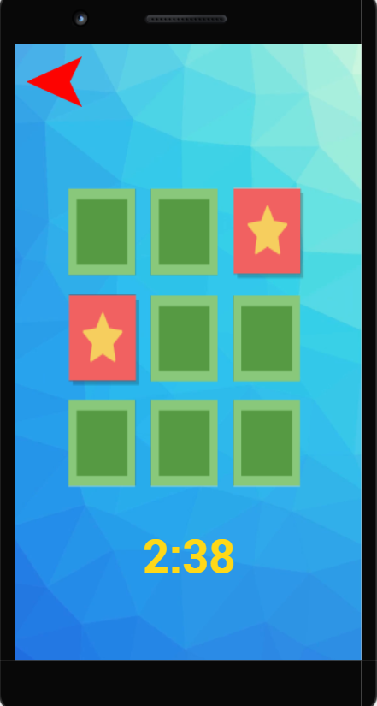

**15**

**16**

**14**

**14. Card** - where the player can tap the card and it will lift the cards up.

**15. Pause Button** – it lets the player pause the game

**16. Back Button** – it allows the player to go back

A close up of a sign

Description generated with high confidence

**20**

**19**

**18**

**17**

**17. Quotation Box** - where the players can read and identify the owner of the given quotation.

**18. Input Answer** - where the player will input his or her answer.

**19. Lives Left** – where the player can see his/her lives left

**20. Back Button** – it allows the player to go back

**21**

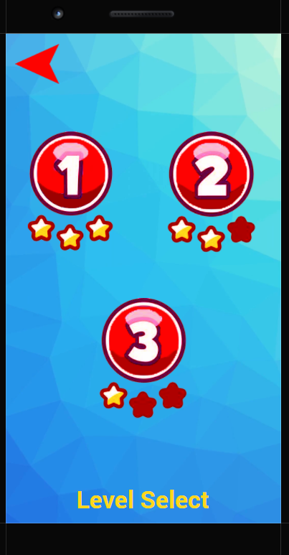

**21. Back Button** - it enables the player to go traverse back to the previous page

**22. Level Button** – it enables the player to play the level

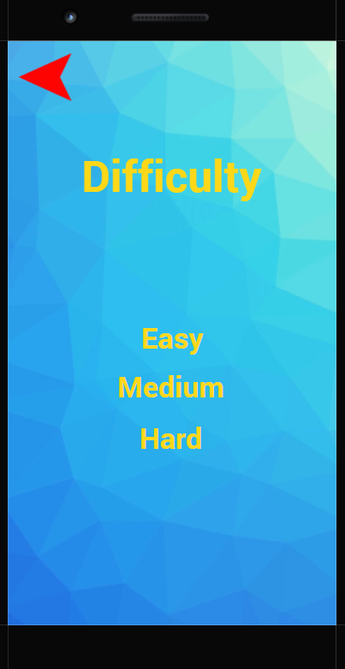

**23. Back Button** - it enables the player to go traverse back to the previous page

**24. Difficulty Buttons** – it enables the player choose the difficulty of the game.

**CURRICULUM VITAE**

**CONTACT INFORMATION**

**Full Name:** Penuel Bahinting Calle 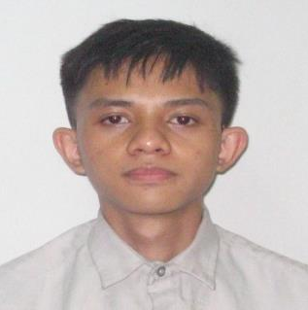

**Current Address:** #46 Echavez St., Brgy Zapatera, Cebu City

**Telephone Number:** 0905 314 9926 / 0947 522 2048

**Email:** p[enuelcalle@gmail.com](mailto:penuelcalle@gmail.com)

**PERSONAL INFORMATION**

Date of Birth: August 6, 1998

Age: 19

Citizenship/Nationality: Filipino

Gender: Male

Marital Status: Single

Number of Children & Age: 0

Language Proficiency: English, Tagalog, Hiligaynon, Cebuano, Japanese

**EDUCATIONAL BACKGROUND**

1. **Educational Level**

Year 2015

School: Destiny Christian Academy - Bacolod

Secondary

Year 2011

School: Destiny Christian Academy - Bacolod

Elementary

**2. Certifications and Accreditations**

1st Honorable Mention - Destiny Christian Academy, 2015

1st Place Honor Roll - Accelerated Christian School, 2009

**TECHNICAL SKILLS**

* **Programming**
* C, C#, Java
* HTML, CSS, PHP, Javascript
* **Media**
* Adobe Premiere Pro
* GIMP
* Unity 3D
* **Office Applications**
* MS Office
* MS Word
* MS Excel
* MS PowerPoint

**STRENGTHS/TRAITS & SKILLS**

* Hands-on experience
* Able to work within tight schedules
* High degree of initiative

**CAREER OBJECTIVES**

To work on a video game development company that makes games that everybody will enjoy.

**CURRICULUM VITAE**

**CONTACT INFORMATION**

**Full Name:** Bryan Bispo

**Current Address:** Ampalaya Village, Gun-ob Lapu-Lapu City Cebu

**Telephone Number:** 09958362635

**Email:** bryan.bispo13@gmail.com

**PERSONAL INFORMATION**

Date of Birth: April 15, 1999

Age: 19

Citizenship/Nationality: Filipino

Gender: Male

Marital Status: Single

Language Proficiency: English, Filipino, Common Tongue

**EDUCATIONAL BACKGROUND**

1. **Educational Level**

Year 2015

School: Saint Alphonsus Catholic School - Lapu-lapu City

Secondary

Year 2011

School: Saint Andrew School - Lapu-Lapu City

Elementary

**2. Certifications and Accreditations**

1st Honorable Mention - Saint Andrews School, 2013

**TECHNICAL SKILLS**

* **Programming**
* C, C#, Java - Console Application, Windows Applications
* HTML/CSS/PHP/JavaScript - Website Front-end, Website Back-end, Database
* **Media**
* Adobe Photoshop
* MS Paint
* Adobe CC
* **Office Applications**
* MS Office
* MS Word
* MS Excel
* MS PowerPoint
* **Other skills**
* Writing

**STRENGTHS/TRAITS & SKILLS**

* Able to work within tight schedules
* Perfectionist that will not stop working until the jobs done
* Hands-on Experience
* Imaginative and Open

**CAREER OBJECTIVES**

To work and program on a hardware that will replace almost every interaction on human society. And to create and build a game that will be played for at least 3 generations of human beings.

**CURRICULUM VITAE**

**CONTACT INFORMATION**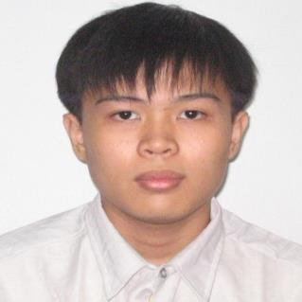

**Full Name:** Kitt Michael Edward P. Yap

**Current Address:** Lower Suran, Bacalso Compound, Quiot, Cebu City, Cebu

**Telephone Number:** 0927 279 1066 / 0933 530 6637

**Email:** kittyap12@gmail.com

**PERSONAL INFORMATION**

Date of Birth: July 29, 1998

Age: 19

Citizenship/Nationality: Filipino

Gender: Male

Marital Status: Single

Number of Children & Age: 0

Language Proficiency: English, Tagalog, Chinese, Cebuano

Computer PMS and Software Skills:

**TECHNICAL SKILLS**

* **Programming**
  + C, Java, C#, HTML, JavaScript, PHP, SQL
* **Media**
  + Adobe Photoshop
  + Unity 3d
  + MS Paint
  + Paint Tool Sai
  + Sony Vegas
* **Office Applications**
  + MS Office
  + MS Word
  + MS Excel
  + MS PowerPoint
* **Others Skills**
  + Drawing

**EDUCATIONAL BACKGROUND**

1. **Educational Level**

Year 2015

School: Cebu Eastern College - Cebu

Secondary

Year 2011

School: Cebu Eastern College - Cebu

Elementary

**2. Certifications and Accreditations**

Top 10 Homeroom Topnotchers Award - Cebu Eastern College, 2011

Bronze Award - Cebu Eastern College, 2015

**STRENGTHS/TRAITS & SKILLS**

* Hands-on experience
* Able to work within tight schedules
* High degree of initiative
* Meticulous

**CAREER OBJECTIVES**

To work under an animation team or as a character designer on a video game development company that makes games that everybody will enjoy.

**CURRICULUM VITAE**

**CONTACT INFORMATION**

**Full Name:** Nicolas Andre Pinote Ferraren 

**Current Address:** 1009 Sangi Rd., Pajo, Lapu-Lapu City, Cebu

**Telephone Number:** 0995 896 5585 / 0932 979 4798

**Email:** hazydreams620@gmail.com

**PERSONAL INFORMATION**

Date of Birth: June 20, 1998

Age: 19

Citizenship/Nationality: Filipino

Gender: Male

Marital Status: Single

Number of Children & Age: 0

Language Proficiency: English, Cebuano, Tagalog, Japanese, Chinese

**EDUCATIONAL BACKGROUND**

1. **Educational Level**

Year 2015

School: Sacred Heart School - Ateneo de Cebu

Secondary

Year 2011

School: Sacred Heart School - Ateneo de Cebu

Elementary

**2. Certifications and Accreditations**

1st Honor Award - Sacred Heart School - Ateneo de Cebu, 2005 - 2008

Loyalty Award - Sacred Heart School - Ateneo de Cebu, 2015

Bronze Award - Sacred Heart School - Ateneo de Cebu, 2015

**TECHNICAL SKILLS**

* **Programming**
* C, C#, Java
* HTML, CSS, PHP, JavaScript
* **Media**
* FL Studio 12
* Adobe Audition CS6
* Audacity
* Sony Vegas Pro
* Melodyne
* **Office Applications**
* MS Office
* MS Word
* MS Excel
* MS PowerPoint

**STRENGTHS/TRAITS & SKILLS**

* Hands-on experience
* Able to work within tight schedules
* High degree of initiative
* Creative
* Open-minded
* Passionate

**CAREER OBJECTIVES**

To work in the video game industry as the lead game designer or music composer in a well-renowned company and make games that I will enjoy making and that everyone else will enjoy. I want to make an impact and leave my mark on this world before I die.