Bill Davis Computer Science 605.411
Problem Set 1 Due: January 31

1. (10) Define speedup as it relates to the execution time resulting from making some improvement in the computer. Speedup = ?
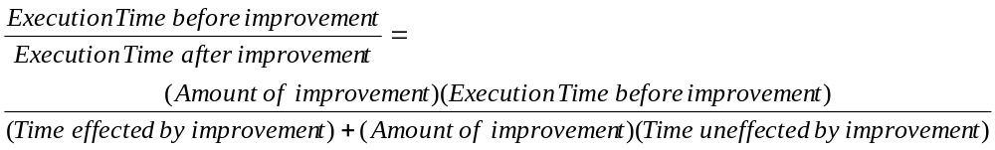
2. Twenty million instructions from a certain program are executed on a processor with a clock cycle time of 250 pico-seconds. The multiply instruction on this machine requires 12 clock cycles and accounts for 10% of the total number of instructions executed in the program. The other 90% of the instructions in the program require an average of 4 clock cycles per instruction.
a) Complete the following statements:
(5) The clock rate for this machine is __4__ GHz.
(5) The execution time for the entire program is _24,000,000,000 _ pico-seconds.
(5) Excluding the multiply instructions, the program consumes _ 72 million_ cycles.
b) (10) Suppose that an improvement is made such that each multiply instruction only takes two 250-picosecond cycles. What speedup factor would this improvement provide for the program? Express your answer in the form =1.26 .
c) (10) What is the maximum speedup that can be obtained for this program by improving only the multiply instructions? Express your answer in the form =1.29 .

3. (20) If improving the multiply instruction in problem 2 so that it consumes only 6 cycles will dictate a 20% increase in the processor’s cycle time, what speedup factor for the program would be produced by this improvement?
=0.95

4. (35) Assume that each of the following instruction types requires the indicated number of clock cycles when executed on a MIPS processor with a 4 GHz clock rate:
Consider the following program:

prog1: addi $6,$0,100
addi $4,$0,4000
addi $5,$4,5000
lw $3,0($4)
lw $2,0($5)
sub $3,$3,$2
sw $3,0($5)
addi $5,$5,4
sw $0,4($5)

Instruction | Clock cycles required
Addi | 3
sub | 4
lw | 8
sw | 6
- The average CPI rating for this instruction sequence is __5.25_____.
- The native MIPS rating for this instruction sequence is __761.90____.
- The peak MIPS rating for this machine, assuming these are the only available types of instructions, is __1333.33_____ .
- The total execution time for the sequence is _11000_ pico-seconds.

