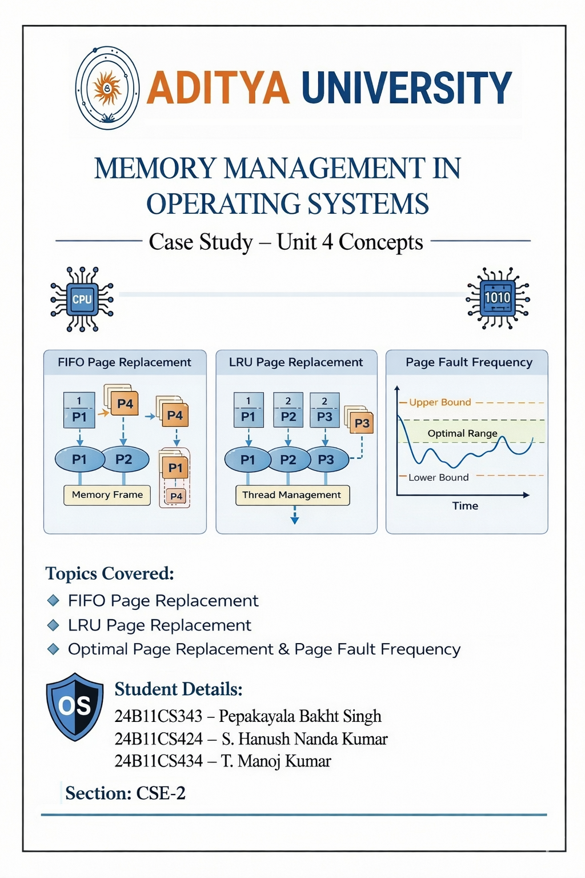
DEPARTMENT OF COMPUTER SCIENCE AND ENGINEERING
OPERATING SYSTEMS

1. Introduction
Virtual Memory Management is an important concept in operating systems that allows execution of processes without loading the entire program into main memory. It provides an illusion of large memory by using disk space as an extension of RAM.
Demand paging is a technique where pages are loaded into memory only when they are required. Page replacement algorithms are used to decide which page should be removed when memory is full.
This approach improves memory utilization, system efficiency, and allows multiple programs to run simultaneously.

2. Objective of the Case Study
The objectives of this case study are:
- To understand virtual memory management
- To study demand paging technique
- To analyze page replacement algorithms
- To understand memory utilization and performance
- To examine how OS handles memory dynamically

3. Scenario Description
Consider a system running multiple applications such as:
- Web browser
- Code editor (VS Code)
- Media player

The system has limited RAM (e.g., 8GB), but multiple applications require more memory.
Instead of loading entire programs into memory:
- Only required pages are loaded (Demand Paging)
- When memory becomes full, some pages are removed (Page Replacement)
This ensures smooth system performance even with limited memory.

4. Problem Statement
The operating system must:
- Efficiently manage limited main memory
- Load only required data into memory
- Avoid unnecessary memory usage
- Handle page faults efficiently
- Select appropriate pages for replacement
To achieve this, demand paging and page replacement algorithms are used.

5. Types of Page Replacement Algorithms

5.1 FIFO (First-In First-Out)
- Oldest page in memory is removed first
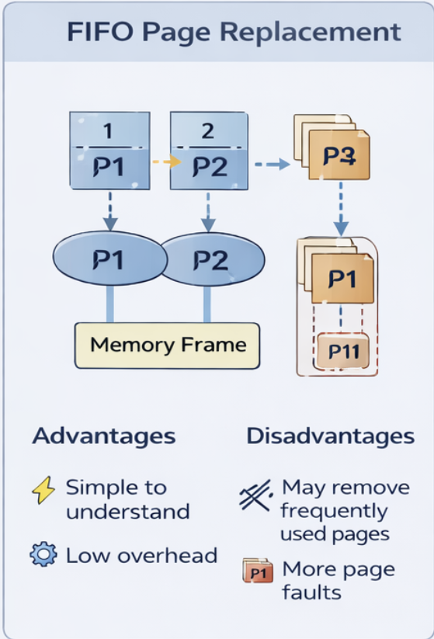
Advantages:
- Simple to implement
- Low overhead
Disadvantages:
- May remove frequently used pages
- Leads to more page faults

5.2 LRU (Least Recently Used)
- Removes the page that was not used for the longest time
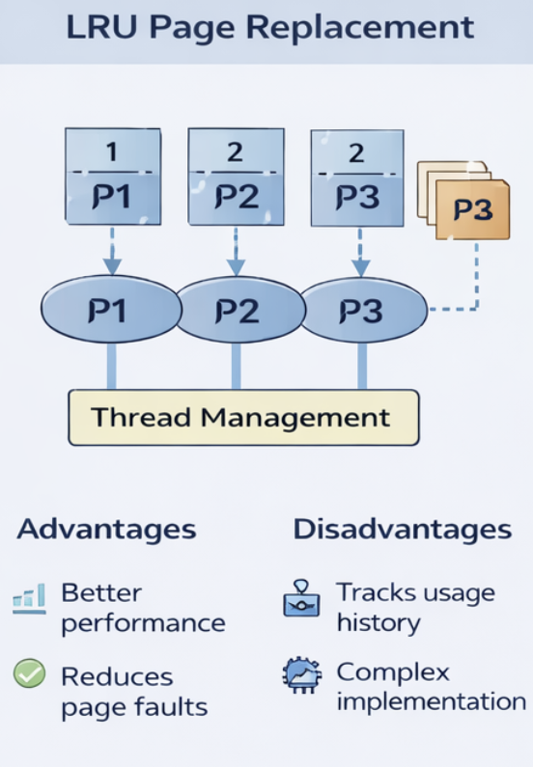
Advantages:
- Better performance than FIFO
- Reduces page faults
Disadvantages:
- Requires tracking usage history
- More complex implementation

5.3 Optimal Page Replacement
- Replaces the page that will not be used for the longest time in future
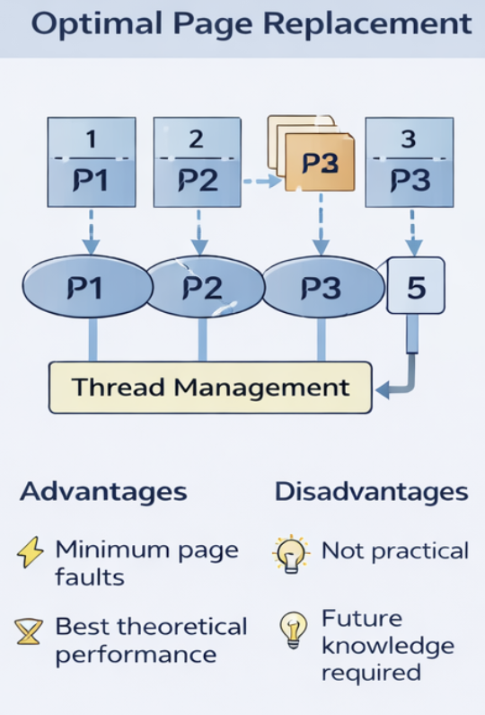
Advantages:
- Gives minimum page faults
- Best theoretical performance
Disadvantages:
- Not practical (future knowledge required)

6. Working of Demand Paging and Page Replacement
Step-by-step working:
1. Process starts execution
2. Required page is checked in memory
3. If present → execution continues
4. If not present → Page Fault occurs
5. OS loads page from disk into memory
6. If memory is full → page replacement algorithm is applied
7. Selected page is removed
8. New page is loaded
9. Execution continues

Example:
Assume page reference string: 1, 2, 3, 4, 1, 2, 5
Memory frames = 3
Using FIFO:
- Pages are loaded sequentially
- When memory is full, oldest page is replaced
- Results in multiple page faults

7. Impact on Performance
- Memory Utilization: Efficient use of RAM
- Concurrency: Multiple programs run simultaneously
- CPU Utilization: CPU remains active
- Page Fault Rate: High faults reduce performance
- Overhead: Disk access is slower than RAM

8. Conceptual Diagram (Explanation)
User Program → Page Table → Main Memory → Disk (Swap Space)
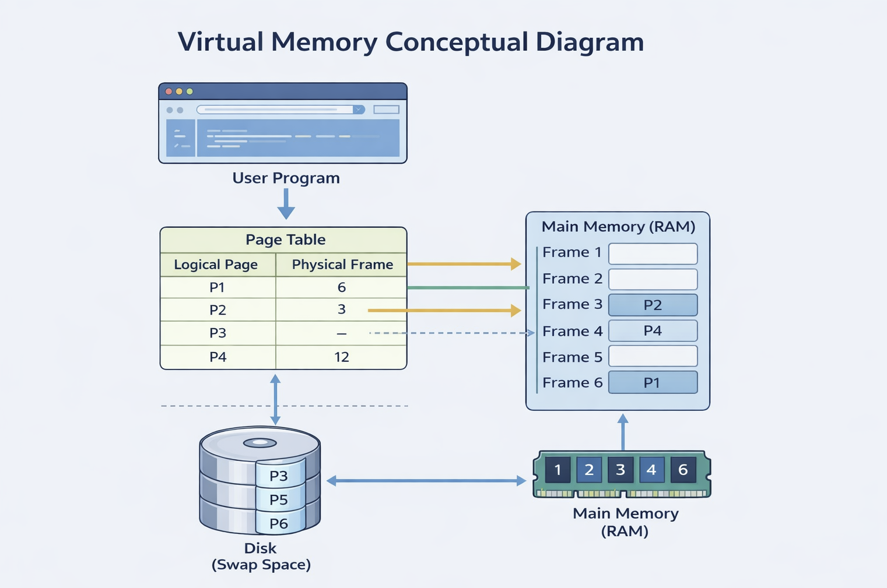

9. Conclusion
This case study explains virtual memory management using demand paging and page replacement algorithms. Demand paging improves memory efficiency by loading only required pages, while page replacement ensures optimal use of limited memory.
Among algorithms, FIFO is simple but inefficient, LRU provides better performance, and Optimal gives best results theoretically. Efficient virtual memory management is essential for modern operating systems to handle multitasking and large applications.

