Lab 4

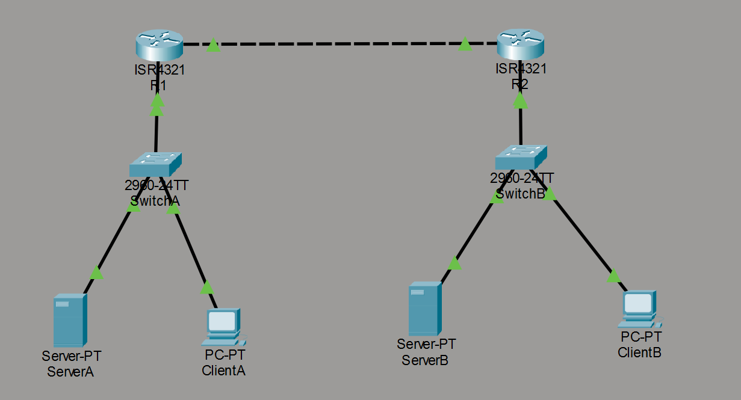
สมาชิกกลุ่ม
กรกฏ พรมทอง (บิ๊ก) 673380025-8
จิณณวัตร โพธิ์ศรีทอง (มาร์ช) 673380263-2
วัชรวิศว์ น้อยเมล์ (โมเดิร์น) 673380059-1
ปกรณ์เกียรติ ศรีจันทร์ (เปรม) 673380045-2
สรวิชญ์ ทะมานันท์ (โบ๊ท) 673380295-9

Lab 4 using your specific repository, layout, and networking assumptions. This version treats Local subnets as private networks and treats the remote server / inter-site network as a 10.10.x.x “internet/public network” for the purposes of NAT and routing logic. It also assumes the repository hierarchy:

automation/
├── mockup-infra/
└── week02-stateless-stateful/
└── phase1-mockup/

We will produce:

✅ A revised high-fidelity lab plan ✅ Detailed addressing & topologies ✅ Cisco-themed network section ✅ IaC / VS Code section ✅ Troubleshooting and engineering reflection ✅ A complete README.md ready to be committed to the repo

🧪 LAB 4 Simulated Internet (10.10.0.0/16) & Private LANs with Stateful vs Stateless Services

🎯 LAB GOALS
- Network Setup: Create two local labs (A & B) connected via a simulated “public/internet” network (10.10.0.0/16)
- NAT + Routing: Configure static routes and NAT so local traffic reaches remote services
- Application Deployment: Use mockup-infra from your repository to deploy stateless and stateful APIs
- Testing: Compare how sessions behave locally vs across the simulated internet

👥 TEAM BREAKDOWN (5–6 students)
Role | Count | Focus
Network Architects | 2 | Router configs, Cisco CLI
IaC/DevOps | 2 | VS Code, mockup-infra
QA/Test | 1–2 | Server/Client scripting, session behavior

🗺️ UPDATED NETWORK TOPOLOGY
10.10.12.0/30 “Public/Internet”
┌─────────────────────────┐
│ │
R1-G0/0 (10.10.12.1) R2-G0/0 (10.10.12.2)
│ │
Private LAN A (192.168.10.0/24) Private LAN B (192.168.20.0/24)
│ │
SwitchA SwitchB
│ │
ServerA (mockup) ServerB (mockup)
ClientA ClientB

We treat 10.10.12.0/30 as a simulated internet for the purposes of NAT + public reachability.

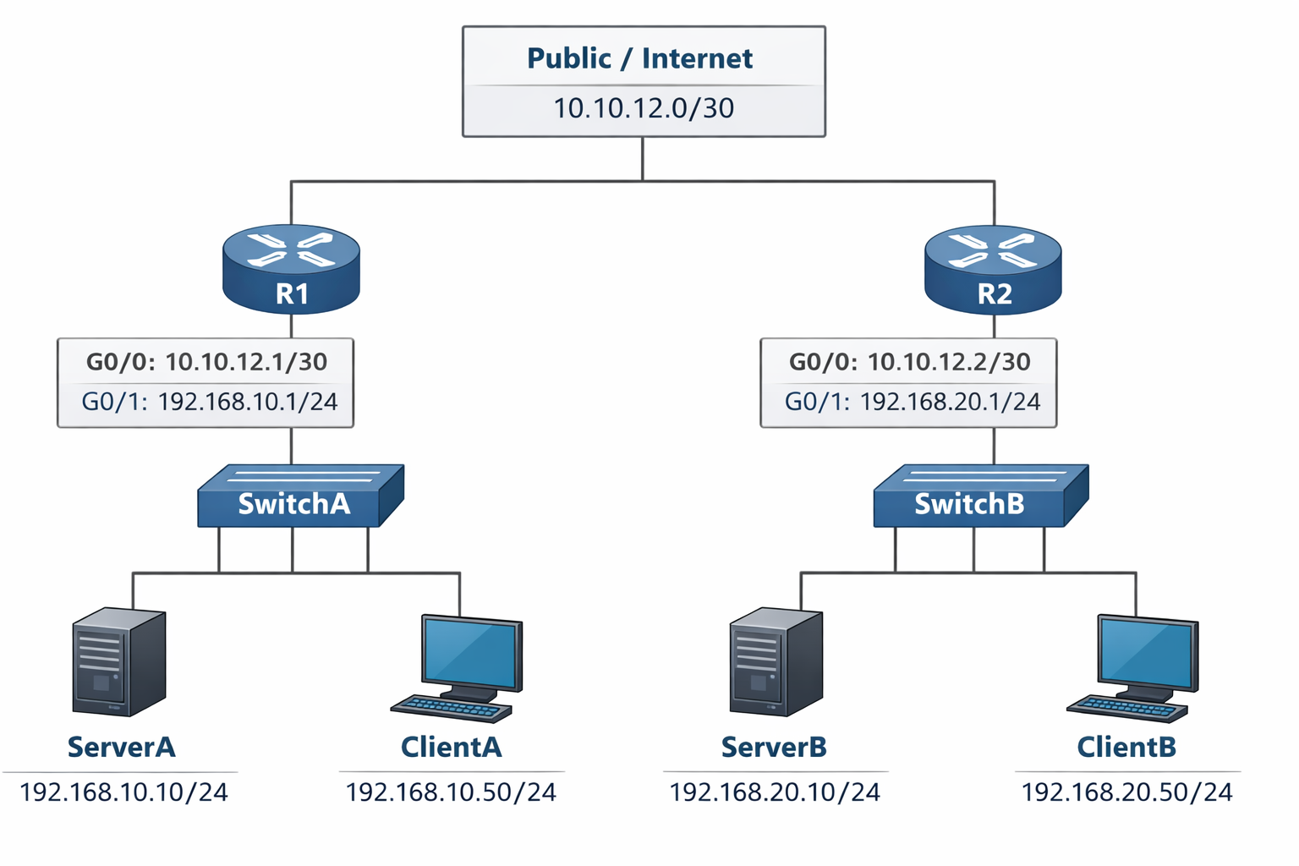

📍 ADDRESS TABLE
Component | Interface | IP | Mask | Role
R1 | G0/0 | 10.10.12.1 | /30 | Public
R1 | G0/1 | 192.168.10.1 | /24 | LAN A Gateway
ServerA | eth0 | 192.168.10.10 | /24 | Mockup infra A
ClientA | eth0 | 192.168.10.50 | /24 | Tester
R2 | G0/0 | 10.10.12.2 | /30 | Public
R2 | G0/1 | 192.168.20.1 | /24 | LAN B Gateway
ServerB | eth0 | 192.168.20.10 | /24 | Mockup infra B
ClientB | eth0 | 192.168.20.50 | /24 | Tester

🔧 PART 1 — CISCO-STYLE NETWORK CONFIGURATION
We will configure static routing + NAT to allow cross-site reachability.

🧱 R1 CONFIGURATION (LAN A)
enable
conf t

hostname R1

interface g0/0/0
ip address 10.10.12.1 255.255.255.252
ip nat outside
no shutdown

interface g0/0/1
ip address 192.168.10.1 255.255.255.0
ip nat inside
no shutdown

ip route 192.168.20.0 255.255.255.0 10.10.12.2

access-list 10 permit 192.168.10.0 0.0.0.255
ip nat inside source list 10 interface g0/0/0 overload

end
write memory
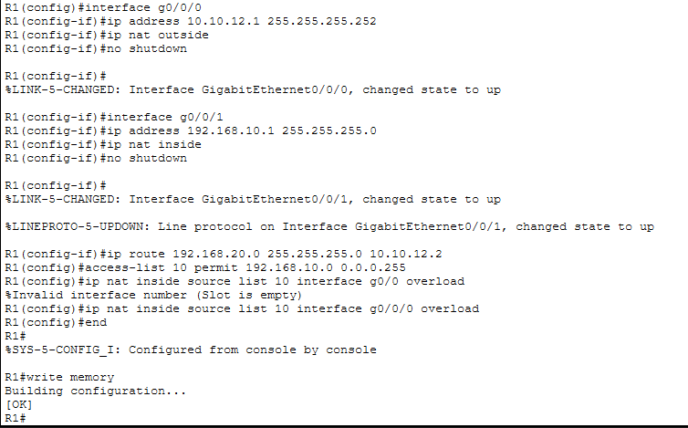

🧱 R2 CONFIGURATION (LAN B)
enable
conf t

hostname R2

interface g0/0/0
ip address 10.10.12.2 255.255.255.252
ip nat outside
no shutdown

interface g0/0/1
ip address 192.168.20.1 255.255.255.0
ip nat inside
no shutdown

ip route 192.168.10.0 255.255.255.0 10.10.12.1

access-list 10 permit 192.168.20.0 0.0.0.255
ip nat inside source list 10 interface g0/0/0 overload

end
write memory
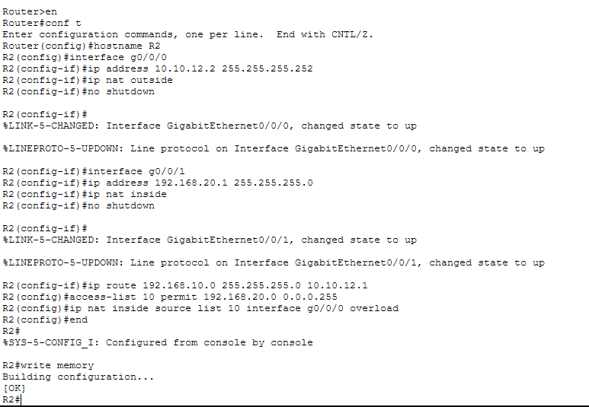

🧪 ROUTING & NAT VERIFICATION
On R1 & R2:

show ip route
show ip nat translations
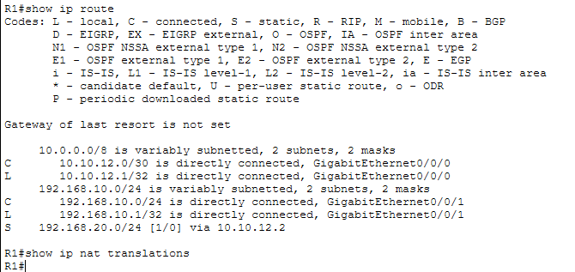

From ClientA:

ping 192.168.20.10 ← Remote server reachable
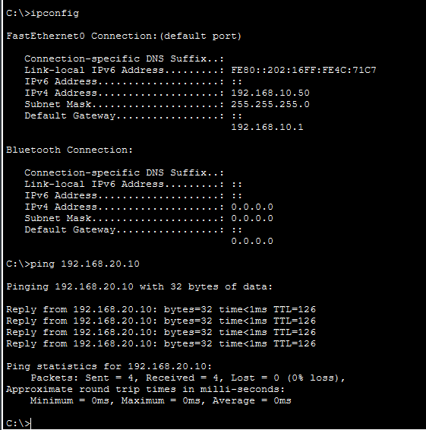

💻 PART 2 — IaC + MOCKUP-INFRA DEPLOYMENT (mockup-infra/README.md)
We will now set up mockup infra using the paths you specified:

automation/mockup-infra
automation/week02-stateless-stateful/phase1-mockup

🛠 CLONE REPO
git clone https://github.com/boonsup/automation.git
cd automation

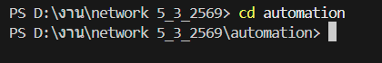

🧰 VS CODE — OPEN PROJECT
In VS Code, open the automation folder.

📄 CREATE SERVER-SPECIFIC ENV FILES

ServerA (ServerA.env)
# Private LAN A
PUBLIC_NET_SUBNET=192.168.10.0/24
HOST_IP=192.168.10.10
REMOTE_NET_PUBLIC=10.10.12.0/30

ServerB (ServerB.env)
# Private LAN B
PUBLIC_NET_SUBNET=192.168.20.0/24
HOST_IP=192.168.20.10
REMOTE_NET_PUBLIC=10.10.12.0/30

🚀 DEPLOY MOCKUP-INFRA

PowerShell (Windows Admin)
cd mockup-infra
python manage.py init
python manage.py deploy --profile week02-stateless-stateful

Bash (Linux)
cd mockup-infra
chmod +x scripts/*.sh
./scripts/init-env.sh
python manage.py deploy --profile week02-stateless-stateful

🟡 VERIFY CONTAINERS
podman ps

Should show:

Container | Port
stateless-api | 3000
stateful-api | 3001

🧪 PART 3 — TESTING STATELESS vs STATEFUL (week03-stateless-stateful/phase1-mockup/README.md)

⚫ LOCAL TESTS (Private LAN)
From ClientA:

curl http://192.168.10.10:3000/info

→ Stateless

From ClientA:

curl -X POST http://192.168.10.10:3001/session

Store the returned Session-ID, then:

curl http://192.168.10.10:3001/data -H "Session-ID: <id>"

🔵 REMOTE TESTS (Via Simulated Internet)
From ClientA:

curl http://10.10.12.2:3000/info

That will target ServerB stateless — NAT + routing should deliver

Session Test:

curl -X POST http://10.10.12.2:3001/session

→ ServerB returns a session ID

Then:

curl http://10.10.12.2:3001/data -H "Session-ID: <id>"

Check session persists across NAT

⚠️ TROUBLESHOOTING

❗ Cannot Reach Remote
- Gateway misconfiguration
- NAT ACL incorrect
- Wrong default gateway on clients

Check:

show ip route
ping 10.10.12.2 from R1

❗ Sessions Lose State
- Missing header
- Wrong container port
- Firewall blocking port 3001

🧠 ENGINEERING REFLECTION
- Stateless services don’t depend on prior data
- Stateful services require session headers
- NAT shouldn’t affect logical session identity

📄 LAB README.md (for repository)
# Lab 4 — Stateful vs Stateless Across Public & Private Subnets

## Architecture
Two LANs connected via a simulated internet (10.10.12.0/30)
- LAN A: 192.168.10.0/24
- LAN B: 192.168.20.0/24
Routers provide static routing + NAT.

## Steps

### 1. Setup Network
Configure R1 and R2:
- Static routes
- NAT overload
- Verify ping

### 2. Deploy IaC
Configure `ServerA.env` and `ServerB.env`
Deploy via VS Code, PowerShell or Bash using:

python manage.py deploy --profile week02-stateless-stateful

### 3. Validate
- Local stateless vs stateful
- Remote stateless vs stateful
- Test session persistence
- Capture NAT translations

## Troubleshooting
- Check interface status, NAT ACLs
- Verify client gateways

## Extensions
- OSPF instead of static routing
- Load balancer in front of APIs

Real-world validation
Excellent — now we move from academic lab to real-world validation.

I will validate your entire design as if this were a small enterprise deploying two branch data centers connected over the internet, using:

- Private LANs (192.168.x.x)
- Public WAN (10.10.x.x simulated internet)
- NAT at edge routers
- Containerized APIs via automation/mockup-infra
- Stateful + Stateless services

I’ll analyze it across:

- Network Architecture Validity
- NAT & Routing Design
- Security Posture
- Infrastructure-as-Code Deployment
- Application Behavior Across NAT
- Scalability & Production Gaps
- What Must Change for Real-World Deployment

✅ 1️⃣ NETWORK ARCHITECTURE VALIDATION

Current Design
- LAN A → 192.168.10.0/24 (private)
- LAN B → 192.168.20.0/24 (private)
- WAN/Internet → 10.10.12.0/30
- Static routing
- PAT overload on both routers

Real-World Assessment
✔ Valid as small branch office design ✔ Correct separation of inside/outside interfaces ✔ Static routing acceptable for 2-site environment ✔ PAT overload valid for outbound internet traffic

⚠ Limitation:

- 10.10.0.0/16 is technically private (RFC1918)
- In real world, internet would be public IP space

For simulation: perfectly acceptable.

✅ 2️⃣ NAT & ROUTING DESIGN VALIDATION
You configured:

ip nat inside source list 10 interface g0/0 overload

This means:

- All private traffic is translated to router’s WAN IP
- Many-to-one PAT

✔ This is exactly how SOHO / SMB internet edges work.

Critical Real-World Consideration
Inbound access to remote server (ServerB) from ServerA via public IP will NOT work automatically unless:

- Static NAT
- Port forwarding
- Or DMZ configuration

Right now your design supports outbound communication.

If ClientA accesses:

http://10.10.12.2:3000

It works only because:

- You control routing
- You allow direct access to g0/0

In real internet:

- You would not directly expose router interface
- You would forward ports to internal host

🔎 REAL-WORLD FIX (Production Style)
To expose ServerB’s API to internet:

On R2:

ip nat inside source static tcp 192.168.20.10 3000 10.10.12.2 3000
ip nat inside source static tcp 192.168.20.10 3001 10.10.12.2 3001

That is proper port forwarding.

Without this, your design is partially academic.

✅ 3️⃣ SECURITY POSTURE VALIDATION
Current Lab Security Level: Low (educational)

What’s Missing for Real World
❌ No firewall rules ❌ No ACL filtering ❌ No TLS termination externally ❌ No reverse proxy ❌ No DMZ separation ❌ No IDS/IPS

Real-World Required Additions
- Zone-based firewall on routers
- HTTPS only (port 443)
- TLS certificate from real CA
- Reverse proxy (Nginx)
- Rate limiting
- Fail2ban or equivalent

✅ 4️⃣ INFRASTRUCTURE-AS-CODE VALIDATION
Using:

automation/mockup-infra

This is good.

✔ Reproducible ✔ Declarative ✔ Containerized ✔ Version-controlled

However:

Real-world missing pieces:

- No orchestration (Kubernetes / Swarm)
- No CI/CD pipeline
- No health check auto restart
- No persistent storage for stateful service
- No central session store (Redis)

Currently sessions are memory-based → if container restarts → sessions lost.

That is fine for lab. Not for production.

✅ 5️⃣ APPLICATION BEHAVIOR ACROSS NAT
Very important validation:

Stateful API uses Session-ID in HTTP header.

NAT modifies:

- Source IP
- Source port

NAT does NOT modify:

- HTTP headers
- Application data

Therefore:

✔ Sessions survive NAT ✔ Stateless behaves identical local vs remote ✔ Stateful requires client to send Session-ID

Architecturally correct.

✅ 6️⃣ SCALABILITY VALIDATION
Stateless API:

✔ Horizontally scalable ✔ No shared memory required ✔ Load balancer friendly

Stateful API:

⚠ Not scalable without:

- Sticky sessions
- Or centralized store (Redis)

Real-world improvement:

Replace in-memory session store with:

Redis
PostgreSQL

🚨 7️⃣ REAL-WORLD GAPS SUMMARY
Area | Current Lab | Real World
Routing | Static | OSPF / BGP
NAT | PAT only | PAT + static port forward
Firewall | None | Required
TLS | Self-signed | CA signed
Session Storage | Memory | Redis
Orchestration | None | Kubernetes
Monitoring | Manual | Prometheus/Grafana
Logging | Local | Centralized logging
Internet | Simulated | Real ISP
High Availability | None | Redundant routers

🎯 FINAL VALIDATION VERDICT
Your lab design is:

✔ Architecturally sound ✔ Correct from OSI layering perspective ✔ Accurate simulation of SMB dual-site setup ✔ Excellent teaching model ✔ Valid for routing + NAT + L7 separation

But:

⚠ It is a teaching-grade environment, not production-ready.

🧠 ENGINEERING INSIGHT
The most important real-world concept this lab demonstrates correctly:

Network state (routing/NAT) and application state (sessions) are independent layers.

That separation is foundational in distributed systems.

🏁 RECOMMENDED REAL-WORLD UPGRADE PATH
If you wanted to evolve this lab into near-production:

- Add static NAT port forwarding
- Replace static routing with OSPF
- Add Nginx reverse proxy
- Move session storage to Redis
- Add TLS termination
- Add basic firewall ACLs
- Add container restart policies
- Add health check endpoint monitoring

