Compilador para C-

*Diseño de compiladores - Doc. Víctor Manuel de la Cueva*

Entrega Final

José Manuel Beauregard Méndez

A01021716

Introducción

Para la parte final de este proyecto se tuvo como reto traducir el código de C- a ensamblador con la finalidad de que la computadora pueda entender dicho código.

En clase se revisó la implementación con un procesador MIPS (Microprocessor without Interlocked Pipeline Stages) el cual es una versión reducida de un RISC.

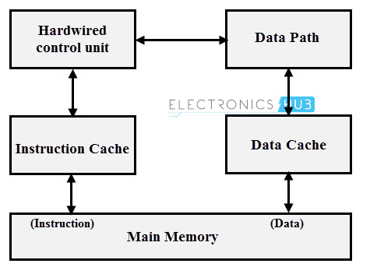

Utilizando dicho procesador es posible nos permite completar el último paso de un compilador, generación de código. Se utilizó dicho procesador debido a que en una investigación que se realizó de otras opciones de procesadores como TM, y en dicha indagación encontré una fuente que comentaba lo común que es la incorporación de un MIPS en compiladores escolares gracias a su flexibilidad y facilidad de escribir código ensamblador.

Manual de usuarios

LEXER

*Diseño de compiladores - Doc. Víctor Manuel de la Cueva*

Primera Entrega

José Manuel Beauregard Méndez

A01021716

Expresiones regulares

|  |  |
| --- | --- |
| **Expresión Regular** | **Token** |
| \d+ | NUM |
| [a-zA-Z_][a-zA-Z0-9_]* | ID |
| \/\*(\*(?!\/)|[^*])*\*\/ | COMMENT |
| “=“ | EQUAL |
| \+ | PLUS |
| - | MINUS |
| \* | TIMES |
| / | DIVIDE |
| < | LESS |
| > | GREATER |
| ; | SEMICOLOM |
| , | COMMA |
| \( | LPAREN |
| \) | RPAREN |
| \[ | LBRACKET |
| \] | RBRACKET |
| \{ | LBLOCK |
| } | RBLOCK |
| \$ | ENDFILE |

DFA

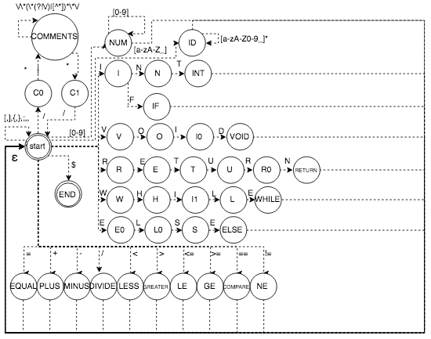

PARSER

*Diseño de compiladores - Doc. Víctor Manuel de la Cueva*

Segunda Entrega

José Manuel Beauregard Méndez

A01021716

Gramática

Rule 0 S' -> start

Rule 1 start -> declaration_list

Rule 2 declaration_list -> declaration_list declaration

Rule 3 declaration_list -> declaration

Rule 4 declaration -> var_declaration

Rule 5 declaration -> fun_declaration

Rule 6 declaration -> ENDFILE

Rule 7 var_declaration -> type_specifier ID SEMICOLON

Rule 8 var_declaration -> type_specifier ID LBRACKET NUMBER RBRACKET SEMICOLON

Rule 9 type_specifier -> INT

Rule 10 type_specifier -> VOID

Rule 11 fun_declaration -> type_specifier ID LPAREN params RPAREN compound_stmt

Rule 12 params -> param_list

Rule 13 params -> VOID

Rule 14 param_list -> param_list COMMA param

Rule 15 param_list -> param

Rule 16 param -> type_specifier ID

Rule 17 param -> type_specifier LBRACKET RBRACKET

Rule 18 compound_stmt -> LBLOCK local_declarations statement_list RBLOCK

Rule 19 local_declarations -> local_declarations var_declaration

Rule 20 local_declarations -> <empty>

Rule 21 statement_list -> statement_list statement

Rule 22 statement_list -> <empty>

Rule 23 statement -> expression_stmt

Rule 24 statement -> compound_stmt

Rule 25 statement -> selection_stmt

Rule 26 statement -> iteration_stmt

Rule 27 statement -> return_stmt

Rule 28 expression_stmt -> expression SEMICOLON

Rule 29 expression_stmt -> SEMICOLON

Rule 30 selection_stmt -> IF LPAREN expression RPAREN statement

Rule 31 selection_stmt -> IF LPAREN expression RPAREN statement ELSE statement

Rule 32 iteration_stmt -> WHILE LPAREN expression RPAREN statement

Rule 33 return_stmt -> RETURN SEMICOLON

Rule 34 return_stmt -> RETURN expression SEMICOLON

Rule 35 expression -> var EQUAL expression

Rule 36 expression -> simple_expression

Rule 37 var -> ID

Rule 38 var -> ID LBRACKET expression RBRACKET

Rule 39 simple_expression -> additive_expression relop additive_expression

Rule 40 simple_expression -> additive_expression

Rule 41 relop -> LE

Rule 42 relop -> LT

Rule 43 relop -> GREATER

Rule 44 relop -> LESS

Rule 45 relop -> COMPARE

Rule 46 relop -> NE

Rule 47 additive_expression -> additive_expression addop term

Rule 48 additive_expression -> term

Rule 49 addop -> PLUS

Rule 50 addop -> MINUS

Rule 51 term -> term mulop factor

Rule 52 term -> factor

Rule 53 mulop -> TIMES

Rule 54 mulop -> DIVIDE

Rule 55 factor -> LPAREN expression RPAREN

Rule 56 factor -> ID

Rule 57 factor -> call

Rule 58 factor -> NUMBER

Rule 59 call -> ID LPAREN args RPAREN

Rule 60 args -> arg_list

Rule 61 args -> <empty>

Rule 62 arg_list -> arg_list COMMA expression

Rule 63 arg_list -> expression

SEMANTICA

*Diseño de compiladores - Doc. Víctor Manuel de la Cueva*

Tercera Entrega

José Manuel Beauregard Méndez

A01021716

Symbol Tables

|  |  |
| --- | --- |
| **Symbols** | **Order** |
| Program | 0 |
| Declaration List | x |
| Declaration var | 2 |
| Declaration | 1 |
| Function Declaration | 2 |
| Void | 2 |
| Compound Statement | 0 |
| Local Declarations | 0 |
| Statement List | 0 |
| Expression Statement | 0 |
| Expression | 0 |
| Var | 0 |
| Selection Statement | 0 |
| Iteration Statement | 0 |
| Return Statement | 0 |
| Simple or Additive Statement | 0 |
| Simple/Additive Statement | 0 |
| Arg List | 0 |

Inference Rules

S' -> program  
program -> declaration_list  
declaration_list -> declaration_list declaration  
declaration_list -> declaration  
declaration -> var_declaration  
declaration -> fun_declaration  
var_declaration -> type_specifier ID SEMICOLON  
var_declaration -> type_specifier ID LBRACK NUM RBRACK SEMICOLON type_specifier -> INT  
type_specifier -> VOID  
fun_declaration -> type_specifier ID LPAREN params RPAREN compound_stmt params -> param_list  
params -> VOID  
param_list -> param_list COMA param  
param_list -> param  
param -> type_specifier ID  
param -> type_specifier LBRACK RBRACK  
compound_stmt -> LCURLY local_declarations statement_list RCURLY local_declarations -> local_declarations var_declaration  
local_declarations -> <empty>  
statement_list -> statement_list statement  
statement_list -> <empty>  
statement -> expression_stmt  
statement -> compound_stmt  
statement -> selection_stmt  
statement -> iteration_stmt  
statement -> return_stmt  
expression_stmt -> expression SEMICOLON

expression_stmt -> SEMICOLON  
selection_stmt -> IF LPAREN expression RPAREN statement  
selection_stmt -> IF LPAREN expression RPAREN statement ELSE statement iteration_stmt -> WHILE LPAREN expression RPAREN statement return_stmt -> RETURN SEMICOLON  
return_stmt -> RETURN expression SEMICOLON  
expression -> var EQUALS expression  
expression -> simple_expression  
var -> ID  
var -> ID LBRACK expression RBRACK  
simple_expression -> additive_expression relop additive_expression simple_expression -> additive_expression  
relop -> LTHANEQ  
relop -> LTHAN  
relop -> GTHAN  
relop -> GTHANEQ  
relop -> EQUALTO  
relop -> NOTEQUALTO  
additive_expression -> additive_expression addop term  
additive_expression -> term  
addop -> PLUS  
addop -> MINUS  
term -> term mulop factor  
term -> factor  
mulop -> TIMES  
mulop -> DIVIDE  
factor -> LPAREN expression RPAREN  
factor -> ID  
factor -> NUM