OOD Resit

Nathan Mills

**4996046**

## About Box

-No changes made

## Accessor

-Removed unused variables DEMO_NAME and DEFAULT_EXTENSION

-Split Accessor into AccessorLoadFile interface and AccessorSaveFile interface as the Accessor interface was handling both the load file and save file methods. As a result some classes now implement either AccessorLoadFile OR AccessorSaveFile instead of Accessor

## BitmapItem

-Removed unused constructor BitmapItems()

## DemoPresentation

-Now implements AccessorLoadFile

## JabberPoint

-No changes made

## KeyController

-Simplified code in method key pressed

## MenuController

-Changed menuItem, fileMenu, viewMenu, helpMenu access modifiers to private as only used in this class.

-Created interface called MenuControlButtons for all static variables.

-Renamed variable parent to parentFrame for readibility and made it final.

-Renamed method mkMenuItem to getNewMenuItem for readability.

-Added a check in moveToSlide method to make sure requested page is not out of bounds (negative or greater then amount of pages).



## Presentation

-Removed ArrayList object type as is redundant

## Slide

Into:

-Removed Vector object type as is redundant

-Removed unused method getSlideItem

## SlideItem

-Removed unused second constructor SlideItem

## SlideViewerComponent

-Removed unused variable serialVersionUID

- Extracted all Static fields into a separate interface called SlideDesign. Placed said interface in the Constants package.

## SlideViewerFrame

-Removed Presentation as an argument in setupWindow as its no longer needed

## Style

-Added access modifiers to variables that did not have but should. This is done to limit access such as colour.

## TextItem

-Removed unused constructor TextItem

-Removed unused variable EMPTYTEXT

## XMLAccessor

-Removed unused variables DEFAULT_API_TO_USE

-Has been split to XMLAccessorSaveFile and XMLAccessorLoadFile due to the XMLAccessor handling both save and load methods. As a result names have been change in some classes such as in the MenuController class. For example:

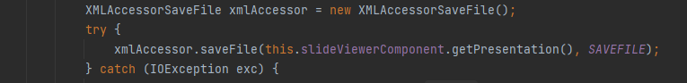

- Extracted all XMLTags into a separate interface called XMLTags. Placed said interface in the Constants package.