Session 6, logic, part 1
Statement must have one of two logical values: true (1) or false (0)
So:
“Is Tuesday today?” this sentence is not a statement
But:
“Today is Tuesday.” is a statement, a false one.

Logical functors:
$$∧∨¬⟹⇔⟶⟷$$
$$∧"\text{and}\text{"} (conjuction)$$
$$∨\text{or} (alternative)$$
$$⟹\text{implies}, \text{if … then…}(implication)$$
$$⇔\text{if and only if} (equivalence)$$
$$¬p NOT p$$
$$⟶it is the same as ⟹$$
$$⟷it is the same as ⇔$$
1.1.1.
If 2 is even, then 5=6. ????
$$p="2 is even"$$
Logical value of p is true
$$q=\text{5=6}$$
Logical value of q is false
If 2 is even, then 5=6.
$$if p then q$$
$$p ⟹q$$
What is the logical value of
$$p ⟹q$$
Using the truth table for the implication functor we see that the value of
$$p(1) ⟹q(0)$$
I s
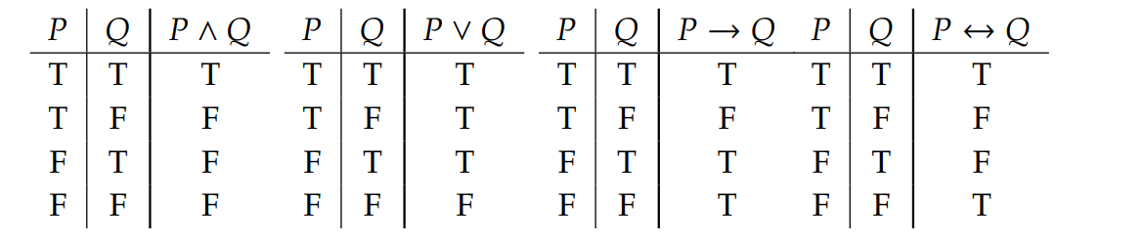

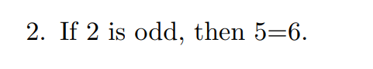
$$p(0) ⟹q(0)$$
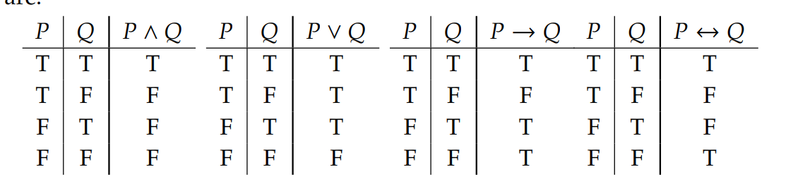
Answer: True (1)
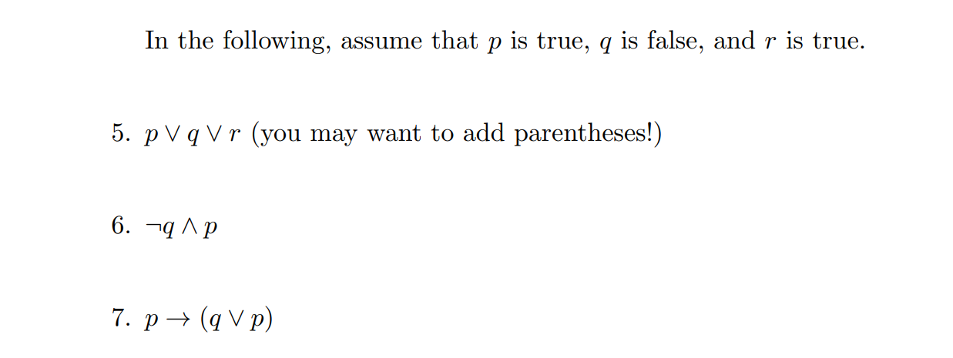
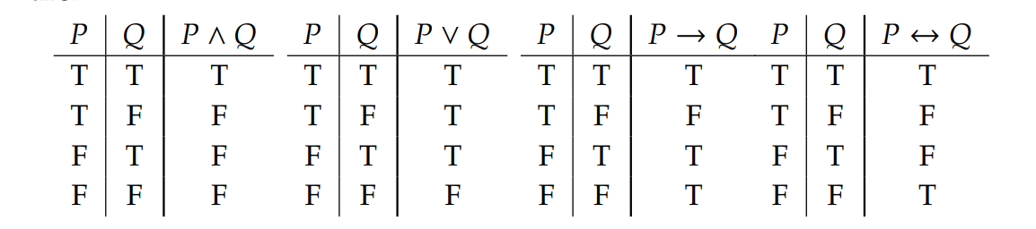
Two variants of inserting parentheses:
$$∧∨¬⟹⇔⟶⟷$$

Variant 1:
$$\left(p∨q\right)∨r$$
Variant 2:
$$p ∨(q ∨r)$$
$$1 ∨0=1$$
$$\left(1∨0\right)∨1=1 ∨1= 1$$
$$p ∨\left( q ∨r\right)=1 ∨\left(0 ∨1\right)=1 ∨1=1$$
p | q | r | $$p∨q$$ | $$\left(p∨q\right)∨r$$ | $$q ∨r$$ | $$p ∨(q ∨r)$$ | $\left(p∨q\right)∨r$ $⇔ p ∨(q ∨r)$
1 | 0 | 1 | 1 | 1 | 1 | 1 | 1
0 | 1 | 1 | 1 | 1 | 1 | 1 | 1
1 | 1 | 1 | 1 | 1 | 1 | 1 | 1
0 | 0 | 1 | 0 | 1 | 1 | 1 | 1
1 | 0 | 0 | 1 | 1 | 0 | 1 | 1
0 | 1 | 0 | 1 | 1 | 1 | 1 | 1
1 | 1 | 0 | 1 | 1 | 1 | 1 | 1
0 | 0 | 0 | 0 | 0 | 0 | 0 | 1

 | 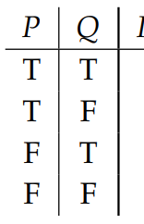 |  | 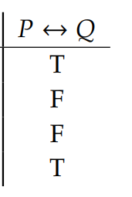
$\left(p∨q\right)∨r$ $⇔ p ∨(q ∨r)$

The formula for which each evaluation is true (1) is called TAUTOLOGY
So the formula (p∨q)∨r ⇔ p ∨(q ∨r) is a tautology (logic law)
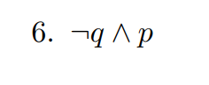
$$∧∨¬⟹⇔⟶⟷$$

p | q | $$¬ q$$ | $$¬ q ∧p$$
0 | 0 | 1 | 0
0 | 1 | 0 | 0
1 | 0 | 1 | 1
1 | 1 | 0 | 0

Last column means that
$$¬ q ∧p$$
Is not a tautology.
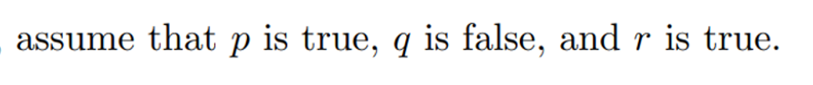
Answer 1.1.6: True

