Software Design Specification Document

Project Name: Bank Loan App  
Version:

Table of Contents

Introduction 3

Purpose 3

Definitions, Acronyms, and Abbreviations 3

Requirements 3

Architecture Design 4

Structure and Relationship 4

Technical Requirements 4

Environment 5

Technologies and Tools 5

Use Cases 5

Use Case 1: Landing Page/Personal Loan/Home Loan/Auto Loan 6

Use Case 2: Login Page 7

Use Case 3: Registration 8

Use Case 4: Account Confirmation 9

Use Case 5: User Dashboard 10

Use Case 6: Forgot Password 11

Use Case 7: Loan Request 12

Use Case 8: Log Off 13

Entity Relationship Diagram 14

User - Data Dictionary 15

Address - Data Dictionary 16

EmailConfirmation - Data Dictionary 16

LoanRequest - Data Dictionary 17

LoanResults - Data Dictionary 18

AuditTrail - Data Dictionary 19

LoanApprovalRules - Data Dictionary 19

Introduction

Purpose

The purpose of this document is to provide a detail definition of the requirements for the Bank Loan application.

Definitions, Acronyms, and Abbreviations

* ***.NET***: Microsoft underlying framework. It contains different namespaces that provide predefined codes that allow a program to interact with the Windows environment along with other environments.
* ***SQL****:* Structured Query Language. Commonly used acronym to refer to any SQL bases database environment.
* ***C#***: Programming language used to develop this tool.
* ***Web Application***: Refers to software created to be deployed in a web server
* ***XML***: Stands for Extended Markup Language. Structured text format recognized by software as a way to effectively store data, configuration values, etc. For this project it will be used to save a draft locally in the device and also to contain a local representation of the data on the main repository.

Requirements

* Loan Calculation
  + Variables to be considered when calculating a loan
    - APR % = APR
    - Down Payment (Auto, House) = DP
    - Income = I
    - Credit Score = CS
    - Amount = A
    - Term = T
    - Monthly Payment = MP
  + Loan Calculation formula
    - The following is the formula that will be used to calculate a loan when the user submits a loan request

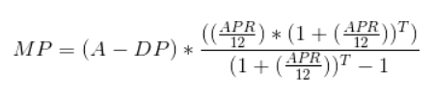

* + Calculate APR %
    - Data will be provided that will included the APR % depending on the payment terms and the credit score
  + Calculate debt-to-income
    - Formula to calculate the amount a user has available to get a loan based on its income.
      * Home Loan = 43% available
      * Car Loan = 36%
      * Personal Loan = 45%

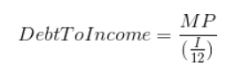

Architecture Design

Structure and Relationship

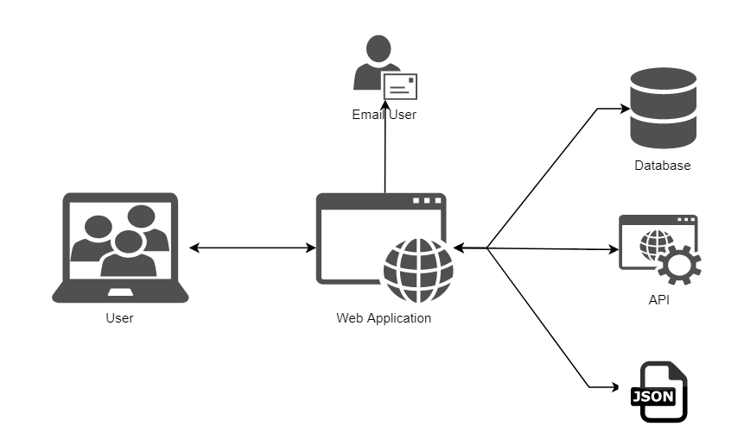

**Figure 1.** System architecture

Technical Requirements

Environment

* Device with Windows 7 or a higher version
* .NET Framework 4.5 or higher

Technologies and Tools

* C#
* Visual Studio 2017 or higher
* SQL Server Management Studio
* Bootstrap
* jQuery
* MSTEST

Use Cases



Use Case 1: Landing Page/Personal Loan/Home Loan/Auto Loan

User wants to visit the Bank Loan Site Landing Page.

**Normal Course:**

1. User opens the Browser.
2. User enters the Bank Loan Site Landing Page URL.
3. User presses Enter.
4. System directs the user to the Landing Page.

**Alternative Course:**

1. To visit the Personal Loan Page, the user clicks the Loans option at the top navigation bar and clicks on Personal.
2. To visit the Auto Loan Page, the user clicks the Loans option at the top navigation bar and clicks on Auto.
3. To visit the Home Loan Page, the user clicks the Loans option at the top navigation bar and clicks on Home.

**Business Rules:**

1. No special business rules.

Use Case 2: Login Page

User wants to log in to the Bank Loan Application.

**Normal Course:**

1. User opens the Browser.
2. User enters the Bank Loan Site landing page URL.
3. User presses Enter.
4. System directs the user to the Landing Page.
5. User clicks on the Login Button.
6. System directs the user to the Login Form.

**Alternative Course:**

1. If user/password combination is incorrect, the system displays an error message. (“User/Password is Incorrect”)
2. If user does not have an account, refer to Use Case 3.
3. If user is logged in and tries to navigate to the Login Page, the system redirects the user to the User Dashboard Page.
4. If user is not confirmed, the system resends the confirmation message on a new page.

**Business Rules:**

1. User must be registered.

**Sequence Diagram:**



Use Case 3: Registration

User wants to register in the Bank Loan Site.

**Normal Course:**

1. User opens the Browser.
2. User enters Bank Loan Site landing page URL.
3. User press Enter.
4. System directs the user to the Landing Page.
5. User clicks on the Login Button.
6. System directs the user to the Login Form.
7. User clicks the Registration Link.
8. System displays the Registration Form.
9. User fills in the following required fields: First Name, Last Name, Phone (10 digit with masking ex. 787-765-4321), Email, Address, City, State, Zip Code (5 number digit), Password/Password (min. 8 alphanumeric), Middle Name, Business Phone (10 digit with auto-masking ex.787-765-4321).
10. User clicks on the Register Button.
11. System sends a Confirmation Token via email.

**Alternative Course:**

1. If user/password combination is incorrect, the system displays an error message. (“User/Password is Incorrect”)
2. If user entered an existing email, the system displays the error message (“User Already Exists”)
3. If user missed a required field, the system displays the message ““Missing Field”)
4. If user cancels the registration, the system closes the page and redirects the user to the Landing Page.
5. If user enters an invalid Email Address, the system displays an error message (“Invalid Email Address ex. janedoe@domain.com”)
6. If user enters an invalid Phone Number, the system displays an error message. (“Invalid Phone Number ex.787-765-4321”)
7. If user enters an invalid Zip Code, the system displays an error message. (“Invalid Zip Code ex. 00000”)

**Business Rules:**

1. User is not registered in the site.

**Sequence Diagram:**



Use Case 4: Account Confirmation

User registered in the Bank Loan Site and received a confirmation email.

**Normal Course:**

1. User received a confirmation email.
2. User clicks on the provided URL link.
3. System directs the user to a Confirmation Page displaying the message “Your Account Has Been Successfully Confirmed”.
4. Status flag is set to active in the database.
5. User clicks the Ok Button.
6. System redirects the user to the Login Page.

**Alternative Course:**

1. If the confirmation token is invalid, the system displays an error message and the user can request a new confirmation code. (“Confirmation Code is Invalid”)

**Business Rules:**

1. User is registered in the site but the account has not been confirmed.

**Sequence Diagram:**



Use Case 5: User Dashboard

User registered on Bank Loan Site and received a confirmation email.

**Normal Course:**

1. User logs in to the Bank Loan Site.
2. System directs the user to the User Dashboard Page.
3. User Personal Information is displayed on the left side of the page (User Name, Home Phone, Work Phone, Complete Address and Email).
4. Edit Button is available to update the Personal Information.
5. Equifax and TransUnion Credit Score gauges are displayed on the right side of the page.
6. A Request History Table is displayed on the bottom of the page which provides the following information: Request Id, Request Status (Filter), Loan Type (Filter), Request Date (Filter), Resolution Date (Filter), Amount, Credit Score, APR, Comments (Tooltip row shows complete comments).

**Alternative Course:**

1. If user account is not confirmed, user cannot be redirected to the User Dashboard Page.

**Business Rules:**

1. User is registered in the site and is and logged in.
2. Credit Score will be updated every 3 days.
3. User can update the following information: Phone Number and Address.
4. If user logs in for the first time, the Request History Table shows empty, only displaying the following message: “No Data Available”

**Sequence Diagram:**



Use Case 6: Forgot Password

User is registered but forgot the password.

**Normal Course:**

1. The login page provides a Forgot Password link.
2. User clicks the Forgot Password link.
3. System directs the user to a Forgot Password Form.
4. User enters a valid email address and presses enter.
5. System sends a new password to the user via email.

**Alternative Course:**

1. If user email is invalid, the system displays an error message. (“Invalid Email Address”)
2. If user is logged in and tries to access the Forgot Password Form, the system redirects the user to the User Dashboard Page.

**Business Rules:**

1. User is registered in the site

**Sequence Diagram:**



Use Case 7: Loan Request

User wants to request a Loan.

**Normal Course:**

1. User clicks on the Loan Request Button.
2. System directs the user to the Loan Request Form.
3. User fills in the required fields (all are required).
4. System retrieves the user information from the following databases: Loan Type (JSON file), Down Payment, Employer, Employment Type (JSON file), Income, Term, Loan Amount, Job Title and Social Security Number.
5. User clicks the Submit Request Button.
6. Once the request is submitted the application contacts the API and makes the calculations to approve or not approve the Loan.
7. User can verify the Loan Request status in the User Dashboard Page.

**Alternative Course:**

1. If any required field is empty, an error message is displayed. (“Missing Field”)

**Business Rules:**

1. No special business rules.

**Sequence Diagram:**



Use Case 8: Log Off

User wants to Log Off from the site.

**Normal Course:**

1. User clicks on the “Hello User” Button.
2. Log Off option appears.
3. User clicks on Log Off Button.
4. User is logged off the application and redirected to the Landing Page.

**Alternative Course:**

1. If user tries to access the User Dashboard or Loan Request pages after logging off, the system redirects the user to the Login Page.

**Business Rules:**

1. No special business rules.

**Sequence Diagram**

Entity Relationship Diagram

**ERD** Entity Relationship Diagram

User - Data Dictionary

|  |  |
| --- | --- |
| **Table Name** | **USER** |
| **Description** | Table used to maintain users information |
| **Fields** | |  |  |  | | --- | --- | --- | | **Field Name** | Data Type | Description | | **PK ID** | INT |  | | **EMAIL** | NVARCHAR (50) |  | | **FIRSTNAME** | NVARCHAR (25) |  | | **LASTNAME** | NVARCHAR (25) |  | | **MIDDLENAME** | NVARCHAR (25) |  | | **TELEPHONE** | NVARCHAR (10) |  | | **FK ADRESSID** | INT |  | | **PASSWORD** | NVARCHAR (15) |  | | **USERSTATUS** | INT |  | | **CREATEDDATE** | DATE |  | |

Address - Data Dictionary

|  |  |
| --- | --- |
| **Table Name** | **ADDRESS** |
| **Description** | Table used to maintain user Address information |
| **Fields** | |  |  |  | | --- | --- | --- | | **Field Name** | Data Type | Description | | **PK ID** | INT |  | | **ADDRESS** | NVARCHAR (50) |  | | **CITY** | NVARCHAR (25) |  | | **STATE** | NVARCHAR (25) |  | | **ZIPCODE** | NVARCHAR (25) |  | |

EmailConfirmation - Data Dictionary

|  |  |
| --- | --- |
| **Table Name** | **EMAILCONFIRMATION** |
| **Description** | Table used to maintain users Email confirmation data |
| **Fields** | |  |  |  | | --- | --- | --- | | **Field Name** | Data Type | Description | | **PK ID** | INT |  | | **FK USERID** | INT |  | | **TOKEN** | NVARCHAR (50) |  | |

LoanRequest - Data Dictionary

|  |  |
| --- | --- |
| **Table Name** | **LOANREQUEST** |
| **Description** | Table used to maintain Loan Request information |
| **Fields** | |  |  |  | | --- | --- | --- | | **Field Name** | Data Type | Description | | **PK ID** | INT |  | | **FK USERID** | INT |  | | **SOCIALSECURITY** | NVARCHAR (9) |  | | **INCOME** | DOUBLE |  | | **EMPLOYER** | NVARCHAR (25) |  | | **JOBTITLE** | NVARCHAR (25) |  | | **EMPLOYMENTTYPE** | NVARCHAR (10) |  | | **STATUS** | NVARCHAR (10) |  | | **AMOUNT** | DOUBLE |  | | **TERM** | INT |  | | **DOWNPAYMENT** | DOUBLE |  | | **LOANTYPE** | NVARCHAR (10) |  | |

LoanResults - Data Dictionary

|  |  |
| --- | --- |
| **Table Name** | **LOANRESULTS** |
| **Description** | Table used to maintain the Loan Results information |
| **Fields** | |  |  |  | | --- | --- | --- | | **Field Name** | Data Type | Description | | **PK ID** | INT |  | | **CREDITSCORE** | INT |  | | **FK REQUESTID** | INT |  | | **APR** | DOUBLE |  | | **MONTHLYPAYMENT** | DOUBLE |  | | **AMOUNT** | DOUBLE |  | | **TERM** | INT |  | | **SUGGESTEDDOWNPAYMENT** | DOUBLE |  | | **DECISION** | NVARCHAR (10) |  | | **RESOLUTIONDATE** | DATE |  | | **COMMENTS** | NVARCHAR (250) |  | |

AuditTrail - Data Dictionary

|  |  |
| --- | --- |
| **Table Name** | **AUDITTRAIL** |
| **Description** | Table used to maintain Audit Trail information |
| **Fields** | |  |  |  | | --- | --- | --- | | **Field Name** | Data Type | Description | | **PK ID** | INT |  | | **ACTIONID** | INT |  | | **FK REQUESTID** | INT |  | | **FK USERID** | INT |  | | **TIMESTAMP** | DATE |  | |

LoanApprovalRules - Data Dictionary

|  |  |
| --- | --- |
| **Table Name** | **LOANAPPROVALRULES** |
| **Description** | Table used to maintain the Loan Approval Rules |
| **Fields** | |  |  |  | | --- | --- | --- | | **Field Name** | Data Type | Description | | **PK ID** | INT |  | | **MINIMUMSOCRE** | INT |  | | **MAXIMUMSCORE** | INT |  | | **DOWNPAYMENTREQ** | DOUBLE |  | | **DOWNPAYMENTPCT** | DOUBLE |  | | **APR** | DOUBLE |  | | **LOANTYPE** | NVARCHAR (10) |  | |